The discriminant power of biometrics for sex determination in European Bee-eaters Merops apiaster
Joana S. Costa, Steffen Hahn, Afonso D. Rocha, Pedro M. Araújo, Juanita Olano-Marín, Tamara Emmenegger and José A. Alves
Online supplementary material

Figure S1. Spearman’s correlation matrix for biometrics from the PT population. Correlation coefficient values for each pair or biometrics is shown in the top. Plots for each pair of biometrics are shown in the bottom. Within each plot, linear regression line is showed in red. A histogram representing the distribution of each biometric is also presented along the matrix diagonal (bill length - B; head-bill length – HB; wing length - W; Kipp’s distance - K; p3 length - P3; tail tip length - TT; tail length – TL; and right rectrix length – RR).

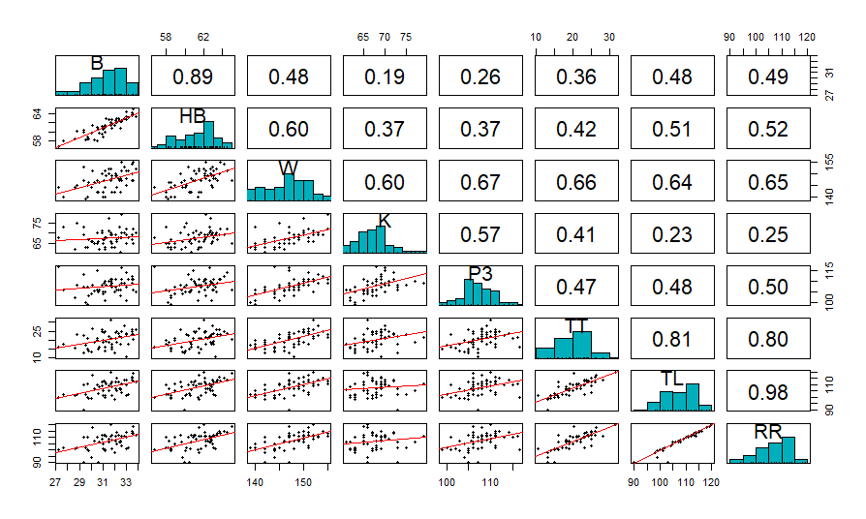
Figure S2. Spearman’s correlation matrix for biometrics from the DE population. Correlation coefficient values for each pair or biometrics is shown in the top. Plots for each pair of biometrics are shown in the bottom. Within each plot, linear regression line is showed in red. A histogram representing the distribution of each biometric is also presented along the matrix diagonal (bill length - B; head-bill length – HB; wing length - W; Kipp’s distance - K; p3 length - P3; tail tip length - TT; tail length – TL; and right rectrix length - RR).
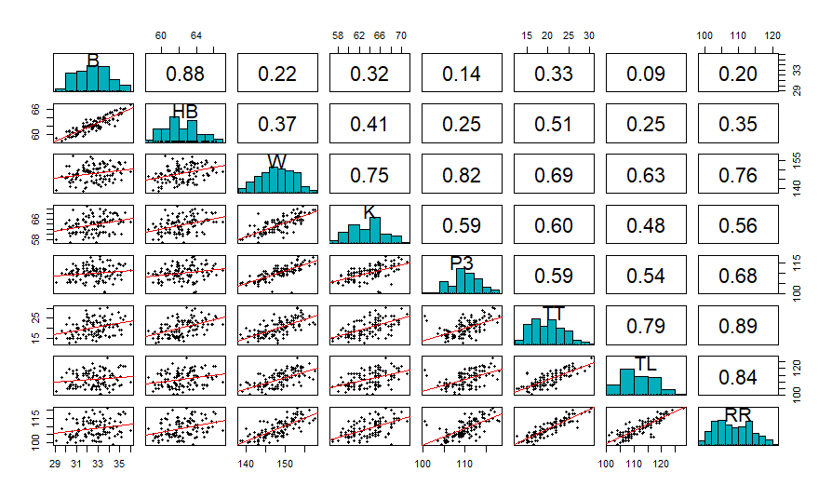
Table S1. Biometrics (mean, se and range, all in mm) for male and female European Bee-eaters breeding in Portugal and Germany, sampled in 2016. Overlap indicate the percentage of range overlap between males and females for each biometric. Positive values of sexual dimorphism index (SDI) indicate that males are larger, negative values that females are larger and zero that sexes are identical in size.
 | Male (n = 34) |  |  |  | Female (n = 23) |  |  |  | Overlap (%) | SDI
Portugal | mean | se | range |  | mean | se | range
Bill length | 31.9 | 0.2 | 28.8-33.8 |  | 30.6 | 0.3 | 27.2-33.5 |  | 89.4 | 0.04
Head-bill length | 62.2 | 0.2 | 59.5-65.0 |  | 59.8 | 0.3 | 56.7-63.5 |  | 71.9 | 0.04
P3 length | 108.9 | 0.4 | 101.0-115.0 |  | 105.7 | 0.8 | 99.0-116.5 |  | 92.2 | 0.03
Wing length | 149.7 | 0.4 | 144.0-155.0 |  | 143.4 | 0.5 | 139.0-148.0 |  | 40.3 | 0.04
Kipp’s distance | 69.6 | 0.5 | 65.0-79.0 |  | 65.0 | 0.6 | 61.0-73.0 |  | 77.1 | 0.07
Right rectrix length | 109.7 | 0.9 | 90.0-120.0 |  | 103.2 | 1.2 | 90.0-113.0 |  | 87.7 | 0.06
Tail length | 110.0 | 1.0 | 90.0-120.0 |  | 104.2 | 1.0 | 98.0-114.0 |  | 87.7 | 0.05
Tail tip length | 22.4 | 0.6 | 10.5-31.5 |  | 17.1 | 0.5 | 10.0-23.0 |  | 71.9 | 0.24
Germany | Male (n = 59) |  |  |  | Female (n = 54)
Bill length | 33.1 | 0.1 | 30.1-36.0 |  | 32.0 | 0.1 | 29.1-35.2 |  | 97.3 | 0.03
Head-bill length | 63.3 | 0.2 | 60.0-67.0 |  | 61.3 | 0.2 | 58.5-65.2 |  | 99.1 | 0.03
P3 length | 111.9 | 0.4 | 100.5-118.0 |  | 108.1 | 0.3 | 103.5-113.5 |  | 84.3 | 0.03
Wing length | 151.0 | 0.3 | 144.5-157.5 |  | 144.9 | 0.4 | 138.5-150.5 |  | 52.1 | 0.04
Kipp’s distance | 65.5 | 0.3 | 61.0-71.0 |  | 61.7 | 0.3 | 57.0-68.0 |  | 71.3 | 0.06
Right rectrix length | 112.6 | 0.5 | 104.0-121.0 |  | 104.7 | 0.4 | 99.0-113.5 |  | 63.1 | 0.07
Tail length | 115.3 | 0.6 | 104.0-128.0 |  | 108.3 | 0.5 | 101.0-117.0 |  | 77.1 | 0.06
Tail tip length | 23.3 | 0.3 | 18.5-30.5 |  | 16.8 | 0.2 | 12.5-22.0 |  | 47.3 | 0.28

