Supplemental Online Appendix

Definition of lines of therapy:
LOT was determined per the treatment algorithm outlined below, which utilizes a comprehensive view of treatment patterns per the National Comprehensive Cancer Network® (NCCN) Guidelines® for Multiple Myeloma (NCCN MM Guidelines v1.2020). It should be noted that updated versions (i.e. as of version 3.2017) of the guidelines for MM removed all melphalan-containing regimens, thalidomide/dexamethasone, liposomal doxorubicin/vincristine/dexamethasone (DVD), and vincristine/doxorubicin/dexamethasone (VAD) for non-SCT candidates and thalidomide/dexamethasone, single-agent dexamethasone, and DVD for SCT candidates. However, due to the time frame of these data, these regimens were included and captured. The treatment algorithm is summarized below.
Patients with an SCT (within 300 days of first-line regimen):
- Induction therapy received prior to SCT was part of the first-line regimen.
- Continuation of the same or a subset of the induction regimen was continuation of first-line , unless the interval between re-treatment and most recent prior regimen was at least 6 months, in which case re-treatment constituted second-line treatment.
- Start of single-agent lenalidomide or bortezomib within 12 months after SCT was part of first-line maintenance therapy.
- The switch/addition of a new drug (not including steroids) after a 60-day gap from SCT was second-line treatment.
Patients with no SCT (within 300 days of first-line regimen):
- Drugs initiated within 90 days of the first date for an MM-specific anticancer agent after first MM diagnosis date constituted the initial frontline regimen.
- Continuation of same regimen or subset thereof was part of first-line treatment unless the interval between re-treatment and the most recent prior regimen was at least 6 months, in which case re-treatment constituted second-line treatment.
- Start of single-agent lenalidomide or bortezomib within 6 months of the end of initial therapy was part of first-line maintenance therapy.
- Switch/addition of a new drug (not including steroids) compared to initial therapy was second-line treatment.
For all patients, subsequent lines of therapy (third and beyond) occurred if:
- There was a switch/addition of a new MM-specific anticancer drug (not including steroids) compared to the regimen in prior line, or
- Re-treatment with the same regimen/subset where a gap between the end of the prior regimen and start of re-treatment was at least 6 months.
- Single-agent dexamethasone (but not prednisone) constituted a regimen if dexamethasone alone was >90 days in duration.

Appendix Table 1. Sensitivity Analysis of First Index Regimen (Patient-Level Adjusted Analysis) vs. Main Analysis of All Index Regimen Use (Patient LOT-Level Adjusted Analysis)ª
Sensitivity Analysis: Patient-Level Analysis |  |  |  |  | Main Analysis: Patient LOT-Level Analysis
All patients, LOT ≥2 |  |  |  |  | All patients, LOT ≥2
Comparison | HR | 95% CI |  | P-value | Comparison | HR | 95% CI |  | P-value
IRd vs. (reference) KRd | 0.80 | 0.57 | 1.11 | 0.1805 | IRd vs. (reference) KRd | 0.84 | 0.63 | 1.13 | 0.2424
IRd vs. (reference) VRd | 0.92 | 0.67 | 1.28 | 0.6377 | IRd vs. (reference) VRd | 0.93 | 0.69 | 1.26 | 0.6431
KRd vs. (reference) VRd | 1.16 | 0.86 | 1.57 | 0.3421 | KRd vs. (reference) VRd | 1.11 | 0.84 | 1.46 | 0.4631
Patients in LOT 2–3, only |  |  |  |  | Patients in LOT 2-3, only
Comparison | HR | 95% CI |  | P-value | Comparison | HR | 95% CI |  | P-value
IRd vs. (reference) KRd | 0.71 | 0.47 | 1.08 | 0.1097 | IRd vs. (reference) KRd | 0.74 | 0.49 | 1.11 | 0.1426
IRd vs. (reference) VRd | 0.79 | 0.54 | 1.17 | 0.2431 | IRd vs. (reference) VRd | 0.81 | 0.57 | 1.16 | 0.2564
KRd vs. (reference) VRd | 1.11 | 0.78 | 1.58 | 0.5497 | KRd vs. (reference) VRd | 1.10 | 0.78 | 1.54 | 0.5900
Fit patients, only^{b} |  |  |  |  | Fit patients, only^{b}
Comparison | HR | 95% CI |  | P-value | Comparison | HR | 95% CI |  | P-value
IRd vs. (reference) KRd | 1.08 | 0.54 | 2.14 | 0.8356 | IRd vs. (reference) KRd | 1.25 | 0.67 | 2.33 | 0.4822
IRd vs. (reference) VRd | 1.05 | 0.53 | 2.07 | 0.8911 | IRd vs. (reference) VRd | 0.96 | 0.52 | 1.77 | 0.8914
KRd vs. (reference) VRd | 0.98 | 0.52 | 1.84 | 0.9377 | KRd vs. (reference) VRd | 0.77 | 0.41 | 1.44 | 0.4074
Intermediate-frail patients, only^{b} |  |  |  |  | Intermediate-frail patients, only^{b}
Comparison | HR | 95% CI |  | P-value | Comparison | HR | 95% CI |  | P-value
IRd vs. (reference) KRd | 0.66 | 0.44 | 0.97 | 0.0364 | IRd vs. (reference) KRd | 0.70 | 0.49 | 0.98 | 0.0389
IRd vs. (reference) VRd | 0.92 | 0.61 | 1.37 | 0.6772 | IRd vs. (reference) VRd | 0.96 | 0.66 | 1.40 | 0.8307
KRd vs. (reference) VRd | 1.40 | 0.98 | 2.00 | 0.0685 | KRd vs. (reference) VRd | 1.38 | 1.00 | 1.89 | 0.0481
No prior PI exposure |  |  |  |  | No prior PI exposure
Comparison | HR | 95% CI |  | P-value | Comparison | HR | 95% CI |  | P-value
IRd vs. (reference) KRd | 0.93 | 0.33 | 2.59 | 0.8871 | IRd vs. (reference) KRd | 0.93 | 0.34 | 2.58 | 0.8866
IRd vs. (reference) VRd | 1.10 | 0.55 | 2.19 | 0.7945 | IRd vs. (reference) VRd | 1.10 | 0.55 | 2.19 | 0.7949
KRd vs. (reference) VRd | 1.18 | 0.49 | 2.84 | 0.7111 | KRd vs. (reference) VRd | 1.18 | 0.50 | 2.81 | 0.7076
Prior PI exposure |  |  |  |  | Prior PI exposure
Comparison | HR | 95% CI |  | P-value | Comparison | HR | 95% CI |  | P-value
IRd vs. (reference) KRd | 0.70 | 0.48 | 1.02 | 0.0603 | IRd vs. (reference) KRd | 0.76 | 0.55 | 1.05 | 0.0924
IRd vs. (reference) VRd | 0.76 | 0.51 | 1.13 | 0.1724 | IRd vs. (reference) VRd | 0.80 | 0.56 | 1.14 | 0.2144
KRd vs. (reference) VRd | 1.08 | 0.77 | 1.53 | 0.6492 | KRd vs. (reference VRd | 1.05 | 0.77 | 1.43 | 0.7534
ª Adjusted for the following covariates: index regimen type (IRd , KRd, VRd), modified frailty score (0 [fit], 1–2 [intermediate to frail]), prior PI and/or IMID exposure, prior SCT, history of CVD or uncontrolled HTN, history of PN, or baseline CRAB symptoms (hypercalcemia, renal failure, anemia, bone disease [all, yes vs. no]), cytogenetic risk (high, standard/unknown]), ISS stage (I/II, III, unknown), PI/IMID refractory status (PI and/or IMID refractory, refractory to neither), time (months) from diagnosis to start of index LOT, refractory status to last therapy (yes, no; yes was defined as a TFI from end of most previous LOT to initiation of index regimen of ≤60 days), time of first relapse (months [i.e. time from start of LOT1 to start of LOT2]), and year of diagnosis (2007–2011, 2012–2015, 2016–2018).
^{b)} Adapted from Palumbo, et al. (Blood. 2015;125(13):2068-2074) and includes age and CCI score only. as IADL and ADL were not available in the EHR database.
Key: CI – confidence interval; CVD – cardiovascular disease; HR – hazard ratio; HTN – hypertension; IMID – immunomodulatory drug; IRd – ixazomib, lenalidomide, dexamethasone; KRd – carfilzomib, lenalidomide, dexamethasone; LOT – line of therapy; PI – proteasome inhibitor; PN – peripheral neuropathy; SCT – stem cell transplant; VRd – bortezomib, lenalidomide, dexamethasone.

Appendix Table 2. The Modified Frailty Score [14]
Variable | Category | Variable Score
Patient age, in years | ≤75 | 0
 | 76–80 | 1
 | ≥81 | 2
CCI score | ≤1 | 0
 | ≥2 | 1
Cumulative Score
0 = Fit | 1= Intermediate | 2 = Frail
Key: CCI – Charlson comorbidity index.
Appendix Table 3. Modified Frailty Scoreª Distribution by Age and CCI Score Across Treatment Groups
Modified Frailty Categoryª | Age group, years | CCI Score | KRd  (N=208) | IRd  (N=168) | VRd  (N=357)
 |  |  | n (%)
Fit | ≤75 | 0–1 | 63 (30.3) | 55 (32.7) | 89 (24.9)
Intermediate | ≤75 | ≥2 | 107 (51.4) | 53 (31.6) | 139 (38.9)
 | 76–80 | 0–1 | 8 (3.9) | 13 (7.7) | 26 (7.3)
Frail | 76–80 | ≥2 | 15 (7.2) | 17 (10.1) | 43 (12.0)
 | ≥81 | 0–1 | 5 (2.4) | 13 (7.7) | 19 (5.3)
 | ≥81 | ≥2 | 10 (4.8) | 17 (10.1) | 41 (11.5)
a) Adapted from Palumbo, et al. (Blood. 2015;125(13):2068-2074) and includes age and CCI score only. as IADL and ADL were not available in the EHR database.
Key: CCI – Charlson comorbidity index; IRd – ixazomib, lenalidomide, dexamethasone; KRd – carfilzomib, lenalidomide, dexamethasone; VRd – bortezomib, lenalidomide, dexamethasone

Appendix Table 4. Baseline Clinical and Treatment Characteristics by Regimen Type for Index Lines of Therapy 2 and 3
Variable,  N (%) except where noted |  |  | Regimen Type
 |  |  | Overall  N=586 | IRd  N=116 | KRd  N=150 | VRd  N=320 | P-Value
Follow-up, median months (IQR) |  |  | 14.7 (6.8, 24.5) | 11.2 (6, 18.8) | 14.5 (7.2, 23.5) | 16.4 (7.1, 27.0) | 0.0007
Age, median years (IQR) |  |  | 69 (61, 77) | 69 (62, 79) | 64 (57, 73) | 70 (62, 78) | <0.0001
Age group, years | 18–64 |  | 229 (39.1) | 45 (38.8) | 79 (52.7) | 105 (32.8) | <.0001
 | 65–74 |  | 165 (28.2) | 28 (24.1) | 42 (28.0) | 95 (29.7)
 | ≥75 |  | 192 (32.8) | 43 (37.1) | 29 (19.3) | 120 (37.5)
CCI scoreª | 0 |  | 180 (30.7) | 50 (43.1) | 40 (26.7) | 90 (28.1) | 0.0078
 | 1 |  | 50 (8.5) | 10 (8.6) | 15 (10.0) | 25 (7.8)
 | ≥2 |  | 356 (60.8) | 56 (48.3) | 95 (63.3) | 205 (64.1)
ECOG PS | 0–1 |  | 166 (28.3) | 37 (31.9) | 48 (32.0) | 81 (25.3) | 0.3575
 | 2–4 |  | 28 (4.8) | 4 (3.5) | 6 (4.0) | 18 (5.6)
 | Unknown |  | 392 (66.9) | 75 (64.7) | 96 (64.0) | 221 (69.1)
Modified frailty score^{b} | Fit |  | 164 (28.0) | 40 (34.5) | 48 (32.0) | 76 (23.8) | 0.0004
 | Intermediate |  | 287 (49.0) | 48 (41.4) | 86 (57.3) | 153 (47.8)
 | Frail |  | 135 (23.0) | 28 (24.1) | 16 (10.7) | 91 (28.4)
Cytogenetics^{c} | High risk |  | 115 (19.6) | 26 (22.4) | 44 (29.3) | 45 (14.1) | 0.0007
 | Standard risk/unknown |  | 471 (80.4) | 90 (77.6) | 106 (70.7) | 275 (85.9)
CRAB symptomsª | Any |  | 473 (80.7) | 78 (67.2) | 135 (90.0) | 260 (81.3) | <0.0001
 | RI |  | 271 (46.3) | 36 (31.0) | 68 (45.3) | 167 (52.2) | 0.0004
 | Anemia |  | 406 (69.3) | 65 (56.0) | 123 (82.0) | 218 (68.1) | <0.0001
 | Hypercalcemia |  | 74 (12.6) | 6 (5.2) | 28 (18.7) | 40 (12.5) | 0.0012
 | Bone disease |  | 119 (20.3) | 19 (16.4) | 39 (26.0) | 61 (19.1) | 0.1304
Comorbidities of interestª | CVD^{d} or uncontrolled HTN |  | 69 (11.8) | 12 (10.3) | 22 (14.7) | 35 (10.9) | 0.4783
 | Peripheral neuropathy |  | 100 (17.1) | 21 (18.1) | 42 (28.0) | 37 (11.6) | 0.0003
ISS stage | I/II |  | 129 (22.0) | 19 (16.4) | 37 (24.7) | 73 (22.8) | 0.2950  (excludes unknown)
 | III |  | 42 (7.2) | 3 (2.6) | 15 (10.0) | 24 (7.5)
 | Unknown |  | 415 (70.8) | 94 (81.0) | 98 (65.3) | 223 (69.7)
Treatment Characteristics
Index LOT | 2 |  | 417 (71.2) | 62 (53.5) | 104 (69.3) | 251 (78.4) | <0.0001
 | 3 |  | 169 (28.8) | 54 (46.6) | 46 (30.7) | 69 (21.6) | <0.0001
Prior exposure to a PI or IMID |  | Both IMID and PI | 238 (40.6) | 61 (52.6) | 92 (61.3) | 85 (26.6) | <0.0001
 |  | IMID only | 121 (20.7) | 34 (29.3) | 7 (4.7) | 80 (25.0) | <0.0001
 |  | PI only | 214 (36.5) | 19 (16.4) | 48 (32.0) | 147 (45.9) | <0.0001
 |  | Neither | 13 (2.2) | 2 (1.7) | 3 (2.0) | 8 (2.5) | 0.8597
Refractory status to PIs and/or IMIDs | Both IMID and PI |  | 21 (3.6) | 10 (8.6) | 10 (6.7) | 1 (0.3) | <0.0001
 | IMID only |  | 21 (3.6) | 6 (5.2) | 3 (2.0) | 12 (3.8) | 0.3213
 | PI only |  | 144 (24.6) | 33 (28.5) | 100 (66.7) | 11 (3.4) | <0.0001
 | Neither |  | 400 (68.3) | 67 (57.8) | 37 (24.7) | 296 (92.5) | <0.0001
Refractory to prior therapy^{e} |  |  | 453 (77.3) | 79 (68.1) | 124 (82.7) | 250 (78.1) | 0.0264
Prior SCT |  |  | 136 (23.2) | 29 (25.0) | 50 (33.3) | 57 (17.8) | 0.0016
Time (months) from Initiation of frontline therapy to first relapse, median (IQR)^{f} |  |  | 11.1 (5.7, 20.2) | 13.6 (8.0, 25.2) | 10.0 (5.5, 17.3) | 10.4 (5.5, 18.0) | 0.0056
Time (months) from dx to index LOT, median (IQR) |  |  | 17.3 (8.7, 33.3) | 27.1 (13.3, 49.6) | 15.8 (8.3, 29.5) | 15.9 (8.0, 30.9) | <0.0001
ª Baseline presence is relative to 6 months prior to initiation of index LOT. Further, CRAB symptoms were not mutually exclusive (ie, patients could have ≥1 CRAB symptom at baseline).
^{b} Adapted from Palumbo, et al. (Blood. 2015;125(13):2068-2074) and includes age and CCI score only. as IADL and ADL were not available in the EHR database.
^{c} High-risk cytogenetics were defined as presence of del[17p], t[4;14], t[14;16], and/or 1q21 gain.
^{d} CVD includes MI, angina, CAD, arrhythmia, sick sinus syndrome, ischemia, and HF.
^{e} Greater than 96% of prior IMID use across all treatment groups was lenalidomide.
^{f} Defined as a TFI from the end of previous LOT to initiation of index regimen of ≤60 days.
^{g} Defined as time from initiation of LOT1 to initiation of LOT2.
Key: CCI – Charlson comorbidity index; CAD – coronary artery disease; CVD – cardiovascular disease; ECOG – Eastern Cooperative Oncology Group; IMID – immunomodulatory drug; HF – heart failure; IQR – interquartile range; IRd – ixazomib, lenalidomide, dexamethasone; ISS – International Staging System; KRd – carfilzomib, lenalidomide, dexamethasone; LOT – line of therapy; MI – myocardial infarction; NR – not reported; PI – proteasome inhibitor; PS – performance status; SCT – stem cell transplant; TFI – treatment-free interval; VRd – bortezomib, lenalidomide, dexamethasone.

Appendix Table 5. Covariates Evaluated as Independent Predictors of Treatment Choiceª
Variable | Comparison: IRd vs. VRd (Reference: VRd) |  |  |  | Comparison: KRd vs. VRd (Reference: VRd) |  |  |  | Comparison: IRd vs. KRd (Reference: KRd)
 | OR | 95% CI |  | P-Value | OR | 95% CI |  | P-Value | OR | 95% CI |  |  | P-Value
Modified frailty score  (intermediate/frail vs. fit) | 0.98 | 0.59 | 1.64 | 0.9386 | 0.69 | 0.43 | 1.12 | 0.1302 | 1.13 | 0.65 |  | 1.98 | 0.6581
Cytogenetics  (high vs. standard/unknown^{b}) | 1.96 | 1.14 | 3.38 | 0.0152 | 2.41 | 1.47 | 3.96 | 0.0005 | 0.90 | 0.52 |  | 1.57 | 0.7129
ISS stage  (III vs. I or II) | 1.01 | 0.32 | 3.18 | 0.9820 | 1.22 | 0.54 | 2.77 | 0.6314 | 0.96 | 0.29 |  | 3.16 | 0.9434
Prior transplant history  (yes vs. no) | 0.78 | 0.46 | 1.32 | 0.3502 | 1.65 | 1.03 | 2.63 | 0.0382 | 0.43 | 0.25 |  | 0.75 | 0.0029
Prior PI exposure  (yes vs. no) | 1.56 | 0.95 | 2.57 | 0.0777 | 7.34 | 3.51 | 15.34 | <0.0001 | 0.21 | 0.10 |  | 0.47 | 0.0001
Prior IMID exposure^{c}  (yes vs. no) | 4.34 | 2.52 | 7.49 | <0.0001 | 2.59 | 1.66 | 4.05 | <0.0001 | 2.24 | 1.18 |  | 4.24 | 0.0134
Symptomatic relapse^{d}  (yes vs. no) | 0.73 | 0.44 | 1.23 | 0.2427 | 2.01 | 1.11 | 3.63 | 0.0214 | 0.44 | 0.23 |  | 0.83 | 0.0111
Time from MM diagnosis to index LOT  (continuous in months) | 1.01 | 1.00 | 1.02 | 0.2069 | 0.99 | 0.98 | 1.01 | 0.3804 | 1.01 | 1.00 |  | 1.03 | 0.0641
Refractory to last therapy^{e}  (yes vs. no) | 0.66 | 0.40 | 1.08 | 0.0967 | 1.16 | 0.67 | 2.03 | 0.5942 | 0.37 | 0.20 |  | 0.70 | 0.0021
Time from LOT1 initiation to LOT2 initiation  (continuous in months) | 1.00 | 0.99 | 1.02 | 0.7785 | 0.99 | 0.97 | 1.02 | 0.6043 | 1.01 | 0.99 |  | 1.04 | 0.2085
History of CVD and/or uncontrolled HTN  (yes vs. no) | 1.30 | 0.67 | 2.52 | 0.4453 | 1.32 | 0.75 | 2.33 | 0.3429 | 0.87 | 0.45 |  | 1.67 | 0.6687
History of PN  (yes vs. no) | 1.55 | 0.88 | 2.71 | 0.1298 | 2.39 | 1.42 | 4.01 | 0.0010 | 0.80 | 0.44 |  | 1.44 | 0.4520
ª Covariates included: modified frailty score (0 [fit], 1–2 [intermediate to frail]), baseline CRAB symptoms (hypercalcemia, renal failure, anemia, bone disease [all, yes vs. no]), cytogenetic risk (high, standard/unknown), ISS stage (I/II, III, unknown), prior IMID exposure, prior PI exposure, prior SCT, history of PN, CVD/uncontrolled HTN, time (months) from diagnosis to start of index LOT, refractory status to last therapy (yes, no [defined as a TFI from end of most previous LOT to initiation of index regimen of ≤60 days]), time of first relapse (months [i.e. time from start of LOT1 to start of LOT2]).
^{b} Includes those for whom cytogenetics were unknown.
^{c} Greater than 96% of all prior IMID exposure was lenalidomide.
^{d} Defined as presence of any CRAB symptoms (hypercalcemia, renal insufficiency, anemia, bone disease) at the start of the index regimen.
^{e} Defined as a TFI ≤60 days between most previous LOT and index LOT.
Key: CI – confidence interval; CVD – cardiovascular disease; HTN – hypertension; IMID – immunomodulatory drug; IRd – ixazomib, lenalidomide, dexamethasone; ISS – International Staging System; KRd – carfilzomib, lenalidomide, dexamethasone; LOT – line of therapy; MM – multiple myeloma; OR – odds ratio; PI – proteasome inhibitor; PN – peripheral neuropathy; SCT – stem cell transplant; TFI – treatment-free interval; VRd – bortezomib, lenalidomide, dexamethasone.

Appendix Table 6. Sensitivity Analysis to Evaluate Impact of Missing Values of Covariates Adjusted Analysisª for TTNT
Analysis | Comparison: IRd vs. VRd (Reference: VRd) |  |  |  | Comparison: KRd vs. VRd (Reference: VRd) |  |  |  | Comparison: IRd vs. KRd (Reference: KRd)
 | HR | 95% CI |  | P-Value | HR | 95% CI |  | P-Value | HR | 95% CI |  | P-Value
Main Analysis | 0.93 | 0.69 | 1.26 | 0.6431 | 1.11 | 0.84 | 1.46 | 0.4631 | 0.84 | 0.63 | 1.13 | 0.2424
Excluding patients with missing EGOG PSª | 0.89 | 0.48 | 1.65 | 0.7112 | 1.46 | 0.87 | 2.43 | 0.1517 | 0.61 | 0.38 | 1.00 | 0.0490
Excluding patients with missing ISS Stageª | 1.06 | 0.52 | 2.17 | 0.8718 | 1.57 | 0.66 | 2.88 | 0.1447 | 0.68 | 0.32 | 1.45 | 0.3160
Excluding patients with missing Cytogenetic riskª | 0.73 | 0.33 | 1.62 | 0.4383 | 1.41 | 0.65 | 3.05 | 0.3895 | 0.52 | 0.26 | 1.04 | 0.0656
^{a)} Adjusted for the following covariates: index regimen type (IRd , KRd, VRd), modified frailty score (0 [fit], 1–2 [intermediate to frail]), prior PI and/or IMID exposure, prior SCT, history of CVD or uncontrolled HTN, history of PN, or baseline CRAB symptoms (hypercalcemia, renal failure, anemia, bone disease [all, yes vs. no]), PI/IMID refractory status (PI and/or IMID refractory, refractory to neither), time (months) from diagnosis to start of index LOT, refractory status to last therapy (yes, no; yes was defined as a TFI from end of most previous LOT to initiation of index regimen of ≤60 days), time of first relapse (months [i.e. time from start of LOT1 to start of LOT2), year of diagnosis (2007–2011, 2012–2015, 2016–2018), Cytogenetic risk (high, standard/unknown), ISS stage (I/II, III, unknown), and ECOG PS (0-1, 2-4, unknown) --
Key: CI – confidence interval; CVD – cardiovascular disease; ECOG – Eastern Cooperative Oncology Group; HR – hazard ratio; HTN – hypertension; IMID – immunomodulatory drug; IRd – ixazomib, lenalidomide, dexamethasone; ISS – International Staging System; KRd – carfilzomib, lenalidomide, dexamethasone; LOT – line of therapy; MM – multiple myeloma; PI – proteasome inhibitor; PN – peripheral neuropathy; PS – performance status; SCT – stem cell transplant; TFI – treatment-free interval; VRd – bortezomib, lenalidomide, dexamethasone.
Appendix Figure 1. Study Design Schema
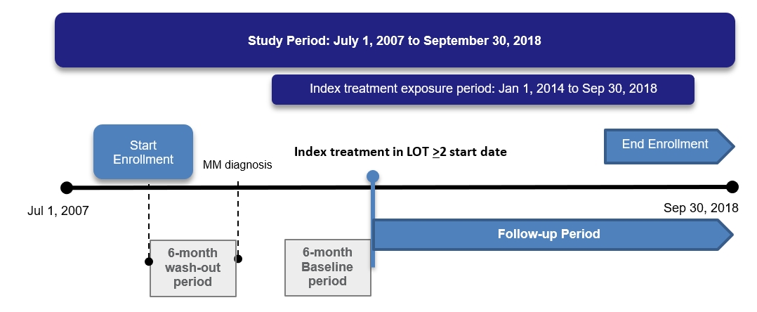

Appendix Figure 2. Overall Survival by Treatment-Free Interval Prior to Index Regimen Initiation Among MM Patients Treated With LOT ≥2
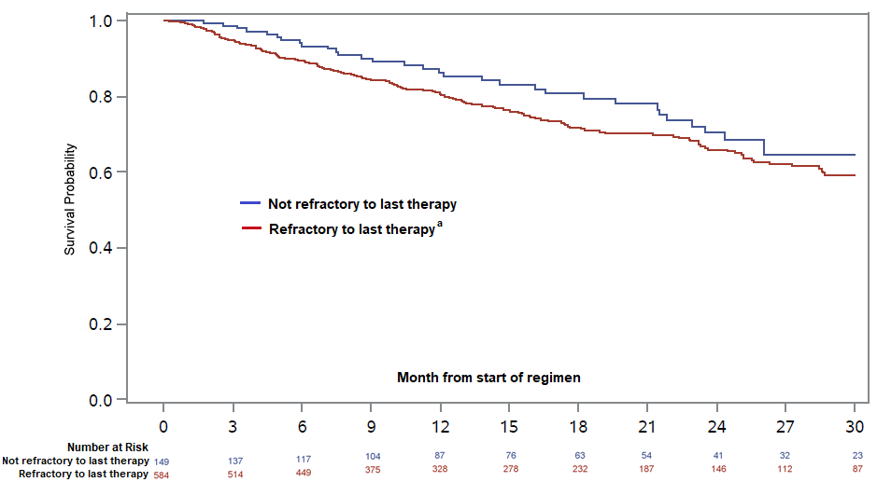
ª Refractory to last therapy was defined as a TFI between end of previous LOT to initiation of index LOT of ≤60 days.
Key: CI – confidence interval; HR – hazard ratio; LOT – line of therapy; TFI – treatment-free interval from most immediate prior regimen end to initiation of index LOT

Appendix Figure 3. Duration of Therapy by Index Regimen Among MM Patients Treated With LOT ≥2
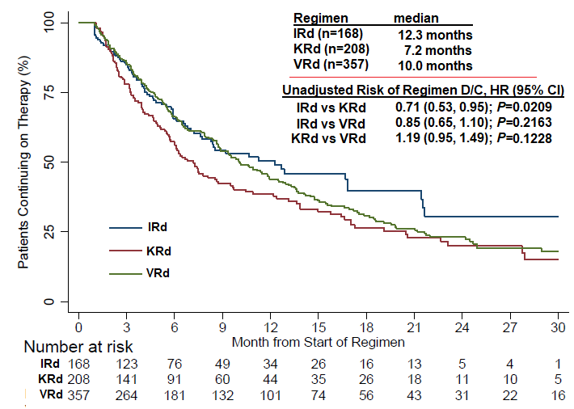
Key: CI – confidence interval; D/C – discontinuation; HR – hazard ratio; IRd – ixazomib, lenalidomide, dexamethasone; KRd – carfilzomib, lenalidomide, dexamethasone; VRd – bortezomib, lenalidomide, dexamethasone

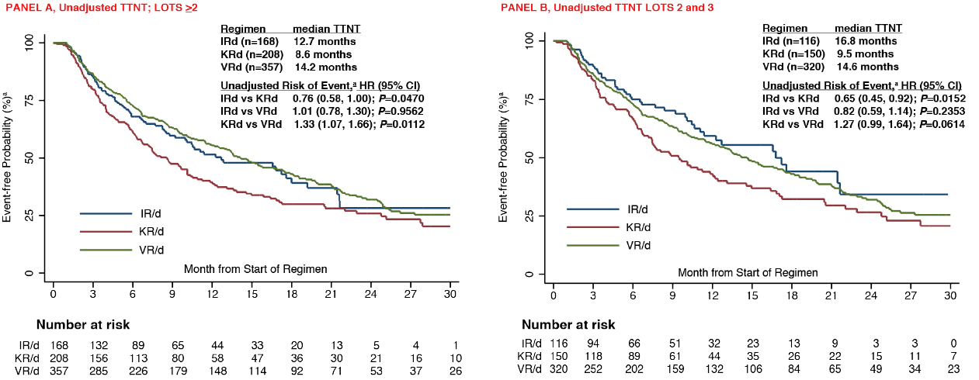
Appendix Figure 4. Unadjusted TTNT for Patients in LOT ≥2 (Panel A) and in LOTs 2 and 3 (Panel B)
ª An event was defined as start of the next line of therapy or death.
Key: CI – confidence interval; HR – hazard ratio; IRd – ixazomib, lenalidomide, dexamethasone; KRd – carfilzomib, lenalidomide, dexamethasone; TTNT – time to next therapy; VRd – bortezomib, lenalidomide, dexamethasone.

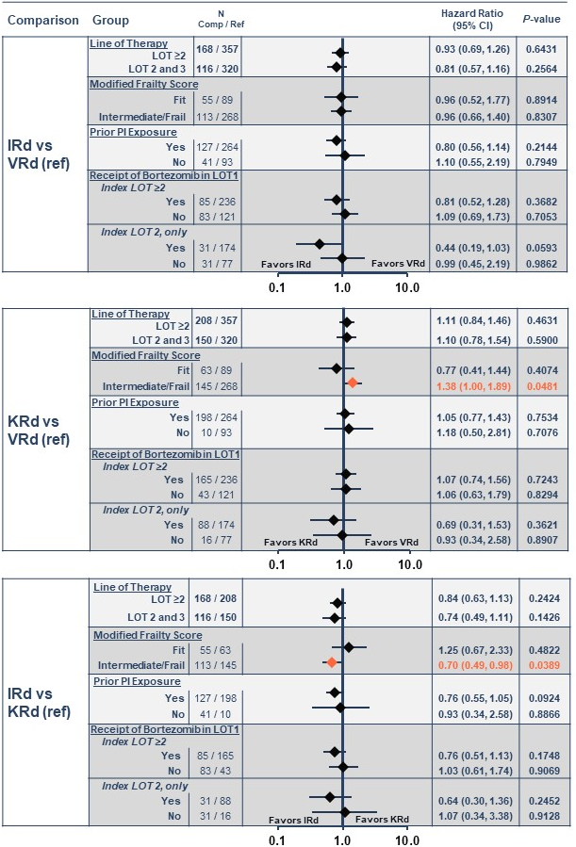

ª Adjusted for the following covariates: index regimen type (IRd, KRd, VRd), modified frailty score (0 [fit], 1–2 [intermediate to frail]), prior PI and/or IMID exposure, prior SCT, history of CVD or uncontrolled HTN, history of PN, or baseline CRAB symptoms (hypercalcemia, renal failure, anemia, bone disease [all, yes vs. no]), cytogenetic risk (high, standard/unknown), ISS stage (I/II, III, unknown), PI/IMID refractory status (PI and/or IMID refractory, refractory to neither), time (months) from diagnosis to start of index LOT, refractory status to last therapy (yes, no; yes was defined as a TFI from end of previous LOT to initiation of index regimen of ≤60 days), time of first relapse (months [i.e. time from start of LOT1 to start of LOT2]), and year of diagnosis (2007–2011, 2012–2015, 2016–2018)
Key: CI – confidence interval; CVD – cardiovascular disease; HR – hazard ratio; HTN – hypertension; IMID – immunomodulatory drug; IRd – ixazomib, lenalidomide, dexamethasone; ISS – International Staging System; LOT – line of therapy; PI – proteasome inhibitor; PN – peripheral neuropathy; SCT – stem cell transplant; VRd – bortezomib, lenalidomide, dexamethasone; TFI – treatment-free interval; TTNT – time to next therapy.
Appendix Figure 5. TTNTª by PI-Rd Regimen for All Patients (LOT ≥2) and for Subgroups of Interest

