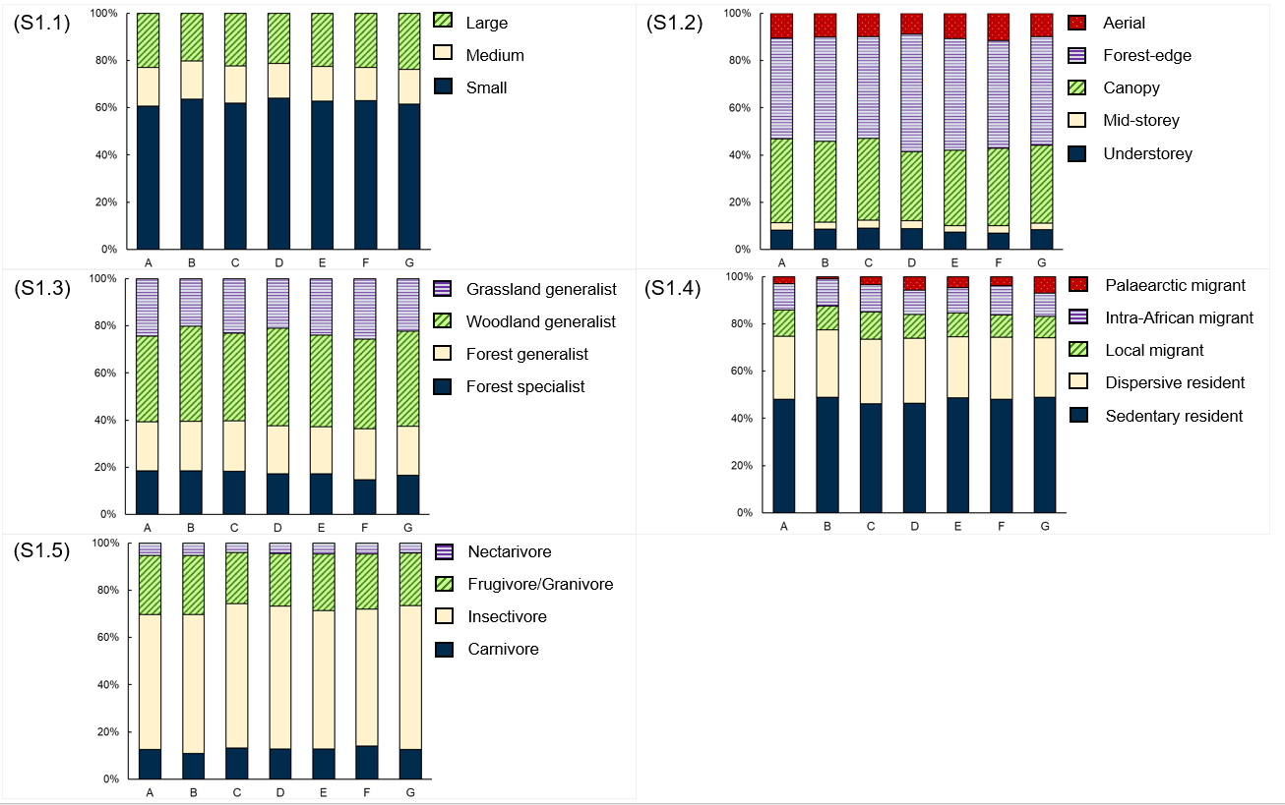Figure S1: Stacked bar-graphs showing the proportions of different aspects within each functional trait group present at each of the seven Afrotemperate forests surveyed: (S1.1) body size; (S1.2) primary foraging stratum; (S1.3) habitat specialisation; (S1.4) dispersal behaviour; and (S1.5) feeding guild. Forest are: A – Ngele; B – Gomo; C – Baziya; D – Manubi; E – Kubusi; F – Fort Fordyce; G – Alexandria. Forest community structures were highly similar (no significant χ2 results with *p*> 0.05)

Table S2: Species-levels within each functional trait class across seven Afrotemperate forests in the Eastern Cape. Bracketed values are the number of species present, as estimated from SABAP2 data, and percentage values show the contributions by each trait-level towards the diversity within each functional trait class. Proportional differences within each functional trait class between forests were determined from χ2 tests

Values indicated by * denotes χ2 test p-value <0.05; Values indicated by ** denotes χ2 test p-value <0.01Table S3: Bird species detected (Det.), and the proportion of total diversity within different functional trait class represented (%T) by point count surveys within seven Afrotemperate forests in the Eastern Cape. A series of χ2 tests were used to determine the proportional differences of the representation for each functional trait class by point count surveys between all seven forests.

Values indicated by * denotes χ2 test p-value <0.05; Values indicated by ** denotes χ2 test p-value <0.01

Table S4: Bird species detected (Det.), and the proportion of total diversity within different functional trait class represented (%T) by mist-netting surveys within seven Afrotemperate forests in the Eastern Cape. A series of χ2 tests were used to determine the proportional differences of the representation for each functional trait class by mist-netting surveys between all seven forests.

Values indicated by * denotes χ2 test p-value <0.05; Values indicated by ** denotes χ2 test p-value <0.01

Table S5: AIC model selection of generalised linear mixed-effect logistic regression model representing factors affecting avian species detection in Afrotemperate forests by point counts. Included are the AIC values, AIC difference (∆AIC), model fit (Conditional R2), and Akaike weights (w­­i) for each model. The global model is in bold

|  |  |  |  |  |
| --- | --- | --- | --- | --- |
| Model R code* | AIC | ∆AIC | *Cond.* R2 | wi |
| ~Stratum+Size+Specialization+Dispersal+(1|Forest) | 1021.98 | 0.00 | 0.80 | 0.43 |
| ~Stratum+Specialization+Dispersal+(1|Forest) | 1022.25 | 0.27 | 0.70 | 0.40 |
| **~Stratum+Size+Specialization+Dispersal+Diet+(1|Forest)** | 1024.60 | 2.62 | 0.78 | 0.04 |
| ~Stratum+Dispersal+(1|Forest) | 1033.36 | 11.38 | 0.70 | 0.00 |
| ~Stratum+(1|Forest) | 1048.16 | 26.18 | 0.84 | 0.00 |
| Null (~1) | 1256.19 | 234.21 | 0.00 | 0.00 |
| Null (~1+(1|Forest)) | 1257.96 | 235.98 | 0.00 | 0.00 |

*Mixed-effects models were fitted using ‘glmer’ function in the ‘lme4’ R package, and the final null model was fitted using the function ‘glm’ in the ‘Stats’ R package.

Table S6: AIC model selection of generalised linear mixed-effect logistic regression model representing factors affecting species detection in Afrotemperate forests by mist-netting. Included are the AIC values, AIC difference (∆AIC), model fit (Conditional R2), and Akaike weights (w­­i) for each model

|  |  |  |  |  |
| --- | --- | --- | --- | --- |
| Model | AIC | ∆AIC | *Cond.* R2 | wi |
| ~**Stratum+Size+Specialization+Dispersal+Diet+(1|Forest)** | 736.50 | 0.00 | 0.83 | 0.66 |
| ~Stratum+Size+Dispersal+Diet+(1|Forest) | 738.20 | 1.70 | 0.86 | 0.29 |
| ~Stratum+Size+Dispersal+(1|Forest) | 744.28 | 7.78 | 0.83 | 0.01 |
| ~Stratum+Size+(1|Forest) | 761.31 | 24.81 | 0.48 | 0.00 |
| ~Stratum+(1|Forest) | 830.98 | 94.48 | 0.39 | 0.00 |
| Null (~1) | 1049.06 | 312.56 | 0.00 | 1.00 |
| Null (~1+(1|Forest)) | 1051.06 | 314.56 | 0.00 | 1.00 |

*Mixed-effects models were fitted using ‘glmer’ function in the ‘lme4’ R package, and the final null model was fitted using the function ‘glm’ in the ‘Stats’ R package.

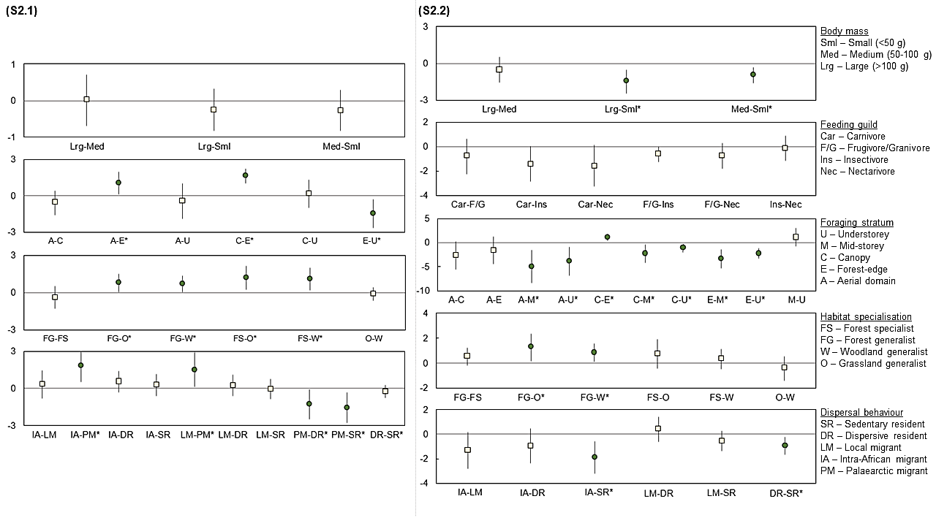

Figure S2: Post hoc comparisons of effect sizes between sub-levels between factors of the best-supported GLM models explaining forest-utilising bird species detectability by point counts (S2.1) and mist-netting (S2.2) across the seven Afrotemperate forest sites: body mass, feeding guild, foraging stratum, habitat specialisation, and dispersal behaviour. Error bars indicate 95 % confidence intervals (CI). -- are significant comparisons (*=*p* <0.05), while -- are non-significant. Comparisons not shown are non-significant, with CI exceeding the range of related comparisons.