Synthesis and DFT calculations of linear and nonlinear optical responses of novel 2-thioxo-3-N,(4-methylphenyl) thiazolidine-4 one
B. Baroudiª, K. Argoubª, D. Hadji^{b}, A.M. Benkouiderª, K. Toubal^{c}, A. Yahiaouiª, D. Ayada^{c}
ª Laboratory of Organic Chemistry, Macromolecular and Materials, University Mustapha Stambouli of Mascara, BP 763, 29000 Mascara, Algeria;
^{b} Modeling and Calculation Methods Laboratory, Department of Chemistry, University Dr Moulay Tahar of Saida, 20000 Saida, Algeria;
^{c} Laboratory of Applied Organic Synthesis, Department of Chemistry, Faculty of Sciences, University of Oran 1 Ahmed Ben Bella, 31000 Oran, Algeria.

Table S1. The coordinates of the minimized structure of the 2–thioxo–3–N, (4–methylphenyl) thiazolidine–4–one obtained at B3LYP/6–311+G(d,p) level.
---------------------------------------------------------------------
Atom Type Coordinates (Angstroms)
X Y Z
---------------------------------------------------------------------
C 1.40359100 -1.57164300 0.00073500
C 1.63500700 0.81070800 -0.00037800
N 0.80290500 -0.30269300 0.00035700
C -0.63567500 -0.18554300 0.00047400
C -1.32313600 -0.13825600 1.20737400
C -1.32361200 -0.14227700 -1.20670800
C -2.71114400 -0.04154100 1.20101100
H -0.77655000 -0.16895500 2.14234700
C -2.71124700 -0.04561700 -1.20036600
H -0.77713100 -0.17615400 -2.14163800
C -3.42775900 0.00444400 0.00049100
H -3.24390700 0.00141400 2.14499000
H -3.24427000 -0.00600500 -2.14440800
C -4.93486400 0.07965300 -0.00062800
H -5.37453600 -0.92282400 -0.04142800
H -5.31033500 0.56598500 0.90223400
H -5.30532900 0.63472400 -0.86539900
O 0.79579000 -2.61148500 0.00119200
S 1.17178200 2.38305000 -0.00118000
C 2.91966900 -1.46458000 0.00050000
H 3.31332300 -1.96193000 -0.88667600
H 3.31351600 -1.96110400 0.88805400
S 3.33281700 0.31529300 -0.00039100
-----------------------------------------------------------------------
Figure S1. The optimized molecular geometry of the 2–thioxo–3–N, (4–methylphenyl) thiazolidine–4–one obtained at B3LYP/6–311+G(d,p) level.

The $β_{HRS}$ calculation details:
We provided a full sheet for calculated values of $β_{HRS}$, their full expressions can be find in Ref. [43]:
$$\sqrt{〈β_{HRS}^{2}〉}=\sqrt{〈β_{ZZZ}^{2}〉+〈β_{ZXX}^{2}〉}$$
We calculate the orientational averages of the $β$ tensor components $〈β_{ZZZ}^{2}〉$ and $〈β_{ZXX}^{2}〉$

For the invariant $〈β_{ZZZ}^{2}〉$:
$$〈β_{ZZZ}^{2}〉=\frac{1}{7}\sum_{ζ}^{x,y,z}{β_{ζζζ}^{2}+}\frac{4}{35}\sum_{ζ≠η}^{x,y,z}{β_{ζζη}^{2}+\frac{2}{35}\sum_{ζ≠η}^{x,y,z}{β_{ζζζ}}}β_{ζηη}+\frac{4}{35}\sum_{ζ≠η}^{x,y,z}{β_{ηζζ}β_{ζζη}}$$
$$+\frac{4}{35}\sum_{ζ≠η}^{x,y,z}{β_{ζζζ}β_{ηηζ}+\frac{1}{35}\sum_{ζ≠η}^{x, y ,z}{β_{ηζζ}^{2}}+\frac{4}{105}\sum_{ζ≠η≠ε}^{x,y,z}{β_{ζζη}β_{ηεε}}}+\frac{1}{105}\sum_{ζ≠η≠ε}^{x,y,z}{β_{ηζζ}β_{ηεε} }$$
$$+\frac{4}{105}\sum_{ζ≠η≠ε}^{x,y,z}{β_{ζζη}β_{εεη}+\frac{2}{105}\sum_{ζ≠η≠ε}^{x,y,z}{β_{ζηε}^{2}+\frac{4}{105}\sum_{ζ≠η≠ε}^{x,y,z}{β_{ζηε}β_{ηζε} (4)}}}$$

For the invariant $〈β_{XZZ}^{2}〉$:

$$〈β_{XZZ}^{2}〉=\frac{1}{35}\sum_{ζ}^{x,y,z}{β_{ζζζ}^{2}+}\frac{4}{105}\sum_{ζ≠η}^{x,y,z}{β_{ζζζ}β_{ζηη}-}\frac{2}{35}\sum_{ζ≠η}^{x,y,z}{β_{ζζζ}β_{ηηζ}} +\frac{8}{105}\sum_{ζ≠η}^{x,y,z}{β_{ζζη}^{2}}$$
$$+\frac{3}{35}\sum_{ζ≠η}^{x,y,z}{β_{ζηη}^{2}-\frac{2}{35}\sum_{ζ≠η}^{x,y,z}{β_{ζζη}β_{ηζζ}+}}\frac{1}{35}\sum_{ζ≠η}^{x,y,z}{β_{ζηη}β_{ζεε}}$$
$$-\frac{2}{105}\sum_{ζ≠η≠ε}^{x,y,z}{β_{ζζη}β_{ηεε}+\frac{2}{35}\sum_{ζ≠η≠ε}^{x,y,z}{β_{ζηε}^{2}-\frac{2}{105}\sum_{ζ≠η≠ε}^{x,y,z}{β_{ζηε}β_{ηζε}} (5)}}$$

after, we detail each sum separately:
The invariant $〈β_{ZZZ}^{2}〉$:
$$\frac{1}{7}\sum_{ζ}^{x,y,z}{β_{ζζζ}^{2}=}\frac{1}{7}\left[β_{xxx}^{2}+β_{yy}^{2}+β_{zzz}^{2}\right]$$
$$\frac{4}{35}\sum_{ζ≠η}^{x,y,z}{β_{ζζη}^{2}= \frac{4}{35}\left[β_{xxy}^{2}+β_{xxz}^{2}+β_{yyx}^{2}+β_{yyz}^{2}+β_{zzx}^{2}+β_{zzy}^{2}\right] }$$
$$\frac{2}{35}\sum_{ζ≠η}^{x,y,z}{β_{ζζζ}β_{ζηη}=\frac{2}{35} \left[β_{xxx}β_{xyy}+β_{xxx}β_{xzz}+β_{yyy}β_{yzz}+β_{yyy}β_{yxx}+β_{zzz}β_{zxx}+β_{zzz}β_{zyy}\right]}$$
$$\frac{4}{35}\sum_{ζ≠η}^{x,y,z}{β_{ηζζ}β_{ζζη}}=\frac{4}{35}\left[β_{xyy}β_{yyx}+β_{yxx}β_{xxy}+β_{zxx}β_{xxz}+β_{zyy}β_{yyz}+β_{yzz}β_{zzy}+β_{xzz}β_{xxz}\right]$$
=$\frac{4}{35}\left[β_{xyy}^{2}+β_{yxx}^{2}+ β_{zxx}^{2}+β_{zyy}^{2}+β_{yzz}^{2}+β_{xzz}^{2}\right]$
$$\frac{4}{35}\sum_{ζ≠η}^{x,y,z}{β_{ζζζ}β_{ηηζ}=\frac{4}{35} \left[β_{xxx}β_{yyx}+β_{xxx}β_{zzx}+β_{yyy}β_{xxy}+β_{yyy}β_{zzy}+β_{zzz}β_{xxz}+β_{zzz}β_{yyz}\right]}$$
$$\frac{1}{35}\sum_{ζ≠η}^{x,y,z}{β_{ηζζ}^{2}=\frac{1}{35} \left[β_{xyy}^{2}+β_{xzz}^{2}+β_{yxx}^{2}+β_{yzz}^{2}+β_{zxx}^{2}+β_{zyy}^{2}\right]}$$
$$\frac{4}{105}\sum_{ζ≠η≠ε}^{x,y,z}{β_{ζζη}}β_{ηεε}=\frac{4}{105}\left[β_{xxy}β_{yzz}+β_{xxz}β_{zyy}+β_{yyx}β_{xzz}+β_{yyz}β_{zxx}+β_{zzx}β_{xyy}+β_{zzy}β_{yxx}\right]$$
= $\frac{4}{105}\left[{2 β}_{xxy}β_{yzz}+2β_{xxz}β_{zyy}+2β_{yyx}β_{xzz}\right]$
=$\frac{8}{105}\left[{ β}_{xxy}β_{yzz}+β_{xxz}β_{zyy}+β_{yyx}β_{xzz}\right]$
$$\frac{1}{105}\sum_{ζ≠η≠ε}^{x,y,z}{β_{ηζζ}}β_{ηεε}=\frac{2}{105}\left[β_{xyy}β_{xzz}+β_{yxx}β_{yzz}+β_{zxx}β_{zyy}\right]$$
$$\frac{4}{105}\sum_{ζ≠η≠ε}^{x,y,z}{β_{ζζη}}β_{εεη}=\frac{4}{105}\left[β_{xxy}β_{zzy}+β_{xxz}β_{yyz}+β_{yyx}β_{zzx}+β_{yyz}β_{xxz}+β_{zzx}β_{yyx}+β_{zzy}β_{xxy}\right]$$
$$=\frac{8}{105}\left[β_{xxy}β_{zzy}+β_{xxz}β_{yyz}+β_{yyx}β_{zzx}\right]$$
$\frac{2}{105}\sum_{ζ≠η≠ε}^{x,y,z}{β_{ζηε}^{2}=\frac{2}{105}\left[β_{xyz}^{2}+β_{xzy}^{2}+β_{yxz}^{2}+β_{yzx}^{2}+β_{zxy}^{2}+β_{zyx}^{2}\right]}$ ${=\frac{12}{105}β}_{xyz}^{2}$
$$\frac{4}{105}\sum_{ζ≠η≠ε}^{x,y,z}{β_{ζηε}}β_{ηεζ}=\frac{24}{105}β_{xyz}^{2}$$
and the same for the second term $〈β_{XZZ}^{2}〉$.

Table S2. First hyperpolarizability β contributions and the gas phase EFISHG $β_{//}$ obtained using eight DFT functionals at 6–311+G(d,p) basis set.
 | B3LYP | PBE0 | B3PW91 | CAM–B3LYP | ωB97X–D | M06 | M05–2X | M06–2X
$$β_{xxx}$$ | 97.87 | 221.66 | 106.52 | 9.59 | 19.66 | 100.19 | 15.058 | 8.15
$${ β}_{xxy}$$ | 194.49 | 191.66 | 190.44 | 197.93 | 207.64 | 188.67 | 198.64 | 199.53
$$β_{xyy}$$ | 248.73 | 277.85 | 239.44 | 228.69 | 227.35 | 249.48 | 214.07 | 220.36
$$β_{yyy}$$ | 14.29 | -1.58 | 13.80 | 27.19 | 46.28 | 34.20 | 50.75 | 33.05
$$β_{xxz}$$ | -0.22 | -0.13 | -0.10 | -0.13 | -0.08 | -0.12 | -0.24 | -0.09
$$β_{xyz}$$ | -0.24 | -0.27 | -0.24 | -0.23 | -0.22 | -0.31 | -0.16 | -0.23
$$β_{yyz}$$ | -0.94 | -0.97 | -0.96 | -0.89 | -0.95 | -0.72 | -1.10 | -0.85
$$β_{xzz}$$ | -2.46 | -5.55 | -5.66 | -3.82 | -1.56 | -18.27 | -1.150 | -16.25
$$β_{yzz}$$ | 58.00 | 59.46 | 54.89 | 52.93 | 57.63 | 58.02 | 55.93 | 45.40
$$β_{zzz}$$ | 1.08 | 1.08 | 1.07 | 1.04 | 1.08 | 0.74 | 0.85 | 0.78
$$β_{//}$$ | –234.24 | –281.34 | –230.17 | –208.71 | –228.24 | –234.27 | –223.59 | –204.66

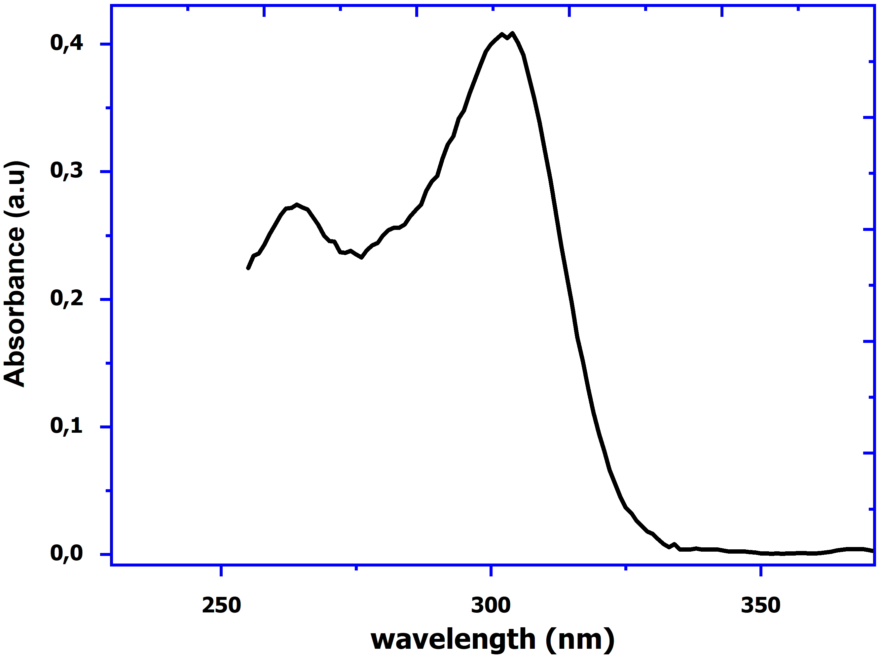
Figure S2. Optical absorbance spectra for the 2–thioxo–3–N, (4–methylphenyl) thiazolidine–4–one.

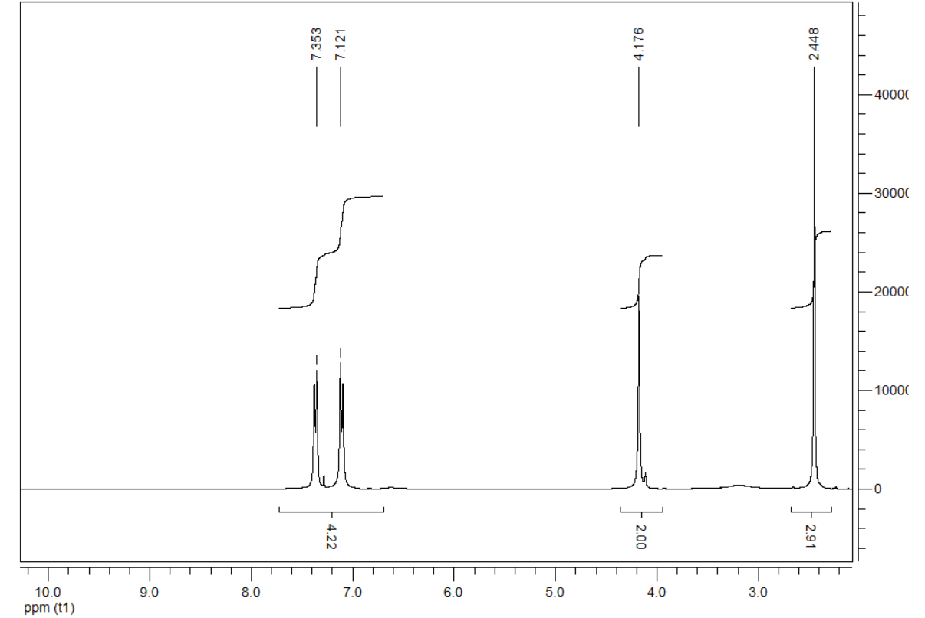
Figure S3. ¹H NMR spectrum for the 2–thioxo–3–N, (4–methylphenyl) thiazolidine–4–one.
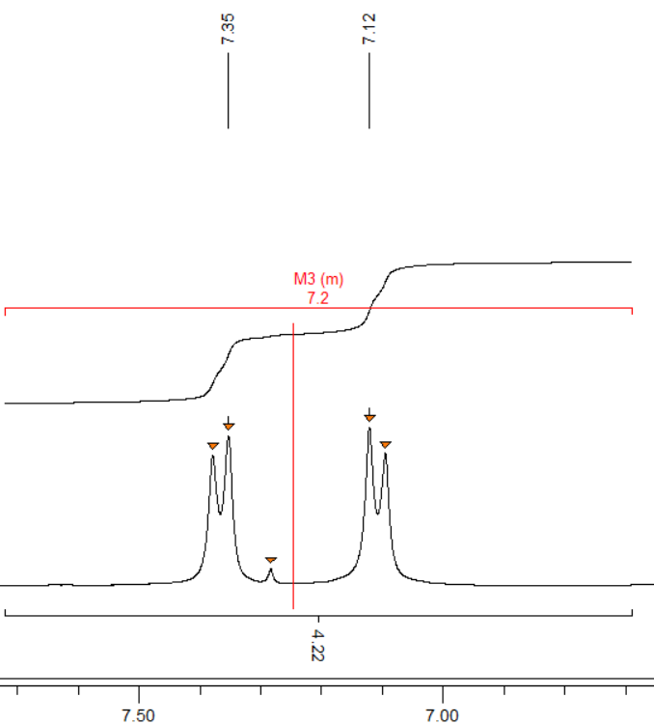
Figure S4. Spread of 7 to 7.75 ppm (AB system).

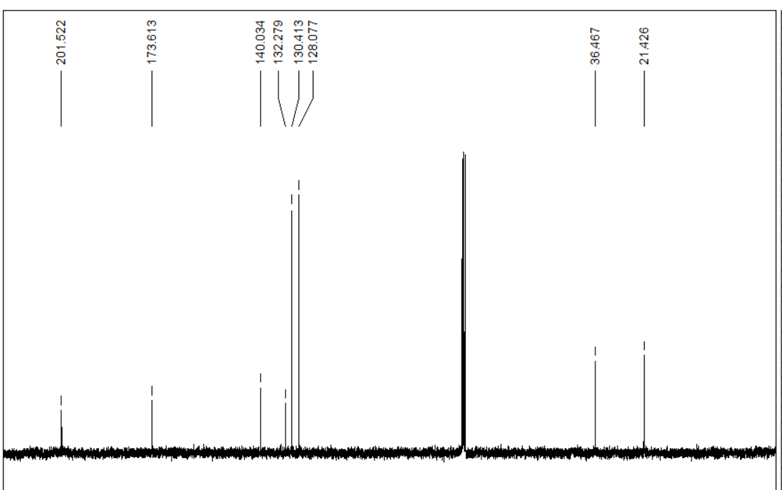
Figure S5. ¹³C NMR spectrum for the 2–thioxo–3–N, (4–methylphenyl) thiazolidine–4–one.

