AIE-Active Fluroscent Polymeric Nanoparticles about Dextran Derivative: Preparation and Bioimaging Application

Figure S1. Synthesis of OH-CHO

Figure S2. ¹H NMR spectrum of compound OH-CHO in d₆-DMSO

Figure S3. Mass spectrum of compound OH-CHO

The synthesis of N-hydroxyethyl-4-formylphenyl-1,8-naphthalimide (OH-CHO) is outlined in Scheme S1.
0.403 g (1 mmol) of the intermediate product 1, 0.25 g (1.5 mmol) of 4-formylbenzeneboronic acid, 45 mg of Pd(PPh₃)₄ were placed in a three-necked flask. After three cycles of vacuum-nitrogen filling, 3 mL of saturated potassium carbonate solution, 60 mL of toluene and 20 mL of ethanol were injected. The reaction solution was refluxed at 80 ℃ for 48 h under the protection of N₂. After cooling to room temperature, the reaction mixture was added dropwise into distilled water. The solid was filtered, recrystallized from anhydrous ethanol for three times and then dried under vacuum to get OH-CHO as greyish power. Yield: 0.879 g (84%). 1H NMR (400 MHz, DMSO-d6;) δ (ppm): 10.17(s,1H), 8.59 (dd, 2H), 8.22 (d, 1H), 8.14 (d, 2H), 7.87 (d, 2H), 7.82 (d, 2H), 4.84 (t, 2H), 4.19 (t, 2H). FTMS m/z: calculated for C₂₁H₁₅NO₄; 345.1001, found (M+1); =346.1070.

Figure S1. Synthesis of OH-CHO

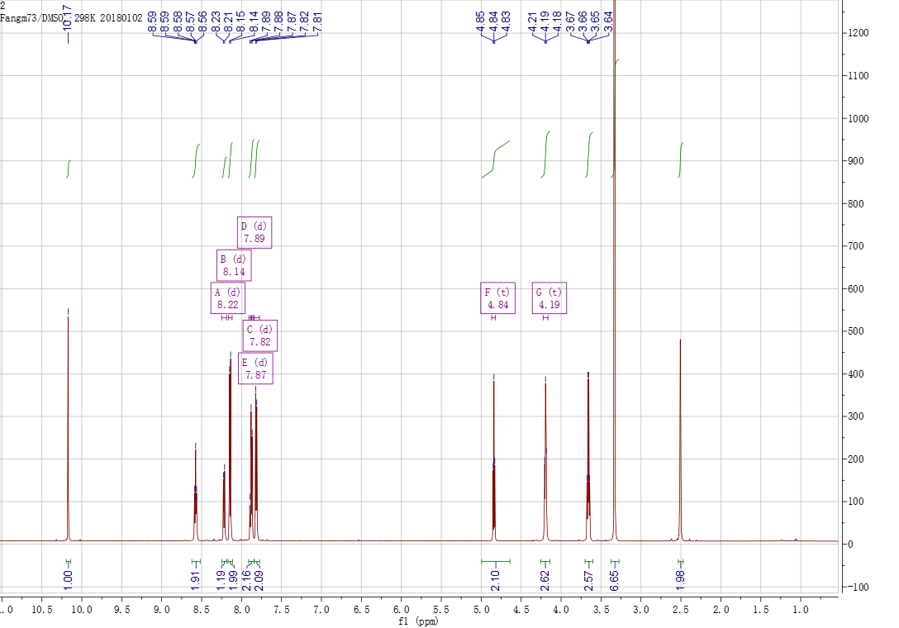

Figure S2. ¹H NMR spectrum of compound OH-CHO in d₆-DMSO

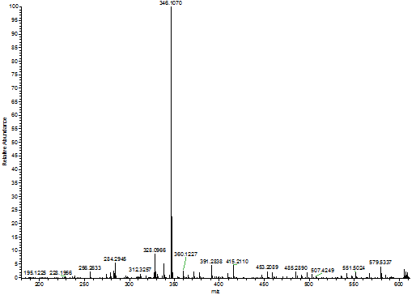

Figure S3. Mass spectrum of compound OH-CHO

