Study information
Phase | Study number | Indication | Main objective | Location | Study design | N | E2V/DNG, n |  | Age group, years | Treatment duration | Comparator
 |  |  |  |  |  |  | ≤25 years | >25 years
II | NCT00805415 | OC | Ovulation inhibition | Europe | Parallel group | 200  100/treatment group | 55 (55.0%) | 45 (45.0%) | 18–35 | 3 cycles | DNG increased regimen
 | NCT00185224 | OC | Impact on plasma lipids, haemostatic variables, and carbohydrate metabolism | Europe | Parallel group | 60  30/treatment group | 10 (33.3%) | 20 (66.7%) | 18–50 | 7 cycles | Triquilar®
 | NCT00318799 | OC | Impact of Qlaira® on haemostatic parameters | Europe | Cross-over | 30  30/treatment group (cross-over design) | 17 (63.0%) | 10 (37.0%) | 18–50 | 3 cycles | Microgynon®
III | NCT00185367 | OC | Bleeding pattern and cycle control | Europe | Parallel group | 798  399/treatment group | 120 (30.1%) | 279 (69.9%) | 18–50 | 7 cycles | Miranova®
 | NCT00185289 | OC | Contraceptive efficacy | Europe | Single group | 1377 | 477 (34.6%) | 900 (65.4%) | 18–50 | 20 cycles | n.a.
 | NCT00206583 | OC | Contraceptive efficacy | US, Canada | Single group | 490 | 287 (58.6%) | 203 (41.4%) | 18–35 | 13 cycles  extended to 28 cycles | n.a.
 | NCT00293059 | DUB | Impact of Qlaira® on dysfunctional uterine bleeding | US, Canada | Parallel group | 190  120 on Qlaira®, 70 on placebo | 12 (10.1%) | 107 (89.9%) | ≥18 | 7 cycles | Placebo
 | NCT00307801 | DUB | Impact of Qlaira® on dysfunctional uterine bleeding | Europe, Australia | Parallel group | 231  149 on Qlaira®, 82 on placebo | 6  (4.1%) | 139 (95.9%) | ≥18 | 7 cycles | Placebo
IIIb | NCT00754065 | OC | Effect on HWAS | US, Canada | Parallel group | 395  191 on Qlaira®, 204 on Ortho Tri-Cyclen® Lo | 106 (55.5%) | 85 (44.5%) | 18–50 | 13 cycles | Ortho Tri-Cyclen® Lo
 | NCT00778609 | OC | Effect on HWAS | International (AP, Europe, LA) | Parallel group | 441  223 on Qlaira®, 218 on Microgynon® | 84 (37.7%) | 139 (62.3%) | 18–50 | 7 cycles | Microgynon®
 | NCT00764881 | OC | Effect on FSD | Europe, Australia, Thailand | Parallel group | 213  106 on Qlaira®, 107 on Microgynon® | 28 (26.4%) | 78 (73.6%) | 18–50 | 6 cycles | Microgynon®
 | NCT00909857 | OC | Effect on primary dysmenorrhea | International (Europe, NA, LA, US) | Parallel group | 464  234 on Qlaira®, 230 on Miranova® | 107 (45.7%) | 127 (54.3%) | 14–50 | 3 cycles | Miranova®
AP, Asia Pacific; DNG, dienogest; DUB, dysfunctional uterine bleeding; FSD, female sexual dysfunction; HWAS, hormone-withdrawal-associated symptoms; LA, Latin America; n.a., not available; NA, North America; OC, oral contraception.

Methods

2.1 Pool 1: safety analysis
We included all phase II–IIIb studies using the final E2V/DNG regimen. Only treatment-emergent adverse events (AEs) were considered, i.e. AEs that started at any time after the start of study medication. In the case of incomplete dates, we took a conservative approach, i.e. the AE was included in the analysis if it appeared to have started during/after treatment from a comparison of month/year of onset and treatment timing. MedDRA version 18.1 was used. For weight and body mass index (BMI), we used the last available (non-missing) value before start of treatment. If a baseline value was unavailable, we used the screening value. For participants with missing baseline and screening values, weight and BMI were deemed ‘missing’.

2.2 Pool 2: bleeding profile
With the exception of the dysfunctional uterine bleeding studies, all phase II–IIIb studies using the final E2V/DNG regimen were included. We treated missing diary entries as follows: cycle days from original data were kept untouched, and in the case of missing diary entries, cycle days were filled so that increasing cycle days per cycle were granted. This means that cycle days were imputed backwards from the first non-missing cycle day onward. The first reference period was taken to start on the day when the first study medication was taken. Study medication start and end dates were derived from tablet intake information collected in the bleeding diary.
Bleeding/spotting data are described per 90-day reference period (recommended by WHO). The evaluation by reference period enables a description of the bleeding pattern irrespective of the treatment regimen, i.e. to allow for comparisons between e.g. an oral contraceptive and an intrauterine device.
Intracyclic and withdrawal bleeding were evaluated by cycle as those data are more meaningful for the prescribers and users.

2.3 Pool 3: efficacy
Three studies were included: NCT00185367, NCT00185289 and NCT00206583. No further harmonisation across studies was required for the pooled analysis. We used the efficacy pool for Pearl index evaluations. Further information on the Pearl index calculation can be found in the Supplementary material (2.5. Pearl index calculation).

2.4 Pool 4: hormone-withdrawal-associated symptoms
Two studies were included: NCT00754065 and NCT00778609. No further harmonisation across studies was required for the pooled analysis.

2.5 Pearl index calculation
The Pearl index and adjusted Pearl index were calculated as follows:
The Pearl index is defined – model independent – as the number of unintended pregnancies multiplied by 100 divided by the exposure time in women years (Gerlinger C et al., 2003).
Calculation of Pearl Index:
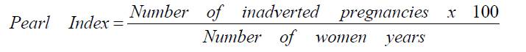
It was assumed that the number of pregnancies X during treatment in this study followed a Poisson distribution with parameter λ⋅E, i.e.,
In the formula E stands for exposure in 100 woman years. The parameter λ⋅E was estimated by the number of observed pregnancies x and the upper 97.5% confidence limit lu for λ⋅E was calculated by the equation
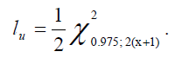
The point estimate PI for the Pearl index was derived by
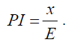
The upper confidence limit for the Pearl index was then calculated (Johnson NL et al., 1993) as
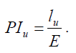
All volunteers in the full analysis set were included in the Pearl index calculations until they had stopped intake of the study OC. Treatment exposure was defined as the time from the first day of OC intake to the last day of pill intake. This time period was calculated irrespective of treatment interruptions. The same rule was applied for volunteers who prematurely dropped out of the study. There were two exceptions for which data were not included in the calculations:
- Treatment exposure after conception
- Treatment exposure during which additional contraceptive measures (so-called ‘back-up contraception’) were taken
In the unlikely event of a pregnancy despite concomitant use of the test contraceptive method and additional contraceptive measure, the pregnancy and the corresponding woman’s treatment exposure were included in the calculations.
The adjusted Pearl index for method failure and the corresponding upper confidence limit were calculated with the same methods as those used for the unadjusted Pearl index. For the calculation of time of correct treatment exposure, treatment cycles that were not considered compliant were excluded. A pregnancy was considered as a method failure unless at least one of the following conditions applied:
- The estimated day of conception was in a non-compliant treatment cycle
- A method failure could be excluded based on comments on the pregnancy report form

Supplementary results
Table 3.1. Treatment-emergent adverse events occurring in ≥5% of women using E2V/DNG by MedDRA 18 primary system organ class
Treatment-emergent adverse event | Women ≤25 years  n = 1309  % (number) | Women >25 years  n = 2132  % (number) | Total  N = 3441  % (number)
Participants with at least one TEAE | 68.3 (894) | 60.7 (1295) | 63.6 (2189)
Gastrointestinal disorders | 19.9 (261) | 14.8 (315) | 16.7 (576)
Infections and infestations | 39.3 (514) | 31.1 (663) | 34.2 (1177)
Investigations | 5.3 (69) | 4.1 (88) | 4.6 (157)
Musculoskeletal and connective tissue disorders | 5.6 (73) | 6.2 (132) | 6.0 (205)
Nervous system disorders | 16.3 (213) | 16.1 (343) | 16.2 (556)
Psychiatric disorders | 5.0 (65) | 5.2 (111) | 5.1 (176)
Reproductive system and breast disorders | 29.6 (388) | 23.4 (498) | 25.7 (886)
Skin and subcutaneous tissue disorders | 7.7 (101) | 7.2 (153) | 7.4 (254)
Of particular interest
Reproductive system and breast disorders | 29.6 (388) | 23.4 (498) | 25.7 (886)
Dysmenorrhea | 8.9 (116) | 4.5 (95) | 6.1 (211)
Metrorrhagia | 5.7 (74) | 3.7 (78) | 4.4 (152)
DNG, dienogest; E2V, estradiol valerate; TEAE, treatment-emergent adverse event.

Bleeding and hormone-withdrawal-associated symptoms
Figure 4.1. Bleeding/spotting by age group (safety analysis set)
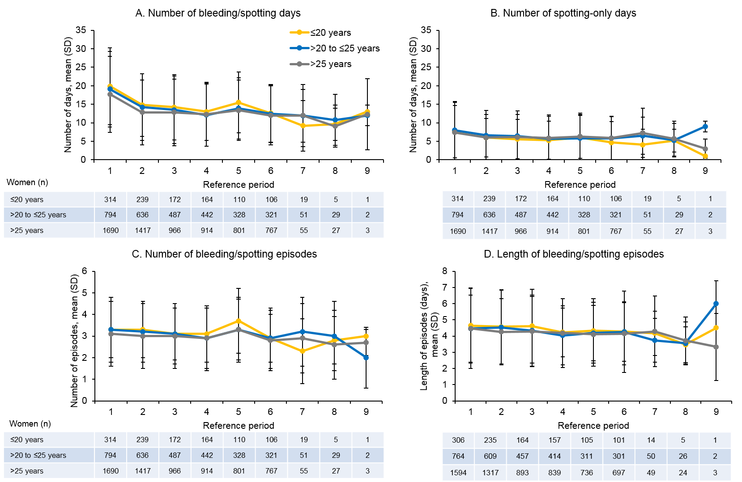
‘Bleeding’ is defined as bleeding that is the same or more than normal menstruation relative to the woman’s experience. ‘Spotting’ is defined as bleeding that is less than that associated with normal menstruation relative to the woman’s experience, with no need for sanitary protection (except panty liners). An ‘episode’ is defined as any set of one or more bleeding or spotting days (consecutive or separated by only one bleeding-free day). An episode is bounded by at least 2 consecutive bleeding-free days.

Figure 4.2. Maximum intensity and percentage of patients with intracyclic bleeding by age group (safety analysis set)
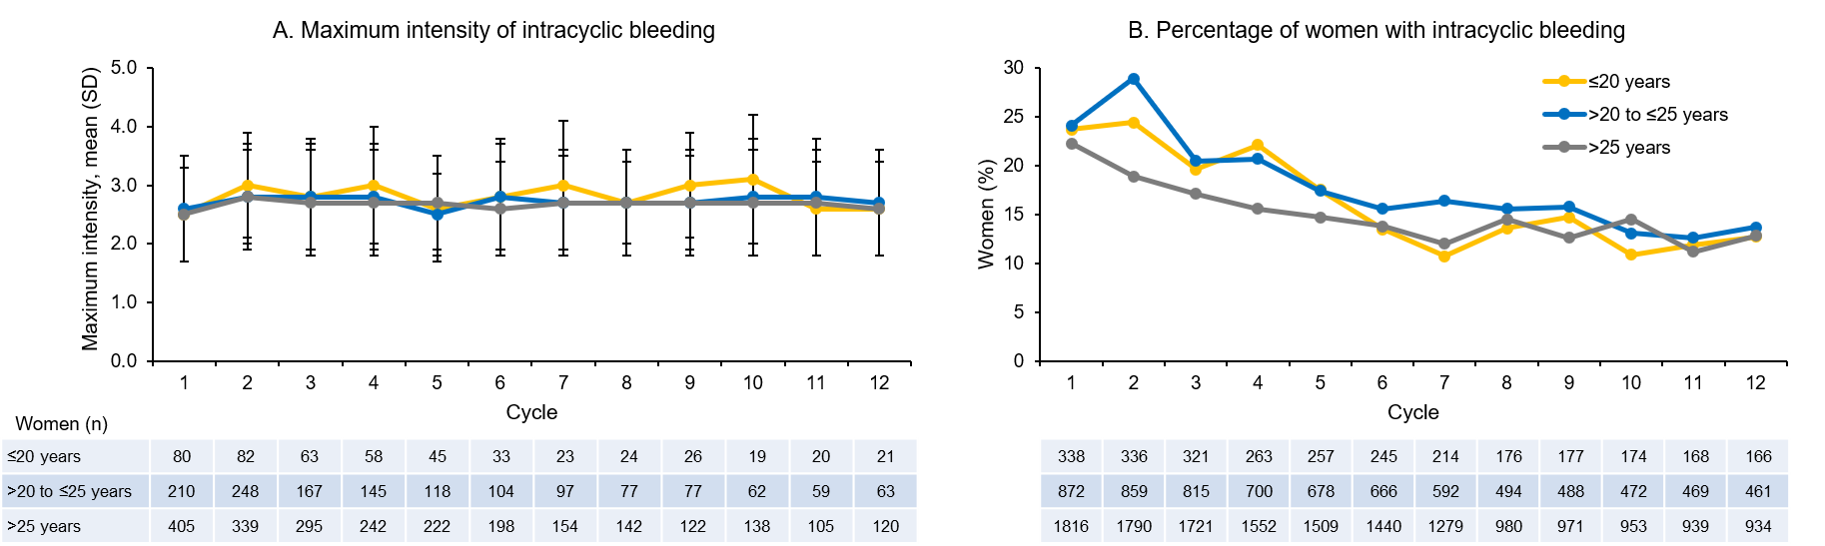
Intensity of intracyclic bleeding episodes (Figure 2B) was graded from 1 to 5, with 1 being no bleeding and 5 being heavy bleeding.
Figure 4.3. Percentage of patients with withdrawal bleeding by age group (safety analysis set)
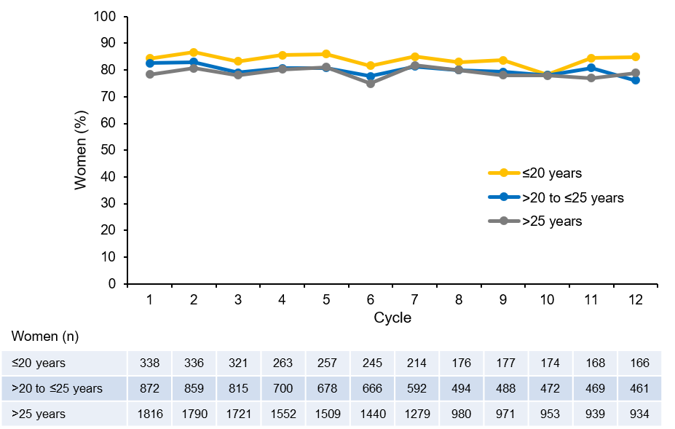

Figure 4.4. Hormone-withdrawal-associated pain as determined by average of the three highest visual analogue scale (VAS) values during days 22 to 28 by visit and age group (full analysis set)
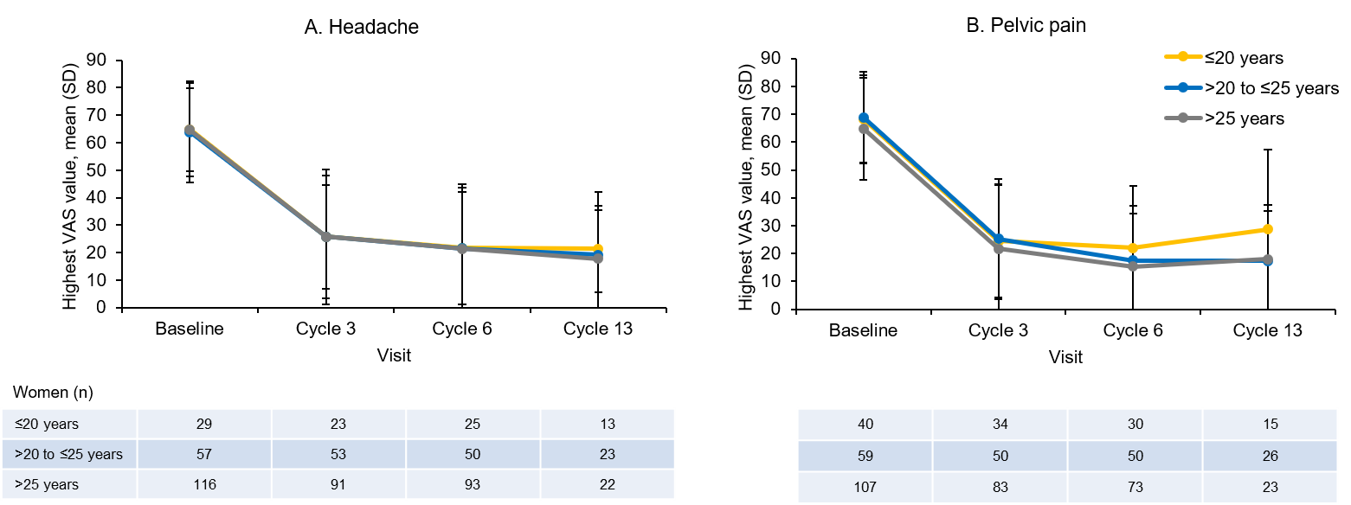
Figure 4.5. Responder analyses of change in pelvic pain and headache as determined by average of the three highest visual analogue scale (VAS) values during days 22 to 28 from baseline to cycle 6 by age group (full analysis set)
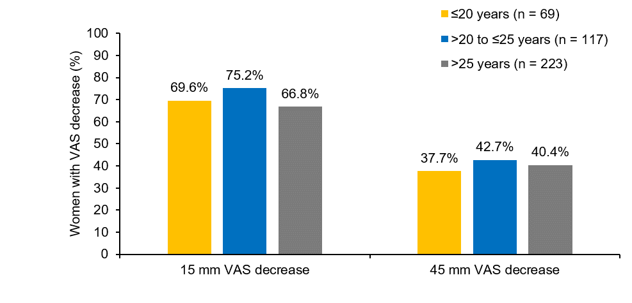

References
Gerlinger C, Endrikat J, van der Meulen EA, Dieben TO, Düsterberg B. Recommendation for confidence interval and sample size calculation for the Pearl Index. Eur J Contracept Reprod Health Care. 2003;8:87-92.
Johnson NL, Kotz S, Kemp AW. Univariate discrete distributions (2nd ed.). 1993. New York: John Wiley & Sons.

