Supplementary Materials
Description of the Classification Algorithm Developed for Outdoor Wood Hydronic Heater (OWHHs) Stack Temperature Data
An algorithm was developed to classify OWHH use patterns and events. First, in-use and not-in-use modes are separated based on the standard deviation of temperature. At each data point i, the standard deviation of the normalized temperature, $t_{i}$ , is calculated, ${SD}_{t(i)}$, using a centered moving window of 60 minutes (6 timesteps backward and 6 timesteps forward). The window size is determined by manually inspecting the temperature time series, and it is approximately equal to the average period of one cycle of the OWHH's thermostat function. The point $i$ is classified as not-in-use if either of the following criteria is satisfied:
C1-1: temperature at point $i$ is less than the 5th percentile of the stack temperature distribution ($t_{i}{<P}_{0.05}\left(t\right)$)
C1-2: The standard deviation of the temperature, ${SD}_{t(i)}$, is less than the 10th percentile of the standard deviation distribution of the entire time series (${SD}_{t(i)}<P_{0.1}({SD}_{t}$)
If none of these criteria is met, the point is classified as in-use. Based on the operation of the boiler, it is assumed that a continuous not-in-use period is greater than 10 hours. Therefore, after finishing the first round of classification, the algorithm would turn all not-in-use points that make a contiguous region less than 10 hours into in-use points. Also, to avoid noise and random temperature fluctuations when the boiler is not-in-use, all in-use periods must be at least 60 minutes long (12 timesteps).
After finalizing the classification of all data points, identifying cold starts is done by calculating the time between two consecutive in-use periods. If they are more than 24 hours apart, it means the boiler has been not in use for more than 24 hours, and therefore, the next start of the combustion (i.e., beginning of the next in-use period) is marked as a cold start. However, if the gap is less than 24 hours, it would be marked as a warm start. Re-loads also constitute another type of warm start event, which happens when the boiler is in the in-use mode and the user adds wood to the active fire. For identifying those warm start events, another algorithm was developed utilizing a first-order differencing method. The first derivative of the temperature time series, $f^{'}\left(t\right)$ approximated through $f^{'}\left(t\right)≈t_{di}=\frac{t_{i+1}-t_{i}}{τ}$, where $t_{i}$ is the normalized stack temperature at timestep $i$, and $τ$ is the 5-minute data acquisition timestep. If the temperature at timestep $i$ is higher than the 95th percentile of the stack temperature distribution ($P_{0.95}\left(t\right)<t_{i}$) and its first-order derivative is higher than the 99th percentile of the derivative distribution ($P_{0.99}\left(t_{d}\right)<t_{di}$), then it is labeled as a warm start. These two criteria are set to check both sudden temperature rise and absolute temperature.
Another algorithm was developed to identify and count cycles caused by the air damper automatic activation. First, a window of 30 minutes (3 timesteps backward and 3 timesteps forward) was established around each in-use point $i$. Within this window, the ratio of the maximum to the minimum temperature (i.e., peak-to-valley ratio) was calculated. This calculation was repeated for all in-use data points. If the peak-to-valley ratio at point $i$ was higher than the 10th percentile all peak-to-valley ratios, that window is marked as one complete cycle.

Description of the Classification Algorithm Developed for Indoor Wood Stoves (IWSs)
Stack Temperature Data
The developed algorithm classifies inactive periods and is partially reliant on the manual tuning of if-then logic, but generalized in light of its inclusion of parameters from the sample distribution for each time series. The first derivative of the temperature time series, $f^{'}\left(t\right)$ is approximated through $f^{'}\left(t\right)≈t_{di}=\frac{t_{i+1}-t_{i}}{τ}$, where $t_{i}$ is the normalized stack temperature at timestep $i$, and $τ$ is the 5 minute data acquisition timestep. In the next step, the standard deviation, ${SD}_{td(i)}$, of the first order derivative time series, $t_{d}$, is calculated with one hour window size forward (12 timesteps). The classification of data points starts as follows: if temperature is less than the 10th percentile of the temperature distribution ($t_{i}<P_{0.1}\left(t\right)$) it is classified as inactive. Otherwise, the following criteria are checked:
C2-1: The first derivative of the temperature, $t_{di}$ is in the range of the 95th percentile and the 1st percentile of the $t_{d}$ distribution: $P_{0.01}\left(t_{d}\right)<t_{di}<P_{0.95}(t_{d})$. This condition is to check that temperature $t_{i}$ is not increasing suddenly nor decreasing abruptly, which are characteristics of active mode.
C2-2: The standard deviation of the first derivative ${SD}_{i}$ is less than the 50th percentile the standard deviation distribution: ${SD}_{i}<P_{0.5}(SD)$. This step checks that temperature fluctuations are low enough so that the point can be considered to belong to an inactive period
Initially, if both C2-1 and C2-2 are met, the point $i$ is classified as inactive, otherwise, it would be classified as active. We defined an inactive period as a period with no significant fluctuations of the stack temperate (i.e., activity) for more than 4 hours. During inactive mode, the overall temperature trend is downward, but there may be noise or random fluctuations. To avoid misclassification of the noisy data as active points, we assumed all active periods must be at least 30 minutes (6 timesteps). Therefore, after finishing the initial classification, the algorithm would turn all active points that make a contiguous region less than 30 minutes into inactive points. Finally, the length of the inactive periods is used to count and classify the re-load events. When the length of an inactive period exceeds 10 hours, it is marked as a not-in-use period. If the gap between two consecutive active periods is less than 24 hours, the next start of the fire is marked as a warm start, otherwise it counts as a cold start.

Table S-1. Descriptive statistics of the temperature time series of OWHHs. (n is the number of data points, and all values are in degree Celsius)

Logger ID | Season | n | Percentiles |  |  |  |  |  | Min | Max | Mean | Median | SD
 |  |  | 5th | 10th | 25th | 75th | 90th | 95th
OWHH1 | winter | 24665 | 24 | 31 | 40 | 126 | 194 | 225 | 0 | 517 | 90 | 62 | 120
OWHH2 | Fall | 12779 | 32 | 34 | 40 | 90 | 138 | 161 | 11 | 548 | 72 | 56 | 76
OWHH2 | Winter | 10127 | 25 | 31 | 50 | 100 | 158 | 191 | -2 | 806 | 86 | 66 | 129
OWHH3 | winter | 9417 | 78 | 80 | 86 | 112 | 225 | 297 | 7 | 451 | 120 | 95 | 122
OWHH4 | Fall | 17760 | 4 | 8 | 18 | 52 | 70 | 88 | 1 | 470 | 37 | 31 | 52
OWHH4 | Winter | 11895 | 17 | 46 | 55 | 82 | 115 | 137 | 2 | 559 | 72 | 65 | 64

Table S-2. Descriptive statistics of the temperature time series of IWSs. (n is the number of data points, and all values are in degree Celsius)

Logger # | n | Percentiles |  |  |  |  |  | Min | Max | Mean | Median | SD
 |  | 5th | 10th | 25th | 75th | 90th | 95th
N1 (15) | 12200 | 21 | 24 | 29 | 53 | 62 | 68 | 10 | 110 | 42 | 41 | 15
N1 (16) | 32510 | 19 | 20 | 23 | 42 | 52 | 58 | 16 | 140 | 34 | 32 | 13
N2 (15) | 16299 | 20 | 24 | 41 | 74 | 91 | 104 | 15 | 230 | 59 | 58 | 26
N3 (15) | 11505 | 35 | 39 | 45 | 73 | 87 | 95 | 12 | 153 | 59 | 55 | 20
N4 (15) | 10386 | 23 | 25 | 31 | 65 | 82 | 92 | -5 | 133 | 49 | 43 | 23
N5 (15) | 11394 | 15 | 16 | 18 | 54 | 87 | 97 | 3 | 162 | 38 | 22 | 29
N5 (16) | 11793 | 43 | 52 | 62 | 101 | 121 | 132 | 6 | 248 | 83 | 80 | 28
N6 (15) | 28281 | 34 | 40 | 48 | 70 | 83 | 91 | 9 | 146 | 59 | 57 | 17
N7 (15) | 12348 | 16 | 18 | 23 | 69 | 88 | 97 | 11 | 167 | 49 | 45 | 27
N8 (15) | 11279 | 22 | 26 | 34 | 67 | 82 | 90 | 3 | 121 | 52 | 50 | 21
N8 (16) | 11375 | 15 | 18 | 28 | 132 | 162 | 178 | 10 | 240 | 83 | 77 | 56
N9 (15) | 57038 | 14 | 15 | 17 | 56 | 122 | 146 | 9 | 299 | 45 | 21 | 45
N9 (16) | 11540 | 24 | 35 | 76 | 172 | 196 | 212 | 1 | 319 | 127 | 138 | 60
N10 (15) | 26260 | 18 | 20 | 51 | 155 | 185 | 203 | 16 | 318 | 108 | 114 | 61
N10 (16) | 11818 | 31 | 41 | 55 | 105 | 136 | 152 | 1 | 258 | 82 | 74 | 37
N11 (15) | 28136 | 32 | 39 | 51 | 95 | 133 | 150 | 10 | 260 | 76 | 66 | 36
W1 (15) | 8499 | 24 | 30 | 47 | 80 | 95 | 104 | 10 | 176 | 64 | 63 | 24
W2 (15) | 26229 | 13 | 18 | 21 | 91 | 111 | 117 | 6 | 148 | 50 | 24 | 39
W3 (15) | 26228 | 13 | 18 | 20 | 23 | 24 | 25 | 6 | 104 | 22 | 22 | 6
W4 (15) | 26228 | 12 | 18 | 20 | 23 | 81 | 117 | 5 | 250 | 33 | 21 | 34
W5 (15) | 26228 | 13 | 16 | 20 | 25 | 92 | 106 | 6 | 199 | 35 | 22 | 30
W6 (15) | 26228 | 12 | 13 | 20 | 34 | 56 | 66 | 6 | 191 | 29 | 23 | 17
W7 (15) | 26227 | 13 | 18 | 20 | 24 | 42 | 51 | 7 | 103 | 25 | 22 | 11
W8 (15) | 26227 | 13 | 17 | 19 | 22 | 24 | 47 | 6 | 177 | 24 | 21 | 20
W9 (15) | 26227 | 12 | 14 | 18 | 23 | 25 | 54 | -6 | 131 | 23 | 21 | 15

Table S-3. Usage pattern of the studied indoor wood stoves during January 2015

Use Category | Logger # | Active | Inactive | Not in Use | Warm Starts per week | Cold Starts per week | Continuous Active Mode Duration (min) |  |  | HDD per week
 |  |  |  |  |  |  | Min | Max | Mean
High | N10 (15) | 76.6% | 23.4% | 0.0% | 7.2 | 0.00 | 225 | 2385 | 1071 | 407
 | N5 (15) | 75.7% | 24.3% | 0.0% | 7.1 | 0.00 | 325 | 2505 | 1075 | 402
 | N9 (15) | 71.6% | 28.4% | 0.0% | 7.7 | 0.00 | 175 | 2640 | 943 | 411
 | N2 (15) | 59.6% | 40.4% | 0.0% | 11.1 | 0.00 | 160 | 1120 | 543 | 406
 | N7 (15) | 70.3% | 26.3% | 3.4% | 6.6 | 0.00 | 645 | 2610 | 1071 | 406
 | N11 (15) | 65.6% | 21.6% | 12.7% | 7.5 | 0.00 | 105 | 2005 | 880 | 411
Low | N1 (15) | 55.6% | 20.2% | 24.2% | 7.6 | 0.00 | 175 | 1115 | 738 | 416
 | N3 (15) | 56.0% | 13.6% | 30.4% | 8.3 | 0.00 | 205 | 1155 | 683 | 410
 | N6 (15) | 43.4% | 19.1% | 37.5% | 7.2 | 0.40 | 125 | 1075 | 574 | 406
 | N8 (15) | 41.4% | 12.1% | 46.5% | 5.5 | 1.00 | 130 | 1025 | 640 | 411
 | N4 (15) | 21.7% | 5.0% | 73.3% | 4.0 | 1.49 | 150 | 850 | 400 | 407

Table S-4. Usage pattern of the studied indoor wood stoves during February 2015

Use Category | Logger # | Active | Inactive | Not in Use | Warm Starts per week | Cold Starts per week | Continuous Active Mode Duration (min) |  |  | HDD per week
 |  |  |  |  |  |  | Min | Max | Mean
High | N5 (15) | 80.6% | 15.1% | 4.4% | 4.0 | 0.25 | 520 | 6760 | 1919 | 458
 | N10 (15) | 72.0% | 21.6% | 6.4% | 6.3 | 0.26 | 140 | 2430 | 1098 | 458
 | N2 (15) | 60.0% | 33.3% | 6.7% | 9.0 | 0.00 | 115 | 2520 | 671 | 454
 | W1 (15) | 80.4% | 11.4% | 8.2% | 3.8 | 0.00 | 165 | 8025 | 2136 | 185
 | N7 (15) | 60.7% | 26.1% | 13.3% | 7.4 | 0.00 | 205 | 1135 | 822 | 457
 | N9 (15) | 66.1% | 20.3% | 13.6% | 6.1 | 0.28 | 275 | 2690 | 1054 | 457
 | N11 (15) | 67.6% | 18.5% | 13.9% | 5.8 | 0.00 | 95 | 3795 | 1168 | 457
Low | N6 (15) | 54.6% | 22.7% | 22.6% | 6.6 | 0.28 | 85 | 1910 | 800 | 458
 | N1 (15) | 52.9% | 23.5% | 23.5% | 7.1 | 0.24 | 120 | 1075 | 724 | 448
 | W6 (15) | 51.7% | 19.2% | 29.1% | 5.0 | 0.22 | 120 | 1915 | 1007 | 421
 | W2 (15) | 45.1% | 19.5% | 35.5% | 5.6 | 0.21 | 165 | 1595 | 777 | 187
 | N3 (15) | 44.7% | 17.8% | 37.5% | 7.6 | 0.26 | 50 | 975 | 574 | 187
 | N8 (15) | 46.2% | 13.8% | 40.0% | 6.6 | 0.55 | 85 | 1515 | 654 | 458
 | W5 (15) | 40.0% | 9.5% | 50.5% | 5.0 | 0.21 | 535 | 1125 | 773 | 457
 | W7 (15) | 36.4% | 9.7% | 53.9% | 5.2 | 0.21 | 160 | 1065 | 675 | 187
 | W4 (15) | 27.5% | 12.9% | 59.6% | 3.1 | 0.42 | 110 | 3080 | 781 | 187
 | N4 (15) | 26.6% | 4.5% | 68.9% | 4.1 | 1.65 | 145 | 1010 | 464 | 187
 | W9 (15) | 15.3% | 2.0% | 82.7% | 3.4 | 1.29 | 125 | 745 | 325 | 457
 | W3 (15) | 7.1% | 0.0% | 92.9% | 0.4 | 1.25 | 125 | 1730 | 431 | 187
 | W8 (15) | 4.5% | 1.2% | 94.3% | 0.9 | 0.85 | 155 | 540 | 268 | 187

Table S-5. Usage pattern of the studied indoor wood stoves during March 2015

Use Category | Logger # | Active | Inactive | Not in Use | Warm Starts per week | Cold Starts per week | Continuous Active Mode Duration (min) |  |  | HDD per week
 |  |  |  |  |  |  | Min | Max | Mean
Low | W2 (15) | 17.4% | 4.1% | 78.5% | 2.2 | 0.00 | 210 | 3170 | 802 | 129
 | W8 (15) | 2.5% | 1.1% | 96.5% | 0.7 | 0.12 | 145 | 480 | 294 | 129
 | W6 (15) | 1.1% | 1.1% | 97.9% | 0.2 | 0.12 | 180 | 410 | 298 | 130
 | W5 (15) | 1.8% | 0.0% | 98.2% | 0.4 | 0.00 | 110 | 830 | 500 | 129
 | W7 (15) | 1.0% | 0.0% | 99.0% | 0.1 | 0.00 | 870 | 870 | 870 | 129
 | W9 (15) | 1.0% | 0.0% | 99.0% | 0.2 | 0.00 | 120 | 760 | 440 | 130
 | W3 (15) | 0.2% | 0.0% | 99.8% | 0.0 | 0.12 | 205 | 205 | 205 | 129
 | W4 (15) | 0.0% | 0.0% | 100.0% | 0.0 | 0.00 | 0 | 0 | 0 | 129

Table S-6. Usage pattern of the studied indoor wood stoves during December 2015

Use Category | Logger # | Active | Inactive | Not in Use | Warm Starts per week | Cold Starts per week | Continuous Active Mode Duration (min) |  |  | HDD per week
 |  |  |  |  |  |  | Min | Max | Mean
High | N5 (16) | 76.0% | 17.0% | 6.9% | 4.7 | 0.43 | 230 | 4690 | 1503 | 226
 | N10 (16) | 66.5% | 24.7% | 8.7% | 8.1 | 0.00 | 95 | 2940 | 828 | 226
Low | N9 (16) | 57.3% | 19.7% | 23.0% | 6.2 | 0.57 | 310 | 1130 | 847 | 241
 | N1 (16) | 35.6% | 12.1% | 52.3% | 4.0 | 0.90 | 300 | 1270 | 728 | 231
 | N8 (16) | 10.8% | 0.0% | 89.2% | 1.5 | 1.50 | 115 | 565 | 364 | 205

Table S-7. Usage pattern of the studied indoor wood stoves during January 2016

Use Category | Logger # | Active | Inactive | Not in Use | Warm Starts per week | Cold Starts per week | Continuous Active Mode Duration (min) |  |  | HDD per week
 |  |  |  |  |  |  | Min | Max | Mean
High | N5 (16) | 77.5% | 22.5% | 0.0% | 7.1 | 0.00 | 235 | 4100 | 1320 | 336
 | N10 (16) | 78.5% | 18.0% | 3.5% | 6.2 | 0.00 | 145 | 3520 | 1360 | 330
 | N9 (16) | 64.2% | 23.1% | 12.7% | 8.2 | 0.22 | 105 | 2560 | 849 | 333
Low | N1 (16) | 46.2% | 12.7% | 41.1% | 6.6 | 0.23 | 280 | 1195 | 685 | 336
 | N8 (16) | 32.4% | 2.4% | 65.2% | 4.8 | 1.13 | 160 | 905 | 555 | 333

Table S-8. Usage pattern of the studied indoor wood stoves during February 2016

Use Category | Logger # | Active | Inactive | Not in Use | Warm Starts per week | Cold Starts per week | Continuous Active Mode Duration (min) |  |  | HDD per week
 |  |  |  |  |  |  | Min | Max | Mean
High | N5 (16) | 79.3% | 20.7% | 0.0% | 6.1 | 0.00 | 220 | 5620 | 1633 | 324
 | N10 (16) | 72.6% | 24.0% | 3.4% | 6.8 | 0.00 | 90 | 3175 | 1081 | 330
Low | N9 (16) | 47.3% | 22.0% | 30.7% | 6.4 | 0.73 | 85 | 1210 | 672 | 324
 | N1 (16) | 47.3% | 16.4% | 36.3% | 6.0 | 0.23 | 175 | 1165 | 713 | 325
 | N8 (16) | 40.3% | 10.1% | 49.6% | 5.2 | 0.96 | 140 | 1125 | 652 | 325

Table S-9. Usage pattern of the studied indoor wood stoves during March 2016

Use Category | Logger # | Active | Inactive | Not in Use | Warm Starts per week | Cold Starts per week | Continuous Active Mode Duration (min) |  |  | HDD per week
 |  |  |  |  |  |  | Min | Max | Mean
High | N10 (16) | 62.9% | 23.9% | 13.2% | 7.5 | 0.00 | 55 | 4015 | 843 | 253
 | N5 (16) | 63.3% | 23.1% | 13.6% | 6.9 | 0.31 | 90 | 2665 | 887 | 253
Low | N9 (16) | 50.0% | 25.6% | 24.4% | 9.6 | 0.00 | 95 | 1230 | 526 | 252
 | N8 (16) | 35.7% | 5.3% | 59.0% | 5.2 | 0.68 | 155 | 1090 | 612 | 232
 | N1 (16) | 27.9% | 7.0% | 65.1% | 3.7 | 1.46 | 200 | 985 | 548 | 238

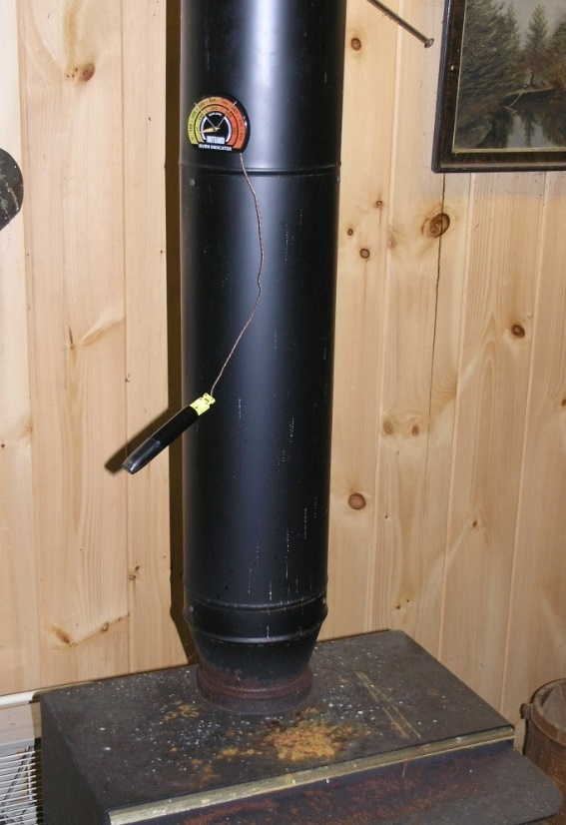
Figure S-1. Type K thermocouple logger deployed on the stack wall of an indoor wood stove.

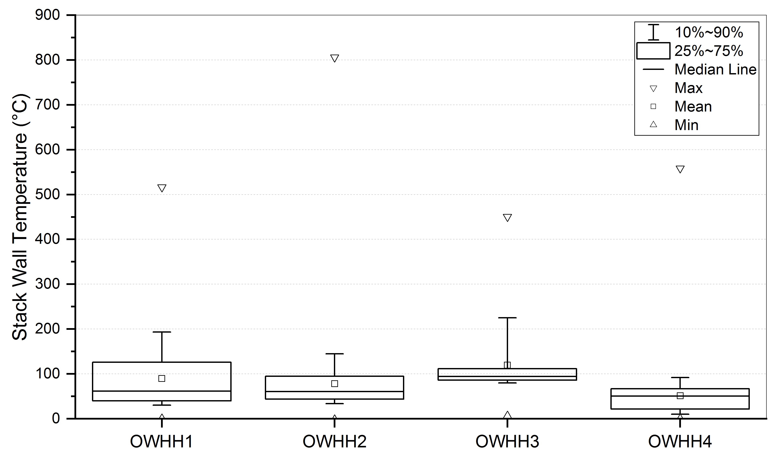
Figure S-2. Box plot of the stack wall temperature of the OWHHs.

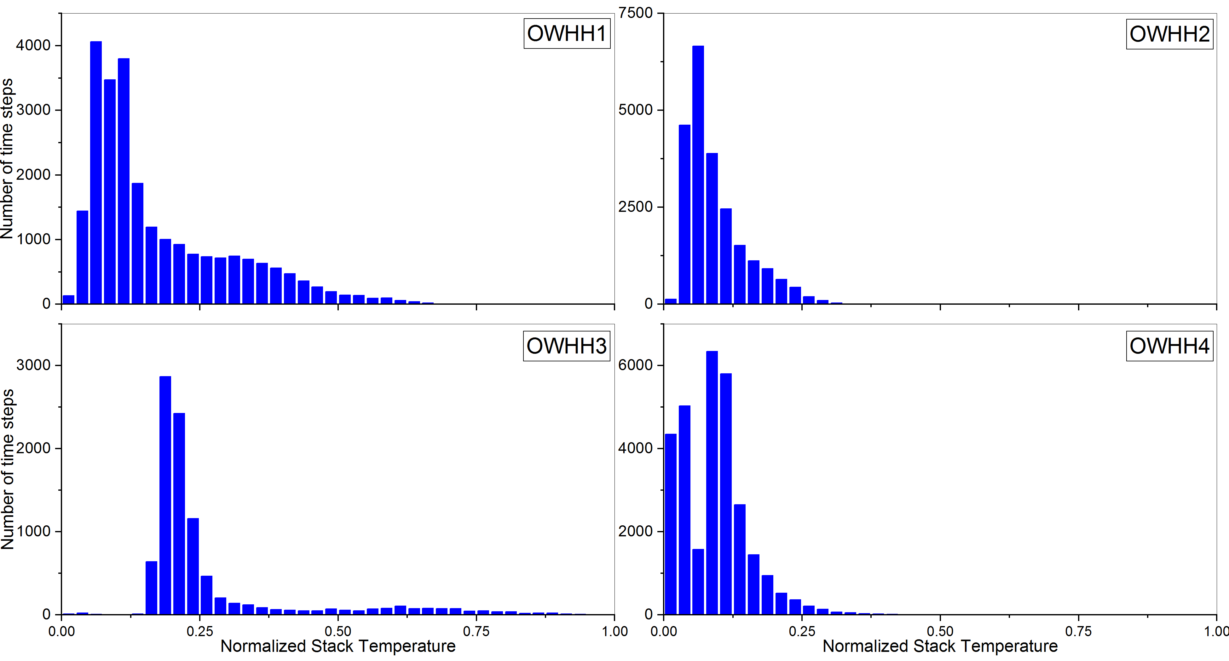
Figure S-3. Histogram of the normalized stack wall temperature of the OWHHs.

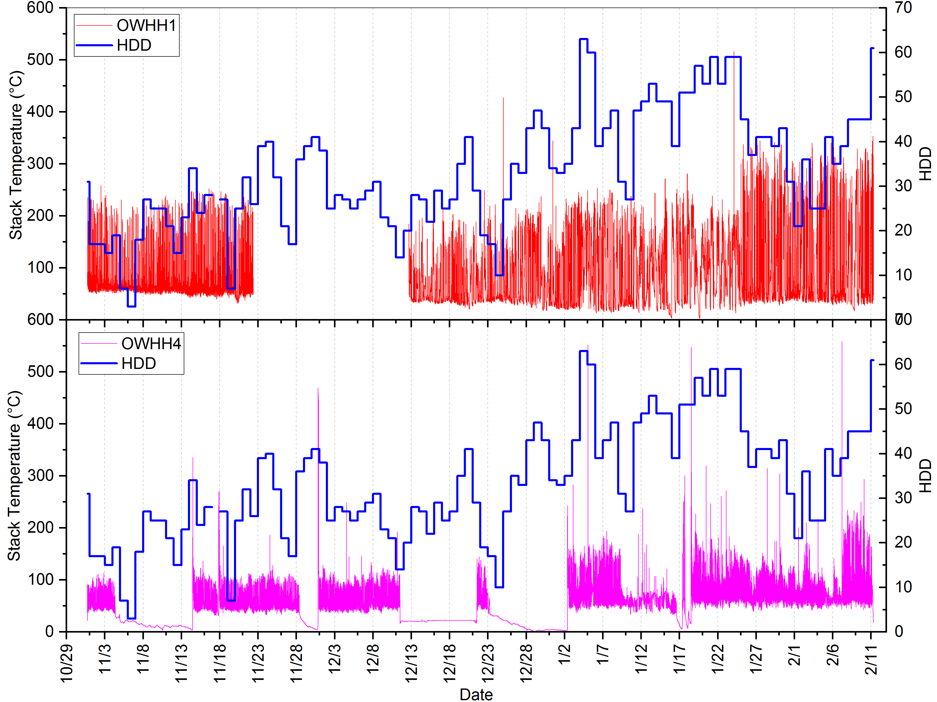
Figure S-4. Comparison between OWHH1 and 4 temperature profiles.

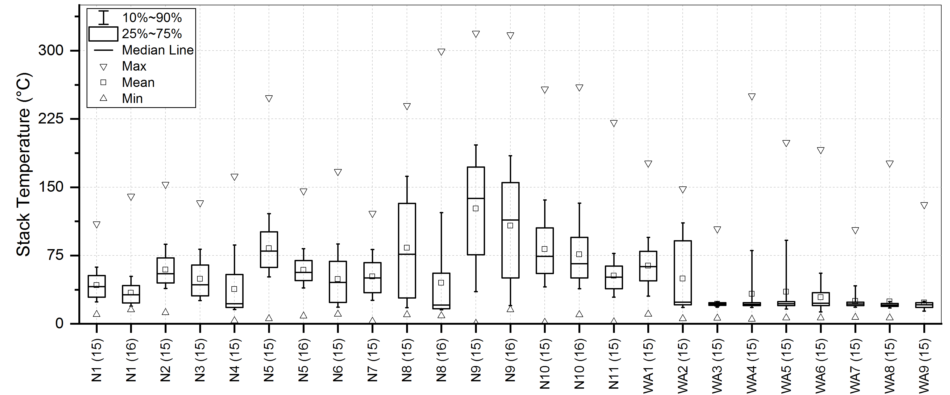
Figure S-5. Box plot of the stack wall temperature of the IWSs.

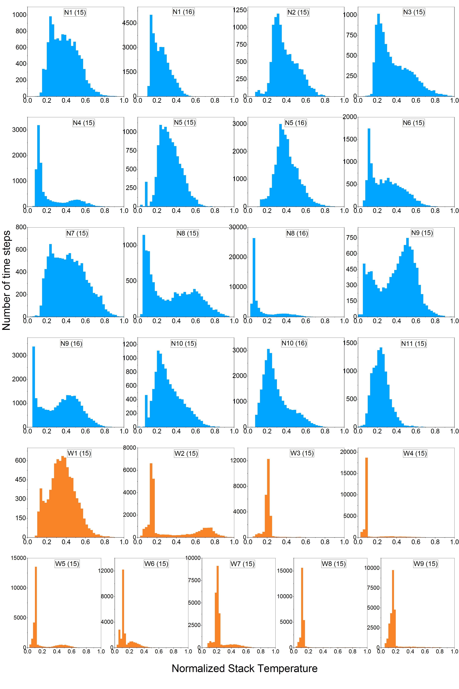
Figure S-6. Histogram of the normalized stack temperature data.
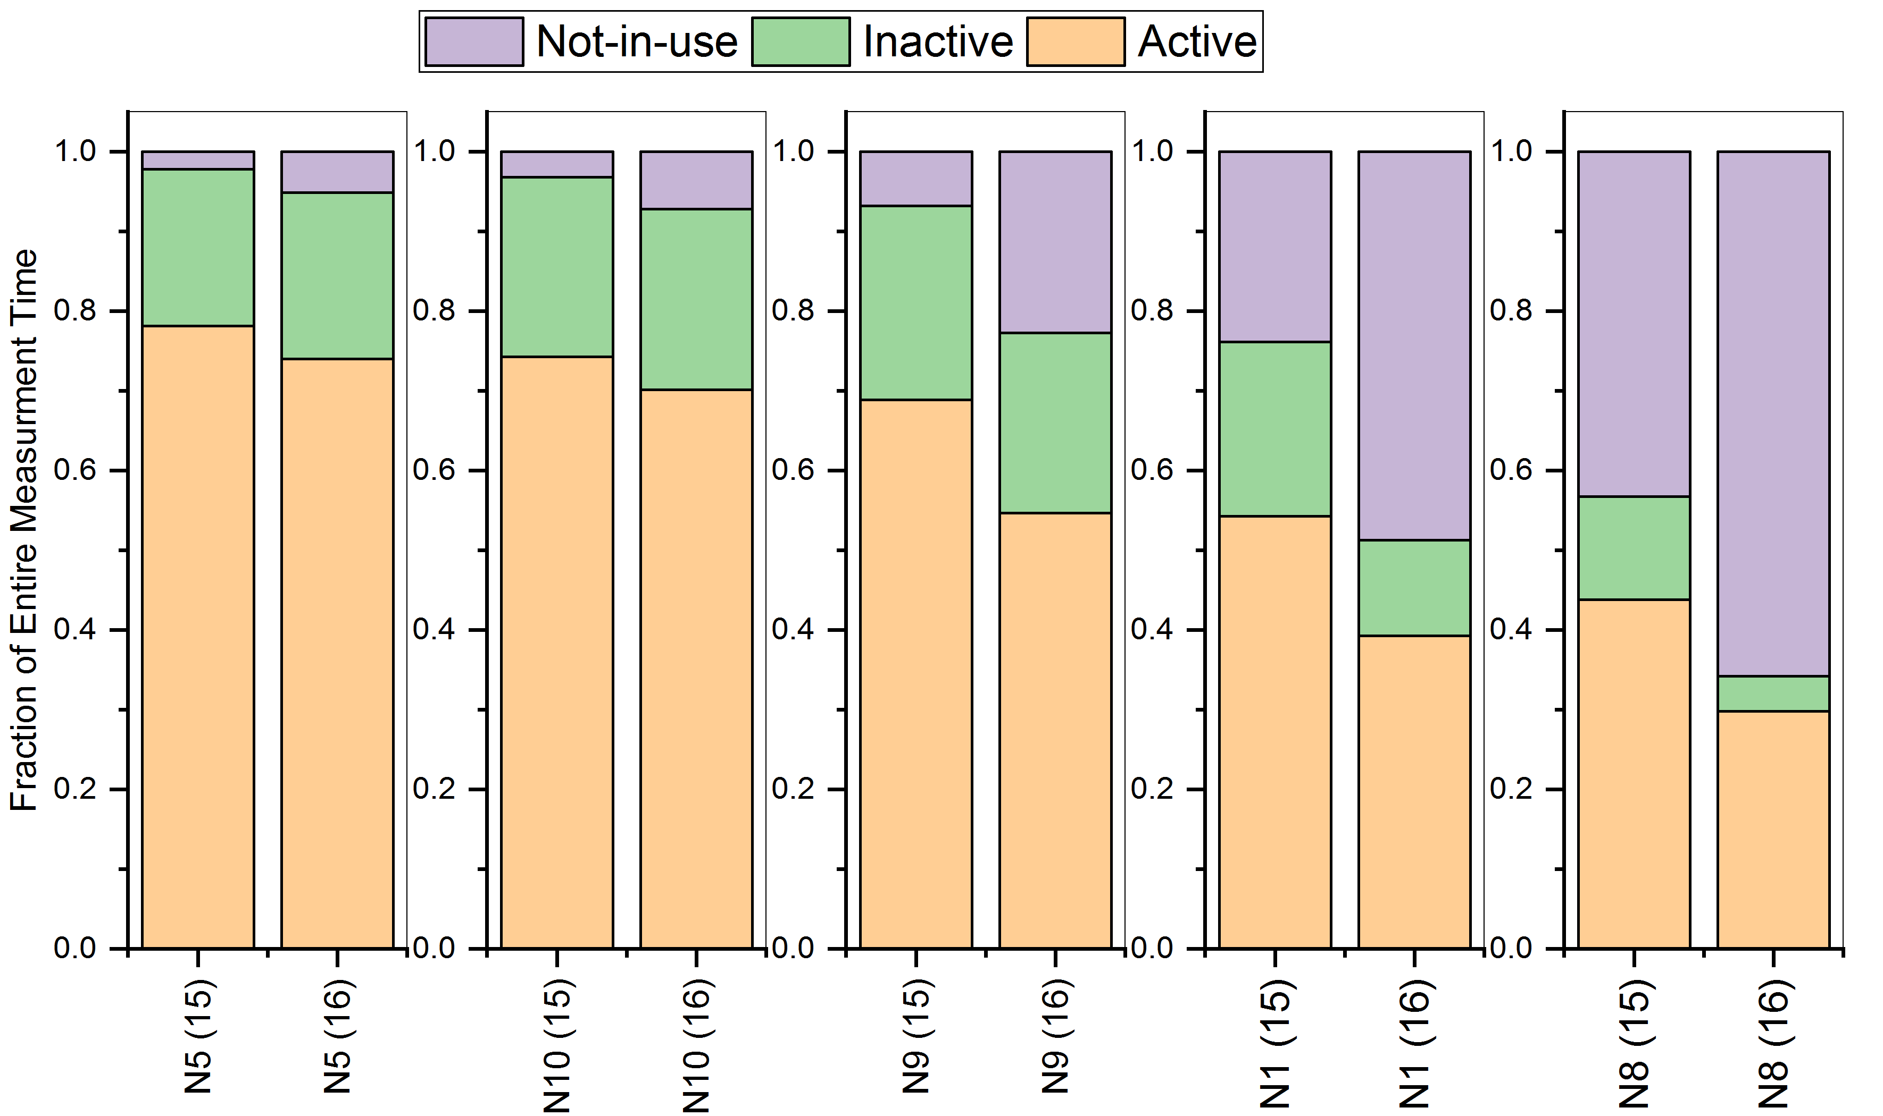
Figure S-7. Comparison of usage modes for 5 NYS IWSs in 2015 and 2016 heating seasons.

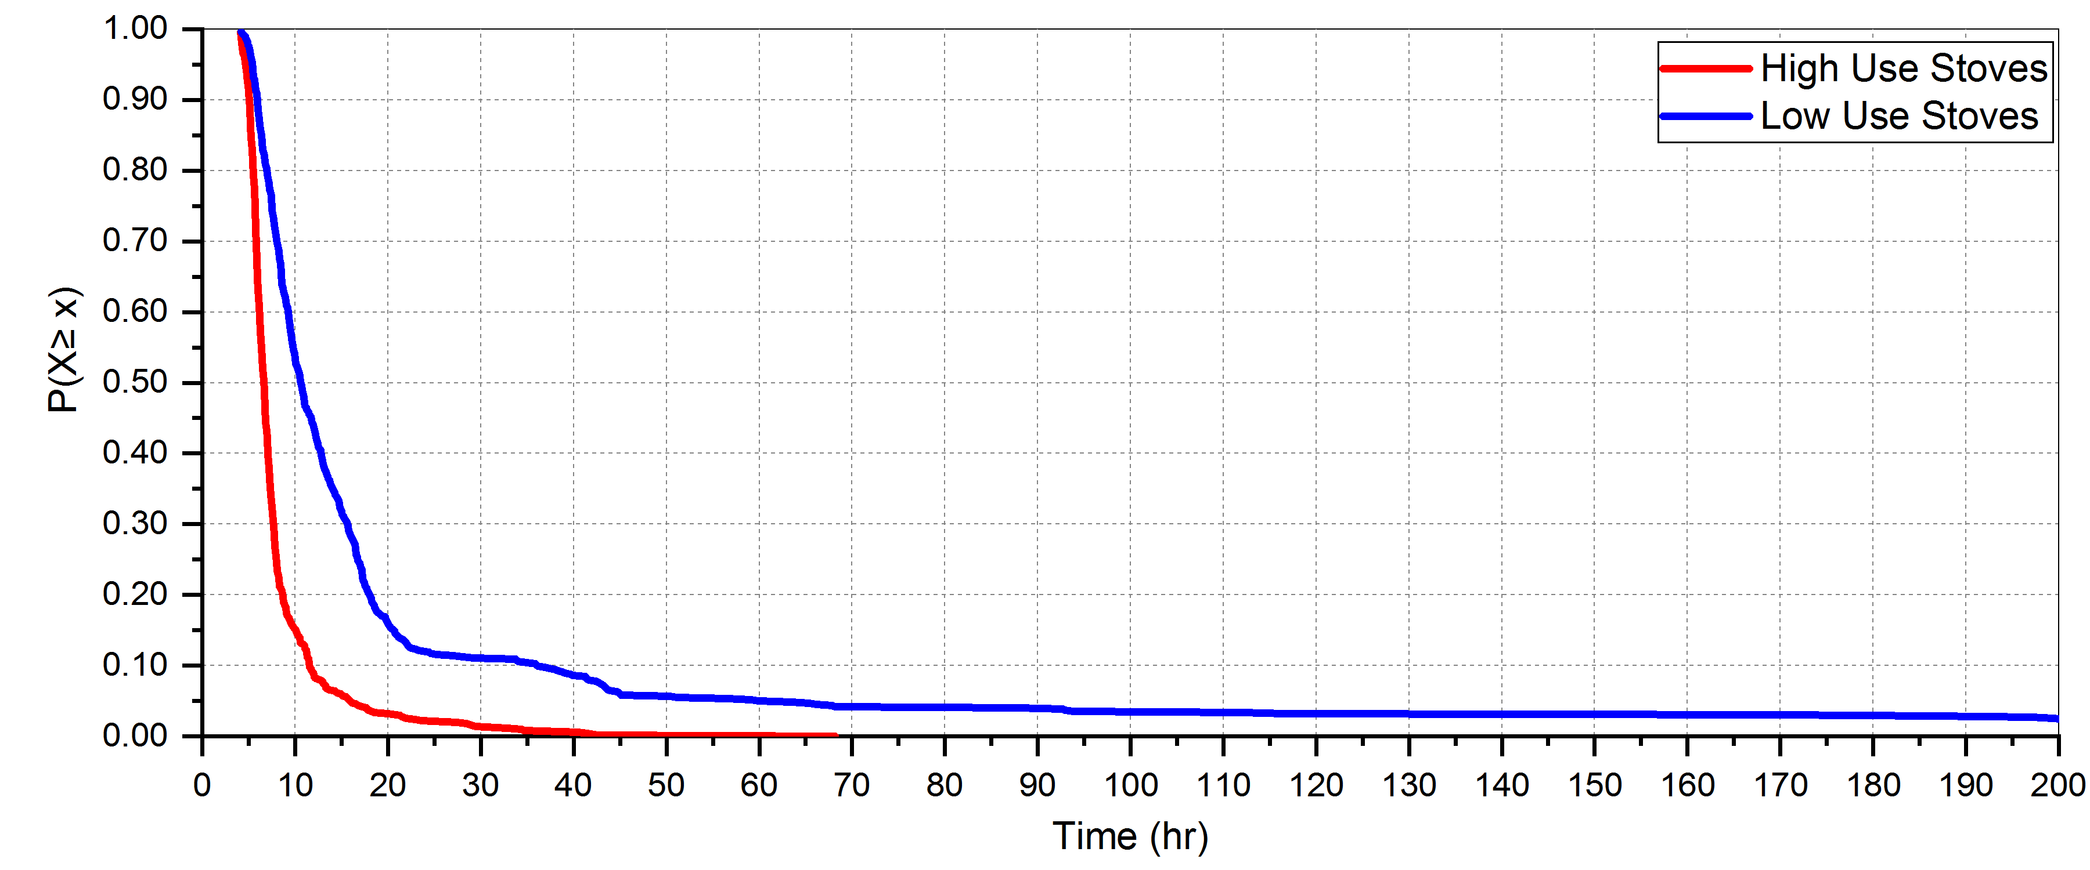
Figure S-8. The empirical complementary cumulative distribution functions (CCDF) for active period spacing. For this plot, all activity data in each IWS use group were pooled together and were analyzed to build the empirical CCDFs without curve fitting. The Y-axis shows the probability of stoves in a given use group not being active for more than a given length of time (x). The CCDF curve of the high use stoves ends at 68 hours because there were no cases having a gap between two active periods greater than 68 hours. However, the low use stove curve has a long tail that represents long periods of inactivity in the WA stoves.

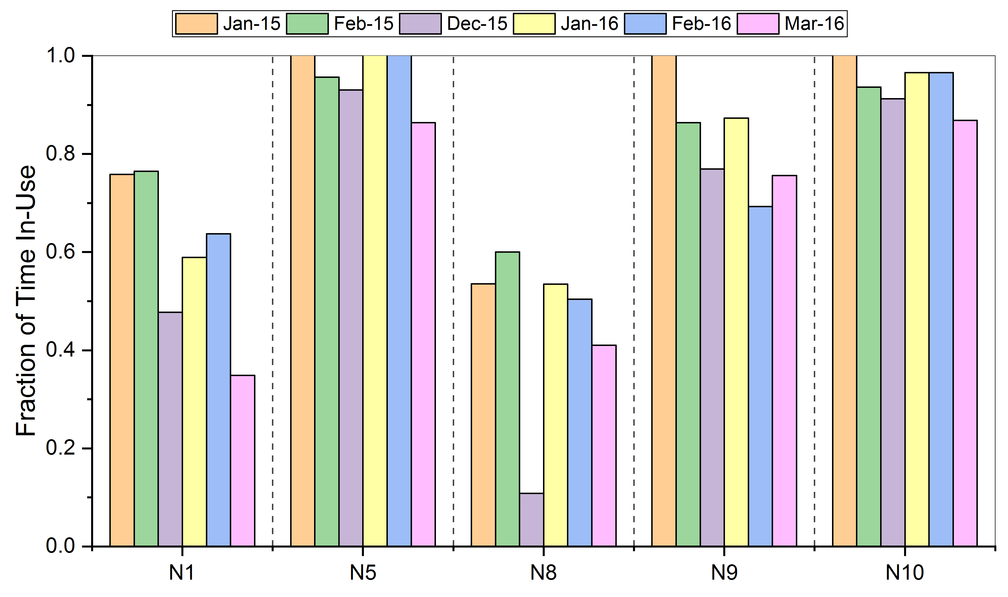
Figure S-9. Monthly Percent Time In-Use for the Five NYS IWSs Monitored Over Two Seasons

