Supplementary Information
Photoluminescent report on red light emitting europium(III) complexes with heterocyclic acid
Priyanka Dhankhar, Manisha Bedi, Jyoti Khanagwal, V.B. Taxak, S. P. Khatkar, Priti Boora*
Department of Chemistry, Maharshi Dayanand University, Rohtak-124001, India
*Corresponding Author: Tel: +9416175000, E-mail Address: pritiboora@gmail.com

Fig. S1 Energy dispersive X-ray spectrum (EDAX) of complex C1 [Eu(IPA)₃.2H₂O] of europium (III) ion with ligand 3-isopropylpyrazole-5-carboxylate (IPA). EDAX analysis confirms presence of carbon (C), nitrogen (N), oxygen (O) and europium (Eu) elements.
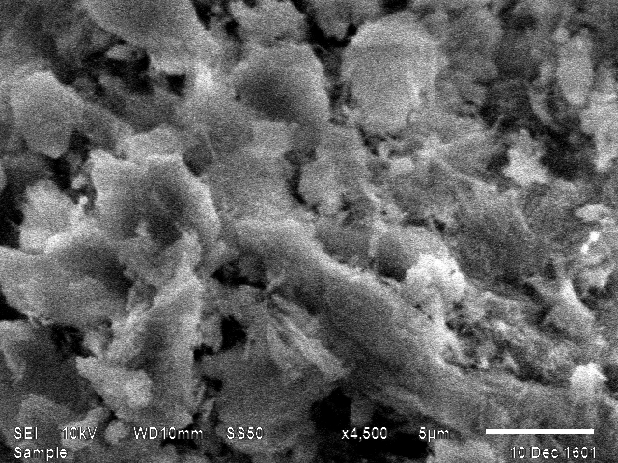
Fig S2 Scanning electron microscope (SEM) image of complex C5 [Eu(IPA)₃.phen] of europium ion with primary ligand 3-isopropylpyrazole-5-carboxylate (IPA) and secondary ligand 1,10-phenanthroline (phen). The image shows that matrix of complex consists of uniformly dispersed particles.

Fig. S3 Proton nuclear magnetic resonance spectra of ligand 3-isopropylpyrazole-5-carboxylic acid (HIPA) (a) and complex C5 [Eu(IPA)₃.phen] with primary ligand 3-isopropylpyrazole-5-carboxylate (IPA) and secondary ligand 1,10-phenanthroline (phen) (b). The change in signal pattern of complex as compare to free ligand confirm bond formation between depronated ligand and europium ion as well as coordination of secondary ligand to europium ion.
Fig. S4 Luminescence decay profile of ⁵D₀ excited level of binary complex C1 [Eu(IPA)₃.2H₂O] of europium ion with ligand 3-isopropylpyrazole-5-craboxylate (IPA) and ternary complexes C2 [Eu(IPA)₃.dmbipy], C3 [Eu(IPA)₃.bipy], C4 [Eu(IPA)₃.dmph] and C5 [Eu(IPA)₃.phen] with primary ligand IPA and secondary ligand 4,4’-dimethyl-2,2’-bipyridyl (dmbipy), 2,2’-bipyridyl (bipy), 5,6-dimethyl-1,10-phenanthroline (dmph) and 1,10-phenanthroline (phen) respectively, in solid state at room temperature.
Fig. S5 Phosphorescence spectrum of binary complex G1 [Gd(IPA)₃.2H₂O] of gadolinium ion with ligand 3-isopropylpyrazole-5-craboxylate (IPA). The energy of triplet state of ligand is found to be 24630 cm⁻¹ corresponding to wavelength 406 nm.

Fig. S6 Scheme of energy transfer mechanism of complex C3 [Eu(IPA)₃.bipy] of europium ion with primary ligand 3-isopropylpyrazole-5-carboxylate (IPA) and secondary ligand 2,2’-bipyridyl (bipy). The figure illustrates various energy transfer pathways from primary ligand IPA and secondary ligand bipy to europium metal ion. The dotted and solid vertical lines represent non-radiative transitions and radiative transitions, respectively.

