Supplementary Figures
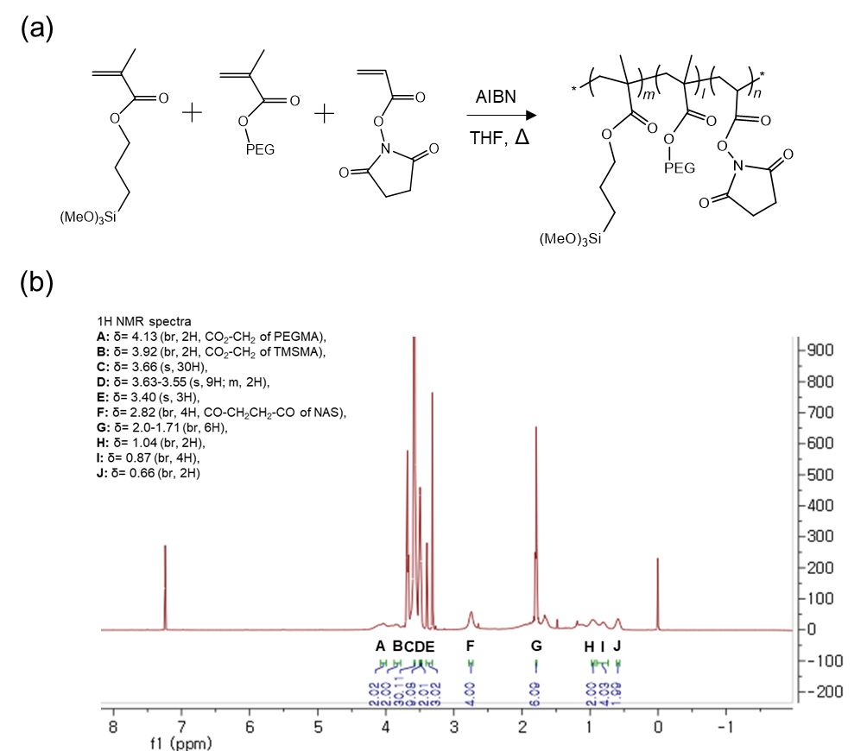
Figure S1. Synthesis of poly(TMSMA-r-PEGMA-r-NAS) (a) and its ¹H NMR spectra (b).

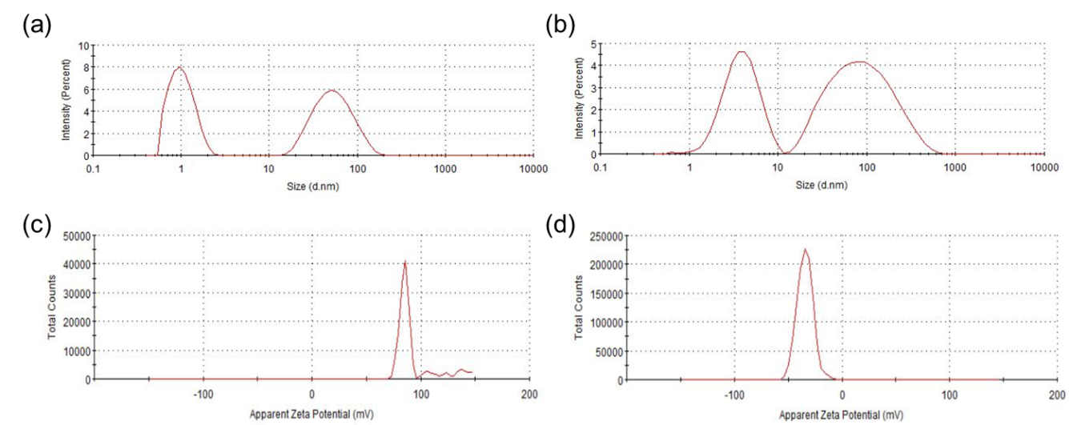
Figure S2. DLS size (a, b) and zeta potential (c, d) measurements of CTAB-GNRs (a, c) and p-GNRs (b, d).

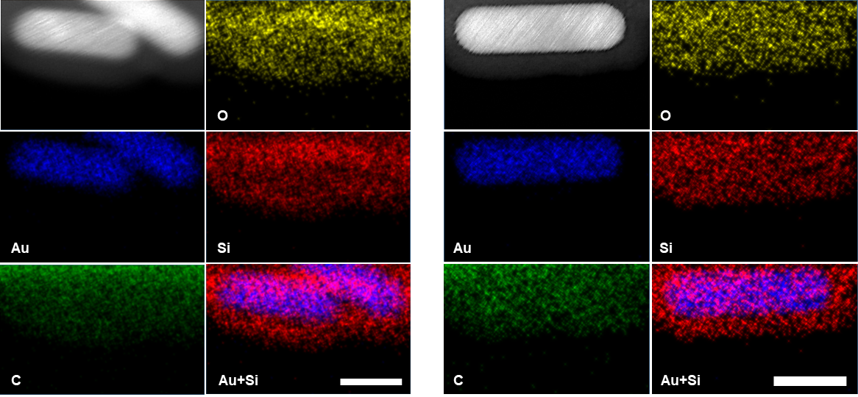
Figure S3. TEM-EDS mapping images of p-GNRs for Au, C, O, and Si. Scale bars, 20 nm.

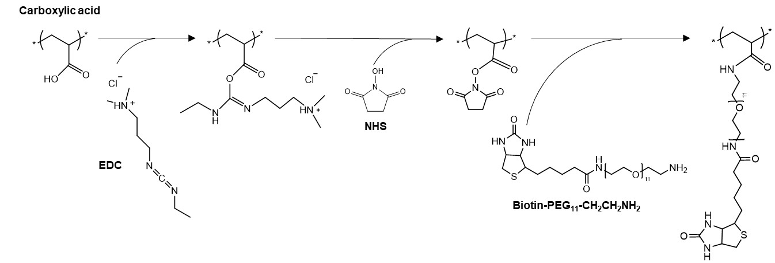Figure S4. Synthesis of biotin functionalization on p-GNRs via a DC/NHS amine coupling reaction.

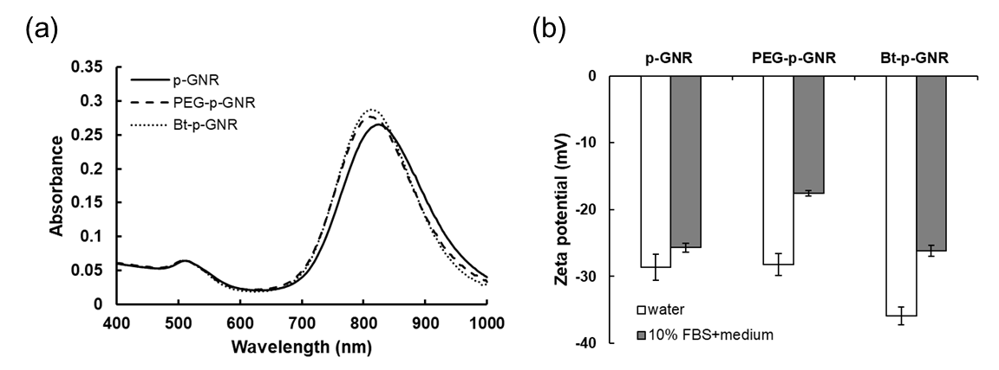
Figure S5. (a) Absorbance spectra of p-GNRs, PEG-p-GNRs, and Bt-p-GNRs. (b) Zeta potentials of p-GNRs, PEG-p-GNRs, and Bt-p-GNRs that had been incubated in water or 10% FBS+medium for 4 h. Data are presented as means ± SD (n = 3).

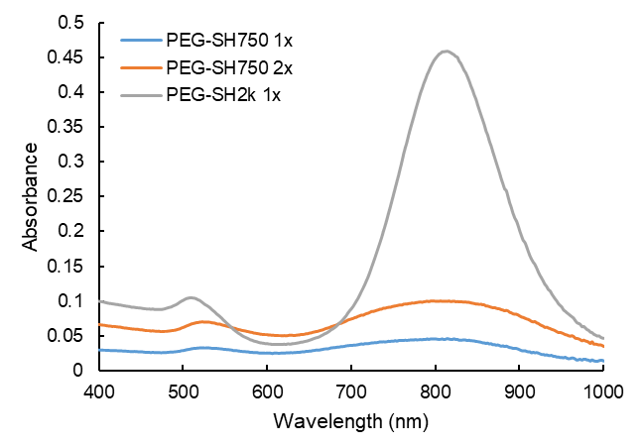
Figure S6. Absorbance spectra of GNRs that had been PEGylated with either thiol-mPEG₇₅₀ or thiol-mPEG_{2k}.

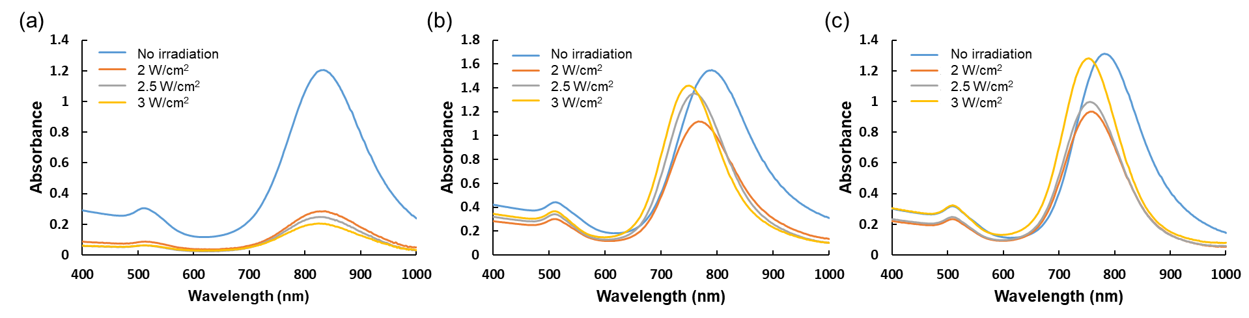
Figure S7. Photothermal stability of PEG_{2k}-S-GNRs (a), p-GNRs (b), and Bt-p-GNRs (c) after irradiation for 5 min with an 808-nm laser at various intensities (2–3 W/cm²).

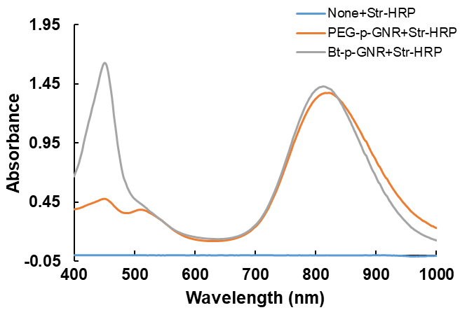
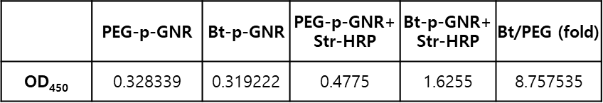
Figure S8. TMB coloration was measured after incubation of streptavidin-HRP with PEG-p-GNRs or Bt-p-GNRs for the detection of specific binding between streptavidin and biotin on Bt-p-GNRs.

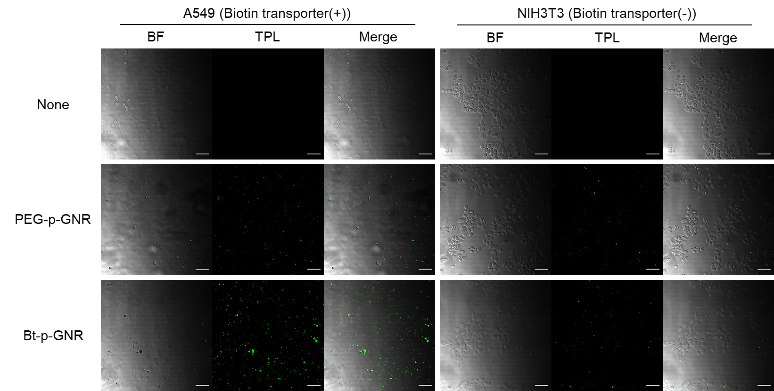
Figure S9. Bright field (BF) and TPL microscopy images of A549 and NIH3T3 cells that had been treated with PEG-p-GNRs or Bt-p-GNRs for 4 h (excitation, 810 nm). Scale bars, 50 μm.

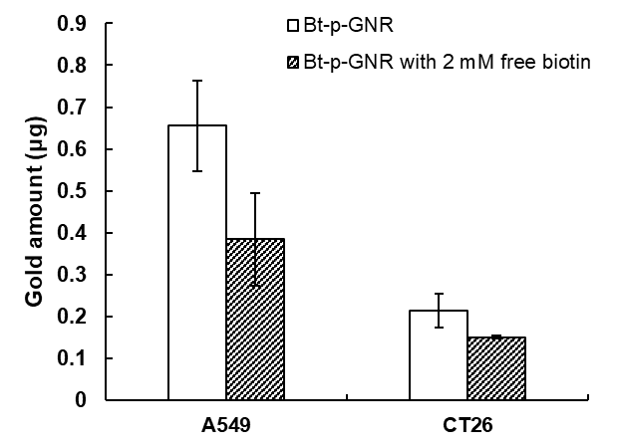
Figure S10. Cellular uptake of Bt-p-GNRs in the absence or presence of excess free biotin was compared using ICP-OES. Data are presented as means ± SD (n = 3).

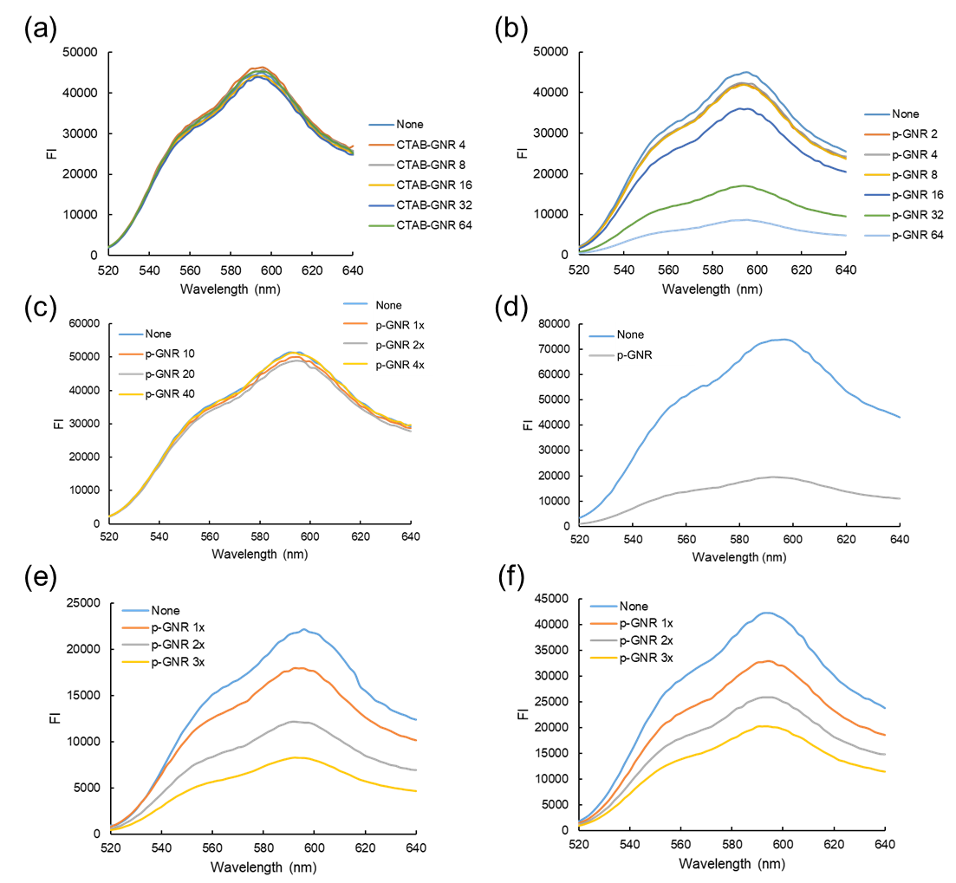
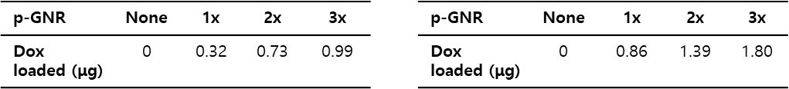
Figure S11. (a-d) Dox loading with CTAB-GNRs (a), base-catalyzed p-GNRs (b), acid-catalyzed p-GNRs washed with water (c), or acid-catalyzed p-GNRs washed with borate buffer (pH 8.5), tested at a constant Dox concentration (d). (e, f) The amount of Dox loaded on acid-catalyzed p-GNRs washed with borate buffer was tested at Dox concentrations of 25 μg/mL (e) and 50 μg/mL (f).

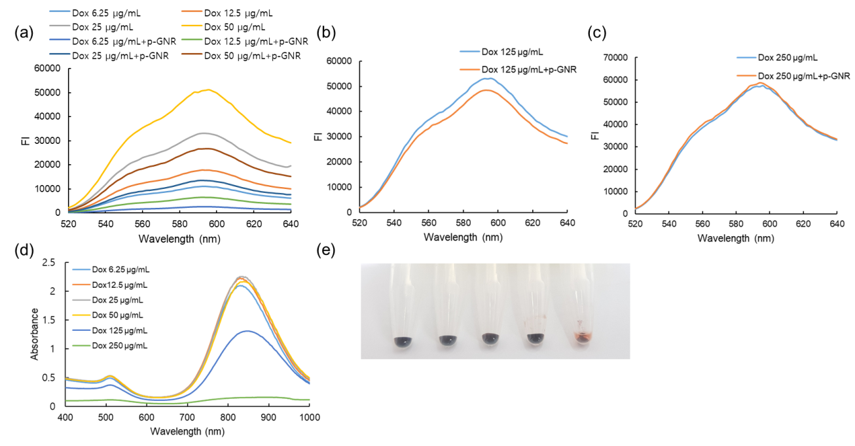
Figure S12. Dox loading tested with different Dox concentrations at a constant p-GNR concentration.

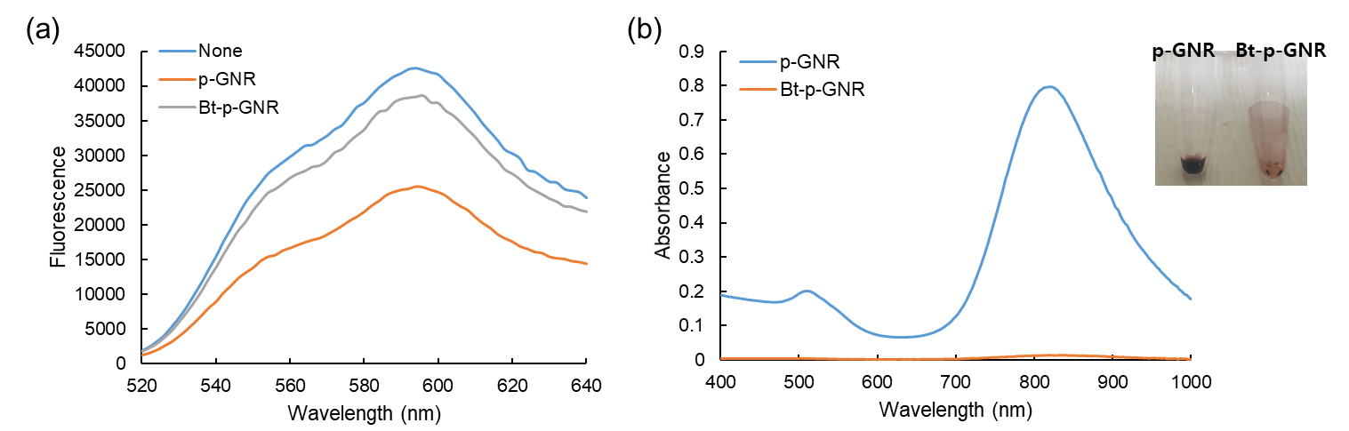
Figure S13. Dox loading tested with Bt-p-GNRs.

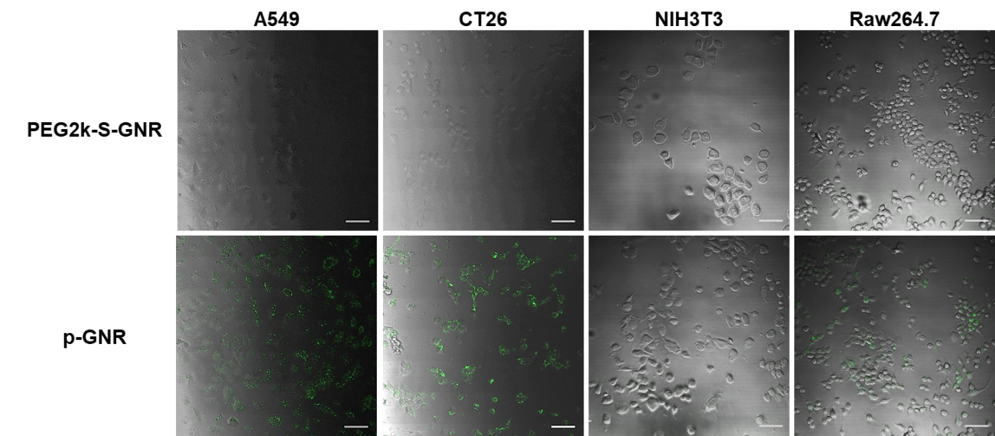
Figure S14. Cellular uptake of PEG_{2k}-S-GNRs and p-GNRs in cancer (A549, CT26), fibroblast (NIH3T3), and macrophage (Raw264.7) cell lines (excitation, 810 nm). Scale bars, 50 μm.

