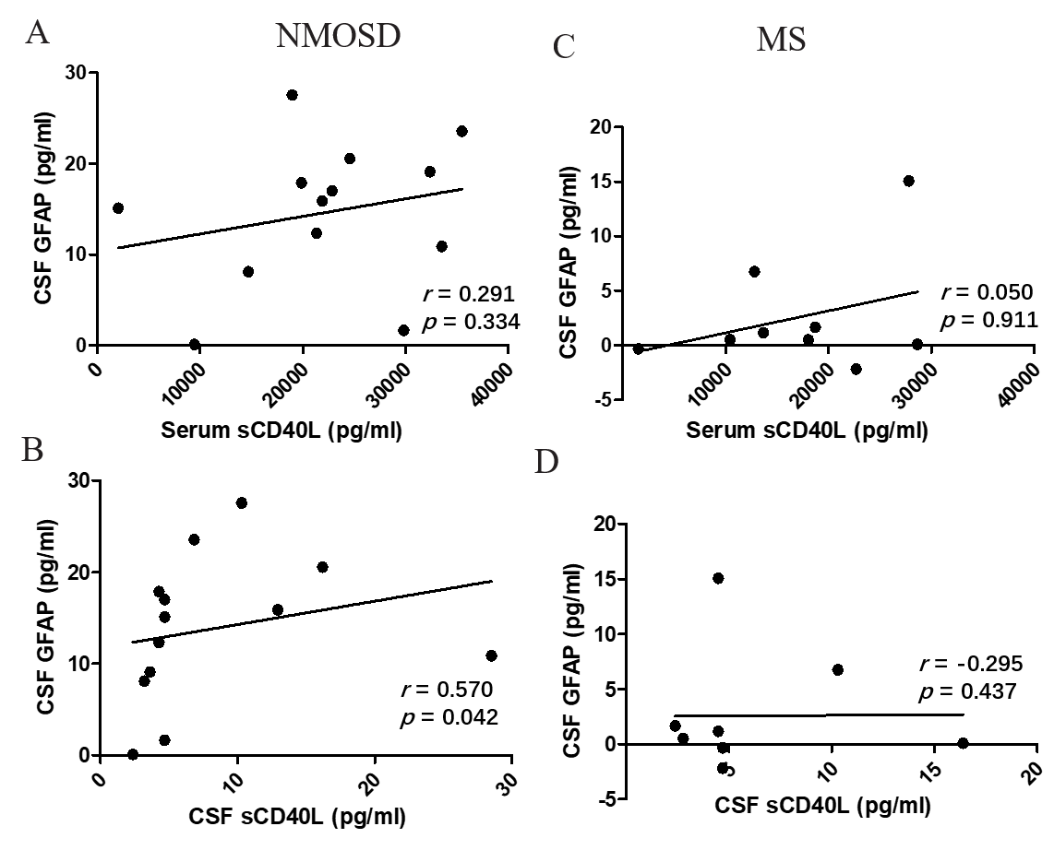
Figure s1. Relation of sCD40L and GFAP levels in MS and NMOSD. (A, B) In NMOSD, CSF sCD40L levels were positively correlated with CSF GFAP levels. No correlation was found between CSF sCD40L levels and CSF GFAP levels. (C, D) In MS, sCD40L levels were not correlated with CSF GFAP levels.
Statistical testing was performed using Spearman’s rank correlation analysis. r = Spearman’s rho.

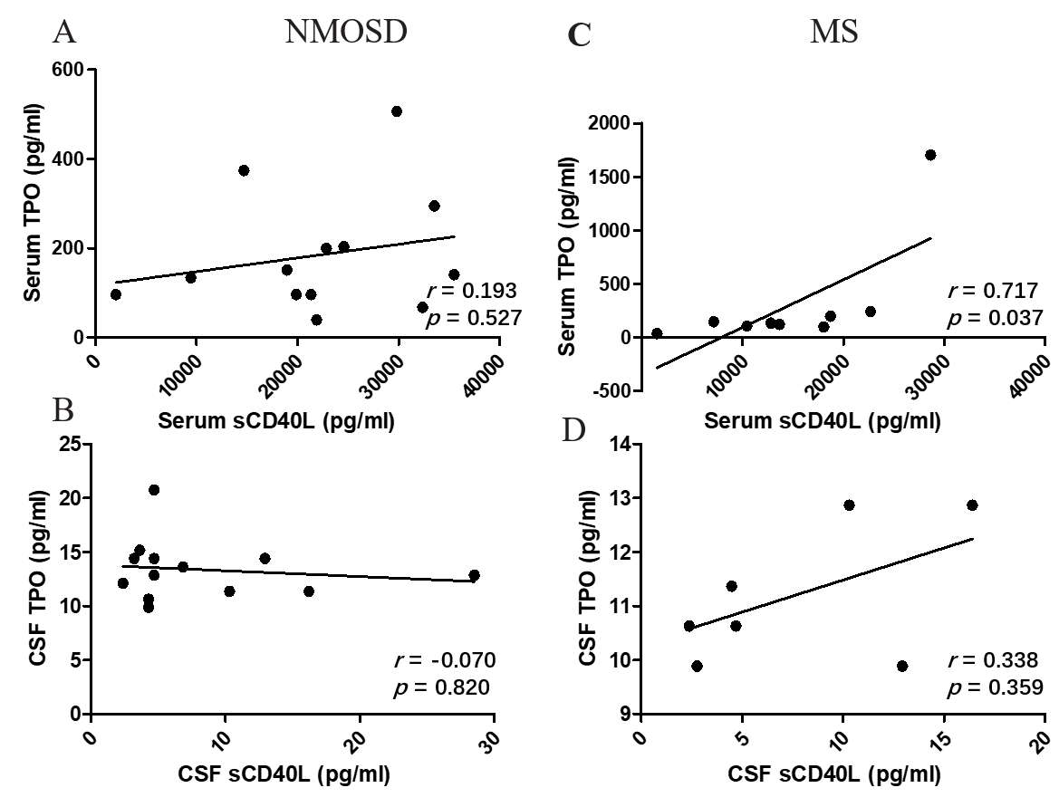
Figure s2. Relation of sCD40L and TPO levels in MS and NMOSD. (A, B) No correlation was found between sCD40L levels and TPO levels in NMOSD. (C, D) In MS, serum sCD40L concentration was positively correlated with serum TPO. CSF sCD40L was not correlated with CSF TPO.
Statistical testing was performed using Spearman’s rank correlation analysis. r = Spearman’s rho.
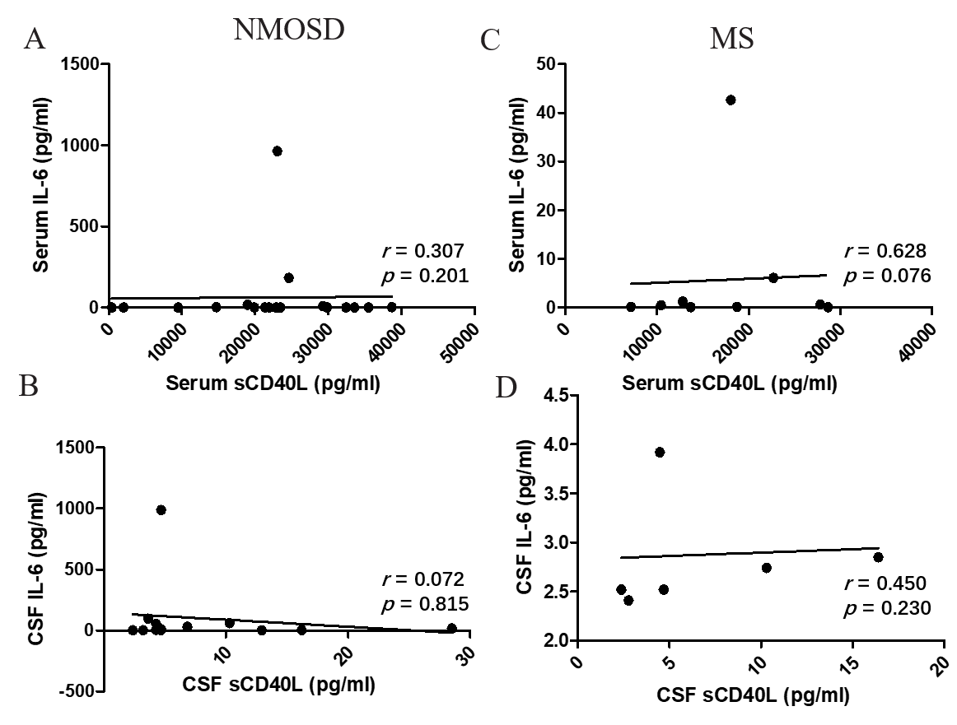

Figure s3. Relation of sCD40L levels and IL-6 levels in NMOSD and MS. (A, B) The serum or CSF sCD40L levels did not correlate with IL-6 levels in NMOSD. (C, D) The serum or CSF sCD40L levels did not correlate with IL-6 levels in MS.
Statistical testing was performed using Spearman’s rank correlation analysis. r = Spearman’s rho.

