SUPPLEMENTAL DATA
APPENDIX 1: SELECTED PHOTOGRAPHS OF BERNARD OWENS
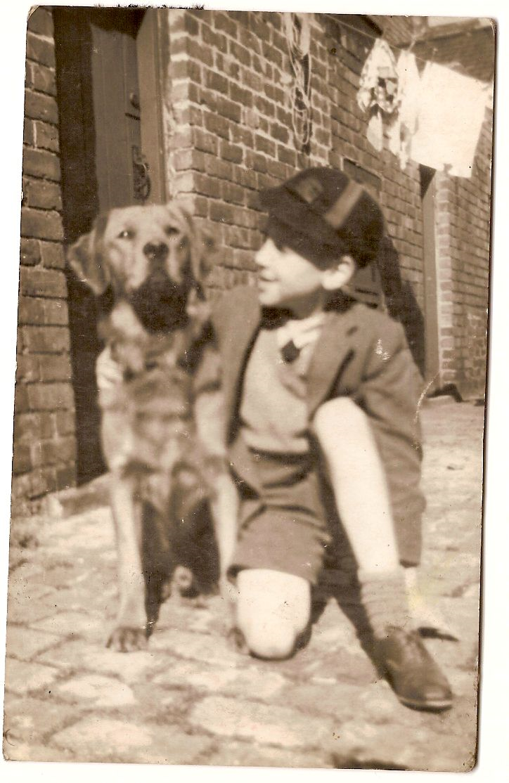
Figure 1. Bernard when he was a schoolboy at Beaumont Street Primary School with a dog belonging to a neighbour in the alley behind his home in Clifton Road, Darlington. Precise date and photographer unknown. Reproduced with the permission of the Owens family.

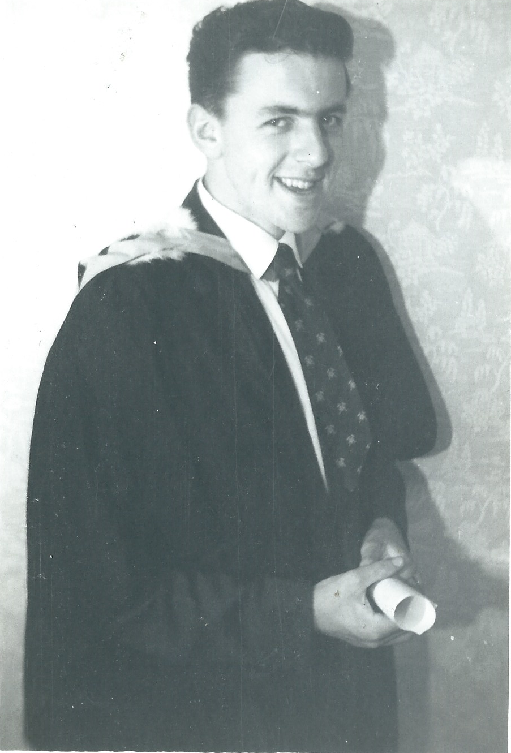
Figure 2. A graduation photograph of Bernard when he received his BSc honours degree in Geology from the University of Sheffield in the summer of 1960. Precise date and photographer unknown. Reproduced with the permission of the Owens family.

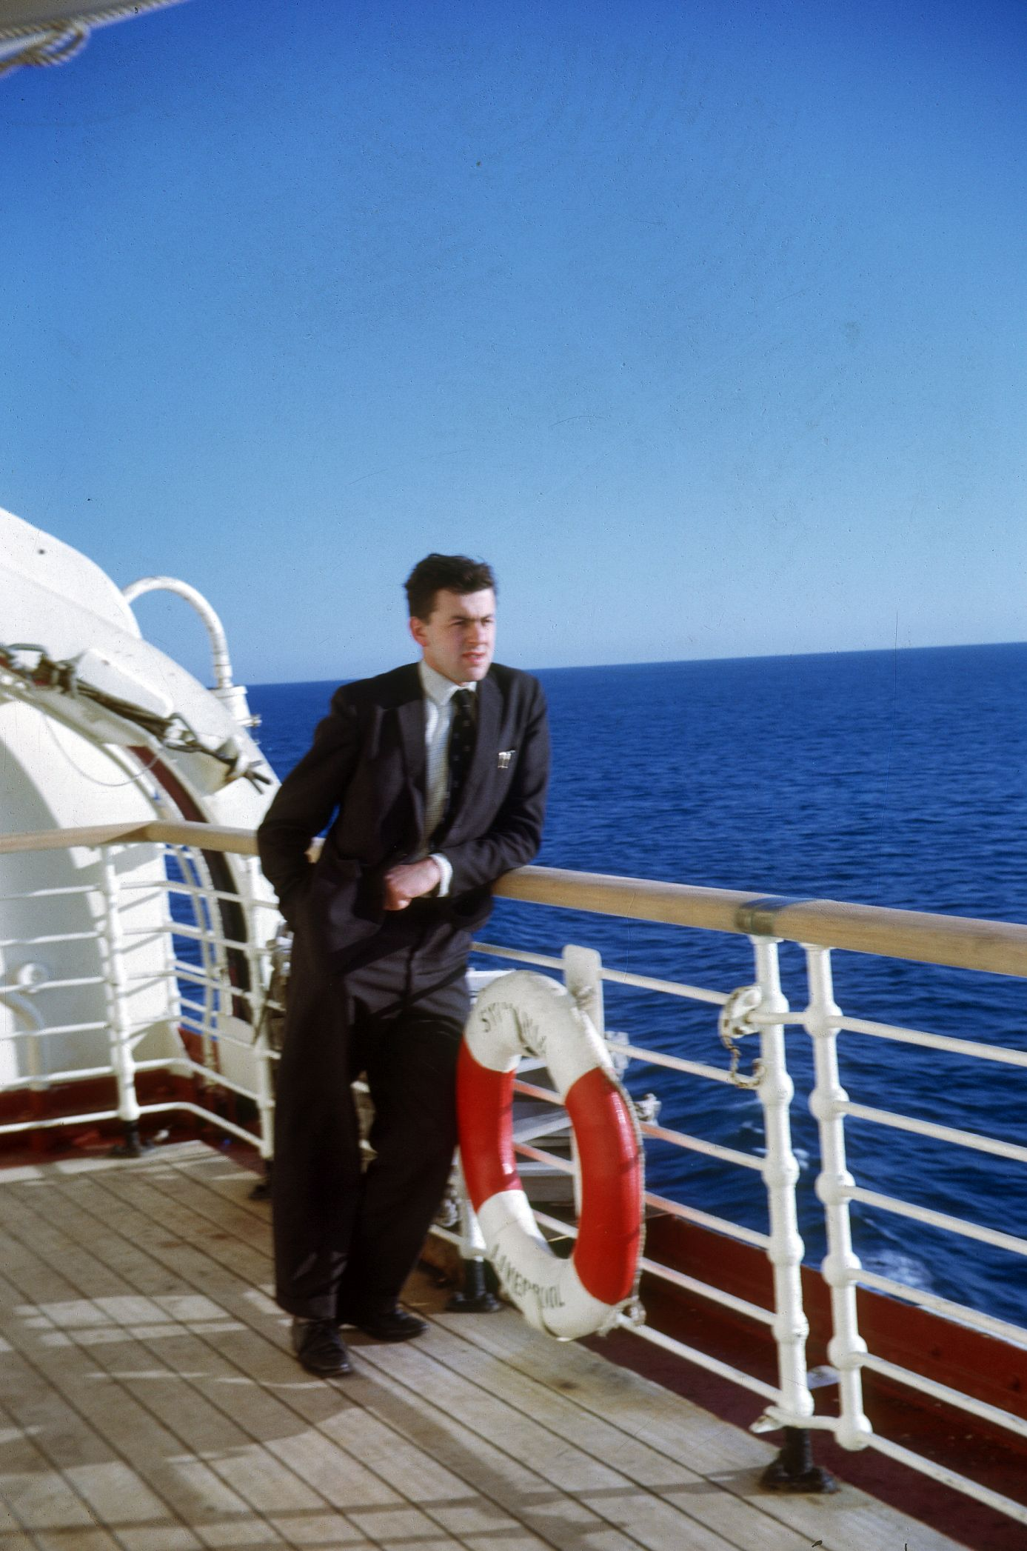

Figure 3. Bernard on board the RMS Sylvania the way to Canada for his postdoctoral fellowship in late November 1963. Reproduced with the permission of the Owens family.

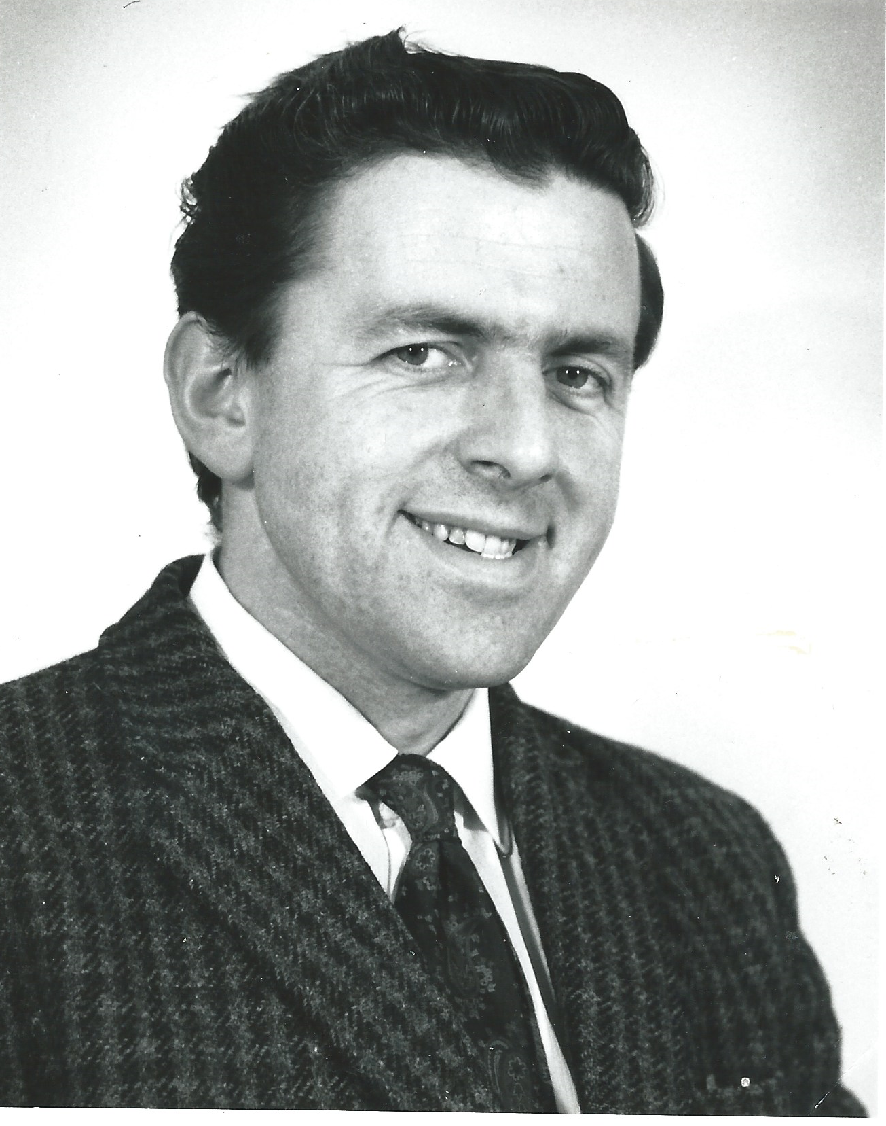
Figure 4. The official Institute of Geological Sciences photograph of Bernard taken soon after he joined the organisation in March 1965. Precise date and photographer unknown. Reproduced with permission.

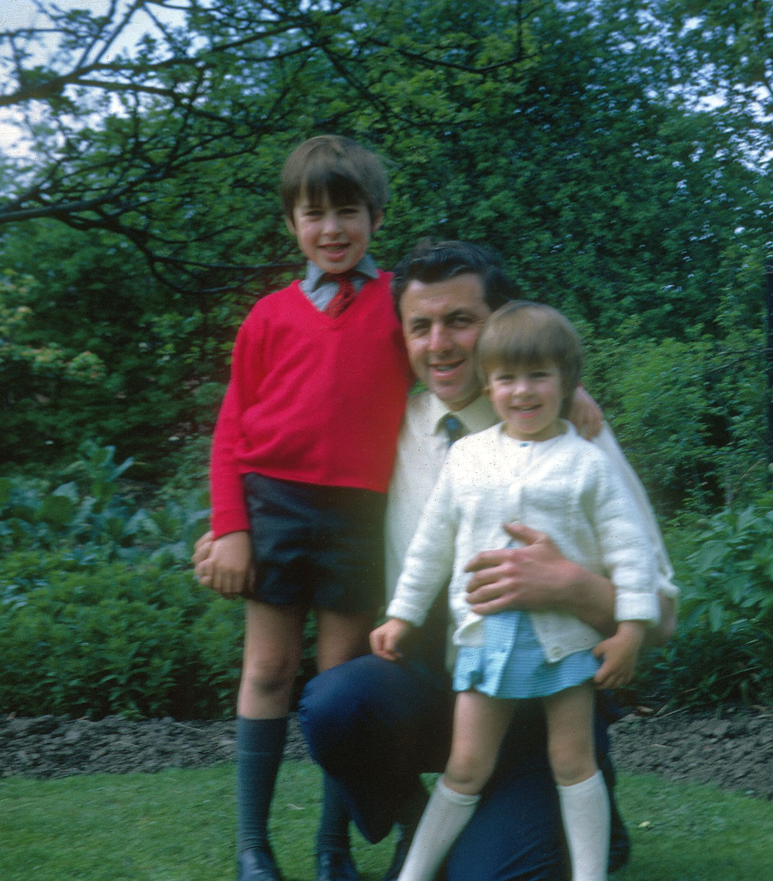
Figure 5. Bernard with both his children (Graham on the left and Kathryn on the right) in the garden of their home in Valley Drive, Halton, east Leeds in 1971. Reproduced with the permission of the Owens family.

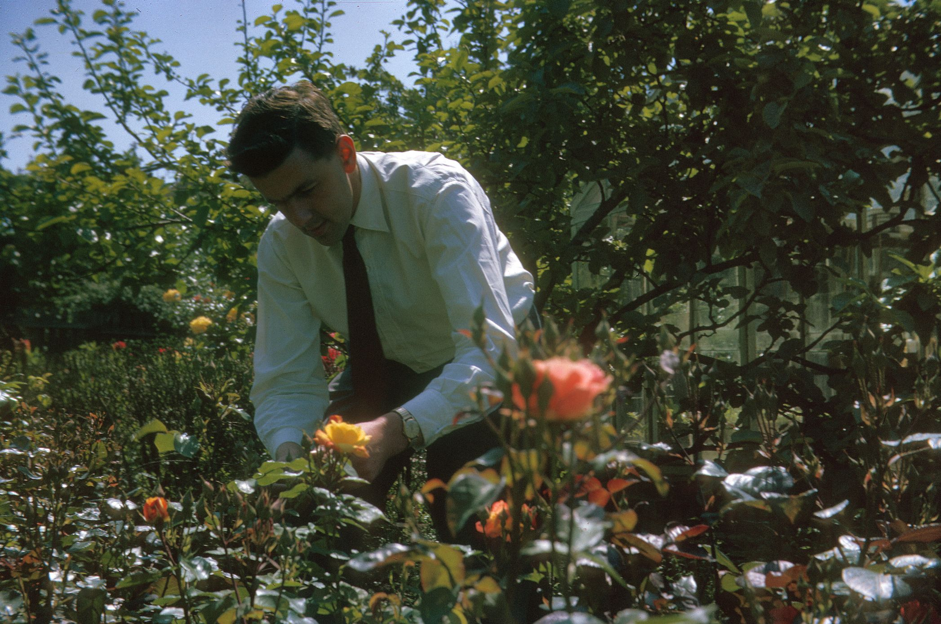
Figure 6. A very formally-dressed Bernard tending his rose garden at Valley Drive, Halton, east Leeds in 1971. Reproduced with the permission of the Owens family.

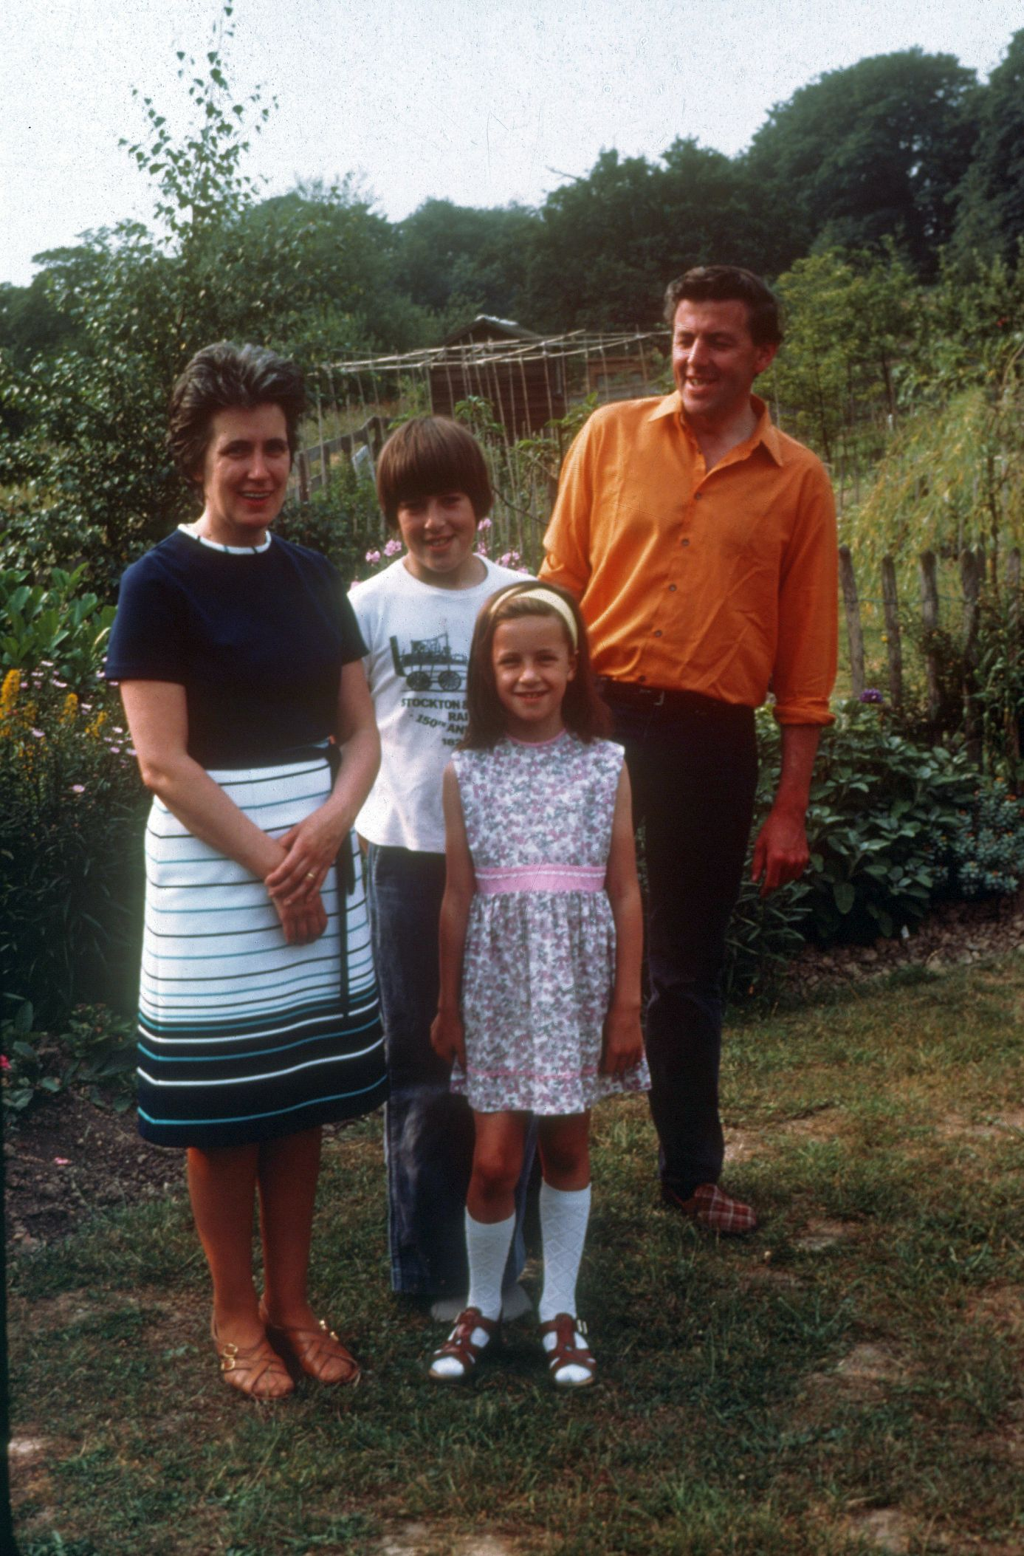
Figure 7. The Owens family pictured in the garden at Elmete Drive, near Roundhay Park in northeast Leeds in 1975. From left to right: Pat, Graham, Kathryn and Bernard. Precise date and photographer unknown. Reproduced with the permission of the Owens family.

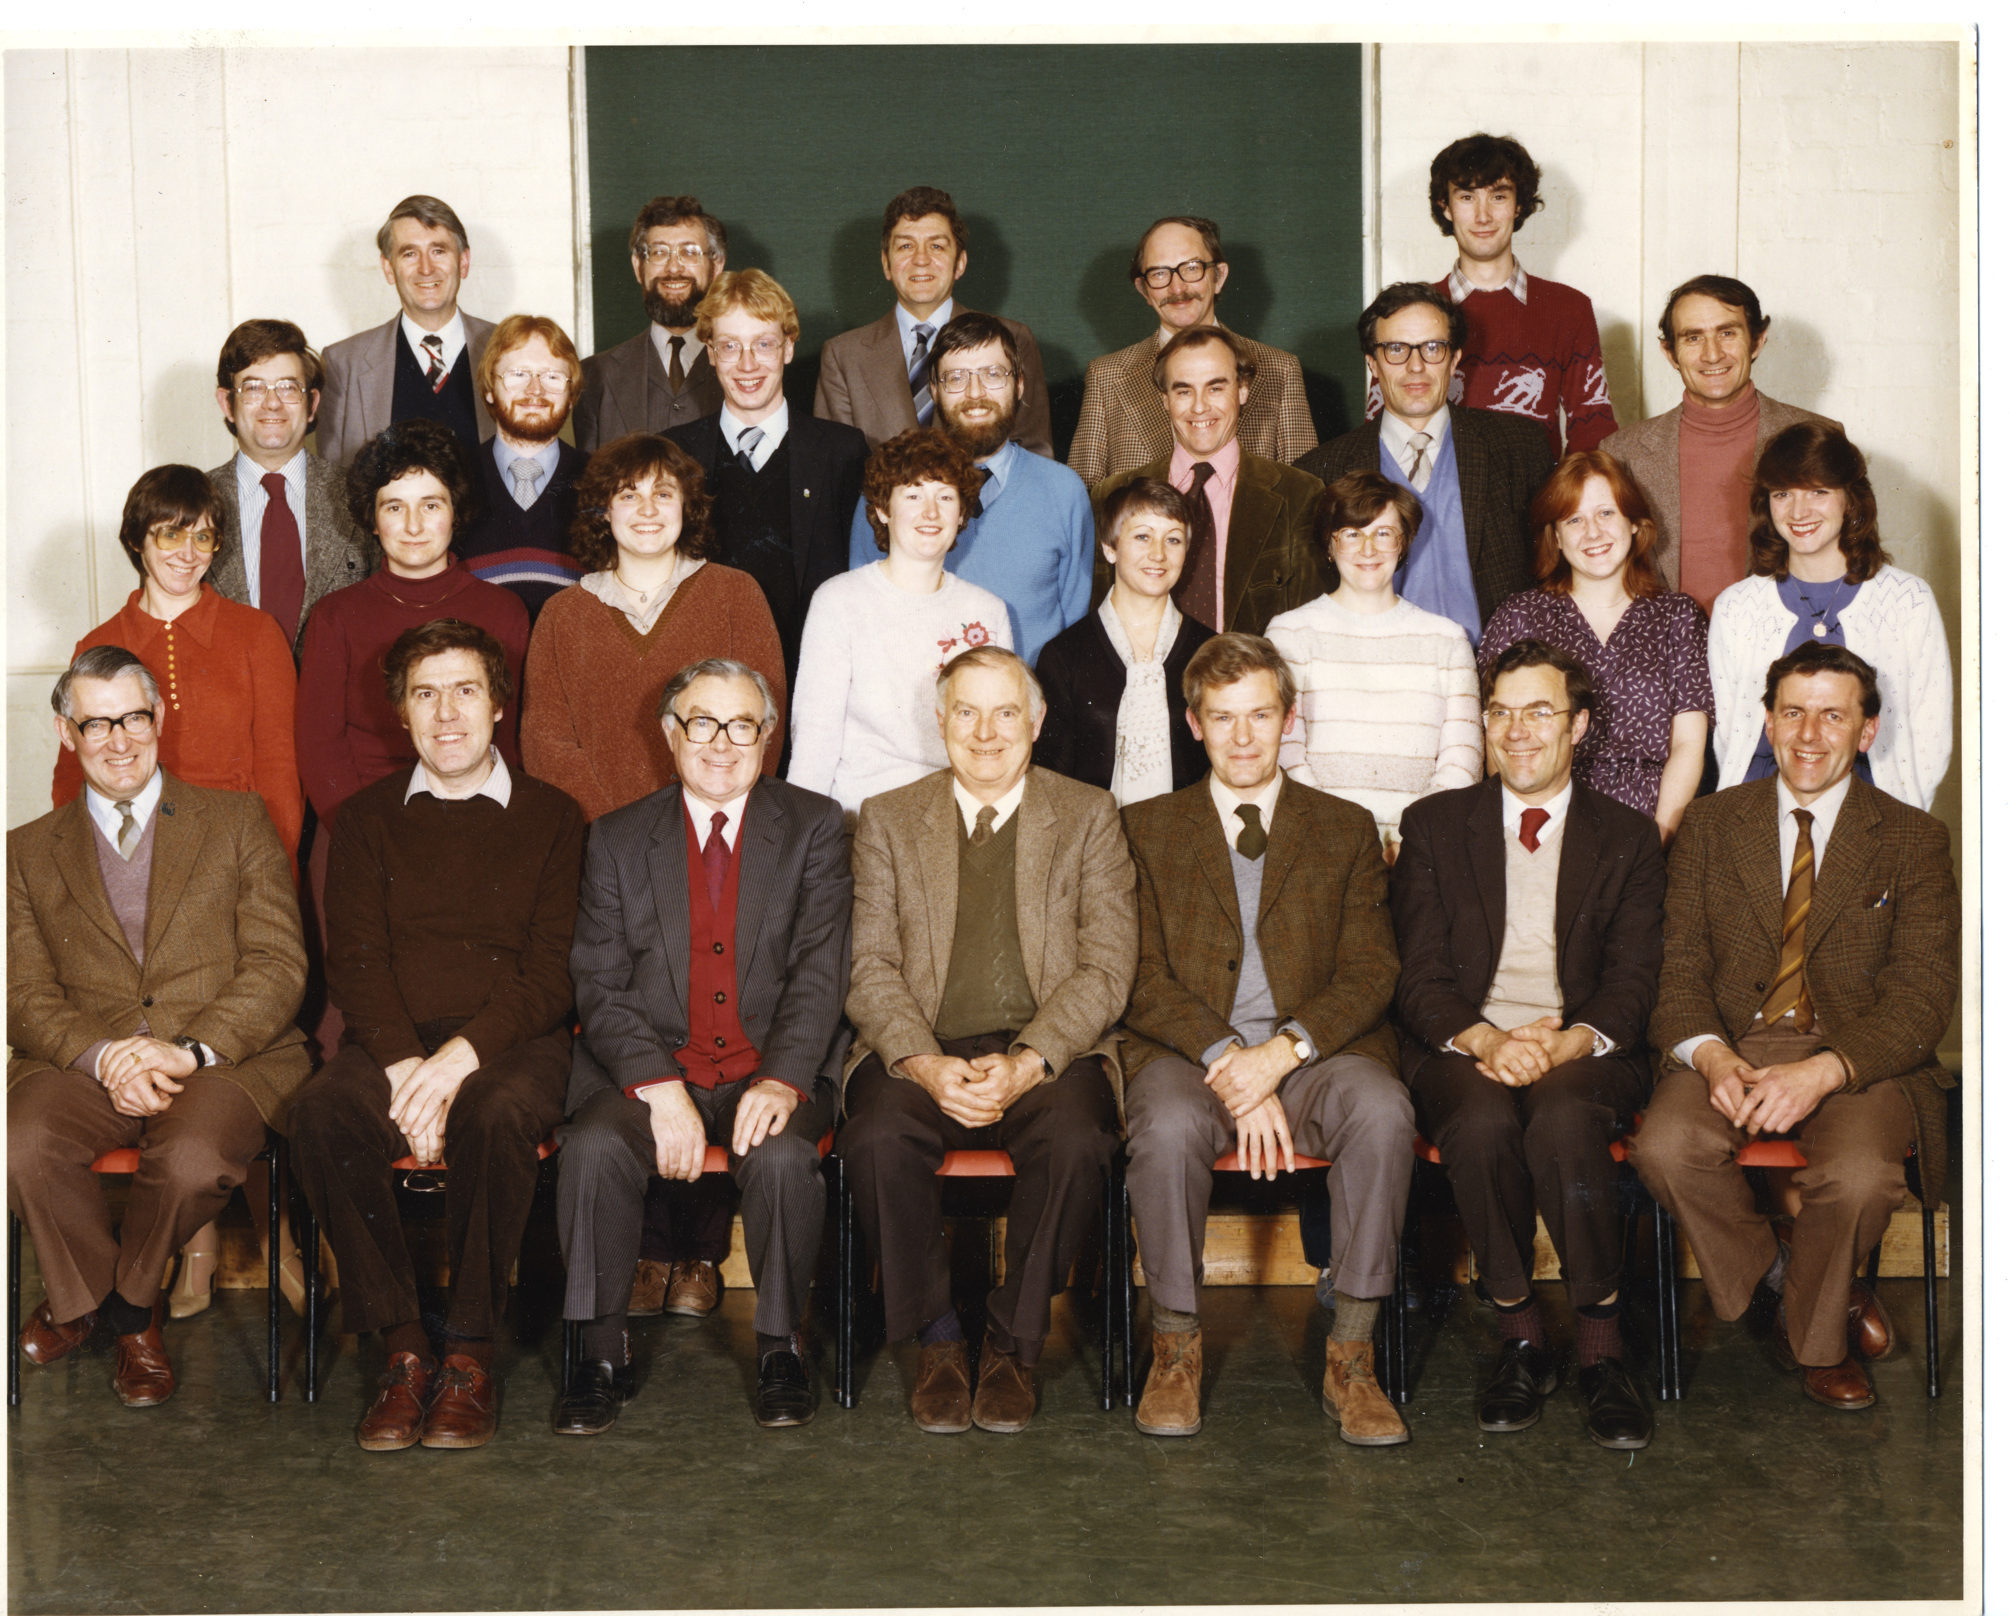
Figure 8. The Palaeontology Department of the Institute of Geological Sciences in 1981. Bernard is on the extreme right hand side of the bottom row. The photograph was taken by Keith Thornton in the IGS Leeds Office, and is reproduced with permission. Back row, from left to right: Jeremy Smith; Chris Wood; Dennis White; Murray Hughes; and Nick Riley. Third row, from left to right: Geoff Warrington; Ron Woollam; Jim Riding; Ian Wilkinson; Rex Harland; Jack Pattison; and Mike Reynolds. Second row, from left to right: Diane Gregory; Beris Cox; Lucinda Cleasby; Jane Sharp; Pauline Ryan; Linda Orange; Susan Barber; and Angela Strank. Front row, from left to right: Peter Brand; Alan Medd; Mike Calver; Bill Ramsbottom (Chief Palaeontologist); Murray Mitchell; Hugh Ivimey-Cook; and Bernard Owens.

Figure 9. Bernard’s official graduation photograph when he received his DSc from the University of Sheffield in 1998. Precise date and photographer unknown. Reproduced with the permission of the Owens family.

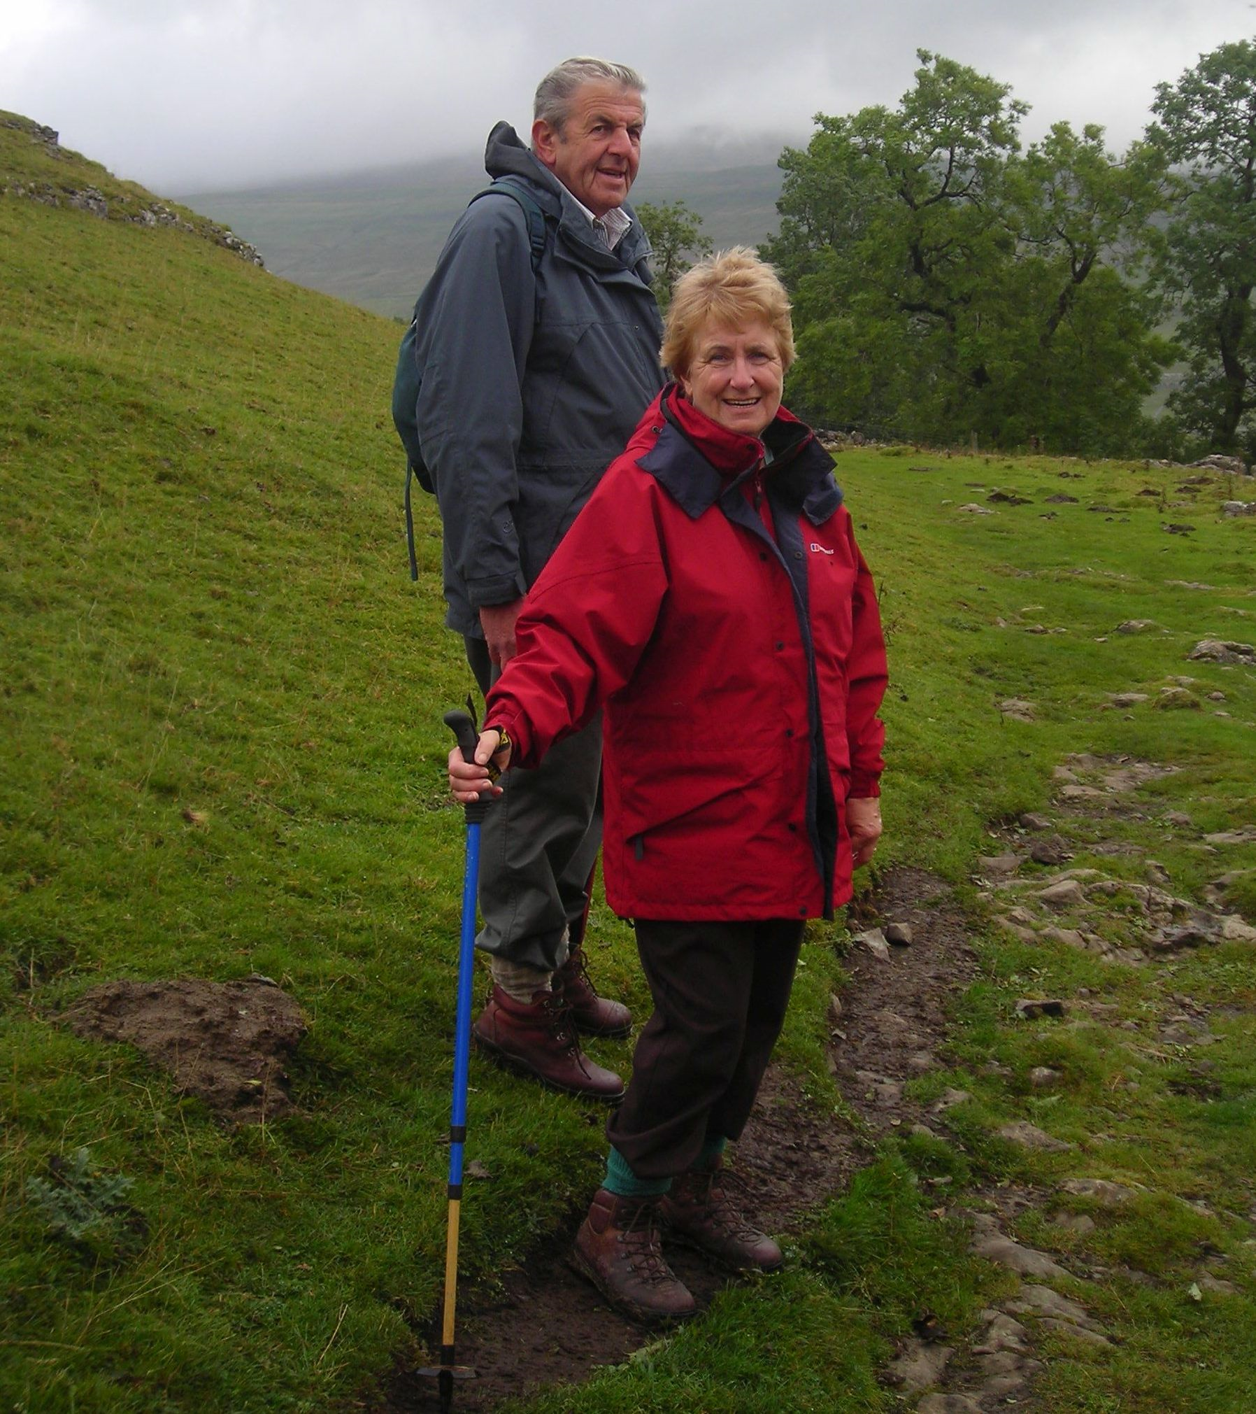
Figure 10. Bernard and Pat on a recreational walk above Hubberholme on a footpath from Yockenthwaite and Cray at the head of Wharfedale, North Yorkshire in 2005. Precise date and photographer unknown. Reproduced with the permission of the Owens family.

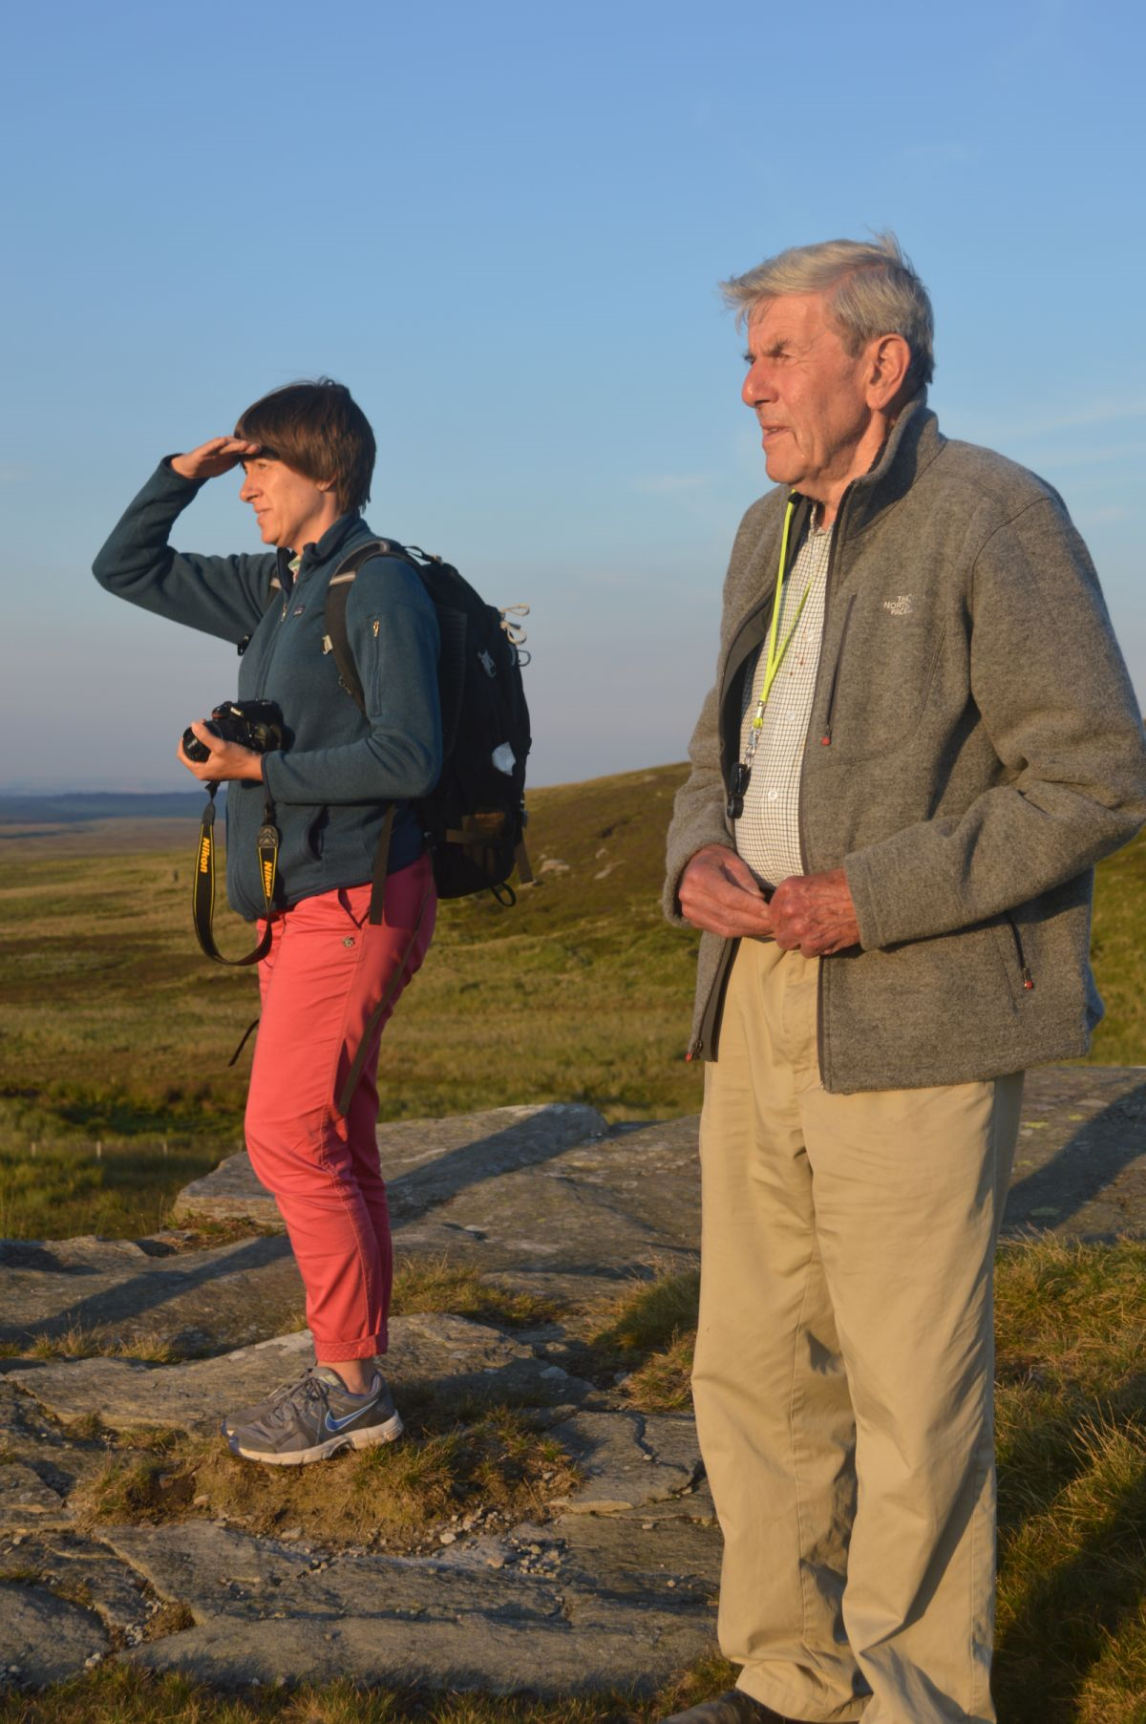
Figure 11. Bernard with his daughter Kathryn looking towards the setting sun at Tan Hill, near Keld and Kirkby Stephen, North Yorkshire in 2015. This famous and isolated beauty spot is a high point on the famous Pennine Way long distance footpath, close to the northern boundary of the Yorkshire Dales National Park, at the confluence of Arkengarthdale, Bowes Moor and Swaledale. Tan Hill is largely formed of the Warley Wise Grit (Pendleton Formation). This coarse-grained sandstone, formerly known as the Upper Howgate Edge Grit, is of late Mississippian (Serpukhovian/Pendelian) age and is overlain by shale and the Tan Hill coal seam which was worked here until the early 1930s. No doubt because of the coal mining heritage in this area and his love of the geology of the Yorkshire Dales, Bernard is sporting a hand-lens around his neck. Close by is the famous Tan Hill Inn, the topographically highest public house in the UK. Precise date and photographer unknown. Reproduced with the permission of the Owens family.

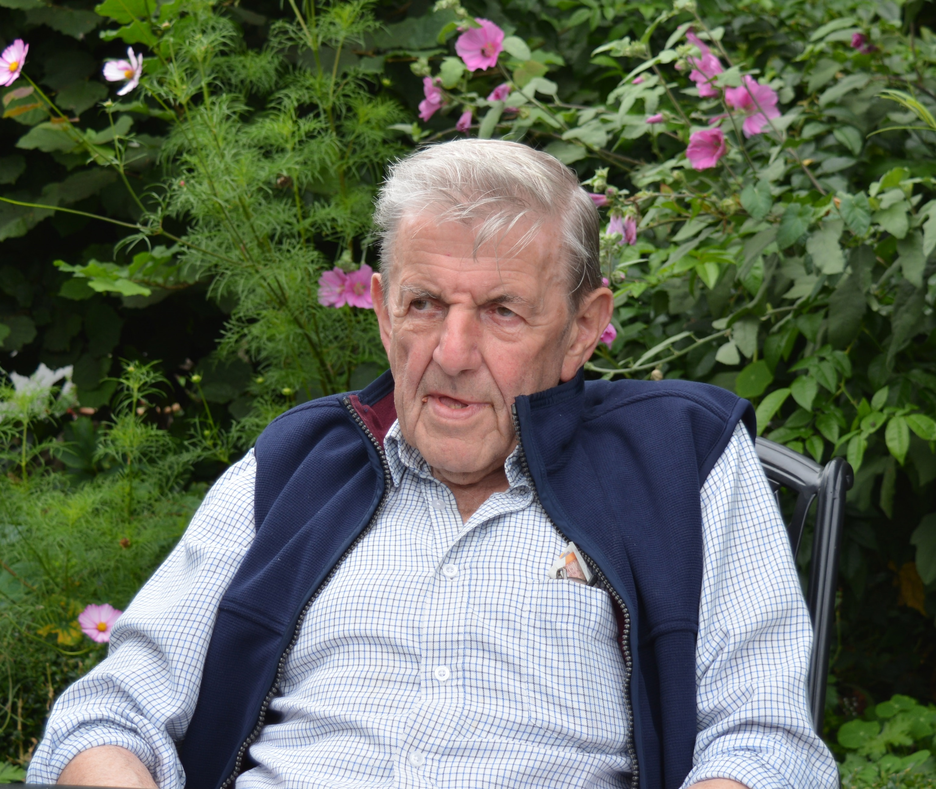
Figure 12. Bernard relaxing in a local public house garden after lunch in the summer of 2018. Precise date and photographer unknown. Reproduced with the permission of the Owens family.

APPENDIX 2: LIST OF PUBLICATIONS BY BERNARD OWENS (1959–2019)

This Appendix is a chronologically-arranged list of the 103 substantive scientific publications either authored or co-authored by Bernard Owens between 1959 and 2019. These represent a research career of 60 years. This listing does not include ‘grey literature’ such as abstracts, newsletter articles and Bernard’s numerous unpublished British Geological Survey Technical Reports. Obviously the vast majority of these items were written during Bernard’s 33-year career with the Institute of Geological Sciences/British Geological Survey. However numbers one to three and the 27 items from 2000 onwards were produced during his two spells at the University of Sheffield which bookended his career.

- Owens, B. 1959. The Yoredale Series and chert deposits of Swaledale. Journal of the University of Sheffield Geological Society, 3: 106–111.

- Owens, B. and Varker, W.J. 1961. The geology of the Stainmore district of Westmoreland. Journal of the University of Sheffield Geological Society, 4: 20–30.

- Owens, B. and Burgess, I.C. 1965. III. The stratigraphy and palynology of the Upper Carboniferous outlier of Stainmore, Westmorland. Bulletin of the Geological Survey of Great Britain, No. 23: 17–44.

- McGregor, D.C. and Owens, B. 1966. Illustrations of Canadian fossils. Devonian spores of Eastern and Northern Canada. Geological Survey of Canada Paper, No. 66-30, 66 p.

- Neves, R. and Owens, B. 1966. Some Namurian camerate miospores from the English Pennines. Pollen et Spores, 8: 337–360.

- Owens, B. and Streel, M. 1967. Hymenozonotriletes lepidophytus Kedo, its distribution and significance in relation to the Devonian–Carboniferous boundary. Review of Palaeobotany and Palynology, 1: 141–150.

- Wadge, A.J., Owens, B. and Downie, C. 1967. Microfossils from the Skiddaw Group. Geological Magazine, 104: 506–507.

- Owens, B. 1968. Contribution on palaeontology. In: Evans, W.B., Wilson, A.A., Taylor, B.J. and Price, D. Geology of the Country around Macclesfield, Congleton, Crewe and Middlewich. Second Edition. Memoirs of the Geological Survey of Great Britain. Her Majesty’s Stationery Office, London, 328 p.

- Owens, B. 1968. Contribution on palaeontology. In: Greig, D.C., Wright, J.E., Hains, B.A. and Mitchell, G.H. Geology of the country around Church Stretton, Craven Arms, Wenlock Edge and Brown Clee. Memoirs of the Geological Survey of Great Britain. Her Majesty’s Stationery Office, London, 379 p.

- McQuillin, R., Wright, J.E., Owens, B. and Lister, T.R. 1969. Recent geological investigations in the Irish Sea. Nature, 222: 365–366.

- Owens, B. 1970. A review of the palynological methods employed in the correlation of Palaeozoic sediments. (Contributions to the Third C.I.M.P. Meeting on Palaeozoic Stratigraphy). Les Congres et Colloques de l’Université de Liège, 55: 99–112.

- Owens, B. 1970. Recognition of the Devonian–Carboniferous boundary by palynological methods. Les Congres et Colloques de l’Université de Liège, 55: 349–364.

- Owens, B. and Streel, M. 1970. Palynology of the Devonian–Carboniferous boundary. (Report on Project B of the Third C.I.M.P. Meeting on Palaeozoic Stratigraphy). Les Congres et Colloques de l’Université de Liège, 55: 113–120.

- Owens, B. 1971. Miospores from the Middle and Early Upper Devonian rocks of the Western Queen Elizabeth Islands, Arctic Archipelago. Geological Survey of Canada Paper, No. 70-38, 157 p.

- Owens, B. 1972. A derived Lower Tournasian miospore assemblage from the Permo-Triassic deposits of South Devon, England. Compte Rendu, Septième Congrès Internationale de Stratigraphie et de Géologie du Carbonifère, Krefeld, Germany, 23rd to 28th August 1971, 1: 359–365.

- Owens, B. and Richardson, J.B. 1972. Some recent advances in Devonian palynology – a review, Report of C.I.M.P. Working Group No. 13B. Compte Rendu, Septième Congrès Internationale de Stratigraphie et de Géologie du Carbonifère, Krefeld, Germany, 23rd to 28th August 1971, 1: 325–343.

- Owens, B. 1973. Contribution on palaeontology. In: Smith, E.G., Rhys, G.H. and Goossens, R.F. Geology of the country around East Retford, Worksop and Gainsborough. Memoirs of the Geological Survey of Great Britain (England and Wales). Her Majesty’s Stationery Office, London, 348 p.

- Owens, B. 1974. Contribution. In: Williams, B.J. and Whittaker, A. Geology of the country around Stratford-upon-Avon and Evesham. Memoirs of the Geological Survey of Great Britain (England and Wales). Her Majesty’s Stationery Office, London, 127 p.

- Owens, B. 1974. The Permian and Triassic symposium – An appraisal. Review of Palaeobotany and Palynology, 17: 3–4.

- Owens, B., Mishell, D.R.F. and Marshall, J. 1976. Kraeuselisporites from the Namurian of northern England. Pollen et Spores, 18: 145–156.

- Calver, M.A. and Owens, B. 1977. Progress report of working group on proposed boundary-stratotypes for the Westphalian A, B and C. In: Holub, V.M. and Wagner, R.H. (editors). Symposium on Carboniferous Stratigraphy. The Geological Survey, Prague, Czechoslovakia, 65–68.

- Clayton, G., Coquel, R., Doubinger, J., Gueinn, K.J., Loboziak, S., Owens, B. and Streel, M. 1977. Carboniferous miospores of western Europe: illustration and zonation. Mededelingen Rijks Geologische Dienst, 29, 71 p.

- Owens, B., Downie, C. and Reynolds, M.J. 1977. Appendix 2. Micropalaeontology of the Devonian sediments. In: Poole, E.G. Stratigraphy of the Steeple Aston Borehole, Oxfordshire. Bulletin of the Geological Survey of Great Britain, No. 57: 28–40.

- Owens, B., Gueinn, K.J. and Cameron, I.B. 1977. A Tournaisian miospore assemblage from the Altagoan Formation (Upper Calciferous Sandstone), Draperstown, Northern Ireland. Pollen et Spores, 19: 313–324.

- Owens, B., Neves, R., Gueinn, K.J., Mishell, D.R.F., Sabry, H.S.M.Z. and Williams, J.E. 1977. Palynological division of the Namurian of northern England and Scotland. Proceedings of the Yorkshire Geological Society, 41: 381–398.

- Warrington, G. and Owens, B. (compilers). 1977. Micropalaeontological biostratigraphy of offshore samples from south-west Britain. Report of the Institute of Geological Sciences, No. 77/7, 49 p.

- Owens, B., Loboziak, S. and Teteriuk, V.K. 1978. Palynological subdivision of the Dinantian to Westphalian deposits of northwest Europe and the Donetz basin of the U.S.S.R. Palynology, 2: 69–91.

- Owens, B. and Marshall, J. (compilers). 1978. Micropalaeontological biostratigraphy of samples from around the coasts of Scotland. Report of the Institute of Geological Sciences, No. 78/20, 35 p.

- Byvsheva, T.V., Owens, B. and Teteriuk, V.K. 1979. Stratigraphical palynology of the Tournaisian to Stephanian deposits of the USSR and western Europe. Compte Rendu Huitième Congrès Internationale de Stratigraphie et de Géologie du Carbonifère, Moscow, 1975, 3: 209–215.

- Holliday, D.W., Neves, R. and Owens, B. 1979. Stratigraphy and palynology of Early Dinantian (Carboniferous) strata in shallow boreholes near Ravenstonedale, Cumbria. Proceedings of the Yorkshire Geological Society, 42: 343–356.

- Ramsbottom, W.H.C., Higgins, A.C. and Owens, B. 1979. Palaeontological characterisation of the Namurian of the stratotype area (A report of the Namurian Working Group). Compte Rendu Huitième Congrès Internationale de Stratigraphie et de Géologie du Carbonifère, Moscow, 1975, 3: 85–99.

- Teteriuk, V.K., Coquel, R., Loboziak, S., Neves, R., Owens, B. and Jachowicz, A. 1979. Interregional correlation by miospores of the Namurian–Westphalian boundary deposits of the Carboniferous period of Europe. Doklady Akademii Nauk SSSR, 5: 58–60 (in Russian).

- Turner, R.E., Taylor, R.T., Goode, A.J.J. and Owens, B. 1979. Palynological evidence for the age of the Mylor Slates, Mount Wellington, Cornwall. Proceedings of the Ussher Society, 4: 274–283.

- Owens, B. 1980. Micropalaeontology - The IGS approach. The British Geologist, 6: 111–113.

- Owens, B. 1981. Chapter 13. Palynology, its biostratigraphic and environmental potential. In: Illing, L.V. and Hobson, G.D. (editors). Petroleum Geology of the Continental Shelf of North-West Europe. Heyden and Son Limited on behalf of the Institute of Petroleum, London, 162–168.

- Owens, B. and Visscher, H. (editors). 1981. Late Palaeozoic and Early Mesozoic stratigraphic palynology. Review of Palaeobotany and Palynology, 34(1), 135 p.

- Mitchell, M., Reynolds, M.J., Laloux, M. and Owens, B. 1982. Biostratigraphy of the Knap Farm Borehole at Cannington Park, Somerset. Report of the Institute of Geological Sciences, No. 82/5: 8–17.

- Owens, B. 1982. Palynological zonation of mid-Namurian strata in northern England. In: Rambsottom, W.H.C., Saunders, W.B. and Owens, B. (editors). Biostratigraphic data for a Mid-Carboniferous boundary. IUGS Subcommission on Carboniferous Stratigraphy, Biennial Meeting, Leeds, UK (1981), 22–26.

- Rambsottom, W.H.C., Saunders, W.B. and Owens, B. (editors). 1982. Biostratigraphic data for a Mid-Carboniferous boundary. IUGS Subcommission on Carboniferous Stratigraphy, Biennial Meeting, Leeds, UK (1981), 156 p.

- Mykura, W. and Owens, B. 1983. The Old Red Sandstone of the Mealfuarvonie Outlier, west of Loch Ness, Inverness-shire. Report of the Institute of Geological Sciences, No. 83/7, 17 p.

- Owens, B. 1983. Bascaudaspora gen. nov., a new reticulate miospore genus from the Namurian of northern England. Report of the Institute of Geological Sciences, No. 83/10: 45–49.

- Smith, A.H.V. and Owens, B. 1983. The Caergwrle Bowl: its composition, geological source and archaeological significance - an addendum. Report of the Institute of Geological Sciences, No. 83/1: 24–27.

- Welsh, A. and Owens, B. 1983. Early Dinantian miospore assemblages from the Caldon Low Borehole, Staffordshire, England. Pollen et Spores, 25: 253–264.

- Coquel, R., Loboziak, S., Owens, B. and Teteriuk, V.K. 1984. Comparison entre la distribution des principales microspores-guides du Namurien et du Westphalien en Europe occidentale et dans le bassin du Donetz (URSS). Compte Rendu Neuvième Congrès Internationale de Stratigraphie et de Géologie du Carbonifère, Washington and Champaign-Urbana, May 17th–26th 1979, 2: 443–446.

- Loboziak, S., Coquel, R. and Owens, B. 1984. Les microspores des Formations Hale et Bloyd du nord de l’Arkansas. Compte Rendu Neuvième Congrès Internationale de Stratigraphie et de Géologie du Carbonifère, Washington and Champaign-Urbana, May 17th–26th 1979, 2: 385–390.

- Molyneux, S.G., Manger, W.L. and Owens, B. 1984. Preliminary account of Late Devonian palynomorph assemblages from the Bedford Shale and Berea Sandstone Formations of central Ohio, U.S.A. Journal of Micropalaeontology, 3: 41–51.

- Owens, B. 1984. Miospore zonation of the Carboniferous. Compte Rendu Neuvième Congrès Internationale de Stratigraphie et de Géologie du Carbonifère, Washington and Champaign-Urbana, May 17th–26th 1979, 2: 90–102.

- Owens, B., Loboziak, S. and Coquel, R. 1984. Late Mississippian–Early Pennsylvanian miospore assemblages from northern Arkansas. Compte Rendu Neuvième Congrès Internationale de Stratigraphie et de Géologie du Carbonifère, Washington and Champaign-Urbana, May 17th–26th 1979, 2: 377–384.

- Lane, H.R., Bouckaert, J., Brenckle, P., Einor, O.L., Havlena, V., Higgins, A.C., Yang, J.-Z., Manger, W.L., Nassichuk, W., Nemirovskaya, T., Owens, B., Ramsbottom, W.H.C., Reitlinger, E.A. and Weyant, M. 1985. Proposal for an International Mid-Carboniferous Boundary. Compte Rendu, Dixième Congrès Internationale de Stratigraphie et de Géologie du Carbonifère, Madrid, Spain, 12th–17th September 1983, 4: 323–339.

- Owens, B., Riley, N.J. and Calver, M.A. 1985. Boundary stratotypes and new stage names for the Lower and Middle Westphalian sequences in Britain. Compte Rendu, Dixième Congrès Internationale de Stratigraphie et de Géologie du Carbonifère, Madrid, Spain, 12th–17th September 1983, 4: 461–472.

- Riley, N.J., Razzo, M.J. and Owens, B. 1985. A new boundary stratotype section for the Bolsovian (Westphalian C) in northern England. Compte Rendu, Dixième Congrès Internationale de Stratigraphie et de Géologie du Carbonifère, Madrid, Spain, 12th–17th September 1983, 1: 35–44.

- Thusu, B. and Owens, B. (editors). 1985. Palynostratigraphy of north-east Libya. Journal of Micropalaeontology, 4(1), 182 p.

- Loboziak, S., Clayton, G. and Owens, B. 1986. Aratrisporites saharaensis sp. nov.: a characteristic Lower Carboniferous miospore species of North Africa. Geobios, 19: 497–503.

- Riley, N.J., Varker, W.J., Owens, B., Higgins, A.C. and Ramsbottom, W.H.C. 1987. Stonehead Beck, Cowling, North Yorkshire, England: a British proposal for the Mid-Carboniferous boundary stratotype. In: Brenckle, P.L., Lane, H.R. and Manger, W.L. (editors). Selected studies in Carboniferous paleontology and biostratigraphy. Courier Forschungsinstitut Senckenberg, 98: 159–177.

- El-Arnauti, A., Owens, B. and Thusu, B. (editors). 1988. Subsurface palynostratigraphy of northeast Libya. Garyounis University Publications, Benghazi, Libya, 275 p.

- Owens, B. 1988. Contribution. In: Arthurton, R.S., Johnson, E.W. and Mundy, D.J.C. Geology of the country around Settle. Memoir of the British Geological Survey, Sheet 60 (England and Wales). Her Majesty’s Stationery Office, London, 147 p.

- Foster, D., Holliday, D.W., Jones, C.M., Owens, B. and Welsh, A. 1989. The concealed Upper Palaeozoic rocks of Berkshire and South Oxfordshire. Proceedings of the Geologists’ Association, 100: 395–407.

- Owens, B., Clayton, G., Gao Lianda and Loboziak, S. 1989. Miospore correlation of the Carboniferous deposits of Europe and China. Compte Rendu Onzième Congrès Internationale de Stratigraphie et de Géologie du Carbonifère, Beijing, China, August 31st–September 4th 1987, 3: 189–210.

- Mitchell, W.I. and Owens, B. 1990. The geology of the western part of the Fintona Block, Northern Ireland: evolution of Carboniferous basins. Geological Magazine, 127: 407–426.

- Owens, B., Varker, W.J. and Hughes, R.A. 1990. Lateral biostratigraphical consistency across the Mid-Carboniferous boundary in northern England. In: Brenckle, P.L. and Manger, W.L. (editors). Intercontinental correlation and division of the Carboniferous System. Contributions from the Carboniferous Subcommission Meeting, Provo, Utah, September 1989. Courier Forschungsinstitut Senckenberg, 130: 237–244.

- Owens, B. and Visscher, H. (editors). 1990. Special Issue. Circum-Mediterranean Palynology. Review of Palaeobotany and Palynology, 66(3/4): i–iv, 167–377.

- Varker, W.J., Owens, B. and Riley, N.J. 1990. Integrated biostratigraphy for the proposed Mid-Carboniferous boundary, Stonehead Beck, Cowling, North Yorkshire, England. In: Brenckle, P.L. and Manger, W.L. (editors). Intercontinental correlation and division of the Carboniferous System. Contributions from the Carboniferous Subcommission Meeting, Provo, Utah, September 1989. Courier Forschungsinstitut Senckenberg, 130: 221–235.

- Owens, B. 1991. Contribution on palaeontology. In: Old, R.A., Hamblin, R.J.O., Ambrose, K. and Warrington, G. Geology of the country around Redditch. Memoir of the British Geological Survey, Sheet 183 (England and Wales). Her Majesty’s Stationery Office, London, 83 p.

- Owens, B. 1993. Contribution on biostratigraphy. In: Kellaway, G.A. and Welch, F.B.A. Geology of the Bristol district. Memoir of the British Geological Survey. Her Majesty’s Stationery Office, London, 199 p.

- Riley, N.J., Claoué-Long, J., Higgins, A.C., Owens, B., Spears, A., Taylor, L. and Varker, W.J. 1993. Geochronometry and geochemistry of the European mid-Carboniferous boundary global stratotype proposal, Stonehead Beck, North Yorkshire, UK. Annales de la Société géologique de Belgique, 116: 275–289.

- Turner, N. and Owens, B. 1993. Palynological evidence for an early Namurian age of the Cornbrook Sandstone Formation, Clee Hill, Shropshire. Proceedings of the Yorkshire Geological Society, 49: 189–196.

- Owens, B. 1994. Contribution on palaeontology. In: Gaunt, G.D. Geology of the country around Goole, Doncaster and the Isle of Axholme. Memoir of the British Geological Survey, sheets 79 and 88 (England and Wales). Her Majesty’s Stationery Office, London, 169 p.

- Turnau, E., Avchimovitch, V.I., Byvscheva, T.V., Clayton, G., Higgs, K.T. and Owens, B. 1994. Taxonomy and stratigraphical distribution of Verrucosisporites nitidus Playford, 1964 and related species. Review of Palaeobotany and Palynology, 81: 289–295.

- Owens, B. 1995. Contribution on palaeontology. In: Hamblin, R.J.O. and Coppack, B.C. Geology of Telford and the Coalbrookdale Coalfield. Memoir of the British Geological Survey, parts of sheets 152 and 153 (England and Wales). Her Majesty’s Stationery Office, London, 158 p.

- Owens, B., Al-Tayyar, H., Van der Eem, J.G.L.A. and Al-Hajri, S. (editors). 1995. Palaeozoic palynostratigraphy of the Kingdom of Saudi Arabia. Review of Palaeobotany and Palynology, 89(1/2), 150 p.

- Owens, B. and Turner, N. 1995. Late Westphalian palynomorphs from northern Saudi Arabia. In: Owens, B., Al-Tayyar, H., Van der Eem, J.G.L.A. and Al-Hajri, S. (editors). Palaeozoic palynostratigraphy of the Kingdom of Saudi Arabia. Review of Palaeobotany and Palynology, 89: 125–137.

- Owens, B. 1996. Chapter 18D. Upper Carboniferous spores and pollen. In: Jansonius, J. and McGregor, D.C. (editors). Palynology: Principles and Applications. American Association of Stratigraphic Palynologists Foundation, Dallas, 2: 597–606.

- Owens, B. 1996. The scientific work of Maurice Streel. Review of Palaeobotany and Palynology, 93: 3–8.

- Podgainaya, N.N., Loboziak, S. and Owens, B. 1996. Assemblages of Middle and Upper Carboniferous zonal miospores from the south-western Precaspian Depression, Russia. Bulletin des Centres de Recherches Exploration-Production Elf-Aquitaine, 20: 91–129.

- Riley, N.J., Owens, B. and Winlow, A. 1996. The Mansfield Marine Band: A case study in scientific conservation and industrial co-operation. In: Stow, D.A.V. and McCall, G.J.H. (editors). Geoscience Education and Training. In schools and universities, for industry and public awareness. Joint Special Publication of The Commission on Geoscience Education and Training of the International Union of Geological Sciences and The Association of Geoscientists for International Development, AGID Special Publication Series, No. 19: 707–714. A.A. Balkema, Rotterdam, The Netherlands and Brookfield, U.S.A.

- Clayton, G., Manger, W.L. and Owens, B. 1998. Mississippian (Lower Carboniferous) miospores from the Cuyahoga and Logan formations of northeastern Ohio, USA. Journal of Micropalaeontology, 17: 183–191.

- Owens, B. 1998. Contribution on palaeontology. In: Rees, J.G. and Wilson, A.A. Geology of the country around Stoke-on-Trent. Memoir of the British Geological Survey, Sheet 123 (England and Wales). Her Majesty’s Stationery Office, London, 152 p.

- Al-Hajri, S. and Owens, B. (editors). 2000. Stratigraphic palynology of the Palaeozoic of Saudi Arabia. Special GeoArabia Publication, No. 1, 231 p. Gulf PetroLink, Manama, Bahrain.

- Al-Hajri, S. and Owens, B. 2000. Sub-surface palynostratigraphy of the Palaeozoic of Saudi Arabia. In: Al-Hajri, S. and Owens, B. (editors). Stratigraphic palynology of the Palaeozoic of Saudi Arabia. Special GeoArabia Publication, No. 1: 10–17. Gulf PetroLink, Manama, Bahrain.

- Clayton, G., Owens, B., Al-Hajri, S. and Filatoff, J. 2000. Latest Devonian and Early Carboniferous miospore assemblages from Saudi Arabia. In: Al-Hajri, S. and Owens, B. (editors). Stratigraphic palynology of the Palaeozoic of Saudi Arabia. Special GeoArabia Publication, No. 1: 146–153. Gulf PetroLink, Manama, Bahrain.

- Owens, B., Filatoff, J., Clayton, G. and Al-Hajri, S. 2000. Evidence of Mid-Carboniferous miospore assemblages from central Saudi Arabia. In: Al-Hajri, S. and Owens, B. (editors). Stratigraphic palynology of the Palaeozoic of Saudi Arabia. Special GeoArabia Publication, No. 1: 154–167. Gulf PetroLink, Manama, Bahrain.

- Frederick, C.D., Buckland, P.C., Bateman, M.D. and Owens, B. 2001. South Ferriby Cliff (SE 998225) and Eastside Farm (SE 946208). In: Bateman, M.D., Buckland, P.C., Frederick, C.D. and Whitehouse, N.J. (editors). The Quaternary of East Yorkshire and North Lincolnshire. Field Guide. Quaternary Research Association, London, 103–112.

- Owens, B. and Osterloff, P. 2001. Palynology of the Misfar Formation Oman and its correlation with sequences in Saudi Arabia. GeoArabia, 6: 319.

- El-Nakhal, H.A., Stephenson, M.H. and Owens, B. 2002. New Late Carboniferous – Early Permian palynological data from glacial sediments in the Kooli Formation, Republic of Yemen. Micropaleontology, 48: 222–228.

- Owens, B., Huaicheng Zhu and Turner, N. 2002. Comparative palynostratigraphy of the early Arnsbergian (Namurian) sequences between Great Britain and northwest China. Review of Palaeobotany and Palynology, 118: 227–238.

- Austin, R.L., Owens, B. and Spinner, E.G. 2004. Obituary. Alan Charles Higgins (1936–2004). Journal of Micropalaeontology, 23: 191–192.

- McLean, D., Owens, B. and Bodman, D. 2004. Palynostratigraphy of the Upper Carboniferous Langsettian–Duckmantian Stage boundary in Britain. In: Beaudoin, A.B. and Head, M.J. (editors). The Palynology and Micropalaeontology of Boundaries. Geological Society, London, Special Publications, No. 230: 123–135.

- Owens, B., McLean, D. and Bodman, D. 2004. A revised palynozonation of British Namurian deposits and comparisons with eastern Europe. Micropaleontology, 50: 89–103.

- Spinner, E.G., Lunn, P. and Owens, B. 2004. Leslie Rowsell Moore. Proceedings of the Yorkshire Geological Society, 55: 159–160.

- Spinner, E., Owens, B. and Lunn, P. 2004. Obituary. Professor Leslie Rowsell Moore 1912–2003. Journal of Micropalaeontology, 23: 1–2.

- McLean, D., Owens, B. and Neves, R. 2005. Carboniferous miospore biostratigraphy of the North Sea. In: Collinson, J.D., Evans, D.J., Holliday, D.W. and Jones, N.S. (editors). Carboniferous Hydrocarbon Geology. The southern North Sea and surrounding onshore areas. Occasional Publications of the Yorkshire Geological Society, No. 7: 13–24.

- Owens, B., McLean, D., Simpson, K.R.M., Shell, P.M.J. and Robinson, R. 2005. Reappraisal of the Mississippian palynostratigraphy of the East Fife coast, Scotland, United Kingdom. Palynology, 29: 23–47.

- McLean, D., Owens, B., Bek, J. and Oliwkiewicz‐Miklasińska, M. 2006. A structural reinterpretation of the enigmatic Carboniferous miospore Pteroretis Felix & Burbridge 1961 emend. nov. Palynology, 30: 17–32.

- Stephenson, M.H. and Owens, B. 2006. Taxonomy Online 2: The ‘Bernard Owens Collection’ of single grain mount palynological slides: Carboniferous spores part I. British Geological Survey Research Report, No. RR/06/05, 80 p.

- Ghavidel-syooki, M. and Owens, B. 2007. Palynostratigraphy and palaeogeography of the Padeha, Khoshyeilagh, and Mobarak formations in the eastern Alborz Range (Kopet-Dagh region), northeastern Iran. Revue de Micropaléontologie, 50: 129–144.

- Paris, F., Owens, B. and Miller, M.A. (editors). 2007. Palaeozoic Palynology of the Arabian Plate and Adjacent Areas. Revue de Micropaléontologie, 50(1), 144 p.

- Riding, J.B., Kyffin-Hughes, J.E. and Owens, B. 2007. An effective palynological preparation procedure using hydrogen peroxide. Palynology, 31: 19–36.

- Bek, J., Libertín, M., Owens, B., McLean, D. and Oliwkiewicz-Miklasińska, M. 2009. The first compression Pteroretis-producing sphenophyllalean cones, Pennsylvanian of the Czech Republic. Review of Palaeobotany and Palynology, 155: 159–174.

- McLean, D., Owens, B., Pendleton, J.L. and Bodman, D. 2013. Pennsylvanian (Namurian and Westphalian) miospore assemblages from the west coast of Scotland. Review of Palaeobotany and Palynology, 190: 1–14.

- Burgess, I.C., Haslam, R.B., Holliday, D.W., Kearsey, T., Millward, D., Owens, B., Pattison, J., Soper, N.J., Turner, B., Turner, D. and Waters, C.N. 2014. Discussion on ‘A Lower Palaeozoic inlier in Wharfedale, North Yorkshire, UK’. Proceedings, Vol. 59, 2013, pp. 173–176. Proceedings of the Yorkshire Geological Society, 60: 141.

- Wellman, C.H., Breuer, P., Miller, M.A., Owens, B. and Al-Hajri, S. (editors). 2015. Palaeozoic palynostratigraphy of the Arabian plate [a joint project between Saudi Aramco and the Commission Internationale de Microflore du Paléozoïque (CIMP)]. Review of Palaeobotany and Palynology, 212, 226 p.

- McLean, D., Owens, B., Bodman, D.J. and McLean, F.D. 2018. Miospores from the Brigantian stratotype section at Janny Wood, Cumbria. Proceedings of the Yorkshire Geological Society, 62: 89–100.

- Owens, B., Romano, M., Wellman, C.H. and Riding, J.B. 2019. Obituary. Edwin George (‘Ted’) Spinner (1938–2018). Palynology, 43: 184–187.

