Supplementary Information for:
A new rhynchocephalian from the Late Triassic of southern Brazil enhances eusphenodontian diversity
Paulo R. Romo de Vivar, Agustín G. Martinelli, Annie Schmaltz Hsiou and Marina Bento Soares
We include here additional cladograms discussed in the main text (1), final character list used for the phylogenetic analyses (2), and the modified data matrix (3).
1. Additional cladograms
Figure S1. Strict Consensus Tree of 136 most parsimonious trees (273 steps each) (CI = 0.385; RI = 0.695). Bremmer support and Standard Bootstrap are indicated above the nodes (Bremmer support / Standard Bootstrap).

Figure S2. Topology obtained by iterPCR protocol. Strict Consensus Tree of 34 most parsimonious trees (268 steps each) (CI = 0.396; RI = 0.708). Bremmer support and Standard Bootstrap are indicated above the nodes (Bremmer support / Standard Bootstrap). The two reduced cladograms in the down left part of the figure show the new nodes when the taxa with “??” were pruned.

2. Character list
Description of 73 characters used in the phylogenetic analyses, 72 of which are the same used by Herrera-Flores et al. (2018), Hsiou et al. (2015) and Apesteguía et al. (2014). Some modifications were made to the dataset of Herrera-Flores et al. (2018), as follows:

Character 39 (Coronoid process, height relative to that of the jaw at the level of the anterior end of the coronoid process). We used it as was proposed by Bever & Norell (2017). We scored Clevosaurus convalis, Cl. bairdi, Cl. petilus, Cl. sectumsemper, Cl. mcgilli and Cl. wangi based on bibliographic revision, and Cl. brasiliensis by direct observation (UFRGS-PV-606-T, UFRGS-PV-748-T, UFRGS-PV-754-T, UFRGS-PV-758-T).

Character 42 (Marginal dental implantation, type). We scored Planocephalosaurus with ‘1’ (degree of posterior acrodonty), following the score by Reynoso (1996). Also, we considered this genus as having the anterior dentition weakly pleurodont and the posterior one acrodont, following Jenkins et al. (2017) and Fraser & Shelton (1988).

Character 44 (Dentary regionalization with small juvenile teeth in the anterior region of maxilla and dentary). We simplified it as in Reynoso (1996), because the character states are redundant with those of Character 42.

Character 73 (Anterior caniniform teeth in maxillae and dentary). We added this character that was taken from Bever & Norell (2017; see character 80 of their list of characters, and 78 in the matrix).

Characters 62 and 63. These were removed, because in the original data set of Apesteguía et al. (2014), and subsequent works (Hsiou et al. 2015; Herrera-Flores et al. 2018), all taxa were coded as missing data (?). Consequently, our dataset has 73 characters and not 75 (which would be expected when adding one character to the data set of 74 original characters).

The modified characters are denoted with an asterisk. The original source of each character is indicated between brackets.

Abbreviations

A&14, Apesteguía et al. (2014);
AGR12, Apesteguía et al. (2012);
AN03, Apesteguía & Novas (2003);
B85, Benton (1985);
BN17, Bever & Norell (2017);
E88, Evans (1988);
FB89, Fraser & Benton (1989);
G88, Gauthier et al. (1988);
H&15, Hsiou et al. (2015)
HF18, Herrera-Flores et al. (2018);
R96, Reynoso (1996);
R97, Reynoso (1997);
RC98, Reynoso & Clark (1998);
S94, Sues et al. (1994);
W94, Wu (1994).

1. Antorbital region, length relative to skull length: one-third or more (0); between one-fourth and one-third (1); one fourth or less (2).
(HF18, H&15, A&14, AN03, R96, S94, W94)

2. Orbit, length relative to skull length: one third or greater (0); less than one third (1). (HF18, AH&15, A&14, AN03, RC98)

3. Supratemporal fenestra, length relative to orbit length: less than 75% (0); 75% or greater (1).
(HF18, AH&15, A&14, AN03, S94)

4. Supratemporal fenestra, length relative to skull length: one-fourth or less (0); more than one-fourth (1).
(HF18, AH&15, A&14, AN03, R96, W94)

5. Lower temporal fenestra, length relative to skull length: one-fourth or less (0); more than one-fourth (1).
(HF18, AH&15, A&14, AN03, R96, W94)

6. Maxilla, premaxillary process: elongate (0); reduced (1).
(HF18, AH&15, A&14, AN03, R96, S94, W94)

7. Maxilla, participation in margin of external naris: entering into margin (0); excluded from margin by posterodorsal process of premaxilla (1).
(HF18, AH&15, A&14, AN03, R9, S94)

8. Maxilla, shape of posterior end: tapering posteriorly or very narrow (0); dorsoventrally broad (1).
(HF18, AH&15, A&14, AN03, R96, W94)

9. Lacrimal: present (0); absent (1).
(HF18, AH&15, A&14, AN03, R96, S94, W94)

10. Jugal, shape of dorsal process: broad and short (0); narrow and elongate (1).
(HF18, AH&15, A&14, AN03, R96, W94)

11. Prefrontal and postfrontal, profuse sculpture on bone surface: absent (0); present (1).
(HF18, AH&15, A&14, AN03)

12. Prefrontal-jugal contact: absent (0); present (1).
(HF18, AH&15, A&14, AN03, R97, S94)

13. Postorbital, marked dorsal ridge and deep ventrolateral concavity: absent (0); present (1).
(HF18, AH&15, A&14, AN03)

14. Frontals, relation: separated (0); fused (1).
(HF18, AH&15, A&14, AN03, R96, S94, W94)

15. Parietals, relation: separated (0); fused (1).
(HF18, AH&15, A&14, AN03, R96, S94, W94)

16. Parietal, width between supratemporal passages relative to interorbital width: broader (0); narrower (1).
(HF18, AH&15, A&14, AN03, R96, S94, W94)

17. Parietal crest: absent (0); present (1).
(HF18, AH&15, A&14, AN03, R96, S94, W94)

18. Parietal, shape of posterior edge: greatly incurved inward (0); slightly incurved inward (1); convex (2).
(HF18, AH&15, A&14, AN03, R96, W94)

19. Parietal foramen, position relative to anterior border of supratemporal fenestra: posterior (0); at the same level or anterior (1).
(HF18, AH&15, A&14, AN03, R96, S94, W94)

20. Lower temporal bar, position: aligned with the maxillary tooth (0); bowed away beyond the limit of the abductor chamber (1).
(HF18, AH&15, A&14, AN03, R96, S94, W94)

21. Lower temporal bar, posteroventral process of jugal: absent (0); poorly- to moderately-developed, less than half the length of the lower temporal fenestra (1); well-developed, half the length of the lower temporal fenestra or more (2).
(HF18, AH&15, A&14, AN03, R96, S94, W94)

22. Palatine, shape of posterior end: tapers posteriorly (0); widens posteriorly (1).
(HF18, AH&15, A&14, AN03, R96, S94, W94)

23. Pterygoids, anterior contact between bones*: absent (0); small (1); broad (2)
(HF18, AH&15, A&14, AN03, R97)

24. Pterygoids, posterior opening of the interpterygoid vacuity between posteromedial processes: widely open (0); moderately open, as wide as the vacuity (1); almost closed by the posteromedial processes (2).
(HF18, AH&15, A&14, AN03, R97)

25. Pterygoid, central region between three rami: short (0); elongate (1).
(HF18, AH&15, A&14, AN03, R96, S94, W94)

26. Pterygoid, participation in margin of suborbital fenestra: form part of the margin (0); excluded from margin (1).
(HF18, AH&15, A&14, AN03, R96, S94, W94)

27. Quadrate-quadratojugal foramen, relative size: small (0); large (1).
(HF18, AH&15, A&14, AN03, RC98)

28. Quadrate-quadratojugal foramen, location: between the quadrate and the quadratojugal (0); entirely within the quadrate (1).
(HF18, AH&15, A&14, AN03, RC98)

29. Quadrate-quadratojugal emargination, shape: pronounced (0); reduced (1).
(HF18, AH&15, A&14, AN03, RC98, S94, W94, E88)

30. Supratemporal, as a discrete bone: present (0); absent (1).
(HF18, AH&15, A&14, AN03, R97, S94)

31. Inferred jaw motion: orthal (0); propalinal (1).
(HF18, AH&15, A&14, AN03, R96, S94, W94)

32. Degree of propaliny, measured either as palatal tooth row extension or length in which palatines keep parallel to the maxillae: small palatal row, parallel line restricted to the anterior region (0); enlarged, palatines accompanying maxilla half its own length (1); palatines accompanying maxilla by its complete length (eupropaliny?) (2).
(HF18, AH&15, A&14, AN03, R96, S94, W94)

33. Mandibular symphysis, mentonian process*: absent (0); reduced (1); well developed and pointed (2); well developed and rounded (3).
(HF18, AH&15, A&14, AN03)

34. Mandibular symphysis, shape: almost circular, high/length relation near one (0); oval, high/length clearly greater than one (1).
(HF18, AH&15, A&14, AN03, R96, B85)

35. Mandibular symphysis, angle between anterior margin and longitudinal axis of the mandible in lateral view: <120º, symphysis nearly vertical, typically devoid of ventral projections (0); ≥120º, symphysis anterodorsally projected (1).
(HF18, AH&15, A&14, AN03)

36. Mandibular symphysis, symphyseal spur: absent (0); well-developed, anterodorsally projected (1); moderately developed (2).
(HF18, AH&15, A&14, AN03)

37. Mandibular foramen, relative size: small (0); large (1).
(HF18, AH&15, A&14, AN03, R96, B85)

38. Glenoid cavity, shape: smooth surface, lacking an anteroposterior central ridge (0); elongate and asymmetrical surface, with a strong anteroposterior central ridge (1); symmetrical facet with a strong anteroposterior central ridge (2).
(HF18, AH&15, A&14, AN03)

39. Coronoid process, height relative to that of the jaw at the level of the anterior end of the coronoid process: (0) low, weak, less than 1/2 jaw; (1) moderately high, around 1/2 jaw height; (2) very high, nearly as high as jaw.
*This modified character takes of BN17. (BN17, A&14, AN03, R96, S94, W94)

40. Retroarticular process, shape: pronounced (0); reduced, caudally projected (1); reduced, dorsally curved (2).
(HF18, AH&15, A&14, AN03, R96, S94, W94)

41. Dentary, posterior process, relative length: short, not reaching glenoid level (0); elongate, reaching glenoid level (1); elongate, reaching the end of glenoid level (2).
(HF18, AH&15, A&14, AN03, R97, S94)

42. Marginal dental implantation, type: pleurodont (0); degree of posterior acrodonty (1); fully acrodont (2).
(HF18, AH&15, A&14, AN03, R96, S94, W94)

43. Tooth replacement, type: alternate (0); addition at back of jaw (1).
(HF18, AH&15, A&14, AN03, R96, B85)

44. Dentary regionalization with small juvenile teeth in the anterior region of maxilla and dentary: absent (0); present (1)
*This modified character takes of R96. (R96)

45. Dentary, posterior successionals, number in mature individuals: zero (0); one (1); two or more (2).
(HF18, AH&15, A&14, AN03, R96, G88)

46. Marginal teeth, lateral wear facets on dentary and/or medial wear facets on maxilla: absent or smooth (0); present, conspicuous (1).
(HF18, AH&15, A&14, AN03, R96, S94, W94)

47. Marginal teeth, shape of cross section of posterior teeth: nearly circular (0); squared (1); rectangular, wider than long (2).
(HF18, AH&15, A&14, AN03, R96, FB89)

48. Premaxillary teeth, number in mature individuals: more than seven (0); seven to four (1); three or less (2).
(HF18, AH&15, A&14, AN03, R96, S94, W94)

49. Premaxillary teeth, general organization in adults: present as discrete teeth (0); merged into a chisel-like structure (1).
(HF18, AH&15, A&14, AN03, R96, S94, W94)

50. Maxillary teeth, posteromedial flanges on posterior teeth: absent or inconspicuous (0); present as small flanges on at least one tooth (1); present as extensive flanges on most teeth (2).
(HF18, AH&15, A&14, AN03, R96, S94, W94)

51. Maxillary teeth, anterolateral flange on posterior teeth: absent (0); present (1).
(HF18, AH&15, A&14)

52. Palatine teeth, number of tooth rows: two or more (0); a single row plus one isolated tooth (1); a single lateral row (2).
(HF18, AH&15, A&14, AN03, R96, S94, W94)

53. Palatine teeth, flanges: completely absent (0); present at least on a few teeth (1).
(HF18, AH&15, A&14, AN03, R96, FB89)

54. Palatine teeth, hypertrophied tooth on anterior region of the palatine bone (stabbing palatine): absent (0); present (1).
(HF18, AH&15, A&14, AN03)

55. Pterygoid teeth, number of tooth rows: three or more (0); two (1); one or none (2); radial crests (3).
(HF18, AH&15, A&14, AN03, R96, S94, W94)

56. Mandibular teeth, anterolateral flanges: absent (0); present, at least in one tooth (1).
(HF18, AH&15, A&14, AN03, R96, S94, W94)

57. Mandibular teeth, anteromedial flanges: absent (0); present (1).
(HF18, AH&15, A&14, AN03)

58. Mandibular teeth, additionals, enamel ornamentation in adults: absent (0); present, with numerous fine striae (1); present, with a combination of a few striae and wide grooves (2).
(HF18, AH&15, A&14, AN03)

59. Second sacral vertebra, posterior process: absent (0); present, small (1); present, prominent (2).
(HF18, AH&15, A&14, AN03, R96, G88)

60. Ischium, process on posterior border: absent (0); present as small tubercle (1); present as prominent process (2).
(HF18, AH&15, A&014, AN03, R96, FB89, E88)

61. Humerus, length relative to length of presacral column: <0.12 (0); between 0.12 and 0.21 (1); > 0.21.
(HF18, AH&15, A&14, AN03, R96, FB89)

62. Dentary, proportions (pre-coronoid length/ maximum pre-coronoid height ratio, L/H): gracile, long and low, L/H < 0.18 (0); average, L/H between 0.18?0.28 (1),robust, short and high, L/H > 0.28 (2).
*Character 64 of A&14 (HF18, AH&15, A&14, AGR12)

63. Dentary, successional teeth, maximum concurrent number during ontogeny: six or more (0); three to five (1); two or less (2)
* Character 65 of A&14 (HF18, AH&15, A&14, AGR12)

64. Dentary, anterior successional teeth (not “caniniform”), number in the adult: two or more clearly discrete teeth (0); one or two poorly distinct (1); none or indistinct(2).
* Character 66 of A&14 (HF18, AH&15, A&14, AGR12)

65. Dentary, successional teeth, striation: present (0); absent (1).
* Character 67 of A&14 (HF18, AH&15, A&14, AGR12)

66. Dentary, posterior successional teeth, lingual groove: absent (0); present (1).
* Character of 68 A&14 (HF18, AH&15, A&14, AGR12)

67. Dentary, hatchling teeth, striation: absent (0); present (1)
*Old ch 69 A&14 (HF18, AH&15, A&14, AGR12)

68. Dentary, successional “caniniform” teeth, shape of basal cross section: nearly circular (0); clearly oval, labio-lingually compressed (1).
* Character of A&14 (HF18, AH&15, A&14, AGR12)

69. Mandibular teeth, additionals, grooves or fossae on labial or lingual sides: absent (0); present (1).
* Character 71 of A&14 (HF18, AH&15, A&14)

70. Mandibular teeth, additionals, posterior groove: absent (0); wide and poorly defined (1); relatively deep and well-defined (2).
* Character 72 of A&14 (HF18, AH&15, A&14)

71. Maxilla, facial process, shape of anterior margin relative to main axis of maxilla: low slope, straight or concave (0); high slope, in straight angle (1); high slope, continuous and concave (2); high slope, continuous and convex (3).
* Character 73 of A&14 (HF18, AH&15, A&14)

72. Maxilla, facial process, maximum high (FH) with respect to length of maxilla
* Character 74 of A&14 (HF18, AH&15, A&14)

73. Anterior caniniform teeth in maxillae and dentaries (Dupret 2004, 31): (0) absent; (1) present.
* (BN 2017, character 80 in the list of characters but in the matrix of BN it is character 78)

3. Modified data matrix
Youngina 00000000100000000000200000000?0000?0?00000002000000000000?10?00010??00000
Ankylosphenodon ???1?????1????????????????????1?111?1?211?1?01????0????0?0221121????0???0
Clevosaurus_brasiliensis 1011111[01]110100000111202101??000111001110121101121001000000???1?2??0?0?210
Eichstaettisaurus 10110000010?011000000??000???00?0???????????????????????????????????000?0
Sophineta 00010000?0??00000?0?0???00??????00?0?????00?????????????????????????00000
Brachyrhinodon 211111011100?000000120120?????0011101?10121101121101001?????11????????21?
Clevosaurus_hudsoni 2111111111010001000120210100000011101110121101121201001101211112??0?00210
Cynosphenodon ??????????????????????????????1?2112??1??2111112110????100???112100100111
Diphydontosaurus 100000001000010000012010000001010000100011112001000000000121?000001?00000
Eilenodon ??????????1???????????????????123111120222100122?21210?112???222????0122?
Gephyrosaurus 0000000000000110000120000000010100?0000010002000000000000?10200010??00010
Godavarisaurus_ ??????1????????????????????????0110[0 2]?????211200[1 2]01021??100???[0 1]10010100??1
Homoeosaurus_cf_maximiliani 11[01][01]????1?0??00?0?11?02??1?????[01]1???1?11121101[01]??20[12]??2?????21???????????
Homoeosaurus_maximiliani 1[01]0000011000?0000[12]11??2001???10111101?11121101[01]21202??21112221??????000?0
Kallimodon_cerinensis ????????1??????????1??2010?????[01]110?1?1?1211??[01]21202002000221122????00???
Kallimodon_pulchellus 01110?011?00?0011211112001???10[01]11021?10121101121202??2001221122????00??0
Kawasphenodon_expectatus ????????1?????????????????????1??????????211?10?????1??112???[12]??????02???
Kawasphenodon_peligrensis ????????1?????????????????????1??????????21??10????????112??????????02???
Oenosaurus 20???0?11?0?10111????02201????11[23]?12112112??0?[01]????2?02000???2?2????00?10
Opisthias_rarus ????????1???????????????????????3111??0??211010??20????112???122????10??0
Palaeopleurosaurus 01110000100010111200202110110100111?1?1[01]121101121102002101210022????00010
Pamizinsaurus ??????1?1?0????????????211??0?0?[12]11?1?11?2110?[01]2?102???101???12???1?????0
Planocephalosaurus 00000000100001100101202000010101110000101111?0[01]201000011012111[12]00?1?00100
Pleurosaurus_ginsburgi 0110?0001?00?001????0?????????0?0110??1??21?0012000??0?110120022????00000
Pleurosaurus_goldfussi 0110?0001100?0011210002[12]101001020110??10121?00120002102110?20022????00000
Priosphenodon_avelasi 01100111111110011111012201000112311112022210012212121031122?2222????00320
Pristidactylus 1111100011100110001?0001000?000?00?0000000002000000???200?11100010??00010
Rebbanasaurus ???????01??0??????????????????0?3102?????211200201001??101???[01]11000100??1
Sapheosaurus_thiollerei 111100?110???0011211211001????0[01]11021?10[01]???01?21?0???2???221122?????????
Sphenocondor ????????1???????????????????????1?1?1?1?1211200????????0?0???0[12]?010100??1
Sphenodon_punctatus 1111100111001001111121221110111211121111121111[01]21102112100012[12]22100000111
Sphenovipera ????????1?????????????????????1?21021???1211211????????112???1[12]211??10??1
Theretairus ????????1?????????????????????1?210??????21121?????????1?????12?10??00??1
Toxolophosaurus ????????1?????????????????????1?31111?0??210012????????112???222????01??0
Zapatadon 10?01??01??1??1?1?1?102210101[01]1?1112??1??2110?[01]??102??2??????12????????00
CAPPA/UFSM_0226 ????????1???????????????????????210[02]1?1??111?10????????10????01?100?00???
Sphenotitan 211101111??11?11111121220?1001123111020012100122121110011????122100???0?0
Pelecymala ?????0011?????????????????????0??????????211?00??00???????????221?????0??
Polysphenodon 2000???11100?0000001?00??1????01???????01211?10211?1??1?????1?????????1??
Fraserosphenodon_latidens ?????1?11?????????????????????1?3110?????211??2?1???????01????221???0????
Clevosaurus_convalis ?????1??1????????????0??????????0110??0??2110111?20??0?100???1?2??0?00??0
Clevosaurus_bairdi 211111111101?001000120??010?00011??001[12]0?21?010212?1??11?02??1?2??0?00310
Clevosaurus_petilus 11111111110100?00001?02101000001?1?011?01211?10212011001?0???????????0??0
Clevosaurus_sp_SAM ?????1101101?0?????1??2?????0??12??01???1?1????21??1????????????????????0
Priosphenodon_minimus 11???1111?1??0?1?????1220???01122??11?02?210012??212103121????2?????003?0
Derasmosaurus 2011??00??0?0011111??????????????????????21???1???????????2?0???????????0
Clevosaurus_sectumsemper ?????11??????????????0??0?????0?21?01?00?21101120201?01100?????2??0?00??0
Clevosaurus_mcgilli 20111111110100?00001212101010001?1?01?001211?10212?11011?0??????????002?0
Clevosaurus_wangi 1?111111110?00?00001202111??0001????011?1211?10??201?001?0??????????002?0

4. Additional plot of teeth

We include the teeth of Lanceirosphenodon ferigoloi in the data plotted by Jones (2009) for testing tooth shape. The data for L. ferigoloi includes the last posterior successional tooth (Lst), and the two last additional teeth (A5 and A6).
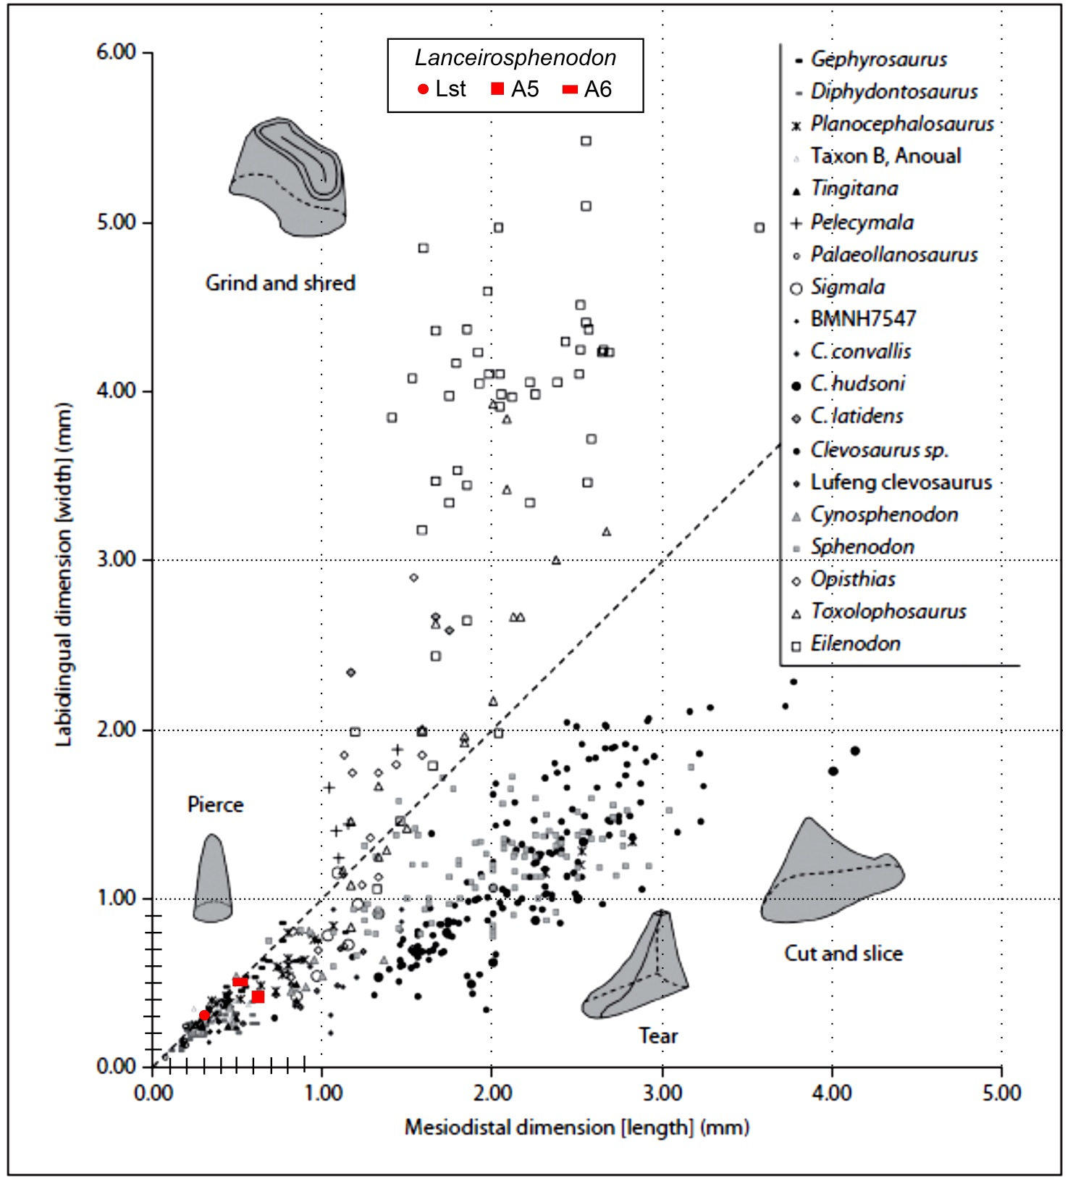
Figure S3. Dimensions of the dentary tooth base in Rhynchocephalia. Dashed line represents values of equal width and length. Diagrammatic representations of right dentary teeth in distolabial view are positioned near their respective data points. Taken and modified from Jones (2009).

References

Apesteguía, S. & Carballido, J. A. 2014. New eilenodontine (Lepidosauria, Sphenodontidae) from the Lower Cretaceous of central Patagonia. Journal of Vertebrate Paleontology, 34, 303–317.

Bever, G. S. & Norell, M. A. 2017. A new rhynchocephalian (Reptlia: Lepidosuria from the Late Jurassic of Solnhofen (Germany) and the origin of the marine Pleurosauridae. Royal Society Open Science, 4, 170570. doi:10.1098/rsos.170570

Herrera-Flores, J. A., Stubbs, T. L., Elsler, A. & Benton M. J. 2018. Taxonomic reassessment of Clevosaurus latidens Fraser, 1993 (Lepidosauria, Rhynchocephalia) and rhynchocephalian phylogeny based on parsimony and Bayesian inference. Journal of Paleontology, 92, 734–742.

Jones, M. E. H. 2009. Dentary tooth shape in Sphenodon and its fossil Relatives (Diapsida: Lepidosauria: Rhynchocepahlia). Frontiers of Oral Biology, 13, 9–15.

Reynoso, V. H. 1996. A Middle Jurassic Sphenodon-like sphenodontian (Diapsida: Lepidosauria) from Huizachal canyon, Tamaulipas, México. Journal of Vertebrate Paleontology, 16, 210–221.

