Supplementary Material 1. Flow chart of patient enrollment and exclusion.
SALS, Smart Advanced Life Support; OHCA, out-of-hospital cardiac arrest; ROSC, return of spontaneous circulation.
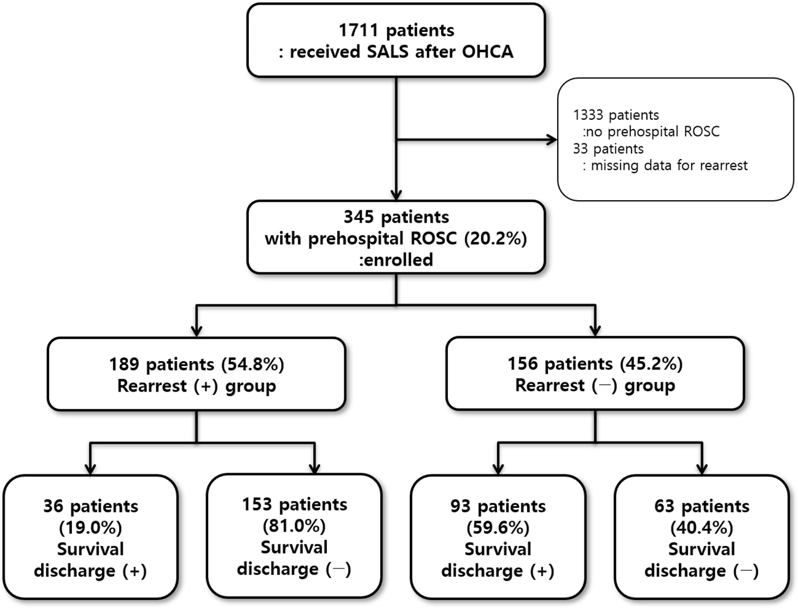

Supplementary Material 2. Description of rearrest
Variables | Rearrest (+)  group  n = 189
Sex (male), n (%) | 139 (73.5%)
Age (years) | 62 (54-73)
Location of rearrest, n (%)
Ambulance | 83 (43.9%)
Field | 95 (50.3%)
Hospital | 1 (0.5%)
Unknown | 10 (5.3%)
Rhythm of rearrest, n (%)
VF/pulseless VT | 29 (15.3%)
PEA | 61 (32.3%)
Asystole | 33 (17.5%)
Unknown | 66 (34.9%)
Interval from first prehospital ROSC to rearrest (min) | 3.0 (2.0-6.0)
Frequency of rearrest
1 | 150 (79.4%)
2 | 22 (11.6%)
3 | 7 (3.7%)
≥4 | 2 (1.1%)
Unknown | 8 (4.2%)
Values are expressed as numbers (percentages) or medians (interquartile ranges).
Abbreviations: VF, ventricular fibrillation; VT, ventricular tachycardia; PEA, pulseless electrical activity; ROSC, return of spontaneous circulation.

