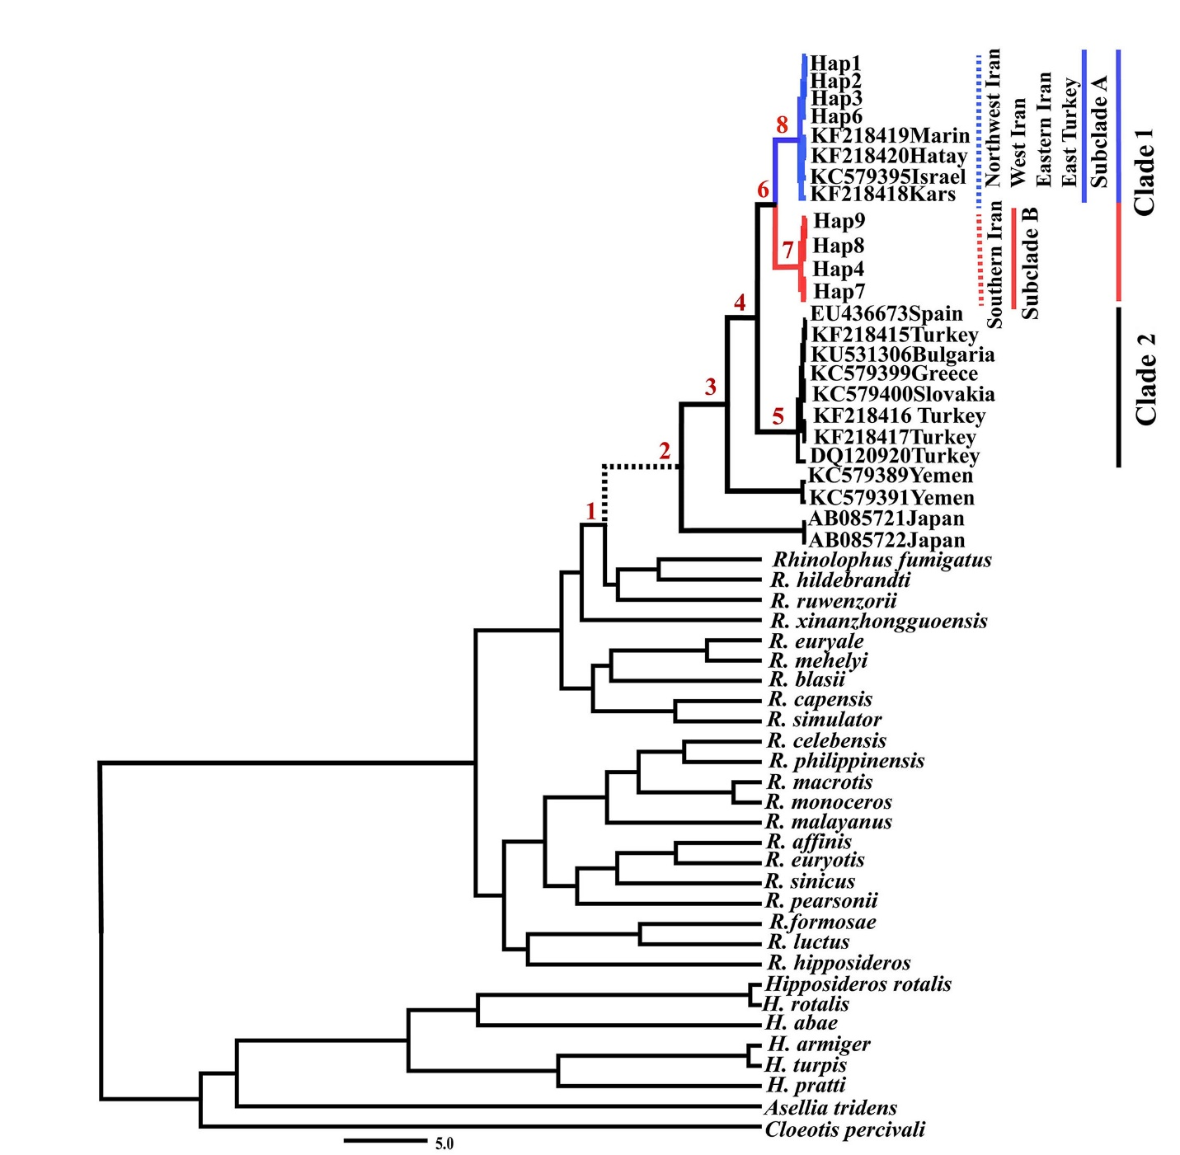

Supplementary Figure 1. Maximum clade credibility tree inferred in BEAST based on the Cytb data analysis of ferrumequinum/clivosus complex using external, rate and fossil calibrations. Numbers above the branches present the divergence times for nodes in million years with 95% highest posterior as expressed in Table 2.

