Mesomorphic properties of lactic acid derivatives and their racemic mixtures in comparison with analogous non-chiral compounds

Vladimíra Novotná,¹ Sergey Stulov,¹ Martin Cigl,¹ Věra Hamplová,¹ Ewa Gorecka,² and Damian Pociecha²

¹Institute of Physics of the Czech Academy of Sciences, Na Slovance 2, Prague, Czech Republic; novotna@fzu.cz
² Chemistry Department, Warsaw University, Al. Zwirki i Wigury Warsaw, Poland

1. Synthesis
1.1. General
1.2. Synthetic procedures and characterisation
2. Experimental
2.1. Equipments and apparatus in details
2.2. Mesomorphic properties
3. References

- Synthesis
  - General
All starting materials and reagents were purchased from Sigma-Aldrich, Acros Organics or Lach:Ner. All solvents used for the synthesis were “p.a.” grade. ¹H NMR spectra were recorded on Varian VNMRS 300 instrument; deuteriochloroform (CDCl₃) and hexadeuteriodimethyl sulfoxide (DMSO-d₆) were used as solvents and signals of the solvent served as internal standard. Chemical shifts (δ) are given in ppm and J values are given in Hz. Signals were identified by APT, gCOSY and gHMBC experiments. Elemental analyses were carried out on Elementar vario EL III instrument. The purity of all final compounds was checked by HPLC analysis (high-pressure pump ECOM Alpha; column WATREX Biospher Si 100, 250 × 4 mm, 5 μm; detector WATREX UVD 250) and were found to be >99.8 %. Column chromatography was carried out using Merck Kieselgel 60 (60−100 μm). Enantiomeric purity of chiral compounds was confirmed by chiral HPLC system (chiral column: Daicel Chiralpak AD-3, 150 × 4.6 mm I.D., 3 µm) Specific rotation of materials ${\left[α\right]}_{D}^{20}$ was measured in dichloromethane solutions using Optical Activity automatic polarimeter polAAr 3000.
Scheme S1: General synthetic route leading to studied mesogens.
  - Synthetic procedures and characterisation
1-(Butoxy)-1-oxoethyl 3'-chloro-4'-[(methoxycarbonyl)oxy]biphenyl-4-carboxylate (3a)
Biphenylcarboxylic acid (1) (1.68 g, 4.66 mmol) was suspended in dry dichloromethane (100 ml), oxalyl chloride (2.0 ml, 23.64 mmol) was added and to this mixture few drops of DMF were added carefully. Reaction mixture was stirred until the clear solution was formed and the gas evolution of stopped (ca. 1 h). Evaporation of solvent and excess of oxalyl chloride under reduced pressure yielded acyl chloride which was dissolved in dry dichloromethane (50 ml) and added dropwise with stirring to the cooled mixture (0 °C) of butyl glycolate (2a) (0.68 g, 5.15 mmol) and pyridine (7 ml) in dry dichloromethane (50 ml). The cooling bath was removed and the reaction mixture stirred for additional 3 h. resulting mixture was washed with HCl (70 ml, 10% ). The organic layer was separated, washed with water and dried with anhydrous magnesium sulphate. The solvent was removed under reduced pressure. Crude product was crystallised from heptane yielding 3a (1.71 g 87 %). ¹H NMR (CDCl₃): 8.14 (2 H, d, J=8.8, H-3, H-5), 7.54–7.65 (3 H, m, H-2, H-6, H-2’), 7.43 (1 H, dd, J=8.8, 2.1, H-6’), 7.10 (1 H, d, J=8.8, H-5‘), 4.86 (1 H, s, CH₂COO), 4.21 (2 H, t, J = 6.7, CH₂COOCH₂), 3.98 (3 H, s, OCH₃), 1.65 (2 H, dt, J₁=J₂=6.6, COOCH₂CH₂), 1.39 (2 H, tq, J₁=J₂= 6.6, CH₂CH₃), 0.93 (3 H, t, J = 7.5, CH₂CH₃).

1-(Decyloxy)-1-oxoethyl 3'-chloro-4'-[(methoxycarbonyl)oxy]biphenyl-4-carboxylate (3b)
Ester 3b was prepared analogously as reported for carboxylate 3a. The reaction of acid (1) (4.52 g, 14.76 mmol), oxalyl chloride (6.0 ml, 69.49 mmol) and subsequent reaction of formed acyl chloride with decyl glycolate (3.20 g, 14.79 mmol) in the presence of pyridine (20 ml) yielded ester 3b (6.86 g, 92 %). ¹H NMR (CDCl₃): 8.14 (2 H, d, J=8.8, H-3, H-5), 7.54–7.64 (3 H, m, H-2, H-6, H-2’), 7.43 (1 H, dd, J=8.8, 2.1, H-6’), 7.10 (1 H, d, J=8.8, H-5‘), 4.86 (1 H, s, CH₂COO), 4.19 (2 H, t, J = 6.7, CH₂COOCH₂), 4.03–4.30 (2 H, m, C*HCOOCH₂), 3.99 (3 H, s, OCH₃), 1.65 (2 H, dt, J₁=J₂=6.6, COOCH₂CH₂), 1.20–1.38 (14 H, m, (CH₂)₇), 0.87 (3 H, t, J = 6.7, CH₂CH₃).

1-(Butoxy)-1-oxoethyl 3'-chloro-4'-hydroxy-1,1'-biphenyl-4-carboxylate (4a)
Ester 3a (1.65 g, 3.9 mmol) was dissolved in THF (40 ml) and cooled to 0°C. To this solution, concentrated aqueous ammonium hydroxide (1.40 ml, 25%) was added with stirring. The reaction was let warm to room temperature and the progress of hydrolysis was monitored by TLC (CH₂Cl₂ : acetone, 99 : 1). After ca. 1 h, the reaction mixture was poured into diluted HCl (30 ml, 1 : 15) and extracted with diethylether (3 × 20 ml). Combined organic layers were washed with water, brine and dried with anhydrous sodium sulphate. The solvent was removed under reduced pressure and the crude product was purified crystallisation from heptane. Yield 1.12 g (79 %). ¹H NMR (CDCl₃): 8.14 (2 H, d, J=8.8, H-3, H-5), 7.52–7.65 (3 H, m, H-2, H-6, H-2’), 7.43 (1 H, dd, J=8.8, 2.1, H-6’), 7.10 (1 H, d, J=8.8, H-5‘), 5.71 (1 H, s, OH), 4.87 (1 H, s, CH₂COO), 4.21 (2 H, t, J = 6.7, CH₂COOCH₂), 1.65 (2 H, dt, J₁=J₂=6.6, COOCH₂CH₂), 1.39 (2 H, tq, J₁=J₂= 6.6, CH₂CH₃), 0.93 (3 H, t, J = 7.5, CH₂CH₃).
1-(Decyloxy)-1-oxoethyl 3'-chloro-4'-hydroxy-1,1'-biphenyl-4-carboxylate (4b)
Phenol 4b was prepared analogously as reported for phenol 4a. The ammonolysis of ester 3b
(6.75 g, 13.37 mmol) by aqueous ammonia (4.8 ml, 25%) in THF yielded 4.60 g (77 %) of phenol 4b ¹H NMR (CDCl₃): 8.12 (2 H, d, J=8.8, H-3, H-5), 7.55–7.67 (3 H, m, H-2, H-6, H-2’), 7.43 (1 H, dd, J=8.8, 2.1, H-6’), 7.10 (1 H, d, J=8.8, H-5‘), 5.71 (1 H, s, OH), 4.87 (1 H, s, CH₂COO), 4.20 (2 H, t, J = 6.7, CH₂COOCH₂), 1.66 (2 H, dt, J₁=J₂=6.6, COOCH₂CH₂), 1.14–1.40 (14 H, m, (CH₂)₇), 0.87 (3 H, t, J = 6.7, CH₂CH₃).

1-(Butoxy)-1-oxoethyl 3'-chloro-4'-{[4'''-(decyloxy)biphenyl-4''-carbonyl]oxy}-biphenyl-4-carboxylate (10ZBBG)
Phenol 4a (1.0 g, 2.76 mmol) and 4'-(decyloxy)biphenyl-4-carboxylic acid (5b) (0.98 g, 2.76 mmol) were suspended in dry dichloromethane (30 ml), and N,N´-dicyclohexylcarbodiimide (DCC) (0.60 g, 2.85 mmol) and 4-(N,N-dimethylamino)pyridine (DMAP) (0.17 g, 1.39 mmol) were added. The mixture was stirred at room temperature for 2 h and then filtered. The filtrate was evaporated and the residue purified by column chromatography (dichloromethane – acetone, 99.8 : 0.2) and recrystallised from hexane. Yield 1.83 g (95 %) of 10ZBBG. ¹H NMR (CDCl₃): 8.30 (2 H, d, J=8.8, H-3´´, H-5´´), 8.19 (2 H, d, J=8.2, H-3, H-5), 7.55–7.79 (8 H, m, H-2, H-6, H-5´, H-6´, H-2´´, H-6´´, H-2´´´, H-6´´´), 7.41 (1 H, d, J=8.2, H-5´), 7.01 (2 H, d, J=8.8, H-3´´´, H-5´´´), 4.88 (2 H, s, CH₂COO), 4.22 (2 H, t, J = 6.7, CH₂COOCH₂), 4.02 (3 H, t, J=6.7, CH₂O), 1.82 (2 H, dt, J₁=J₂=6.6, CH₂CH₂O), 1.66 (2 H, dt, J₁=J₂=6.6, COOCH₂CH₂), 1.21–1.55 (16 H, m, 8 × CH₂), 0.83–1.0 (6 H, m, 2 × CH₂CH₃). ¹³C NMR (CDCl₃): 167.87 (s, COOCH₂), 165.65 (s, ArCOOCH₂), 164.22 (s, COOAr), 159.62 (s, C-4´´´), 147.24 (s, C-4´), 146.40 (s, C-1´´), 143.99 (s, C-4), 139.10 (s, C-1´), 131.83 (s, C-1´´´), 130.97 (s, C-3´´, C-5´´), 130.59 (s, C-3, C-5), 129.10 (s, C-2´), 128.55 (s, C-4´´), 128.40 (s, C-2, C-6), 127.68 (s, C-3´), 127.13 (s, C-2´´´, C-6´´´), 126.70 (s, C-2´´, C-6´´), 126.65 (s, C-6´), 126.54 (s, C-1), 124.32 (s, C-5´), 114.98 (s, C-3´´´, C-5´´´), 68.15 (s, CH₂O), 65.36 (s, CH₂OOC), 61.26 (s, CH₂COO), 31.90 (s, CH₂CH₂CH₃), 30.50 (s, CH₂CH₂CH₃), 29.40–29.58 (m, (CH₂)₃), 29.32 (s, CH₂(CH₂)₃O), 29.23 (s, CH₂CH₂O), 26.04 (s, CH₂(CH₂)₂O), 22.68 (s, CH₂CH₃), 19.0 (s, CH₂CH₃), 14.13 (s, CH₂CH₃), 13.65 (s, CH₂CH₃). Anal. calcd for C₄₂H₄₇ClO₇: C, 72.14; H, 6.77. Found: C, 71.56; H, 5.97C, 30.04; H, 0.75.

1-(Decyloxy)-1-oxopropan-2-yl 3'-chloro-4'-{[4''-(decyloxy)biphenyl-4-carbonyl]oxy}-biphenyl-4-carboxylate (10ZBDG)
Preparation of compound 10ZBDG was analogous to the preparation of compound ZBBG. Reaction of phenol 4b (4.5 g, 10.07 mmol) with acid 5b (4.0 g, 11.28 mmol) in dry dichloromethane (150 ml) in the presence of dicyclohexylcarbodiimide (2.44 g, 11.47 mmol) and DMAP (0.6 g, 4.9 mmol) yielded 7.02 g (89 %), (column chromatography: dichloromethane – acetone, 99.8 : 0.2). ¹H NMR (CDCl₃): 8.30 (2 H, d, J=8.8, H-3´´, H-5´´), 8.19 (2 H, d, J=8.2, H-3, H-5), 7.55–7.79 (8 H, m, H-2, H-6, H-5´, H-6´, H-2´´, H-6´´, H-2´´´, H-6´´´), 7.41 (1 H, d, J=8.2, H-5´), 7.01 (2 H, d, J=8.8, H-3´´´, H-5´´´), 4.88 (2 H, s, CH₂COO), 4.22 (2 H, t, J = 6.7, CH₂COOCH₂), 4.02 (3 H, t, J=6.7, CH₂O1.82 (2 H, dt, J₁=J₂=6.6, CH₂CH₂O), 1.66 (2 H, dt, J₁=J₂=6.6, COOCH₂CH₂), 1.13–1.57 (28 H, m, 14 × CH₂), 0.76–0.98 (6 H, m, 2 × CH₂CH₃). ¹³C NMR (CDCl₃): 167.84 (s, COOCH₂), 165.62 (s, ArCOOCH₂), 164.19 (s, COOAr), 159.61 (s, C-4´´´), 147.23 (s, C-4´), 146.37 (s, C-1´´), 143.97 (s, C-4), 139.09 (s, C-1´), 131.82 (s, C-1´´´), 130.95 (s, C-3´´, C-5´´), 130.58 (s, C-3, C-5), 129.08 (s, C-2´), 128.54 (s, C-4´´), 128.39 (s, C-2, C-6), 127.67 (s, C-3´), 127.09 (s, C-2´´´, C-6´´´), 126.67 (s, C-2´´, C-6´´), 126.62 (s, C-6´), 126.53 (s, C-1), 124.32 (s, C-5´), 114.96 (s, C-3´´´, C-5´´´), 68.13 (s, CH₂O), 65.64 (s, CH₂OOC), 61.26 (s, CH₂COO), 31.86 (s, 2 × CH₂CH₂CH₃), 29.16–29.57 (m, 2 × (CH₂)₃, 2 × CH₂(CH₂)₃O, CH₂CH₂O), 28.47 (s, CH₂CH₂O), 26.02 (s, CH₂(CH₂)₂O), 25.76 (s, CH₂(CH₂)₂O), 22.66 (s, 2 × CH₂CH₃), 14.12 (s, 2 × CH₂CH₃). Anal. calcd for C₄₈H₅₉ClO₇: C 73.59 H 7.59. Found: C 73.25, H 7.38.

(S)-1-(Butoxy)-1-oxopropan-2-yl 3'-chloro-4'-{[4''-(nonyloxy)biphenyl-4-carbonyl]oxy}-biphenyl-4-carboxylate (9ZBBL(S))
In the same way as described in ref [S1]: To a solution of acid 5a (0.84 g, 2.47 mmol), hydroxy-ester 4c (0.85 g, 2.26 mmol) and catalytic amount of DMAP (0.10 g, 0.82 mmol) in dry dichloromethane (40 ml), DCC (0.54 g, 2.54 mmol) was added and the reaction mixture was stirred at room temperature for 5 h. Resulting heterogeneous mixture was filtered and the filtrate evaporated. The crude product was purified by column chromatography on silica (CH₂Cl₂) and further by crystallisation from heptane. 1.33 g (84 %) of ester 9ZBBL(S) was obtained. ¹H NMR (CDCl₃): 8.30 (2 H, d, J=8.8, H-3´´, H-5´´), 8.18 (2 H, d, J=8.2, H-3, H-5), 7.76 (1 H, d, J=2.3, H-5´), 7.72 (2 H, d, J=8.8, H-2´´, H-6´´), 7.67 (2 H, d, J=8.2, H-2´´´, H-6´´´), 7.57–7.62 (3 H, m, H-2, H-6, H-6´), 7.41 (1 H, d, J=8.2, H-5´), 7.02 (2 H, d, J=8.8, H-3´´´, H-5´´´), 5.35 (2 H, q, J=7.0, C*H), 4.14–4.26 (2 H, m, C*HCOOCH₂), 4.02 (3 H, t, J=6.7, CH₂O), 1.73–1.96 (2 H, m, CH₂CH₂O), 1.53–1.70 (5 H, m, COOCH₂CH₂, CH*CH₃), 1.19–1.49 (14 H, m, 7 × CH₂), 0.87–0.95 (6 H, m, 2 × CH₂CH₃). ¹³C NMR (CDCl₃): 170.83 (s, COOCH₂), 165.60 (s, COOCH), 164.21 (s, COOAr), 159.62 (s, C-4´´´), 147.20 (s, C-1´), 146.38 (s, C-1´´), 143.82 (s, C-1), 139.15 (s, C-4´), 131.82 (s, C-1´´´), 130.96 (s, C-3´´, C-5´´), 130.50 (s, C-3, C-5), 129.07 (s, C-2´), 128.82 (s, C-4), 128.40 (s, C-2, C-6), 127.65 (s, C-4´´), 127.06 (s, C-2´´´, C-6´´´), 126.68 (s, C-2´´, C-6´´), 126.67 (s, C-6´), 126.55 (s, C-3´), 124.28 (s, C-5´), 114.96 (s, C-3´´´, C-5´´´), 69.29 (s, CH*), 68.15 (s, CH₂O), 65.26 (s, CH₂OOC), 31.91 (s, CH₂CH₂CH₃), 30.49 (s, CH₂CH₂CH₃), 29.61 (s, CH₂), 29.41 (s, CH₂), 29.32 (s, CH₂(CH₂)₃O), 29.21 (s, CH₂CH₂O), 26.04 (s, CH₂(CH₂)₂O), 22.67 (s, CH₂CH₃), 19.0 (s, CH₂CH₃), 17.14 (s, CH*CH₃), 14.13 (s, CH₂CH₃), 13.66 (s, CH₂CH₃). Anal. calcd for C₄₃H₄₉ClO₇: C 72.14, H 6.77. Found: C 72.08, H 6.77, O 15.75. ${\left[α\right]}_{D}^{20}=+16.8$.

1-(Butoxy)-1-oxopropan-2-yl 3'-chloro-4'-{[4''-(undecyloxy)biphenyl-4-carbonyl]oxy}-biphenyl-4-carboxylate (11ZBBL(S))
Preparation of compound 11ZBBL(S) was analogous to the preparation of compound 9ZBBL(S). Reaction of phenol 4c (2.0 g, 5.31 mmol) with acid 5d (2.0 g, 5.43 mmol) in dry dichloromethane (50 ml) in the presence of dicyclohexylcarbodiimide (1.21 g, 5.69 mmol) and DMAP (0.24 g, 1.94 mmol) yielded 3.40 g (88 %), (column chromatography: dichloromethane – acetone, 99.9 : 0.1). ¹H NMR (CDCl₃): 8.30 (2 H, d, J=8.8, H-3´´, H-5´´), 8.18 (2 H, d, J=8.2, H-3, H-5), 7.76 (1 H, d, J=2.3, H-5´), 7.72 (2 H, d, J=8.8, H-2´´, H-6´´), 7.67 (2 H, d, J=8.2, H-2´´´, H-6´´´), 7.57–7.62 (3 H, m, H-2, H-6, H-6´), 7.41 (1 H, d, J=8.2, H-5´), 7.02 (2 H, d, J=8.8, H-3´´´, H-5´´´), 5.35 (2 H, q, J=7.0, C*H), 4.15–4.26 (2 H, m, C*HCOOCH₂), 4.02 (3 H, t, J=6.7, CH₂O), 1.73–1.96 (2 H, m, CH₂CH₂O), 1.55–1.70 (5 H, m, COOCH₂CH₂, CH*CH₃), 1.15–1.52 (18 H, m, 9 × CH₂), 0.87–0.95 (6 H, m, 2 × CH₂CH₃). ¹³C NMR (CDCl₃): 170.84 (s, COOCH₂), 165.61 (s, COOCH), 164.22 (s, COOAr), 159.63 (s, C-4´´´), 147.21 (s, C-1´), 146.40 (s, C-1´´), 143.84 (s, C-1), 139.16 (s, C-4´), 131.83 (s, C-1´´´), 130.97 (s, C-3´´, C-5´´), 130.51 (s, C-3, C-5), 129.09 (s, C-2´), 128.84 (s, C-4), 128.40 (s, C-2, C-6), 127.65 (s, C-4´´), 127.06 (s, C-2´´´, C-6´´´), 126.68 (s, C-2´´, C-6´´), 126.68 (s, C-6´), 126.56 (s, C-3´), 124.30 (s, C-5´), 114.98 (s, C-3´´´, C-5´´´), 69.30 (s, CH*), 68.15 (s, CH₂O), 65.27 (s, CH₂OOC), 31.90 (s, CH₂CH₂CH₃), 30.49 (s, CH₂CH₂CH₃), 29.40–29.61 (m, (CH₂)₄), 29.32 (s, CH₂(CH₂)₃O), 29.23 (s, CH₂CH₂O), 26.04 (s, CH₂(CH₂)₂O), 22.68 (s, CH₂CH₃), 19.0 (s, CH₂CH₃), 17.13 (s, CH*CH₃), 14.13 (s, CH₂CH₃), 13.65 (s, CH₂CH₃). Anal. calcd for C₄₄H₅₁ClO₇: calc. C 72.66, H 7.07. Found: C 72.52, H 7.24. ${\left[α\right]}_{D}^{20}=+15.3$.

(±)-1-(Butoxy)-1-oxopropan-2-yl 3'-chloro-4'-{[4''-(undecyloxy)biphenyl-4-carbonyl]oxy}-biphenyl-4-carboxylate (11ZBBL(rac))
Preparation of compound 11ZBBL(rac) was analogous to the preparation of compound 9ZBBL(S). Reaction of phenol 4d (1.33 g, 3.53 mmol) with acid 5d (1.30 g, 3.53 mmol) in dry dichloromethane (50 ml) in the presence of dicyclohexylcarbodiimide (1.10 g, 5.17 mmol) and DMAP (0.21 g, 1.70 mmol) yielded 2.13 g (83 %), (column chromatography: dichloromethane – acetone, 99.9 : 0.1). ¹H NMR (CDCl₃): 8.30 (2 H, d, J=8.8, H-3´´, H-5´´), 8.18 (2 H, d, J=8.2, H-3, H-5), 7.76 (1 H, d, J=2.3, H-5´), 7.72 (2 H, d, J=8.8, H-2´´, H-6´´), 7.67 (2 H, d, J=8.2, H-2´´´, H-6´´´), 7.57–7.62 (3 H, m, H-2, H-6, H-6´), 7.41 (1 H, d, J=8.2, H-5´), 7.02 (2 H, d, J=8.8, H-3´´´, H-5´´´), 5.34 (2 H, q, J=7.0, C*H), 4.15–4.27 (2 H, m, C*HCOOCH₂), 4.02 (3 H, t, J=6.7, CH₂O), 1.73–1.96 (2 H, m, CH₂CH₂O), 1.55–1.70 (5 H, m, COOCH₂CH₂, CH*CH₃), 1.15–1.52 (18 H, m, 9 × CH₂), 0.87–0.95 (6 H, m, 2 × CH₂CH₃). ¹³C NMR (CDCl₃): 170.84 (s, COOCH₂), 165.61 (s, COOCH), 164.22 (s, COOAr), 159.63 (s, C-4´´´), 147.21 (s, C-1´), 146.40 (s, C-1´´), 143.84 (s, C-1), 139.16 (s, C-4´), 131.83 (s, C-1´´´), 130.97 (s, C-3´´, C-5´´), 130.51 (s, C-3, C-5), 129.09 (s, C-2´), 128.84 (s, C-4), 128.40 (s, C-2, C-6), 127.65 (s, C-4´´), 127.06 (s, C-2´´´, C-6´´´), 126.68 (s, C-2´´, C-6´´), 126.68 (s, C-6´), 126.56 (s, C-3´), 124.30 (s, C-5´), 114.98 (s, C-3´´´, C-5´´´), 69.29 (s, CH*), 68.15 (s, CH₂O), 65.27 (s, CH₂OOC), 31.90 (s, CH₂CH₂CH₃), 30.49 (s, CH₂CH₂CH₃), 29.40–29.61 (m, (CH₂)₄), 29.32 (s, CH₂(CH₂)₃O), 29.23 (s, CH₂CH₂O), 26.04 (s, CH₂(CH₂)₂O), 22.68 (s, CH₂CH₃), 19.0 (s, CH₂CH₃), 17.13 (s, CH*CH₃), 14.13 (s, CH₂CH₃), 13.65 (s, CH₂CH₃). Anal. calcd for C₄₄H₅₁ClO₇: calc. C 72.66, H 7.07. Found: C 72.76, H 7.16. ${\left[α\right]}_{D}^{20}=0$.

2. Experimental
2.1. Equipments and apparatus in details
Spontaneous polarisation, P_{S}, was determined from the switching current detected in a triangular electric field profile at a frequency of 50 Hz and an electric field of about 10-40 V/μm. Current profile has been detected by the memory digital oscilloscope Tektronix. Spontaneous tilt angle, θ_{S}, was determined at the d.c. electric field ±10 V/cm, by measuring the angular difference between the extinction positions of the unwound structures under opposite fields.
Dielectric properties were studied using Schlumberger 1260 impedance analyser. The frequency dispersions were measured on cooling at a rate of about 0.2 K/min, keeping the temperature of the sample stable during the frequency sweeps in the range of 10 Hz ÷ 10 MHz. The frequency dispersion data were analysed using the Cole-Cole formula (1) in a generalized form. For the frequency dependent complex permittivity ε∗(f ) =ε′−iε′′ we have utilized:
(1),
where f_{r} is the relaxation frequency, Δε is the dielectric strength, α is the distribution parameter of the relaxation, ε₀ is the permittivity of a vacuum, ε∞ is the high frequency permittivity and n, m, A are the parameters of fitting. The second and the third terms in the equation are used to eliminate a low frequency contribution from d.c. conductivity σ and a high frequency contribution due to the resistance of the electrodes, respectively. Due to the gold electrodes the contribution of the third term was negligible for the frequencies up to 1 MHz. Measured values of real, ε′, and imaginary, ε′′, parts of the dielectric permittivity ε∗(f) = ε′−iε′′ were simultaneously fitted to formula (1).

2.2. Mesomorphic properties
Figure S1. The columnar phase diagram for mZBBL compounds.

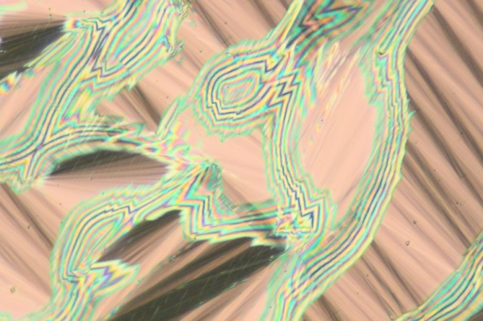
Figure S2. Texture 11ZBBL(S) in the SmC* phase at T=100°C.
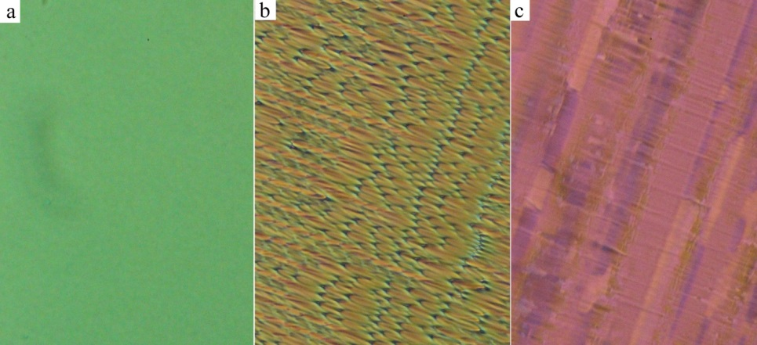
Figure S3. Texture 10ZBBL(rac) in a) the nematic phase, b) focal conic structure in the SmA phase, c) texture with domaines in the SmC phase. The width of each figure corresponds to about 150 μm.
Figure S4. Temperature dependences of the birefringence, Δn, a) for all mZBBl(rac) compounds, b) for 10ZBBL(rac) and 11ZBBl(rac) in details.
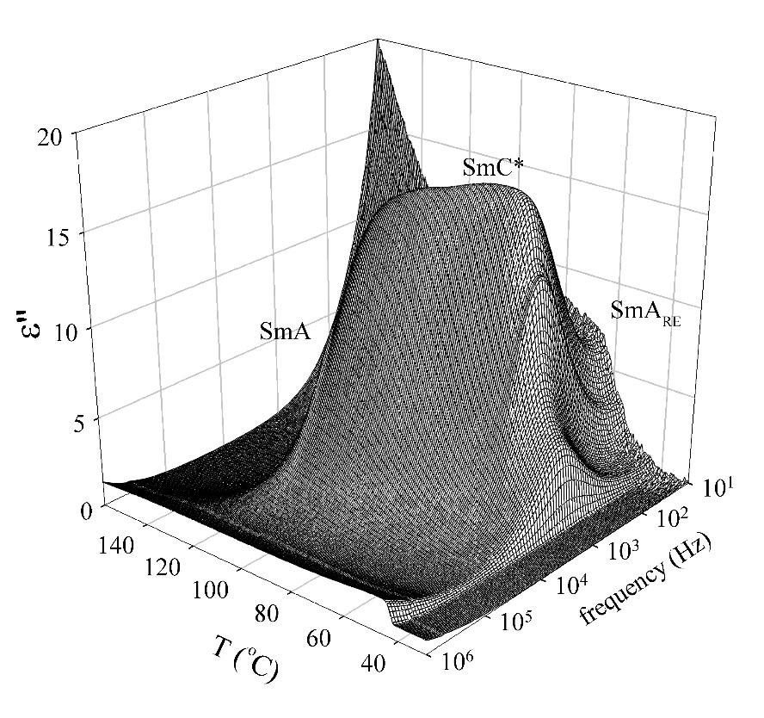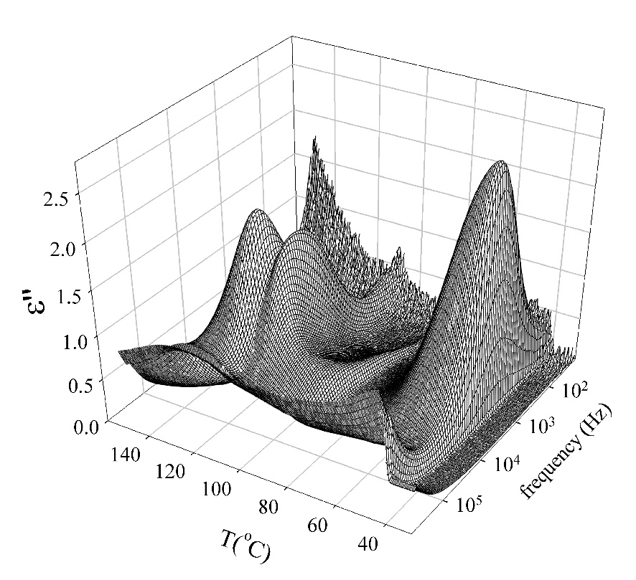
Figure S5. Three-dimensional graph of the imaginary part of the dielectric permittivity, ε’’, for 10ZBBL(S) a) without electric bias and b) under bias field of about 2V/μm.
a)
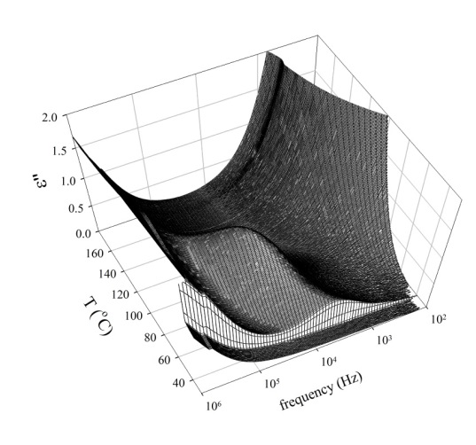
b)
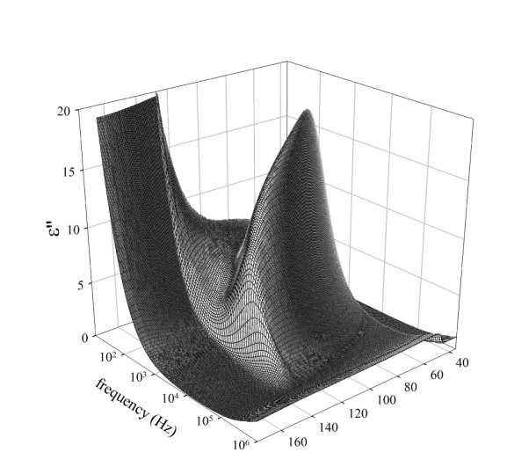
Figure S6. Three-dimensional graph of the imaginary part of the dielectric permittivity, ε’’, for a) 9ZBBL(S) and b) 11ZBBL(S), both measurements were without electric bias.
Figure S7. Temperature dependences of the tilt angle determined from layer spacing, Θ_{XRD}, (black curve) and the tilt angle measured optically, Θ_{opt}, in the d.c. electrical field of about 2V/μm (red curve) for 11ZBBL(S).
Figure S8. The temperature dependences of the layer spacing, d(T), for non-chiral derivatives 10ZBDG and 10ZBBG (black colour) and 10ZBDL(rac) and 10ZBBL(rac) (red colour).

3. References
- V. Novotná, V. Hamplová, L. Lejček, D. Pociecha, M. Cigl, L. Fekete, M. Glogarová, L. Bednárová, E. Gorecka, Organic nanotubes created from mesogenic derivatives. Nanoscale Adv. 1 (2019) 2835- 2839; Electronic supporting information file (ESI).

