SUPPLEMENTARY MATERIAL

One-pot synthesis of novel fused mesoionic compounds: 1-substituted-5-thioxo-5,6-dihydro-[1,2,4]triazolo[1,5-c]quinazolin-1-ium-2-thiolates
Sergiy M. Kovalenkoª, Oleksandr G. Drushlyak^{*b}, and Illia O. Mariutsa^{b}
ª Department of Organic Chemistry, V. N. Karazin Kharkiv National University, Svobody sq. 4, Kharkiv 61077, Ukraine, E-mail: kovalenko.sergiy.m@gmail.com;
^{b} Faculty of Pharmacy, The National University of Pharmacy, 53 Pushkinska st., Kharkiv 61002, Ukraine, E-mail: aldry18@hotmail.com
Corresponding author, e-mail: Oleksandr G. Drushlyak aldry18@hotmail.com

Contents

3-Benzyl-1-(4-oxo-2-thioxo-1,4-dihydroquinazolin-3(2H)-yl)thiourea 3a. 4
Figure S1. ¹H NMR spectrum (400 MHz, DMSO-d6) of 3-benzyl-1-(4-oxo-2-thioxo-1,4-dihydroquinazolin-3(2H)-yl)thiourea 3a 4
Figure S2. ¹³C NMR spectrum (100 MHz, DMSO-d6) of 3-benzyl-1-(4-oxo-2-thioxo-1,4-dihydroquinazolin-3(2H)-yl)thiourea 3a 4
Figure S3. LC/MS data for 3-benzyl-1-(4-oxo-2-thioxo-1,4-dihydroquinazolin-3(2H)-yl)thiourea 3a 5
Figure S4. IR spectrum of 3-benzyl-1-(4-oxo-2-thioxo-1,4-dihydroquinazolin-3(2H)-yl)thiourea 3a 6
Figure S5. UV/Vis spectrum of 3-benzyl-1-(4-oxo-2-thioxo-1,4-dihydroquinazolin-3(2H)-yl)thiourea 3a (MeOH) 6
3-Ethyl-1-(4-oxo-2-thioxo-1,4-dihydroquinazolin-3(2H)-yl)thiourea 3b 7
Figure S6. ¹H NMR spectrum (400 MHz, DMSO-d6) of 3-ethyl-1-(4-oxo-2-thioxo-1,4-dihydroquinazolin-3(2H)-yl)thiourea 3b 7
Figure S7. ¹³C NMR spectrum (100 MHz, DMSO-d6) of 3-ethyl-1-(4-oxo-2-thioxo-1,4-dihydroquinazolin-3(2H)-yl)thiourea 3b 7
Figure S8. LC/MS data for 3-ethyl-1-(4-oxo-2-thioxo-1,4-dihydroquinazolin-3(2H)-yl)thiourea 3b 8
Figure S9. IR spectrum of 3-ethyl-1-(4-oxo-2-thioxo-1,4-dihydroquinazolin-3(2H)-yl)thiourea 3b 9
Figure S10. UV/Vis spectrum of 3-ethyl-1-(4-oxo-2-thioxo-1,4-dihydroquinazolin-3(2H)-yl)thiourea 3b (MeOH) 9
1-(4-Oxo-2-thioxo-1,4-dihydroquinazolin-3(2H)-yl)-3-phenylthiourea 3c 10
Figure S11. ¹H NMR spectrum (400 MHz, DMSO-d6) of 1-(4-Oxo-2-thioxo-1,4-dihydroquinazolin-3(2H)-yl)-3-phenylthiourea 3c 10
Figure S12. ¹³C NMR spectrum (100 MHz, DMSO-d6) of 1-(4-Oxo-2-thioxo-1,4-dihydroquinazolin-3(2H)-yl)-3-phenylthiourea 3c 10
Figure S13. LC/MS data for 1-(4-Oxo-2-thioxo-1,4-dihydroquinazolin-3(2H)-yl)-3-phenylthiourea 3c 11
Figure S14. IR spectrum of 1-(4-Oxo-2-thioxo-1,4-dihydroquinazolin-3(2H)-yl)-3-phenylthiourea 3c 12
Figure S15. UV/Vis spectrum of 1-(4-Oxo-2-thioxo-1,4-dihydroquinazolin-3(2H)-yl)-3-phenylthiourea 3c (MeOH) 12
1-Benzyl-5-thioxo-5,6-dihydro-[1,2,4]triazolo[1,5-c]quinazolin-1-ium-2-thiolate 6a 13
Figure S16. ¹H NMR spectrum (400 MHz, DMSO-d6) of 1-benzyl-5-thioxo-5,6-dihydro-[1,2,4]triazolo[1,5-c]quinazolin-1-ium-2-thiolate 6a 13
Figure S17. ¹³C NMR spectrum (100 MHz, DMSO-d6) of 1-benzyl-5-thioxo-5,6-dihydro-[1,2,4]triazolo[1,5-c]quinazolin-1-ium-2-thiolate 6a 13
Figure S18. LC/MS data for 1-benzyl-5-thioxo-5,6-dihydro-[1,2,4]triazolo[1,5-c]quinazolin-1-ium-2-thiolate 6a 14
Figure S19. IR spectrum of 1-benzyl-5-thioxo-5,6-dihydro-[1,2,4]triazolo[1,5-c]quinazolin-1-ium-2-thiolate 6a 15
Figure S20. UV/Vis spectrum of 1-benzyl-5-thioxo-5,6-dihydro-[1,2,4]triazolo[1,5-c]quinazolin-1-ium-2-thiolate 6a (MeOH) 15
1-Ethyl-5-thioxo-5,6-dihydro-[1,2,4]triazolo[1,5-c]quinazolin-1-ium-2-thiolate 6b 16
Figure S21. ¹H NMR spectrum (400 MHz, DMSO-d6) of 1-ethyl-5-thioxo-5,6-dihydro-[1,2,4]triazolo[1,5-c]quinazolin-1-ium-2-thiolate 6b 16
Figure S22. ¹³C NMR spectrum (100 MHz, DMSO-d6) of 1-ethyl-5-thioxo-5,6-dihydro-[1,2,4]triazolo[1,5-c]quinazolin-1-ium-2-thiolate 6b 16
Figure S23. LC/MS data for 1-ethyl-5-thioxo-5,6-dihydro-[1,2,4]triazolo[1,5-c]quinazolin-1-ium-2-thiolate 6b 17
Figure S24. IR spectrum of 1-ethyl-5-thioxo-5,6-dihydro-[1,2,4]triazolo[1,5-c]quinazolin-1-ium-2-thiolate 6b 18
Figure S25. UV/Vis spectrum of 1-ethyl-5-thioxo-5,6-dihydro-[1,2,4]triazolo[1,5-c]quinazolin-1-ium-2-thiolate 6b (MeOH) 18
1-Phenyl-5-thioxo-5,6-dihydro-[1,2,4]triazolo[1,5-c]quinazolin-1-ium-2-thiolate 6c 19
Figure S26. ¹H NMR spectrum (400 MHz, DMSO-d6) of 1-phenyl-5-thioxo-5,6-dihydro-[1,2,4]triazolo[1,5-c]quinazolin-1-ium-2-thiolate 6c 19
Figure S27. ¹³C NMR spectrum (100 MHz, DMSO-d6) of 1-phenyl-5-thioxo-5,6-dihydro-[1,2,4]triazolo[1,5-c]quinazolin-1-ium-2-thiolate 6c 19
Figure S28. LC/MS data for 1-phenyl-5-thioxo-5,6-dihydro-[1,2,4]triazolo[1,5-c]quinazolin-1-ium-2-thiolate 6c 20
Figure S29. IR spectrum of 1-phenyl-5-thioxo-5,6-dihydro-[1,2,4]triazolo[1,5-c]quinazolin-1-ium-2-thiolate 6c 21
Figure S30. UV/Vis spectrum of 1-phenyl-5-thioxo-5,6-dihydro-[1,2,4]triazolo[1,5-c]quinazolin-1-ium-2-thiolate 6c (MeOH) 21
3-Benzyl-1-(4-oxo-2-thioxo-1,4-dihydroquinazolin-3(2H)-yl)thiourea 3a
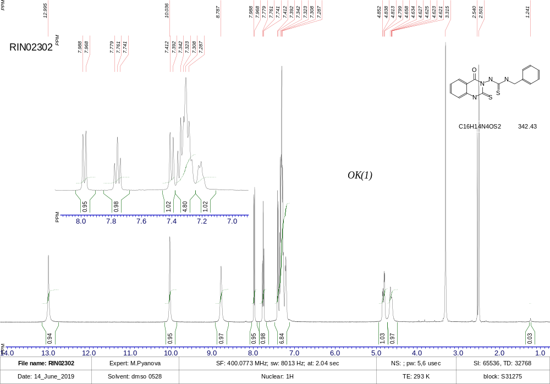
Figure S1. ¹H NMR spectrum (400 MHz, DMSO-d6) of 3-benzyl-1-(4-oxo-2-thioxo-1,4-dihydroquinazolin-3(2H)-yl)thiourea 3a.
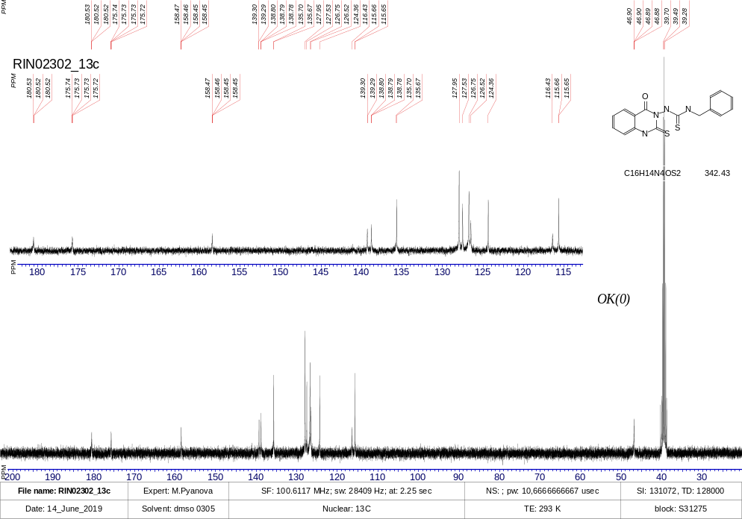
Figure S2. ¹³C NMR spectrum (100 MHz, DMSO-d6) of 3-benzyl-1-(4-oxo-2-thioxo-1,4-dihydroquinazolin-3(2H)-yl)thiourea 3a.

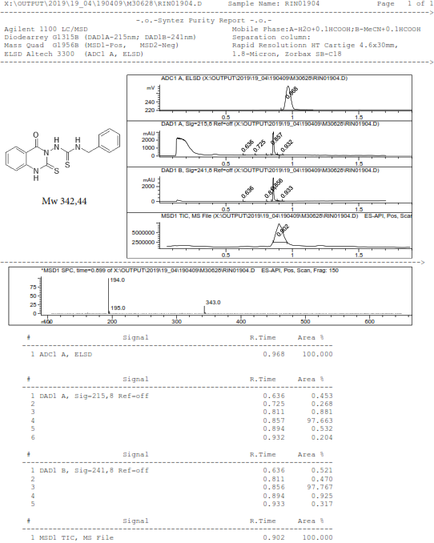

Figure S3. LC/MS data for 3-benzyl-1-(4-oxo-2-thioxo-1,4-dihydroquinazolin-3(2H)-yl)thiourea 3a.
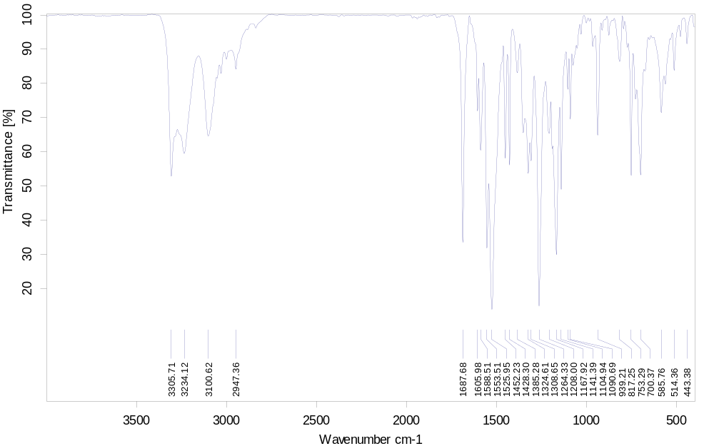
Figure S4. IR spectrum of 3-benzyl-1-(4-oxo-2-thioxo-1,4-dihydroquinazolin-3(2H)-yl)thiourea 3a.
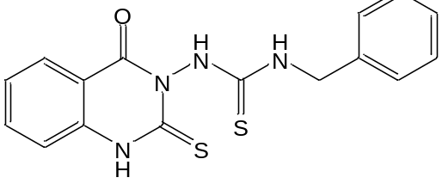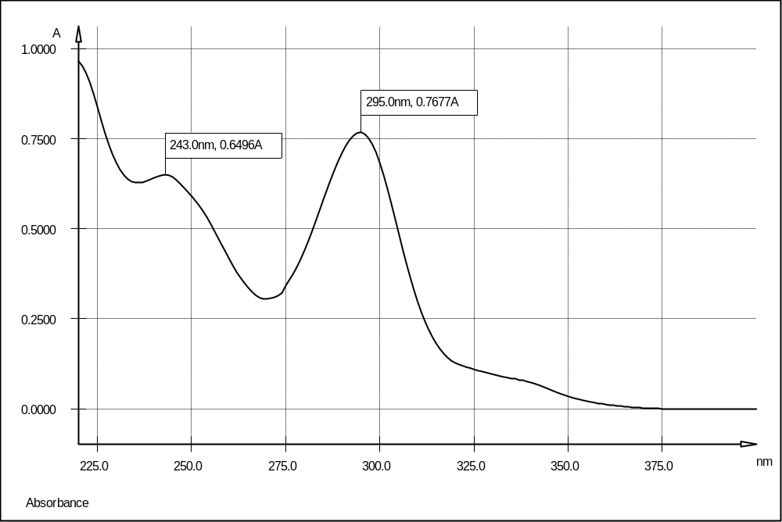
Figure S5. UV/Vis spectrum of 3-benzyl-1-(4-oxo-2-thioxo-1,4-dihydroquinazolin-3(2H)-yl)thiourea 3a (MeOH).
3-Ethyl-1-(4-oxo-2-thioxo-1,4-dihydroquinazolin-3(2H)-yl)thiourea 3b 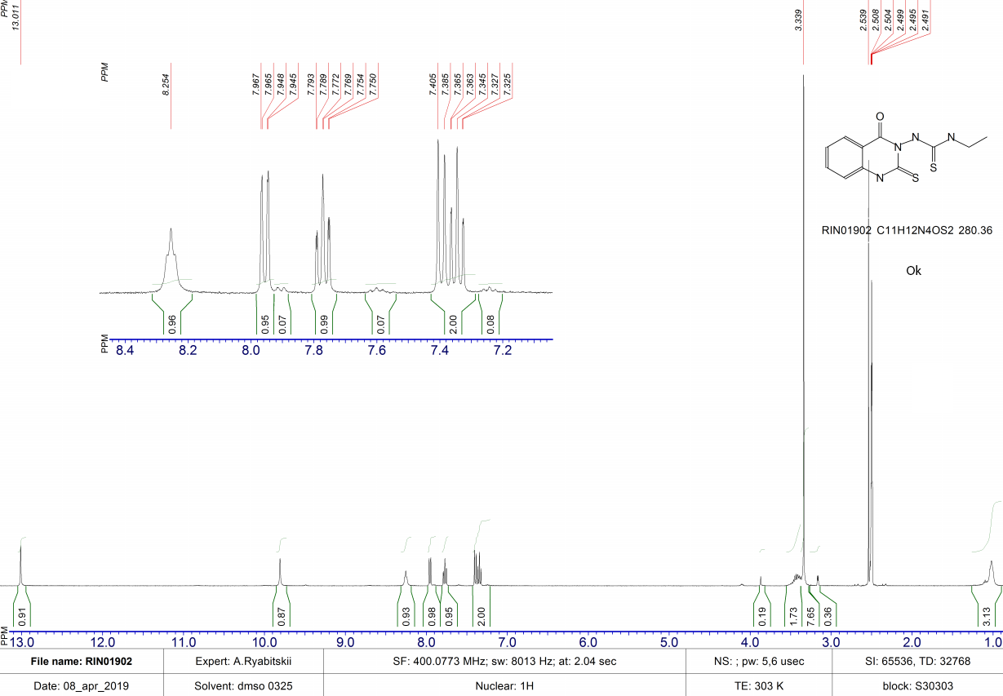
Figure S6. ¹H NMR spectrum (400 MHz, DMSO-d6) of 3-ethyl-1-(4-oxo-2-thioxo-1,4-dihydroquinazolin-3(2H)-yl)thiourea 3b.
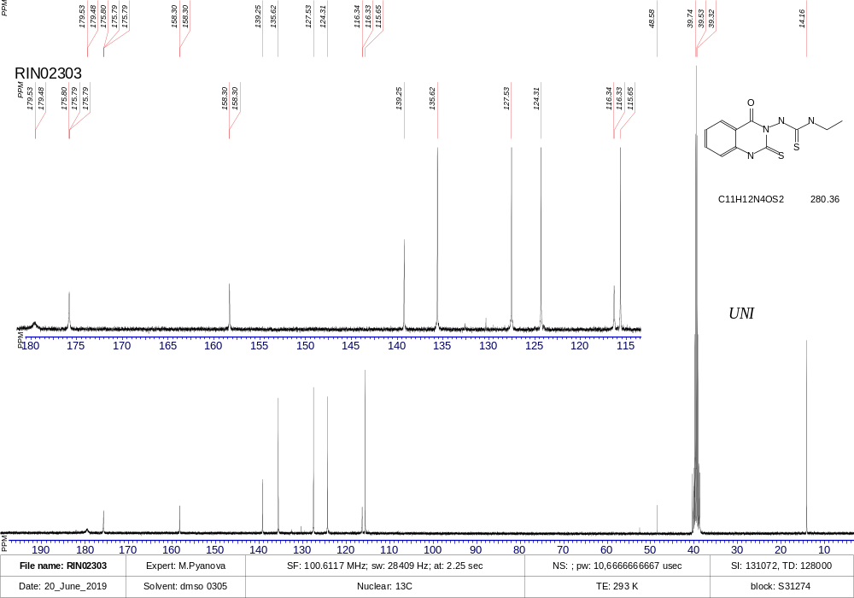
Figure S7. ¹³C NMR spectrum (100 MHz, DMSO-d6) of 3-ethyl-1-(4-oxo-2-thioxo-1,4-dihydroquinazolin-3(2H)-yl)thiourea 3b.

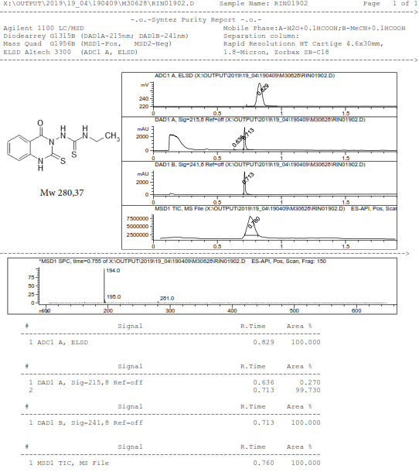

Figure S8. LC/MS data for 3-ethyl-1-(4-oxo-2-thioxo-1,4-dihydroquinazolin-3(2H)-yl)thiourea 3b.

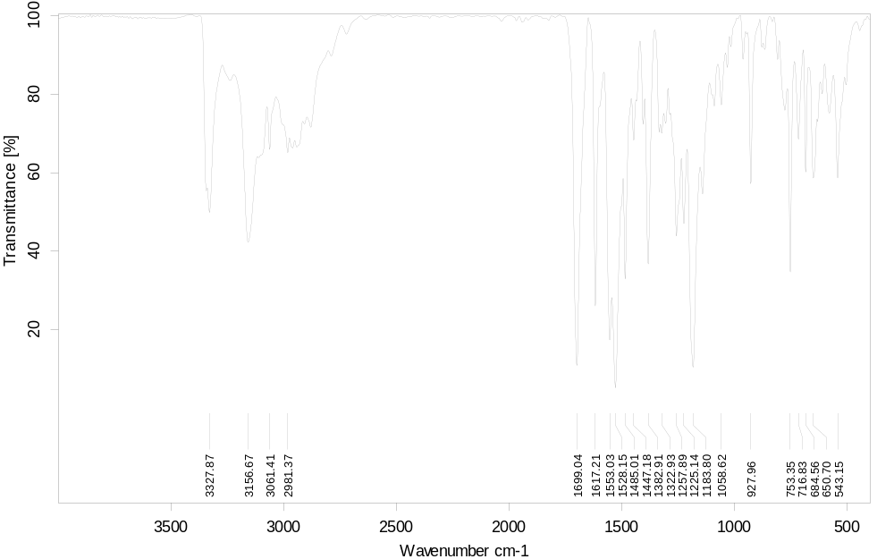
Figure S9. IR spectrum of 3-ethyl-1-(4-oxo-2-thioxo-1,4-dihydroquinazolin-3(2H)-yl)thiourea 3b.
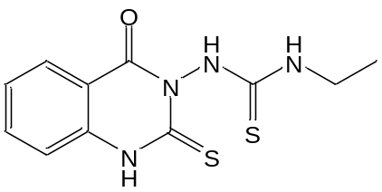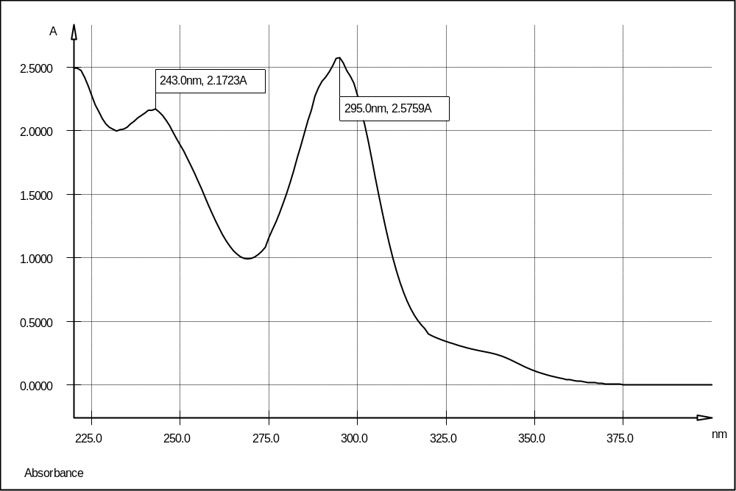
Figure S10. UV/Vis spectrum of 3-ethyl-1-(4-oxo-2-thioxo-1,4-dihydroquinazolin-3(2H)-yl)thiourea 3b (MeOH).
1-(4-Oxo-2-thioxo-1,4-dihydroquinazolin-3(2H)-yl)-3-phenylthiourea 3c.
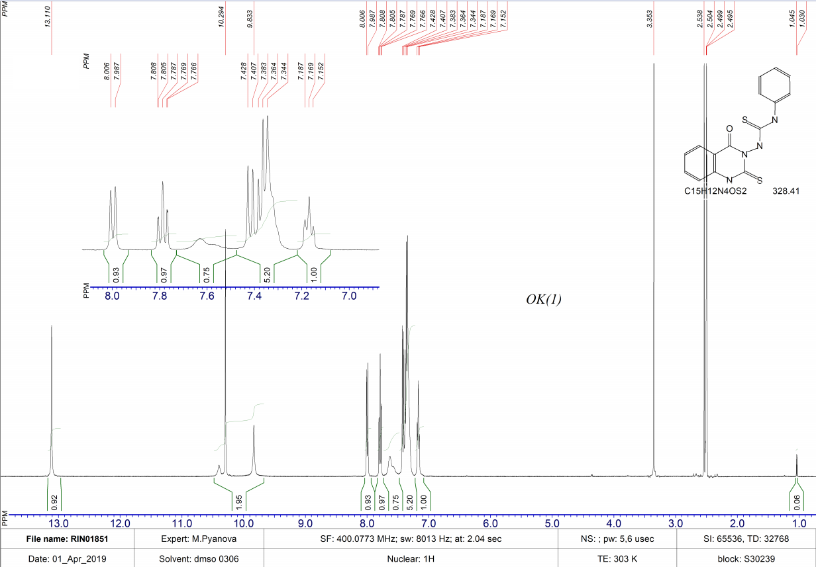
Figure S11. ¹H NMR spectrum (400 MHz, DMSO-d6) of 1-(4-Oxo-2-thioxo-1,4-dihydroquinazolin-3(2H)-yl)-3-phenylthiourea 3c.
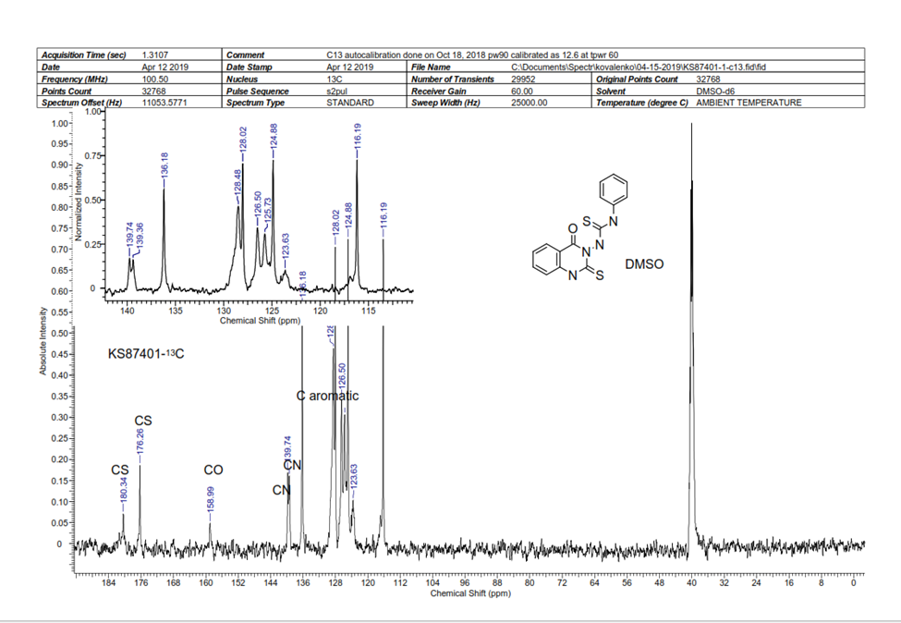
Figure S12. ¹³C NMR spectrum (100 MHz, DMSO-d6) of 1-(4-Oxo-2-thioxo-1,4-dihydroquinazolin-3(2H)-yl)-3-phenylthiourea 3c.

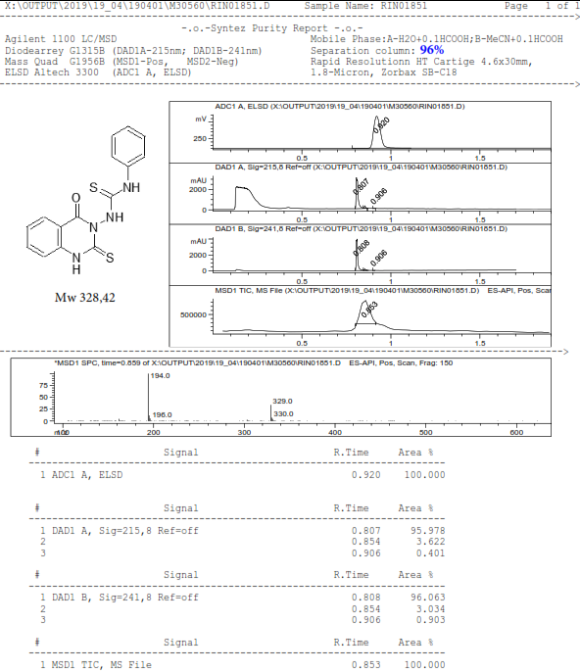

Figure S13. LC/MS data for 1-(4-Oxo-2-thioxo-1,4-dihydroquinazolin-3(2H)-yl)-3-phenylthiourea 3c.
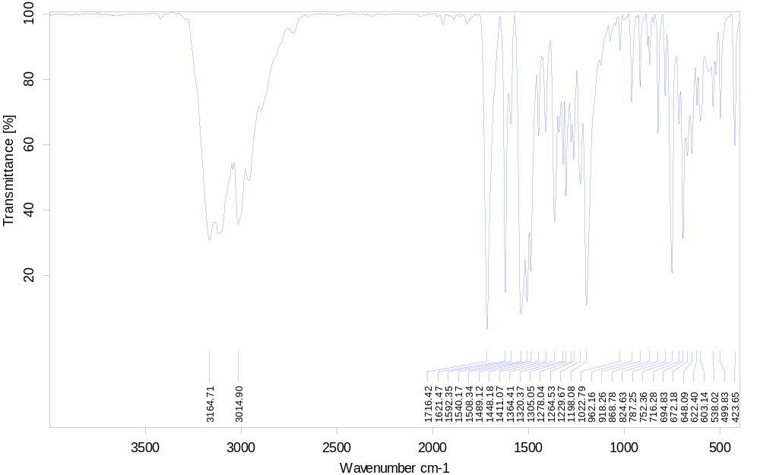
Figure S14. IR spectrum of 1-(4-Oxo-2-thioxo-1,4-dihydroquinazolin-3(2H)-yl)-3-phenylthiourea 3c.
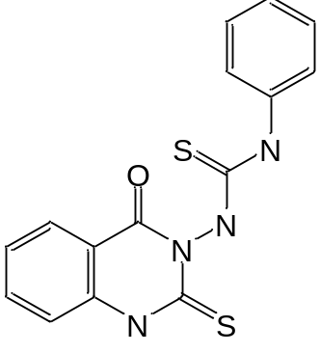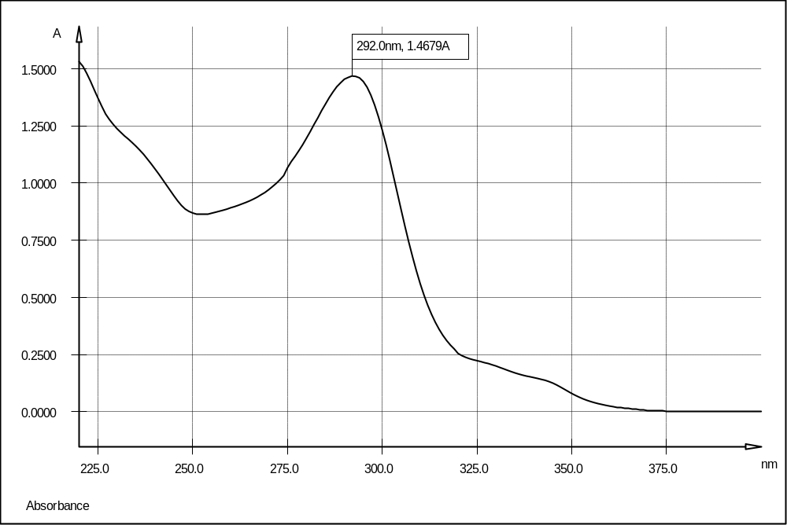
Figure S15. UV/Vis spectrum of 1-(4-Oxo-2-thioxo-1,4-dihydroquinazolin-3(2H)-yl)-3-phenylthiourea 3c (MeOH).
1-Benzyl-5-thioxo-5,6-dihydro-[1,2,4]triazolo[1,5-c]quinazolin-1-ium-2-thiolate 6a.
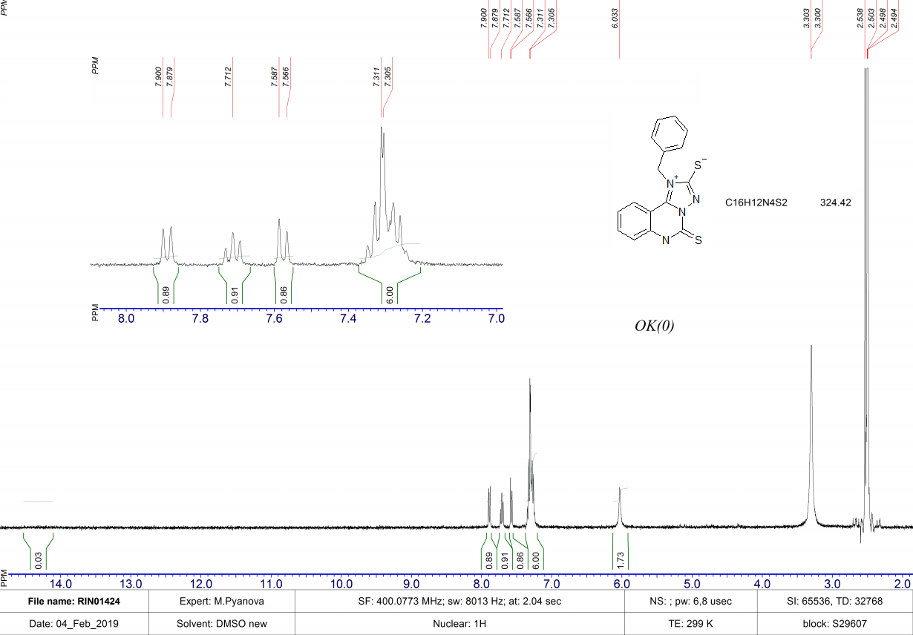
Figure S16. ¹H NMR spectrum (400 MHz, DMSO-d6) of 1-benzyl-5-thioxo-5,6-dihydro-[1,2,4]triazolo[1,5-c]quinazolin-1-ium-2-thiolate 6a.
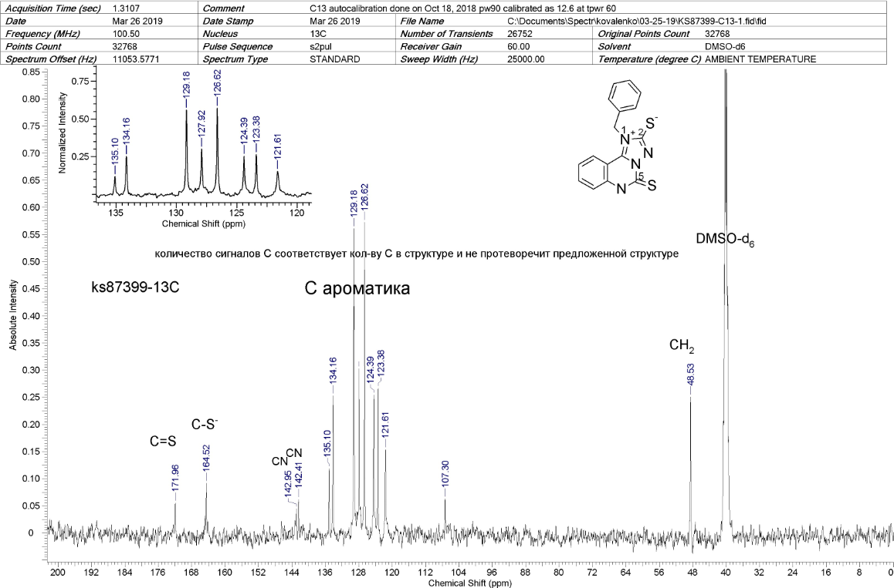
Figure S17. ¹³C NMR spectrum (100 MHz, DMSO-d6) of 1-benzyl-5-thioxo-5,6-dihydro-[1,2,4]triazolo[1,5-c]quinazolin-1-ium-2-thiolate 6a.

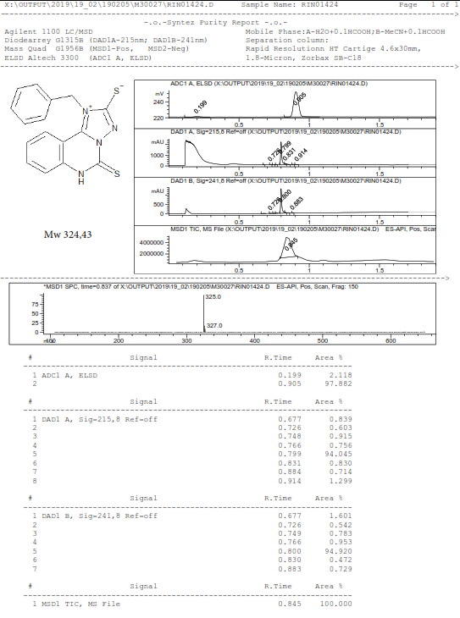
Figure S18. LC/MS data for 1-benzyl-5-thioxo-5,6-dihydro-[1,2,4]triazolo[1,5-c]quinazolin-1-ium-2-thiolate 6a.
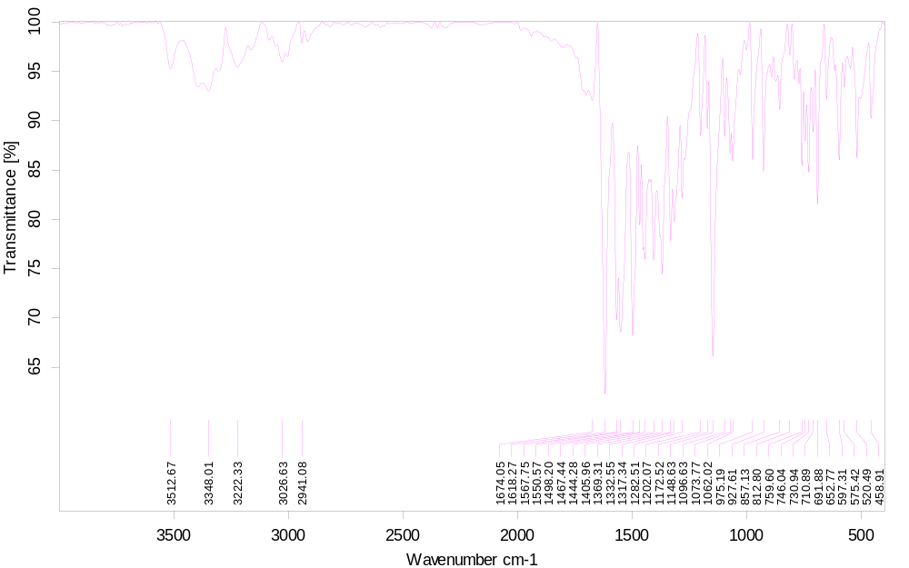
Figure S19. IR spectrum of 1-benzyl-5-thioxo-5,6-dihydro-[1,2,4]triazolo[1,5-c]quinazolin-1-ium-2-thiolate 6a.
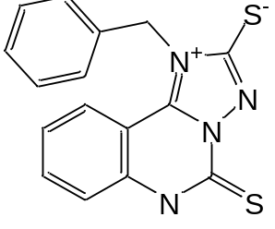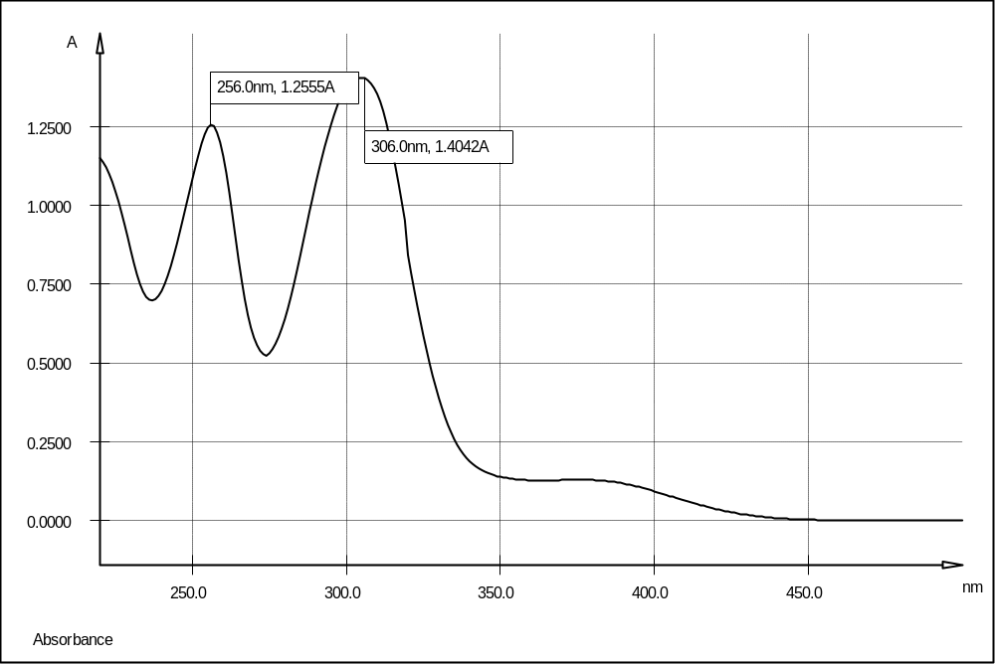
Figure S20. UV/Vis spectrum of 1-benzyl-5-thioxo-5,6-dihydro-[1,2,4]triazolo[1,5-c]quinazolin-1-ium-2-thiolate 6a (MeOH).
1-Ethyl-5-thioxo-5,6-dihydro-[1,2,4]triazolo[1,5-c]quinazolin-1-ium-2-thiolate 6b.
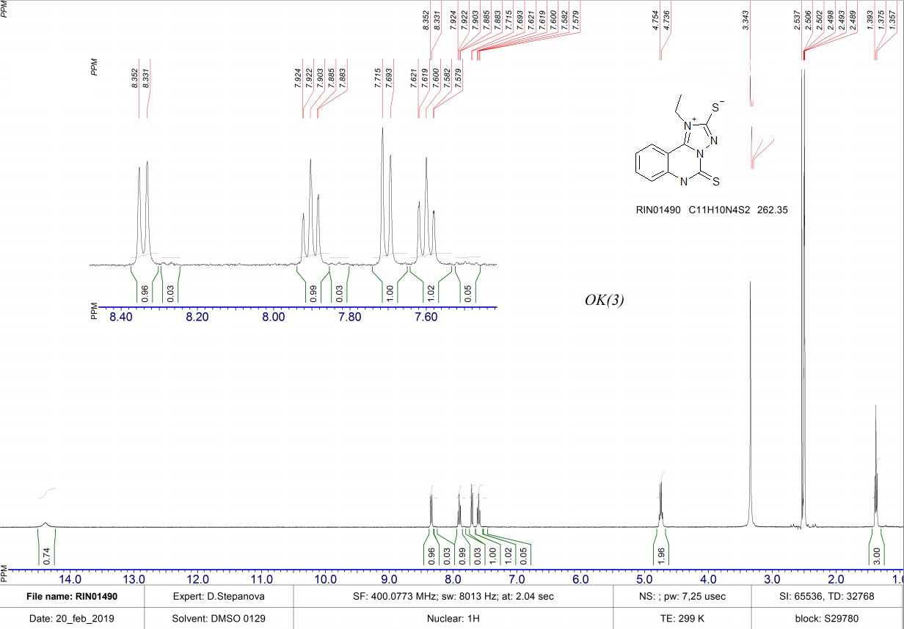
Figure S21. ¹H NMR spectrum (400 MHz, DMSO-d6) of 1-ethyl-5-thioxo-5,6-dihydro-[1,2,4]triazolo[1,5-c]quinazolin-1-ium-2-thiolate 6b.
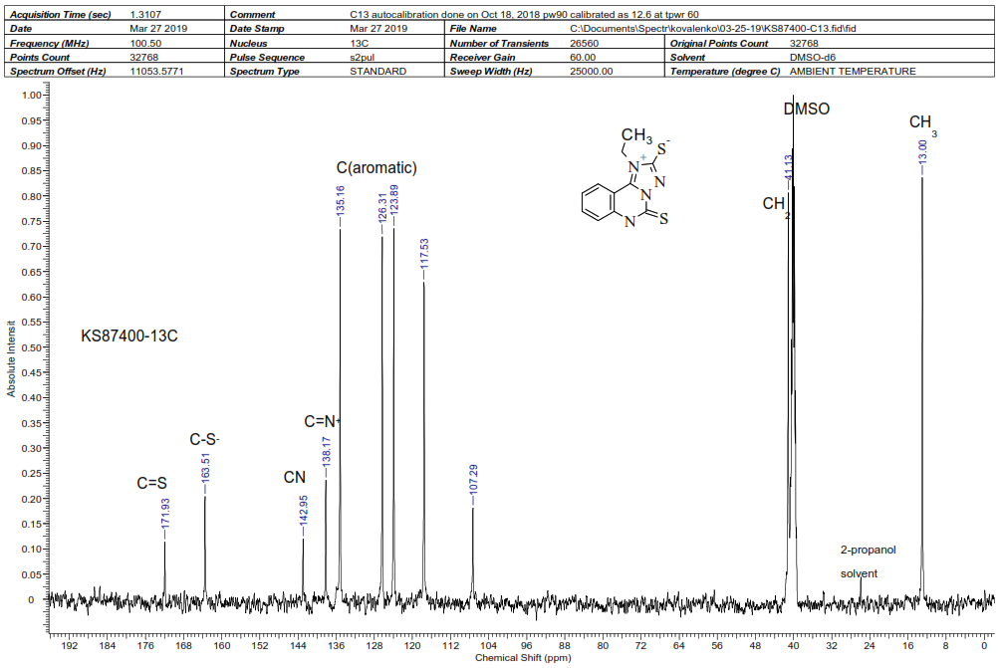
Figure S22. ¹³C NMR spectrum (100 MHz, DMSO-d6) of 1-ethyl-5-thioxo-5,6-dihydro-[1,2,4]triazolo[1,5-c]quinazolin-1-ium-2-thiolate 6b.

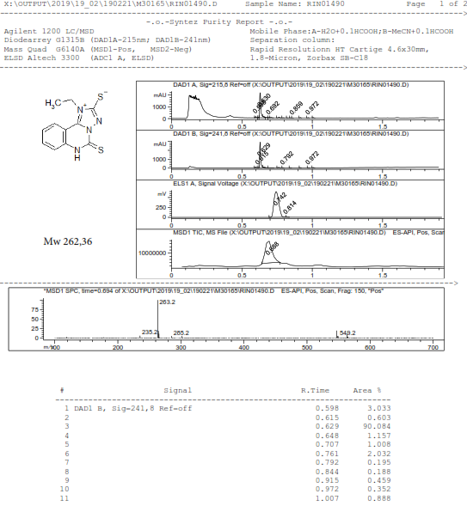

Figure S23. LC/MS data for 1-ethyl-5-thioxo-5,6-dihydro-[1,2,4]triazolo[1,5-c]quinazolin-1-ium-2-thiolate 6b.
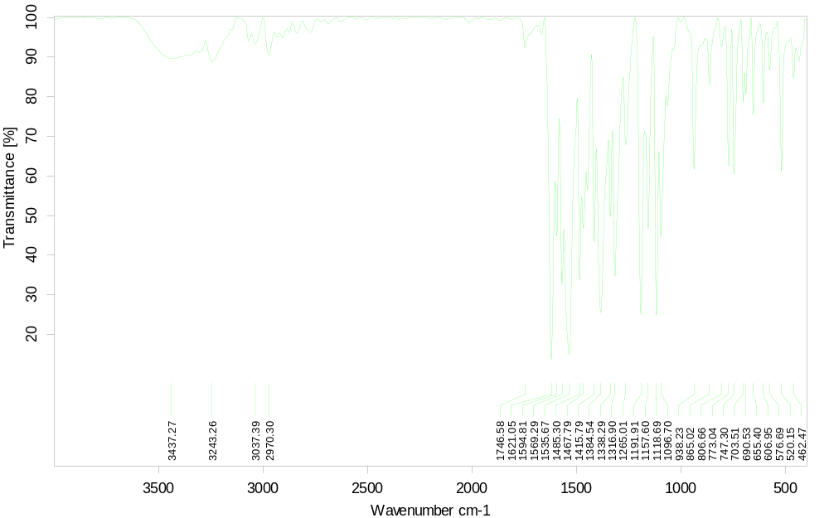
Figure S24. IR spectrum of 1-ethyl-5-thioxo-5,6-dihydro-[1,2,4]triazolo[1,5-c]quinazolin-1-ium-2-thiolate 6b.
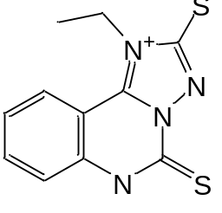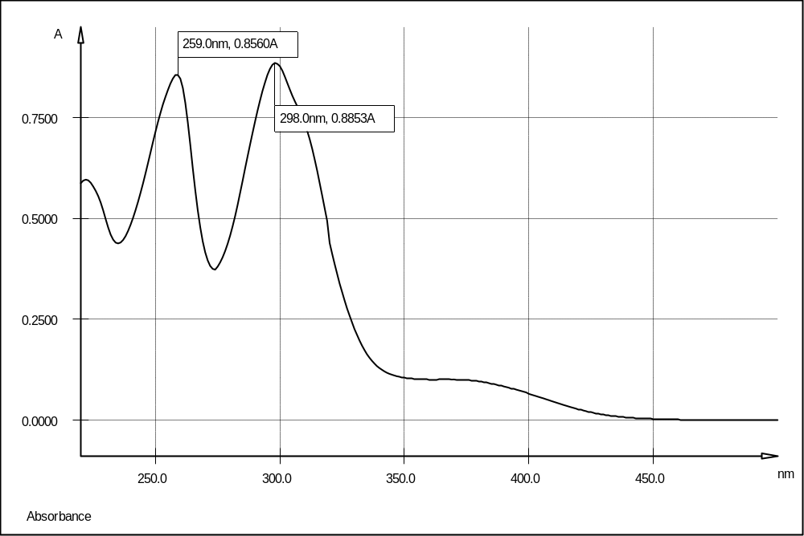
Figure S25. UV/Vis spectrum of 1-ethyl-5-thioxo-5,6-dihydro-[1,2,4]triazolo[1,5-c]quinazolin-1-ium-2-thiolate 6b (MeOH).
1-Phenyl-5-thioxo-5,6-dihydro-[1,2,4]triazolo[1,5-c]quinazolin-1-ium-2-thiolate 6c.
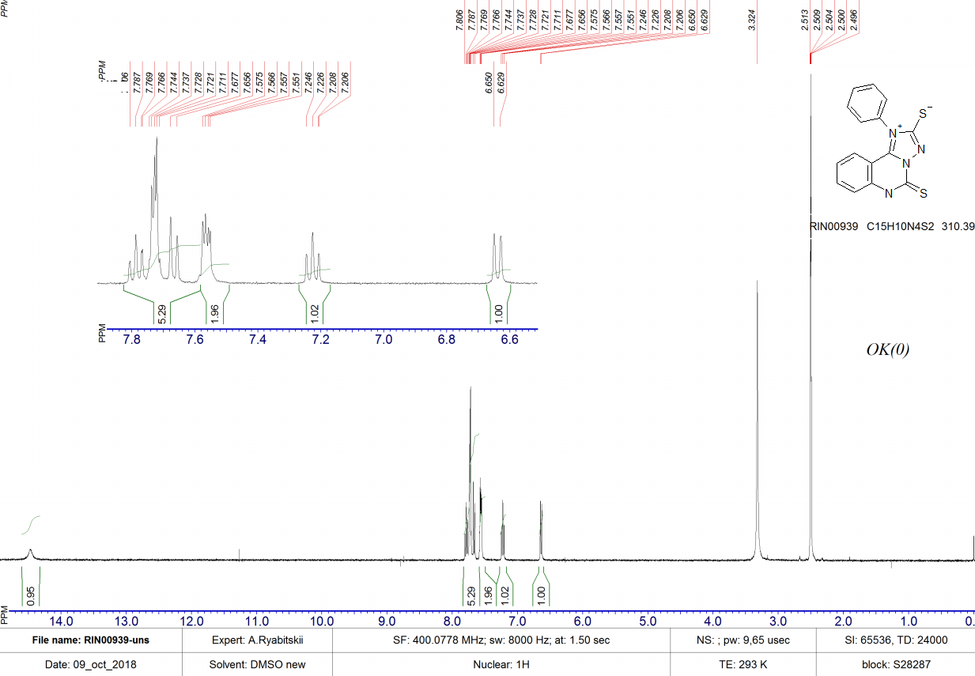
Figure S26. ¹H NMR spectrum (400 MHz, DMSO-d6) of 1-phenyl-5-thioxo-5,6-dihydro-[1,2,4]triazolo[1,5-c]quinazolin-1-ium-2-thiolate 6c.
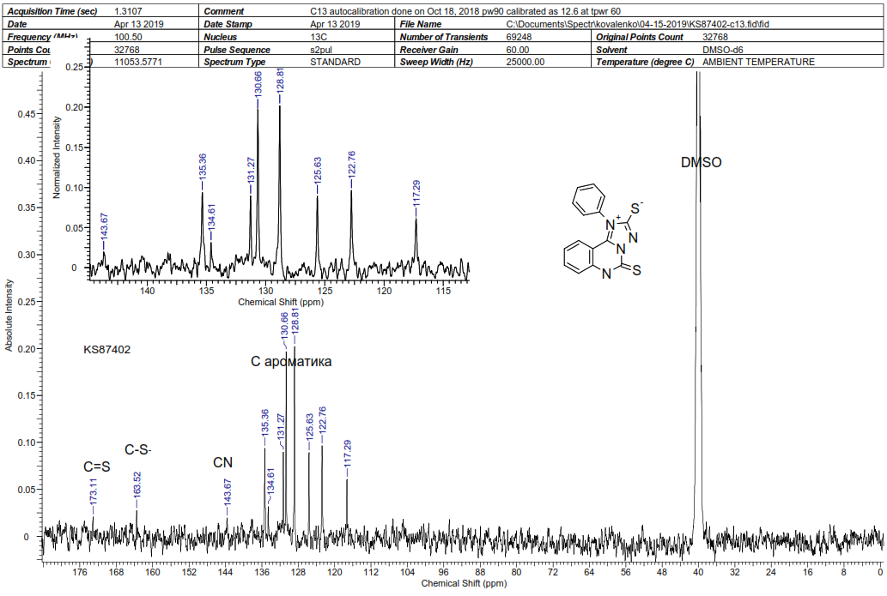
Figure S27. ¹³C NMR spectrum (100 MHz, DMSO-d6) of 1-phenyl-5-thioxo-5,6-dihydro-[1,2,4]triazolo[1,5-c]quinazolin-1-ium-2-thiolate 6c.

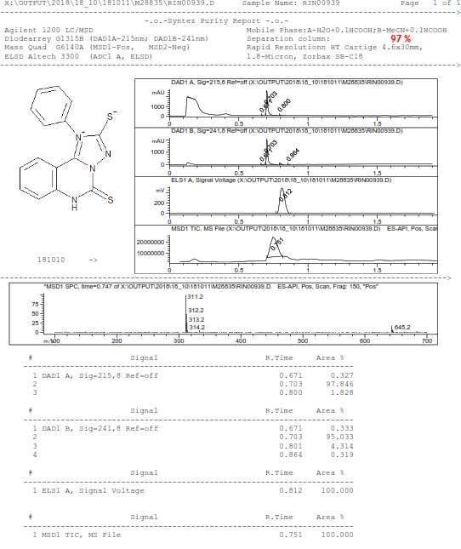

Figure S28. LC/MS data for 1-phenyl-5-thioxo-5,6-dihydro-[1,2,4]triazolo[1,5-c]quinazolin-1-ium-2-thiolate 6c.
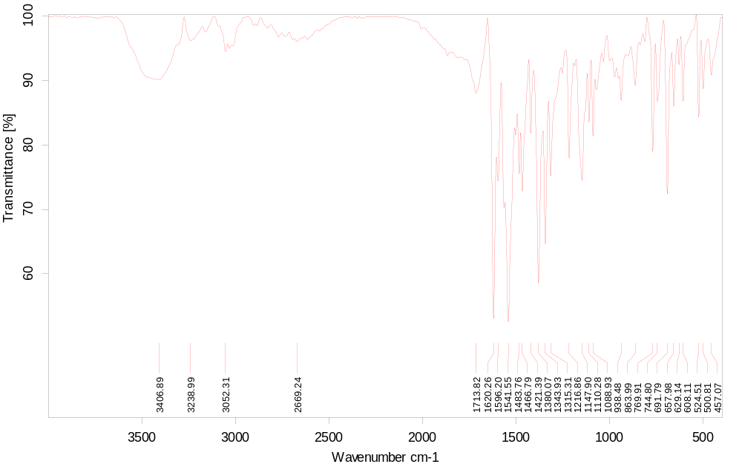
Figure S29. IR spectrum of 1-phenyl-5-thioxo-5,6-dihydro-[1,2,4]triazolo[1,5-c]quinazolin-1-ium-2-thiolate 6c.
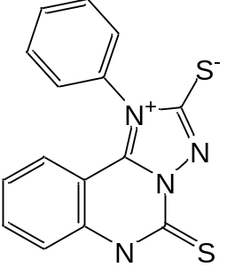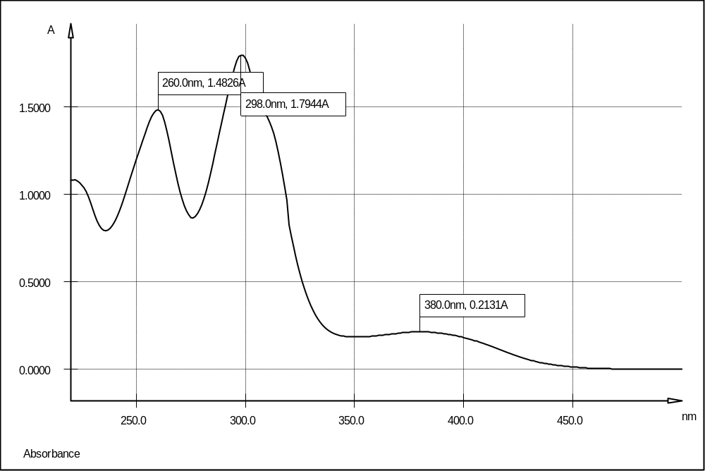
Figure S30. UV/Vis spectrum of 1-phenyl-5-thioxo-5,6-dihydro-[1,2,4]triazolo[1,5-c]quinazolin-1-ium-2-thiolate 6c (MeOH).

