Supplementary material

Green chemistry approach to the synthesis of 3-substituted-quinazolin-4(3H)-ones and 2-methyl-3-substituted-quinazolin-4(3H)-ones and biological evaluation
Mario Komarª, Maja Molnarª, Marijana Jukić^{b}, Ljubica Glavaš-Obrovac^{b}, Teuta Opačak-Bernardi^{b},*
ªFaculty of Food Technology Osijek, Josip Juraj Strossmayer University of Osijek, F. Kuhača 20 HR-31000 Osijek, Croatia;
^{b} Faculty of Medicine, Josip Juraj Strossmayer University of Osijek, J. Huttlera 4, HR-31000 Osijek, Croatia

3-(4-(trifluoromethoxy)phenyl)quinazolin-4(3H)-one (1)

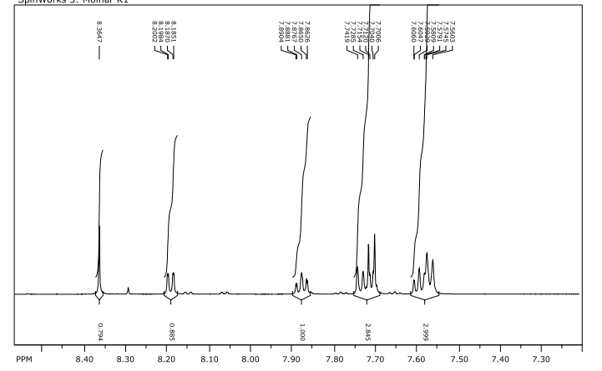

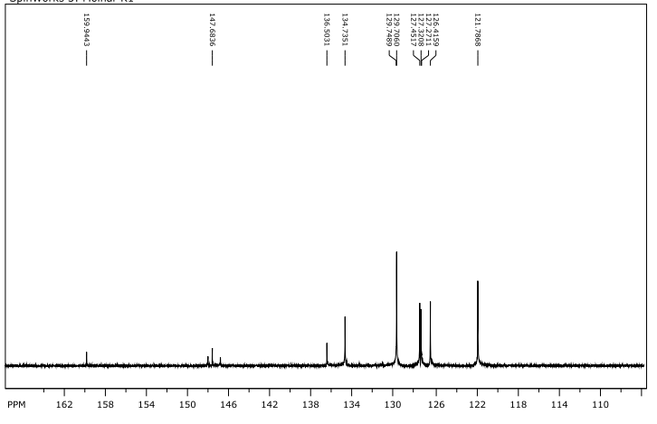

3-(2,5-dimethoxyphenyl)quinazolin-4(3H)-one (2)
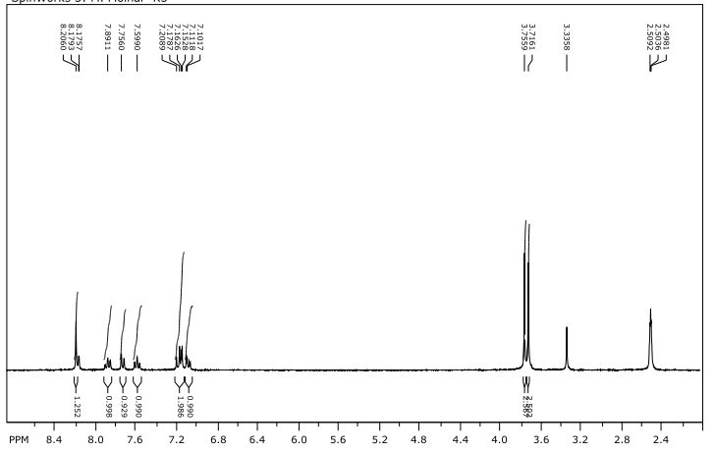

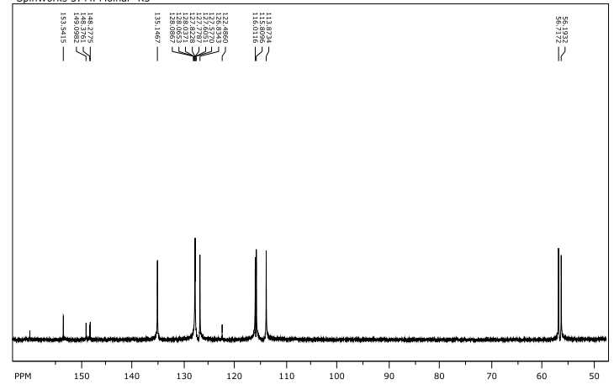

3-phenylquinazolin-4(3H)-one (3)
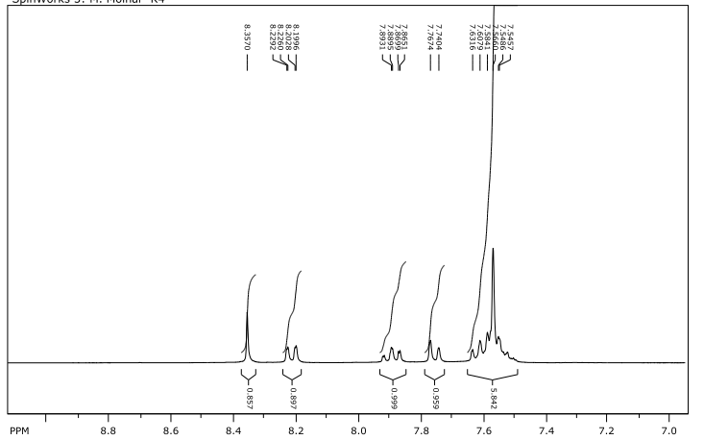
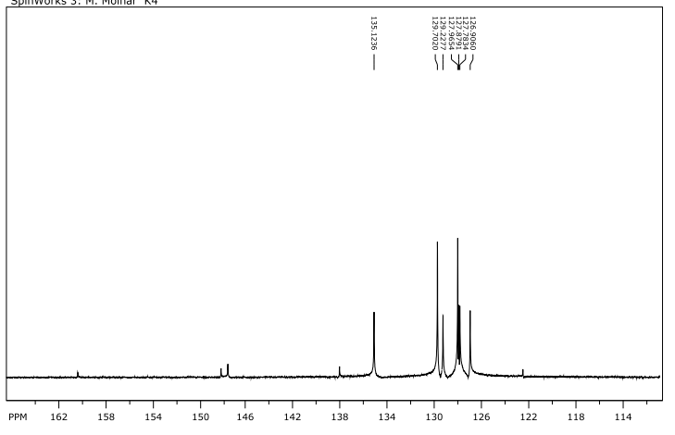

2-(4-oxoquinazolin-3(4H)-yl)benzoic acid (4)
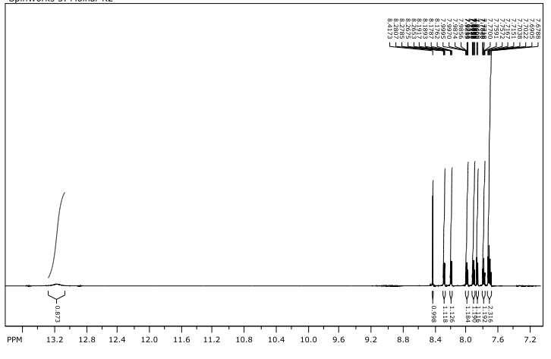

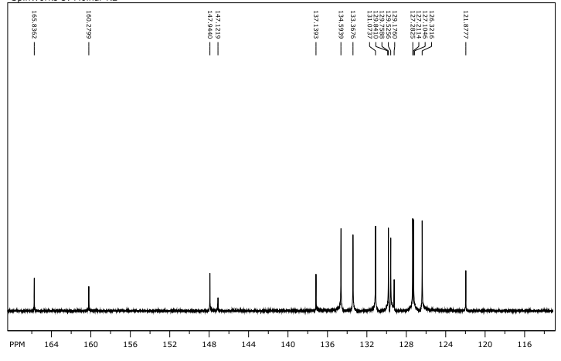

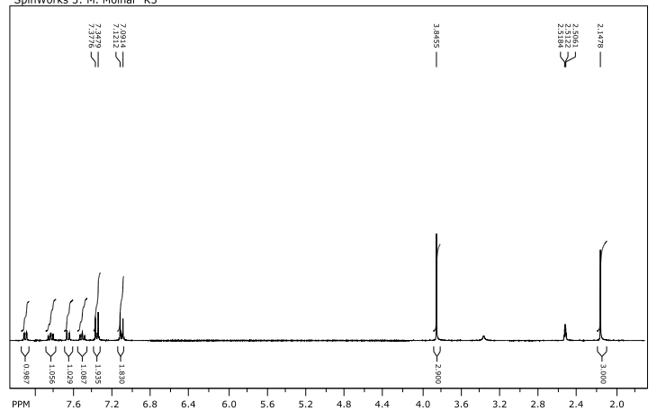
3-(4-methoxyphenyl)-2-methylquinazolin-4(3H)-one (5)

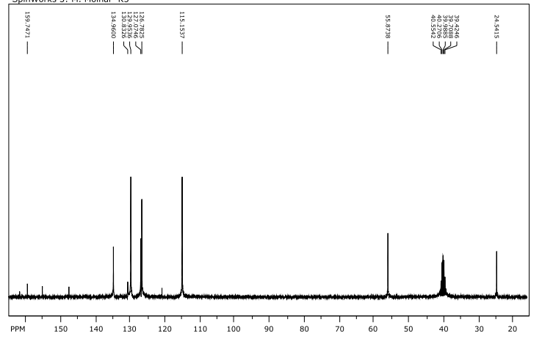

3-(4-chlorophenyl)-2-methylquinazolin-4(3H)-one (6)
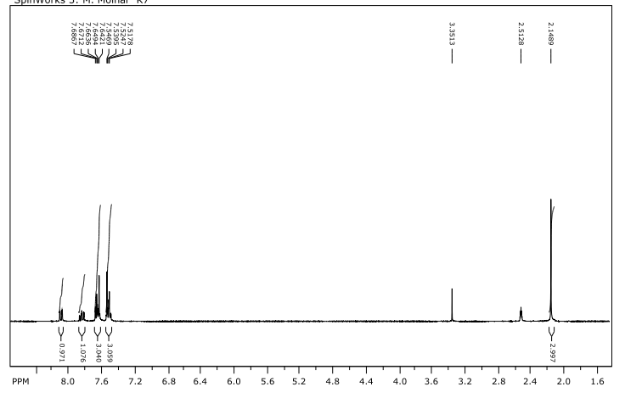

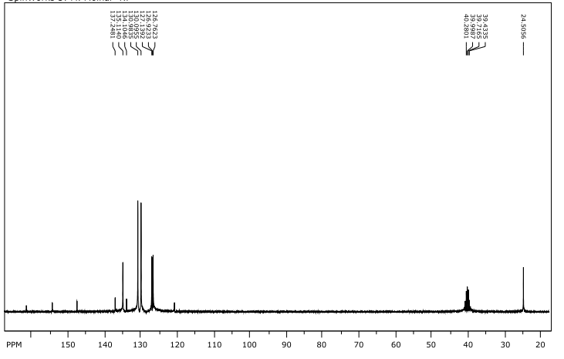

3-(4-methoxyphenyl)-2-methyl-6-nitroquinazolin-4(3H)-one (7)
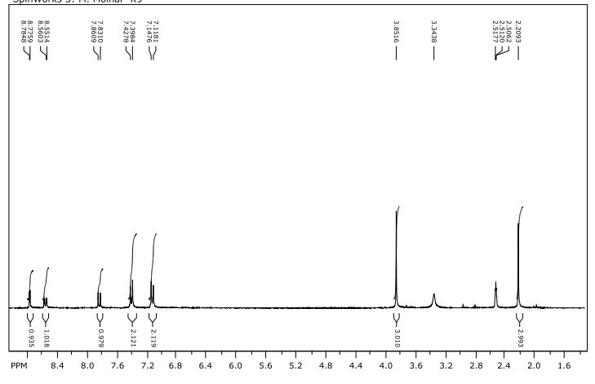

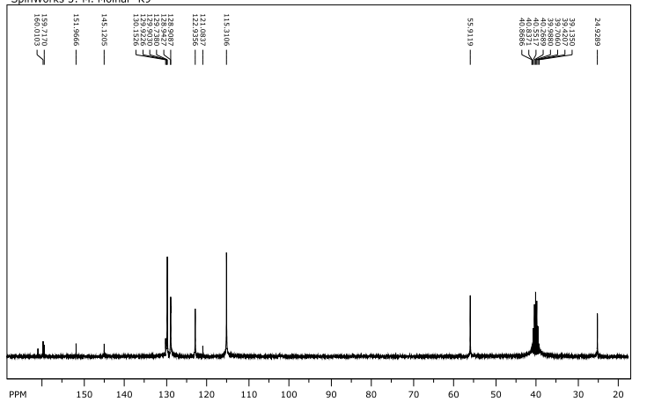

2-(7-hydroxy-2-oxo-2H-chromen-4-yl)-N-(2-methyl-4-oxoquinazolin-3(4H)-yl)acetamide (8)
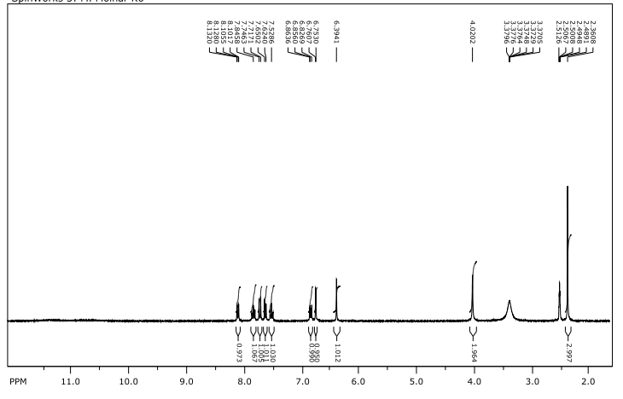

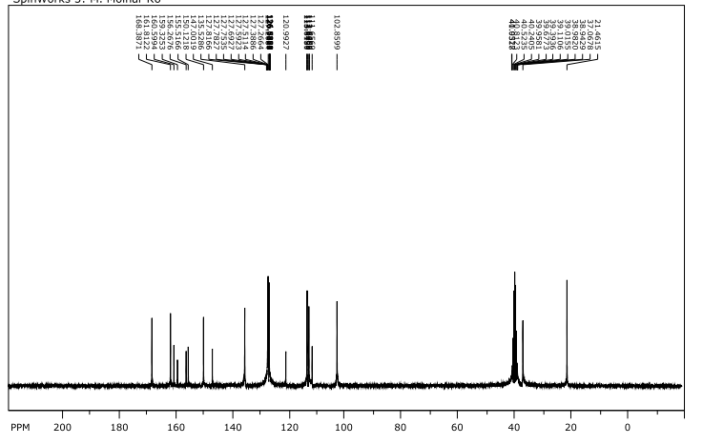

3-(4-bromophenyl)-2-methylquinazolin-4(3H)-one (9)
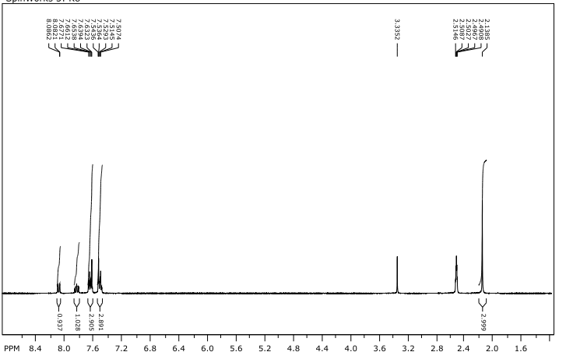

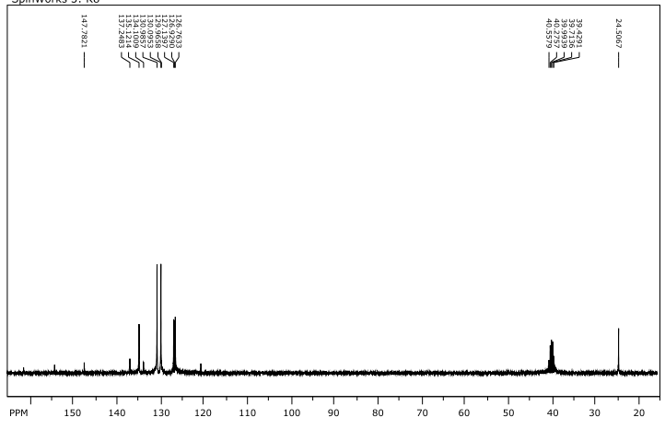

2-((4-methyl-2-oxo-2H-chromen-7-yl)oxy)-N-(2-methyl-4-oxoquinazolin-3(4H)-yl)acetamide (10)
