Supplementary Material

Chitosan/collagen composite films as wound dressings encapsulating allantoin and lidocaine hydrochloride

Gökçen Yaşayana1*, Gizem Karacaa1, Zeynep Püren Akgünerb, Ayça Bal Öztürkb,c

*a Department of Pharmaceutical Technology, Faculty o*f Pharmacy, Marmara University*, Haydarpaşa, Istanbul, Turkey*; *bDepartment of Stem Cell and Tissue Engineering, Institute of Health Sciences, Istinye University, Istanbul, Turkey*; *cDepartment of Analytical Chemistry, Faculty of Pharmacy, Istinye University, Zeytinburnu, Istanbul, Turkey*

*corresponding author: gokcen.yasayan@marmara.edu.tr (Gökçen Yaşayan)

1Equal contribution

Table of contents

1. Development and validation of a RP–HPLC method for determination of allantoin and lidocaine hydrochloride for pharmaceutical formulations

1.1. Preparation of solutions

1.2. Method Development

1.3. Method Validation

2. Characterisation studies of collagen/chitosan scaffolds

1. Development and validation of a RP–HPLC method for determination of allantoin and lidocaine hydrochloride for pharmaceutical formulations

**1.1. Preparation of solutions**

Considering the drug release studies, phosphate buffered saline (PBS) was used as the diluent, and prepared by dissolving 2.3 g of disodium hydrogen phosphate dodecahydrate, 0.19 g of potassium dihydrogen phosphate, and 8 g of sodium chloride in a 1000 ml distilled water, and adjusting the pH to 7.4 ± 0.05 by 1M of phosphoric acid (EP 9.0). For standard solution, approximately 50.0 mg of allantoin and 50.0 mg of lidocaine HCl were weighed into a 50 ml volumetric flask, and diluted to volume with PBS. The solution was stirred with a magnetic stirrer at 650 rpm for 20 minutes. For preparation of the test solution, scaffolds containing allantoin and lidocaine HCl (10 mg:10 mg, w/w) were prepared. The scaffolds were cut into pieces, was transferred into a 100 ml volumetric flask with a quantity equivalent to 10 mg of allantoin and 10 mg of lidocaine HCl. After solving scaffold pieces by a few drops glacial acetic acid, is diluted with PBS. After stirring with a shaker for 60 minutes, the resulting solution was centrifuged at 7800 rpm for 15 minutes. The supernatant was taken, and filtered using a 0.45 μm filter.

**1.2. Method development**

For the chromatographic conditions, phosphate buffer solution (pH 3.0) was prepared in one line, and acetonitrile in the other in order to achieve the shortest acquisition time. 80% of buffer solution, and 20% of acetonitrile was chosen at isocratic 1 ml/min flow. The most appropriate concentration for the test solution was specified as 1 mg/ml after trials in the range of 0.4-2 mg/ml. The absorbance of both allantoin and lidocaine HCl were evaluated over the range of 210 to 400 nm, wavelength of optimum absorbance found to be 220 nm for the substances. An injection volume of 5 µL was considered to be appropriate amount to see intended absorbance values. The column temperature was optimized to 40°C where the peaks are sharp, and resolution between the components are high.

**1.3. Method validation**

Analytical methods should be confirmed with an analytical method validation study before routine analyses to assure the unknown sample results. Specificity, precision, limit of detection and limit of quantification, robustness, linearity, and accuracy parameters were evaluated for method validation. The RP-HPLC method was validated according to ICH guidelines (ICH Q2R1).

**Specificity:** Specificity parameter of the analytical method was demonstrated in three steps: carry over, peak identification, and filter effect.Test solution was injected to the HPLC system before blank injection to verify that there is no carry over between consecutive injections. After six replicate injections, it was observed that there is no carry over from any of the components in scaffolds. After trials with several types of filters, the most suitable filter for this method found to be PET 0.45 µm filter. Peak identification and purity results are given in Table S1.

Table S1. Peak purity parameters of each active substance within formulations

|  |  |  |  |
| --- | --- | --- | --- |
| **Active substance** | **Retention time (min)** | **Purity Angle** | **Purity Threshold** |
| Allantoin | 2.5 | 0.211 | 0.297 |
| Lidocaine HCl | 7.4 | 0.201 | 0.313 |

In the chromatogram, there is no extraneous peak observed at the retention time of peaks of the active substances obtained from blank and placebo solutions. It was seen that peaks of active substance were pure, and all peaks were well resolved from each other (Figure S1-2).

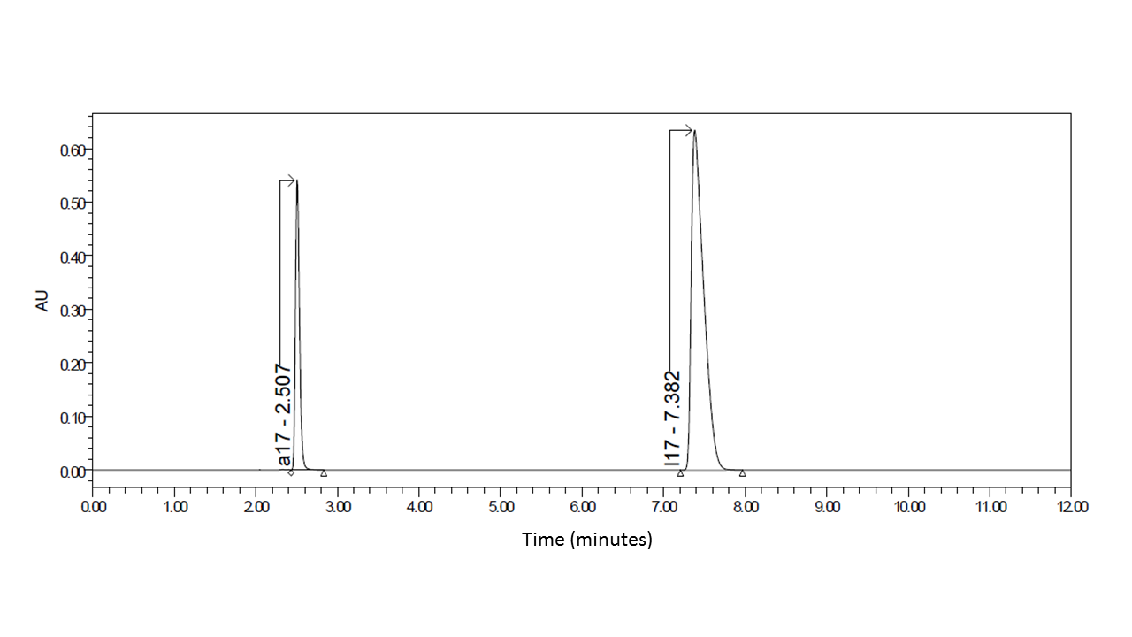

Figure S1. Standard chromatograms of allantoin (a17, peak 1) and lidocaine HCl (l17, peak 2) at their respective retention times.

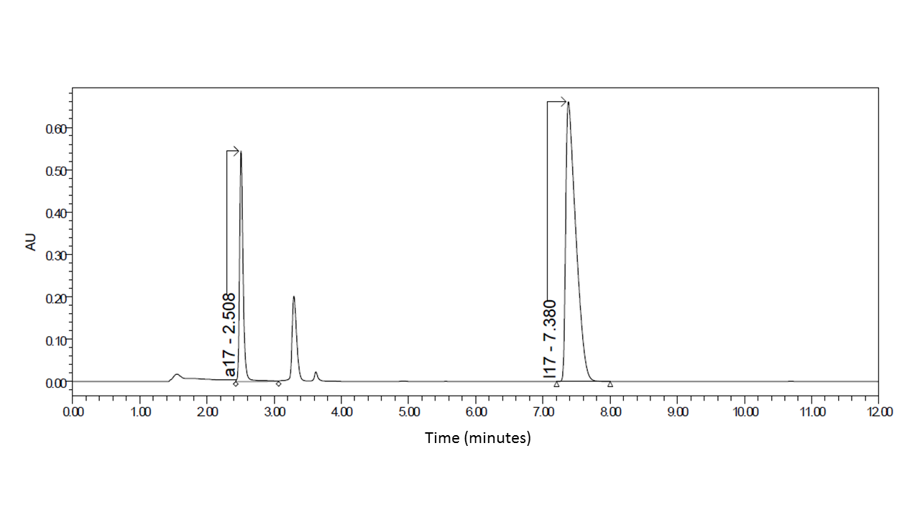

Figure S2. Test chromatograms of allantoin (a17, peak 1) and lidocaine HCl (l17, peak 2) at their respective retention times.

**Precision:** System precision and method precision parameters were evaluated.

***System precision:*** System precision isthe measurement of system performance parameter. It is independent of errors occurred at sample preparation stage. Six replicate injections of the standard solution were given to the HPLC system. According to results, the relative standard deviations of the areas correspond to the drug substances are acceptable, and are given in Table S2.

Table S2. System precision results for allantoin and lidocaine HCl

|  |  |  |
| --- | --- | --- |
| **Injection Number** | **Allantoin** | **Lidocaine HCl** |
| **1** | 1989660 | 7169118 |
| **2** | 1992645 | 7179661 |
| **3** | 1996963 | 7192680 |
| **4** | 1994845 | 7191359 |
| **5** | 1996558 | 7198914 |
| **6** | 1995334 | 7194858 |
| **Average** | 1994334 | 7187765 |
| **SD** | 2750 | 11181 |
| **RSD (%)** | 0.14 | 0.16 |

***Method precision:*** Three different test solutions from the same sample are prepared to measure the precision of the preparation method. Method precision results are given in Table S3.

Table S3. Method precision results for allantoin and lidocaine HCl

|  |  |  |  |  |
| --- | --- | --- | --- | --- |
| **Active substance** | **Content (mg)** | **SD** | **RSD (%)** | **Amount (%)** |
| Allantoin | 10 | 0.4 | 0.4 | 93.9 |
| Lidocaine HCl | 10 | 0.4 | 0.4 | 92.8 |

**Limit of detection (LOD) and limit of quantification (LOQ):** LOD is defined as the lowest concentration of sample that can be detected, but not necessarily quantified under the stated experimental conditions. LOQ is the determination of the lowest amount of sample that could be quantified with suitable precision and accuracy with the analytical method.

For determination of LOD and LOQ, low concentrations of both allantoin and lidocaine HCl solutions were prepared for injection. The concentration which has the signal/noise ratio ≥ 3.0 was determined as the detection limit for peak; and the concentration which has the signal/noise ratio ≥ 10.0 as quantitation limit. LOD and LOQ results are given in Table S4.

Table S4. Limit of detection (LOD) and limit of quantification (LOQ) results for allantoin and lidocaine HCl

|  |  |  |  |
| --- | --- | --- | --- |
| **Parameter** | **Active substance** | **Concentration (µg/ml)** | **Signal/noise** |
| LOD | Allantoin | 0.52 | 4.2 |
| Lidocaine HCl | 0.14 | 5.1 |
| LOQ | Allantoin | 1.04 | 10.1 |
| Lidocaine HCl | 0.29 | 10.7 |

**Robustness:** The robustness of the was established by introducing small changes in the chromatographic condition. It was observed that the method is unaffected by the changes in buffer solution pH by ±0.1, column temperature by ± 5°C,and flow rate by ± 0.05 ml.

**Stability studies:** Standard and test solutions were prepared with the method abovementioned, and kept at least 40 hours and 48 hours at room temperature respectively. Injections were performed, and analysed at the determined time points. The results obtained show that the standard solution is stable for 40 hours, and the test solution is stable for 48 hours at 25°C.

**Linearity:** The linearity range of the method was determined by seven different concentrations of standard solution. Concentration range of each active agent is given in Table S5, which means that at tabulated concentration range, the active agents give linear area response.

Table S5. Linearity results for allantoin and lidocaine HCl

|  |  |  |  |  |
| --- | --- | --- | --- | --- |
| **Active substance** | **Linearity range (mg/mL)** | **R2** | **Intercept** | **Slope** |
| Allantoin | 0.710-1.218 | 0.999689 | 46658 | 1.92x106 |
| Lidocaine HCl | 0.701-1.202 | 0.999997 | 52028 | 7.12x106 |

**Accuracy:** The accuracy of an analytical method is defined as the agreement between the found value and the true, independently determined, concentration value. In other words, accuracy is a prove of test solution giving precise results. Accuracy is demonstrated by adding active agents into the placebo powder between 70% and 120% of the test concentration. Recovery results are given in Table S6.

Table S6. Recovery results for allantoin and lidocaine HCL for the accuracy levels of 70%, 100%, and 120%

|  |  |  |
| --- | --- | --- |
| **Accuracy Level 70%** | **Allantoin** | **Lidocaine HCl** |
| 1 | 100.42 | 100.20 |
| 2 | 100.20 | 100.82 |
| 3 | 99.96 | 101.10 |
| Mean | 100.2 | 100.7 |
| SD | 0.2 | 0.5 |
| RSD (%) | 0.2 | 0.5 |
|  |  |  |
| **Accuracy Level 100%** |  |  |
| 1 | 99.83 | 99.73 |
| 2 | 99.93 | 100.10 |
| 3 | 100.10 | 99.52 |
| Mean | 100.0 | 99.8 |
| SD | 0.1 | 0.3 |
| RSD (%) | 0.1 | 0.3 |
|  |  |  |
| **Accuracy Level 120%** |  |  |
| 1 | 98.98 | 99.31 |
| 2 | 99.31 | 99.62 |
| 3 | 99.12 | 99.66 |
| Mean | 99.1 | 99.5 |
| SD | 0.2 | 0.2 |
| RSD (%) | 0.2 | 0.2 |

2. Characterisation studies of collagen/chitosan scaffolds



Figure S3. Optical microscope images of scaffold formulations; formulations without drugs (A) and with drugs (B) (Scale: 2 mm)



Figure S4. Comparative FT-IR spectra of CS, COL, and physical mixture of CS-COL.



Figure S5. Comparative FT-IR spectra of empty scaffold formulations. Scaffolds prepared from CS/COL blends with ratios of 100/0, 90/10, 70/30, 50/50, and 0/100.



Figure S6. Comparative FT-IR spectra of drug loaded scaffold formulations. Scaffolds prepared from CS/COL blends with ratios of 100/0, 90/10, 70/30, and 50/50.

Table S7. Average roughness and root-mean-square average roughness values of CS/COL blends calculated from AFM image data of Figure 2.

|  |  |  |
| --- | --- | --- |
| **CS/COL Ratio** | **Average Roughness (Ra) (μm)** | **Root-mean-square average roughness**  **(Rq) (μm)** |
| *Formulations without drug* | | |
| **100/0** | 0.08 | 0.10 |
| **90/10** | 0.08 | 0.10 |
| **70/30** | 0.08 | 0.10 |
| **50/50** | 0.11 | 0.14 |
| **0/100** | 0.05 | 0.07 |
| *Formulations with drug* | | |
| **100/0** | 0.21 | 0.24 |
| **90/10** | 0.26 | 0.31 |
| **70/30** | 0.22 | 0.26 |
| **50/50** | 0.18 | 0.22 |

Table S8. Thickness values of scaffolds prepared from CS/COL blends with ratios of 100/0, 90/10, 70/30, 50/50, and 0/100. Thickness values increase in proportion to the amount of CS within the formulation.

|  |  |  |  |  |  |
| --- | --- | --- | --- | --- | --- |
| Thickness values of scaffolds (mm) | | | | | |
| **CS/COL Ratio** | **100/0** | **90/10** | **70/30** | **50/50** | **0/100** |
|  | 0.49 | 0.42 | 0.32 | 0.26 | 0.18 |
|  | 0.41 | 0.39 | 0.25 | 0.18 | 0.16 |
|  | 0.43 | 0.37 | 0.20 | 0.24 | 0.22 |
| **Average** | 0.44 | 0.39 | 0.26 | 0.23 | 0.19 |
| **SD** | 0.04 | 0.03 | 0.06 | 0.04 | 0.03 |
| **RSD%** | 9.39 | 6.40 | 23.48 | 18.37 | 16.37 |

Table S9. Encapsulation efficiencies of AL and LH into scaffolds prepared from CS/COL blends with the ratios of 100/0, 90/10, 70/30, 50/50.

|  |  |  |  |
| --- | --- | --- | --- |
| **Encapsulation Efficiency (%)** | | | |
| **CS/COL Ratio** | **AL** | **LH** |
| **100/0** | 93.209 ± 0.05 | 90.786± 0.03 |
| **90/10** | 91.333± 0.04 | 96.125± 0.04 |
| **70/30** | 93.017± 0.03 | 89.887± 0.04 |
| **50/50** | 94.607± 0.01 | 92.099± 0.002 |

Table S10. Stability test results for formulation CS/COL 50/50. Stability test is carried at 25 °C ± 2 °C / 60% ± 5% relative humidity for 3 months.

|  |  |  |
| --- | --- | --- |
|  | **AL amount (mg)** | **LH amount (mg)** |
| Starting values | 9.62±0.16 | 9.68±0.21 |
| After 3 months | 9.49±0.25 | 9.44±0.01 |
| Drug content | 98.65% | 97.52% |