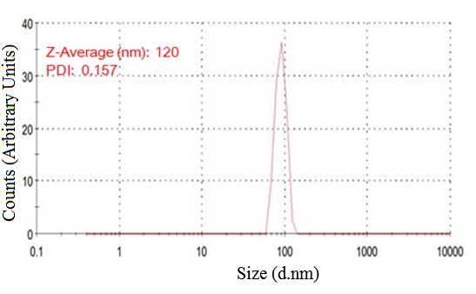
Figure S1 Size distribution of magnetic polymer by zeta measurement in water.

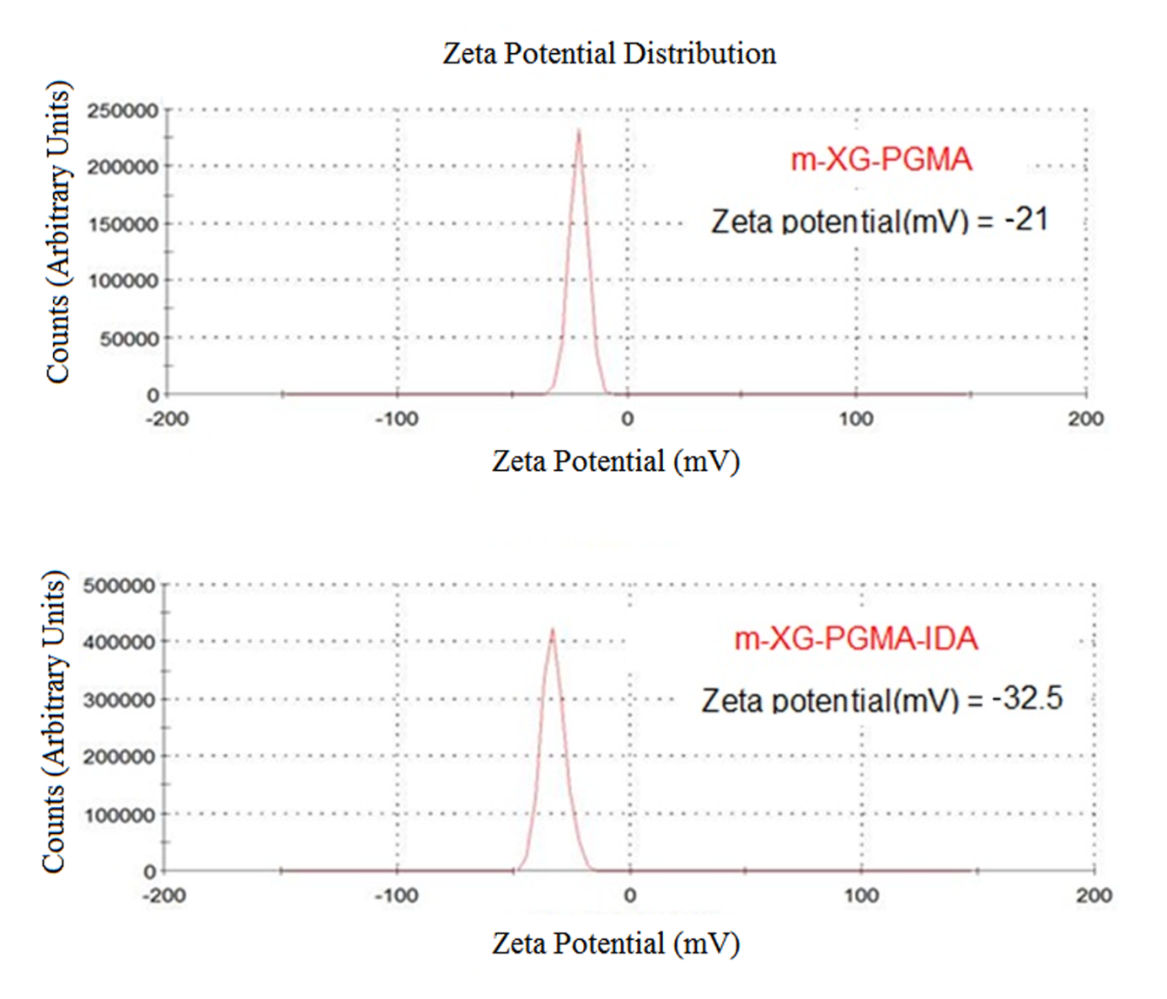

Figure S2 The change of surface charge of poly (glycidyl methacrylate)-grafted xanthan gum before and after iminodiacetic acid coupling at pH 8.

