Ditryptophenaline : White crystal solid, ESI-MS m/z 715.3 [M + Na]⁺; ¹H NMR (500 MHz, CDCl₃) symmetrical: δ 7.55 (2H, m, H-19/21), 7.50 (1H, m, H-20), 7.13 (2H, d, J = 6.5 Hz, H-18/22), 7.06 (1H, dt, J = 7.50, 1.0 Hz, H-6), 6.96 (1H, dd, J = 7.5, 1.0 Hz, H-4), 6.69 (1H, dt, J = 7.5, 0.5 Hz, H-5), 6.54 (1H, d, J = 7.5 Hz, H-7), 4.81 (1H, s, H-2), 4.25 (1H, ddd, J = 4.7, 3.2, 1.8 Hz, H-12), 3.72 (1H, dd, J = 7.5, 7.0 Hz, H-9), 3.65, 3.52 (1H, dd, J = 14.5, 3.0 Hz, H-15a), 3.24 (1H, dd, J = 14.0, 4.0 Hz, H-15b), 3.02 (3H, s, H-16), 2.01 (1H, dd, J = 12.0, 5.0 Hz, H-8α), 1.56 (1H, t, J = 12.0 Hz, H-8β). ¹³C NMR (CDCl₃, 500 MHz) symmetrical: δ 165.4 (C, C-10), 163.9 (C, C-13), 150.1 (C, C-7a), 134.4 (C, C-17), 129.6 (CH, C-6), 129.5 (2× CH, C-18/22), 129.3 (2× CH, C-19/21), 126.4 (C, C-3a), 125.7 (CH, C-4), 118.8(CH, C-5), 109.6 (CH, C-7), 78.7 (CH, C-2), 63.1 (CH, C-12), 58.9 (C, C-3), 58.5 (CH, C-9), 36.2(CH₂, C-8), 36.0 (CH₂, C-15), 32.6 (CH₃, C-16).

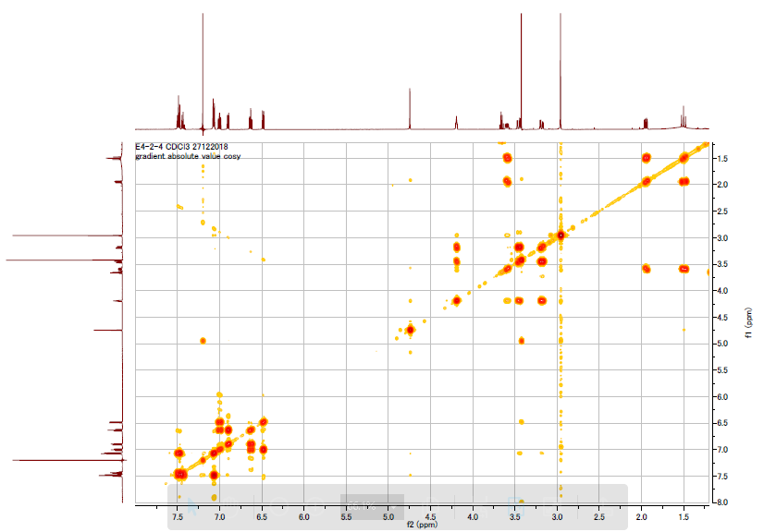

Fig (S1) : COSY spectrum of 1 in CDCl₃ 500 MHz.

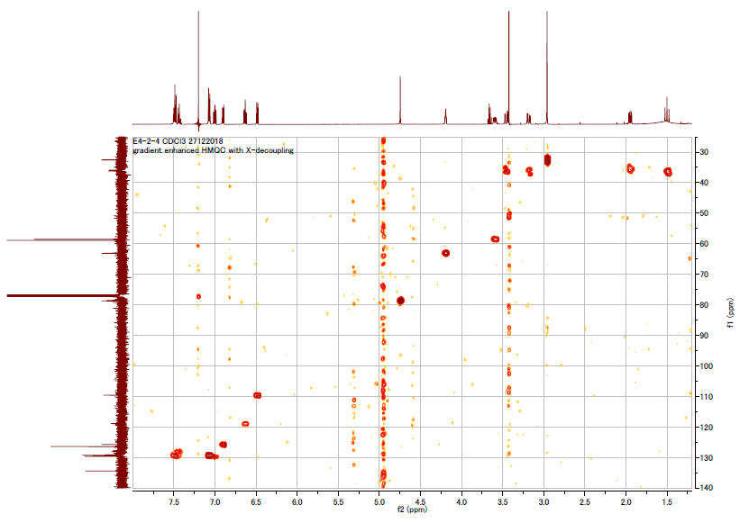
Fig (S2) : HMQC spectrum of 1 in CDCl₃ 500 MHz.

