Appendix A
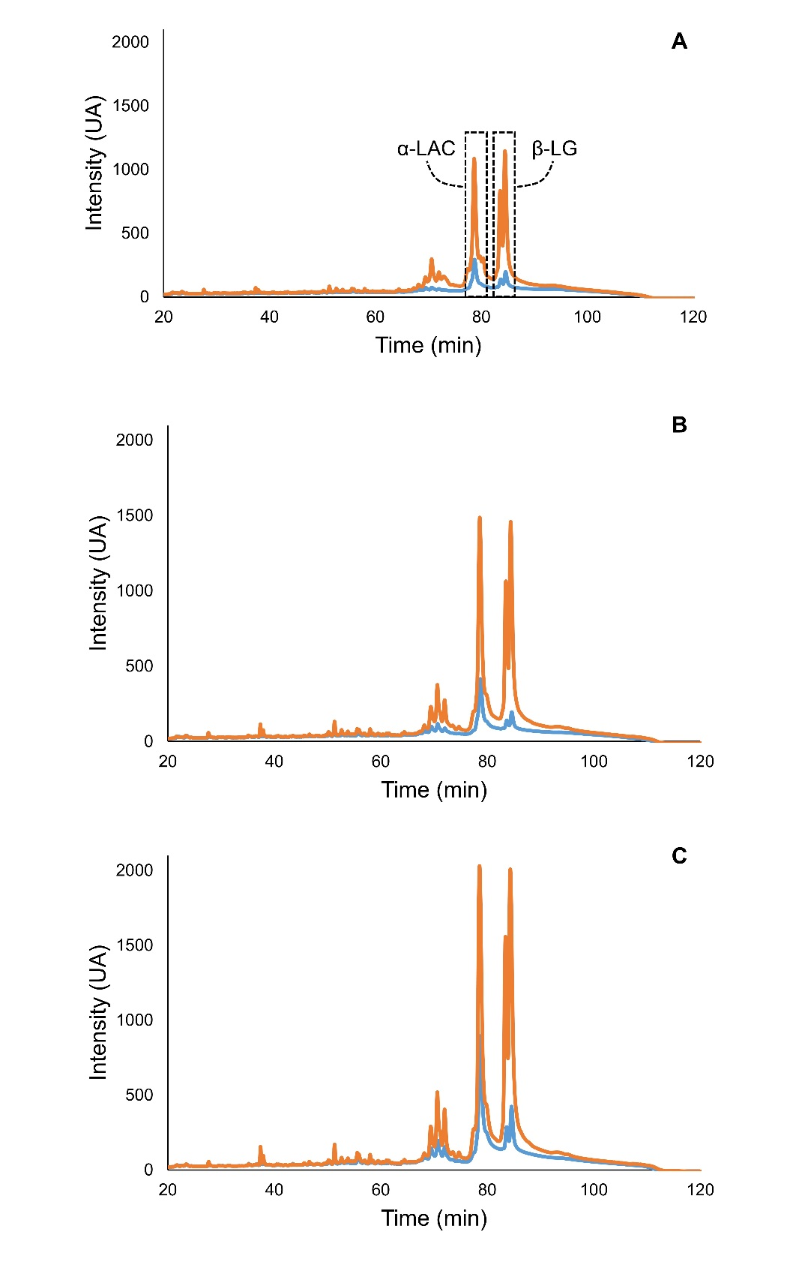
Figure A.1. Chromatogram of non-pressurized (red line) and pressurized milk (orange line) permeates at (A) 1.5×, (B) 3.0× and (C) 4.0×

