Supplementary Material

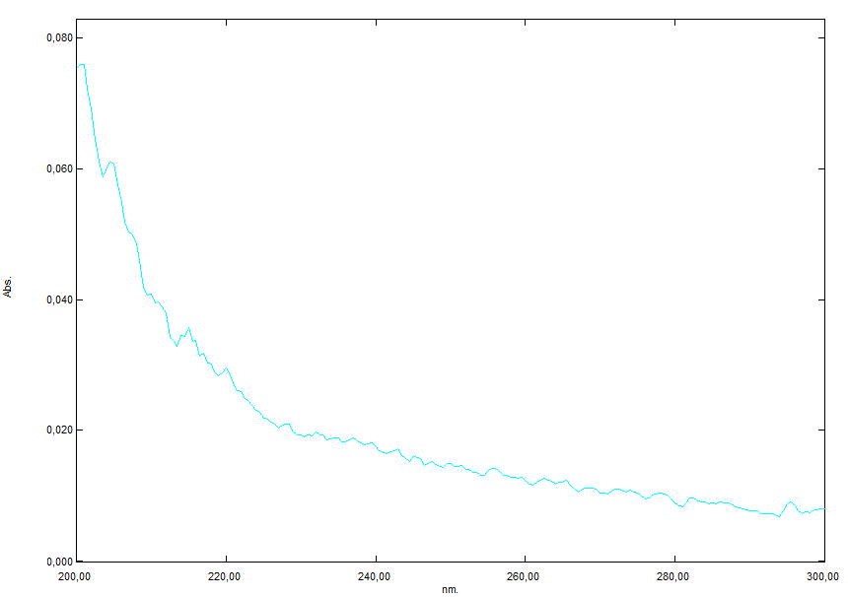
Fig. S1. Absorption spectrum of 100 ppm TBP in Evian water (cuvette width, 10 mm).

 | Sum of  Squares | df | Mean  Square | F  Value | p-value
Source |  |  |  |  | Prob > F
Model | 333.9700 | 4 | 83.4900 | 279.8600 | 0.0001
A-pH | 0.0913 | 1 | 0.0913 | 0.3059 | 0.5858
B-Conc TBP | 8.5300 | 1 | 8.5300 | 28.5800 | 0.0001
C-Eq H2O2 | 305.8000 | 1 | 305.8000 | 1025.0500 | 0.0001
C² | 38.4500 | 1 | 38.4500 | 128.9000 | 0.0001
Residual | 6.5600 | 22 | 0.2983
Cor Total | 340.5300 | 26
Std. Dev. | 0.5462 |  | R-Squared | 0.9807
Mean | 6.7400 |  | Adj R-Squared | 0.9772
C.V. % | 8.1000 |  | Pred R-Squared | 0.9697
 |  |  | Adeq Precision | 40.5729
(P release 60min)^{0,5} | = |  | Model | Significant
2.133590 |  |  | A-pH | Non Significant
0.021709 | * pH |  | B-Conc TBP | Significant
-0.001526 | * Conc TBP |  | C-Eq H2O2 | Significant
0.479000 | * Eq H2O2 |  | C² | Significant
-0.006663 | * Eq H2O2 ² |  | Std. deviation | Significant
 |  |  | Adequation | Significant
 |  |  | Precision | Significant

$$\sqrt{Y_{PO4} (60 \text{min})}=2.13+0.022⋅pH-0.0015⋅C_{TBP}+0.479⋅D_{H_{2}O_{2}}-0.0067 ⋅D_{H_{2}O_{2}}^{2}$$

Fig. S2. Output of the fitting software Design Expert 11 for the reduced quadratic model of phosphate release after 1h.

 | Sum of  Squares | df | Mean  Square | F  Value | p-value
Source |  |  |  |  | Prob > F
Model | 16595.9600 | 8 | 2074.4950 | 74.4900 | 0.0001
A-pH | 211.4400 | 1 | 211.4400 | 7.5900 | 0.0130
B-Conc TBP | 199.4400 | 1 | 199.4400 | 7.1600 | 0.0154
C-Eq H2O2 | 11243.8900 | 1 | 11243.8900 | 403.7200 | 0.0001
AB | 433.6300 | 1 | 433.6300 | 15.5700 | 0.0009
BC | 261.2500 | 1 | 261.2500 | 9.3800 | 0.0067
A² | 349.2100 | 1 | 349.2100 | 12.5400 | 0.0023
B² | 1125.3700 | 1 | 1125.3700 | 40.4100 | 0.0001
C² | 935.8000 | 1 | 935.8000 | 33.6000 | 0.0001
Residual | 501.3200 | 18 | 27.8511
Cor Total | 17097.2800 | 26
Std. Dev. | 5.2800 |  | R-Squared | 0.9707
Mean | 45.8100 |  | Adj R-Squared | 0.9576
C.V. % | 11.5200 |  | Pred R-Squared | 0.9358
 |  |  | Adeq Precision | 26.8683
 |  |  | Model | Significant
TOC removal 60min | = |  | A-pH | Significant
-25.402910 |  |  | B-Conc TBP | Significant
15.574030 | * pH |  | C-Eq H2O2 | Significant
0.092403 | * Conc TBP |  | AB | Significant
0.244197 | * Eq H2O2 |  | BC | Significant
-0.004065 | * pH * Conc TBP |  | A² | Significant
-0.000531 | * Conc TBP * Eq H2O2 |  | B² | Significant
-1.179240 | * pH ² |  | C² | Significant
-6.90E-05 | * Conc TBP ² |  | Std. deviation | Non Significant
0.032868 | * Eq H2O2 ² |  | Adequation | Significant
 |  |  | Precision | Significant

$$X \left(60 \text{min}\right)=- 25.403+15.574⋅pH+0.092⋅C_{TBP}+0.244⋅D_{H_{2}O_{2}}-0.0041 ⋅pH⋅C_{TBP}-5.31⋅{10}^{-4}⋅C_{TBP}⋅D_{H_{2}O_{2}}-1.179⋅pH^{2}-6.90⋅{10}^{-5}⋅ C_{TBP}^{2} +0.033⋅D_{H_{2}O_{2}}^{2}$$

Fig. S3. Output of the fitting software Design Expert 11 for the reduced quadratic model of TOC removal after 1h.
 | Sum of  Squares | df | Mean  Square | F  Value | p-value
Source |  |  |  |  | Prob > F
Model | 236.7700 | 5 | 47.3500 | 154.2300 | 0.0001
A-pH | 1.6500 | 1 | 1.6500 | 5.3800 | 0.0306
B-Conc TBP | 37.2200 | 1 | 37.2200 | 121.2300 | 0.0001
C-Eq H2O2 | 196.2000 | 1 | 196.2000 | 638.9900 | 0.0001
BC | 2.0400 | 1 | 2.0400 | 6.6500 | 0.0175
C² | 6.5800 | 1 | 6.5800 | 21.4400 | 0.0001
Residual | 6.4500 | 21 | 0.3070
Cor Total | 243.2100 | 26
Std. Dev. | 0.5541 |  | R-Squared | 0.9735
Mean | 5.0100 |  | Adj R-Squared | 0.9672
C.V. % | 11.0700 |  | Pred R-Squared | 0.9559
 |  |  | Adeq Precision | 38.0325
(P release 15min)^0.5 | = |  | Model | Significant
1.821930 |  |  | A-pH | Significant
0.092345 | * pH |  | B-Conc TBP | Significant
-0.002251 | * Conc TBP |  | C-Eq H2O2 | Significant
0.304611 | * Eq H2O2 |  | BC | Significant
-4.70E-05 | * Conc TBP * Eq H2O2 |  | B² | Significant
-0.002757 | * Eq H2O2 ² |  | Std. deviation | Significant
 |  |  | Adequation | Significant
 |  |  | Précision | Significant

$$\sqrt{Y_{PO4} (15 min)}=1.822+0.092⋅pH-0.0023⋅C_{TBP}+0.305⋅D_{H_{2}O_{2}}-4.70⋅{10}^{-5}⋅C_{TBP}⋅D_{H_{2}O_{2}}-0.0028 ⋅D_{H_{2}O_{2}}^{2}$$

Fig. S4. Output of the fitting software Design Expert 11 for the reduced quadratic model of phosphate release after 15 min.

