Supplemental online material
Table S1. Rates of grade ≥3 adverse events per treatment arm and cost per adverse event
Adverse Eventsª | Kd70 QW (%) | Kd27 BIW  (%) | Costs per Episode ($)^{b}
Blood and Lymphatic System Disorders
Neutropenia | 5.88 | 6.81 | 9,233
Anemia | 17.65 | 17.87 | 6,161
Thrombocytopenia | 7.14 | 6.81 | 5,394
Vascular Disorders
Hypertension | 5.46 | 5.11 | 2,639
Thrombo-Embolic Event^{c} | 2.10 | 1.28 | 9,867^{c}
General Disorders and Administration Site Conditions
Fatigue | 4.62 | 2.13 | 2,190
Infections and Infestations | 22.69 | 19.57 | 1,281
Infection | 2.10 | 0.85 | 1,281
Bronchitis | 0.84 | 2.13 | 1,230
Pneumonia | 10.08 | 6.81 | 1,648
Sepsis | 2.52 | 1.28 | 13,099
Septic Shock | 2.10 | 0.43 | 41,492
Upper Respiratory Tract Infection | 0.84 | 2.13 | 1,281
Renal and Urinary Disorders
Acute Kidney Injury | 3.36 | 3.40 | 14,545
Eye Disorders
Cataract | 2.94 | 2.55 | 1,313
Investigations
Neutrophil Count Decreased | 2.94 | 0.43 | 9,233
Platelet Count Decreased | 4.20 | 5.11 | 5,394
Metabolism and Nutrition Disorders
Hypercalcemia | 1.26 | 2.55 | 7,871
Hyperglycemia | 1.68 | 2.13 | 4,313
Hypokalemia | 2.52 | 1.28 | 3,963
Tumor Lysis Syndrome | 2.94 | 0.85 | 83,302
Neoplasms benign, malignant and unspecified (including cysts and polyps)
Plasma Cell Myeloma | 1.68 | 3.40 | 0
Nervous system disorders
Syncope | 2.10 | 0.43 | 7,415
Kd70 QW: once weekly carfilzomib 70 mg/m² and dexamethasone; Kd27 BIW: twice weekly carfilzomib 27mg/m² and dexamethasone
ª Percentages and costs are before per cycle adjustments.
^{b} Costs for adverse events were from Policy Analysis Inc. (2015), inflated to September 2018.
^{c} Calculated as a weighted average of the costs for ‘Deep vein thrombosis’ and for ‘Pulmonary embolism’ in the source.

Table S2. Relative frequency of subsequent treatments and cost per cycle
 | Relative frequency (%) | Drug acquisition cost per cycle ($) | Administration cost per cycle ($) | Adverse event cost per cycle ($)
Carfilzomib + lenalidomide + dexamethasone | 6.2% | 24,218 | 584 | 299
Carfilzomib + pomalidomide + dexamethasone | 8.8% | 26,153 | 567 | 1,564
Carfilzomib + cyclophosphamide + dexamethasone | 7.7% | 9,943 | 584 | 299
Daratumumab + lenalidomide + dexamethasone | 21.7% | 24,209 | 361 | 773
Daratumumab + bortezomib + dexamethasone | 10.0% | 18.934 | 918 | 993
Daratumumab + pomalidomide + dexamethasone | 28.3% | 36,769 | 776 | 4,177
Daratumumab | 10.8% | 17,721 | 678 | 749
Elotuzumab + lenalidomide + dexamethasone | 2.7% | 25,256 | 335 | 1,098
Ixazomib + lenalidomide + dexamethasone | 2.3% | 24,587 | 0 | 322
Pomalidomide + bortezomib + dexamethasone | 1.5% | 21,290 | 327 | 1,289

Table S3. Akaike and Bayesian Information Criterion values for fitted survival models to Kd70 QW and Kd27 BIW, progression-free survival
 | Kd70 QW |  | Kd27 BIW
 | AIC | BIC | AIC | BIC
Weibull | 946.9 | 953.8 | 1008.6 | 1015.6
Loglogistic | 946.4 | 953.4 | 1002.2 | 1009.1
Exponential | 944.9 | 948.4 | 1007.0 | 1010.5
Gompertz | 946.9 | 953.8 | 1008.4 | 1015.4
Gen.Gamma | 945.6 | 956.0 | 1001.8 | 1012.3
Lognormal | 943.8 | 950.8 | 999.9 | 1006.8
AIC: Akaike Information Criterion; BIC: Bayesian Information Criterion; Kd70 QW: once weekly carfilzomib 70 mg/m2 and dexamethasone; Kd27 BIW: twice weekly carfilzomib 27 mg/m2 and dexamethasone.

Table S4. Akaike and Bayesian Information Criterion values for fitted survival models to Kd70 QW and Kd27 BIW, overall survival
 | Kd70 QW |  | Kd27 BIW
 | AIC | BIC | AIC | BIC
Weibull | 564.0 | 571.0 | 633.1 | 640.1
Loglogistic | 563.4 | 570.4 | 632.5 | 639.4
Exponential | 562.4 | 565.8 | 631.4 | 634.8
Gompertz | 563.3 | 570.2 | 633.4 | 640.3
Gen.Gamma | 563.8 | 574.2 | 634.4 | 644.8
Lognormal | 561.8 | 568.8 | 633.1 | 640.1
AIC: Akaike Information Criterion; BIC: Bayesian Information Criterion; Kd70 QW: once weekly carfilzomib 70 mg/m2 and dexamethasone; Kd27 BIW: twice weekly carfilzomib 27 mg/m2 and dexamethasone.

Figure S1. Proportional hazards diagnostic plots
Panel 1. Progression-free survival: log cumulative hazard plot (time in log scale)
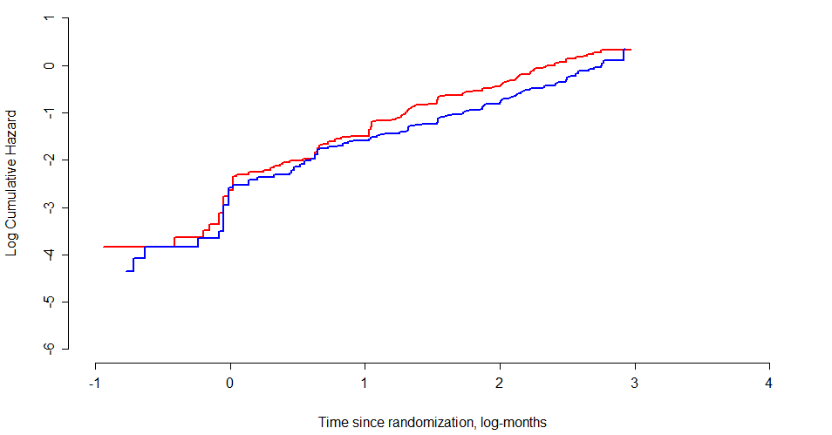
― Kd70 QW
― Kd27 BIW

Kd70 QW: once weekly carfilzomib 70 mg/m2 and dexamethasone; Kd27 BIW: twice weekly carfilzomib 27 mg/m2 and dexamethasone.

Panel 2. Progression-free survival: log cumulative hazard plot (time in real scale)
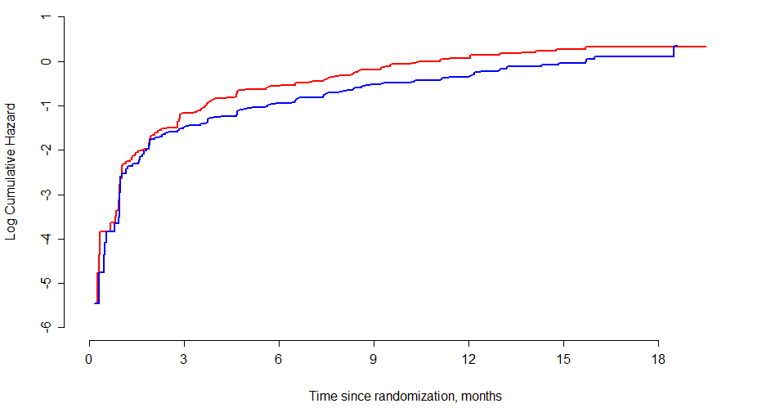
― Kd70 QW
― Kd27 BIW

Kd70 QW: once weekly carfilzomib 70 mg/m2 and dexamethasone; Kd27 BIW: twice weekly carfilzomib 27 mg/m2 and dexamethasone.

Panel 3. Overall survival: log cumulative hazard plot (time in log scale)
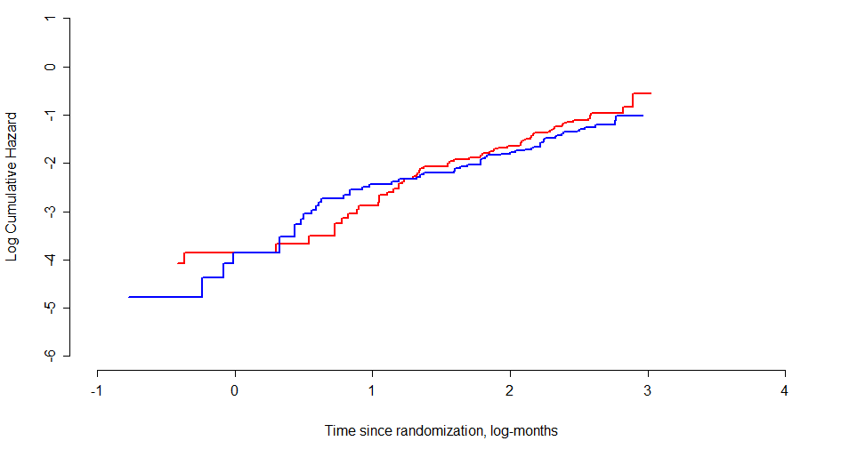
― Kd70 QW
― Kd27 BIW

Kd70 QW: once weekly carfilzomib 70 mg/m2 and dexamethasone; Kd27 BIW: twice weekly carfilzomib 27 mg/m2 and dexamethasone.

Panel 4. Overall survival: log cumulative hazard plot (time in real scale)
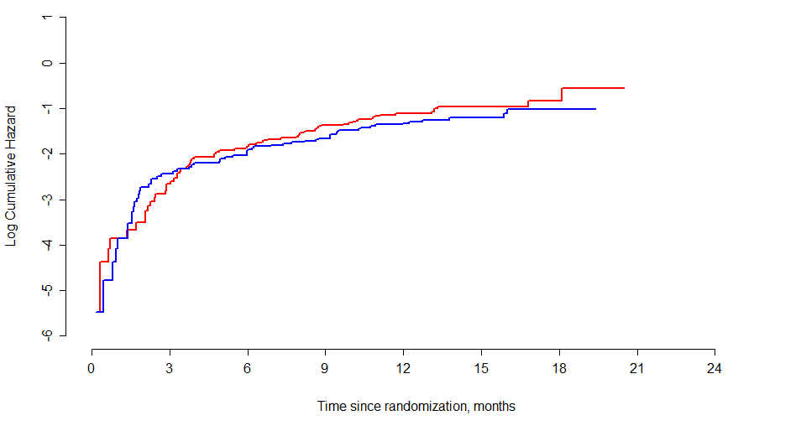
― Kd70 QW
― Kd27 BIW
Kd70 QW: once weekly carfilzomib 70 mg/m2 and dexamethasone; Kd27 BIW: twice weekly carfilzomib 27 mg/m2 and dexamethasone.

