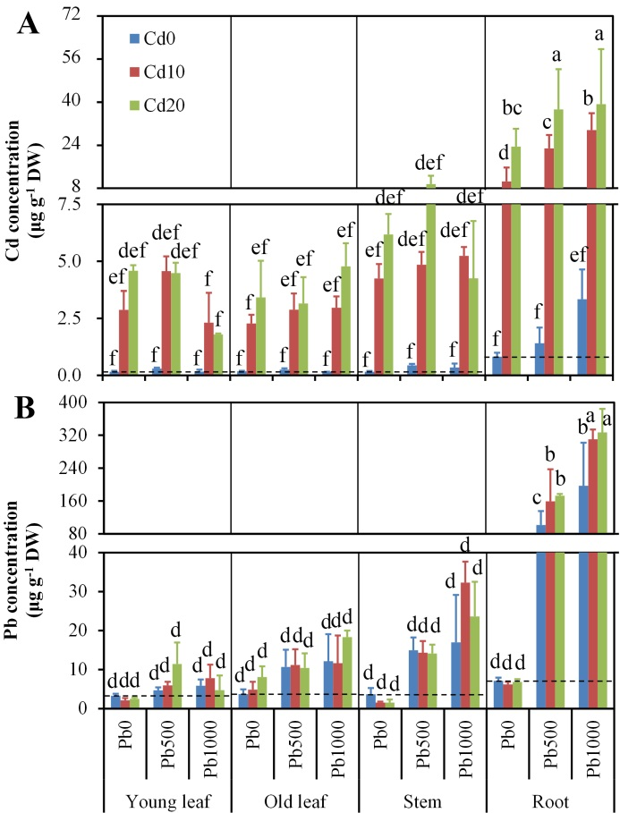
Figure S1. Concentrations of cadmium (Cd) and lead (Pb) in different parts of alfalfa plants grown on a calcareous soil spiked with different levels of Cd and Pb. (A) Cd concentration, and (B) Pb concentration. Data are presented as means + SD (n = 3). Cd0, Cd10, and Cd20 represents soil Cd level of 0, 10, and 20 mg kg⁻¹, respectively; Pb0, Pb500, and Pb1000 represents soil Pb level of 0, 500, and 1000 mg kg⁻¹, respectively. Different lower-case letters above the bars indicate significant (P ≤ 0.05) differences between combinations of Cd х Pb х plant part according to the results of LSD test of three-way (Cd х Pb х plant part) ANOVA.
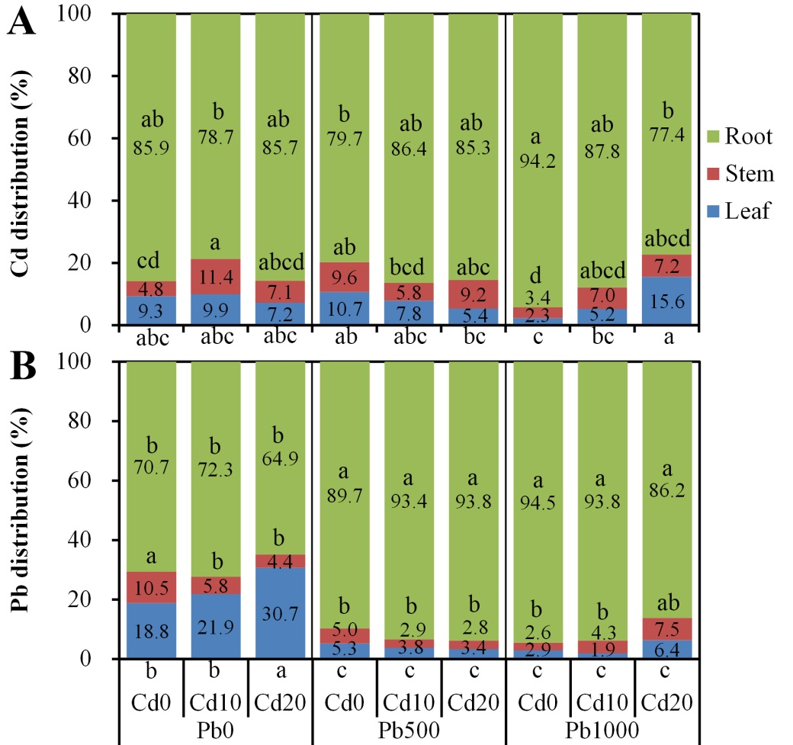
Figure S2. Distributions of cadmium (Cd) and lead (Pb) in different parts of alfalfa plants grown on a calcareous soil spiked with different levels of Cd and Pb. (A) Cd distribution, and (B) Pb distribution. Data are the means of three replicates. Cd0, Cd10, and Cd20 represents soil Cd level of 0, 10, and 20 mg kg⁻¹, respectively; Pb0, Pb500, and Pb1000 represents soil Pb level of 0, 500, and 1000 mg kg⁻¹, respectively. Different lower-case letters above the values of root and stem indicate significant (P ≤ 0.05) differences between treatments for root and stem, respectively, and different lower-case letters below the values of leaf indicate significant (P ≤ 0.05) differences between treatments for leaf, according to the results of LSD test of two-way (Cd х Pb) ANOVA.

