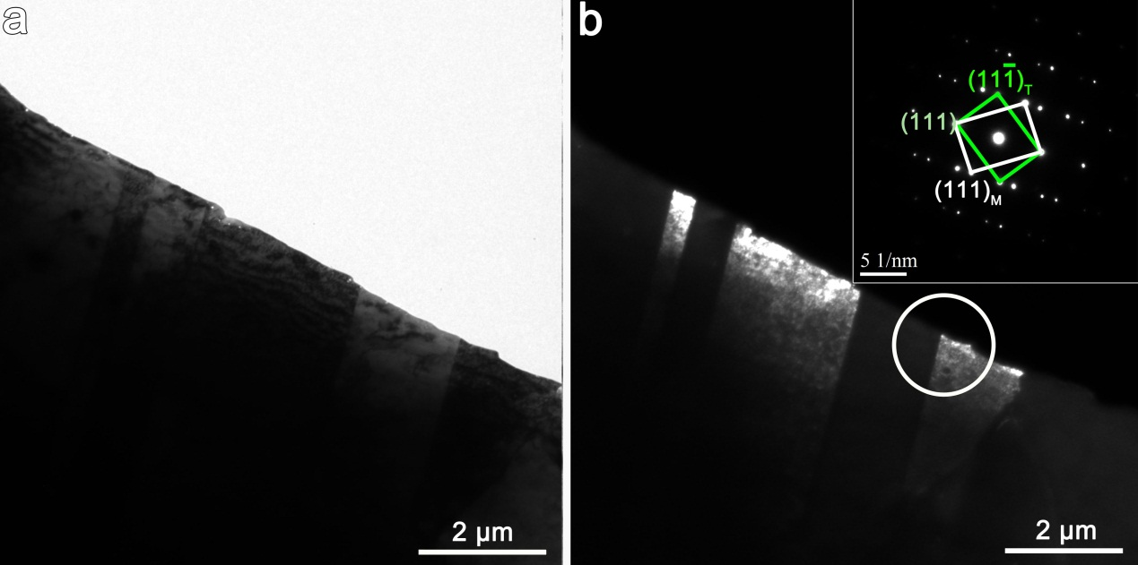
Fig. S1. Selected TEM images of twins observed in super304H treatment at 650℃for 5000 h. (a) Bright field TEM image. (b) Dark field TEM image of twins. The inset is diffraction pattern in Fig. b.

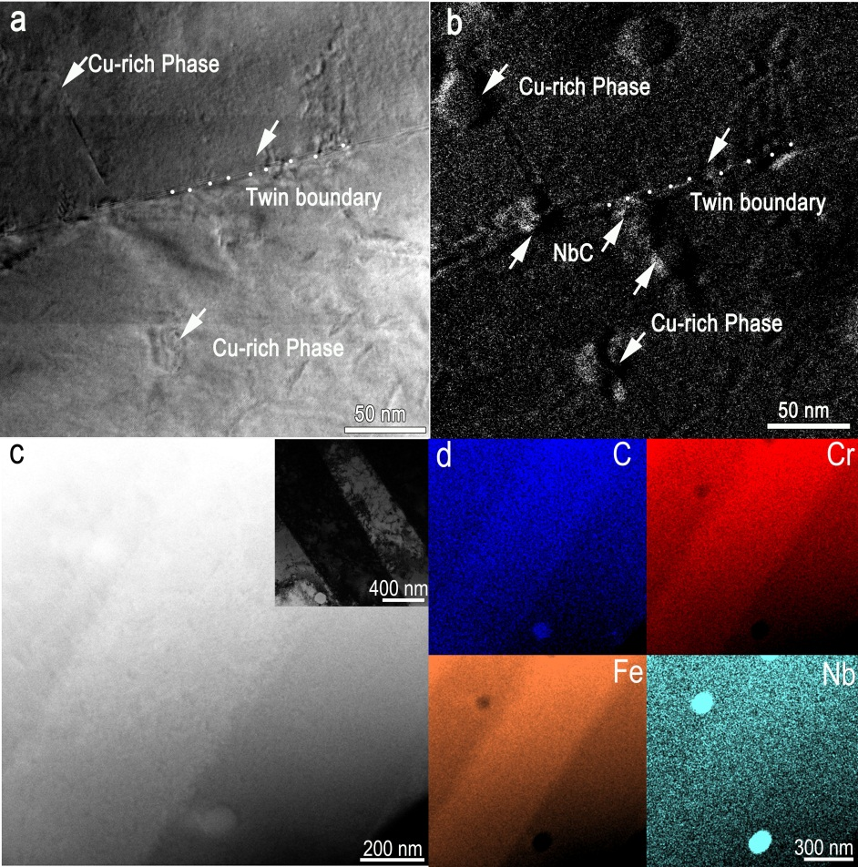
Fig. S2. Energy-filtering TEM mapping of NbC particles. (a) Bright field image. (b) Elemental maps of the interface region shown by C-K elemental map. (c) HAADF-STEM images of the twin boundary in the unaged alloy. The inset shows TEM image of the TB in the unaged alloy. (d) EDS mapping of the twin boundary in the unaged alloy.

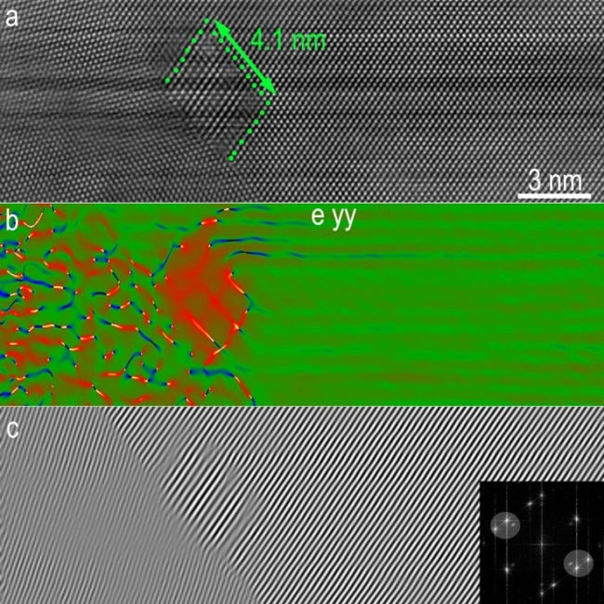
Fig. S3. High-resolution HAADF-STEM image showing an about 4.1 nm NbC precipitated in grain boundary, which is tangent to the TB. (a) HR-HAADF-STEM images of NbC. b) GPA of the interface shows there is no misfit-dislocation. (c) IFFt analysis also shows there is misfit-dislocation at the interface between the NbC and Matrix.

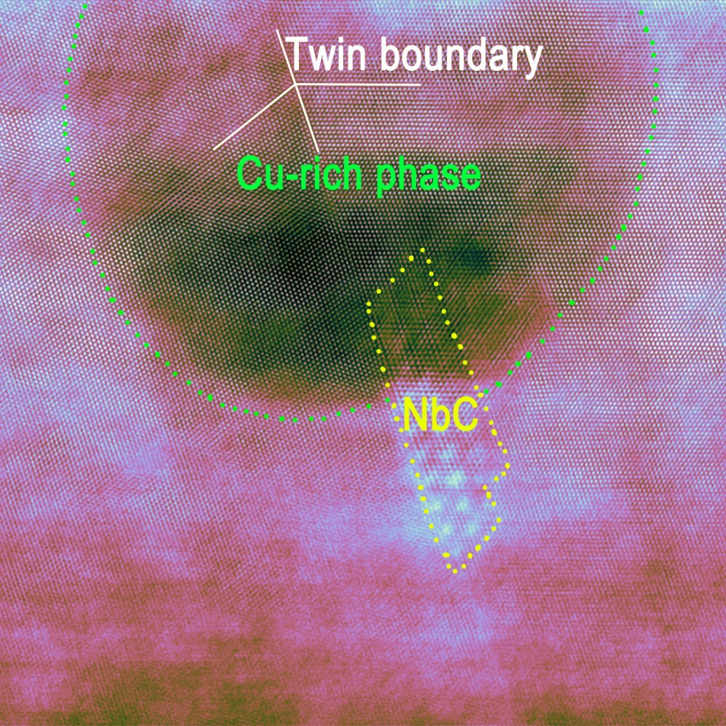
Fig. S4. Aberration-corrected high-resolution HAADF-STEM image of the Cu-rich phase and NbC precipitated phase after aging for 5000 h. The green region is Cu-rich phase and the yellow region is NbC precipitated phase.

