Supplementary material
On the value of isotope-enabled hydrological model calibration
Tricia A. Stadnyk and T.L. Holmes

Modifications were made to the previous version of isoWATFLOODTM, reported in Stadnyk et al. (2013), to account for important cold regions hydrological processes, and wetland-based storage and connectivity within the model. These modifications were necessary for simulating the hydrology of Boreal ecosystems across Canada. We provide here an overview of these modifications, with a more comprehensive description provided in Holmes (2016), along with the amended code.
- Snowpack model: isotope and water balance within a snowpack, as it accumulates throughout the winter was added to explicitly account for new snow added, within pack melt and freezing fractionation, and fractionation and mass balance modifications resulting from snow sublimation. Although fractionation during snowmelt is included in the model, it is not time variant and rather a constant, static offset from frozen water content.
- Surface water: transient surface storage mixing was added to account for the mixing and contributions of rain and snowmelt during the freshet period. This was important for simulation of rain-on-snow events, to ensure the mass and isotope balance accounted for both rain and snowmelt inputs within the same time step. It also allows for explicit separation and tracing of water added to the upper zone through infiltration (and generating interflow) between rain, glacial melt and snowmelt components.
- Upper zone: variable saturation throughout the upper zone (near surface soil layer) was added to account for evaporative fractionation from soil, and distinguish between evaporation (fractionating) and transpiration (non-fractionating) losses.
- Lower zone: storage balance explicitly accounts for contributions from frozen (melt water drainage) and non-frozen soil drainage components combining to generate total baseflow.
- Connected Wetlands: mass and isotope balance was modified to explicitly account for the separation of evaporation (fractionating) and transpiration (non-fractionating) losses, similar to the upper zone.
- Lakes and open water: modifications to include seasonal ice cover were made, such that evaporative losses are not incurred during ice-on periods. In each time step, a flux-weighted isotope mass balance mixing model is used to compute the input composition for each lake in the model.

Table S1. Summary of isoWATFLOOD isotope mass balances for hydrologic storage compartments.
WATFLOOD | isoWATFLOOD
- SNOWPACK
$$\frac{dS_{SP}^{iso}}{dt}=C_{R}^{iso}Q_{RS}+C_{S}^{iso}Q_{S}-C_{SP}^{iso}\left(q_{sub}+q_{melt}\right)$$
$Q_{RS}$= rainfall onto the snowpack  $Q_{S}$= snowfall  $q_{sub}$= sublimation  $q_{melt}$= melt water outflow from the pack | $C_{R}^{iso}$= volume concentration of isotope in rainfall  $C_{S}^{iso}$= volume concentration of isotope in snowfall  $C_{SP}^{iso}$= volume concentration of isotope in snowpack
- SURFACE WATER
$$\frac{dS_{SW}^{iso}}{dt}=C_{R}^{iso}Q_{R}+C_{SP}^{iso}q_{melt}+C_{G}^{iso}Q_{G}-C_{SW}^{iso}\left(q_{df}+q_{dffs}+q_{1}+q_{1fs}\right)$$
$Q_{R}$= rainfall  $Q_{G}$= glacier melt  $q_{df}$= surface water infiltration  $q_{dffs}$= surface water infiltration under snow  $q_{1}$= surface water runoff  $q_{1fs}$= surface water runoff under snow  Notes: It is assumed that there is no evaporation directly from the surface due to relatively rapid infiltration and surface runoff | $C_{G}^{iso}$= volume concentration of isotope in glacier melt  $C_{SW}^{iso}$= volume concentration of isotope in surface water storage
- UPPER ZONE (interflow)
$$\frac{dS_{UZ}^{iso}}{dt}=C_{SW}^{iso}\left(q_{df}+q_{dffs}\right)-C_{UZ}^{iso}\left(q_{drng}+q_{drngfs}+q_{int}+q_{intfs}+q_{T}\right)-C_{E}^{iso}q_{E}$$
$q_{drng}$= vertical exfiltration into LZ  $q_{drngfs}$= vertical exfiltration into LZ under snow  $q_{int}$= lateral interflow flux  $q_{intfs}$= lateral interflow flux under snow  $q_{T}$= transpiration flux from storage  $q_{E}$= evaporation flux from storage | $C_{UZ}^{iso}$= volume concentration of isotope in upper zone storage  $C_{E}^{iso}$= volume concentration of isotope in evaporated water vapor
- LOWER ZONE (baseflow)
$$\frac{dS_{LZ}^{iso}}{dt}=\sum_{i=1}^{c}{C_{UZ,i}^{iso}\left(q_{drng,i}+q_{drngfs,i}\right)}-C_{LZ}^{iso}q_{LZ}$$
$q_{LZ}$= lateral baseflow flux  $c$= number of land classes with UZ storages | $C_{LZ}^{iso}$= volume concentration of isotope in lower zone storage
- CONNECTED WETLAND
$$\frac{dS_{WET}^{iso}}{dt}=C_{R}^{iso}Q_{R}+C_{SP}^{iso}q_{melt}+C_{LZ}^{iso}q_{LZ}+C_{STR}^{iso}q_{i,WET}+\sum_{i=1}^{c}{\left(C_{SW,i}^{iso}\left(q_{1,i}+q_{1fs,i}\right)+C_{UZ,i}^{iso}\left(q_{int,i}+q_{intfs,i}\right)\right)}-C_{WET}^{iso}\left(q_{o,WET}+q_{E}+q_{T}\right)$$
$q_{i,WET}$= wetland inflow from stream channel  $q_{o,WET}$= wetland outflow to stream channel | $C_{STR}^{iso}$= volume concentration of isotope in stream channel  $C_{WET}^{iso}$= volume concentration of isotope in wetland  Notes: If evaporation occurs, the isotope storage is subsequently fractionated using a volume-dependent model (Gibson, 2002)

Table S2. Incremental change in parameter values during manual calibration (Method 2, Fig. 4) using dual-isotope framework and observed isotope values. Initial values are provided (from isotope calibration) with adjusted values for each stage of manual calibration shown in brackets. Footnotes indicate the goal of each calibration stage.
Parameter Name | Function | Stage 1¹ | Stage 2² | Stage 3³
Retn | Soil water holding capacity | 101.2 (58.8)
Theta | Wetland porosity |  | 0.132 (0.6)
Fpet | Evaporation parameter |  | 0.918 (0.5)
Kcond | Wetland conductivity |  |  | 0.158 (0.24)
R2n | Channel roughness parameter related to Manning’s n |  |  | 1E-03 (8E-04)
¹Match subsurface (soil and groundwater) observed isotope data
²Match wetland and channel observed isotope data
³Restore streamflow statistics

Table S3. Incremental change in dual isotope framework isotope simulation performance statistics associated with local mixing line regression slope and intercept.
 | Slope |  |  | Intercept
 | Obs. | Init. | Calib. | Obs. | Init. | Calib.
Lower zone (LZ) | 7.56 | 5.73 | 6.79 | 0.02 | -33.88 | -14.84
Upper zone (UZ) | 7.56 | 6.2 | 6.33 | 0.02 | -25.97 | -21.76
Wetland (WET) | 5.46 | 1.26 | 5.95 | -38.66 | -94.1 | -23.34
Streamflow (STR) | 6.11 | 4.03 | 5.87 | -27.42 | -60.67 | -31.22
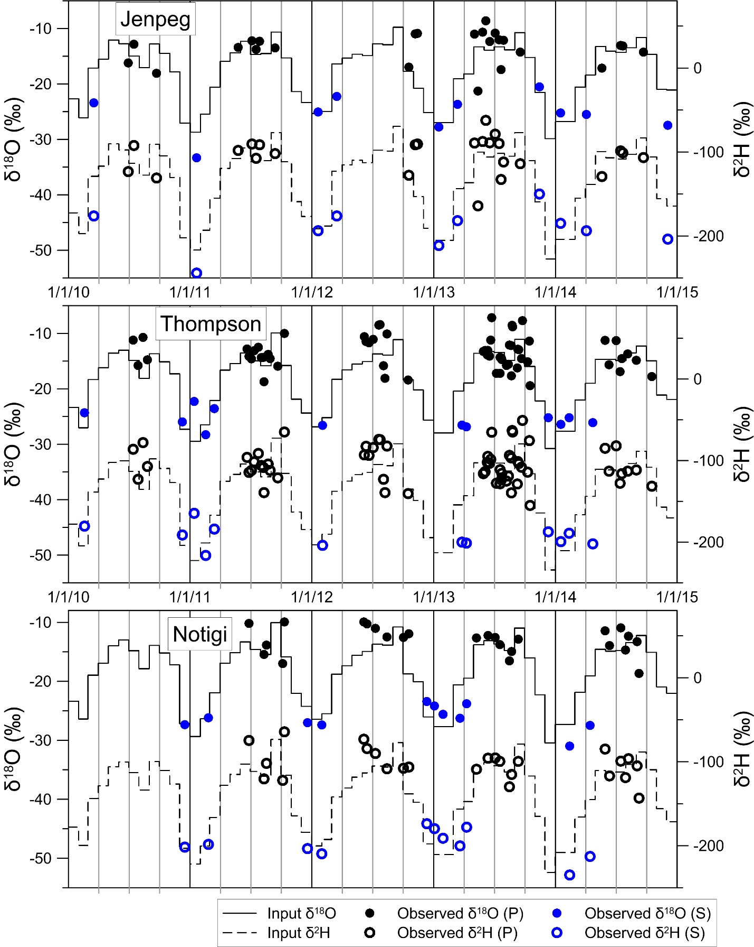
Figure S1. Comparison of monthly simulated isotope in precipitation input from the Delavau et al. (2015) isoP model to isotope in precipitation observations collected at three sites within the study region during the time period of study (adapted from Holmes, 2016).

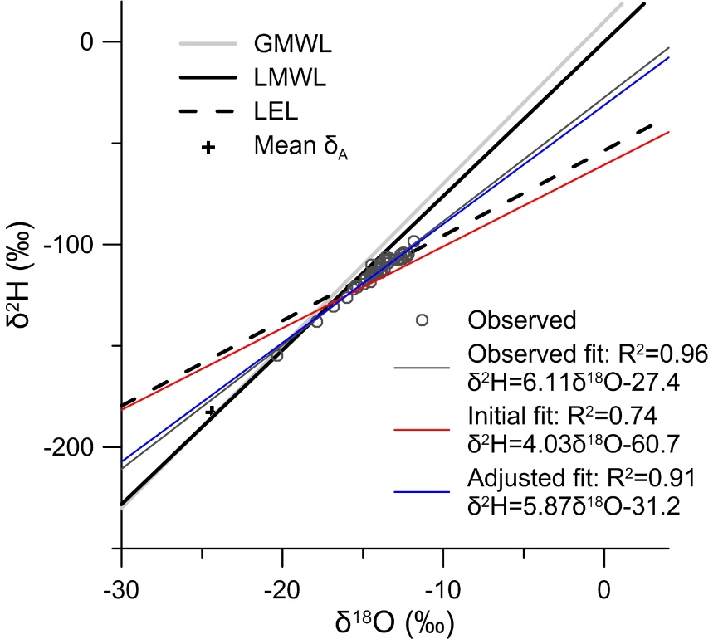
Figure S2. Simulated isotopic framework (2010-2014) from isoWATFLOODTM indicating best fit lines for streamflow (red and blue) at the Odei River gauge relative to observed isotopic values (grey circles) sampled at the gauge. Grey lines represent isotope framework components derived from long-term observed data for the LNRB, and the black line indicates the flux-weighted LMWL derived by Smith et al. 2015. Initial fits correspond to the regional parameterization.

