Supplemental material

Supplemental methods: Detailed description of the RMP measurements
A reference laboratory with accreditation according to ISO 17025 and ISO 15195, performed the RMP measurements on a Cary 300 analyzer (ThermoFisher Scientific). The RMP was an automated version of the manual PRMP developed by the Committee on Reference Systems for Enzymes (C-RSE) of the IFCC, applying the same measurement principle. ALP catalyzes the hydrolysis of NPP, forming phosphate and free 4-nitrophenol; under alkaline conditions, 4-nitrophenol is converted to the 4-nitrophenoxide ion. AMP and H₂O used as phosphate-acceptors. The concentration of 4-nitrophenol is determined by measuring absorbance at 405 nm.
Calculations for d_{CRM} and U_{(dCanRM)}
BCS is the mean ofthe differences Bi.
List of supplemental Figures, Tables and An ethical approval for using patient serum samples
Table S1: The basic information of ALP Kits for commutability evaluation.
Table S2: Imprecision of routine methods for serum ALP measurements. The concentrations of QC materials were 96.9U/L, 245.7U/L and 499.2U/L.
Verification of the imprecision of the routine methods was carried out in accordance with CLSI guideline EP15-A3 [10]. Two levels of GCs were tested in triplicate over 5 consecutive days.
In the imprecision study, the calculated within-run imprecision values for ALP using the three control materials for the five assays were 0.63%-2.98%, 0.45%-1.71%, and 0.51-2.11%, while the corresponding within-laboratory imprecision values were 0.89%-1.86%, 0.77%-1.44% and 0.70%-2.26%, respectively. The imprecision of routine methods are listed in Table.S3.
Table S3 Regression information and Fig.S1
The results from the reference methods were designated as the x-axis, and the results of each of the routine methods were designated as the y-axis. The results from the CSs were used to generate a scatter plot, and the slope, intercept and correlation coefficient of each regression line were calculated.

- Clinical and Laboratory Standards Institute. User verification of precision and estimation of bias; approved guideline, 3rd ed.; ISBN 1-56238-965-3; CLSI document EP 15-A3, 2014.

Table S1: The basic information of TG Kits for commutability evaluation.
Manufacturers | orgin | Calibrator lots | ALP Reagent lots | Catalogue number
Beckman | America | 1121B | AUZ6780 | OSR6004
Biosino | China | 170122 | 180951 | 100020020
DiaSys | Germany | 50239185 | 00004625 | 14104171701
KH | China | 877UE | 20181012 | 30812010205
Roche | Switzerland | 10759350 | 381222 | 05166888190
Wako | Japan | AJ730 | AH993 | 996-63891/99663991

Table S2: Imprecision of routine methods for serum ALP measurements.
Instrument | Method | Level 1 |  |  | Level 2 |  |  | Level 3
 |  | CVr% | CV1% |  | CVr% | CV1% |  | CVr% | CV1%
Beckman AU5400 | Beckman | 2.58 | 1.86 |  | 1.71 | 1.44 |  | 2.11 | 2.26
Hitachi 7180 | Biosino | 1.07 | 1.13 |  | 1.14 | 1.01 |  | 0.51 | 0.71
Hitachi 7180 | Diasys | 1.01 | 1.17 |  | 1.11 | 0.93 |  | 0.91 | 1.04
Hitachi 7180 | KH | 0.63 | 0.98 |  | 0.45 | 0.95 |  | 0.73 | 1.26
Roche C701 | Roche | 0.69 | 0.73 |  | 0.70 | 0.72 |  | 0.62 | 0.71
Hitachi 7180 | Wako | 0.74 | 0.89 |  | 0.60 | 0.77 |  | 0.49 | 0.70

Table S3: Regression information
Analytical system | Intercept | Slope | R²
Beckman | 1.3107 | 1.0343 | 0.9998
Biosino | 2.0152 | 0.9336 | 0.9998
Diasys | 2.7166 | 1.0193 | 0.9998
KH | 2.3922 | 0.8296 | 0.9992
Roche | 3.443 | 0.9096 | 0.9995
Wako | -2.2656 | 1.0058 | 0.9996

Supplemental Figure 1

Supplemental Figure 2
Scatter plots of CRMs ALP concentrations measured by reference method and routine methods.
Scatter plots of 9 CRMs concentrations measured with the comparative method (x-axis) and the routine methods (y-axis). The black solid lines are the regression lines, and the black dotted lines are the two-tailed 95% prediction lines. The black circles, red squares, yellow triangles and blue crosses represent results of CSs, ETVs, GCs and SRMs measured with the reference method and the routine methods.

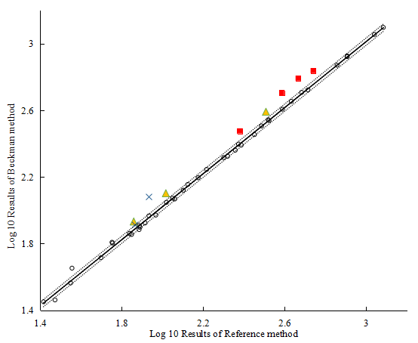
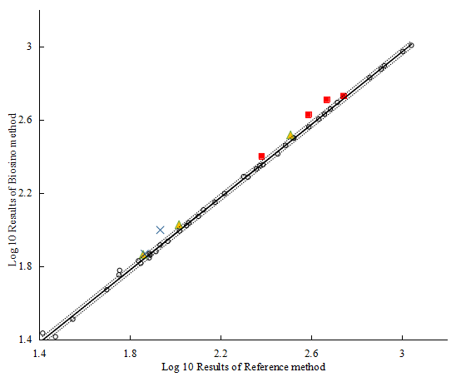
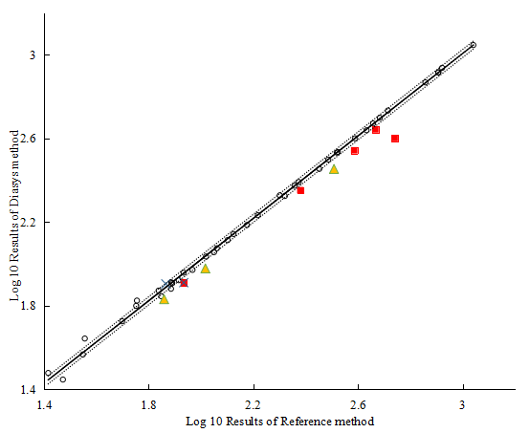

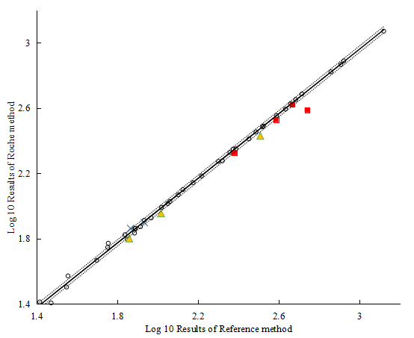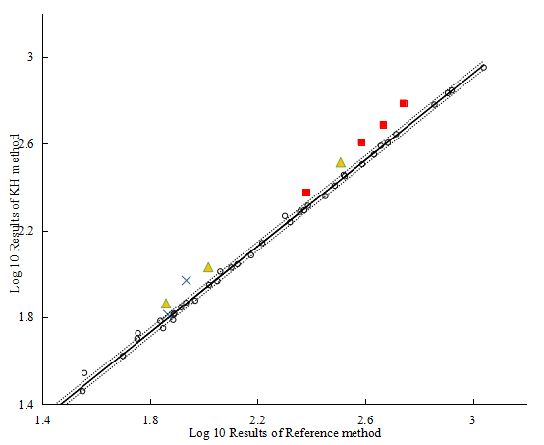
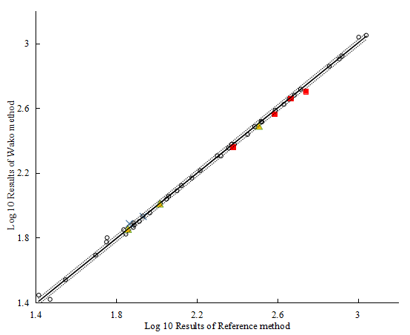

An ethical approval for using patient serum samples
