**A novel reversible fluorescent probe for Zinc(II) ion**

**and bioimaging in living cells**

[1]  Yongxin Changa, Bai Lia, Huihui Meia, Kuxi Xua, Xinmei Xieb *, Li Yang a *

a College of Chemistry and Chemical Engineering, Henan University, Kaifeng, P. R. China

b Pharmaceutical Institute, Henan University, Kaifeng 475004, China.

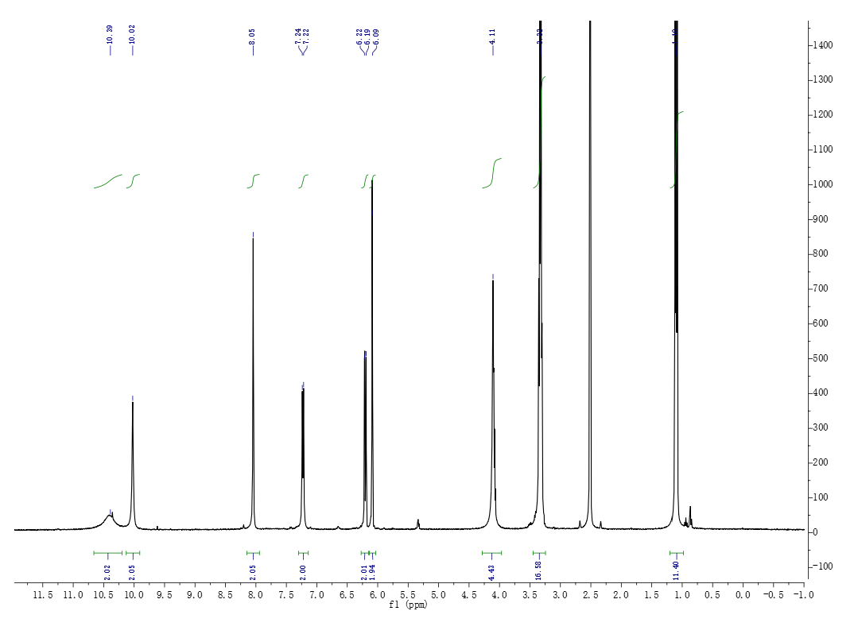

**Fig. s1**. 1H NMR spectra of compound L in DMSO-d6.



**Fig. s2**. 13C NMR spectra of compound L in DMSO-d6.



**Fig. s3**. HRMS spectrum of compound L. Probe L calculate: 441.26141 found:441.26144 [L+H+]



**Fig. s4**. Fluorescence intensity of probe L as the concentration of Zn2+ increase, solid line is a nonlinear fitting curve, R2＝0.99.

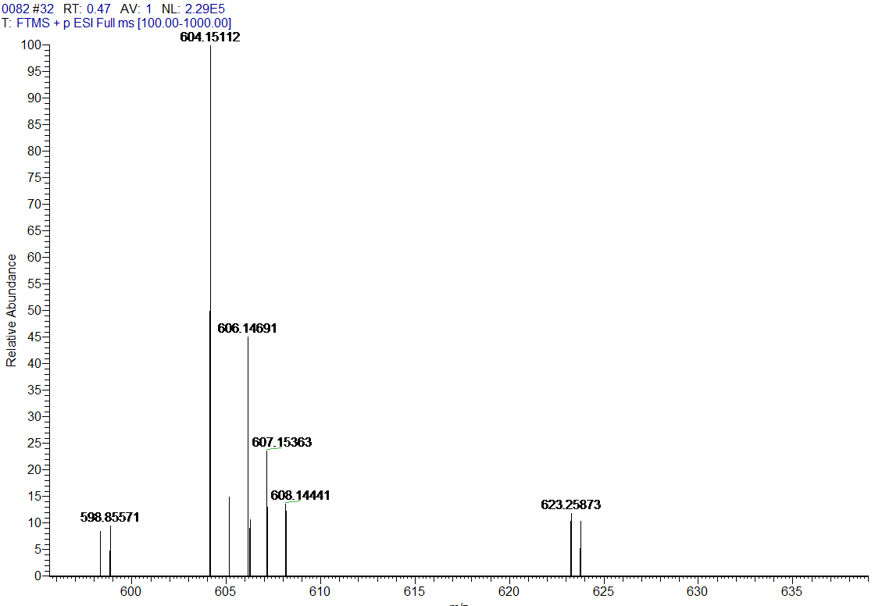

**Fig. s5**. HRMS spectrum of [L+2Zn2++2H2O+2H+] calculate: m/z: 604.13082.



**Fig. s6**. Fluorescence intensity (417 nm) of Probe L in the absence and presence of 2 equiv. Zn2+ at different pH**.**



**Fig. s7**. The HRMS (ESI) of [L+2Zn2++EDTA]+ .

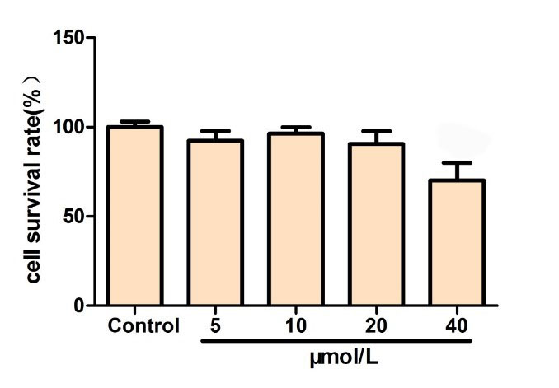

**Fig. s8**. Cell viability (%) estimated by MTT proliferation tests versus incubation concentrations of probe L. PC-12 cells were incubated with 0-40 μM L at 37 ℃ for 24 h.

1. Corresponding author e-mail, X. M. Xie: xxm[@vip.henu.edu.cn](mailto:xukx@henu.edu.cn)); L. Yang: liyang@henu.edu.cn.