Supplementary Information

**AlB2 and MgB2: A comparative study of their electron, phonon and superconductivity properties via first principles**

Cai Cheng,1**,**2,*,Man-Yi Duan1, Zhao Wang1, Xiao-Lin Zhou1,

1 School of Physics and Electronic Engineering, Sichuan Normal University, Chengdu 610101, China

2 School of Materials and Energy, University of Electronic Science and Technology of China, Chengdu 610054, China

*Address correspondence to [ccheng@sicnu.edu.cn](mailto:ccheng@sicnu.edu.cn)

**Electron-Phonon Coupling formalism**

According to the Bardeen-Cooper-Schrieffer (BCS) theory [1,2],the electron-phonon interaction matrix element ${ g}_{k,qv}^{ij}$, which describes the probability amplitude for the scattering of an electron with a transfer of crystal momentum , is expressed as [3]:

 (1),

where *M* is the atomic mass,  and $k$ $k$ are the phonon and electron wave vectors respectively. And $ω_{qv}$ and ${ e}_{qv}$ stand for the phonon frequency of the *v*th phonon mode with the phonon wave vector  and the unit vector along ${ u}_{qv}$, respectively. $\frac{dV_{SCF}}{du_{qv}}$ represent the deformation potential at the small atomic displacement $du_{qv}$ $du_{qv}$ of the given phonon mode. $ψ_{i,k}$ and $ψ_{j,k+q}$ are Kohn-Sham orbitals of electrons. The phonon linewidth $γ_{qv}$ is defined by the integration

 (2),

where $ϵ_{k,i}$ and $ϵ_{k+q,j}$ are eigenvalues of Kohn-Sham orbitals at given bands and wave vectors, and *Ef* is the Fermi energy. The spectral function can be expressed as

 ${ α}^{2}F(ω)=\frac{1}{2πN(E_{f})}\sum_{qv}{δ(ω-ω_{qv})}\frac{γ_{qv}}{hω_{qv}}$ (3),

where *N*(*Ef*) is the density of states at the Fermi level. The EPC constant λ can be determined through summation over the first Brillouin zone or integration of the spectral function in frequency space

 (4),

Where the EPC constant $λ_{qv}$ for mode *v* at wave is defined by

 $λ_{qv}=\frac{γ_{qv}}{πhN(E_{f})ω_{qν}^{2}}$ (5),

Since the relevant electronic and phonon quantities have been obtained, it is possible to estimate the superconducting transition temperature *T*c. The actual *T*c values reported here are obtained from the analytical approximation given by the McMillan equation [3], further modified by Allen and Dynes [4, 5]:

 (6),

Where the $ω_{log}$ is the logarithmically averaged frequency given by

 (7), $ω_{log}=exp⁡[\frac{2}{λ}\int{\frac{dω}{ω}α^{2}F(ω)logω}]$

and $μ^{*}$ is an effective screened Coulomb potential which cannot be determined by the first-principles calculation and usually assumed to between 0.1-0.15 (= 0.1 in this text)

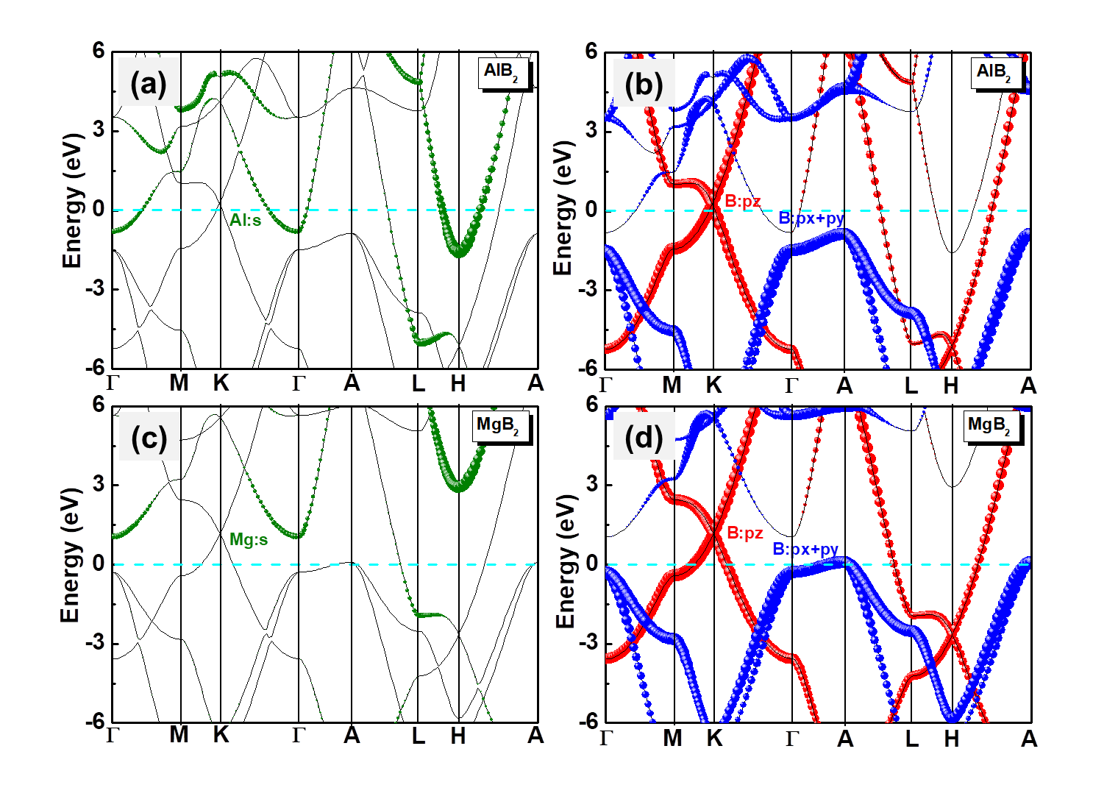

**Fig S1.** **The fat bands of bulk AlB2 and MgB2.** (a)-(b) The fat band projected *s* orbit of Al and *p* orbit of B atom, respectively. (c)-(d) The fat band projected *s* orbit of Mg and *p* orbit of B atom, respectively. The size of the circles is proportional to the magnitude of projected orbit. The Fermi line is remarked by the dotted cyan line.

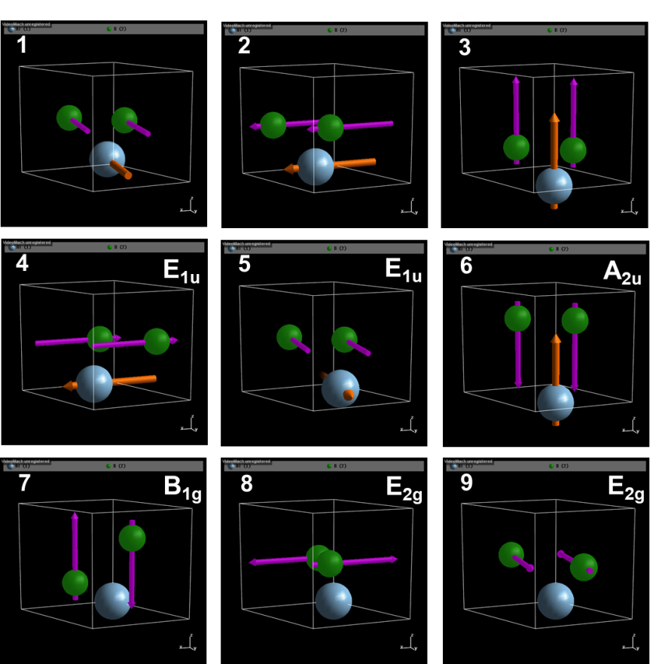

**Fig S2.** **The nine vibrational modes for  point of AlB2.** The numbers of 1, 2, 3 modes are the acoustic branch phonon modes. The numbers of 4-9 modes are the optical branch phonon modes. The numbers of 8 and 9 are the E2g modes.

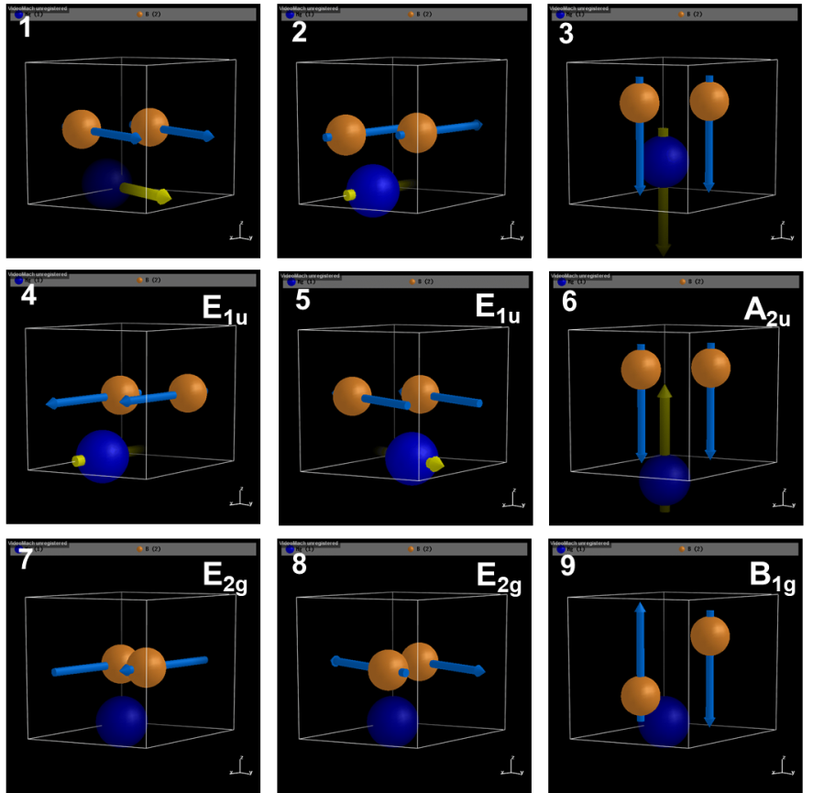

**Fig S3.** **The nine vibrational modes for  point of MgB2.** The numbers of 1, 2, 3 modes are the acoustic branch phonon modes. The numbers of 4-9 modes are the optical branch phonon modes. The numbers of 7 and 8 are the E2g modes.

Table S1 Superconducting related physical quantities under doping engineering

|  |  |  |  |  |  |  |  |
| --- | --- | --- | --- | --- | --- | --- | --- |
|  | AlB2/ MgB2 | λ | *T*c (k) | ωlog (K) | N(Ef) | ΘD (K) | stability |
| 0.1e-/cell | AlB2 | **0.575** | **9.89** | **494.66** | **2.77** | **924.29** | **stability** |
| MgB2 | 0.934 | 43.95 | 704.14 | 4.44 | 917.34 | stability |
| pristine | AlB2 | **0.429**  **0.43a** | **3.43**  **3.43a** | **557.58** | **2.58** | **942.55** | **stability** |
| MgB2 | 0.867  0.748b | 38.47  50b;39.4c;39.8d | 702.85 | 4.68 | 909.12 | stability |
| 0.1h+/cell | AlB2 | **0.385** | **1.90** | **568.71** | **2.40** | **957.42** | **stability** |
| MgB2 | 0.817 | 34.57 | 707.61 | 4.86 | 902.66 | stability |

a Bohnen *et. al.* Phys. Rev. Lett., 86, 5771 (2001);

b Margine et al., Phys. Rev B, 87, 024505 (2013);

c Choi *et. al* Nature, 418, 758-760 (2002).;

dAperis et al., PRB, 92, 054516 (2015)

Table S2 Superconductivity related physical quantities under the z direction strain engineering

|  |  |  |  |  |  |  |  |
| --- | --- | --- | --- | --- | --- | --- | --- |
|  | AlB2/ MgB2 | λ | *T*c (k) | ωlog (K) | N(Ef) | ΘD (K) | stability |
| -4%@c | AlB2 | **0.331** | **0.72** | **614.06** | **2.22** | **987.32** | **stability** |
| MgB2 | 0.777 | 32.82 | 744.28 | 4.55 | 950.95 | stability |
| pristine | AlB2 | **0.429** | **3.43** | **557.58** | **2.58** | **942.55** | **stability** |
| MgB2 | 0.867 | 38.47 | 702.85 | 4.68 | 909.12 | stability |
| 4%@c | AlB2 | **0.546** | **7.54** | **446.16** | **2.79** | **899.93** | **stability** |
| MgB2 | 0.930 | 41.27 | 665.90 | 4.66 | 873.98 | stability |
| 6%@c | AlB2 | **0.657** | **10.25** | **346.29** | **2.90** | **876.67** | **stability** |
| MgB2 | - | - | - | - | - | - |

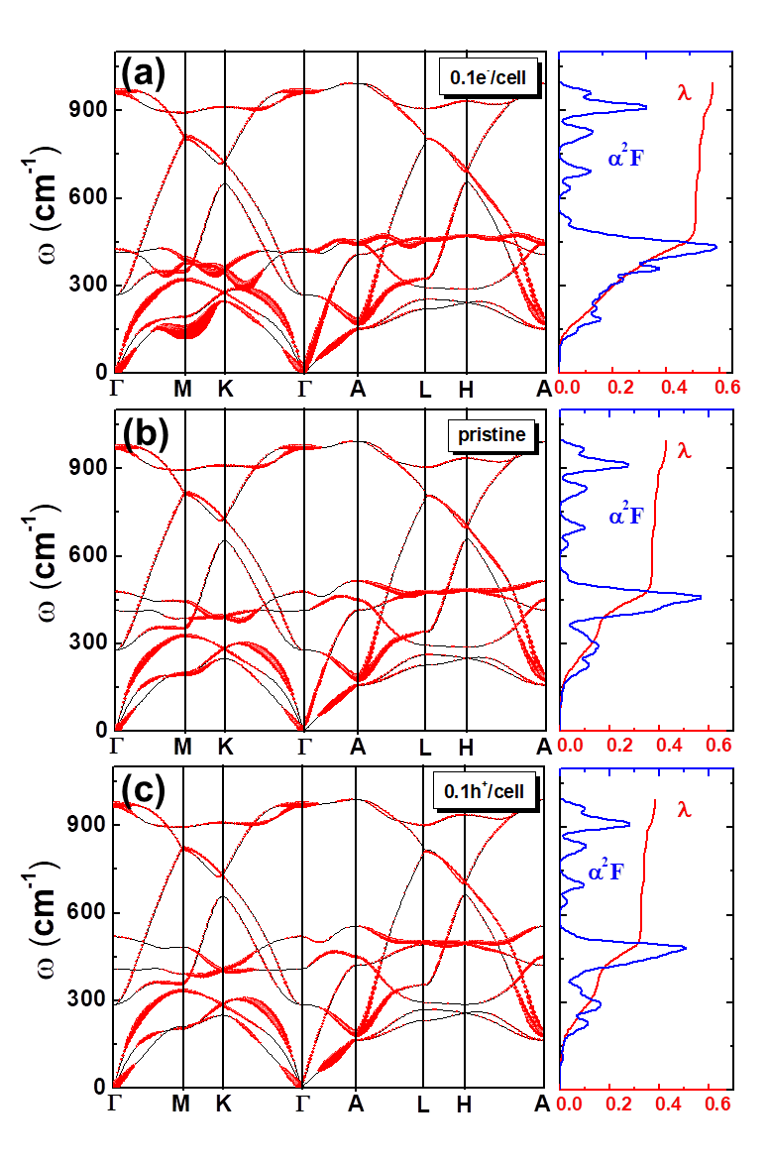

**Fig S4.** **phonon band structure, Eliashberg spectral function as a function of carrier doping.** (a)-(c) Phonon band structures for bulk AlB2 doped by 0.1e-/cell (red) and 0.1h+/cell (blue). In (a)-(c), Pristine bulk AlB2 (black line) is presented for comparison.

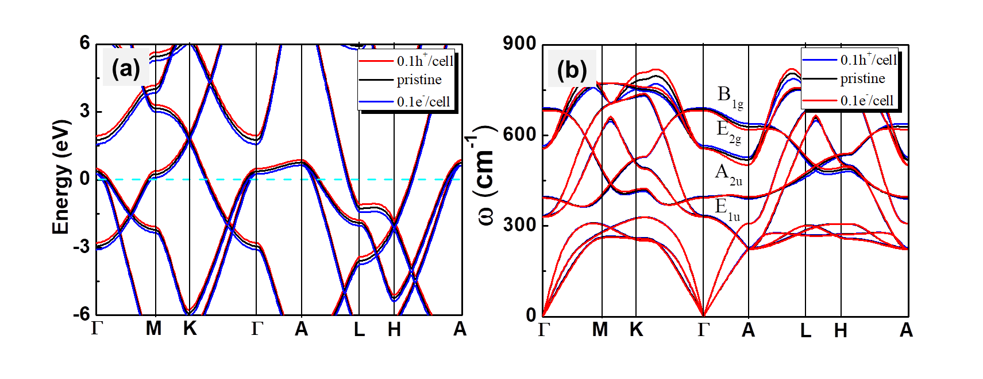

**Fig S5.** **Electronic and phonon band structure of bulk MgB2 as a function of carrier doping.** (a) Band structures for bulk MgB2 doped by 0.1e-/cell (red) and 0.1h+/cell (blue). (The cyan dashed line is the Fermi level, which has been set to zero for each doping case. (b) Phonon dispersion relation for bulk MgB2 doped by 0.1e-/cell (red) and 0.1h+/cell (blue). Pristine bulk MgB2 (black line) is presented for comparison.

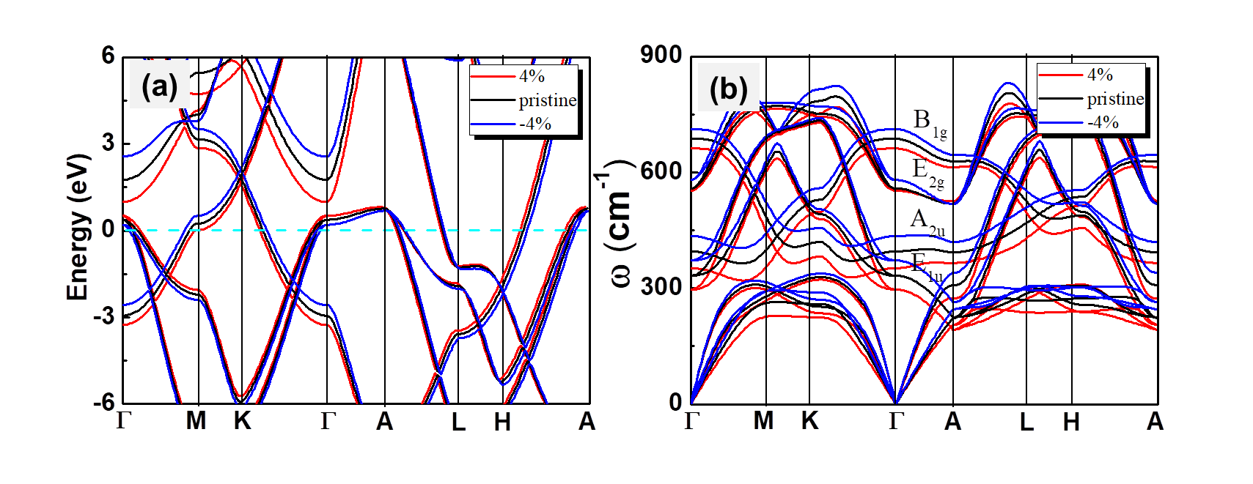

**Fig S6.** **Electronic and phonon band structure of bulk MgB2 as a function of strain engineer (*c* axis represents the Van der Waals).** (a) Band structures for bulk MgB2 by tensile 4% (red)、and compress -4% (blue), respectively. (The cyan dashed line is the Fermi level, which has been set to zero for each strain case. (b) Phonon dispersion relation for bulk MgB2 by tensile 4% (red) and compress -4% (blue), respectively. Pristine bulk MgB2 (black line) is presented for comparison.

**References**

[1] J. Bardeen, L. Cooper, J. Schrieffer. Microscopic Theory of Superconductivity. Phys. Rev, **106,** 162-164 (1957).

[2] J. Bardeen, L. Cooper, J. Schrieffer. Theory of Superconductivity. Phys. Rev, **108**, 1175-1204 (1957).

[3] W. L. McMillan, Transition Te1nperature of Strong-Coupled Superconductors. Phys. Rev, **167**, 331-344 (1968).

[4] P. B. Allen. Neutron spectroscopy of superconductors. Phys. Rev B, **6**, 2577 (1972).

[5] P. B. Allen, R. Dynes. Transition temperature of strong-coupled superconductors reanalyzed. Phys. Rev B, **12**, 905 (1975).