Geomicrobiology Journal supplementary material
Article Title : Biotic and abiotic imprints on Mg-rich stromatolites: lessons from Lake Salda, SW Turkey
Authors : Nurgul Balci^{1*,} Yagmur Gunes¹, Jérôme Kaiser², Sena Akcer On³, Kadir Eris¹, Bradley Garczynski ⁴, Briony Horgan ⁴,

¹Department of Geological Engineering Istanbul Technical University, Istanbul, Turkey
ITU Faculty of Mines, Department of Geological Engineering, Ayazaga Campus, 34469 Maslak-Istanbul-Turkey.
²Leibniz-Institute for Baltic Sea Research , Seestrasse 15, D-18119 Rostock, Germany;
³Muğla Sıtkı Kocman University, Faculty of Engineering, Department of Geological Engineering, Muğla, Turkey
⁴Dept. of Earth, Atmospheric, and Planetary Sciences, Purdue University, West Lafayette, IN

*Corresponding author address: Department of Geological Engineering Istanbul Technical University, Istanbul, Turkey, ITU Faculty of Mines, Department of Geological Engineering, Ayazaga Campus, 34469 Maslak-Istanbul-Turkey Email address: ncelik@itu.edu.tr

The following supplementary material is provided in this article :
Supplementary Materials
S1 : Genomic DNA extraction and Real-time qPCR methods
Table S1: Water chemistry results of lake surface and groundwaters.
Table S2: Geochemical characteristics of sediments (SLS), fossil (FS) and mats (SLM)
Figure S1. Pictures of the modern stromatolites (Site S1 and Site S2): (a, b,c), Domed shape stromatolites covered with a smooth surface. (d), Stromatolitic mats on muds. (e,f), Stromatolite formation on muddy embayments. (g,h), Stromatolites with mini columnar structure covered by orange color mats. (i) A view from cauliflower shape .

Figure S2. Pictures of fossil (FS1 and FS3) and subfossil (SF2) stromatolites. (a) Remnants of stromatolites in hydromagnesite terrace deposits. (b) Part of dome structure (A closer view of red square in a). (c) Cauliflower shaped subfossil stromatolite island and sample location (red arrow). Note knobby surface (small square) .(d) A slab from subfossil stromatolite . Note the poorly layered mini columns (red arrows). (e) Subfossil columnar stromatolites. (f) Subfossil columnar stromatolites with rectangular (1), convex (2) and parabolic internal lamination.
S1:
Genomic DNA extraction
Microbial mat and sediment samples (200 mg) were transferred into vials containing 400 µl 0.1 M Tris-HCl at pH 8.0 and 200 mg of glass beads with a diameter of 0.1 mm. Samples were vortexed for a minute at 6000 rpm using a ProH-6000 homogenizer (Inovia Technology, Turkey). Samples were incubated for 10 min at 95 ºC after adding 400 µl of binding buffer (4 M Guanidine thiocyanate, 20 mM Tris-HCl, pH 8). Samples were cooled down to room temperature and were loaded to silica columns after adding 400 µl of 2-propanol. DNA of the samples were held within the column via centrifugation at 10000 g for a minute and washed with a washing buffer (20 mM NaCl, 2 mM Tris-HCl, pH 8; 80% v/v Ethanol). The columns were later centrifuged to dry up. DNA was re-suspended from the column with sterile, deionized, nuclease free water (pH 7). The purity (ABS₂₆₀/ABS₂₈₀) and concentration of the DNA samples were measured using a MSP-100 micro spectrophotometer (Inovia Technology, Turkey). 20 ng/µl of DNA isolates were used in analyses having ABS₂₆₀/ABS₂₈₀ values ranging between 1.6-2.
Real-time qPCR
DNA isolates of bacterial and archaeal 16S rRNA regions were amplified using Bact8f / Bact1541r primers (Lane, 1991) and Arc46f/Arc1384r (Øvreas et al. 1997; Lueders and Manefield 2004) primer sets, respectively. qPCR was performed for 15 sec at 95°C (10 min at the first cycle), 15 sec at 53°C, and 30 sec 72°C conditions per cycle. Reactions were facilitated using 10 µl volume containing 1.5 mM MgCl₂, 0.2 mM dNTP mix, 1x Reaction Tampon, 0.1U High Fidelity Hot Start Taq DNA Polymerase, 1x EvaGreen-I, 5 ng/μl DNA and 0.5 μM of each primer. To determine whether only the desired regions were amplified during qPCR, melting curve analysis was performed between 65°C - 95°C. qPCR data were analyzed using the CFX manager software 3.0. Amounts of the same target genes in different samples relative to each other were calculated via the 2^{- ΔCt} method (Livak and Schmittgen, 2001). Number of bacterial and archaeal genes were divided with 3.6 and 1.6 constants, respectively, to convert them into number of cells.

Table S1- Water chemistry results of lake surface and groundwaters.

Sample ID | SLW1 | SLW2 | SLW3 | SLW4 | SLW5 | SLW6 | SLW7 | SLW8 | SLW9 | SLW10 | SGW1 | SGW2
T (ºC) | 35.4 | 29 | 27.4 | 27.2 | 28.1 | 29.2 | 27.5 | 27.8 | 25.3 | 28.2 | 17.8 | 23.8
pH | 8.6 | 8.9 | 9.09 | 9.1 | 9.4 | 9.4 | 9.14 | 9.1 | 9.2 | 9.26 | 8.7 | 8.5
O₂ (mg/L) | 6.5 | 5.1 | 7.2 | 7.1 | n.d | 7.9 | 7.8 | 8.1 | 8.3 | n.d | n.d | n.d
EC (mS/cm) | 1.64 | 1.02 | 1.63 | 1.93 | 2.1 | 3.1 | 2.8 | 1.88 | 1.86 | n.d | 0.3 | 0.79
Alkalinity (mol/L) | 0.0306 | 0.015 | 0.0242 | 0.0294 | 0.0334 | 0.0408 | 0.0316 | 0.0296 | 0.0282 | 0.031 | 0.0064 | 0.0120
(mg/L)
DOC | 13.5 | 25.2 | 14.16 | n.d | n.d | 5.2 | n.d | 7.7 | 12.1 | n.d | 23.9 | 0.79
Si | 7.8 | 9.6 | n.d | 5.2 | 4 | n.d | 6.3 | 8.9 | 10.2 | n.d | 7.2 | 15
Na | 413.2 | 138.7 | 244.5 | 230.2 | 234.46 | 233.18 | 233.5 | 206.7 | 191 | 231.4 | 113 | 198.1
K | 16.4 | 11.2 | 53.9 | 39 | 31.44 | 30.24 | 31 | 34 | 23.4 | 30 | 15.2 | 14.2
Mg | 51.3 | 230 | 396.2 | 306.5 | 388.13 | 390.33 | 384 | 370.2 | 408.4 | 386 | 114.9 | 245.8
Ca | 65.5 | 24.3 | 21.6 | 11.5 | 17.78 | 17.51 | 4.3 | 11.1 | 23.5 | 4.2 | 31.2 | 366.7
Mg/Ca | 0.78 | 9.47 | 18.34 | 26.65 | 21.83 | 22.30 | 89.30 | 33.35 | 17.38 | 91.90 | 3.68 | 0.67
Cl | 928 | 253.1 | 281.7 | 316.1 | 320.85 | 317.35 | 197.2 | 296.7 | 9.7 | 195.6 | 1738.5 | 890.5
NH₄⁺ | 2.5 | 2.1 | 0.7 | <0.01 | 1.03 | 1.01 | <0.01 | 0.21 | 6.3 | <0.01 | 0.8 | n.d
NO₃⁻ | 32.5 | 57.1 | 30.7 | <0.01 | <0.01 | <0.01 | <0.01 | 10.7 | <0.01 | <0.01 | 95.3 | 32
SO₄²⁻ | 222.1 | 934.3 | 66.3 | 17.6 | 19.11 | 19.04 | 14.83 | 90.05 | 12.5 | 14.48 | 1025.9 | 63.3
n.d, not determined

Table S2- Geochemical characteristics of sediments (SS), fossil (FS) and subfossil (SF2) stromatolites and mats (SLM) (% )
Sample ID | SS1 | SS2 | SS3 | SS4 | FS1 | SF2 | FS3 | SLM1 | SLM2
%
SiO₂ | 17.62 | 0.7 | 1.53 | 4.35 | 1.93 | 2.31 | 2.31 | 2.23 | 1.04
TiO₂ | 0.06 | 0.13 | 0.04 | 0.08 | 0.1 | 0.02 | 0.02 | 0.18 | 0.02
Al₂O₃ | 1.08 | 3.58 | 1.11 | 3 | 1.52 | 0.03 | 0.03 | 2.68 | 0.04
FeO | 2.26 | 2.42 | 2.1 | 1.95 | 5 | 0.16 | 0.16 | 3.84 | 0.23
MnO | 0.03 | 0.05 | 0.03 | 0.04 | 0.07 | 0.001 | 0.001 | 0.07 | 0.002
MgO | 39.88 | 49.46 | 48.43 | 45.99 | 47.8 | 48.13 | 48.13 | 44.3 | 40.97
CaO | 4.17 | 5.16 | 3.21 | 4.32 | 2.42 | 2.11 | 2.11 | 3.11 | 1.91
Na₂O | 0.98 | 1.22 | 0.75 | 1.07 | 0.86 | 0.61 | 0.61 | 0.96 | 0.79
K₂O | 0.13 | 0.18 | 0.14 | 0.26 | 0.11 | 0.08 | 0.08 | 0.19 | 0.12
P₂O₅ | 0.02 | 0.01 | 0.02 | n.d | 0.04 | 0.05 | n.d | 0.06 | 0.07
TOC | 0.96 | 1.02 | 0.42 | 0.5 | 1.38 | 1.79 | 2.1 | 25 | 32.9
LOI | 30.34 | 35.1 | 41.28 | 38.1 | 39.42 | 39.61 | 39.3 | 17.1 | 21.1
Total | 97.53 | 99.21 | 99.06 | 99.66 | 100.65 | 94.901 | 96.751 | 100.02 | 98.4
Trace elements
(ppm)
B | 95.85 | 90.98 | 81.21 | 113.15 | 90.37 | 62.01 | 62.01 | 87.87 | 106.34
V | 56.7 | 54.26 | 31.04 | 49.94 | 63.71 | 14.84 | 14.84 | 60.54 | 17.54
Co | 33.78 | 32.27 | 30.96 | 28.69 | 55.37 | 6.02 | 6.02 | 50.64 | 6.9
Ni | 800.25 | 475.66 | 725.16 | 377.03 | 1613.51 | 42.87 | 42.87 | 940.08 | 38.68
Cu | 27.89 | 20.22 | 28.22 | 23.07 | 21.97 | 26.95 | 26.95 | 27.13 | 32.72
Zn | 332.15 | 358.92 | 327.96 | 329.65 | 305.18 | 274.13 | 274.13 | 360.19 | 335.76
As | 10.01 | 2.59 | 2.54 | 5.92 | 6.79 | 3.93 | 3.93 | 3.82 | 1.84
Se | 198.55 | 193.63 | 187.52 | 194.5 | 172.84 | 156.77 | 156.77 | 191.28 | 187.83
Sr | 23.8 | 95.05 | 58.35 | 80.85 | 68.16 | 21.11 | 21.11 | 61.58 | 19.33
Mo | 42.69 | 43.2 | 41 | 42.41 | 38.81 | 33.46 | 33.46 | 41.63 | 40.52
Cd | 21.59 | 21.03 | 20.78 | 21.54 | 19.66 | 16.88 | 16.88 | 21.24 | 20.61
Ba | 27.15 | 44.55 | 41.3 | 97.3 | 34.28 | 16.81 | 16.81 | 54.6 | 23.34
Pb | 20.43 | 19.6 | 18.83 | 20.96 | 18.52 | 20.62 | 15.43 | 18.38 | 15.43

Figure S1.
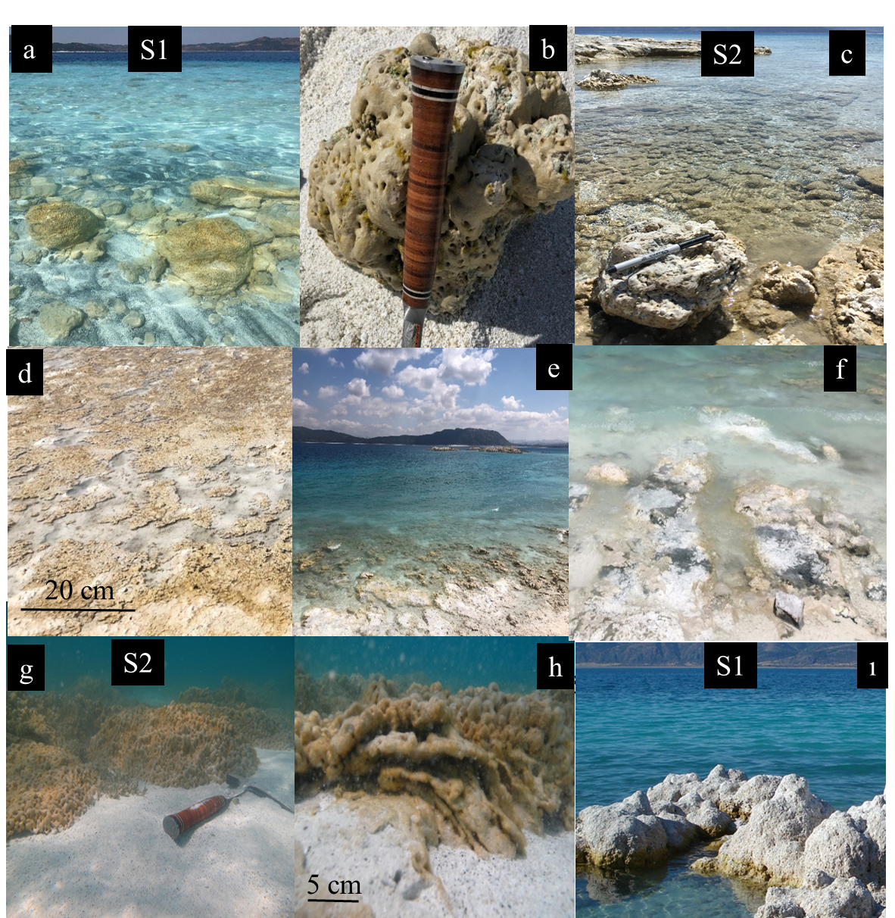

Figure S2.
