Supplementary Figures

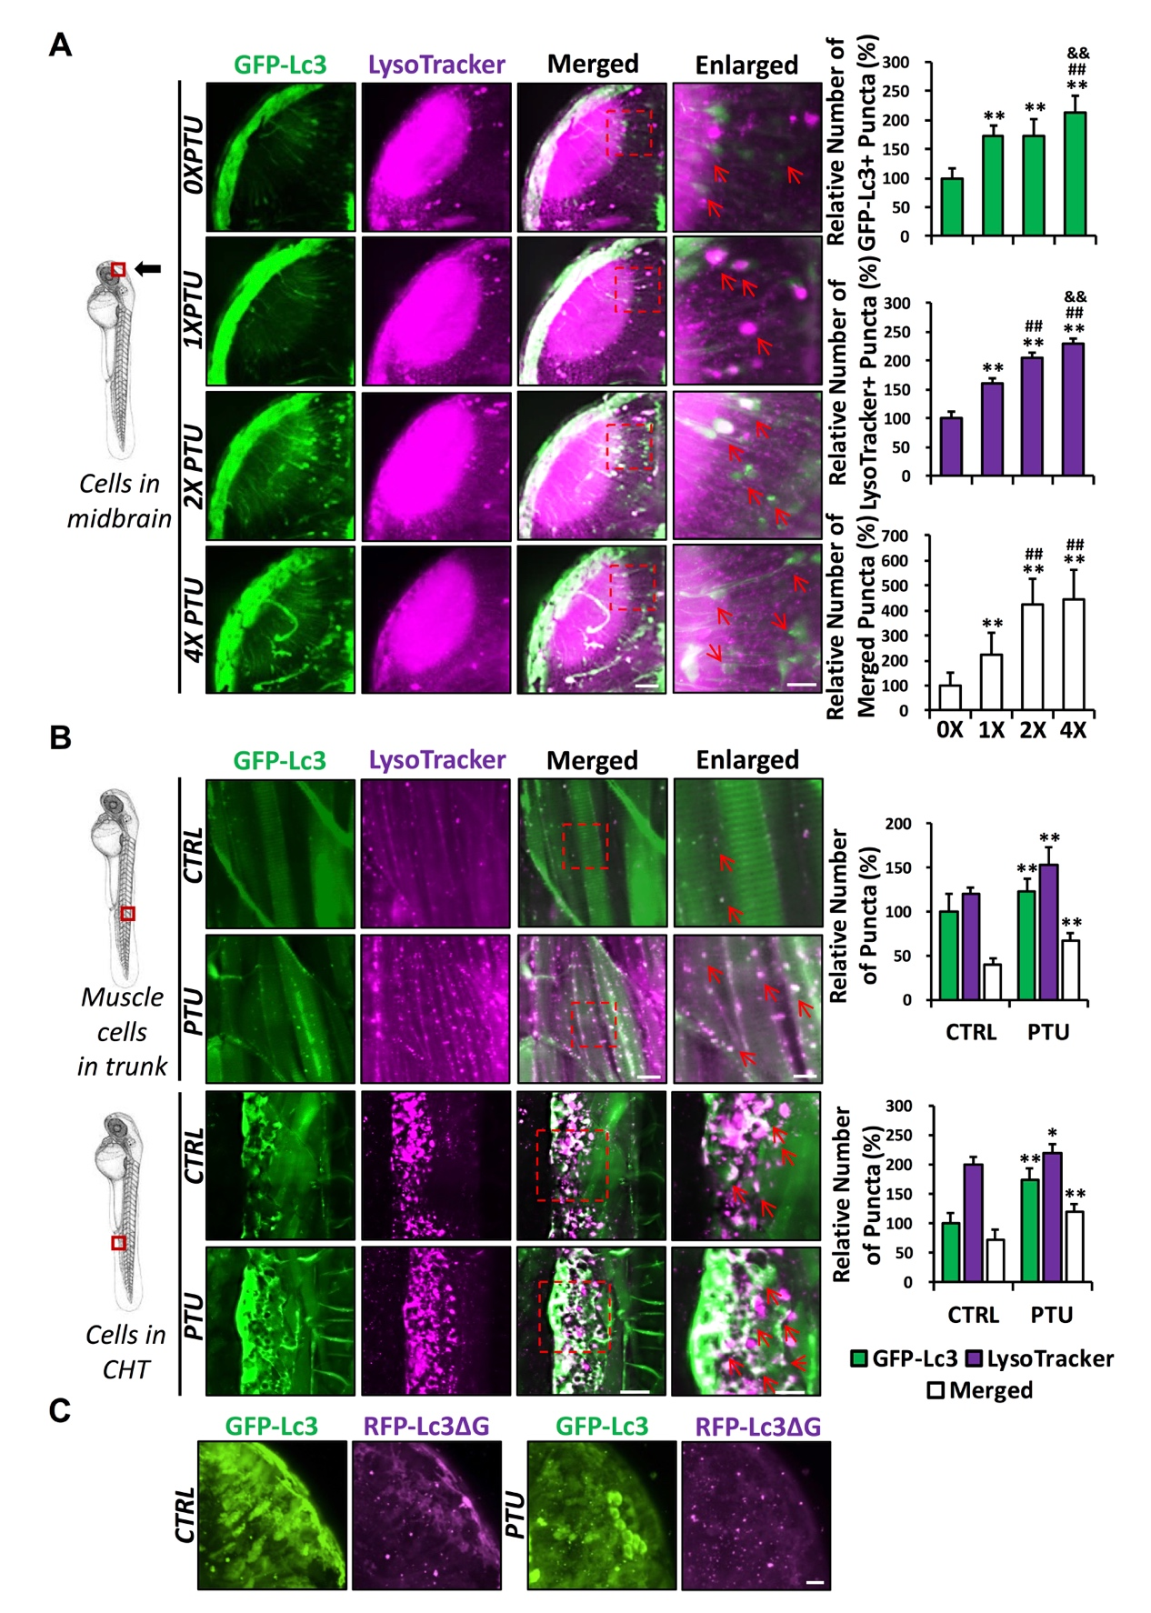
Figure S1
Figure S1. 1-phenyl-2-thiourea (PTU) induces a dose-dependent autophagosome and autolysosome formation in various tissues of zebrafish embryos. (A) Schematic diagram showing the position (cells in the midbrain) of imaging. The relative number of GFP-Lc3⁺, LysoTracker⁺, and Merged (GFP-Lc3⁺ and LysoTracker⁺) puncta per cell were counted based on Z-Stack (10 layers out of 100 layers) images. Representative images of nine Tg(GFP-Lc3) zebrafish treated with various doses of PTU (0X, 1X, 2X, and 4X) and stained with LysoTracker prior to imaging from three independent experiments were shown. Red arrowhead, GFP-Lc3⁺ and/or LysoTracker⁺ puncta. **, p<0.01 compared with 0X PTU; ##, p<0.01 compared with 1X PTU; &&, p<0.01 compared with 2X PTU. Scale bar: 40 μm (Merged), 6 μm (Enlarged). (B) upper panel: Schematic diagram showing the position (muscle cells in the trunk) of imaging. The number of GFP-Lc3⁺, LysoTracker⁺, and Merged (GFP-Lc3⁺ and LysoTracker⁺) puncta per muscle cell in the trunk were counted. Representative images for nine Tg(GFP-Lc3) zebrafish embryos treated with PTU and stained with LysoTracker from three independent experiments were shown. Red arrowhead, GFP-Lc3⁺ and/or LysoTracker⁺ puncta. **, p<0.01 compared with control (CTRL). Scale bar: 10 μm (Merged), 5 μm (Enlarged). Lower panel: Schematic diagram showing the position caudal hematopoietic tissue (CHT) of imaging. The number of GFP-Lc3⁺, LysoTracker⁺, and Merged (GFP-Lc3⁺ and LysoTracker⁺) puncta per cell in caudal hematopoietic tissue (CHT) were counted. Representative images for nine Tg(GFP-Lc3) zebrafish treated with PTU and stained with LysoTracker prior to imaging from three independent experiments were shown. Red arrowhead, GFP-Lc3⁺ and/or LysoTracker⁺ puncta. **, p<0.01 compared with control (CTRL). (C) GFP-Lc3⁺ and RFP-Lc3ΔG⁺ cytoplasm and puncta in the midbrain of 24 dpf GFP-Lc3-RFP-Lc3ΔG probe-injected embryo treated with PTU from 6 hpf. Scale bar: 150 μm.

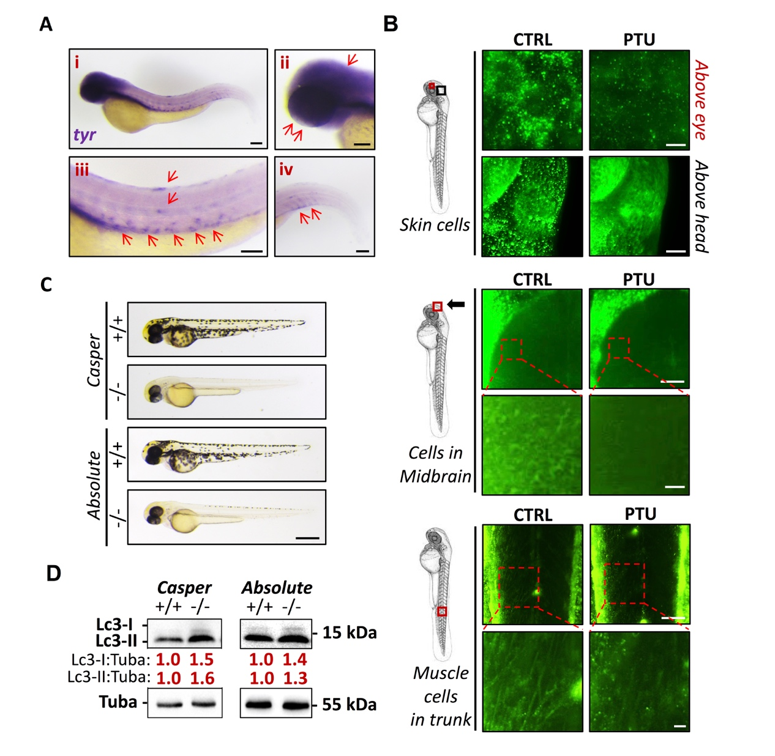
Figure S2

Figure S2. Spatial expression of tyr/Tyr in wild-type and aberrant autophagic activity in Casper and Absolute zebrafish embryos. (A) Representative whole-mount in situ hybridization images showing tyr expression in bleached 3 dpf wild-type zebrafish embryo. Expression of tyr was observed in the whole body of zebrafish embryo (i), largely in the eye and head (or brain) (ii), melanocytes (Red arrow) and trunk (or muscle) (iii), and caudal hematopoietic tissue (CHT) (iv), Red arrowhead, tyr⁺ signal. Scale bar: 100 μm; (B) Representative immunostaining images showing Tyr protein expression in the skin cells (higher panel), midbrain (middle panel) and muscle cells (lower panel) of bleached zebrafish embryos treated with or without PTU. Scale bar: 5 μm (skin cell above eye); 200 μm (skin cell above head); 50 μm (midbrain); 10 μm (enlarged midbrain); 50 μm (muscle); 10 μm (enlarged muscle); (C) Representative bright-field images showing the pigmentation of 2 dpf homozygous (⁻/⁻) Casper and Absolute zebrafish embryo and their wildtype (⁺/⁺) siblings. Scale bar: 0.5 mm; (D) Western blot results showing accumulation of Lc3-I and Lc3-II in homozygous (⁻/⁻) Casper or Absolute zebrafish embryos compared with their wild-type (⁺/⁺) siblings. Mean relative ratio of Lc3-I:Tuba and Lc3-II:Tuba was presented under the bands. 50 embryos were collected per group for 3 independent experiments. Paired t-test was applied and significant increase (p<0.05) in Lc3-I:Tuba and Lc3-II:Tuba of homozygous Casper and Absolute zebrafish embryos compared with their wild-type siblings were detected.

Figure S3

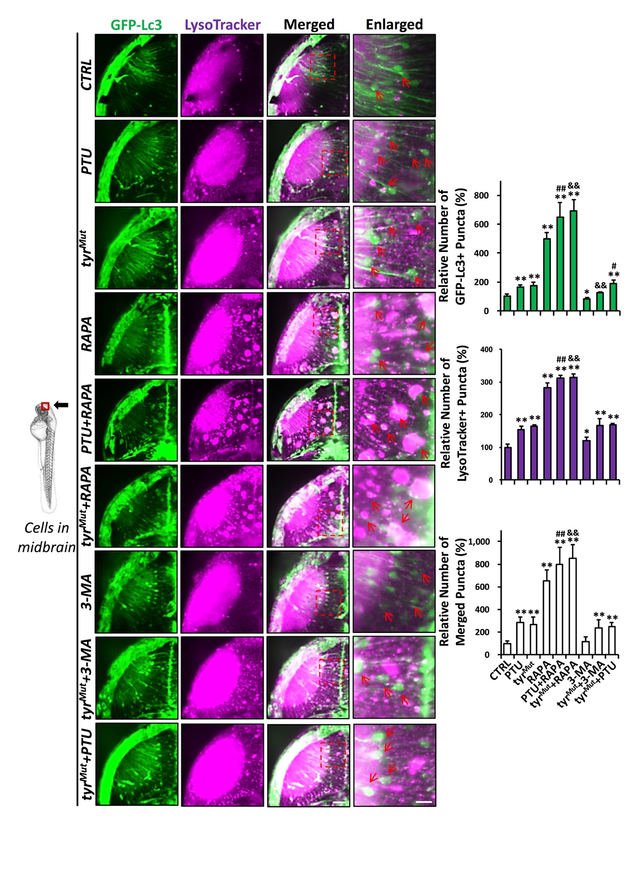
Figure S3. Autophagic modulators modulate autophagy in PTU-treated and tyr^{Mut} zebrafish embryos. Schematic diagram showing the position (cells in the midbrain) of imaging. The number of GFP-Lc3⁺, LysoTracker⁺, and Merged (GFP-Lc3⁺ and LysoTracker⁺) puncta per cell in the neuron of midbrain were counted based on Z-Stack (10 layers out of 100 layers) images. Representative images of nine Tg(GFP-Lc3) zebrafish injected with tyr gRNA (tyr^{Mut}) and/or treated with PTU and various autophagic modulators, including rapamycin and 3-methyladenine (3-MA), and stained with LysoTracker prior to imaging from three independent experiments were shown. Red arrowhead, GFP-Lc3⁺ and/or LysoTracker⁺ puncta. *, p<0.05, **, p<0.01 compared with control (CTRL); #, p<0.05, ##, p<0.01 compared with PTU; &&, p<0.01 compared with tyr^{Mut}. Scale bar: 40 μm (Merged), 6 μm (Enlarged).

Supplementary materials and methods

Whole-mount in situ hybridization.

Partial cDNA sequence of tyr was amplified by PCR with specific primers (tyr-F: GATCGAGAGCGATGGCCTTT and tyr-R: GGGCACCATGAAGTATCCGT). PCR product was then cloned into a pGEM-T-easy vector (Promega, A1360) and subsequently applied as a template to generate an antisense digoxigenin (DIG)-labeled RNA probe via using DIG RNA Labeling Kit (Roche, 11277073910). Whole-mount in situ hybridization (WISH) was performed as described previously [1].

Whole-mount immunostaining.

Dechorionated embryos were fixed in 4% paraformaldehyde (PFA; Sigma-Aldrich, P6148) at 4°C overnight and then dehydrated and rehydrated with gradient concentration ethanol in phosphate-buffered saline (VWR International, 97062-732) plus Tween 20 (Bio-Rad Laboratories, 1610781) (PBST). After washing with PBST, embryo washed with Tris buffer (150 mM Tris-HCl, pH 9.0) and equilibrated in Tris buffer at 70°C for 15 min. Afterward, embryos were penetrated with pre-chilled acetone at -20°C for 20 min and then blocked with 10% normal goat serum (NGS; Thermo Fisher, 10000C) and 2% bovine serum albumin (BSA; Sigma-Aldrich, A3803) in phosphate-buffered saline plus Triton X-100 (Bio-Rad Laboratories, 1610407) (PBT) for 4 h at 4°C. Embryos were probed with anti-Tyr (Santa Cruz Biotechnology, sc-20035) primary antibody diluted in 2% NGS and 2% BSA in PBT at 4°C overnight and then incubated with Alexa Fluor 488-labeled goat anti-mouse IgG secondary antibody (Invitrogen, A-11029) in 2% NGS and 2% BSA in PBT in the dark for 2 h at room temperature. After washing, embryos were stored in the dark at 4°C before imaging.

Reference
1. Ma AC, Ward AC, Liang R, et al. The role of jak2a in zebrafish hematopoiesis. Blood. 2007;110(6):1824-1830.

