Supporting Information

Reactive mesogens for ultraviolet-transparent liquid crystal polymer networks
R. Plamont* ^{a,b}, F. Lancia ^{a,b}, A. Ryabchun ^{a,b}

ª Stratingh Institute for Chemistry, University of Groningen, Nijenborgh 8, 9747 AG Groningen, The Netherlands
^{b} MESA+ Institute for Nanotechnology, University of Twente, 7500 AE Enschede, The Netherlands
* corresponding author: remi.plamont@gmail.com

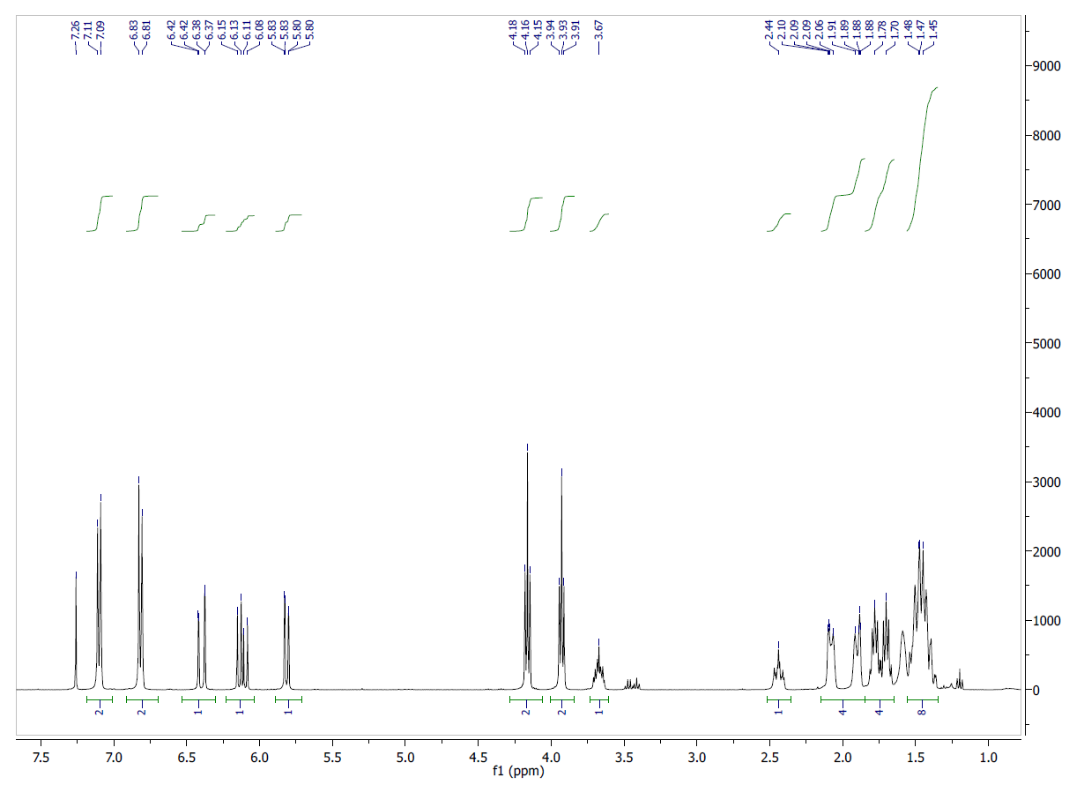
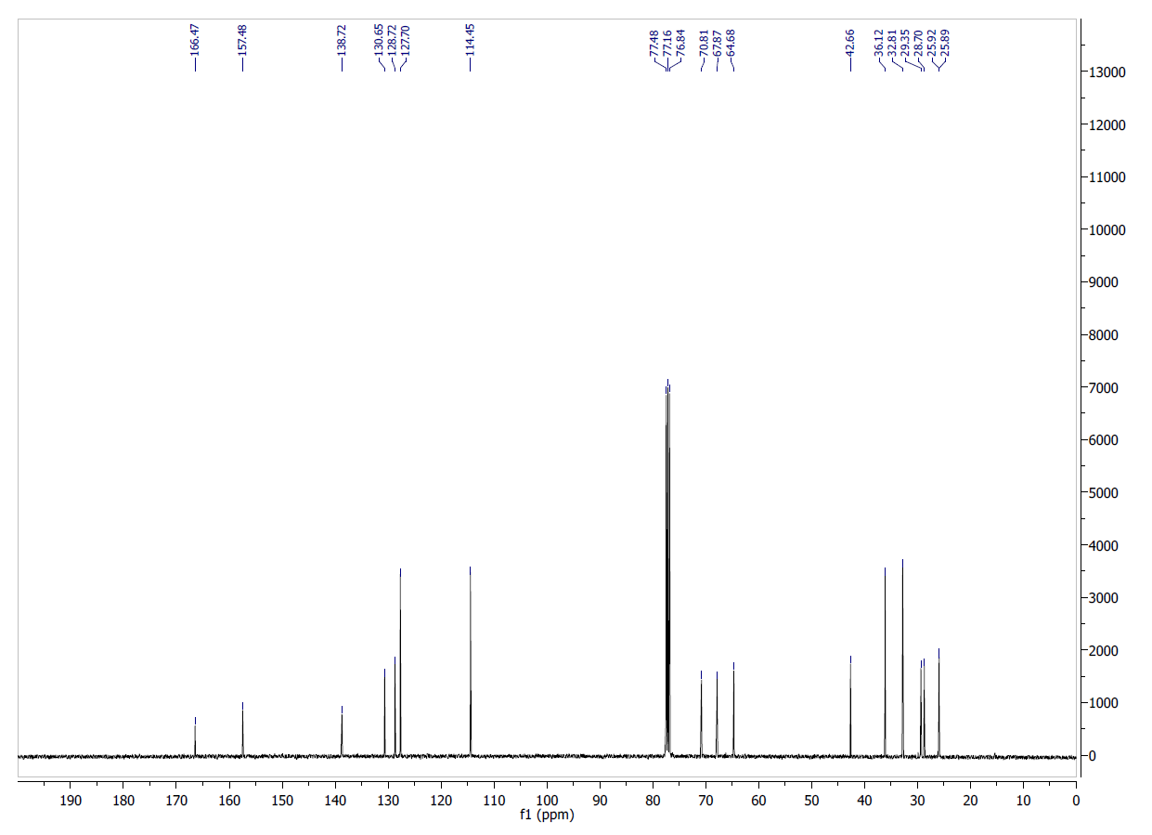Figure S1. ¹H NMR (TOP) (CDCl₃, 400 MHz) and ¹³C NMR (BOTTOM) (CDCl₃, 100 MHz) of compound 11
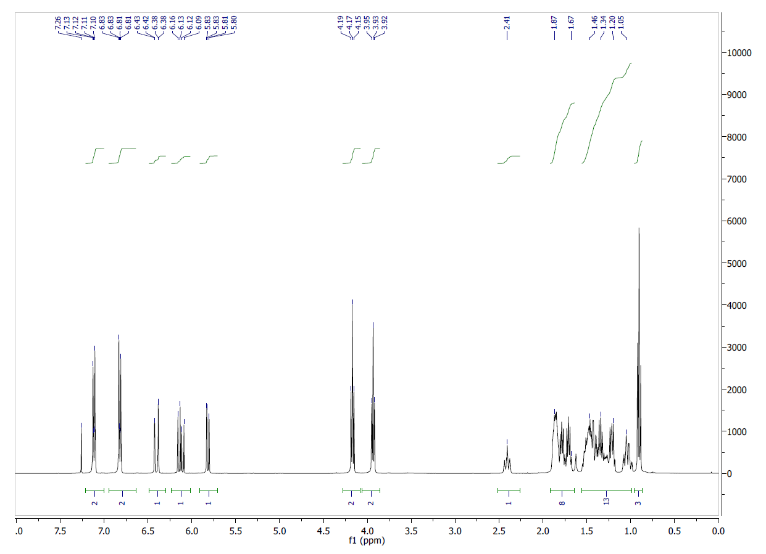
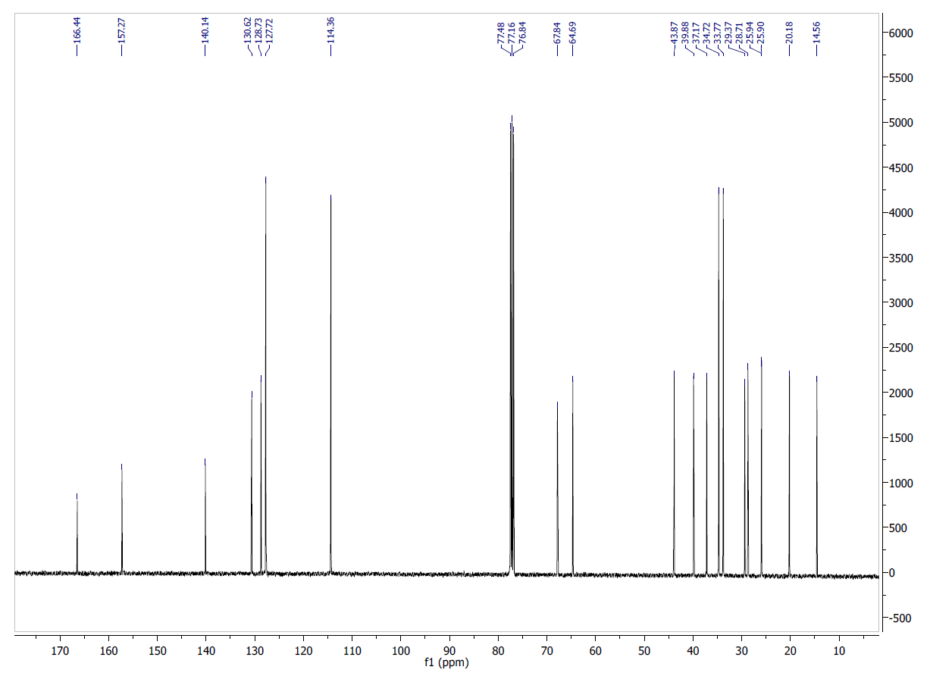Figure S2. ¹H NMR (TOP) (CDCl₃, 400 MHz) and ¹³C NMR (BOTTOM) (CDCl₃, 100 MHz) of compound 12
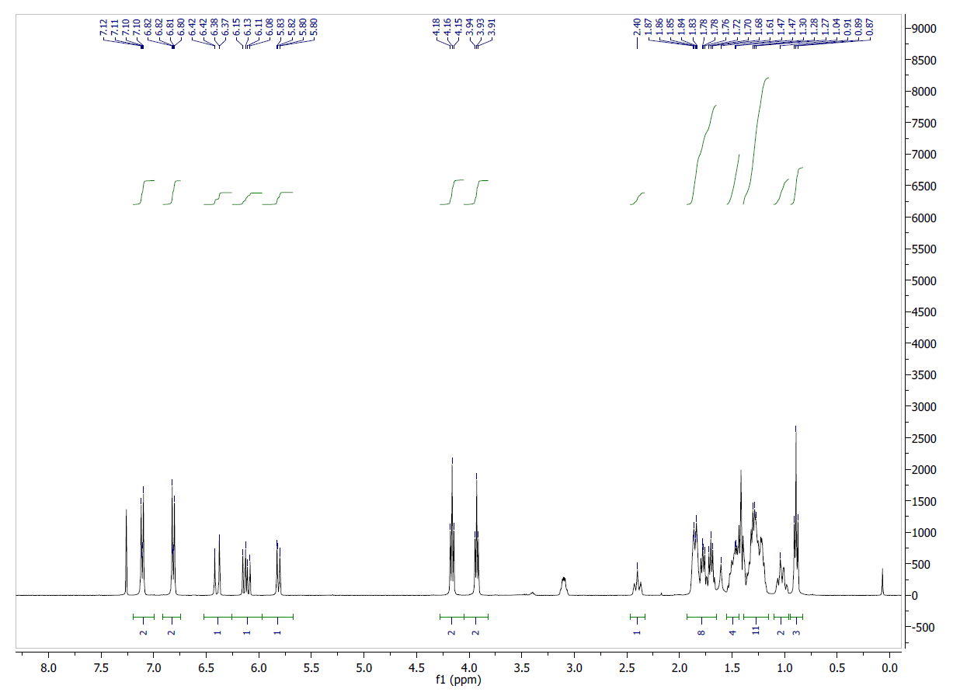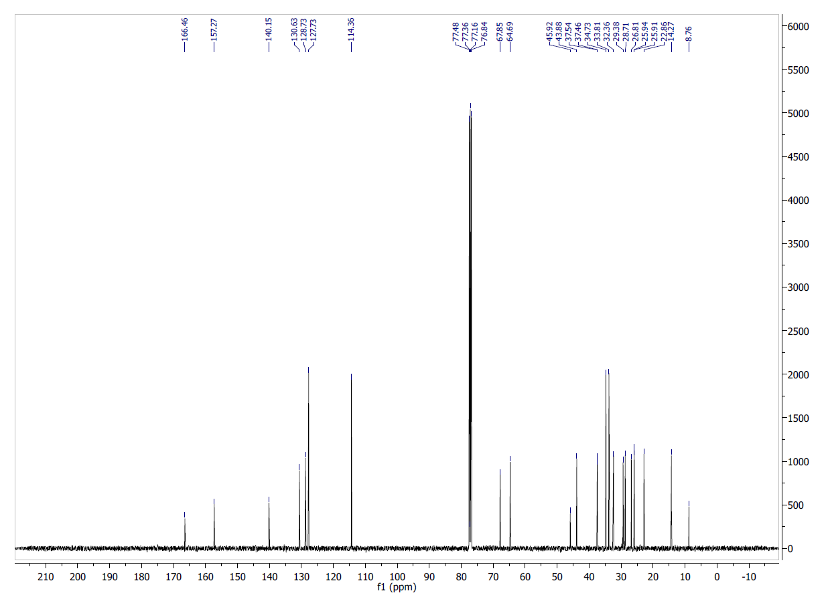
Figure S3. ¹H NMR (TOP) (CDCl₃, 400 MHz) and ¹³C NMR (BOTTOM) (CDCl₃, 100 MHz) of compound 13
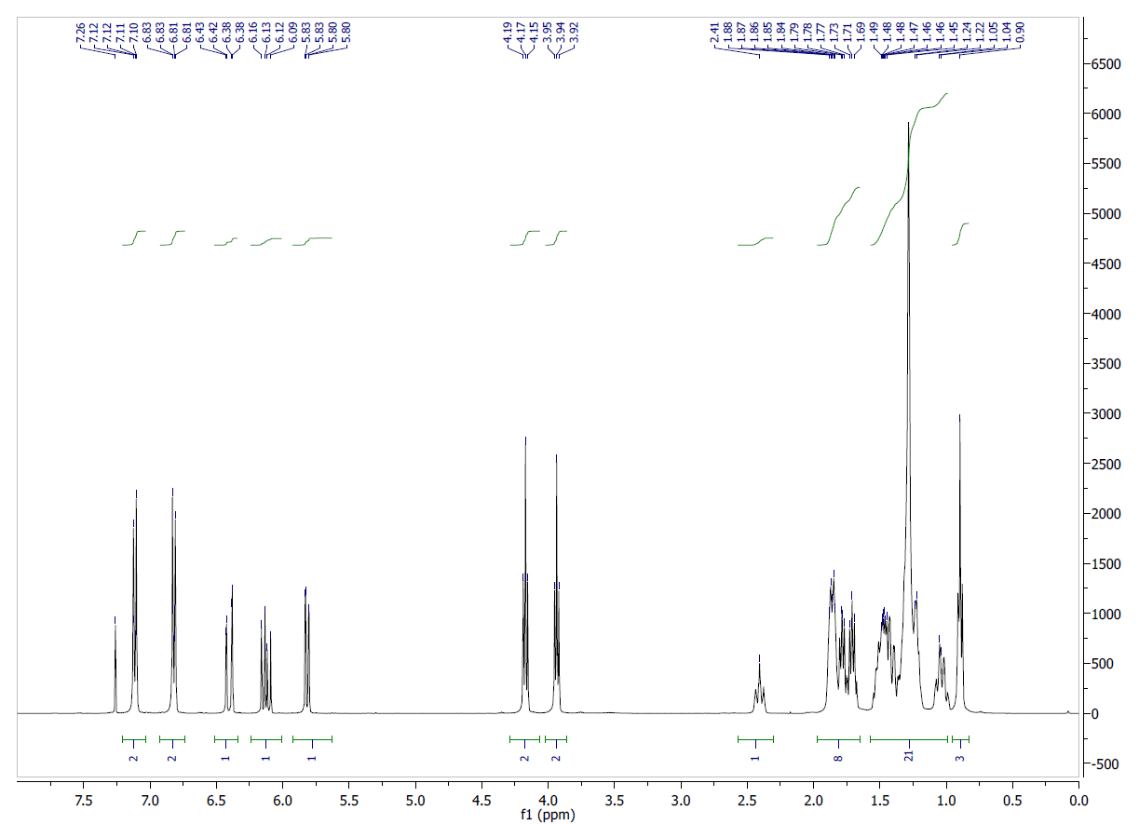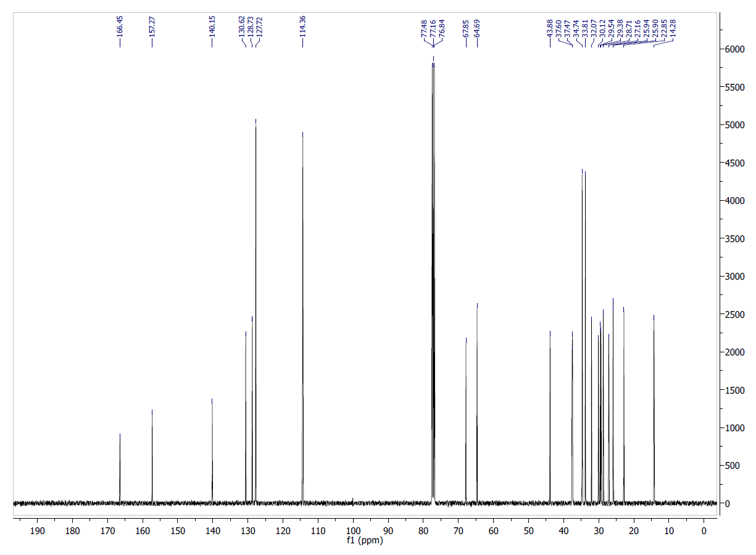
Figure S4. ¹H NMR (TOP) (CDCl₃, 400 MHz) and ¹³C NMR (BOTTOM) (CDCl₃, 100 MHz) of compound 14
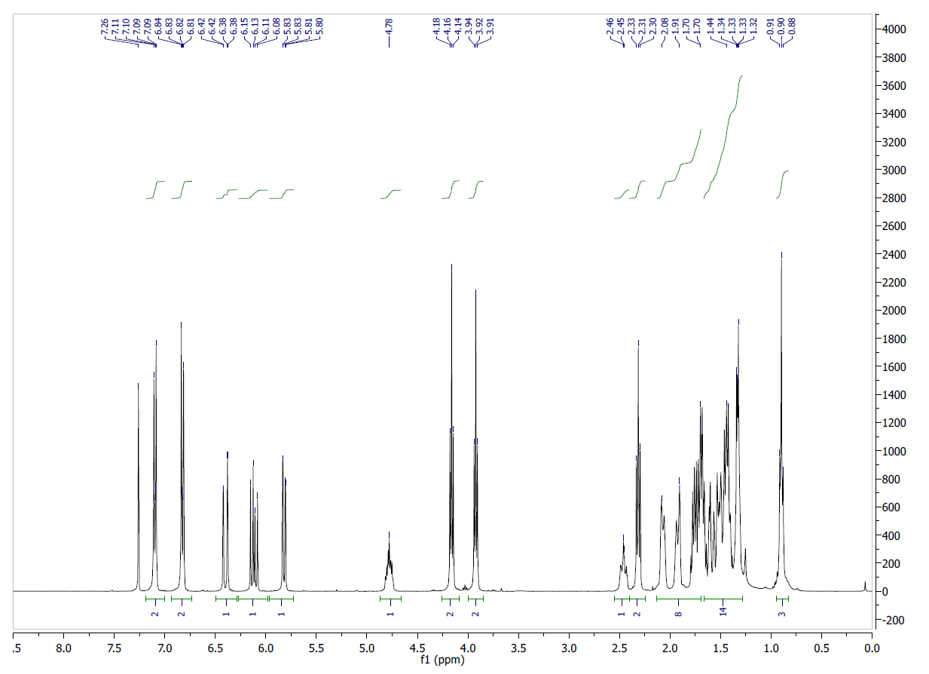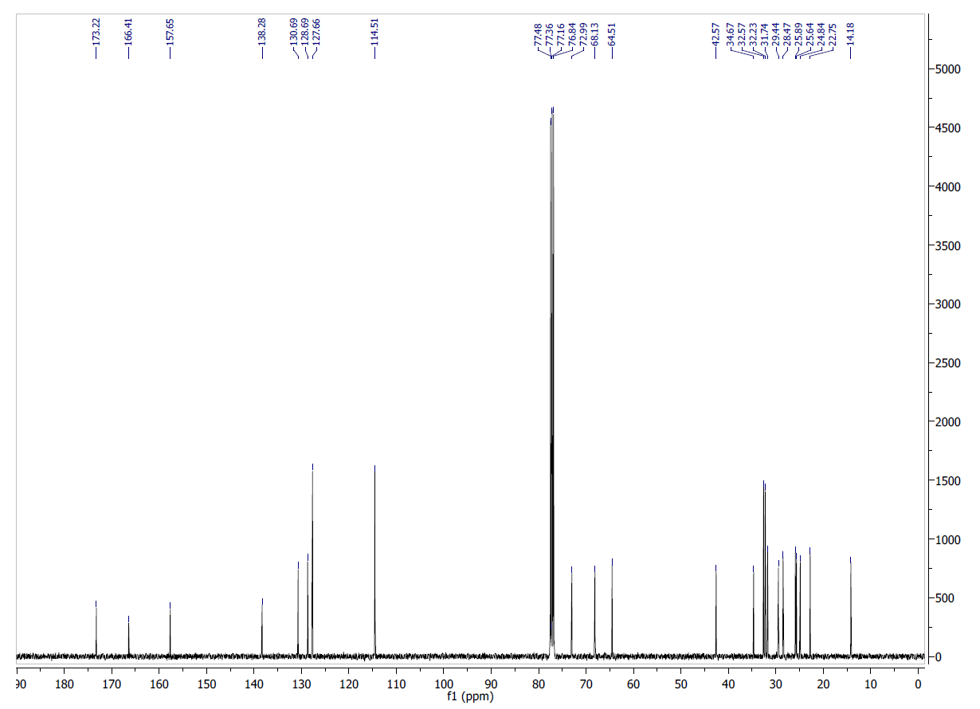
Figure S5. ¹H NMR (TOP) (CDCl₃, 400 MHz) and ¹³C NMR (BOTTOM) (CDCl₃, 100 MHz) of compound 15
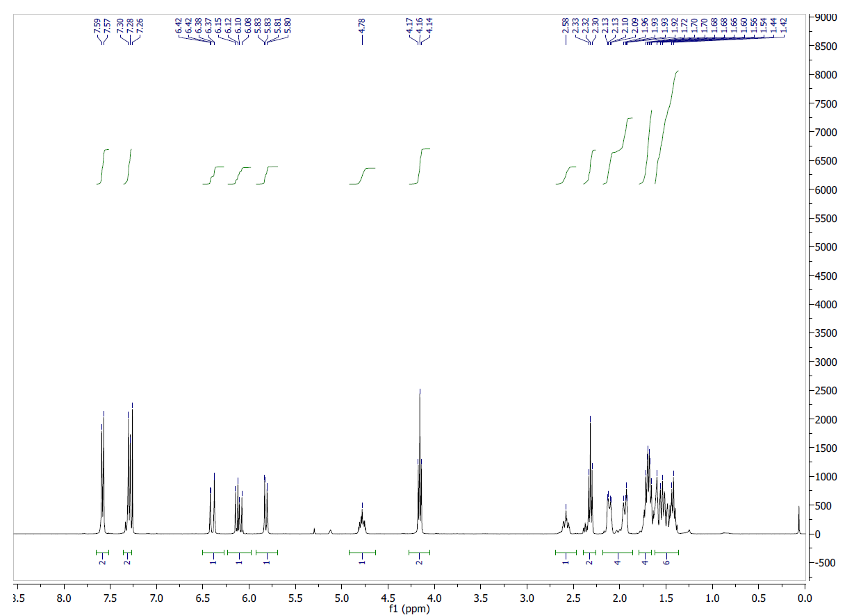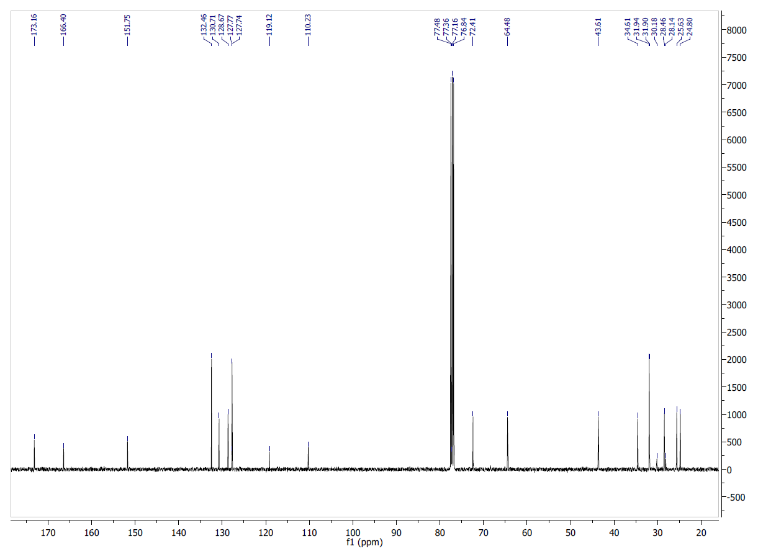
Figure S6. ¹H NMR (TOP) (CDCl₃, 400 MHz) and ¹³C NMR (BOTTOM) (CDCl₃, 100 MHz) of compound 16
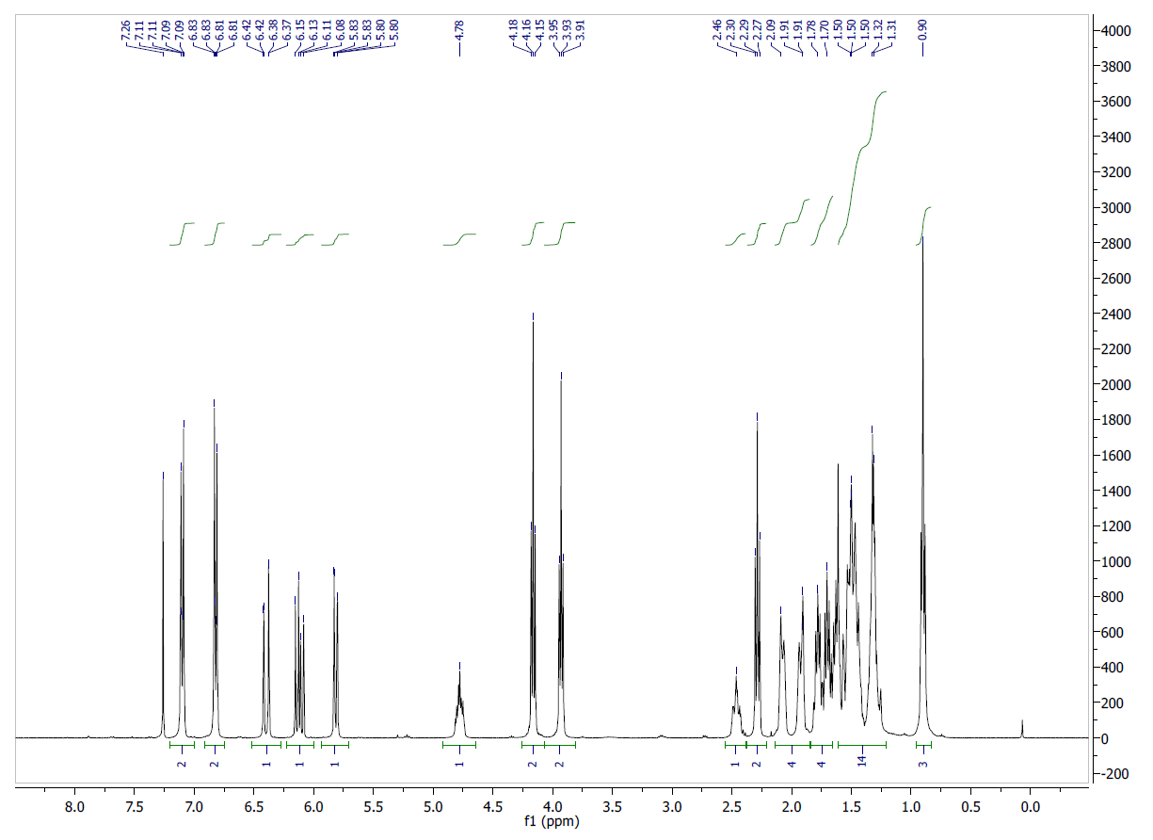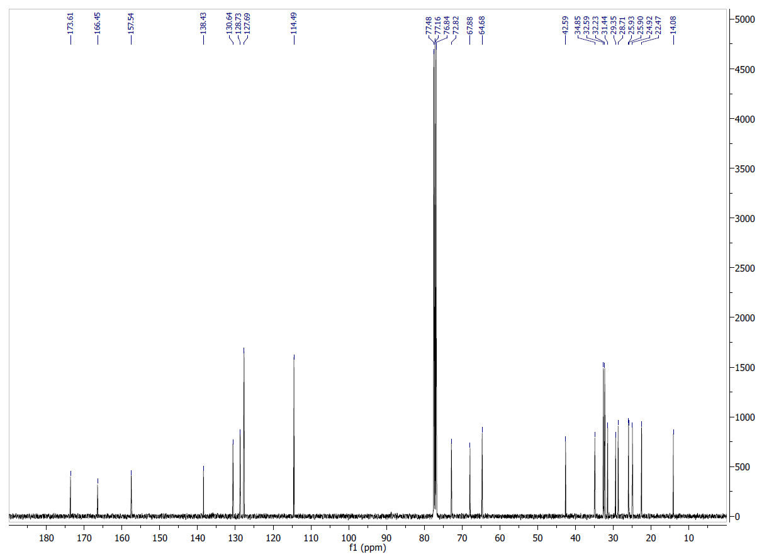
Figure S7. ¹H NMR (TOP) (CDCl₃, 400 MHz) and ¹³C NMR (BOTTOM) (CDCl₃, 100 MHz) of compound 17
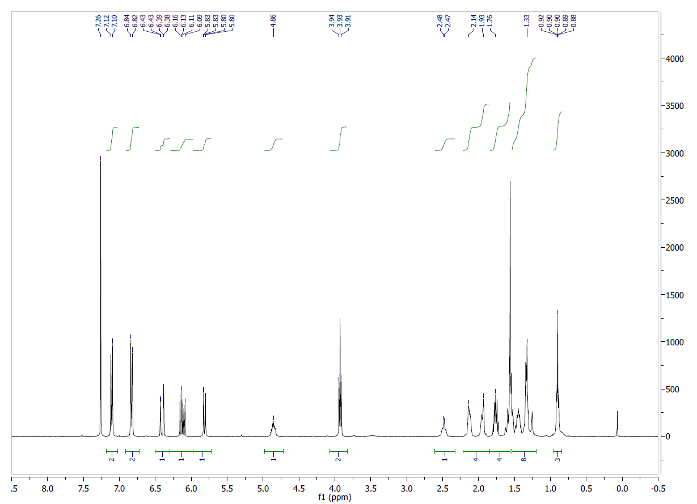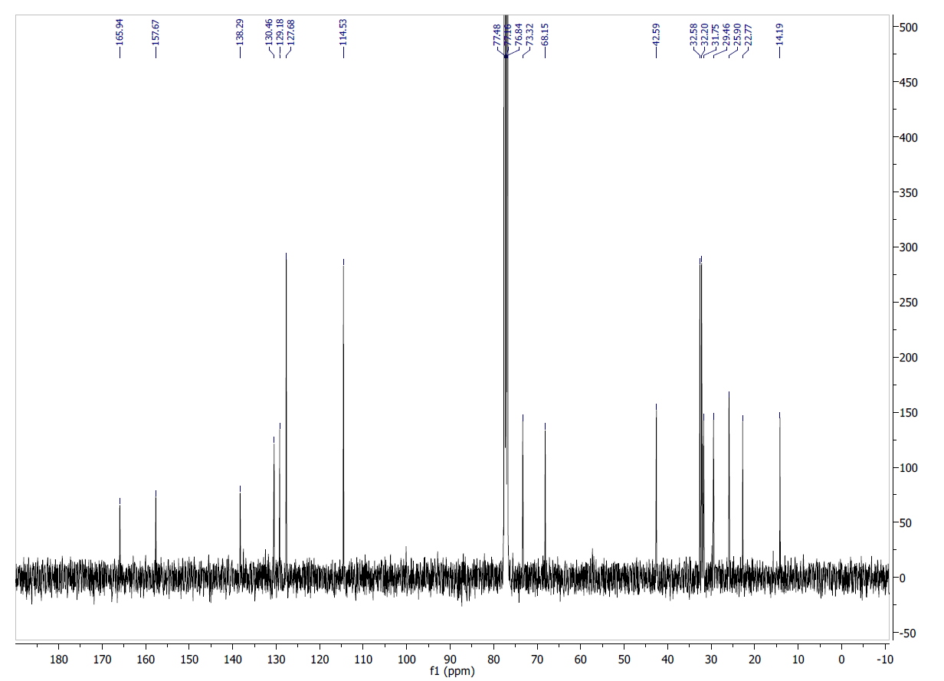
Figure S8. ¹H NMR (TOP) (CDCl₃, 400 MHz) and ¹³C NMR (BOTTOM) (CDCl₃, 100 MHz) of compound 18
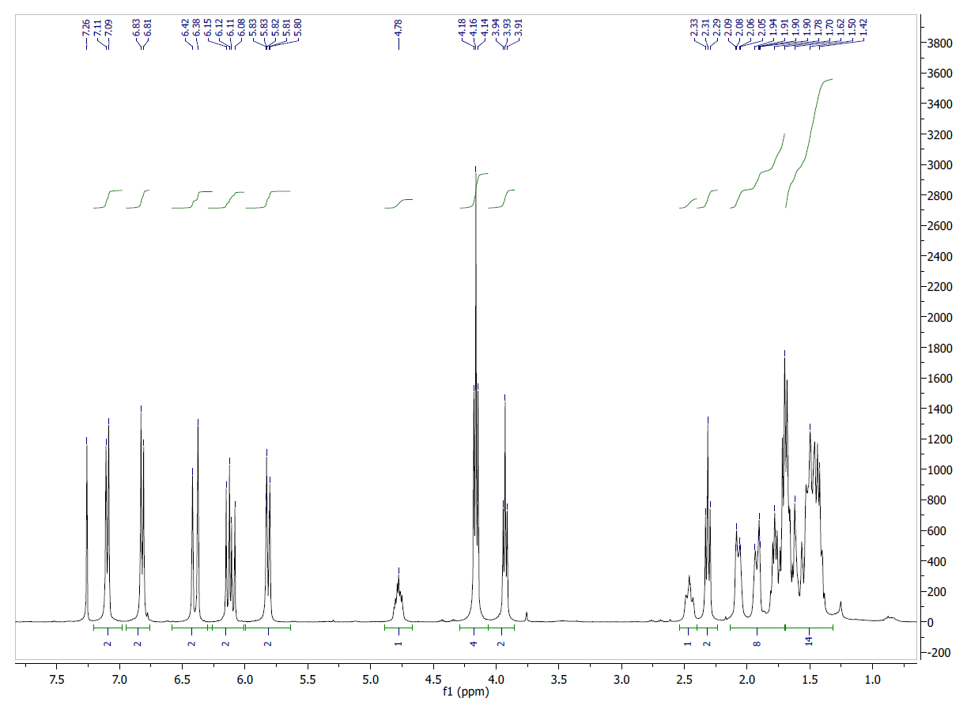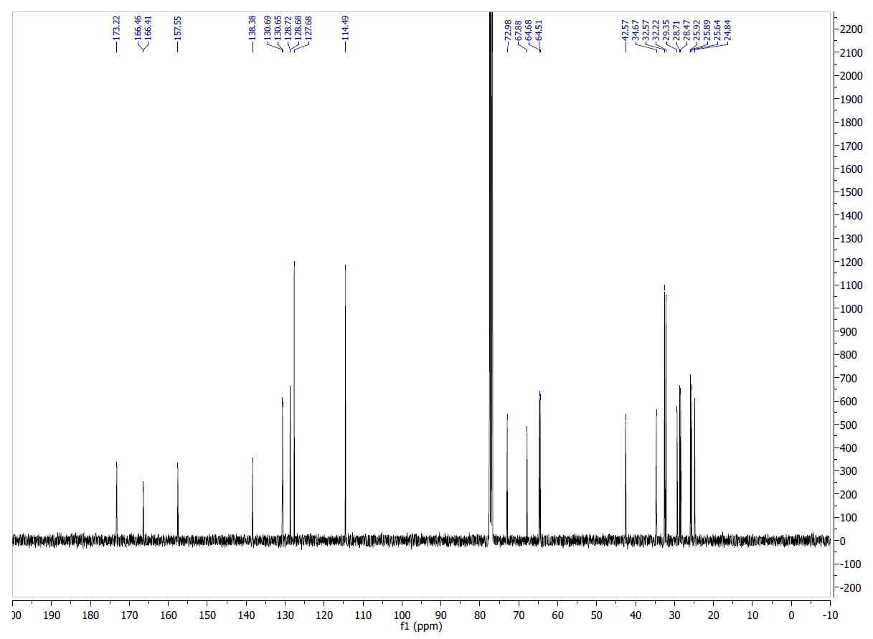
Figure S9. ¹H NMR (TOP) (CDCl₃, 400 MHz) and ¹³C NMR (BOTTOM) (CDCl₃, 100 MHz) of compound 19
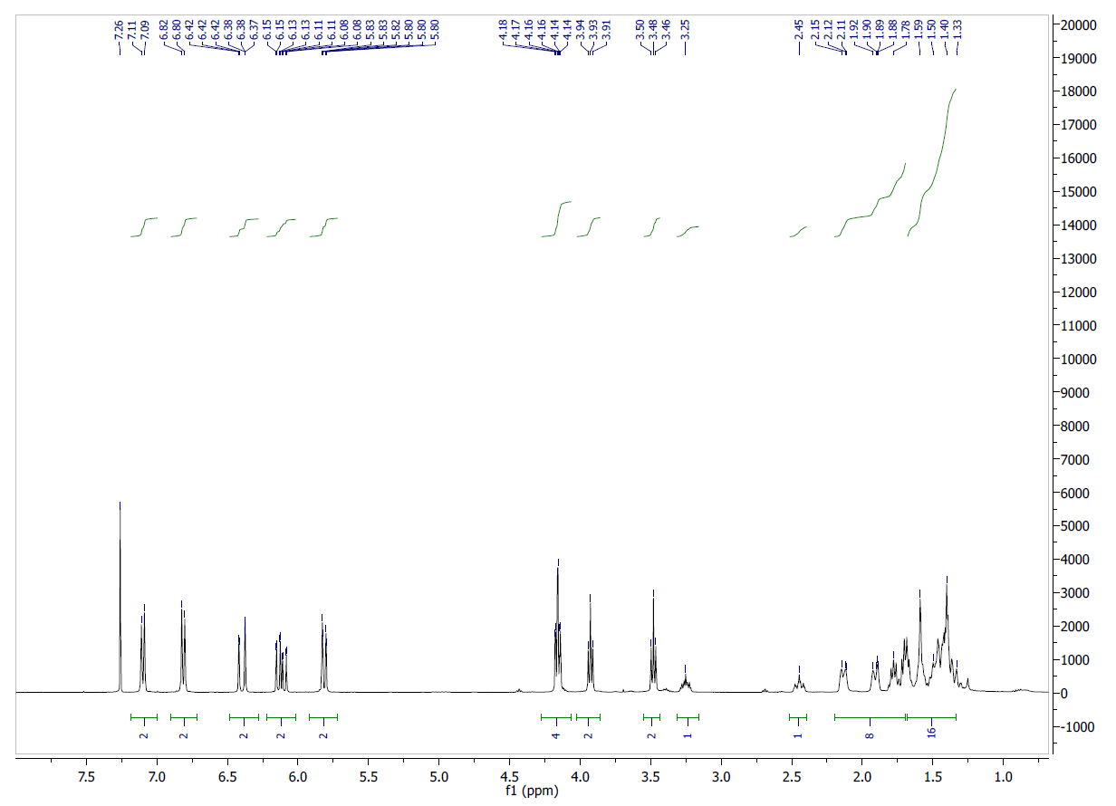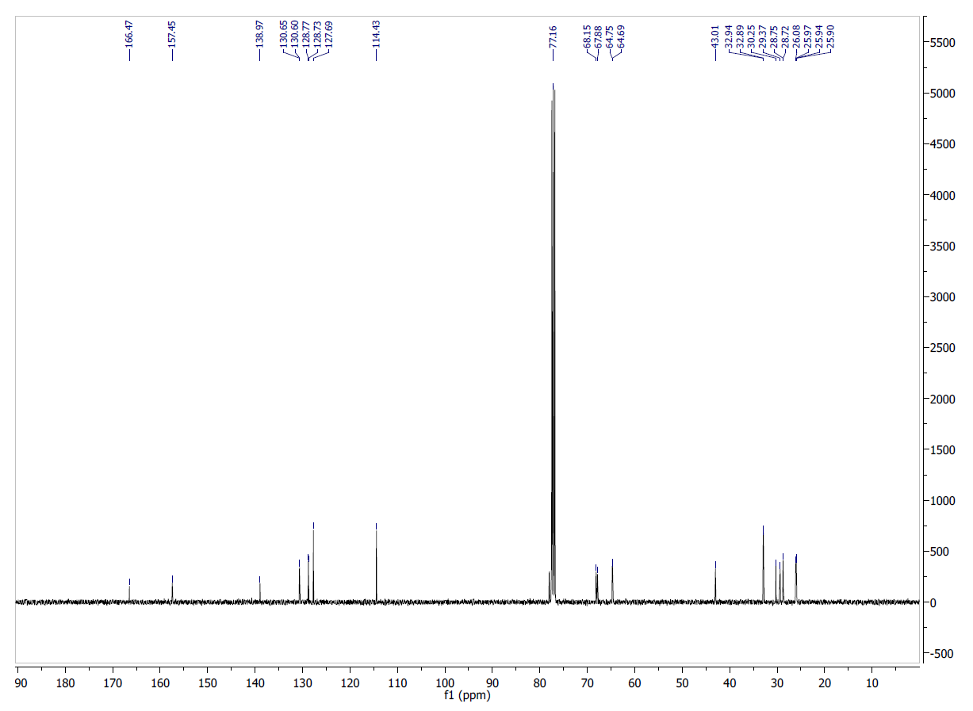
Figure S10. ¹H NMR (TOP) (CDCl₃, 400 MHz) and ¹³C NMR (BOTTOM) (CDCl₃, 100 MHz) of compound 20
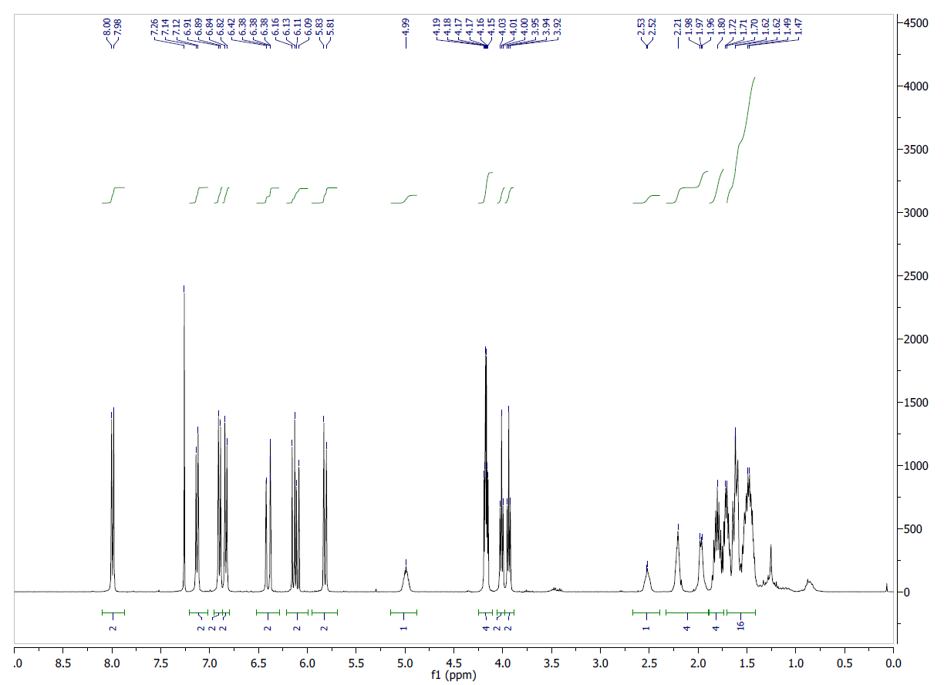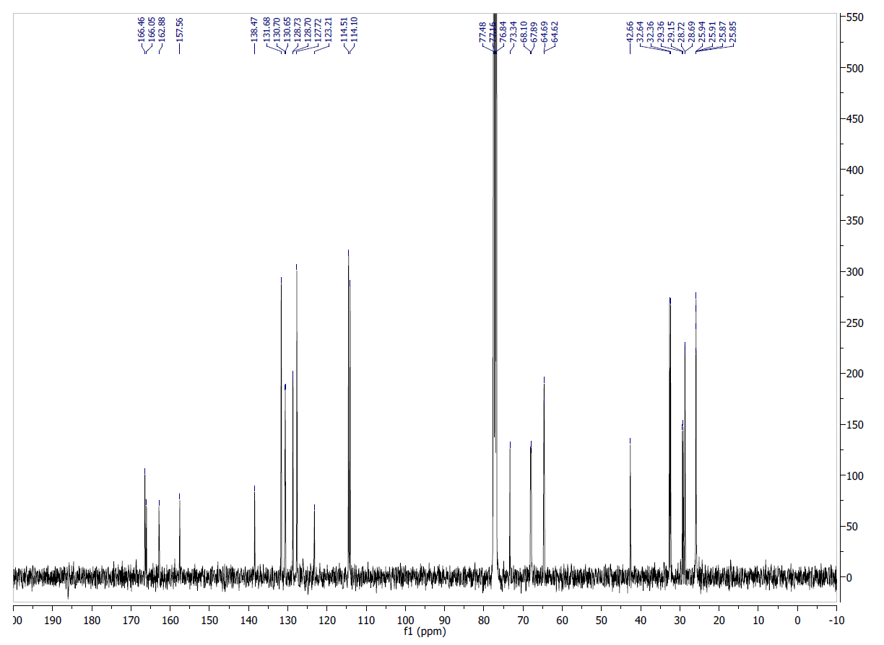
Figure S11. ¹H NMR (TOP) (CDCl₃, 400 MHz) and ¹³C NMR (BOTTOM) (CDCl₃, 100 MHz) of compound 21
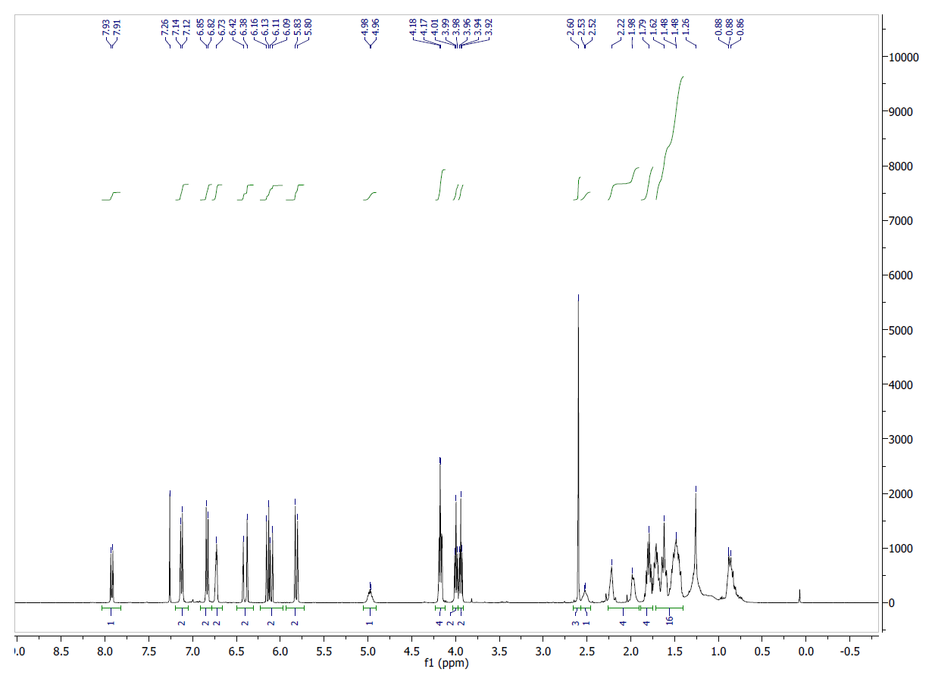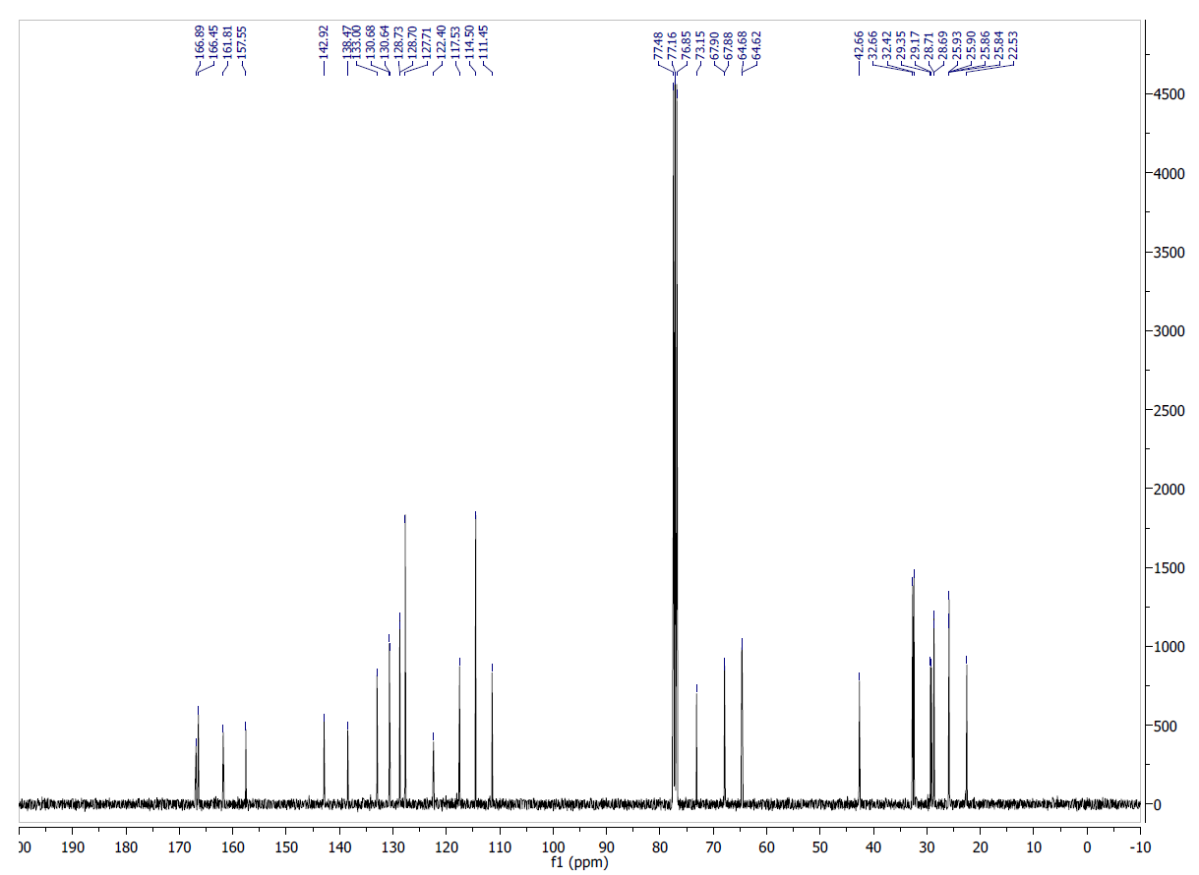
Figure S12. ¹H NMR (TOP) (CDCl₃, 400 MHz) and ¹³C NMR (BOTTOM) (CDCl₃, 100 MHz) of compound 22
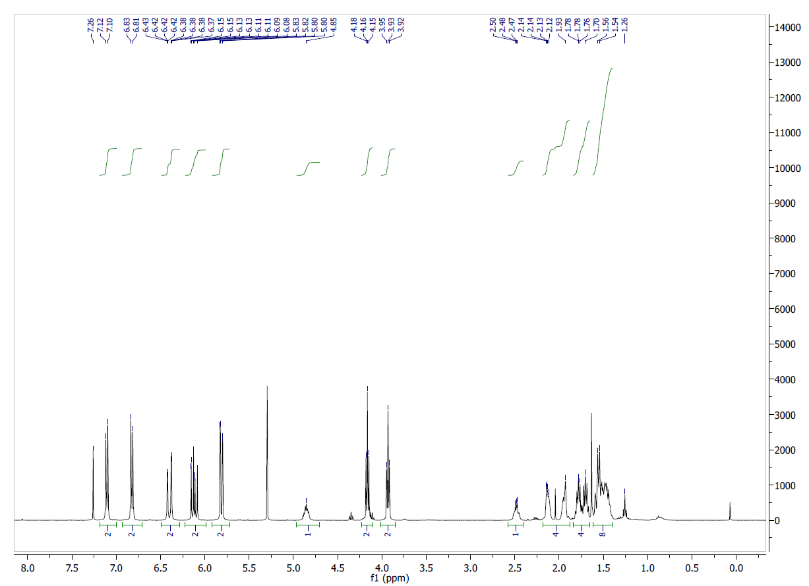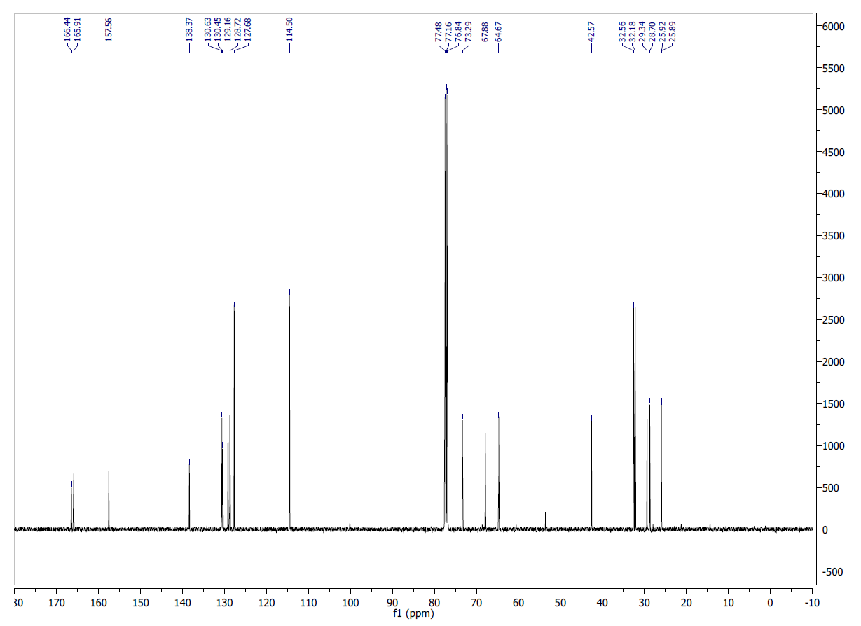
Figure S13. ¹H NMR (TOP) (CDCl₃, 400 MHz) and ¹³C NMR (BOTTOM) (CDCl₃, 100 MHz) of compound 23

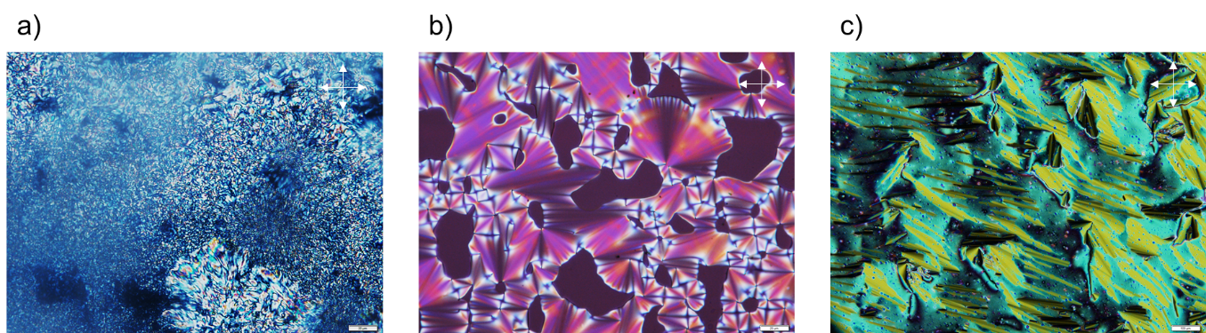
Figure S14. Polarized optical microscopy images of LC textures of compound 20 (-10ºC) (a), compound 21 (100ºC) (b), and compound 22 (50ºC) (c). Scale bares correspond to 20, 100 and 20 μm, respectively. Polarizer and analyzer are represented with white arrows.

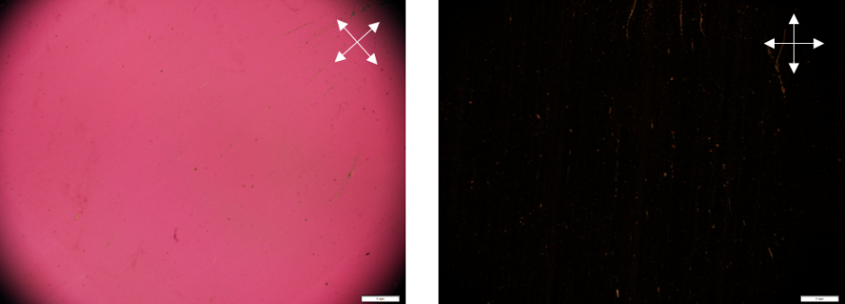
Figure S15. Polarized optical microscopy images of LCPN film TN with unidirectional alignment. Scale bare corresponds to 1mm. Polarizer and analyzer are represented with white arrows.

Table S1. Compositions (in wt.%) and nematic to isotropic transition temperatures of the mixtures consisting of mono-acrylates 12-14.
 | 12 | 13 | 14 | T_{N-I}, ºC
Mix1 | 30 | 30 | 40 | 21.9
Mix2 | 10 | 30 | 60 | 26.7
Mix3 | 10 | 20 | 70 | 27.1
Mix4 | 0 | 50 | 50 | 27.5
Mix5 | 0 | 40 | 60 | 29.0

