Chemical Constituents from the Thorns of Gleditsia sinensis and Their Cytotoxic Activities

List of Supporting information Pages

Structural identification for 3-25 1
Fig. S2. HRESIMS of 1 3
Fig. S3. UV spectrum of 1 (CH₃OH) 3
Fig. S4. IR spectrum of 1 (KBr disc) 4
Fig. S5. ¹H NMR spectrum of 1 in DMSO 4
Fig. S6. ¹³C NMR spectrum of 1 in DMSO 5
Fig. S7. DEPT-135 spectrum of 1 in DMSO 5
Fig. S8. ¹H-¹H COSY spectrum of 1 in DMSO 6
Fig. S9. HSQC spectrum of 1 in DMSO 6
Fig. S10. HMBC spectrum of 1 in DMSO 7
Fig. S11. NOESY spectrum of 1 in DMSO 7
Fig. S12. HRESIMS of 2 8
Fig. S13. UV spectrum of 2 (CH₃OH) 8
Fig. S14. IR spectrum of 2 (KBr disc) 9
Fig. S15. ¹H NMR spectrum of 2 in CD₃OD 9
Fig. S16. ¹³C NMR spectrum of 2 in CD₃OD 10
Fig. S17. DEPT-135 spectrum of 2 in CD₃OD 10
Fig. S18. ¹H-¹H COSY spectrum of 2 in CD₃OD 11
Fig. S19. HSQC spectrum of 2 in CD₃OD 11
Fig. S20. HMBC spectrum of 2 in CD₃OD 12
Fig. S21. NOESY spectrum of 2 in CD₃OD 12
Fig. S22. ¹H NMR spectrum of 3 in CD₃OD 13
Fig. S23. ¹³C NMR spectrum of 3 in CD₃OD 13
Fig. S24. ¹H NMR spectrum of 4 in DMSO 14
Fig. S25. ¹³C NMR spectrum of 4 in DMSO 14
Fig. S26. ¹H NMR spectrum of 5 in CD₃OD 15
Fig. S27. ¹³C NMR spectrum of 5 in CD₃OD 15
Fig. S28. ¹H NMR spectrum of 6 in CD₃OD 16
Fig. S29. ¹³C NMR spectrum of 6 in CD₃OD 16
Fig. S30. ¹H NMR spectrum of 7 in CD₃OD 17
Fig. S31. ¹³C NMR spectrum of 7 in CD₃OD 17
Fig. S32. ¹H NMR spectrum of 8 in CD₃OD 18
Fig. S33. ¹³C NMR spectrum of 8 in CD₃OD 18
Fig. S34. ¹H NMR spectrum of 9 in CDCl₃ 19
Fig. S35. ¹³C NMR spectrum of 9 in CDCl₃ 19
Fig. S36. ¹H NMR spectrum of 10 in CD₃OD 20
Fig. S37. ¹³C NMR spectrum of 10 in CD₃OD 20
Fig. S38. ¹H NMR spectrum of 11 in CD₃OD 21
Fig. S39. ¹³C NMR spectrum of 11 in CD₃OD 21
Fig. S40. ¹H NMR spectrum of 12 in CD₃OD 22
Fig. S41. ¹³C NMR spectrum of 12 in CD₃OD 22
Fig. S42. ¹H NMR spectrum of 13 in CD₃OD 23
Fig. S43. ¹³C NMR spectrum of 13 in CD₃OD 23
Fig. S44. ¹H NMR spectrum of 14 in CD₃OD 24
Fig. S45. ¹³C NMR spectrum of 14 in CD₃OD 24
Fig. S46. ¹H NMR spectrum of 15 in CD₃OD 25
Fig. S47. ¹³C NMR spectrum of 15 in CD₃OD 25
Fig. S48. ¹H NMR spectrum of 16 in CD₃OD 26
Fig. S49. ¹³C NMR spectrum of 16 in CD₃OD 26
Fig. S50. ¹H NMR spectrum of 17 in CD₃OD 27
Fig. S51. ¹³C NMR spectrum of 17 in CD₃OD 27
Fig. S52. ¹H NMR spectrum of 18 in CD₃OD 28
Fig. S53. ¹³C NMR spectrum of 18 in CD₃OD 28
Fig. S54. ¹H NMR spectrum of 19 in CD₃OD 29
Fig. S55. ¹³C NMR spectrum of 19 in CD₃OD 29
Fig. S56. ¹H NMR spectrum of 20 in CD₃OD 30
Fig. S57. ¹³C NMR spectrum of 20 in CD₃OD 30
Fig. S58. ¹H NMR spectrum of 21 in CD₃OD 31
Fig. S59. ¹³C NMR spectrum of 21 in CD₃OD 31
Fig. S60. ¹H NMR spectrum of 22 in CDCl₃ 32
Fig. S61. ¹³C NMR spectrum of 22 in CDCl₃ 32
Fig. S62. ¹H NMR spectrum of 23 in CDCl₃ 33
Fig. S63. ¹³C NMR spectrum of 23 in CDCl₃ 33
Fig. S64. ¹H NMR spectrum of 24 in C₅D₅N 34
Fig. S65. ¹³C NMR spectrum of 24 in C₅D₅N 34
Fig. S66. ¹H NMR spectrum of 25 in CDCl₃ 35
Fig. S67. ¹³C NMR spectrum of 25 in CDCl₃ 35
Fig. S68. HPLC chromatogram of the acid hydrolysis of 1 36

Structural identification for 3-25
Twenty-three known compounds were identified as (7S,8R)-4,9′-dihydroxyl-3,3′- dimethoxyl-7,8-dihydrobenzofuran-1′-propylneolignan (3) [1], (7S,8R)-threo-1′-[3′ -hydroxy-7-(4-hydroxy-3-methoxyphenyl)-8-hydroxymethyl-7,8-dihydrobenzofuran]acrylaldehyde (4) [2], (2R-trans)-2,3-dihydro-2-(4-hydroxy-3-methoxyphenyl)-3- (hydroxymethyl)-7-methoxy-5-benzofuranpropanol acetate (5) [3], (7R,8S)-dehydrodiconiferyl alcohol (6) [4], (-)-secoisolariciresinol (7) [5], (+)-pinoresinol (8) [6], (+)-medioresinol (9) [7], syringaresinol (10) [8], garbanzol (11) [9], 7,4ʹ-dihydroxy-5,3ʹ-dimethoxyflavanonol (12) [10], 4′-O-methyldihydroquercetin (13) [10], (+)-aromadendrin (14) [11], (-)-eriodictyol (15) [12], 5-hydroxy-7-methoxyflavanone (16) [13], quercetin (17) [29], scopoletin (18) [14], 3-formylindole (19) [15], indazole (20) [16], isovanillic acid (21) [17], friedelin (22) [18], lupenone (23) [19], betulin (24) [19], sitosterol (25) [20] respectively, by comparing their spectroscopic and physical data with those of related literatures.

Fig. S1. The chemical structures of 3-25.

References
- X.G. Tong, and Y.X. Cheng, Nat. Prod. Res. Dev. 23, 404 (2011).
- S.J. Zhang, Y.Y. Huang, Y. Li, Y.H. Wang, and X.J. He, Food Chem. 286, 421 (2019).
- T. Popoff, and O. Theander, Phytochemistry 14, 2065 (1975).
- M.S.M. Yuen, F. Xue, T.C.W. Mak, and H.N.C. Wong, Tetrahedron 54, 12429 (1998).
- H.B. Park, K.H. Lee, K.H. Kim, I.K. Lee, H.J. Noh, S.U. Choi, and K.R. Lee, Nat. Prod. Sci. 15, 17 (2009).
- N. Bai, K. He, M. Roller, C.S. Lai, L. Bai, and M.H. Pan, J. Agric. Food Chem. 63, 2458 (2015).
- H.L. Ji, M. Sai, S.Y. Zhou, L.Q. Deng, H. Wang, H. Quan, M. Chen, and X.Z. Lan, Acta Pharm. Sin. 53, 97 (2018).
- H.L. Ji, M. Sai, S.Y. Zhou, L.Q Deng, H. Wang, H. Quan, M. Chen, X.Z. Lan, Acta Pharm.Sin. 53, 97 (2018).
- K. Saejueng, and N. Panthama, Nat. Prod. Res. 29, 1177 (2015).
- N. Zhang, X.Y. Wei, and L.D. Lin, J. Trop. Subtrop. Bot. 22, 96 (2014).
- Y.X. Shen, H.L. Teng, G.Z. Yang, Z.N. Mei, and X.L. Chen, Nat. Prod. Res. 45, 1139 (2010).
- G.M.V. Júnior, C.M. Sousa, A.J. Cavalheiro, J.H.G. Lago, and M.H. Chaves, Helv. Chim. Acta 91, 2159 (2010).
- M. Bai, C.J. Zheng, L.J. Wu, S.Y. Wu, Y. Cai, G.Y. Chen, C.R. Han, and X.P. Song, Chem. Nat. Compd. 54, 350 (2018).
- S.A.L. Bayoumi, M.G. Rowan, J.R. Beeching, and I.S. Blagbrough, Phytochemistry 71, 598 (2010).
- S. Martínez-Luis, J.F. Gómez, C. Spadafora, H.M. Guzmán, and M. Gutiérrez, Molecules 17, 11146 (2012).
- E. Dubost, S. Stiebing, T. Ferrary, T. Cailly, F. Fabis, and V. Collot, Tetrahedron 70, 8413 (2014).
- L.L. Ge, H.Q. Wan, S.M. Tang, H.X. Chen, J.M. Li, K.D. Zhang, B.P. Zhou, J. Fei, S.P. Wu, and X.B. Zeng, RSC Adv. 8, 35374 (2018).
- J. Chen, S.L. Wei, and K. Gao, Chem. Nat. Compd. 51, 592 (2015).
- H. Yamashita, M. Matsuzaki, Y. Kurokawa, T. Nakane, M. Goto, K.H. Lee, T. Shibata, H. Bando, and K. Wada, Phytochem. Lett. 31, 140 (2019).
- A.A. Al-Fadhli, and J.A. Nasser, Asian J. Chem. 26, 8019 (2014).
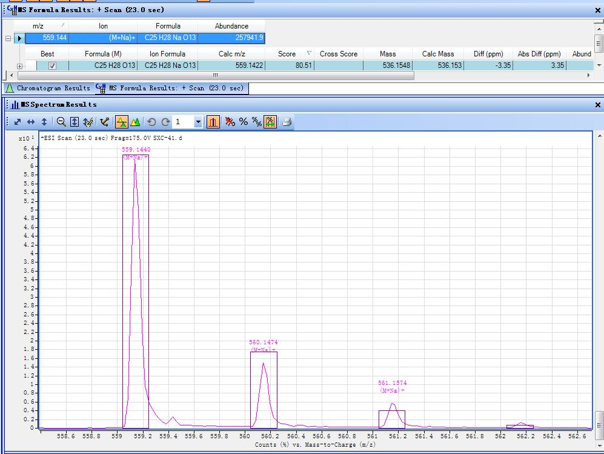

Fig. S2. HRESIMS of 1
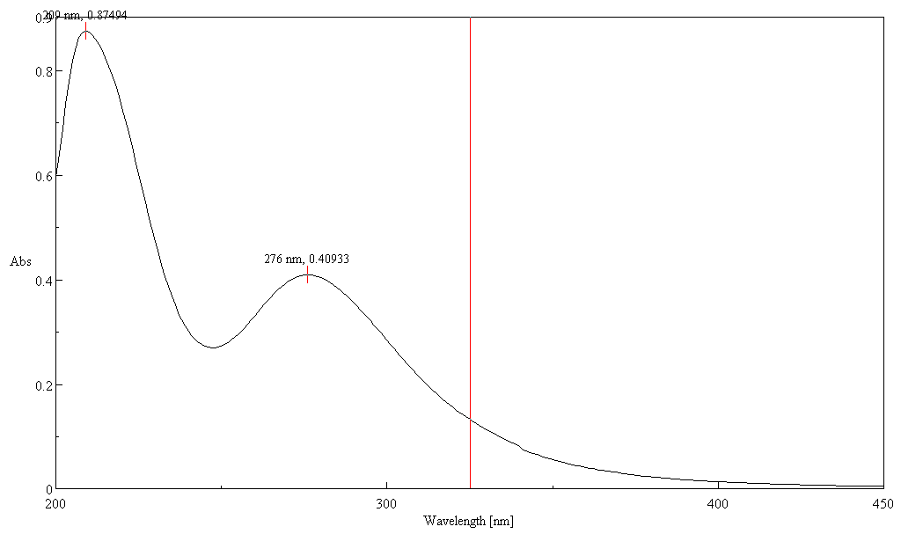

Fig. S3. UV spectrum of 1 (CH₃OH)

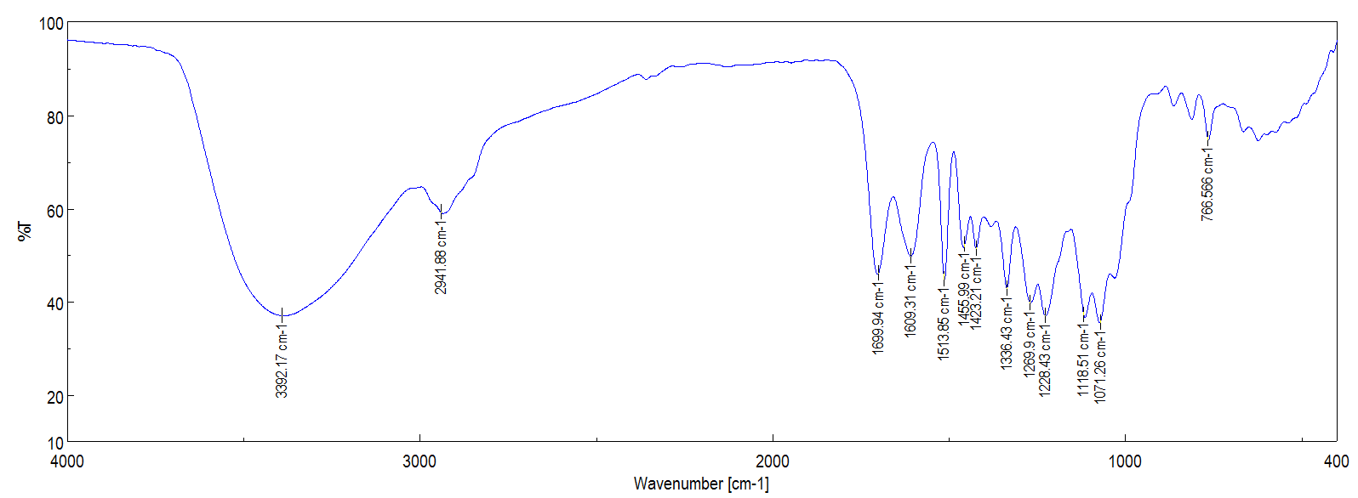

Fig. S4. IR spectrum of 1 (KBr disc)
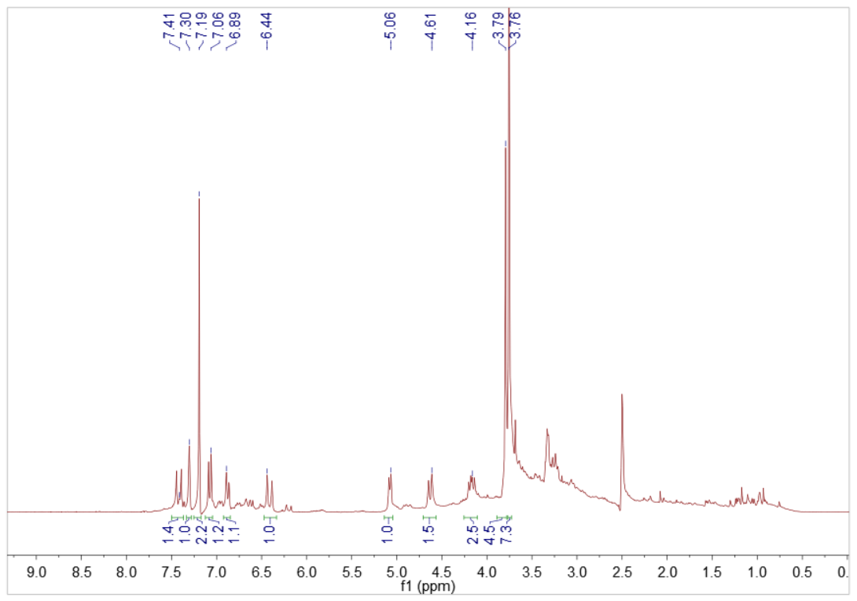

Fig. S5. ¹H NMR spectrum of 1 in DMSO

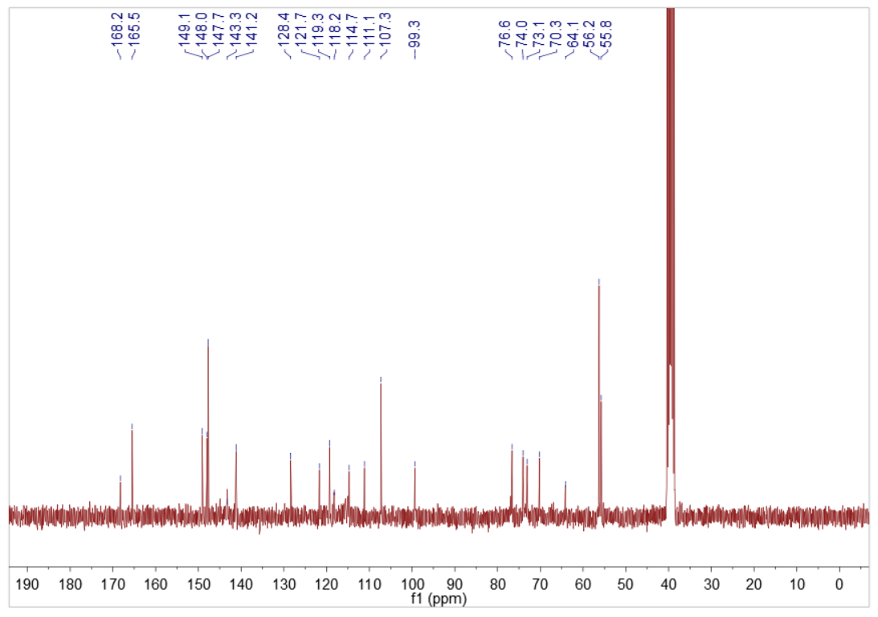

Fig. S6. ¹³C NMR spectrum of 1 in DMSO
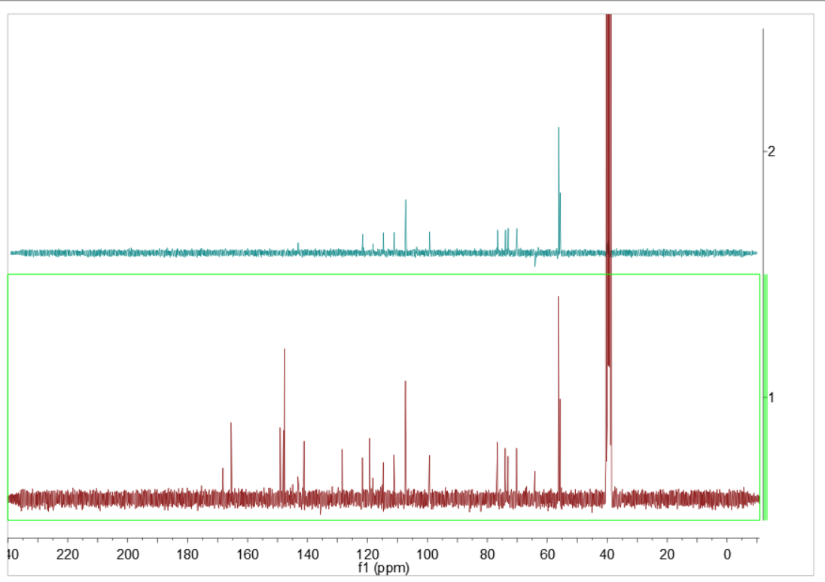

Fig. S7. DEPT-135 spectrum of 1 in DMSO

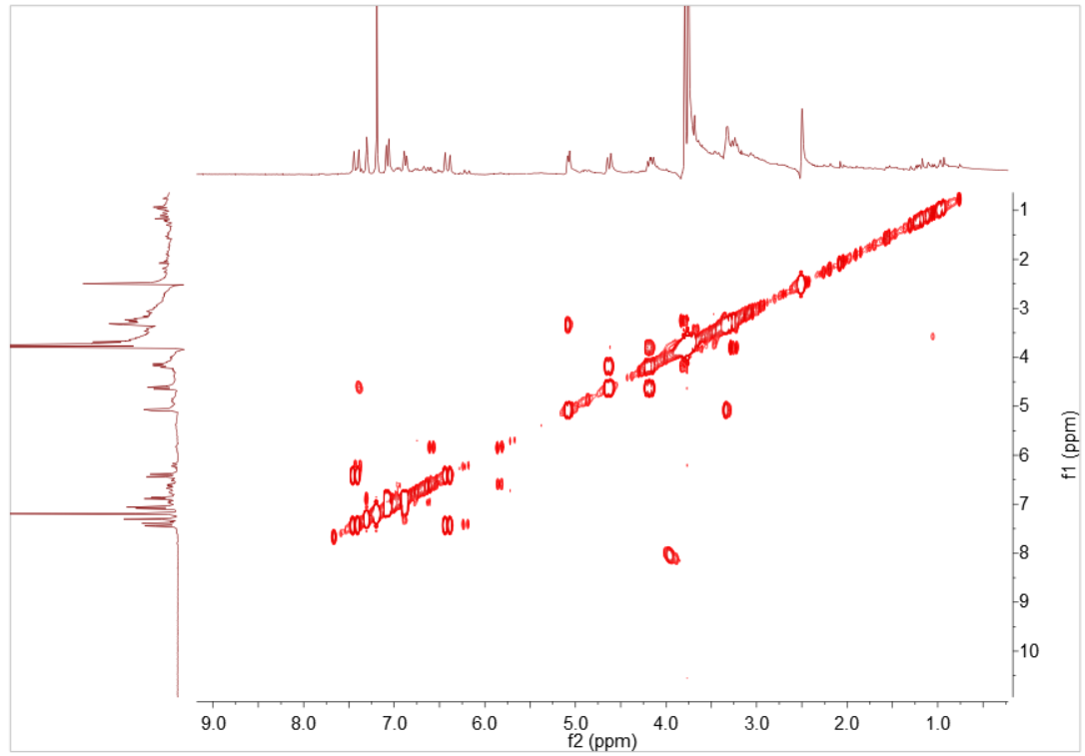

Fig. S8. ¹H-¹H COSY spectrum of 1 in DMSO

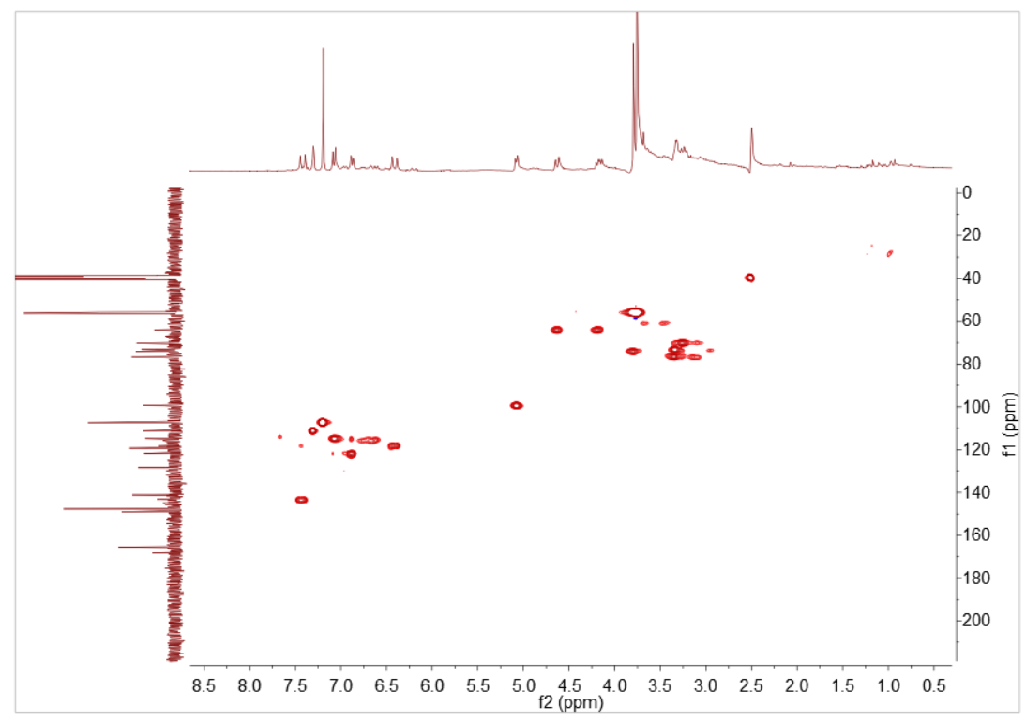

Fig. S9. HSQC spectrum of 1 in DMSO

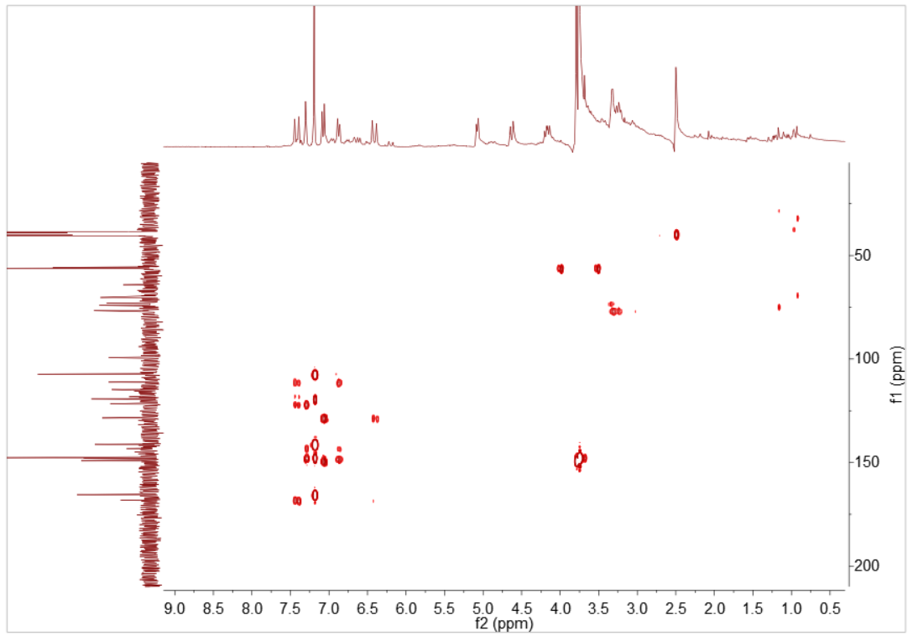

Fig. S10. HMBC spectrum of 1 in DMSO

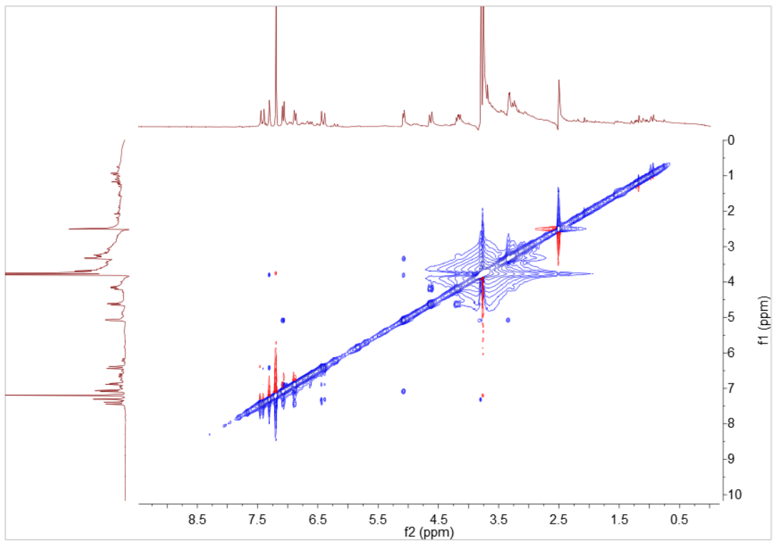

Fig. S11. NOESY spectrum of 1 in DMSO

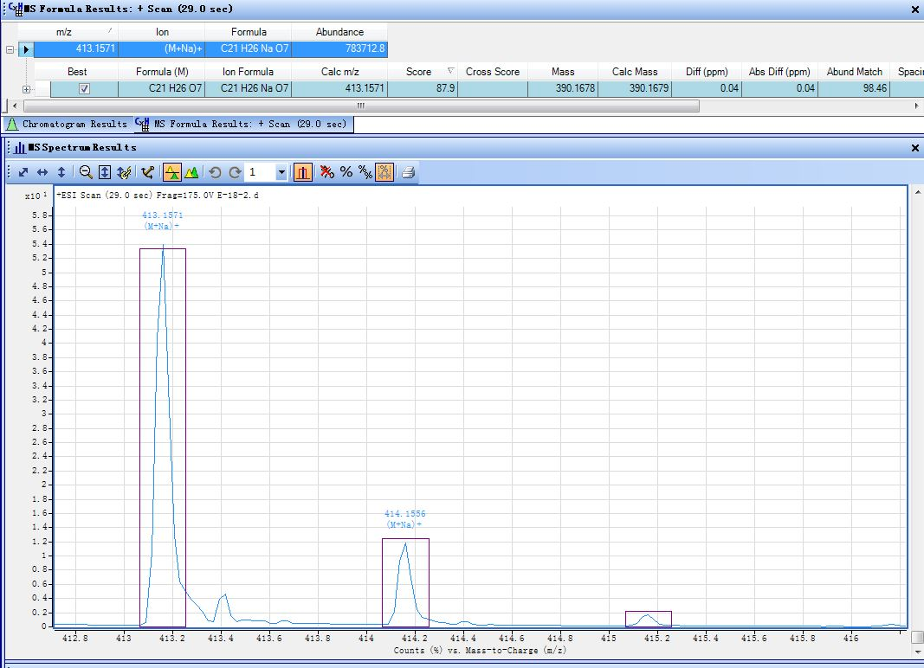

Fig. S12. HRESIMS of 2
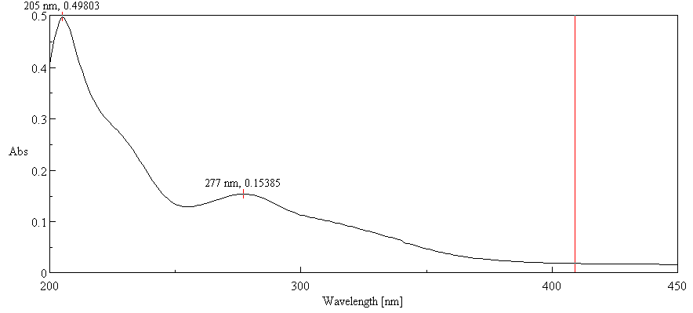

Fig. S13. UV spectrum of 2 (CH₃OH)

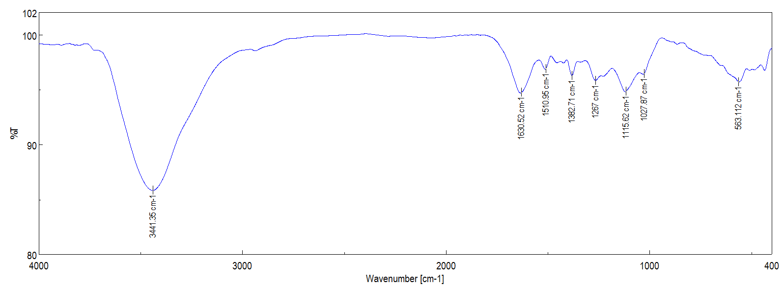

Fig. S14. IR spectrum of 2 (KBr disc)
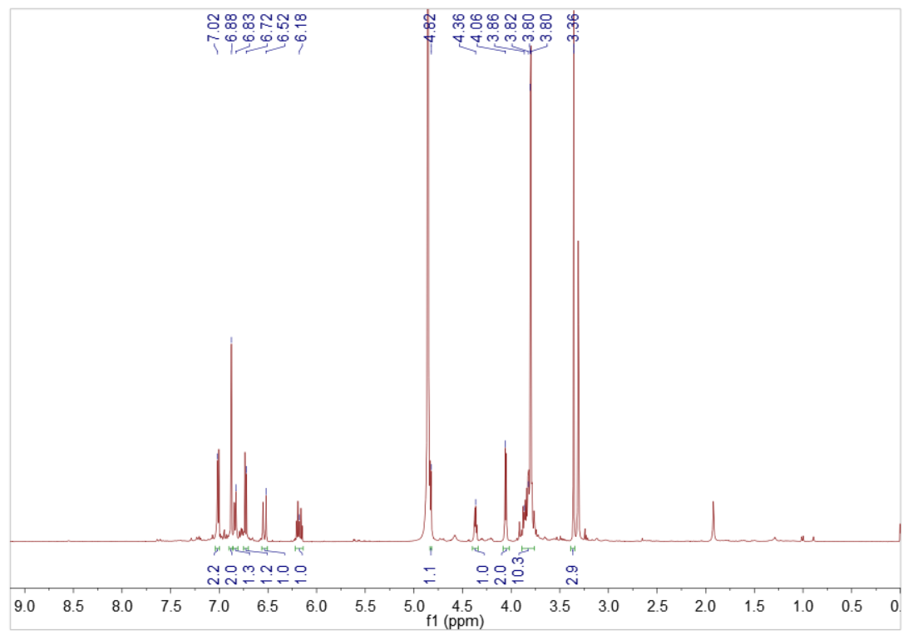

Fig. S15. ¹H NMR spectrum of 2 in CD₃OD

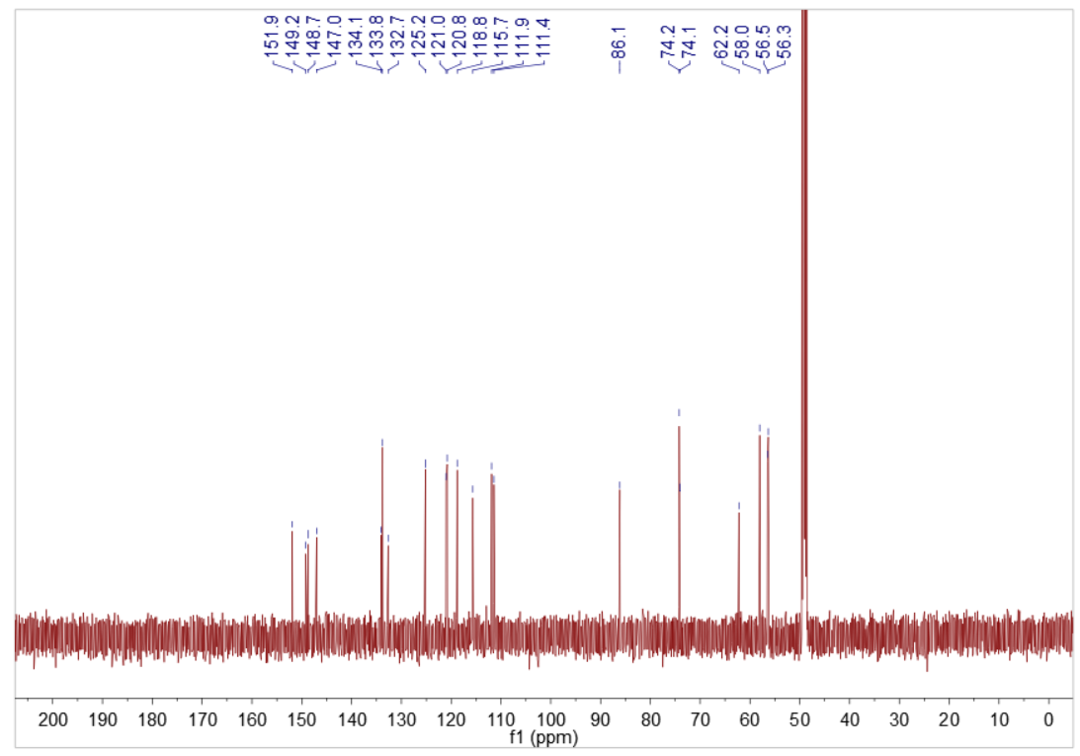

Fig. S16. ¹³C NMR spectrum of 2 in CD₃OD
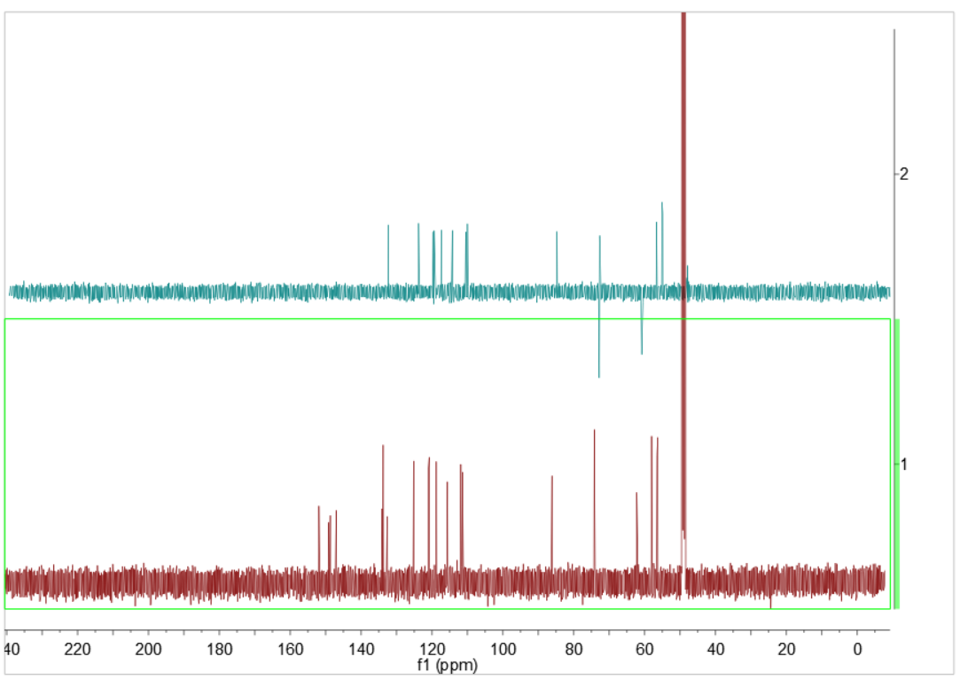

Fig. S17. DEPT-135 spectrum of 2 in CD₃OD

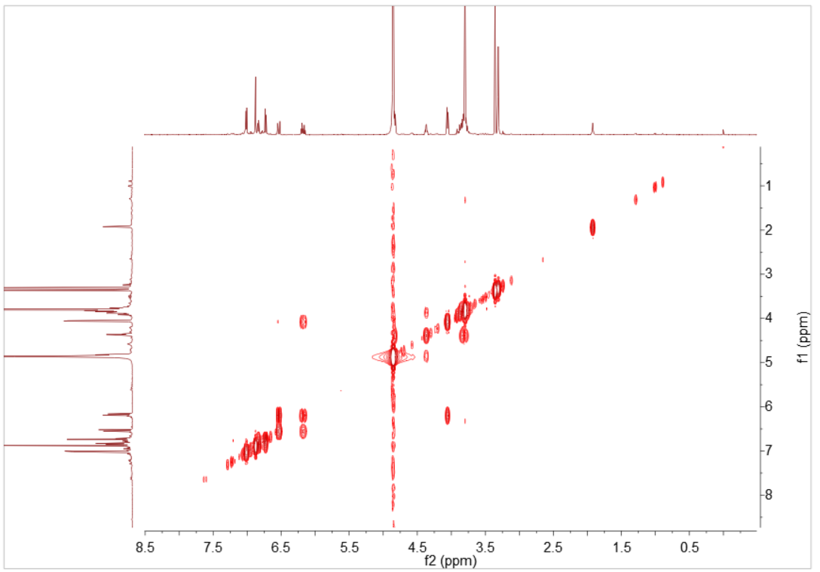

Fig. S18. ¹H-¹H COSY spectrum of 2 in CD₃OD

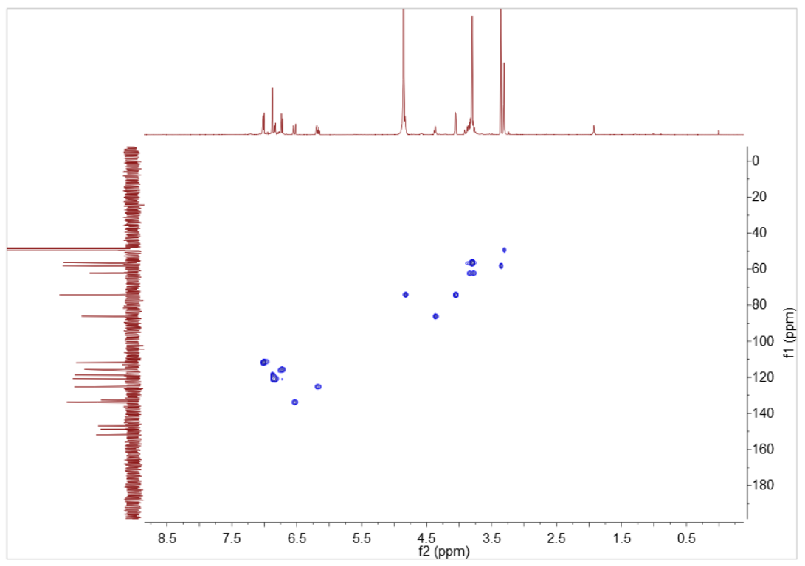

Fig. S19. HSQC spectrum of 2 in CD₃OD

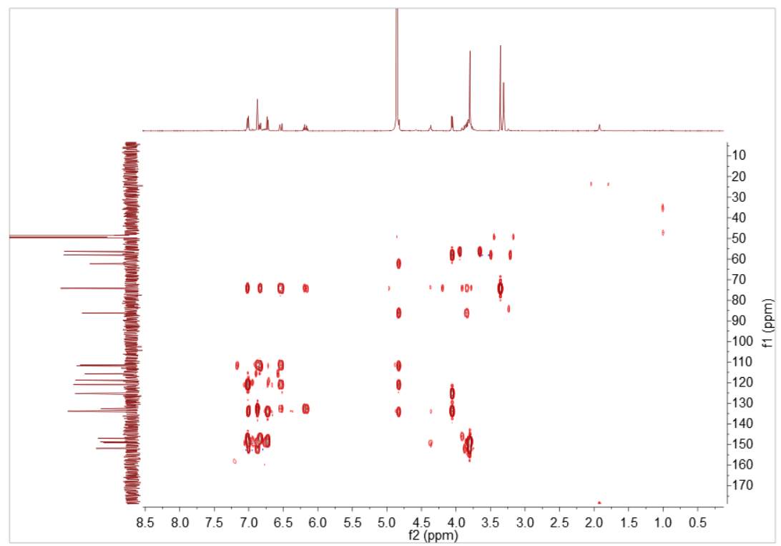

Fig. S20. HMBC spectrum of 2 in CD₃OD
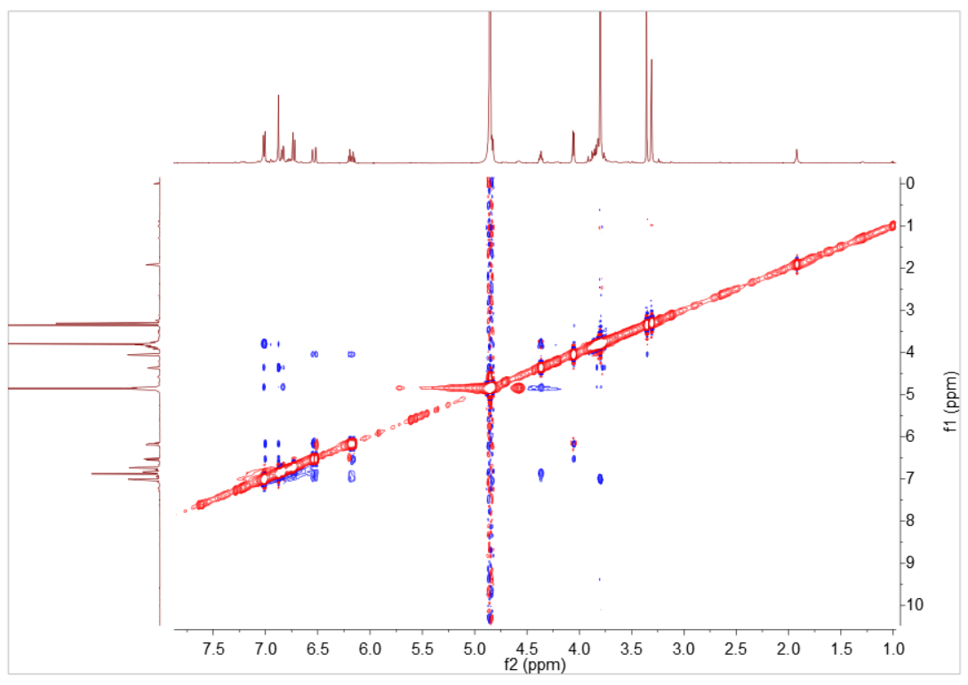

Fig. S21. NOESY spectrum of 2 in CD₃OD

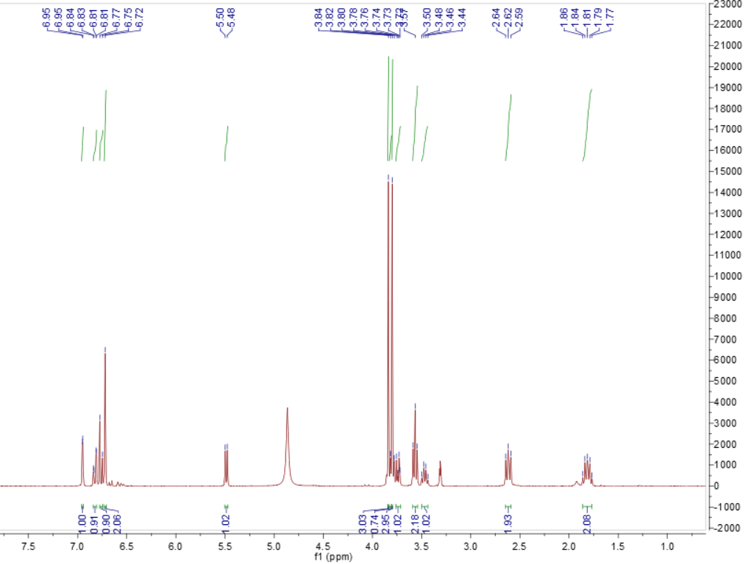

Fig. S22. ¹H NMR spectrum of 3 in CD₃OD
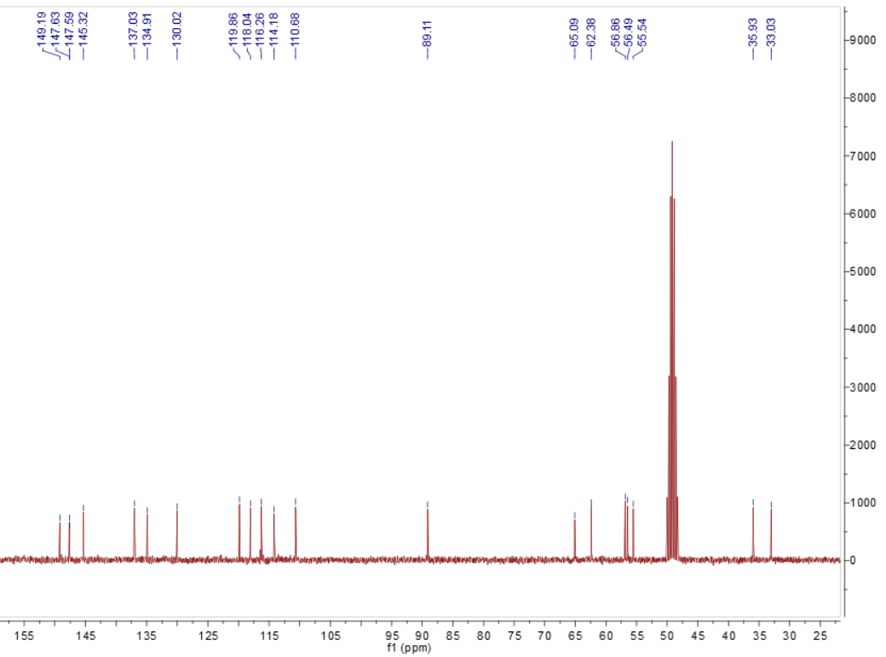

Fig. S23. ¹³C NMR spectrum of 3 in CD₃OD

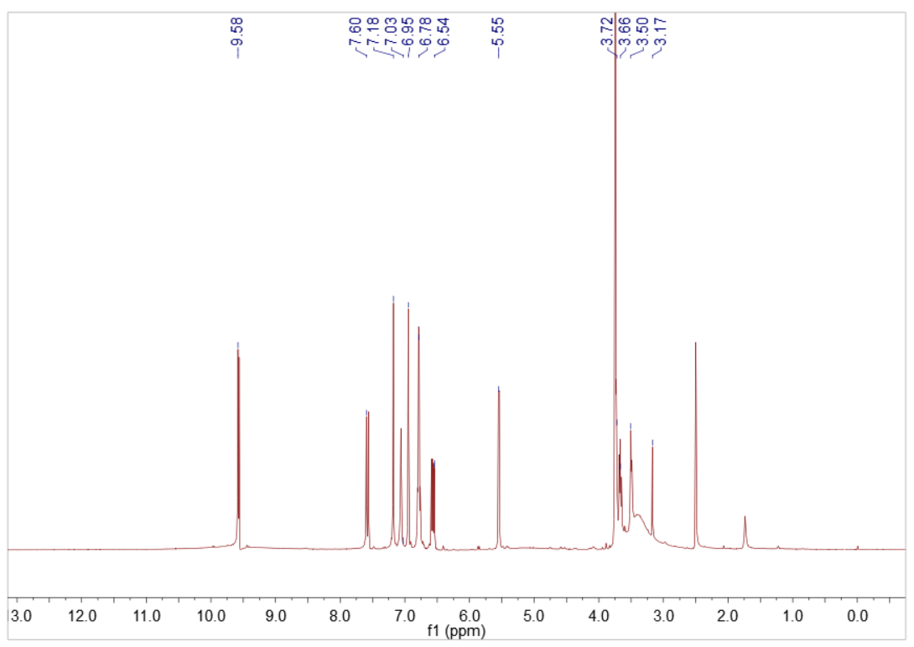

Fig. S24. ¹H NMR spectrum of 4 in DMSO
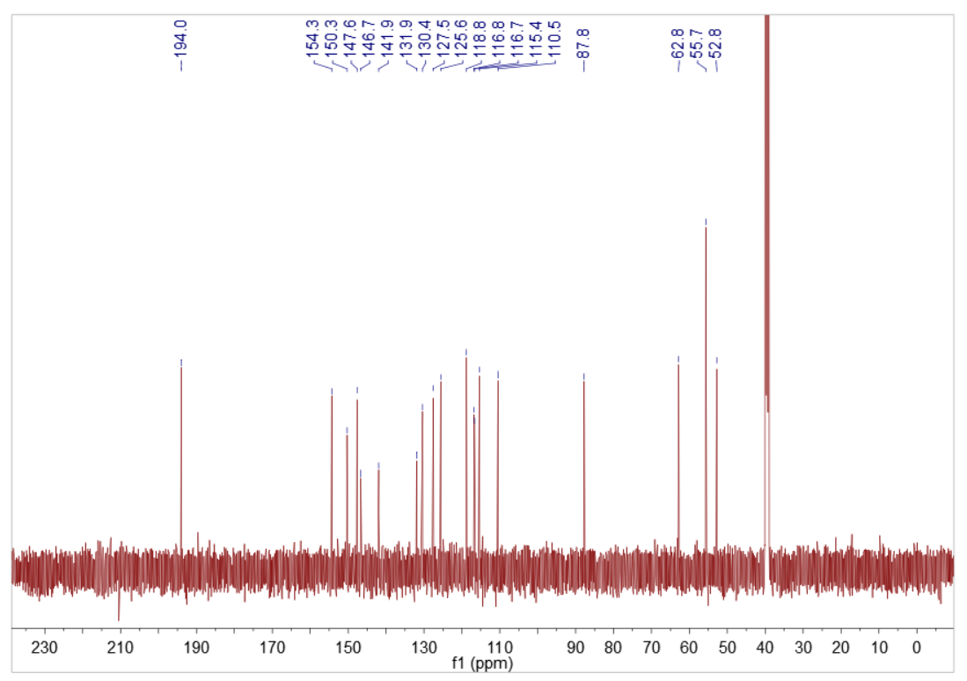

Fig. S25. ¹³C NMR spectrum of 4 in DMSO

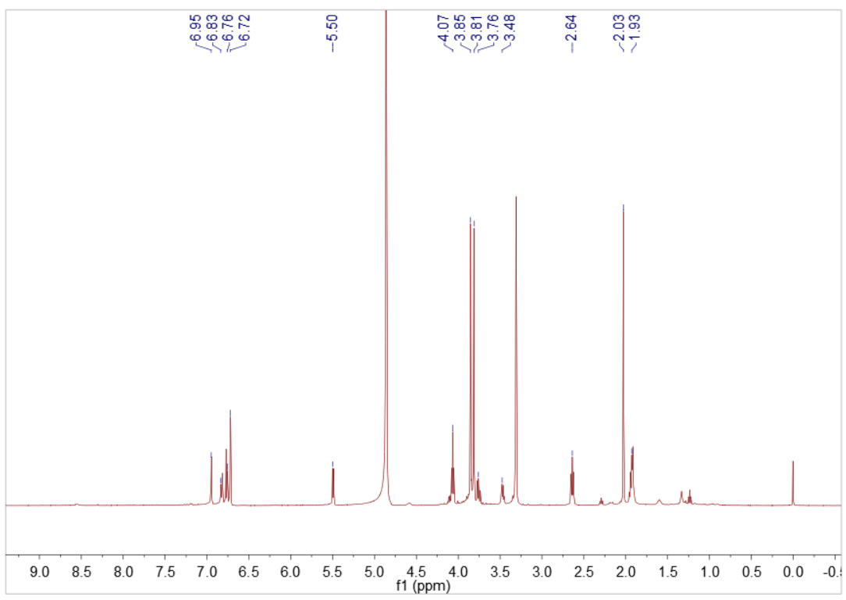

Fig. S26. ¹H NMR spectrum of 5 in CD₃OD
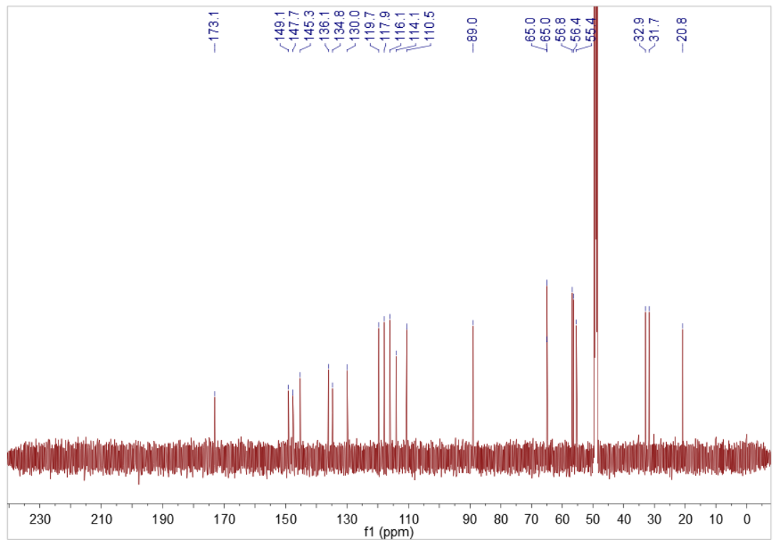

Fig. S27. ¹³C NMR spectrum of 5 in CD₃OD

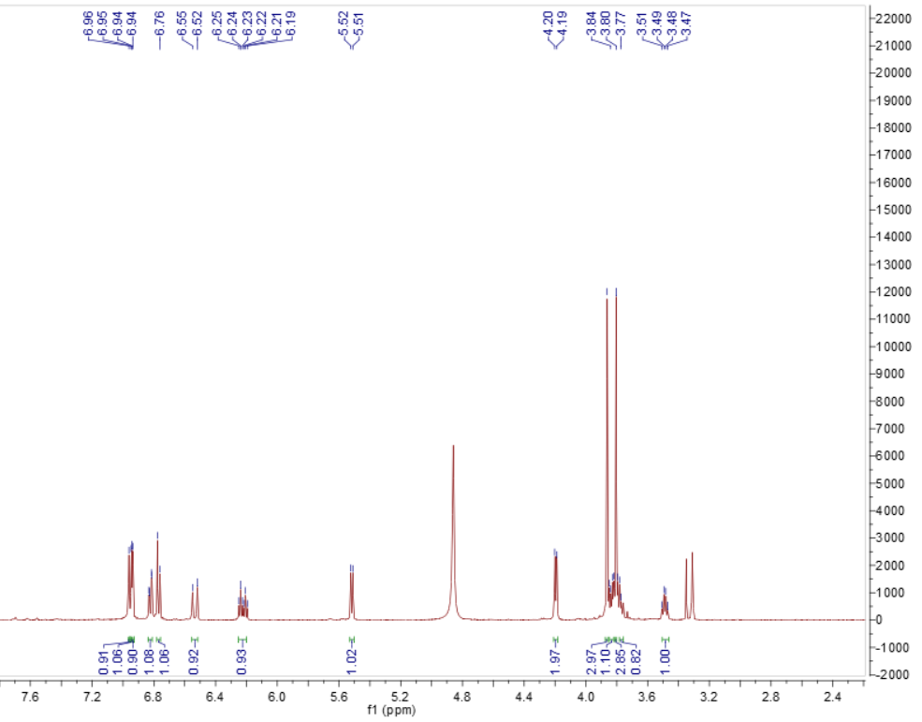

Fig. S28. ¹H NMR spectrum of 6 in CD₃OD
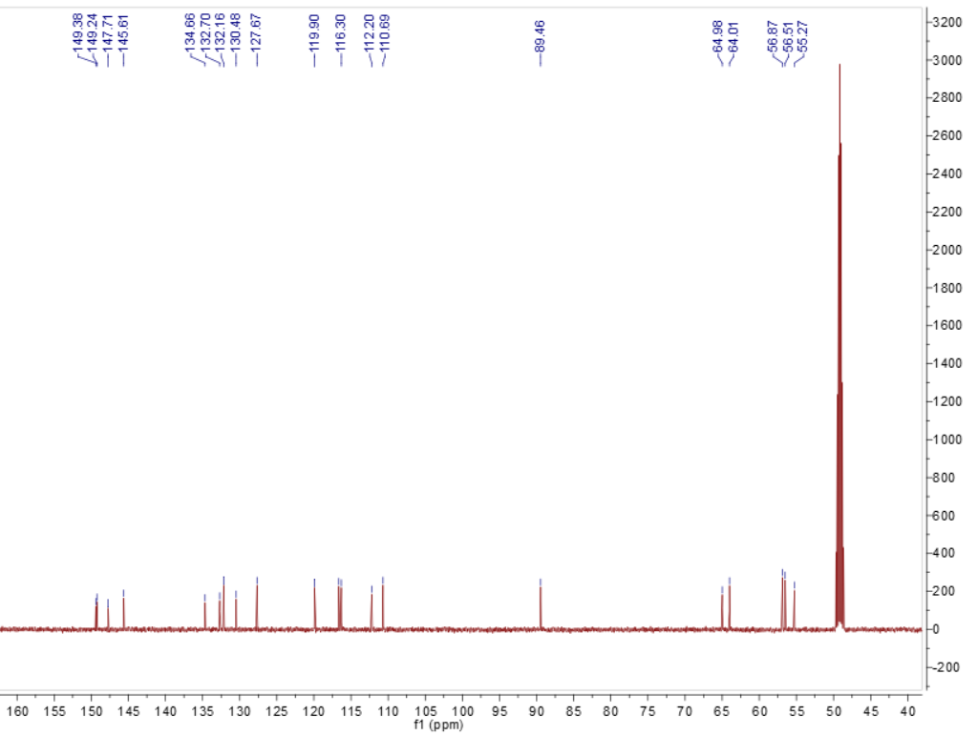

Fig. S29. ¹³C NMR spectrum of 6 in CD₃OD

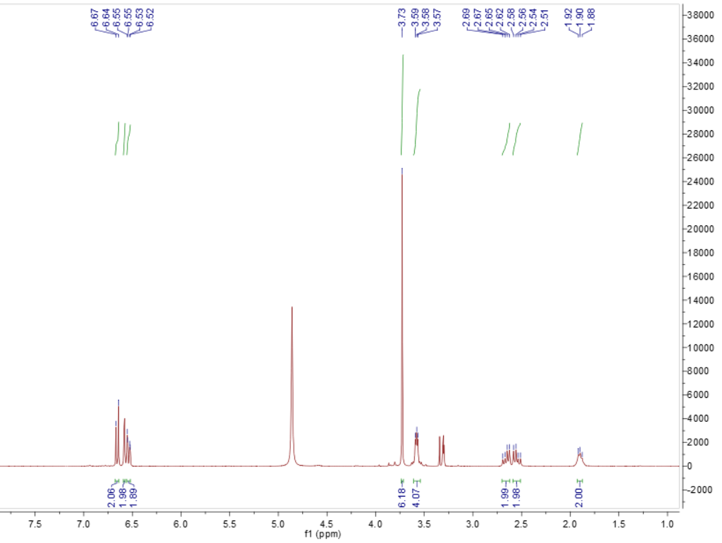

Fig. S30. ¹H NMR spectrum of 7 in CD₃OD
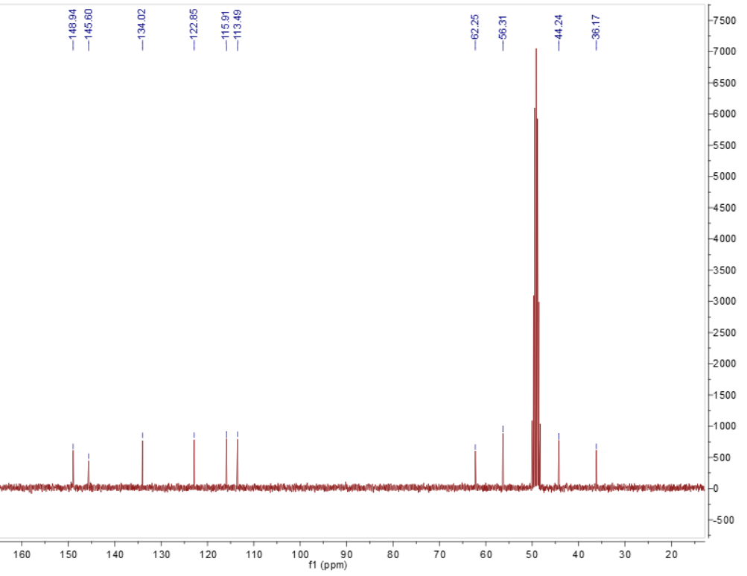

Fig. S31. ¹³C NMR spectrum of 7 in CD₃OD

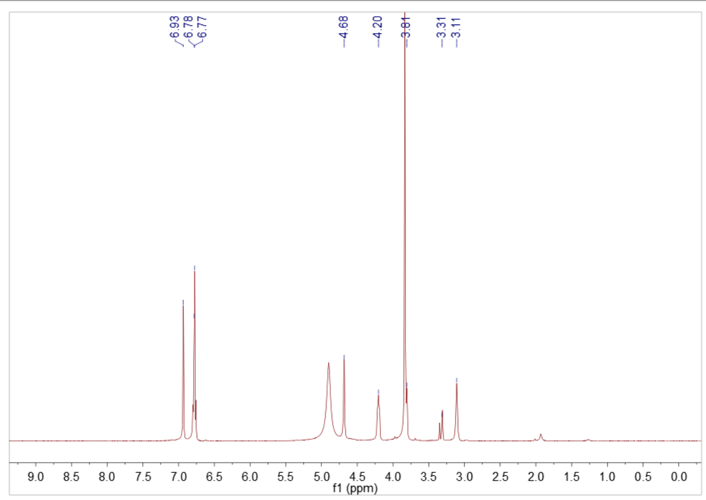

Fig. S32. ¹H NMR spectrum of 8 in CD₃OD
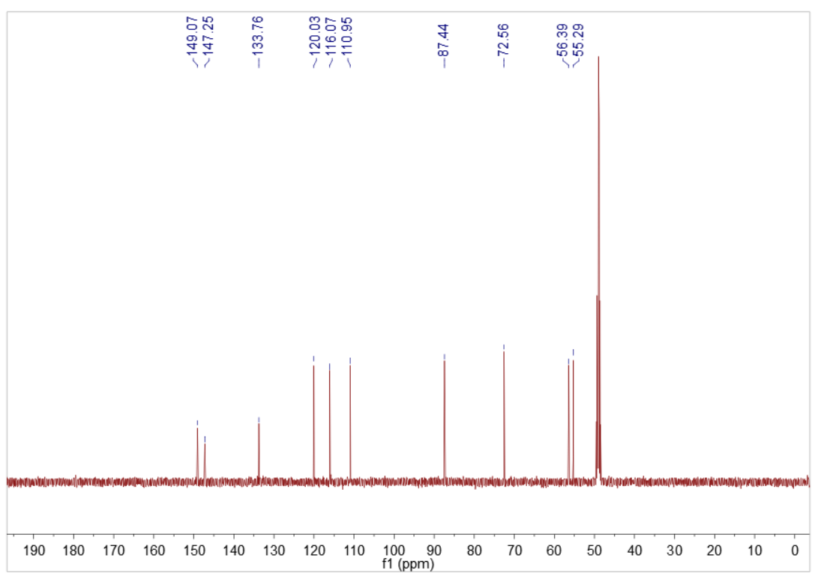

Fig. S33. ¹³C NMR spectrum of 8 in CD₃OD

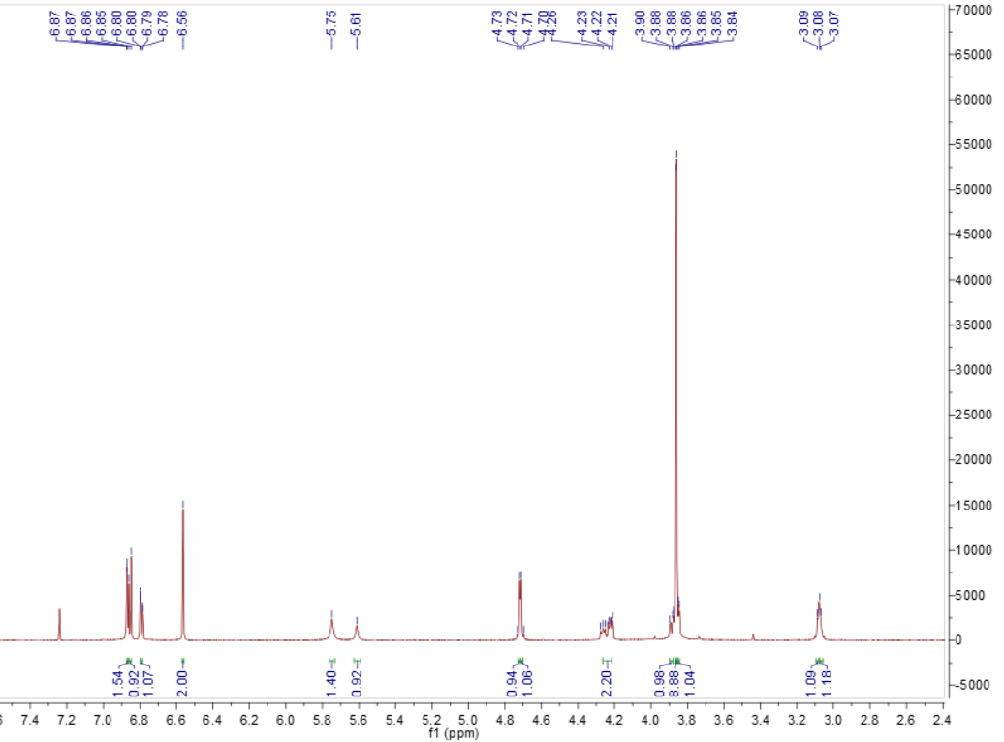

Fig. S34. ¹H NMR spectrum of 9 in CDCl₃
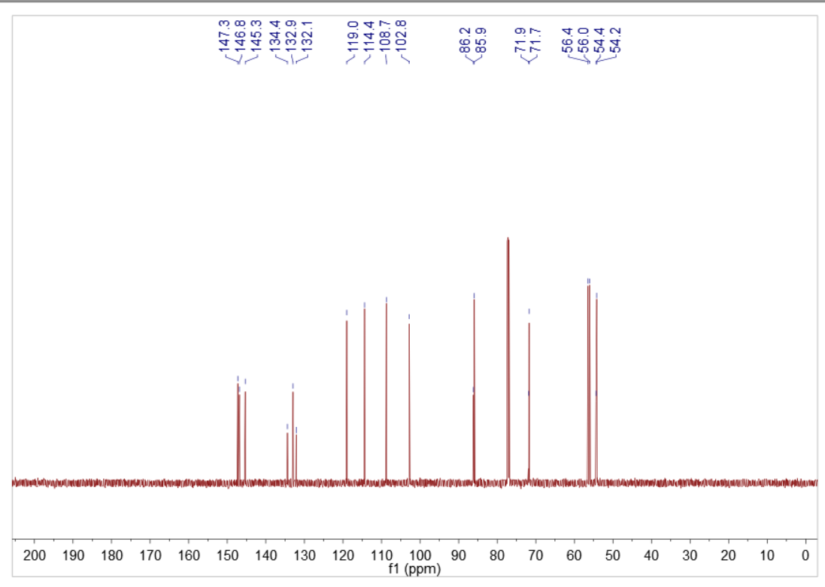

Fig. S35. ¹³C NMR spectrum of 9 in CDCl₃

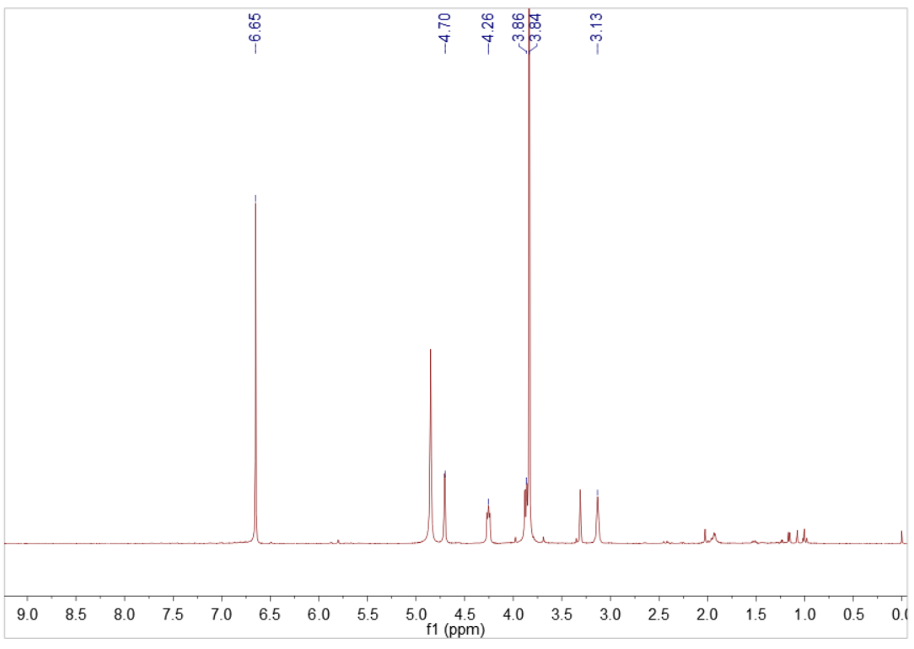

Fig. S36. ¹H NMR spectrum of 10 in CD₃OD
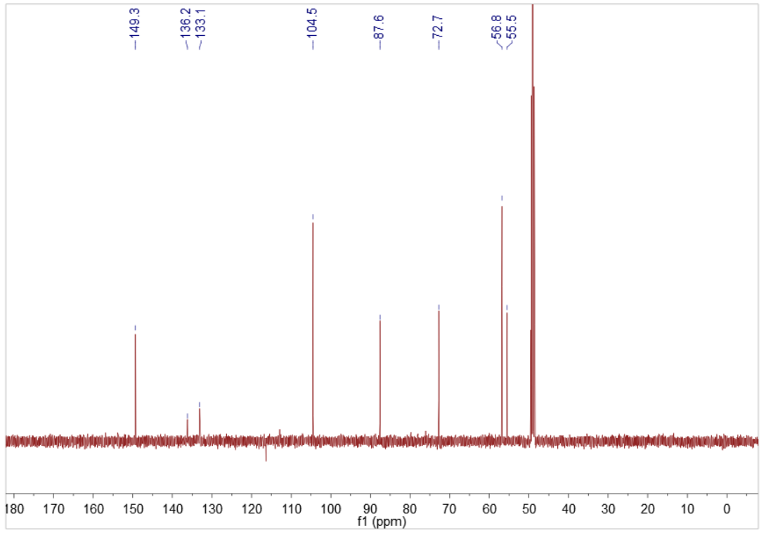

Fig. S37. ¹³C NMR spectrum of 10 in CD₃OD

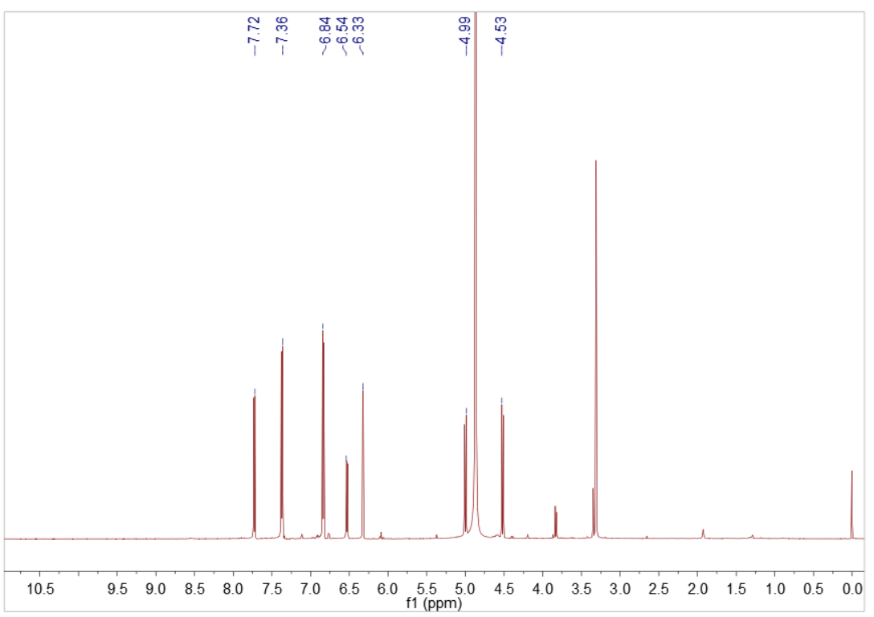

Fig. S38. ¹H NMR spectrum of 11 in CD₃OD
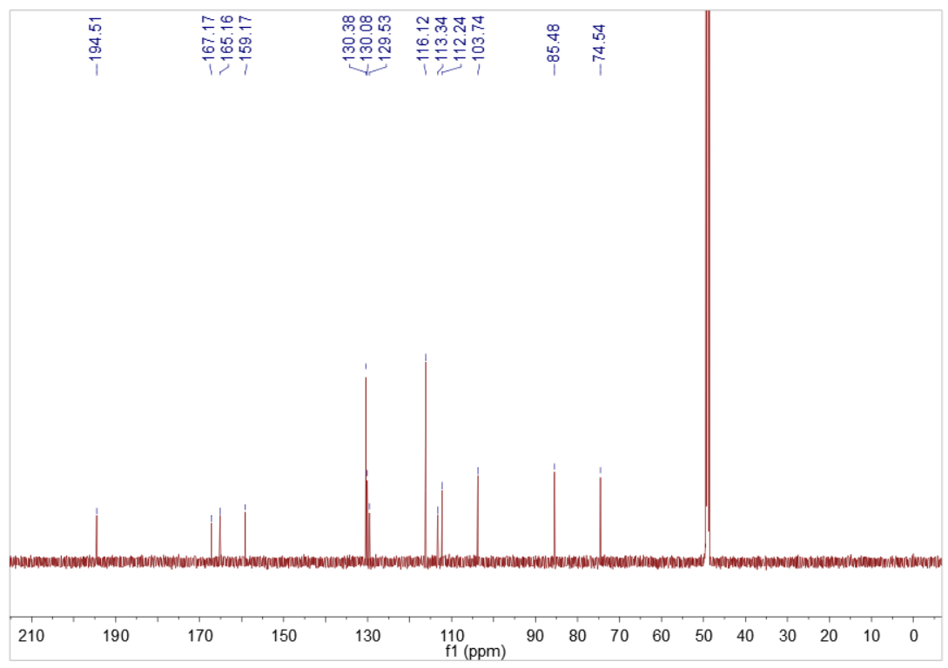

Fig. S39. ¹³C NMR spectrum of 11 in CD₃OD

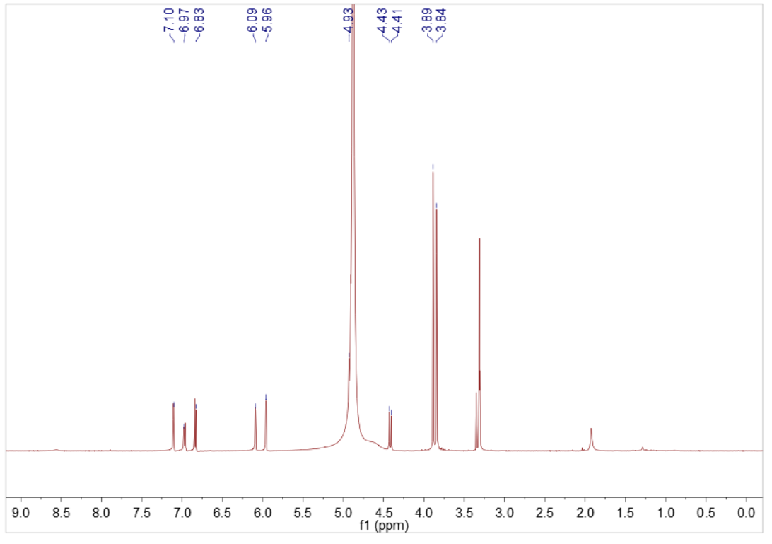

Fig. S40. ¹H NMR spectrum of 12 in CD₃OD
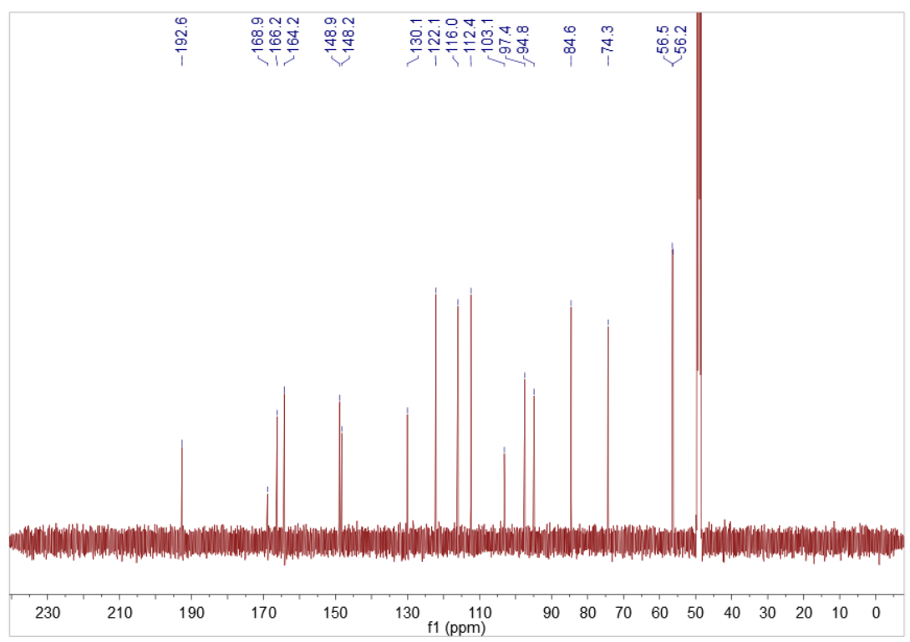

Fig. S41. ¹³C NMR spectrum of 12 in CD₃OD

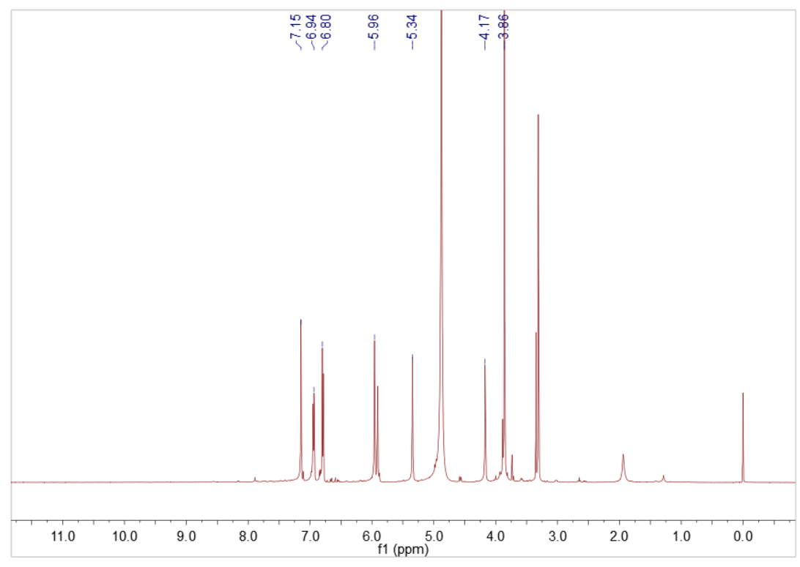

Fig. S42. ¹H NMR spectrum of 13 in CD₃OD
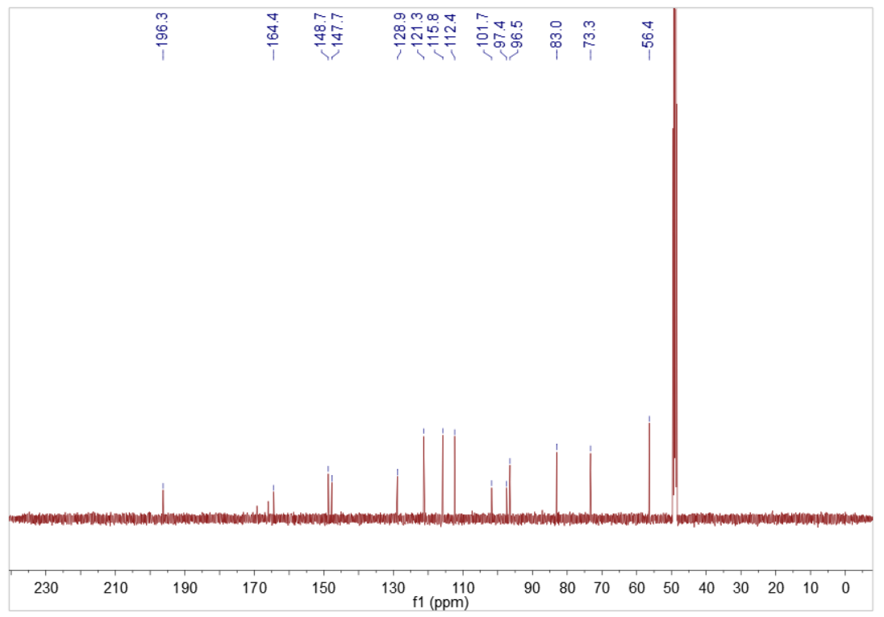

Fig. S43. ¹³C NMR spectrum of 13 in CD₃OD

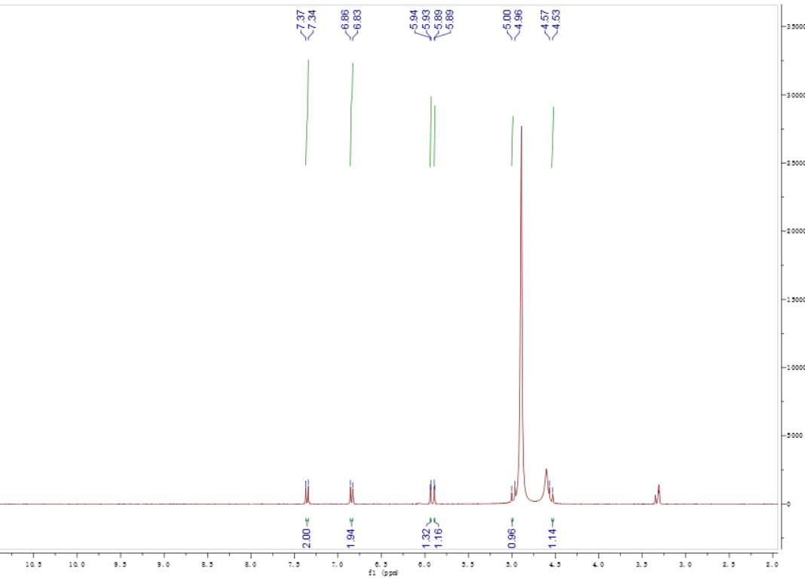

Fig. S44. ¹H NMR spectrum of 14 in CD₃OD
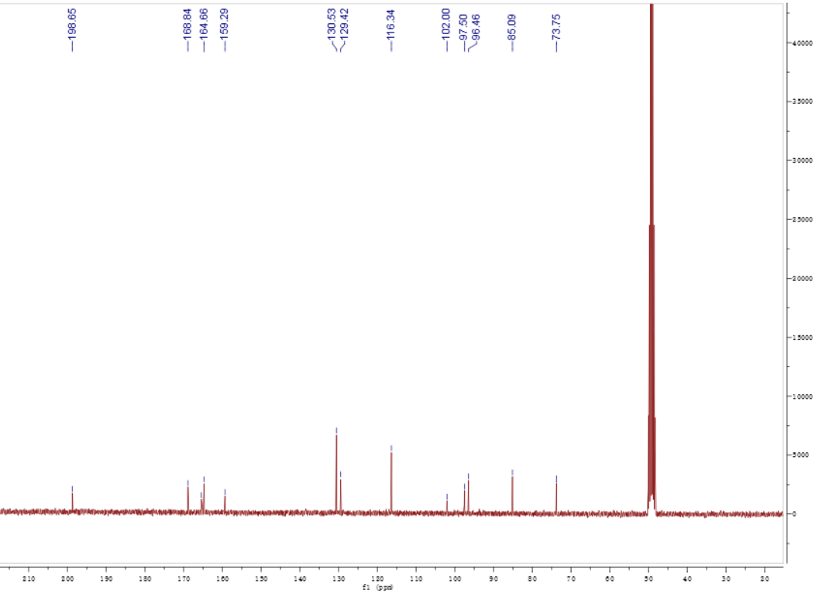

Fig. S45. ¹³C NMR spectrum of 14 in CD₃OD

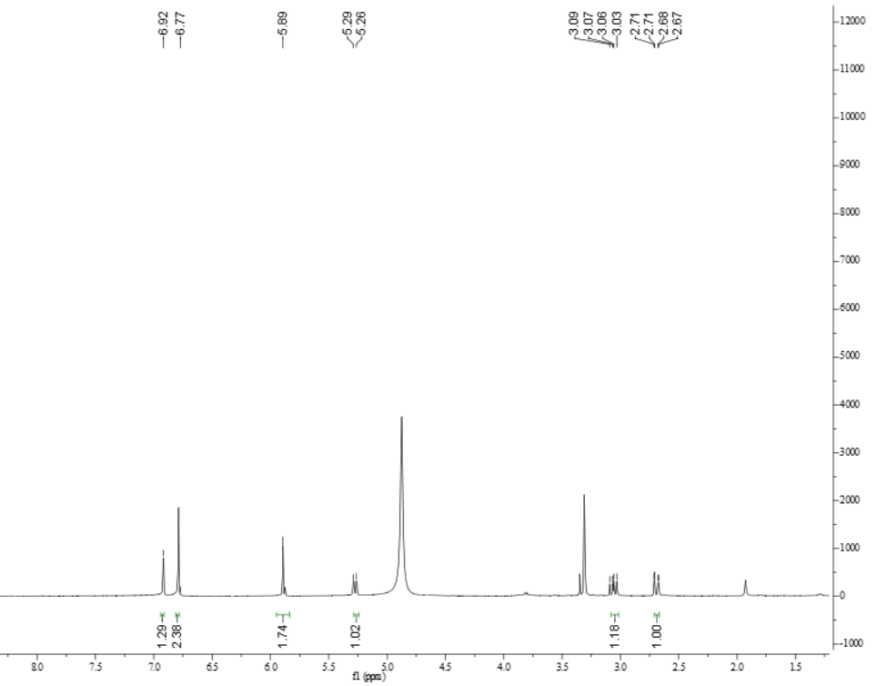

Fig. S46. ¹H NMR spectrum of 15 in CD₃OD
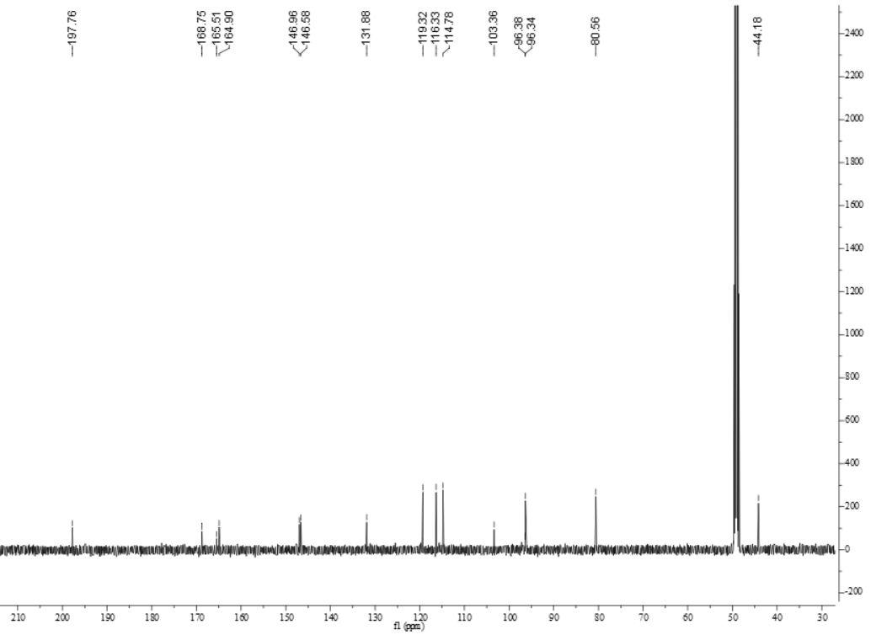

Fig. S47. ¹³C NMR spectrum of 15 in CD₃OD

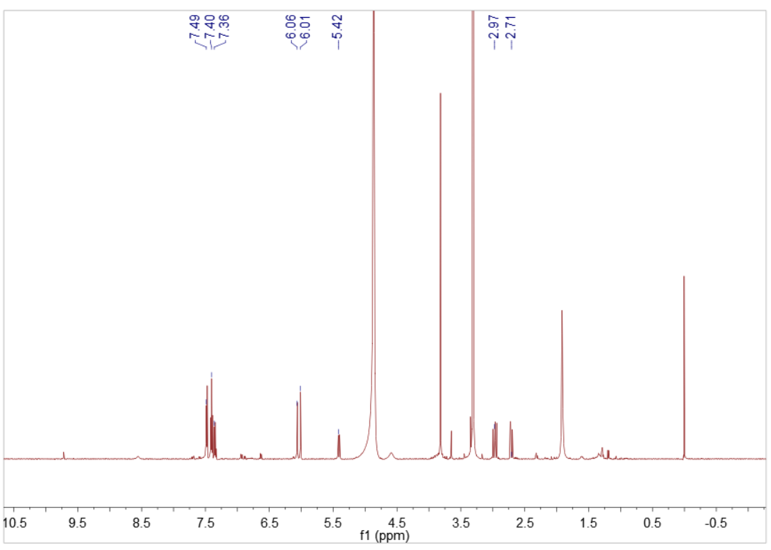

Fig. S48. ¹H NMR spectrum of 16 in CD₃OD

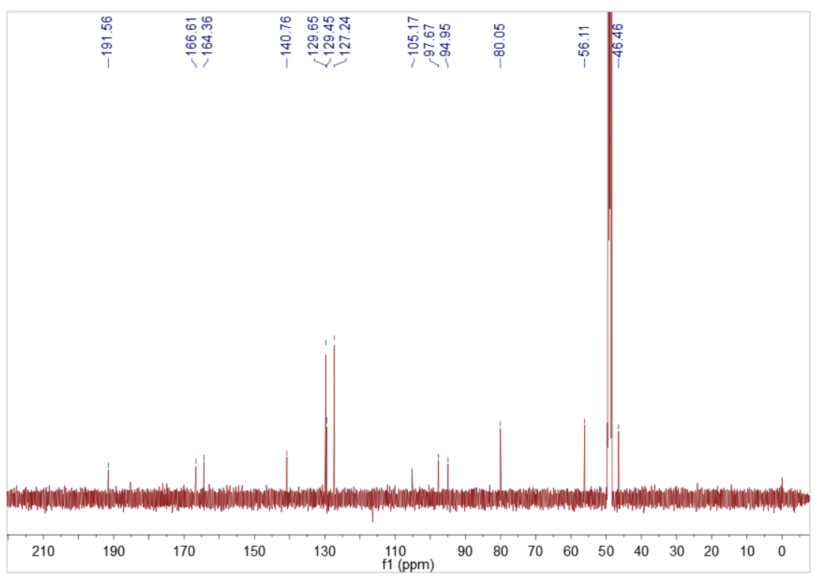

Fig. S49. ¹³C NMR spectrum of 16 in CD₃OD

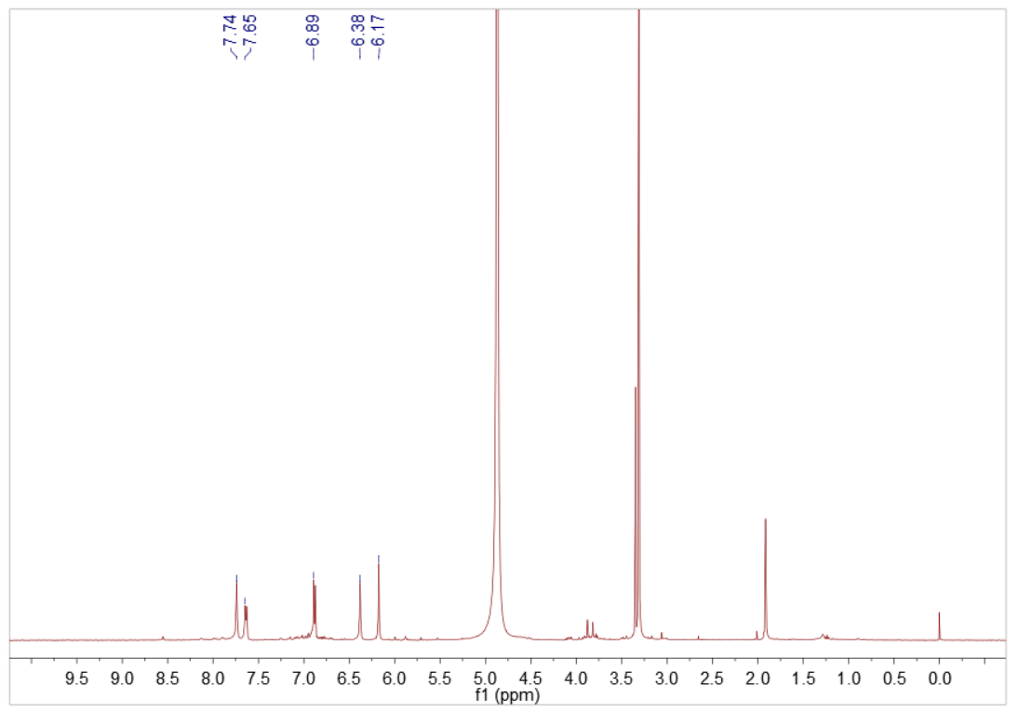

Fig. S50. ¹H NMR spectrum of 17 in CD₃OD
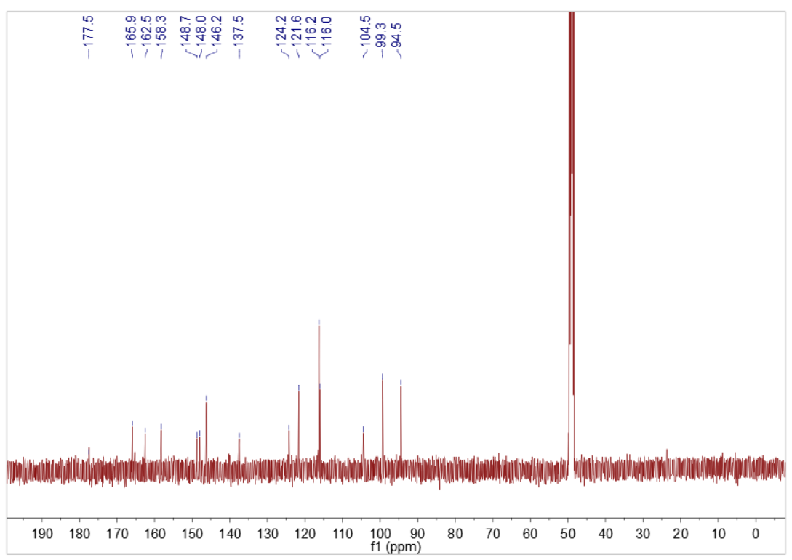

Fig. S51. ¹³C NMR spectrum of 17 in CD₃OD

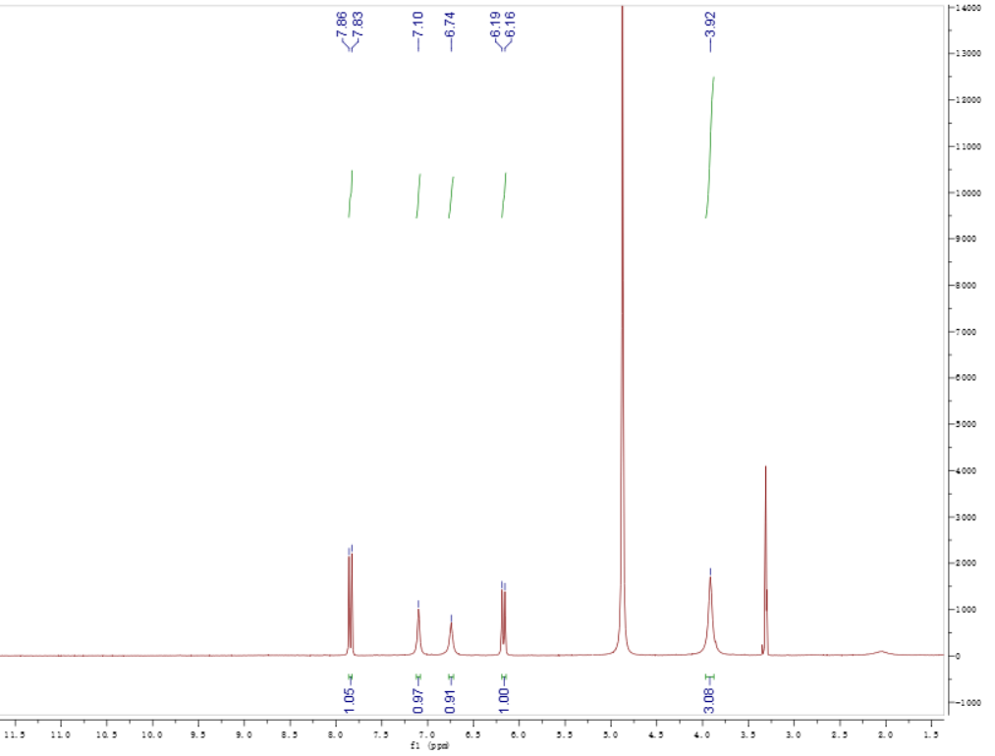

Fig. S52. ¹H NMR spectrum of 18 in CD₃OD
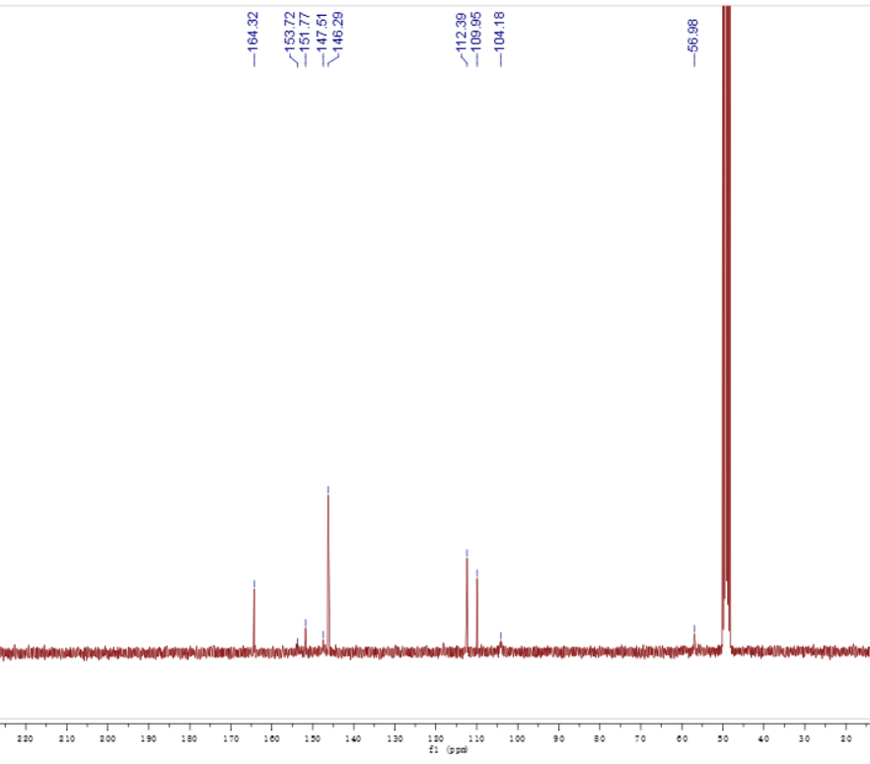

Fig. S53. ¹³C NMR spectrum of 18 in CD₃OD

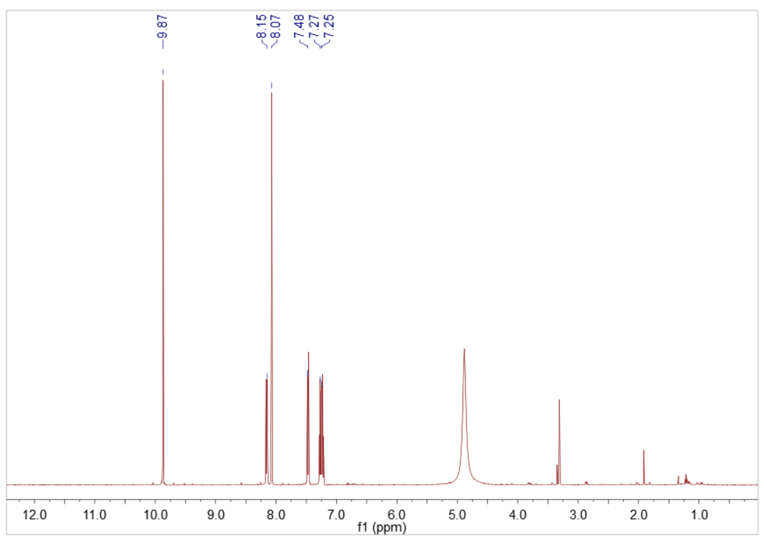

Fig. S54. ¹H NMR spectrum of 19 in CD₃OD
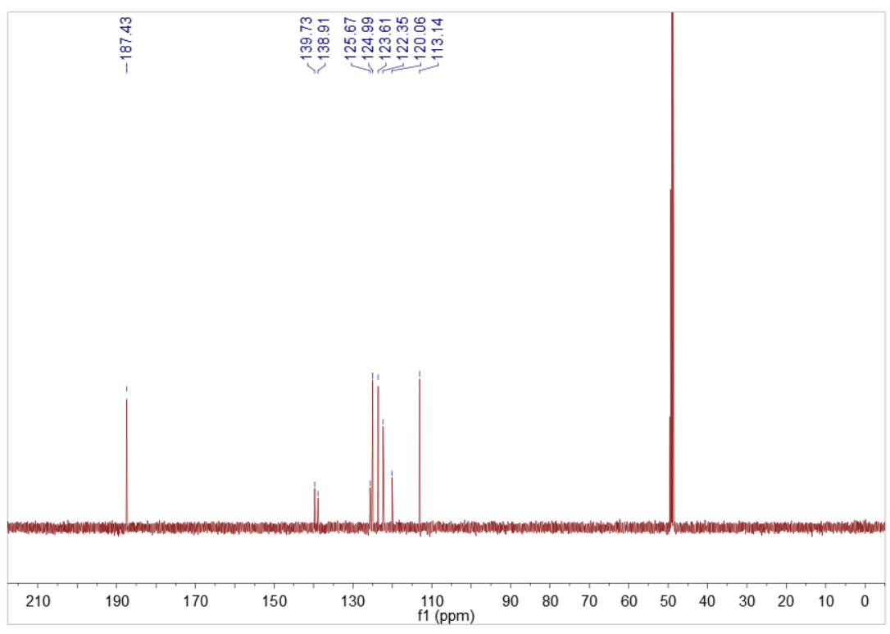

Fig. S55. ¹³C NMR spectrum of 19 in CD₃OD

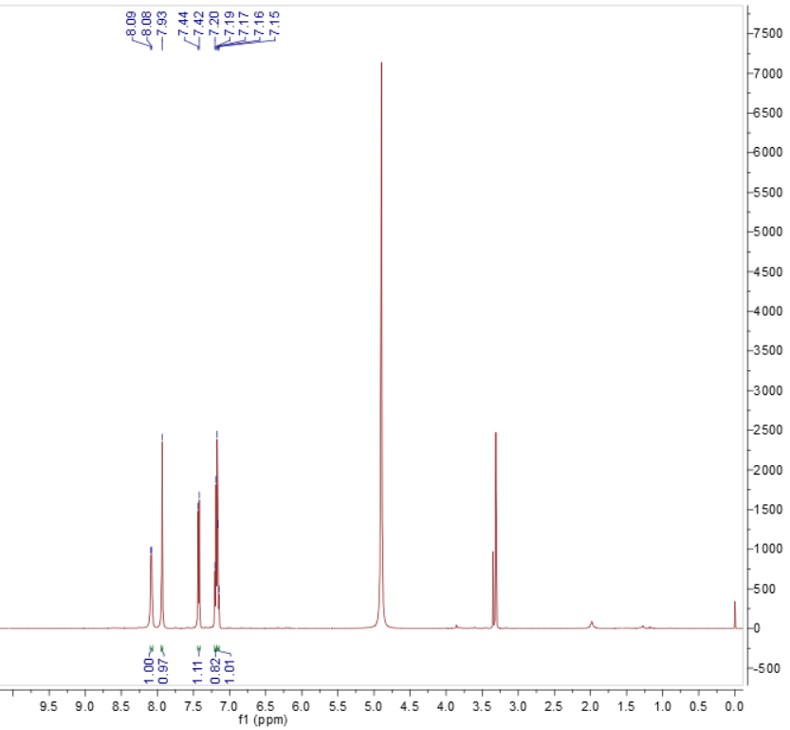

Fig. S56. ¹H NMR spectrum of 20 in CD₃OD
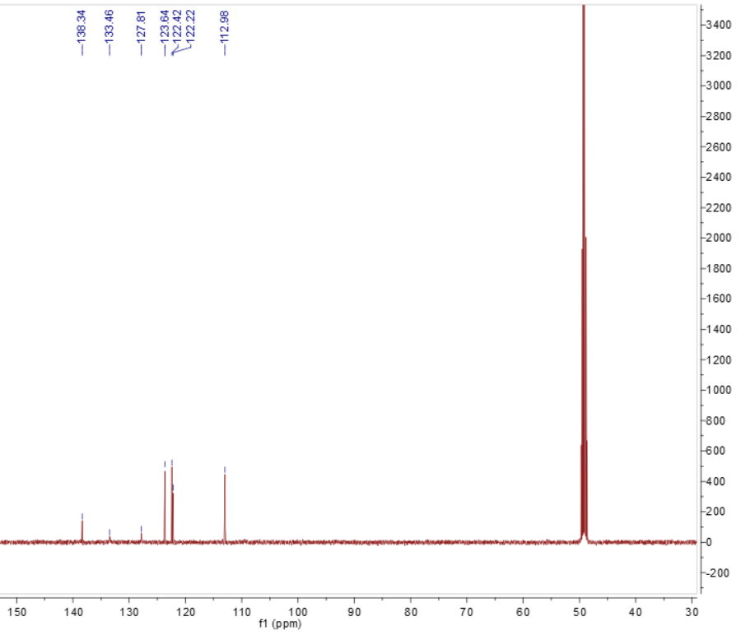

Fig. S57. ¹³C NMR spectrum of 20 in CD₃OD

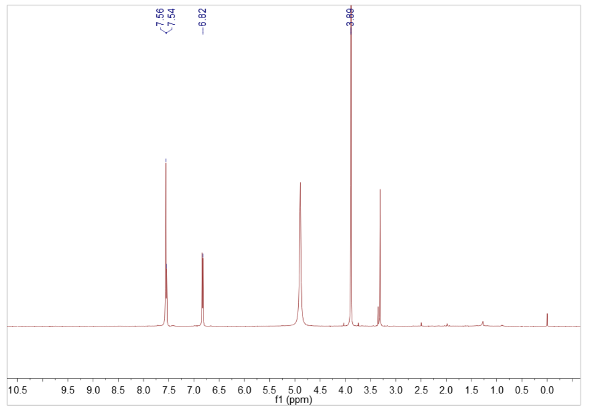

Fig. S58. ¹H NMR spectrum of 21 in CD₃OD
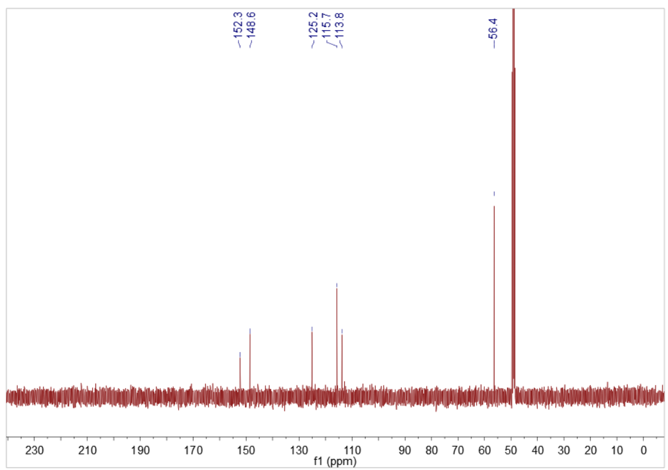

Fig. S59. ¹³C NMR spectrum of 21 in CD₃OD

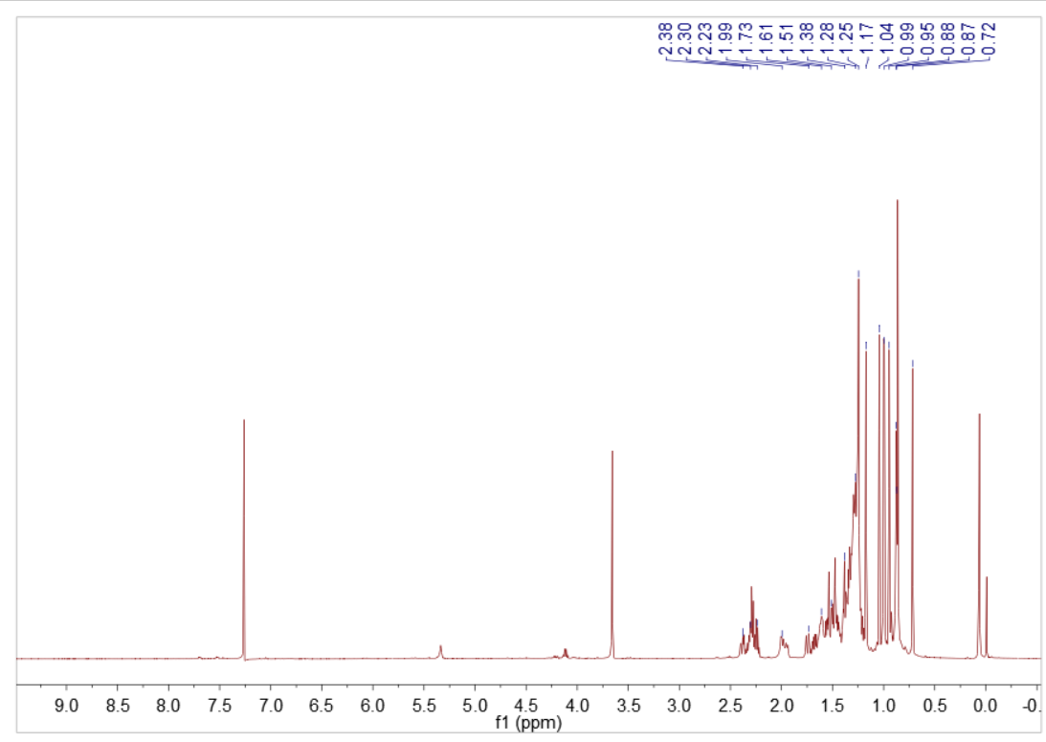

Fig. S60. ¹H NMR spectrum of 22 in CDCl₃

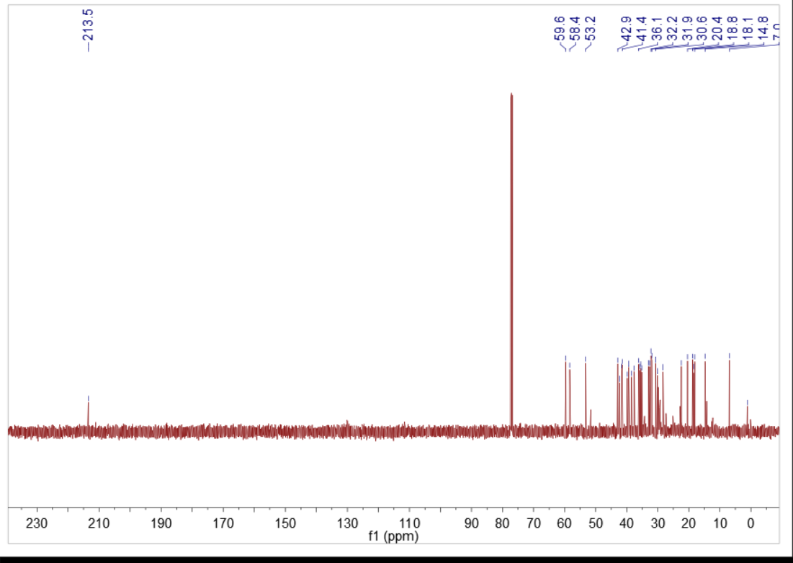

Fig. S61. ¹³C NMR spectrum of 22 in CDCl₃

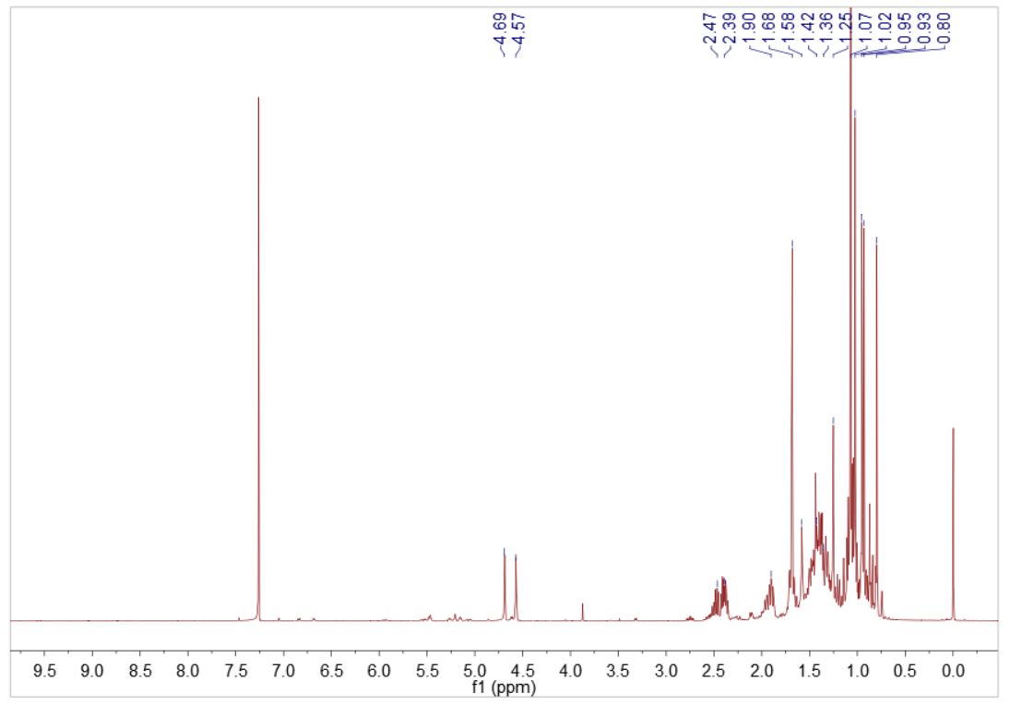

Fig. S62. ¹H NMR spectrum of 23 in CDCl₃
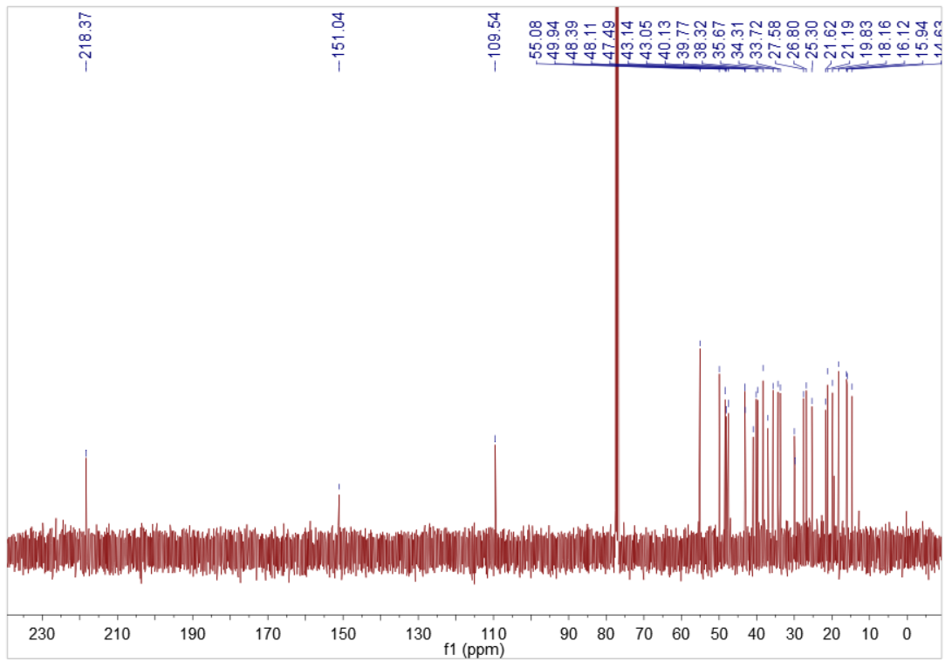

Fig. S63. ¹³C NMR spectrum of 23 in CDCl₃

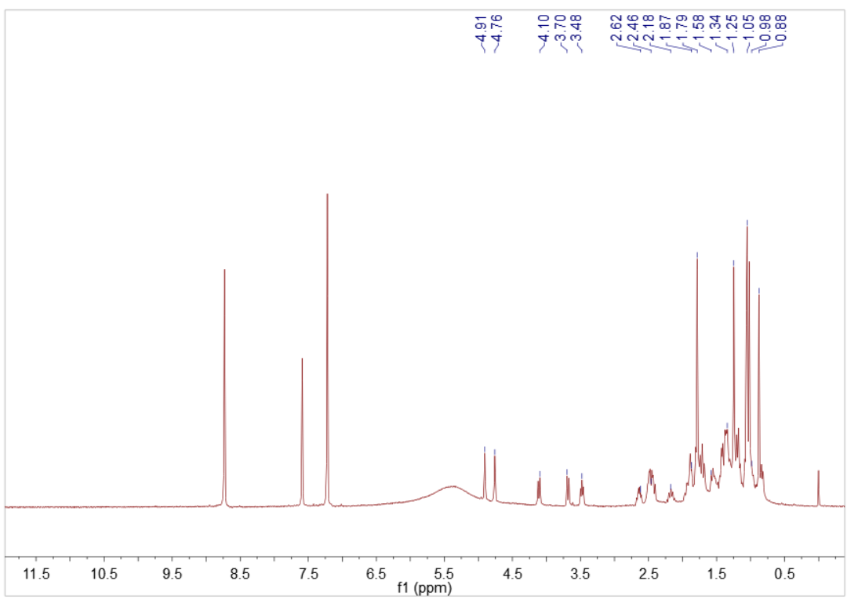

Fig. S64. ¹H NMR spectrum of 24 in C₅D₅N

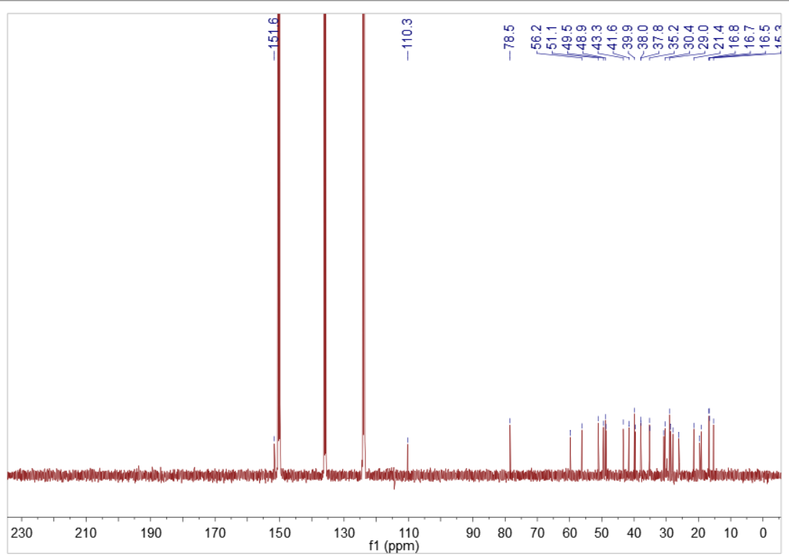

Fig. S65. ¹³C NMR spectrum of 24 in C₅D₅N

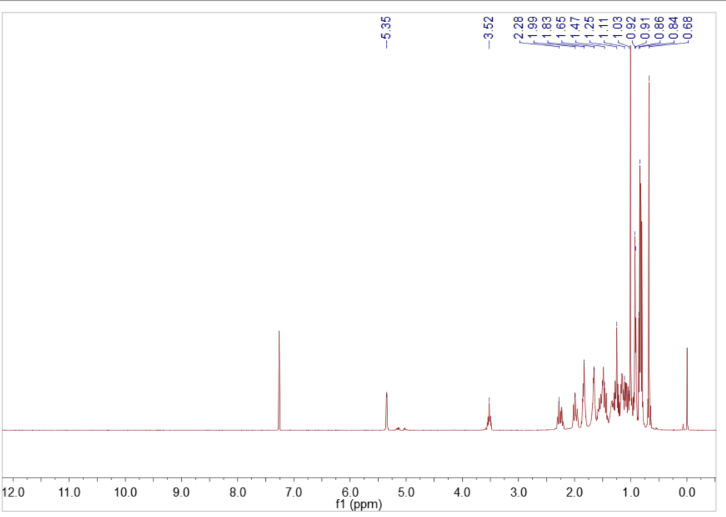

Fig. S66. ¹H NMR spectrum of 25 in CDCl₃
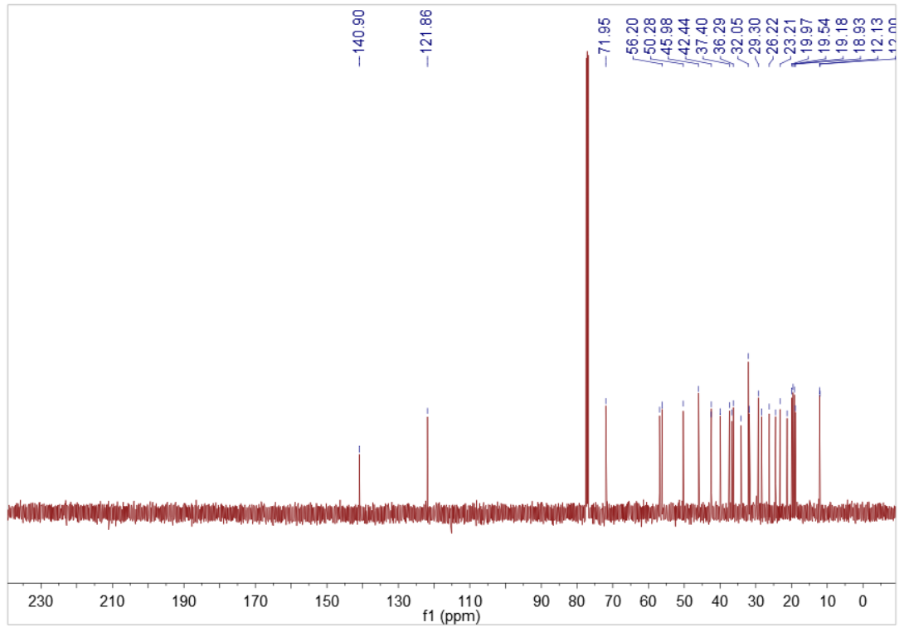

Fig. S67. ¹³C NMR spectrum of 25 in CDCl₃

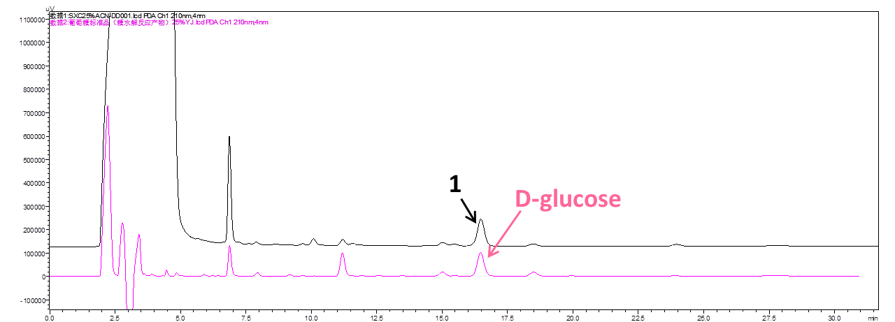

Fig. S68. HPLC chromatogram of the acid hydrolysis of 1

