Supplementary Material
Figure S1. Location of Acanthophyllums.l. samples used in this study (map made in dismo package in R).

Figure S2: Bayesian inference analysis of Acanthophyllums.l.A) based on two combined DNA regions (nrDNA ITS and rps16) using published ITS and plastid substitution rates, B)based onnrDNA ITS using published ITS substitution rate, C) based on rps16 using published plastid substitution rate, D)based on two combined DNA regions (nrDNA ITS and rps16) using a lognormal distribution prior with offset = 33.9 Ma, and SD = 1 Ma, using the age of a described fossil inflorescence from the Middle–Late Eocene (33.9–47.8 Ma; see text). Chronograms represent the maximum clade credibility trees using *BEAST implemented in BEAST, with mean divergence dates in million years ago (Ma) shown for key nodes. Blue bars represent 95% highest posterior density credibility intervals for node ages.

Appendix S1. Voucher information: species name, geographical origin, collector(s), voucher (herbarium), GenBank accession numbers for ITS and rps16 markers.

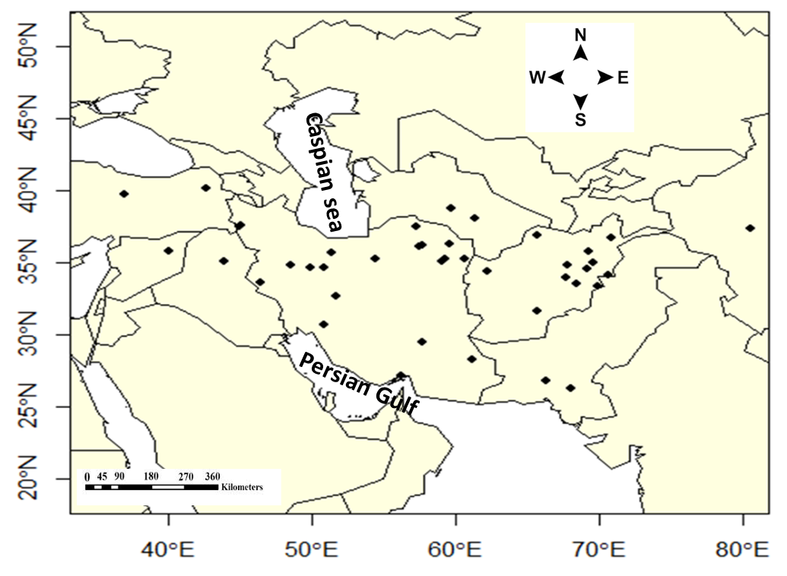

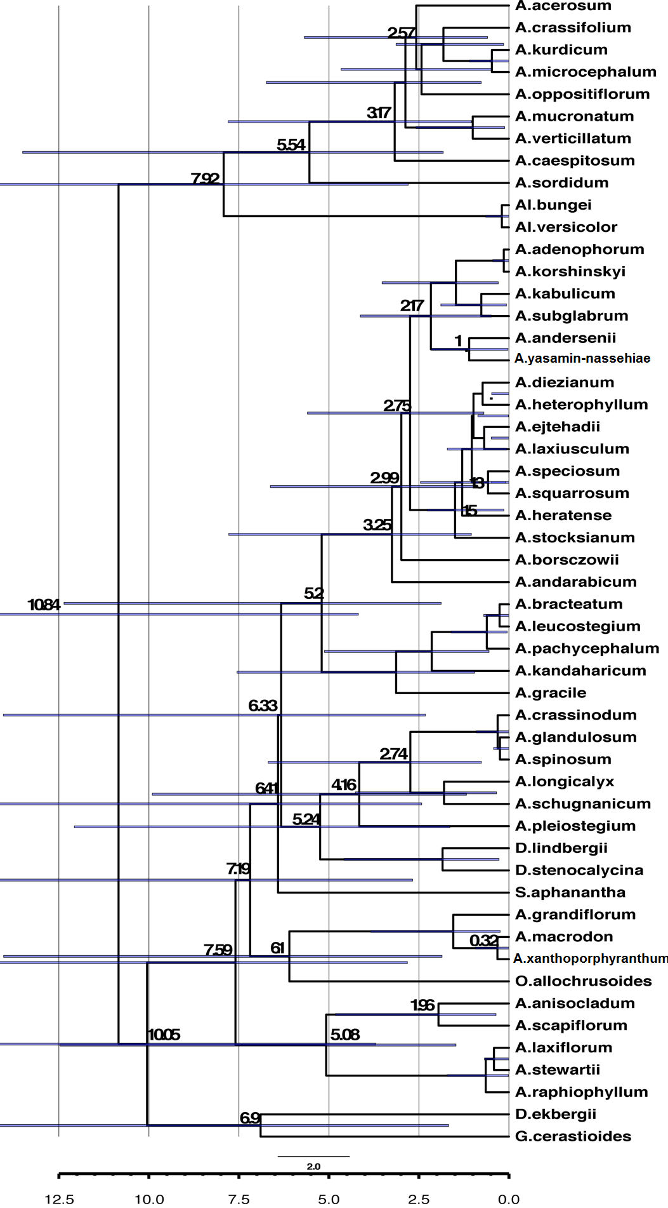
A
B
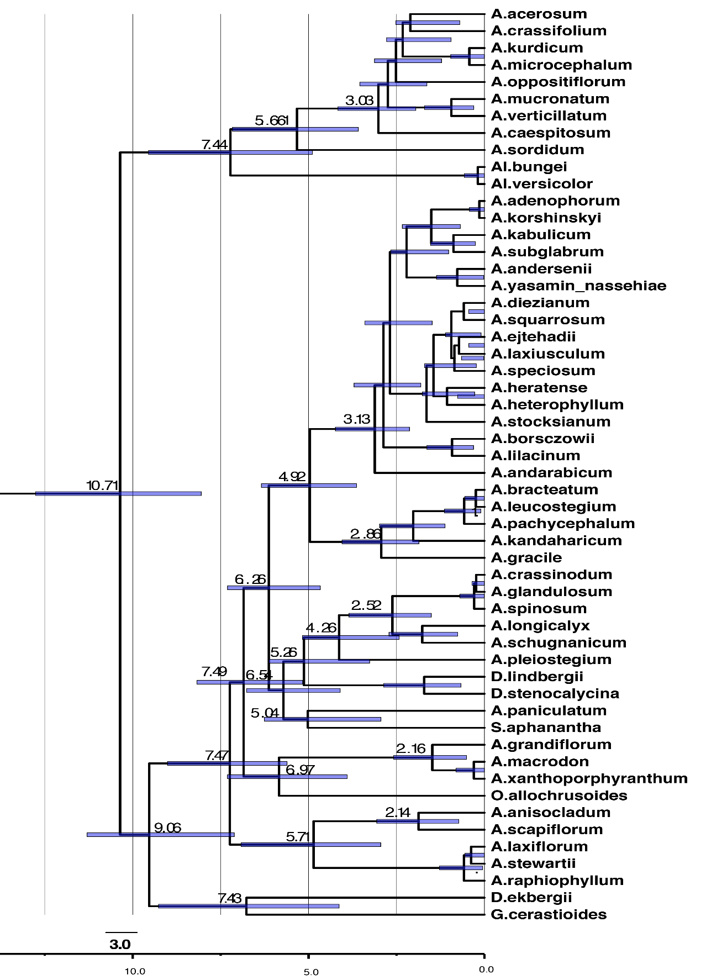
C

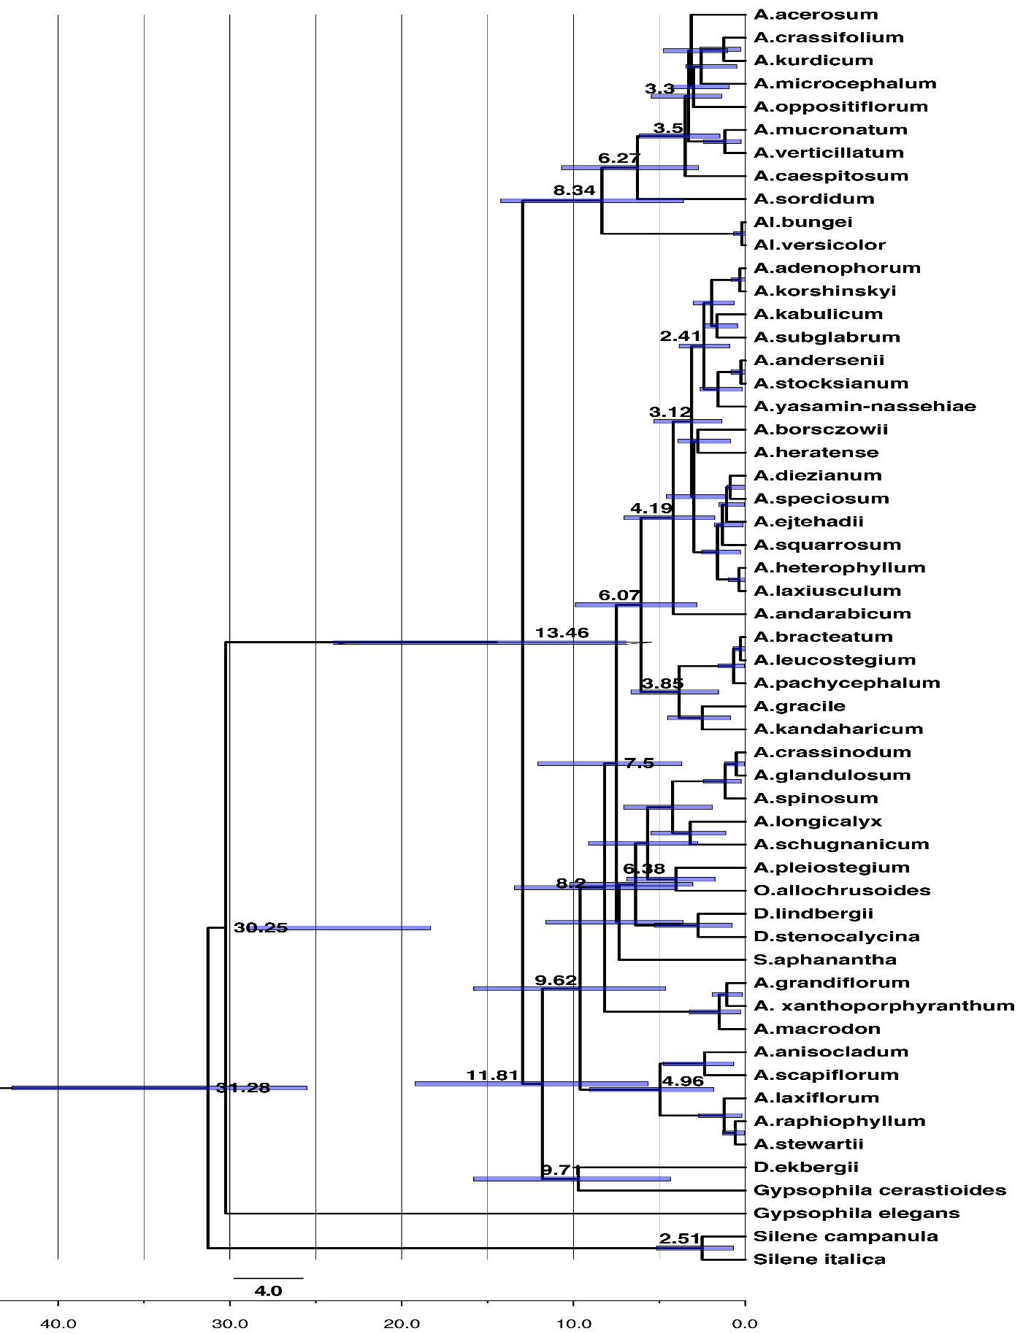
D
Appendix S1.
Species name | geographical origin, collector(s), voucher
AcanthophyllumacerosumSosn. | Iran, W Azarbaijan, Zarre& al. 41900 (TUH),KF924680, KF924732
AcanthophyllumadenophorumFreyn | Iran, Khorassan, Pirani &Moazzeni 1947 (TMRC),KF924679, KF924731
AcanthophyllumandarabicumPodlech ex Schiman-Czeika | Afghanistan, Baghlan, Podlech 10985 (MSB),KF924678, KF924730
AcanthophyllumanderseniiRech.f. &Schiman-Czeika | Iran, Khorassan, Anders & Peterson 320 (GB), KF924677, KF924729
AcanthophyllumanisocladumSchiman-Czeika | Afghanistan, Lugar, Ekberg W9180 (GB), KF924676, KF924728
AcanthophyllumborsczowiiLitv. | Iran, Khorassan, Zarre& al. 41034 (TUH),KF924675, KF924727
AcanthophyllumbracteatumBoiss. | Iran, Kohghiluyeh&Boyerahmad, Pirani &Moazzeni 2104 (TMRC), KF924674, KF924726
AcanthophyllumcaespitosumBoiss. | Iran, Hamadan, Zarre& al. 41903 (TUH), KF924673, KF924725
AcanthophyllumcrassifoliumBoiss. | Iran, Mazandaran, Pirani&Moazzeni 41702 (TUH), KF924672, KF924724
AcanthophyllumcrassinodumYukhan. &J.R.Edm. | Iran, Kerman, Pirani &Moazzeni 2923 (TMRC), KF924671, KF924723
AcanthophyllumdiezianumHand.-Mazz. | Iran, Khorassan, Zarre& al. 41040 (TUH), KF924669, KF924721
AcanthophyllumejtehadiiMahmoudi&Vaezi | Iran, Khorassan, Pirani &Moazzeni 2181 (TMRC), KF924669, KF924721
Acanthophyllumglandulosum Bunge ex Boiss. | Iran, Khorassan, Zarre& al. 41037 (TUH), KF924668, KF924720
Acanthophyllum gracile Bunge ex Boiss. | Iran, Semnan, Pirani&Moazzeni 2989 (TMRC), KF924667, KF924719
Acanthophyllum grandiflorum Stocks | Afghanistan, Bamian, Podlech 1340 (MSB), KF924666, KF924718
AcanthophyllumheratenseSchiman-Czeika | Iran, Tehran, Bomhen,Abali road, Arazm&Dini 1994 (TARI), LC523987.  Iran, Isfahan, Pirani &Moazzeni 2152 (TMRC), KF924665, KF924717
AcanthophyllumheterophyllumRech.f. | Iran, Kerman, Pirani &Moazzeni 2921 (TMRC), KF924664, KF924716
AcanthophyllumkabulicumSchiman-Czeika | Afghanistan, Ghazni, Frey s.n. (GB), KF924663, KF924715
AcanthophyllumkandaharicumGilli | Iran, Khorassan, Joharchi&Zangouei 36245 (FUMH), KF924662, KF924714
AcanthophyllumkorshinskyiSchischk. | Iran, Khorassan, Pirani &Moazzeni 2123 (TMRC), KF924661, KF924713
AcanthophyllumkurdicumBoiss. &Hausskn. ex Boiss. | Iran, Ilam, Hamzehee&Lashkarbolooki 1756 (TARI), KF924660, KF924712
AcanthophyllumlaxiflorumBoiss. | Afghanistan, Lugar, Ekberg W9184 (GB), KF924659, KF924711
AcanthophyllumlaxiusculumSchiman-Czeika | Iran, Azarbaijan, Jolfa, Foroghi, 3823(TARI),LC523988.  Iran, Qom, Pirani&Moazzeni 1941 (TMRC), KF924658, KF924710
AcanthophyllumleucostegiumSchiman-Czeika | Iran, Bandar Abbas, Ghahreman&Mozaffarian 5656 (TUH), KF924657, KF924709
AcanthophyllumlilacinumSchischk. | Afghanistan, Badghis, Podlech&Jarmal 29855 (MSB), KF924656
Acanthophyllumlongicalyx Hedge &Wendelbo | Afghanistan, Jawzjan, Freitag 6580 (MSB), KF924655, KF924708
AcanthophyllummacrodonEdgew. | Afghanistan, Kandahar, Hedge & al. W7641 (GB), KF924654, KF924707
AcanthophyllummicrocephalumBoiss. | Iran, Tehran, Rajamand&Bazargan 32055 (TARI),KF924653, KF924706
AcanthophyllummucronatumC.A.Mey. | Iran, W Azarbaijan, Assadi&Olfat 68668 (TARI), KF924652, KF924705
AcanthophyllumoppositiflorumAytaç | Turkey, Sivas, Aytaç 7476 (GAZI), KF924651, KF924704
AcanthophyllumpachycephalumSchiman-Czeika | Iran, Tehran, Ganjalizadeh 6106 (TUH), KF924650,  KF924703
AcanthophyllumpachystegiumRech.f. | Afghanistan, Badakhshan, Hedge &Wendelbo W9282 (GB), KF924649, KF924702
AcanthophyllumpleiostegiumSchiman-Czeika | Afghanistan, Kataghan, Grey-Wilson & Hewer 1320 (GB), KF924648, KF924701
Acanthophyllumraphiophyllum (Rech.f.) Barkoudah | Afghanistan, Kapisa, Podlech 12548 (MSB), KF924647, KF924700
AcanthophyllumscapiflorumSchiman-Czeika | Afghanistan, Kabul, Podlech 31232 (MSB), KF924646, KF924699
AcanthophyllumschugnanicumSchischk. | Afghanistan, Bamian, Wendelbo& Ekberg W9796 (GB), KF924645, KF924698
Acanthophyllumsordidum Bunge ex Boiss. | Iran, Isfahan, Pirani &Moazzeni 2147 (TMRC), KF924644, KF924697
AcanthophyllumspeciosumRech.f. &Schiman-Czeika. | Iran, Khorassan, Pirani &Moazzeni 2186 (TMRC), KF924643, KF924733
AcanthophyllumspinosumC.A.Mey. | Iran, Isfahan, Pirani &Moazzeni 2150 (TMRC), KF924642, KF924696
AcanthophyllumsquarrosumBoiss. | Iran, Kerman, Shahrebabak, Assadi&Bazgosha, 56451 (TARI), LC523986.  Iran, Semnan, Pirani&Moazzeni 2974 (TMRC), KF924641, KF924695
Acanthophyllumstewartii (Thoms. ex Edgew. &Hook.f.) Barkoudah | Afghanistan, Khost, Anders 8994 (MSB), KF924640, KF924694
AcanthophyllumstocksianumBoiss. | Afghanistan, Kandahar, Toncevs.n. (MSB), KF924639, KF924693
AcanthophyllumsubglabrumSchischk. | Afghanistan, Nangarhar, Hedge & al. W7483 (GB), KF924638, KF924692
AcanthophyllumverticillatumHand.-Mazz. | Iran, Markazi, Mozaffarian&Sardabi 42175 (TARI), KF924637, KF924691
Acanthophyllumxanthoporphyranthum Hedge &Wendelbo | Afghanistan, Herat, Hedge & al. W8003 (GB), KF924636, KF924690
Acanthophyllumyasamin-nassehiaeJoharchi& Pirani | Iran, Khorassan, Memariani&Zangouei 41448 (FUMH), KF924635, KF924689
AllochrusabungeiBoiss. | Iran, E Azarbaijan, Rechinger 43834 (M), KF924634, KF924688
Allochrusa versicolorBoiss. | Turkey, Kars, Nydegger 43597b (MSB), KF924633, KF924687
Diaphanopteralindbergii Hedge &Wendelbo | Afghanistan, Fariab, Hedge & al. W8336 (GB), KF924630 KF924685
DiaphanopterastenocalycinaRech.f. &Schiman-Czeika | Iran, Golestan, Attar &Mehdigholi 24422 (TUH), KF924629, KF924684
DiaphanopteraekbergiiHedge &Wendelbo | Afghanistan, Takhar, Podlech11848 (MSB) & 11760 (MSB), KF924631, KF924686
DiaphanopteraafghanicaPodlech | Afghanistan, Baghlan, Podlech 21075 (MSB), KF924632
OchotonophilaallochrusoidesGilli | Afghanistan, Bamian, Wendelbo& Ekberg W9801 (GB), KF924627, KF924682
Scleranthopsisaphanantha (Rech.f.) Rech.f. | Afghanistan, Kabul, Rechinger 31265 (M), KF924626, KF924681
Gypsophila cerastioidesD.Don | Pakistan, Hazar, Ewald &Zetterlund 6227 (GB), KF924628, KF924683
Spergularia marina (L.) Besser | KX282437.1
Spergulaarvensis L. | KY513576.1 , JX966242.1
Sileneitalica (L.) Pers. | DQ059395.1 , KF305909.1
Silene campanula Pers. | KX852586.1 , KX852604.1
SilenerothmaleriP.Silva | DQ059402.1
Lychniscoronaria (L.) Desr. | EF674193.1
Saponariaofficinalis L. | AY594313.1
Saponariaocymoides L. | MF401130.1, KX183966.1
Gypsophila repens L. | MF401153.1 , KX183987.1
Gypsophila elegansM.Bieb. | MF401143.1 , MF401081.1
Drypisspinosa L. | KF737482.1
Minuartialaricifolia (L.) Schinz&Thell. | AY936282.1
Minuartiageniculata (Poir.) Thell. | KF737455.1
Holosteumumbellatum L. | AY936242.1
Cerastiumarvense L. | MH219805.1

