Supplementary Information for “Sensitivity and Accuracy of Refractive Index Retrievals from Measured Extinction and Absorption Cross Sections for Mobility-Selected Internally Mixed Light Absorbing Aerosols”
Michael I. Cotterell,^{1,2,3}* Kate Szpek,² Jim M. Haywood^{1,2} and Justin M. Langridge²
¹College for Engineering, Mathematics and Physical Sciences, University of Exeter, Exeter, UK, EX4 4QF
²Observation Based Research, Met Office, Exeter, UK, EX1 3PB
³Now at: School of Chemistry, University of Bristol, Bristol, UK, BS8 1TS
* Author for correspondence: m.cotterell@bristol.ac.uk
Contents
S1. Cavity ring-down spectroscopy measurements 2
S2. Photoacoustic spectroscopy measurements 2
S3. Calibrating CPC₃₀₁₀ measurements of number concentrations 4
S4. Aerosol transmission factors 5
S5. Modelling the particle size distribution and fractional contribution to optical cross sections for particles transmitted through a differential mobility analyser 7
S6. Optimising the charge distribution for a soft x-ray neutraliser 8
S7. Sensitivity in PAS-measured absorption coefficients 11
S8. Figure of merits for example refractive index retrievals 12
S9. Effective density for AS-nigrosin mixtures 14
S10. Parameterised variation in n and k with both wavelength and composition for internally-mixed AS-nigrosin mixtures 15
S11. Bias magnitudes used to assess uncertainties in refractive index retrievals 16
S12. Results from a Monte Carlo analysis of RI retrieval uncertainties 18
References 22

S1. Cavity ring-down spectroscopy instrument description
We used two CRDS instruments with similar configurations. The output from a continuous wave diode laser (Toptica Photonics, iBeam Smart) was injected into a high finesse optical cavity consisting of two highly reflective mirrors (reflectivities of >99.999%) separated by a distance of 40 cm. The laser diode current was modulated with a 50:50 duty cycle square wave signal to pulse the laser power between 0 mW and maximum power (~300 mW for the 405-nm laser and ∼100 mW for the 658-nm laser) at a frequency of 2000 Hz. The manufacturer quotes the rise and fall time in the laser power as < 1.5 nanoseconds. The laser coupled passively into the optical cavity (with the ~100 GHz spectral width of the lasers much larger than the ~375 MHz free spectral range of the CRDS optical cavity) and excited numerous longitudinal cavity modes. For each pulse injected into the optical cavity, a fraction of light leaking from the rear mirror was detected with a photomultiplier tube, the voltage from which was recorded by a 2.5 mega-samples per second (MS/s) data acquisition card. The time trace in this voltage is referred to as the ring-down trace. The time dependence in the cavity output intensity obeys a single exponential decay, with the characteristic 1/e folding time for this decay referred to as the ring-down time (τ). Therefore, the ring-down trace was fit to a single exponential for the determination of τ. For the 2000 Hz laser power modulation, each ring-down trace was fit individually to a single exponential and the 2000 values of τ were averaged over one second for recording to an output data file. The cavity mirrors were mounted on kinematic mirror mounts (Newport). The alignment of each cavity mirror was optimised to maximise both τ and the maximum voltage of the ring-down trace, thereby maximising the sensitivity of each CRDS channel. Sample inlet and outlet ports were located at opposite ends of the cavity and 3 cm away from the CRDS mirrors. To prevent contaminants depositing on the highly reflective mirror surfaces, a 0.05 L min⁻¹ flow of high purity (>99.999 %) zero air was passed over the mirror surfaces. Before and after measurements of mobility selected aerosol, filtered sample was passed through the CRDS and the mean background ring-down time ($τ_{0}$) was characterised over a 60 s period. From knowledge of the ring-down time in the presence ($τ$) and absence ($τ_{0}$) of the sample, the extinction coefficient $α_{ext}$ is calculated using:
 | $$α_{ext}=\frac{R_{L}}{c}\left(\frac{1}{τ}-\frac{1}{τ_{0}}\right)$$ | Equation S 1
in which c is the speed of light and R_{L} is the ratio of the cavity mirror separation (40 cm) to the length over which the sample occupies the cavity. We take this latter length to be the distance between the sample inlet and outlet ports (34 cm) and R_{L} is thus 1.1765 for both CRDS channels. Typical values of the recorded (one second average) $τ_{0}$ are 24 ± 0.004 and 34 ± 0.04 µs for the 405-nm and 658-nm CRDS channels, with the uncertainties representing one standard deviation over 60 seconds.

S2. Photoacoustic spectroscopy instrument description
We used two photoacoustic spectrometers operating at optical wavelengths of 405 and 658 nm. The output from a continuous wave diode laser (Toptica Photonics, iBeam Smart) was directed into an astigmatic multi-pass optical cavity that provided multiple reflections (~50) of the laser beam through a photoacoustic cell (PAS cell). The intensity of the laser beam was modulated periodically with a frequency that matched the resonance frequency of the PAS cell (see below). A photodiode behind the rear cavity mirror monitored the RMS laser power, W_{RMS}. The PAS cell amplified acoustic sources (see below) and the geometry of the cell is critical to optimal detection. Here, we used two cell geometry designs; the 658-nm PAS used the same cell design first reported by Lack et al.¹ and that has since been used by multiple research groups,^{2–5} while the 405-nm PAS used an optimised cell geometry that we reported recently.⁶ Nonetheless, both cell designs consisted of two acoustic resonator pipes capped by acoustic buffer volumes. We used Brewster-angled windows to minimise the detection of laser interactions with the PAS cell windows and improve the sensitivity to aerosol absorption. The laser beam was multi-passed through the lower acoustic resonator only. Sample inlet and outlet ports were located in opposite acoustic buffer volumes and the sample flow was drawn through the PAS cell. Light absorbing sample passing through the laser beam was heated and the heat energy transferred to the bath gas (air) through collisional energy transfer. The heat in the bath gas generated a pressure (acoustic) wave through adiabatic expansion. These pressure waves coupled into a standing wave pressure eigenmode of the PAS cell, with the amplitude of the excited eigenmode detected by sensitive microphones located in each resonator. The voltage from each microphone was passed through a differential amplifier and the amplified output sent to a DAQ card that recorded the microphone waveform with a time resolution of 8 MS/s over a one-second interval. A speaker was located close to the microphone in the lower resonator and was driven by a voltage waveform that, in the frequency domain, was a top hat distribution over the frequency range 1250 – 1650 Hz. At multiple intervals, the speaker was used to excite the standing wave eigenmode of the PAS cell. The one-second microphone time trace was recorded and processed through a Fast Fourier Transform that gave an acoustic spectrum with a Lorentzian distribution. By fitting this measured distribution to a Lorentzian function, the cell resonance frequency f_{res} and quality factor Q were measured. Importantly, the measured f_{res} was used to set the modulation frequency of the laser to ensure this frequency matched the PAS cell resonance frequency at all times.

To measure the PAS response from aerosol absorption, one-second differential-amplified microphone waveforms were processed through a Fourier transform and the amplitude of the frequency component corresponding to f_{res} was recorded. This amplitude is denoted S_{raw}. As described in previous publications,^{1,2,7} S_{raw} requires correcting for f_{res}, Q and W_{RMS} and it can be shown from first principles that this correction should be performed according to:
 | $$S_{cor}=S_{raw}∙\frac{f_{res}}{W_{RMS}Q}$$ | Equation S 2
in which $S_{cor}$ is the corrected PAS signal. In our measurements, W_{RMS} is measured from the voltage response of an uncalibrated photodiode detector with a linear response to laser power. Therefore, the units of W_{RMS} and $S_{cor}$ are arbitrary. An additional correction is required to account for a background contribution to $S_{cor}$ from laser interactions with the PAS cell windows. We denote this background contribution $S_{cor,bg}$. This background contribution is negligible for our optimised cell used on the 405-nm PAS,⁶ but is a considerable fraction (> 50%) of the total signal for 658-nm PAS measurements. Before and after measurements of mobility-selected aerosol, filtered sample devoid of any light absorbing species was passed through the PAS cells and the mean $S_{cor,bg}$ was characterised over 60 s periods. These two mean background values were identical within measurement precision and a linear interpolation between these values was used to describe $S_{cor,bg}$ during measurements of mobility-selected aerosol. The PAS signal of interest is then:
 | $$S_{final}=S_{cor}-S_{cor,bg}$$ | Equation S 3
To relate S_{final} to an absorption coefficient, the PAS cells are calibrated using concentrations of ozone gas injected into air, with the recorded photoacoustic responses referenced to measured absorption coefficients recorded by their corresponding CRDS spectrometers in serial flow configuration. We refer the reader to our previous publications which describe this calibration thoroughly and demonstrate the excellent accuracy achieved in subsequent measurements of aerosol absorption coefficient.^{2,7}

S3. Calibrating CPC₃₀₁₀ measurements of number concentrations
The uncertainties in measurements of extinction and absorption cross sections and the associated RI retrievals are often dominated by uncertainties in the CPC number concentration.^{8,9} We used the CPC₃₀₁₀ to measure number concentrations N₃₀₁₀ at the sample exit port of the 658-nm PAS channel and related these concentrations to those in the 405-nm channel from measured aerosol transmission correction factors (see Sect. 3.2). We opted to use the CPC₃₀₁₀ for number concentration measurements because it operated at a flow rate of 1.0 L min⁻¹ and at the same flow rate for which the Brechtel sample splitters are optimised for equal splitting of the aerosol-laden sample to the 405-nm and 658-nm channels. However, our CPC₃₀₁₀ had not been calibrated in many years by the manufacturer and we therefore calibrated the CPC₃₀₁₀ in-house by comparing N₃₀₁₀ to measured number concentrations (N₃₇₇₆) from our CPC₃₇₇₆ (that samples at flow rates of either 0.3 or 1.5 L min⁻¹) that was calibrated recently by the manufacturer.

Ammonium sulfate aerosol was atomised and dried prior to being mobility-selected using the DMA described in Sect. 2. The subsequent mobility-selected aerosol was passed to an aluminium mixing volume with a flow rate of 0.33 L min⁻¹. The CPC₃₀₁₀ and CPC₃₇₇₆ sampled from this mixing volume at flow rates of 1.0 and 1.5 L min⁻¹ respectively, with make-up air drawn into the opposite end of the mixing volume through a HEPA filter. We mobility-selected particles at 13 different diameters in the range 100 – 400 nm in 25 nm intervals. For each mobility-selected diameter, we waited for the measured N₃₀₁₀ and N₃₇₇₆ to stabilise and then recorded number concentrations for 5 minutes. Figure S1 shows how the mean N₃₀₁₀ values for each mobility-selected diameter varies with the corresponding mean N₃₇₇₆. We performed a log-log linear regression, using a least-squares routine to fit equation 1 to the data in Figure S1:
 | $$N_{3776}={\left(N_{3010}\right)}^{b}$$ | Equation S 4
in which b is an exponent to be determined. This regression analysis for relating CPC data, where the standard deviation in the number concentration is directly proportional to the number concentration, is the correct method in linear regression theory, while a direct linear regression between N₃₀₁₀ and N₃₇₇₆ (e.g. N₃₀₁₀ = m⋅N₃₇₇₆, with m a best-fit slope) would yield biased fit parameters.¹⁰ We find b = 1.00676, with a mean fit residual between our measured N₃₇₇₆ and our corrected N₃₀₁₀ values of 0.81%.

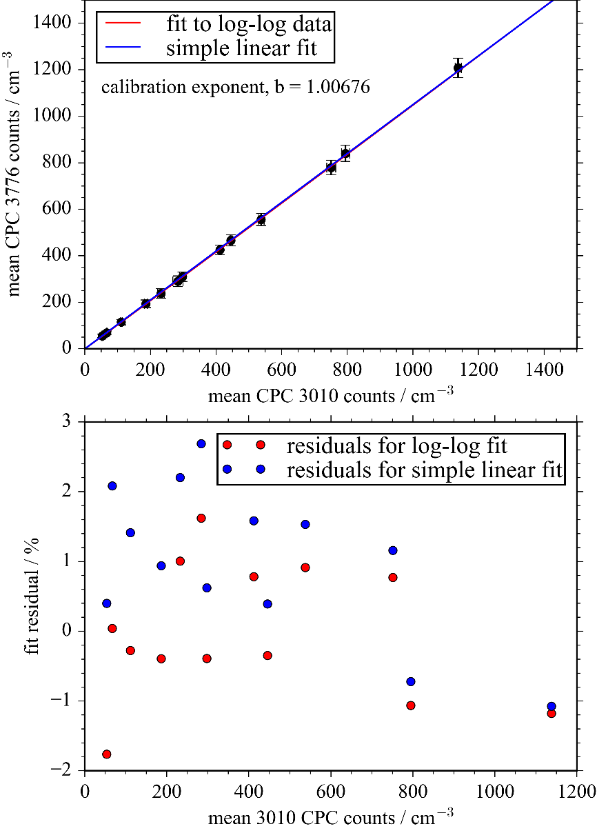
Figure S1. Top panel: Comparison of the mean N₃₇₇₆ and N₃₀₁₀ for 13 different mobility-selected diameters of ammonium sulfate aerosol, with each data point representing the mean of number concentration measurements made at 1 Hz sampling frequency over 5 minutes. The solid lines represent a fit of either N₃₀₁₀ = m⋅N₃₇₇₆ (blue line) or N₃₀₁₀ = (N₃₇₇₆)^{b} (red line), with m or b the fit coefficients. Bottom panel: The variation in the fit residual with the measured N₃₀₁₀. The mean fit residual across all measurements is 1.294% when using N₃₀₁₀ = m⋅N₃₇₇₆ to relate number concentrations, and 0.811% when using N₃₀₁₀ = (N₃₇₇₆)^{b}.

S4. Aerosol transmission factors
To relate aerosol number concentrations measured at the exit port for the 658-nm PAS channel to those for the other spectroscopy channels, we passed mobility-selected ammonium sulfate aerosol to the CRDS-PAS, measuring N₃₀₁₀ with the CPC₃₀₁₀ located at the sample exit port of the 658-nm PAS (N₃₀₁₀₋₆₅₈) for one minute. We then moved the CPC₃₀₁₀ to sample from the exit port of the 405-nm PAS to those for the other CRDS and PAS channels, ensuring that the aerosol number concentration being passed to the common inlet of the CRDS-PAS instrument was unchanged, recording the number concentration at each exit port for one minute. These measurements were performed for a mobility-selected diameter of 200 nm and this measurement procedure to compare number concentrations between the two wavelength channels was repeated twice.We find very little difference in the measured number concnetrations between those measured at the exit of one CRDS cell and the exit of the corresponding PAS cell. Therefore, particle losses are very low within the PAS instruments. However, there were notable difference in particle number concentrations between the 405-nm and 658-nm spectroscopy flow lines. We define a transmission correction factor for the 405-nm channels (T₄₀₅) using:
 | $$T_{405}=\frac{{\left(N_{3010-405}\right)}^{b}}{{\left(N_{3010-658}\right)}^{b}}$$ | Equation S 5
in which N₃₀₁₀₋₄₀₅ and N₃₀₁₀₋₆₅₈ is the raw measured aerosol number concentration at the exit port of the 405-nm and 658-nm PAS cells, respectively, and b is the CPC calibration contant described in Sect. S1. We calculated a mean T₄₀₅ of 0.93 ± 0.01. Thus, the number concentrations in the 405-nm channel are reduced by 7.3% compared to those in the 658-nm channel. In subsequent calculations of optical cross sections reported below, the CPC₃₀₁₀ data are corrected using:
 | $$N_{}={\left(N_{3010}\right)}^{b}T_{}$$ | Equation S 6
with b = 1.00676, T₄₀₅ = 0.93 and T₆₅₈ = 1.00.

S5. Modelling the particle size distribution and fractional contribution to optical cross sections for particles transmitted through a differential mobility analyser
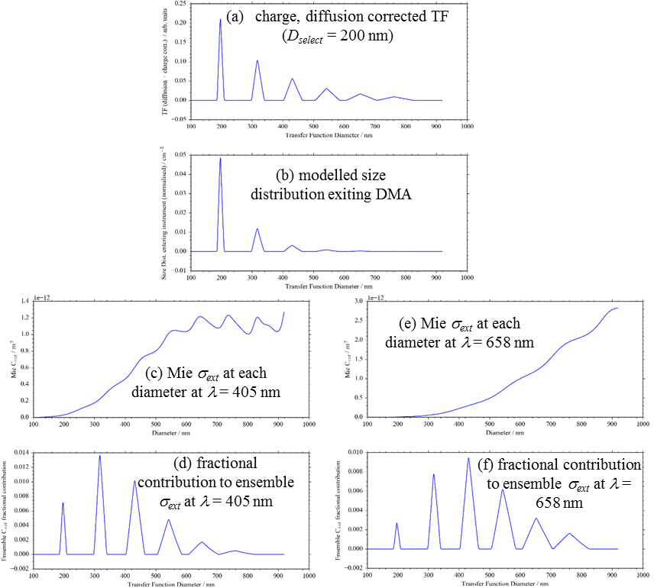
Figure S2. For D_{select} = 200 nm, the charge-corrected diffusion-corrected transfer function of the 3081 DMA for a 3.5 L min⁻¹ and 0.3 L min⁻¹ sheath and aerosol flow, respectively. The transfer function includes up to q = 6 charges. (b) The modelled size distribution exiting the DMA, calculated from the convolution of the normalised transfer function in (a) with the SMPS-measured size distribution entering the DMA. (c) and (e) show the single particle Mie σ_{ext} variation with particle diameters at optical wavelengths of 405 and 658 nm, respectively, using the complex RI for AS (n₄₀₅ = 1.54, n₆₅₈ = 1.525, k = 0). (d) and (f) show the fractional contribution to the ensemble-mean σ_{ext} from each diameter in the particle size distribution exiting the DMA for wavelengths 405 and 658 nm, respectively.

S6. Optimising the charge distribution for a soft x-ray neutraliser
For a soft x-ray neutraliser, Tigges et al. recommend using Z₊/Z₋ = 0.957 and c₊/c₋ = 1.0 in the Gunn formula, i.e. c₊Z₊/c₋Z₋ = 0.957. Figure S3(a) shows the Tigges parameterisations for q/e = 0, ±1, ±2 and Gunn formula predictions using c₊/c₋ = 1.0, Z₊/Z₋ = 0.957 (as recommended by Tigges et al.¹¹) for q/e in the range 0 – 6. The Gunn formula calculations using q/e = 0, ±1, ±2 describe the Tigges parametrisations accurately over the particle diameter range of interest (100 – 1000 nm). Thus, we can use the Gunn formula directly to describe the entire aerosol charge distribution in the diameter range 100 – 1000 nm; the parameterisations of the Fuchs charging model by Wiedensohler¹² or Tigges et al.¹¹ would be needed only if we were to extend measurements to particle diameters less than ~50 nm (i.e. diameters at which the Gunn formula breaks down).
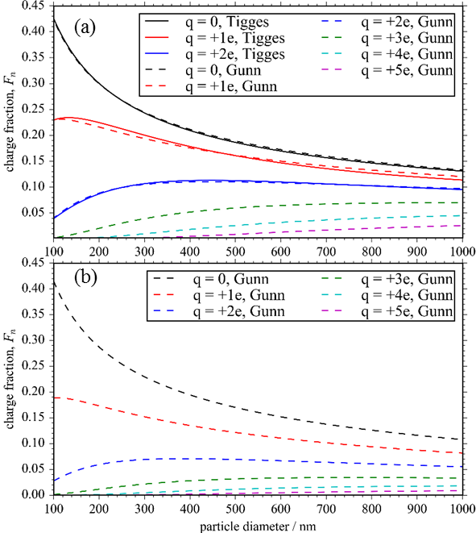
Figure S3: (a) The aerosol charge distribution for a soft x-ray neutraliser as recommended by Tigges et al., using the Tigges parameterisation to describe q/e = 0, ±1, ±2 charge states and the Gunn formula with c₊/c₋ = 1.0 and Z₊/Z₋ = 0.957 for higher charge states. The plot also shows the Gunn formula prediction for q/e = 0, ±1, ±2 for comparison. (b) The optimal aerosol charge distribution to achieve best agreement between measured and modelled σ_{ext} at the 405 nm spectroscopy wavelength, using the Gunn formula with c₊Z₊/c₋Z₋ = 0.80.
The Z₊/Z₋ = 0.957 value recommended by Tigges et al. is significantly higher than values used to describe other chargers. A comprehensive review¹³ of ion mobilities for a 24 aerosol neutralisers, including radioactive, electric and x-ray sources, shows that the mean Z₊/Z₋ is 0.81 ± 0.1, with the uncertainty corresponding to one standard deviation in reported values. The large variation of 0.1 in measured Z₊/Z₋ values is associated with the use of different neutraliser types, differing intensities of ionising radiation, variations in the sample flow rates through the neutraliser and associated residence times between the neutraliser and DMA, and the impacts of humidity.^{13,14} Considering measurements that include x-ray sources only, Z₊/Z₋ is reported in the range 0.92 – 0.96.¹³ No consideration is given to the ion concentration ratio by Tigges et al., assuming c₊/c₋ = 1.0.¹³ A good strategy for finding the c₊Z₊/c₋Z₋ ratio appropriate to our x-ray charger and operating conditions is to measure optical cross sections for mobility-selected aerosol of a known refractive index, then use the Gunn formula to describe the aerosol charge distribution and optimise the c₊Z₊/c₋Z₋ ratio for best agreement between measured and modelled cross sections. Here, we measured the σ_{ext} of mobility-selected ammonium sulfate (AS) particles with Toon et al. reporting RI values of n₄₀₅ = 1.540, n₆₅₈ = 1.525 and k₄₀₅ = k₆₅₈ = 10⁻⁷ for AS.¹⁵ Using the same experimental procedure described above, we measured σ_{ext} at both λ = 405, 658 nm for 10 values of D_{select} from 125 to 350 nm in 25 nm intervals. We compared the measured σ_{ext} values to predictions using the model described above, varying the c₊Z₊/c₋Z₋ ratio until best agreement between measured and modelled extinction cross sections is achieved. To quantify the level of agreement between measured and modelled cross sections, we calculated the merit function ${}_{ext}^{2}$ (see main text).

Figure S4(a) shows the variation in ${}_{ext}^{2}$ with c₊Z₊/c₋Z₋ for the merit function calculated using 405-nm σ_{ext} only, 658-nm σ_{ext} only, and the mean of the merit functions from measurements at both wavelengths. We find that the optimal c₊Z₊/c₋Z₋ takes different values for the two different spectroscopy wavelengths, with values of 0.80 and 0.86 found for separate optimisations of 405-nm and 658-nm data. Figure S4(b) shows the excellent agreement between the measured and predicted σ_{ext} when calculations at each spectroscopy wavelength use the corresponding optimised value for c₊Z₊/c₋Z₋. Figure S3(b) shows the Gunn-predicted charge distributions for c₊Z₊/c₋Z₋ = 0.80 over the particle diameter range of interest and demonstrates the much reduced charging probabilities for higher q charge states when using c₊Z₊/c₋Z₋ = 0.80 compared to the probabilities using c₊Z₊/c₋Z₋ = 0.957 shown in Figure S3(a).

The reason for the difference in the optimal c₊Z₊/c₋Z₋ values at each spectroscopy wavelength is likely a consequence of the use of the Tigges et al. charge distribution by the SMPS software to invert raw number count distributions to a size distribution. In our optimisation study above, we did not recalculate the inverted SMPS size distribution for a given c₊Z₊/c₋Z₋. For a mobility selected diameter of 200 nm, Figure S2 shows that contributions to the ensemble σ_{ext} are dominated by particles with charges q < 5 (diameters below 600 nm) for the 405 nm wavelength, while the 658-nm σ_{ext} takes significant contributions from particles with diameters in the range 500 – 800 nm. Re-calculating the SMPS size distribution for a given value of c₊Z₊/c₋Z₋ will change the size distribution at small and larger diameters to different extents. The different sensitivities in the σ_{ext} at both spectroscopy wavelengths to the number concentrations at different diameter ranges will lead to inaccuracies in the direct association of the optimised c₊Z₊/c₋Z₋ to the charge distribution produced by the neutraliser. Moreover, differences in c₊Z₊/c₋Z₋ between spectroscopy wavelengths may arise from different size-dependent losses of aerosols in the two channels; through the above optimisation procedure, we have corrected for inaccurate descriptions of c₊Z₊/c₋Z₋ in our soft x-ray charger in addition to correcting for size-dependent losses to the walls. The sample residence lengths prior to the spectrometers is similar for both spectroscopy wavelengths, but small differences in tubing lengths and bend angles could be responsible in part for the different c₊Z₊/c₋Z₋ found for each spectroscopy wavelength.
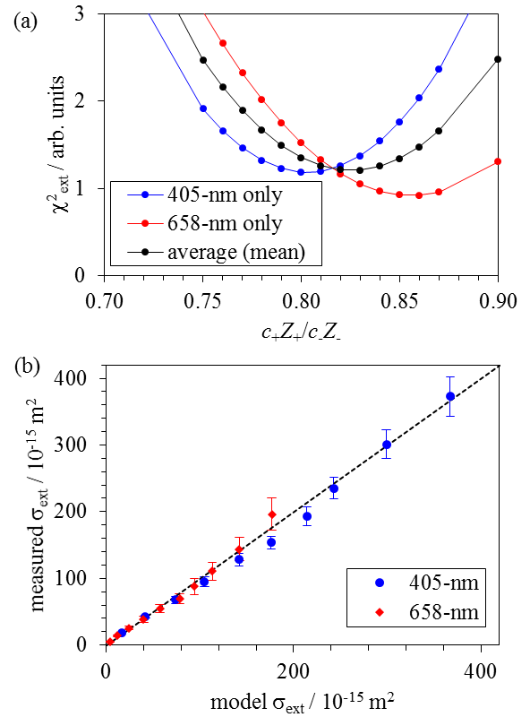
Figure S4: (a) For mobility-selected ammonium sulfate aerosol, the variation in the weighted merit function with the ratio c₊Z₊/c₋Z₋. Merit function distributions are shown for calculations using the 405-nm data only, 658-nm data only, and the mean merit function for both spectroscopy wavelengths. (b) The correlation between the measured and modelled σ_{ext}, with model calculations using the optimal values for c₊Z₊/c₋Z₋ of 0.80 and 0.86 for the 405 and 658 nm spectroscopy wavelengths, respectively. Vertical error bars in (b) represent one standard deviation in the mean σ_{ext_meas}. Calculations of σ_{ext_model} used the literature values of refractive index reported by Toon et al. for ammonium sulfate.¹⁵

S7. Sensitivity in PAS-measured absorption coefficients
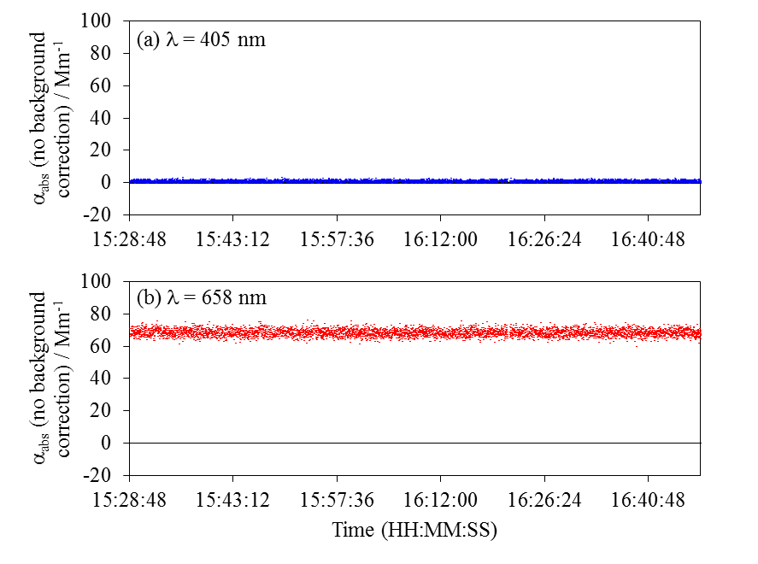
Figure S5. The measured absorption coefficient (not corrected for the laser-window interaction background) over time for the (a) 405-nm, and (b) 658-nm PAS channels for when non-absorbing ammonium sulfate aerosols are passed through the spectrometers during a data set for which the mobility-selected diameter is varied from 120 to 340 nm in 20 nm intervals. The 405-nm PAS measurements used an optimised photoacoustic cell that is insensitive to laser-window interactions, while the 658-nm PAS measurements used the Lack cell that is sensitive to laser scattering/absorption at the cell windows. The measured α_{abs} is invariant with changes in D_{select} because ammonium sulfate is non-absorbing and, therefore, there is no sensitivity to the presence of ammonium sulfate. The non-zero α_{abs} for the 658-nm channel arises from laser-window interactions only.

S8. Figure of merits for example refractive index retrievals
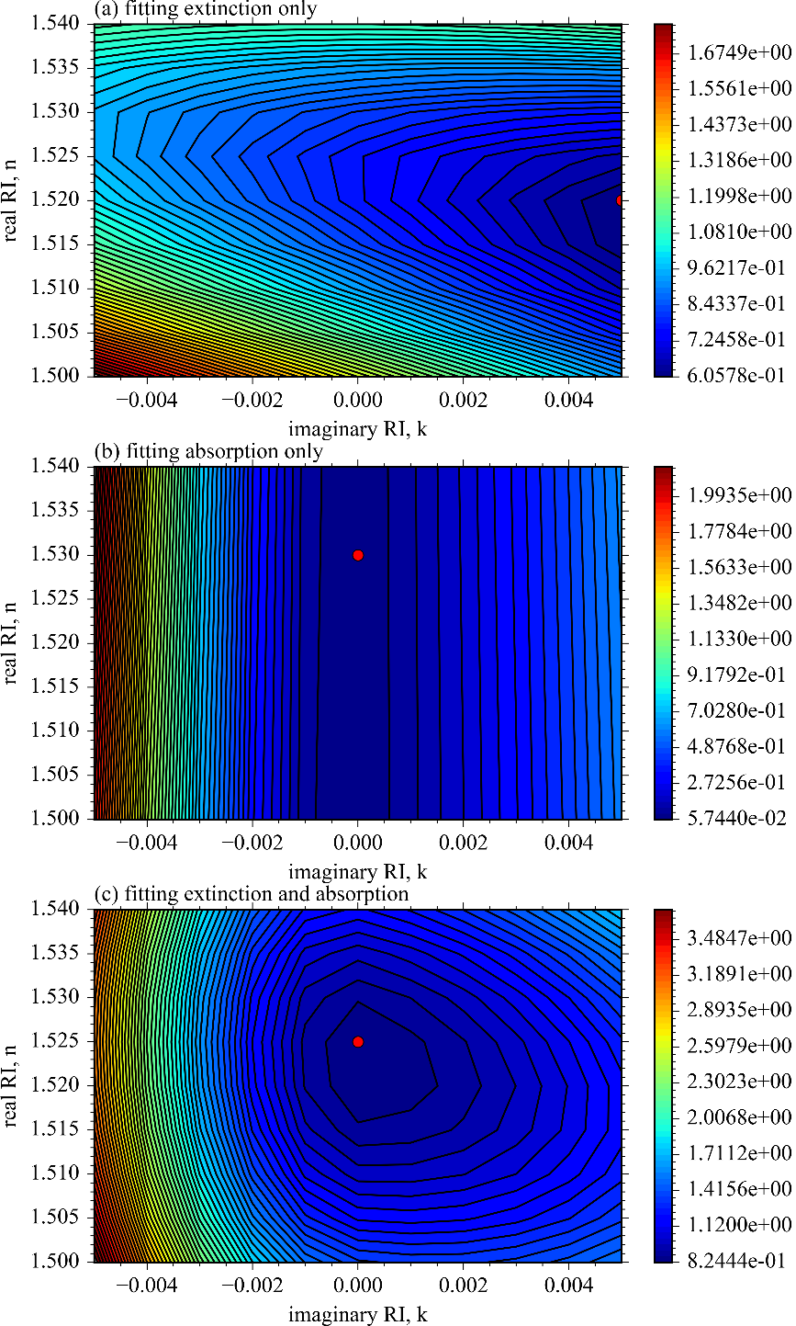
Figure S6. For a representative AS data set where cross sections were measured at the 658 nm wavelength, the variation is the merit functions (a) ${}_{ext}^{2}$ from fitting the extinction data only, (b) ${}_{abs}^{2}$ from fitting the absorption data only, and (c) ${}_{total}^{2}$ from fitting both extinction and absorption. The filled red circle represents the minimum locations in the corresponding merit functions. These merit function plots show the results of an initial grid search where k was varied with a coarse step size of Δk = 0.005. This step size was chosen to calculate the merit function over a broad k range that clearly demonstrated the minimum in k.

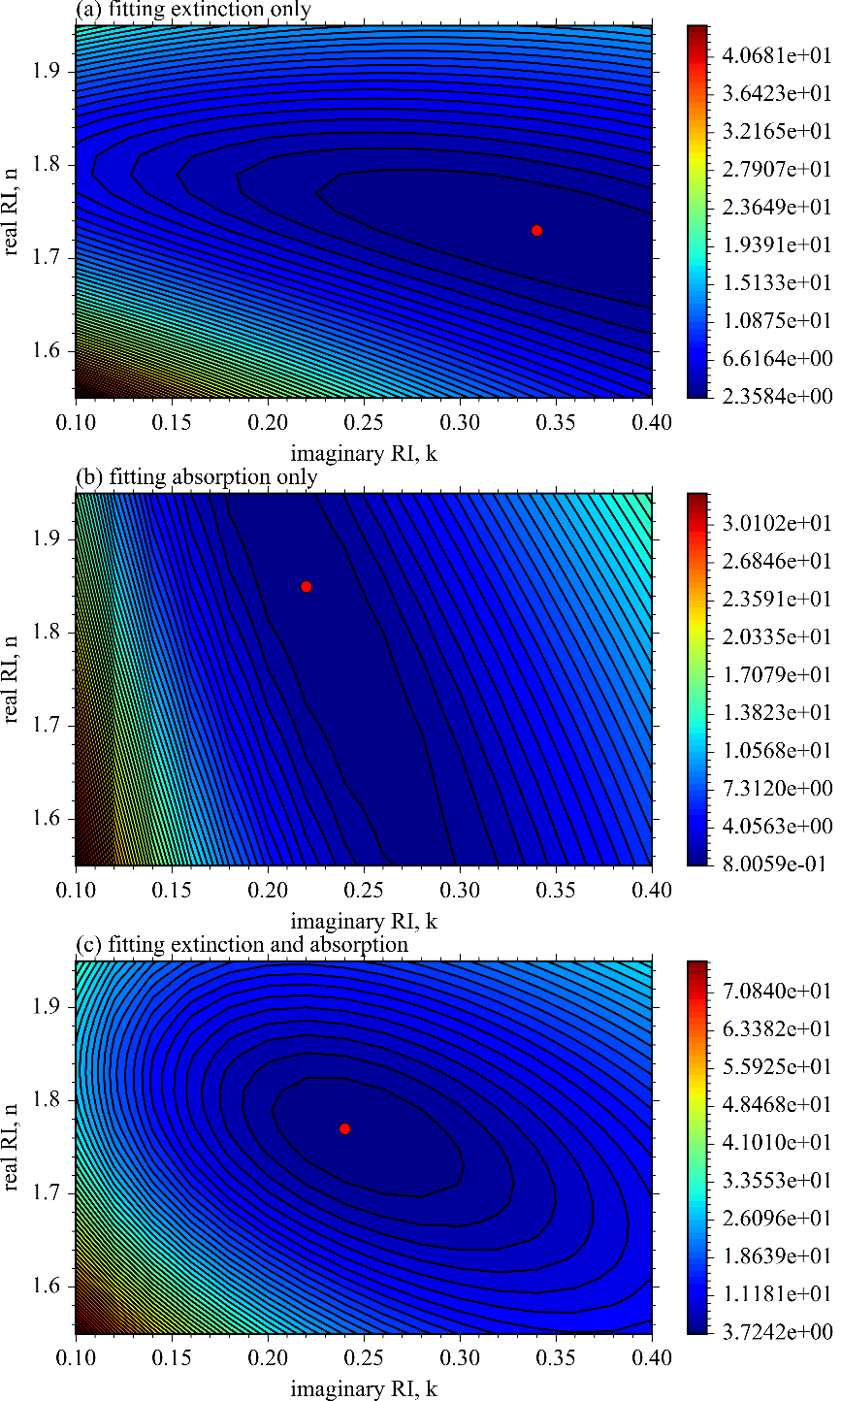
Figure S7. For a representative nigrosin data set where cross sections were measured at the 658 nm wavelength, the variation is the merit functions (a) ${}_{ext}^{2}$ from fitting the extinction data only, (b) ${}_{abs}^{2}$ from fitting the absorption data only, and (c) ${}_{total}^{2}$ from fitting both extinction and absorption. The filled red circle represents the minimum locations in the corresponding merit functions.

S9. Effective density for AS-nigrosin mixtures

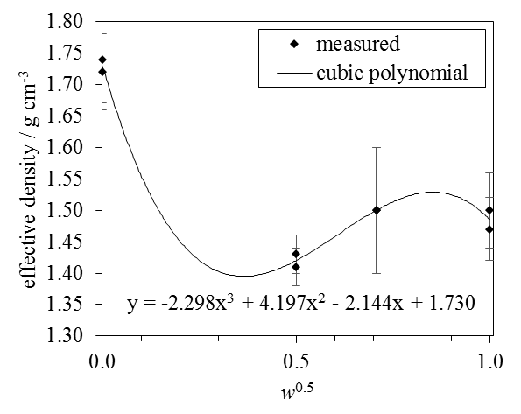
Figure S8. The measured values of ρ_{e} from Radney and Zangmeister¹⁶ for internally-mixed AS-nigrosin aerosols, with variation in the square-root of the nigrosin mass fraction. The solid line represents the fit of a cubic polynomial to the measured data. See main text for details.

S10. Parameterised variation in n and k with both wavelength and composition for internally-mixed AS-nigrosin mixtures
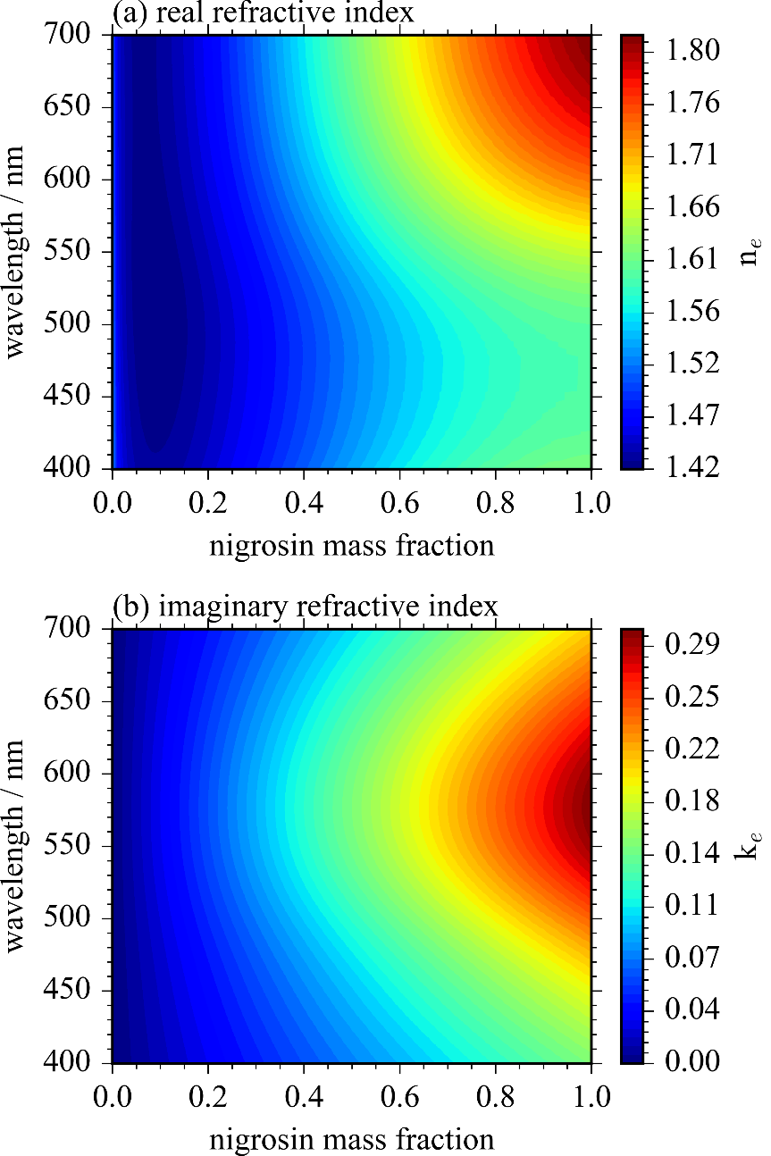
Figure S9. Contour plots showing the predicted variation in (a) n_{e} and (b) k_{e} with variation in both wavelength and nigrosin mass fraction for AS-nigrosin mixtures. The n_{e} is calculated using the molar refraction mixing rule in combination with the density parameterisation described in the main text, in combination with our Cauchy description of n_{AS} and the Bluvshtein et al.⁴ description of n_{nig} over the wavelength range 400 – 700 nm. The k_{e} is calculated from the mass fraction mixing rule using k_{AS} = 0 and the k_{nig} reported by Bluvshtein et al. over the 400 – 700 nm wavelength range.

S11. Bias magnitudes used to assess uncertainties in refractive index retrievals
Uncertainty in the relative length of the cavity occupied by the aerosol sample dominates the bias in the CRDS-measured extinction. Equation S1 shows that the extinction coefficient depends on the ratio R_{L} of the cavity length occupied by aerosol (l) to the geometric length (L) between the two cavity mirrors. While L is measured to an accuracy of ~ 1 mm to be 40 cm, the uncertainty in l is more uncertain. We take l as the distance between the sample inlet and outlet locations, but this length has an uncertainty of ±0.5 cm. These uncertainties in l and L combine to give a potential bias in R_{L} of 0.0173, corresponding to a 1.5 % bias. This bias could be larger if aerosol penetrates into the purge volumes of the cavity, although quantifying this penetration is difficult.

Uncertainty in the PAS calibration dominates bias in the PAS-measured absorption coefficient. Section S2 described our calibration of the PAS microphone response, while Figure S10 shows the measured variation in the dimensionless PAS calibration coefficient for both the 405-nm and 658-nm PAS instruments. The percentage standard deviation in these measured calibration coefficients are 4.97 % and 2.96 % for the 405-nm and 658-nm PAS instruments, respectively. Therefore, we attribute a 5 % bias to the PAS calibration coefficient.

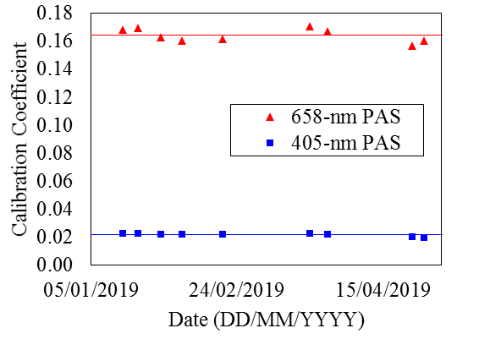
Figure S10. Measured PAS calibration coefficients over time for the 405-nm and 658-nm PAS instruments.

The manufacturer quotes the accuracy of CPC measurements of aerosol number concentration (N_{CPC}) as ±10 %. However, a comprehensive assessment of CPC counting accuracies by Fletcher et al. using NIST traceable methods found that N_{CPC} was biased by 5.03 (± 0.25) %.¹⁰ We assigned a ±5 % bias to N_{CPC}, noting that previous bias attribution studies have assumed 5 % biases in CPC-measured aerosol number concentrations.⁹

Section 2.5 of the main text shown that the ratio c₊Z₊/c₋Z₋ governs the aerosol charge distribution. While Sect. 2.5 determined c₊Z₊/c₋Z₋ using a calibration data set of σ_{ext} measured for mobility-selected AS, we also measured five additional AS data sets for the RI retrievals discussed in Sect. 3.1. Optimising c₊Z₊/c₋Z₋ for each of these five AS data sets in the same way as performed in Sect. 2.5 facilitated estimation of uncertainty in c₊Z₊/c₋Z₋ for each spectroscopy wavelength. In this way, we estimate uncertainties in c₊Z₊/c₋Z₋ of 0.08 and 0.02 at the 405 and 658 nm spectroscopy wavelengths, respectively.

The diffusion-corrected transfer function for the DMA column depends on the aerosol and sheath flow rates. The sheath flow was constant at 3.5 L min⁻¹ and there was no evidence to suggest bias in this value. The aerosol flow rate, however, varied during experiments. The aerosol flow rate was set to a value in the range 0.32 – 0.34 L min⁻¹ at the beginning of a measurement data set, but this flow could increase over the course (~ 90 minutes) of the measurement by up to 10 % caused by gradual build-up up of liquid in the drain line from the atomiser. Therefore, we attribute a 10 % bias to the aerosol flow rate.

To estimate error in the SMPS-measured particle size distribution input to the DMA, we assumed that the manufacturer calibration of the particle size bins could be attributed incorrectly by one bin width. Because the bin centres are distributed equally in the log-diameter domain, one bin width corresponds to a 3.66% error in the particle diameter for the bin width distribution used. Therefore, we assigned a 3.66 % bias to the SMPS bin diameters. Additional uncertainty in the SMPS-measured size distribution arises from errors in the description of aerosol charge distribution, but propagating the attributed uncertainty in c₊Z₊/c₋Z₋ through the SMPS inversion routine to a particle size distribution is difficult and we ignore this contribution to the SMPS measurement uncertainty.

S12. Results from a Monte Carlo analysis of RI retrieval uncertainties
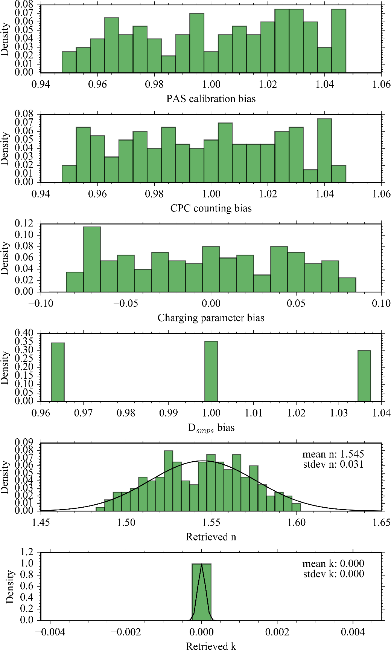
Figure S11. Monte Carlo error analysis for AS refractive index retrievals at the 405 nm spectroscopy wavelength. The top four panels show the randomly-distribute biases applied to the PAS calibration coefficient, CPC counting efficiency, c₊Z₊/c₋Z and the SMPS diameter (D_{smps}). For the PAS calibration coefficient, CPC counting efficiency and D_{smps}, these biases are represented as a multiplicative factor that were applied to the recorded values. For c₊Z₊/c₋Z, the bias is a factor that was added or subtracted to the optimal value. The bottom two panels show the distribution in the retrieved n and k, with these distribution fit to a Gaussian distribution to determine the mean and standard deviation in the retrieval distributions.
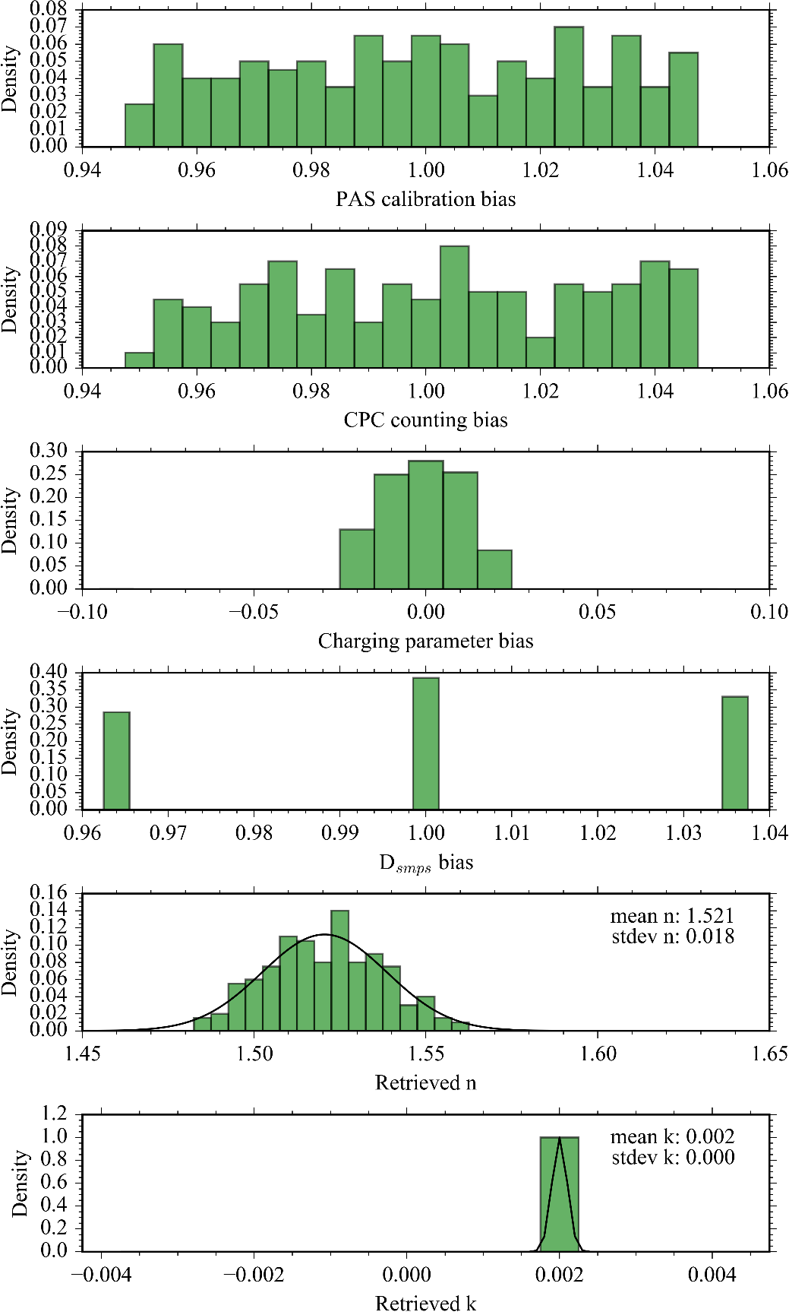
Figure S12. Monte Carlo error analysis for AS refractive index retrievals at the 658 nm spectroscopy wavelength. The top four panels show the randomly-distribute biases applied to the PAS calibration coefficient, CPC counting efficiency, c₊Z₊/c₋Z and the SMPS diameter (D_{smps}). For the PAS calibration coefficient, CPC counting efficiency and D_{smps}, these biases are represented as a multiplicative factor that were applied to the recorded values. For c₊Z₊/c₋Z, the bias is a factor that was added or subtracted to the optimal value. The bottom two panels show the distribution in the retrieved n and k, with these distribution fit to a Gaussian distribution to determine the mean and standard deviation in the retrieval distributions.
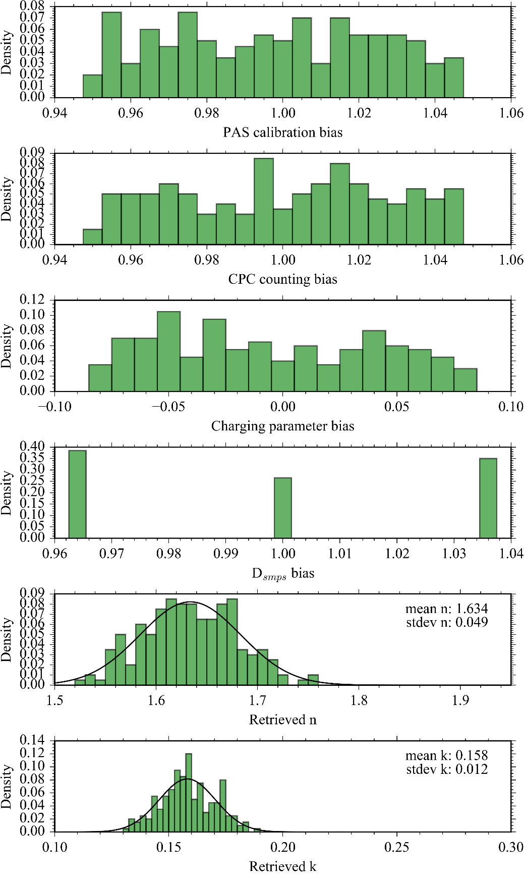
Figure S13. Summary of the Monte Carlo error analysis for nigrosin refractive index retrievals at the 405 nm spectroscopy wavelength. The top four panels show the randomly-distribute biases applied to the PAS calibration coefficient, CPC counting efficiency, c₊Z₊/c₋Z and the SMPS diameter (D_{smps}). For the PAS calibration coefficient, CPC counting efficiency and D_{smps}, these biases are represented as a multiplicative factor that were applied to the recorded values. For c₊Z₊/c₋Z, the bias is a factor that was added or subtracted to the optimal value. The bottom two panels show the distribution in the retrieved n and k, with these distribution fit to a Gaussian distribution to determine the mean and standard deviation in the retrieval distributions.
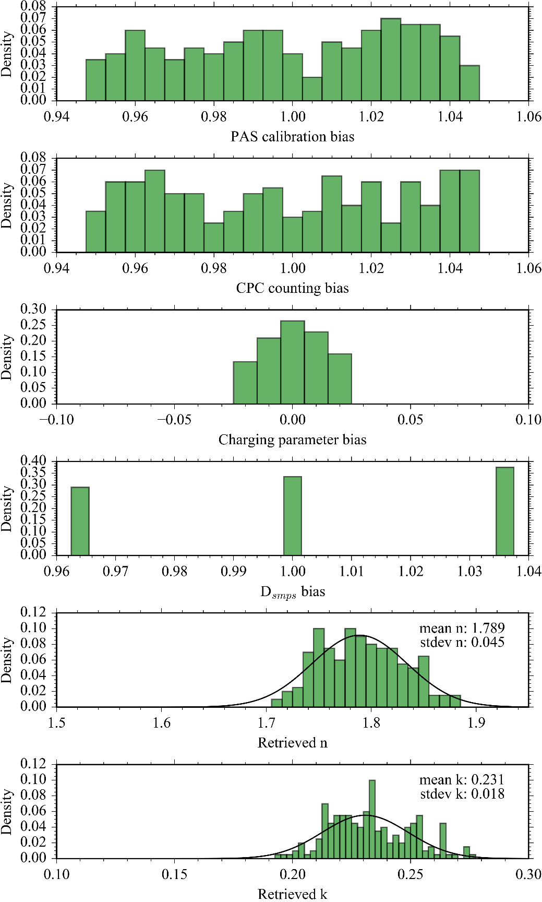
Figure S14. Monte Carlo error analysis for nigrosin refractive index retrievals at the 658 nm spectroscopy wavelength. The top four panels show the randomly-distribute biases applied to the PAS calibration coefficient, CPC counting efficiency, c₊Z₊/c₋Z and the SMPS diameter (D_{smps}). For the PAS calibration coefficient, CPC counting efficiency and D_{smps}, these biases are represented as a multiplicative factor that were applied to the recorded values. For c₊Z₊/c₋Z, the bias is a factor that was added or subtracted to the optimal value. The bottom two panels show the distribution in the retrieved n and k, with these distribution fit to a Gaussian distribution to determine the mean and standard deviation in the retrieval distributions.

References
1 D. A. Lack, E. R. Lovejoy, T. Baynard, A. Pettersson and A. R. Ravishankara, Aerosol Sci. Technol., 2006, 40, 697–708.
2 N. W. Davies, M. I. Cotterell, C. Fox, K. Szpek, J. M. Haywood and J. M. Langridge, Atmos. Meas. Tech., 2018, 11, 2313–2324.
3 K. Foster, R. Pokhrel, M. Burkhart and S. Murphy, Atmos. Meas. Tech., 2019, 12, 3351–3363.
4 N. Bluvshtein, J. M. Flores, Q. He, E. Segre, L. Segev, N. Hong, A. Donohue, J. N. Hilfiker and Y. Rudich, Atmos. Meas. Tech., 2017, 10, 1203–1213.
5 D. Fischer and G. D. Smith, Aerosol Sci. Technol., 2018, 52, 393–406.
6 M. I. Cotterell, G. P. Ward, A. P. Hibbins, J. M. Haywood, A. Wilson and J. M. Langridge, Aerosol Sci. Technol., 2019, 53, 1107–1127.
7 M. I. Cotterell, A. J. Orr-Ewing, K. Szpek, J. M. Haywood and J. M. Langridge, Atmos. Meas. Tech., 2019, 12, 2371–2385.
8 R. E. H. Miles, S. Rudić, A. J. Orr-Ewing and J. P. Reid, Aerosol Sci. Technol., 2011, 45, 1360–1375.
9 K. J. Zarzana, C. D. Cappa and M. A. Tolbert, Aerosol Sci. Technol., 2014, 48, 1133–1144.
10 R. A. Fletcher, G. W. Mulholland, M. R. Winchester, R. L. King and D. B. Klinedinst, 2009, 6826.
11 L. Tigges, A. Wiedensohler, K. Weinhold, J. Gandhi and H. J. Schmid, J. Aerosol Sci., 2015, 90, 77–86.
12 A. Wiedensohler, J. Aerosol Sci., 1988, 19, 387–389.
13 L. Tigges, A. Jain and H. J. Schmid, J. Aerosol Sci., 2015, 88, 119–134.
14 H. M. Lee, C. Soo Kim, M. Shimada and K. Okuyama, J. Aerosol Sci., 2005, 36, 813–829.
15 O. B. Toon, J. B. Pollack and B. N. Khare, J. Geophys. Res., 1976, 81, 5733–5748.
16 J. G. Radney and C. D. Zangmeister, J. Quant. Spectrosc. Radiat. Transf., 2018, 220, 52–66.

