Supramolecular assemblies tailored by di-pyridyl-1,2-4-thiadiazoles: influence of the building blocks in the predictability of the final network

Enrico Podda,a Massimiliano Arca,a Simon J. Coles,b Miriam Crespo Alonso,a Francesco Isaia,a Anna Pintus,a Vito Lippolis,a M. Carla Aragoni,*a

aDipartimento di Scienze Chimiche e Geologiche, Università degli Studi di Cagliari, Cittadella Universitaria, SS. 554 bivio Sestu, 09042 Monserrato – Cagliari, Italy.bUK National Crystallography Service, School of Chemistry, Faculty of Engineering and Physical Sciences, University of Southampton, UK, SO17 1BJ.

E-mail: [aragoni@unica.it](mailto:aragoni@unica.it)

**Electronic Supplementary Material**

**Table S1.** Crystal data and refinement parameters for compounds (**1**∙**L1**)**∞**, (**1**∙**L2**)**2**.

|  |  |  |
| --- | --- | --- |
|  | (**1**∙**L1**)**∞** | (**1**∙**L2**)**2** |
| Formula | C16H20CdN4O4P2S5 | C32H40Cd2N8O8P4S10 |
| M | 667.02 | 1334.04 |
| Crystal System | Orthorhombic | Monoclinic |
| Space Group | Pnna | P21/c |
| *a*/ Å | 9.6094(2) | 14.0414(4) |
| *b*/ Å | 14.2535(4) | 15.3357(4) |
| *c*/ Å | 18.5625(5) | 12.9456(4) |
| *α* / ° | 90.00 | 90.00 |
| *β* / ° | 90.00 | 113.2910(10) |
| *γ* / ° | 90.00 | 90.00 |
| *V* /Å3 | 2542.46 | 2560.47 |
| *Z* | 4 | 2 |
| *ρ*calcd. | 1.743 | 1.730 |
| *T*/K | 120(2) | 120(2) |
| *μ*(Mo-Kα)/mm–1 | 1.426 | 1.416 |
| Collected Refl. | 16542 | 25433 |
| Uniq. Refl. | 2892 | 5847 |
| Refl. with I > 2σ(I) | 2672 | 5144 |
| *R*int | 0.039 | 0.037 |
| *R*1 (I > 2σ(I)) | 0.0365 | 0.0408 |
| *wR*2 (all data) | 0.0802 | 0.0984 |

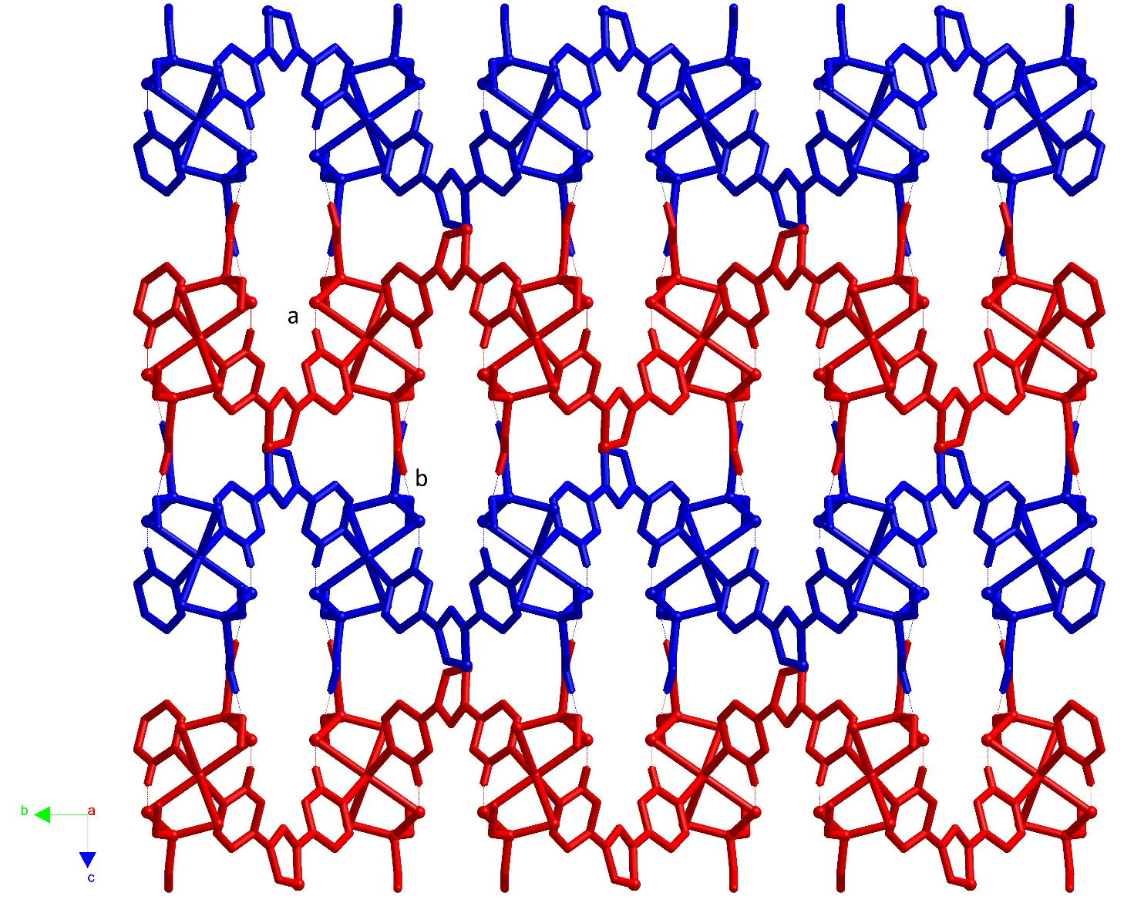

**Figure S1A**: Packing view along 100 direction of (**1**∙**L1**)∞ helices running along 010 (red coloured) and along 0-10 direction (blue coloured).

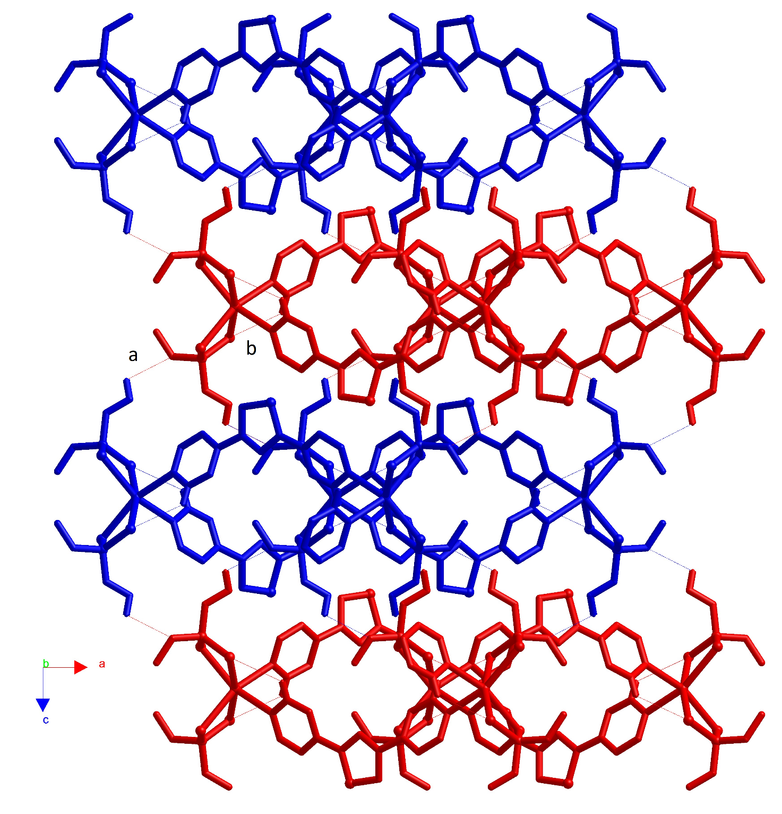

**Figure S1B**: Packing view along 010 direction of (**1**∙**L1**)∞ helices running along 010 (red coloured) and along 0-10 direction (blue coloured).

|  |  |
| --- | --- |
|  |  |

**Figure S2**: **L2** conformations: periplanar (left) and antiperiplanar (right)

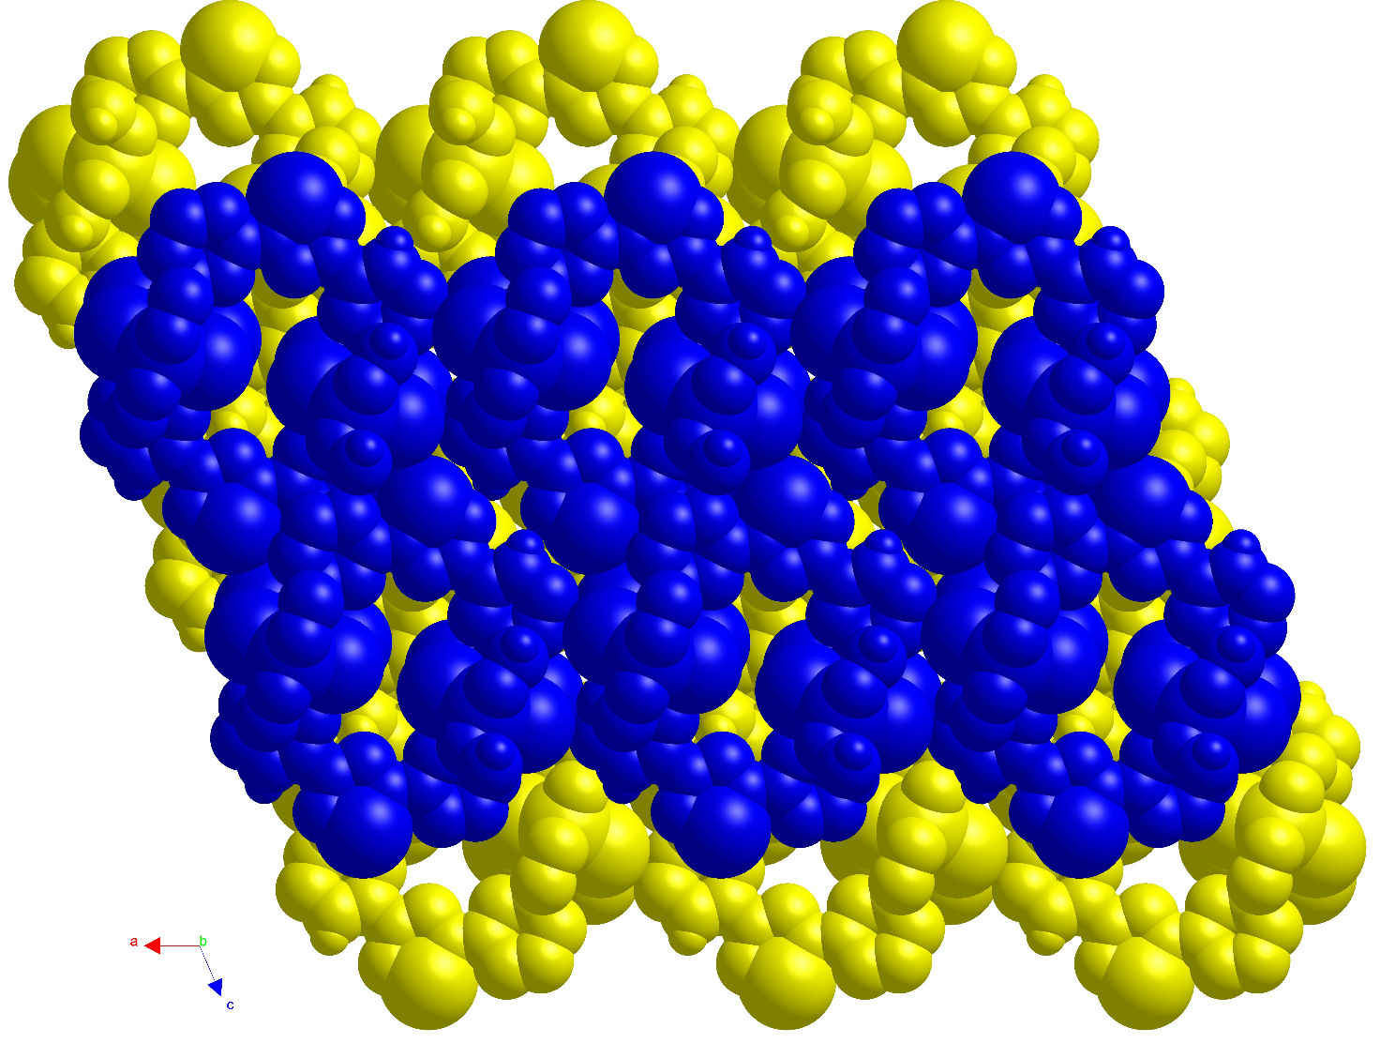

**Figure S3**: Packing view of the off-set compact arrangement along the 010 of layers of dimers (**1**·**L2**)2 evidenced in different colours.



**Figure S4** 1H-NMR spectra in DMSO-d6 for **L1** (blue) and (**1**∙**L1**)**∞** (red), respectively.

(**1·L1**)∞ : 1H NMR (300 MHz, DMSO-d6) δ 8.87 (dd, J = 4.5, 1.5 Hz, 2H), 8.83 (dd, J = 4.5, 1.5 Hz, 2H), 8.22 (dd, J = 4.5, 1.5 Hz, 2H), 8.10 (dd, J = 4.5, 1.6 Hz, 2H), 3.53 (s, 6H), 3.51 (d, 3JPH = 14.6 Hz, 12H) ppm.



**Figure S5** 1H-NMR spectra in DMSO-d6 for **L2** (blue) and (**1**∙**L2**)**2** (red), respectively.

(**1·L2**)2 : 1H-NMR (300 MHz, DMSO-d6) δ 9.49 (d, J = 1.6 Hz, 2H), 9.34 (d, J = 1.8 Hz, 2H), 8.88 – 8.80 (m, 2H), 8.80 – 8.72 (m, 2H), 8.64 (d, J = 8.0 Hz, 2H), 8.54 (d, J = 8.0 Hz, 2H), 7.74 – 7.58 (m, 4H), 3.54 (d, 3JPH = 14.7 Hz, 24H) ppm.