Supplemental Material

Developing a passive acoustic monitoring technique for Australia’s most numerous burrow-nesting seabird, the Short-tailed Shearwater (Ardenna tenuirostris)
Katherine C. Brownlie^{a,b*}, Ross Monash^{c}, Johanna J. Geesonª, Jérôme Fort^{b}, Paco Bustamante^{b,d} and John P.Y. Arnould^{b}
ªSchool of Life and Environmental Sciences, Deakin University, Burwood, Australia
^{b}Littoral Environnement et Sociétés, UMR 7266 CNRS, La Rochelle Université, La Rochelle, France
^{c}Department of Primary Industries, Parks, Water and Environment, Hobart, TAS 7001, Australia
^{d}Institut Universitaire de France (IUF), Paris, France
*Corresponding author: kbrownli@deakin.edu.au

Table S1: Logging duration of eight acoustic data loggers deployed at Short-tailed Shearwater study sites across south-eastern Australia during the 2016/2017 and 2017/2018 breeding seasons.
Site | 2016/2017 |  |  | 2017/2018
 | Logging start date | Logging end date | Total minutes | Logging start date | Logging end date | Total minutes
Kanowna Island 1 | 8 Sep 2016 | 22 May 2017 | 20081 | 27 August 2017 | 4 May 2018 | 19425
Kanowna Island 2 | 8 Sep 2016 | 22 May 2017 | 20106 | 27 August 2017 | 4 May 2018 | 19421
Gabo Island 1 | 3 Oct 2016 | 24 April 2017 | 15445 | 26 Sep 2017 | 23 April 2018 | 15893
Gabo Island 2 | 3 Oct 2016 | 24 April 2017 | 15451 | 26 Sep 2017 | 23 April 2018 | 15892
Point Danger | 15 Sep 2016 | 25 April 2017 | 16962 | 14 Sep 2017 | 18 Dec 2017* | 7124
Fort Direction | 15 Sep 2016 | 6 Dec 2016* | 6141 | 18 Sep 2017 | 8 April 2018 | 14804
Whalebone Point | 16 Sep 2016 | 21 Feb 2017* | 10113 | 18 Sep 2017 | 8 April 2018 | 14804
Cloudy Bay | - | - | - | 18 Sep 2017 | 31 March 2018 | 14070
* In three cases the acoustic data loggers failed to record for unknown reasons (possible device malfunction, battery failure, faulty SD card, human interference), hence data was only collected for a limited period of the breeding season at these sites (Fort Direction 2016/17, Point Danger 2017/18, Whalebone Point 2016/17).
Table S2: Comparison of occupied, unoccupied and unknown burrow status using the burrowscope and grubbing methods for eight Short-tailed Shearwater nest censuses conducted on Gabo Island in 2016/2017 and 2017/18. The difference between occupied burrows for the two methods was averaged for the December and March nest censuses and used to obtain the conversion factors of 1.33 and 1.23 in December and March, respectively.
Site | Census | Burrowscope |  |  |  | Grubbing |  |  |  | Occupied
 |  | Occupied | Unoccupied | Unknown | Total | Occupied | Unoccupied | Unknown | Total | Difference
Gabo Island 1 | December 2016 | 35 | 36 | 5 | 76 | 26 | 44 | 6 | 76 | 1.35
Gabo Island 2 | December 2016 | 75 | 38 | 9 | 122 | 56 | 41 | 25 | 122 | 1.34
Gabo Island 1 | December 2017 | 37 | 22 | 9 | 68 | 29 | 28 | 11 | 68 | 1.28
Gabo Island 2 | December 2017 | 89 | 16 | 18 | 123 | 65 | 18 | 40 | 123 | 1.37
Gabo Island 1 | March 2017 | 0 | 56 | 18 | 74 | 0 | 51 | 23 | 74 | -
Gabo Island 2 | March 2017 | 46 | 44 | 35 | 125 | 34 | 36 | 55 | 125 | 1.35
Gabo Island 1 | March 2018 | 17 | 45 | 7 | 69 | 15 | 31 | 23 | 69 | 1.13
Gabo Island 2 | March 2018 | 70 | 44 | 16 | 130 | 58 | 26 | 46 | 130 | 1.21

Table S3: Linear regressions between the mean census date acoustic index values (normalised difference soundscape index (NDSI), acoustic complexity index (ACI), acoustic diversity index (ADI), acoustic evenness index (AEI), and bioacoustic index (BIO)) and the density of occupied nest-burrows during the incubation (n = 14) and chick-rearing periods (n = 10) for all Short-tailed Shearwater study sites over the breeding seasons 2016/2017 and 2017/2018.
Acoustic index | Incubation |  |  |  |  |  |  | Chick-rearing
 | Intercept | SE | Slope | SE | F _{(1,12)} | P-value | r² | Intercept | SE | Slope | SE | F _{(1,8)} | P-value | r²
NDSI | 0.194 | 0.430 | 0.470 | 0.104 | 20.27 | 0.001 | 0.63 | 0.156 | 0.029 | 0.374 | 0.111 | 11.36 | 0.010 | 0.59
ACI | -1.462 | 1.299 | 0.0009 | 0.0006 | 1.85 | 0.199 | 0.13 | -2.583 | 1.572 | 0.0015 | 0.0008 | 3.07 | 0.118 | 0.28
ADI | -1.547 | 0.901 | 0.861 | 0.419 | 4.23 | 0.062 | 0.26 | -0.433 | 0.513 | 0.327 | 0.278 | 1.39 | 0.273 | 0.15
AEI | 0.588 | 0.142 | -1.200 | 0.559 | 4.61 | 0.053 | 0.28 | 0.363 | 0.235 | -0.434 | 0.519 | 0.70 | 0.427 | 0.08
BIO | 0.200 | 0.210 | 0.010 | 0.019 | 0.26 | 0.620 | 0.02 | 0.573 | 0.309 | -0.043 | 0.032 | 1.74 | 0.224 | 0.18
Significant results are indicated in bold (P < 0.05)
SE: Standard error

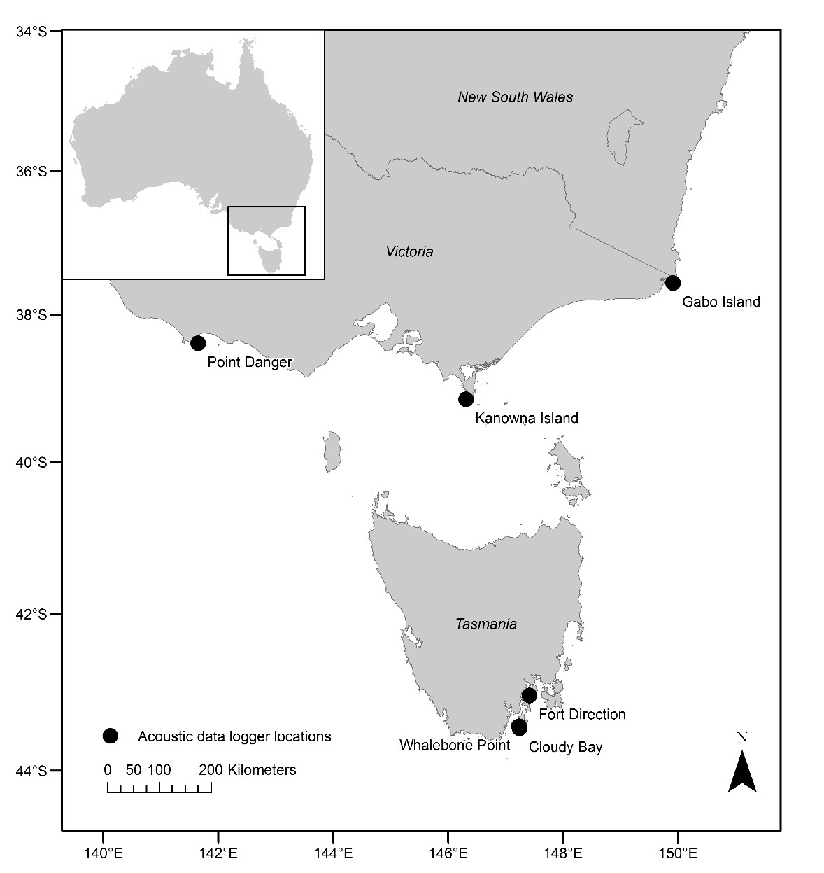
Figure S1: Acoustic data logger deployment locations at six Short-tailed Shearwater breeding sites (Point Danger, Kanowna Island, Gabo Island, Whalebone Point, Cloudy Bay and Fort Direction) across south-eastern Australia during the 2016/17 and 2017/18 breeding seasons.
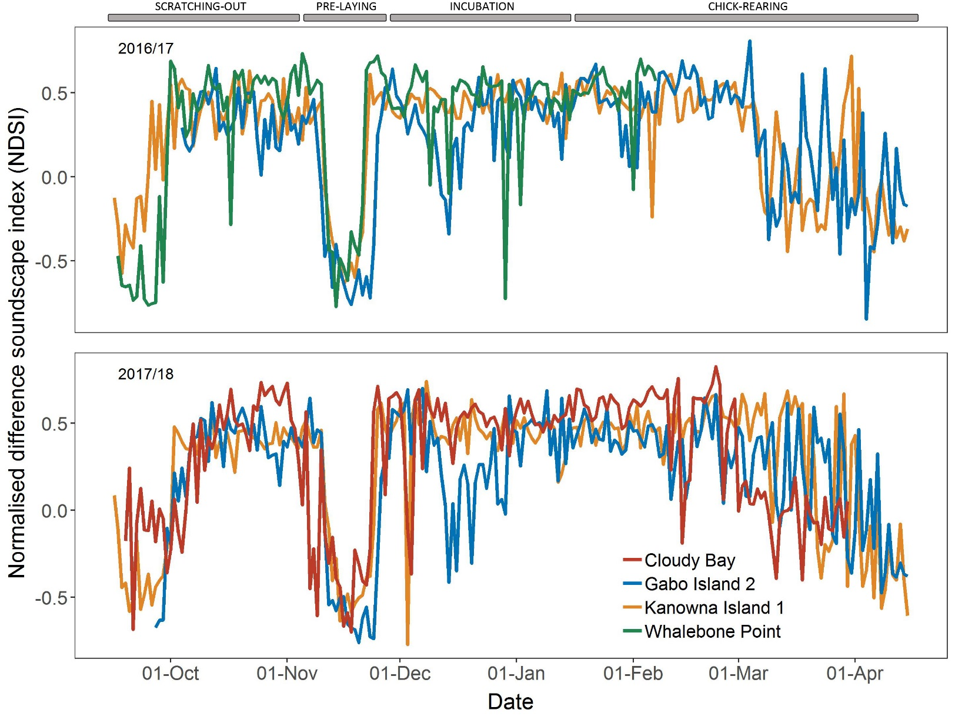
Figure S2: The normalised difference soundscape index (NDSI) over the breeding season for the Short-tailed Shearwater study sites Kanowna Island Site 1, Gabo Island Site 2 and Whalebone Point in 2016/17, and Kanowna Island Site 1, Gabo Island Site 2 and Cloudy Bay in 2017/18. The major phenology events are indicated by grey bars.

