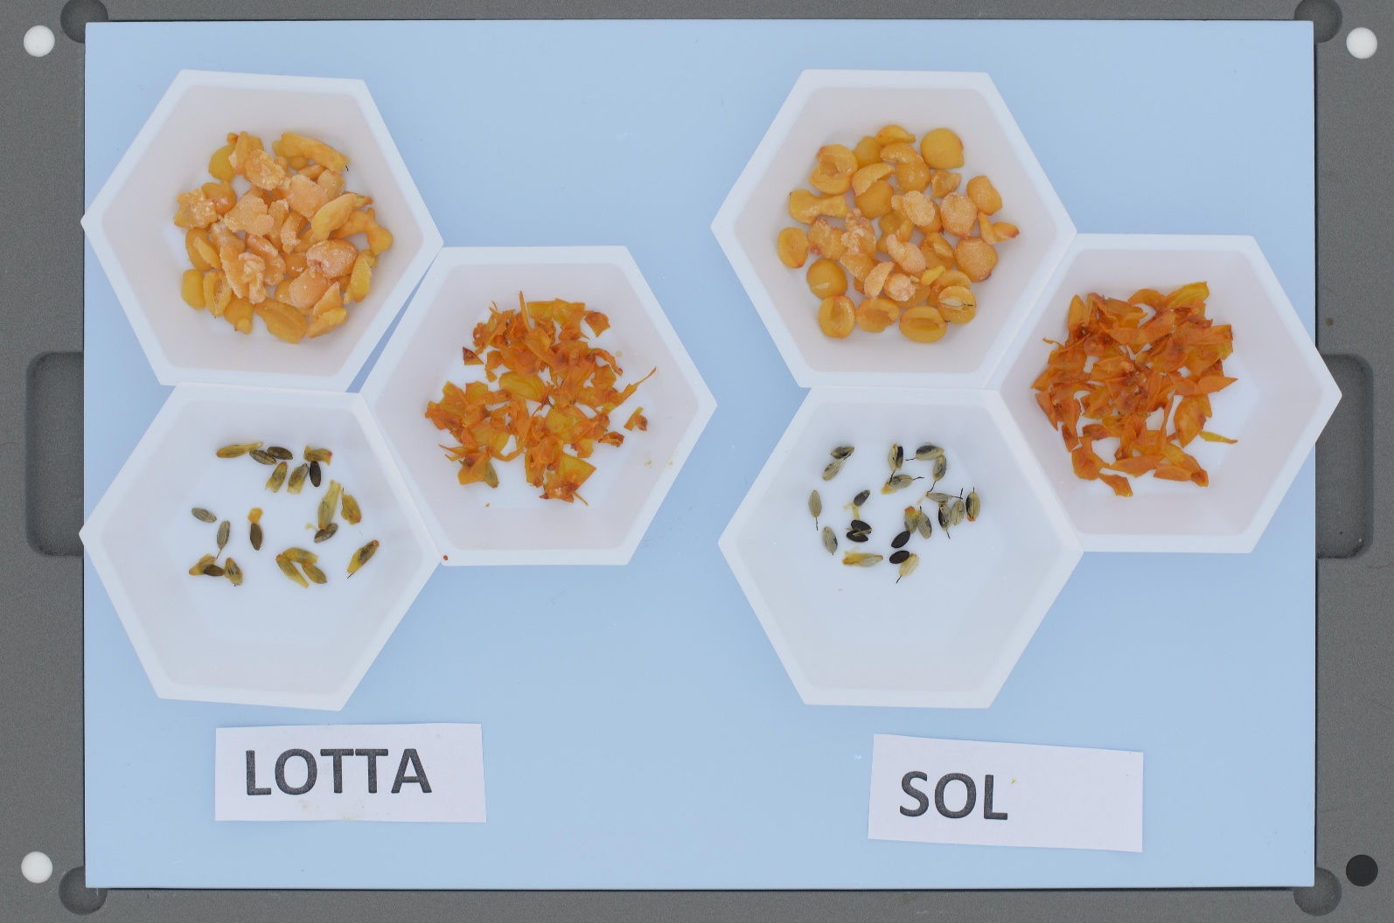

**A**

**B**

**Figure.** Seeds, flesh and skins of LOTTA (A) and SOL (B). The picture is taken with calibrated camera with the DigiEye-system

.



**Figure.** Pictures of purées made of SOL at production (A) and after storage for 3 months at 2 °C (B) and 18 °C (C). The pictures are taken with calibrated camera with the DigiEye-system

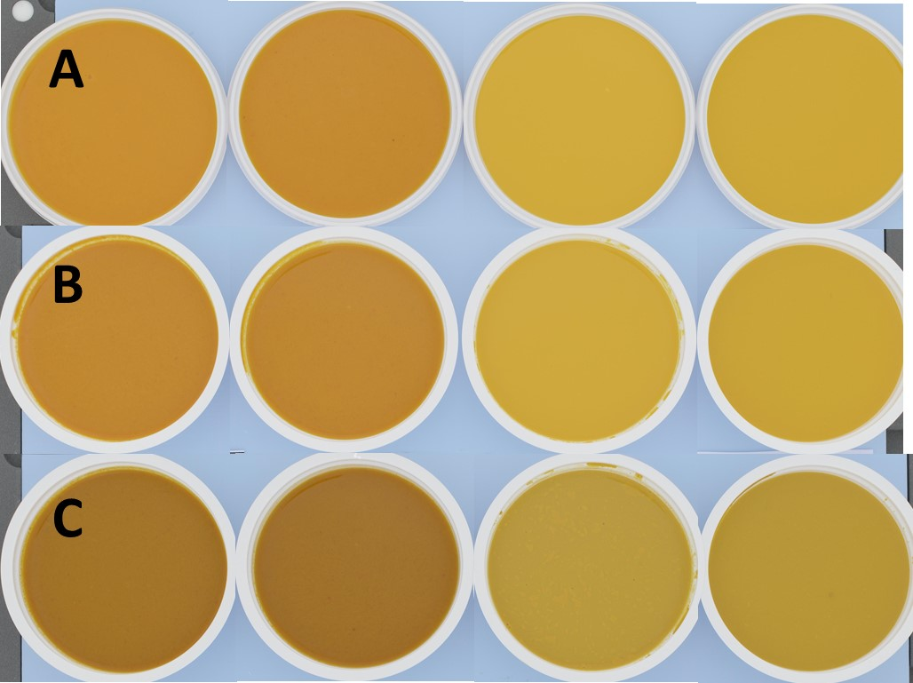

**Figure.** Pictures of purées made of LOTTA at production (A) and after storage for 3 months at 2 °C (B) and 18 °C (C). The pictures are taken with calibrated camera with the DigiEye-system