Intracellular synthesis of gold nanoparticles by Gluconacetobacter liquefaciens for delivery of peptide CopA3 and ginsenoside and anti-inflammatory effect on lipopolysaccharide-activated macrophages

Ying Liu¹, Haribalan Perumalsamy¹, Chang Ho Kang², Seung Hyun Kim¹, Jae-Sam Hwang³, Sung-Cheol Koh⁴, Tae-Hoo Yi^{1,2*}, and Yeon-Ju Kim^{1,2*}

¹Graduate School of Biotechnology, and College of Life Science, Kyung Hee University, Yongin-si, Gyeonggi-do, Republic of Korea
²Division of Applied Life Science and PMBBRC, Gyeongsang National University, 501 Jinju-daero, Jinju 660–701, Republic of Korea
³Department of Agricultural Biology, National Institute of Agricultural Sciences, Rural Development, Administration, Wanju, Republic of Korea
⁴Department of Environmental Engineering, Korea Maritime and Ocean University, Busan, Republic of Korea

Correspondence authors: Yeon-Ju Kim; Tae-Hoo Yi
Tel +82-31-201-2645; Fax +82-31-204-8116
Email: yeonjukim@khu.ac.kr (YJ.K); drhoo@khu.ac.kr

Supplementary Figure 1. Identification of nanoparticle-producing strain. Neighbor-joining tree base on 16S rRNA gene sequence analysis showing relationships of Gluconacetobacter liquefaciens kh-1. The strain was identified as Gluconacetobacter liquefaciens IFO 12388 with high similarity (98%). The genetic variation, biochemical characteristics, and G+C mole% content (39.70 mol%) of the genomic DNA have been well characterized previously. Bootstrap values (>40%) on 1000 replications are shown at branching points. Scale bar, 0.005 substitutions per nucleotide position.
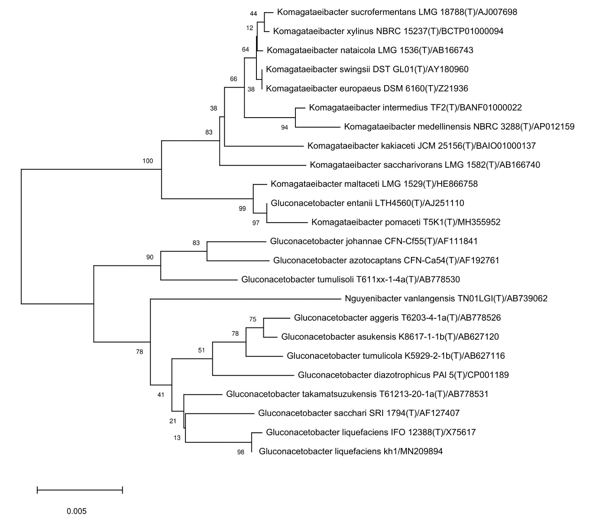
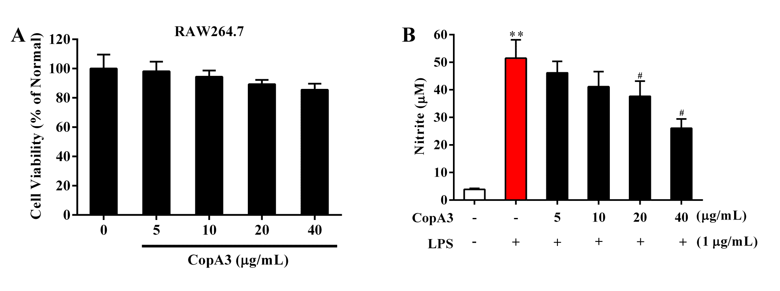
Supplementary Figure 2. Effect of CopA3 on cell viability and NO production in LPS-stimulated RAW264.7 cells. (A) Cell viability of RAW264.7 cells after 24 h incubation with different concentrations of CopA3 was determined by MTT assay. (B) NO production inhibition of CopA3 in LPS-induced RAW264.7 cells. Data are presented as mean ± SEM. **p<0.01 vs. normal control group; #p<0.05 and ##p < 0.01 vs. LPS-treated group.

