Supplementary Information

Design of 2'-O-methyl RNA and DNA double-stranded oligonucleotides: naturally-occurring nucleotide components with strong RNA interference gene expression inhibitory activity
Makoto Koizumi¹*, Yasuhide Hirota¹, Makiko Nakayama¹, Masakazu Tamura¹, Wataru Obuchi¹ Akiko Kurimoto¹ Hiroshi Tsuchida¹ and Hiroaki Maeda¹
¹R&D and Biologics Divisions, Daiichi Sankyo Co., Ltd., Shinagawa, Tokyo, Japan.

*Corresponding author: Makoto Koizumi, Daiichi Sankyo Co., Ltd. 1-2-58, Hiromachi, Shinagawa, Tokyo 140-8710, Japan. E-mail: koizumi.makoto.h7@daiichisankyo.co.jp

This paper is dedicated to Dr. Akira Matsuda, Emeritus Professor of Hokkaido University, on the occasion of his 70th birthday.

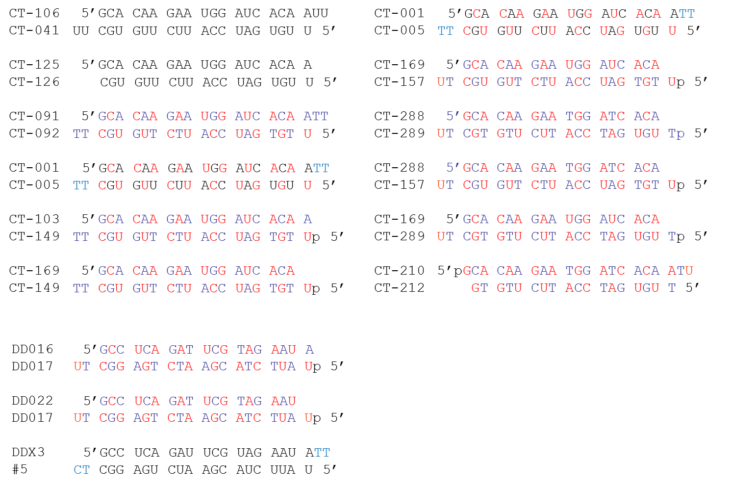

Figure S1. Sequences of unmodified siRNA and MED-siRNA. The black, blue, and red letters represent RNAs, DNAs, and 2'-OMe RNAs, respectively. “p” represents a phosphate group.

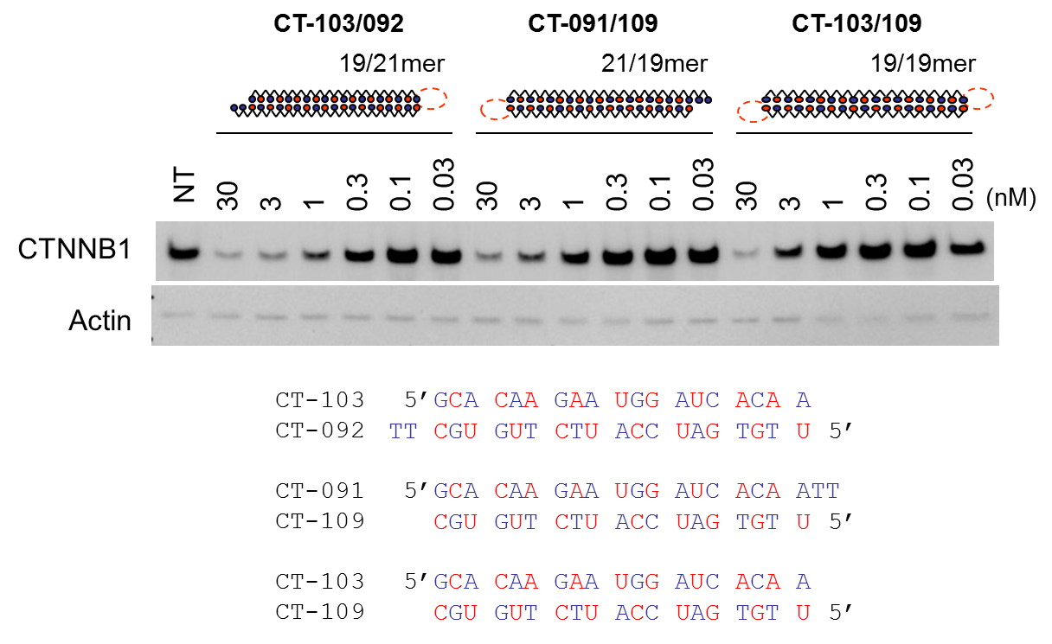

Figure S2. Representation of modified siRNAs and western blot analysis to detect the inhibitory activities of various double-stranded oligonucleotides on the expression of the human β-catenin gene (CTNNB1). “Actin” represents the expression of β-actin proteins used as a control. The sky-blue circles, the open circles, and the red circles represent RNAs, DNAs, and 2'-OMe RNAs, respectively. “p” represents a phosphate group. The chain lengths of the passenger and guide strands are indicated, such as e.g. 19/21mer (passenger/guide). The black, blue, and red letters represent RNAs, DNAs, and 2'-OMe RNAs, respectively. “p” represents a phosphate group.

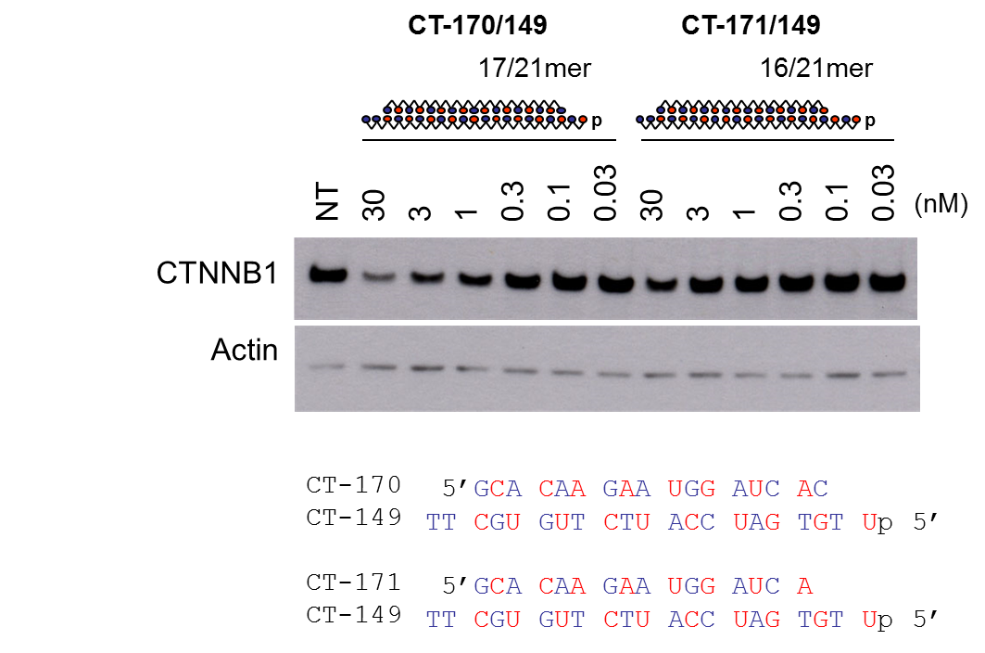

Figure S3. Representation of modified siRNAs and western blot analysis to detect the inhibitory activities of various double-stranded oligonucleotides on the expression of the human β-catenin gene (CTNNB1). “Actin” represents the expression of β-actin proteins used as a control. The sky-blue circles, the open circles, and the red circles represent RNAs, DNAs, and 2'-OMe RNAs, respectively. “p” represents a phosphate group. The chain lengths of the passenger and guide strands are indicated, such as e.g. 17/21mer (passenger/guide). The black, blue, and red letters represent RNAs, DNAs and 2'-OMe RNAs, respectively. “p” represents a phosphate group.

Table S1. Melting temperatures (T_{m}) of duplexes between the target RNA and the guide strand of unmodified siRNA or MED-siRNA.
______________________________________________________________________
Guide strand Type Guide sequences (3'-5') T_{m} (°C) ΔT_{m} (°C)
CT-041 unmodified UUCGUGUUCUUACCUAGUGUU 74.5
CT-157 MED UtCgUgUtCtUaCcUaGtGtUp 70.5 -4.0

Uppercase letters: RNA; underlined: 2'-OMe RNA; lowercase letters; DNA; p: phosphate. The target RNA sequence of β-catenin: 5'-GCACAAGAAUGGAUCACAAUU.

Material and Methods
Measurement of melting temperature
The melting temperature (T_{m}) of the duplexes of the target RNA (5'-GCA CAA GAA UGG AUC ACA AUU-3' for CTTNB1) and the guide strand of unmodified siRNA or MED-siRNA was measured using SYBR Green I (Invitrogen) and Mx4000 (Strategene) [1]. A solution containing 5 μM of duplex, 5 × SYBR Green I, and 1 × PBS buffer was run using Mx4000. The duplex-SYBR mixture was denatured at 95°C for 30 s, then subjected to a 25°C for 8 min. The samples were heated incrementally by 1°C with 30 s holds from 25°C to a final temperature of 90°C. The software attached to Mx4000 performed the melting curve analysis and determined T_{m}.

References
- Gudnason, H.; Dufva, M.; Bang, D.D.; Wolff, A. Comparison of multiple DNA dyes for real-time PCR: effects of dye concentration and sequence composition on DNA amplification and melting temperature. Nucleic Acids Res., 2007, 35, e127.

