Supplemental material
Variations in soil bacterial communities and putative functions in a sugarcane soil following five years of chemical fertilization
Qihua Wu^{b,1}, Shuang Li^{b,1}, Zhongxing Huang^{b,1}, Qing Wang^{a,*}
ªHainan Key Laboratory for Sustainable Utilization of Tropical Bio-resources, College of Agriculture, Hainan University, 570228, Haikou, China
^{b}Guangdong Provincial Bioengineering Institute (Guangzhou Sugarcane Industry Research Institute), Guangdong Modern Agricultural Technology Research and Development Center (Resources and Environment and Agricultural Product Safety), Guangzhou 510316, China.
*Correspondence: Qing Wang Email address: wangqing316000@163.com
¹These authors make equal contributions to this work.

Table S1. List of soil chemical properties after different fertilization treatments.
 | Control | PK | NK | NP | NPK
pH | 6.71±0.02a | 5.84±0.01b | 5.41±0.02e | 5.59±0.01d | 5.69±0.02c
NH₄⁺-N(mg kg⁻¹) | 10.48±0.27d | 5.47±0.34e | 29.24±0.02c | 55.82±1.58a | 43.79±0.80b
NO₃⁻-N(mg kg⁻¹) | 62.73±5.72d | 32.36±2.75e | 281.45±9.46a | 185.89±2.37b | 153.90±2.99c
DOC(mg kg⁻¹) | 32.79±2.53c | 35.34±1.42c | 53.43±2.53b | 78.39±2.22a | 76.52±2.11a
TN (g kg⁻¹) | 0.62±0.005d | 0.69±0.006c | 0.84±0.01a | 0.79±0.01b | 0.78±0.01b
TP(g kg⁻¹) | 0.52±0.009c | 1.88±0.058a | 0.52±0.01c | 1.09±0.005b | 1.02±0.012b
AP(mg kg⁻¹) | 0.74±0.03c | 202.38±1.15a | 0.66±0.01d | 51.23±3.21b | 52.30±1.73b
AK(mg kg⁻¹) | 122.67±2.08c | 365.33±5.77a | 343.33±4.16b | 87.33±2.52d | 329.33±10.07b
Values are mean ± standard deviation (n=3). Different letters in each row indicate a significant difference at p < 0.05.
NH₄⁺-N: ammonium-N; NO₃⁻-N: nitrate-N; DOC: dissolved organic carbon; TN: total nitrogen; TP: total phosphorus; AP: available phosphorus; AK: available potassium.

Table S2 Relative average abundances of the nineteen most abundant classes under different inorganic fertilizer treatments. Data are means ± standard deviation (n=3). Different letters indicate significant differences among the fertilizer treatments at P < 0.05.
 | Control | PK | NK | NP | NPK
Acidobacteria | 1.13±0.35ab | 2.05±1.08a | 0.12±0.02b | 0.33±0.11b | 0.55±0.32b
Blastocatellia | 1.87±0.59a | 1.86±0.30a | 0.10±0.02b | 0.35±0.37b | 0.13±0.04b
Holophagae | 1.40±0.22a | 1.05±0.42a | 0.02±0.01b | 0.02±0.01b | 0.07±0.02b
Solibacteres | 1.66±0.47a | 1.65±0.30a | 0.80±0.10b | 0.74±0.16b | 0.88±0.06b
Acidobacteria-Subgroup_6 | 2.90±1.16a | 1.73±0.28a | 0.09±0.06c | 0.50±0.44bc | 0.44±0.08b
Acidimicrobiia | 1.41±0.50a | 0.99±0.05a | 0.44±0.10b | 0.28±0.16b | 0.28±0.13b
Actinobacteria | 6.45±2.95b | 6.17±1.73b | 10.85±1.99a | 9.38±2.02a | 9.42±0.38a
Thermoleophilia | 2.50±0.05ab | 2.55±0.84a | 0.38±0.14c | 1.37±0.45b | 1.20±0.11bc
Sphingobacteriia | 1.69±0.65b | 1.70±0.67b | 1.30±0.40b | 4.71±1.23a | 5.30±0.54a
Anaerolineae | 2.04±0.99a | 1.44±0.40a | 0.11±0.09b | 0.14±0.16b | 0.13±0.04b
Chloroflexia | 2.48±1.17a | 1.28±0.72ab | 0.22±0.08b | 0.87±1.01b | 0.49±0.04b
Chloroflexi-JG37-AG-4 | 4.72±2.36a | 7.50±4.21a | 0.26±0.12b | 0.24±0.25b | 0.28±0.19b
Thermomicrobia | 0.22±0.16b | 0.25±0.12b | 2.27±0.83a | 2.53±0.60a | 2.31±0.96a
Bacilli | 0.87±0.36b | 1.02±0.6b | 3.45±1.18a | 3.28±1.28a | 3.20±1.30a
Gemmatimonadetes | 1.36±0.58a | 1.39±0.45a | 0.19±0.02c | 0.51±0.16b | 0.35±0.06b
Alphaproteobacteria | 23.03±3.56a | 22.61±7.09a | 11.42±5.59b | 15.42±7.72ab | 10.07±0.46b
Betaproteobacteria | 7.80±3.25a | 7.34±1.95a | 9.12±4.63a | 11.67±0.48a | 12.30±2.96a
Deltaproteobacteria | 2.34±0.85a | 2.95±2.90a | 0.51±0.22a | 1.93±0.65a | 2.15±2.60a
Gammaproteobacteria | 3.82±1.46b | 4.74±2.10b | 10.30±1.63a | 31.73±17.08a | 29.83±11.56a

Table S3 Correlations (R) analysis of soil properties and bacterial community structure using the partial mantel test.
 | R | p
pH | 0.27 | 0.022
NH₄⁺-N | 0.63 | 0.001
NO₃⁻-N | 0.46 | 0.003
DOC | 0.26 | 0.02
TN | 0.70 | 0.001
TP | 0.12 | 0.124
AP | 0.24 | 0.091
AK | -0.02 | 0.506
The values in the table are the Spearman’s correlation coefficients.
NH₄⁺-N: ammonium-N; NO₃⁻-N: nitrate-N; DOC: dissolved organic carbon; TN: total nitrogen; TP: total phosphorus; AP: available phosphorus; AK: available potassium.

Table S4 Pearson’s correlation coefficients between soil properties and abundant classes (relative abundance >1%).
Class | pH | NH₄⁺-N | NO₃⁻-N | DOC | TN | TP | AP | AK
Acidobacteria | 0.39 | -0.66** | -0.77*** | -0.34 | -0.56* | 0.60** | 0.67** | -0.18
Blastocatellia | 0.89*** | -0.63 | -0.69** | -0.44 | -0.91** | -0.09 | -0.01 | -0.50
Holophagae | 0.48** | -0.71** | -0.48 | 0.24 | 0.51 | -0.61* | -0.19 | 0.56
Solibacteres | 0.31 | -0.23 | -0.41 | -0.10 | -0.36 | 0.18 | 0.20 | -0.13
Acidobacteria-Subgroup_6 | 0.87*** | -0.64* | -0.72** | -0.42 | -0.89*** | -0.03 | 0.04 | -0.48
Acidimicrobiia | 0.41 | -0.68** | -0.59* | -0.52* | -0.52* | 0.34 | 0.43 | -0.09
Actinobacteria | -0.23 | 0.08 | 0.44 | -0.13 | 0.29 | -0.32 | -0.29 | 0.36
Thermoleophilia | 0.57* | -0.54* | -0.86*** | -0.19 | -0.72** | 0.52* | 0.56* | -0.50
Sphingobacteriia | -0.27 | 0.69** | 0.16 | 0.82*** | 0.27 | 0.09 | -0.05 | -0.43
Anaerolineae | 0.79*** | -0.76** | -0.76** | -0.54* | -0.85*** | 0.10 | 0.21 | -0.36
Chloroflexia | 0.75** | -0.48 | -0.61* | -0.27 | -0.77*** | -0.04 | 0.004 | -0.51
Chloroflexi-JG37-AG-4 | 0.82*** | -0.69** | -0.82*** | -0.43 | -0.88*** | 0.16 | 0.24 | -0.46
Thermomicrobia | -0.61* | 0.54* | 0.77*** | 0.23 | 0.74** | -0.33 | -0.38 | 0.45
Bacilli | -0.57* | 0.72** | 0.58* | 0.58* | 0.65** | -0.16 | -0.26 | 0.18
Gemmatimonadetes | 0.61* | -0.57* | -0.77*** | -0.27 | -0.74** | 0.36 | 0.41 | -0.52
Alphaproteobacteria | 0.65** | -0.80*** | -0.85*** | -0.51* | -0.78*** | 0.44 | 0.54* | -0.41
Betaproteobacteria | -0.32 | 0.61* | 0.33 | 0.55* | 0.38 | -0.09 | -0.19 | -0.05
Deltaproteobacteria | 0.24 | -0.18 | -0.45 | 0.02 | 0.23 | 0.32 | 0.32 | -0.28
Gammaproteobacteria | -0.44 | 0.83*** | 0.35 | 0.81*** | -0.56* | 0.02 | -0.15 | -0.17
*p <0.05, **p <0.01, ***p <0.001.

Table S5 Pearson’s correlation analysis between relative abundances of functional groups and soil chemical properties.
 | pH | NH₄⁺-N | NO₃⁻-N | DOC | TN | TP | AP | AK
methanol_oxidation | 0.23 | -0.74** | -0.12 | -0.83*** | -0.27 | -0.06 | 0.09 | 0.37
methylotrophy | 0.24 | -0.70** | -0.08 | -0.81*** | -0.26 | -0.11 | 0.036 | 0.37
aerobic_ammonia_oxidation | -0.21 | 0.28 | 0.32 | 0.07 | 0.33 | -0.27 | -0.29 | 0.32
aerobic_nitrite_oxidation | 0.84*** | -0.55* | -0.81*** | -0.24 | -0.91*** | 0.14 | 0.19 | -0.29
nitrification | 0.003 | 0.11 | 0.07 | -0.08 | 0.08 | -0.17 | -0.18 | 0.13
sulfur_respiration | 0.84*** | -0.84*** | -0.84*** | -0.60* | -0.91*** | 0.17 | 0.29 | -0.35
respiration_of_sulfur_compounds | 0.84*** | -0.83*** | -0.84*** | -0.60* | -0.91*** | 0.17 | 0.29 | -0.35
nitrate_denitrification | 0.75** | -0.75** | -0.92*** | -0.41 | -0.87*** | 0.41 | 0.49 | -0.43
nitrite_denitrification | 0.75** | -0.75** | -0.92*** | -0.41 | -0.87*** | 0.41 | 0.49 | -0.43
nitrous_oxide_denitrification | 0.75** | -0.75** | -0.92*** | -0.41 | -0.87*** | 0.41 | 0.49 | -0.43
denitrification | 0.75** | -0.75** | -0.92*** | -0.41 | -0.87*** | 0.41 | 0.49 | -0.43
nitrogen_fixation | 0.51** | -0.48** | -0.45** | 0.40 | -0.15 | 0.41 | 0.33 | -0.30
nitrite_respiration | 0.43 | -0.49 | -0.77*** | -0.17 | -0.60* | 0.57* | 0.60* | -0.42
cellulolysis | -0.21 | -0.17 | -0.32 | 0.01 | 0.03 | 0.70** | 0.70** | 0.01
dark_oxidation_of_sulfur_compounds | -0.47 | 0.65** | 0.35 | 0.68** | 0.42 | 0.05 | -0.07 | -0.21
manganese_oxidation | 0.12 | -0.24 | -0.06 | -0.31 | -0.10 | -0.06 | -0.01 | 0.12
fermentation | -0.12 | 0.19 | -0.08 | 0.20 | 0.15 | 0.17 | 0.13 | 0.14
aerobic_chemoheterotrophy | -0.42 | 0.79*** | 0.35 | 0.78*** | 0.47 | -0.04 | -0.19 | -0.16
human_pathogens_all | -0.09 | 0.26 | 0.22 | 0.25 | 0.14 | -0.19 | -0.23 | -0.14
animal_parasites_or_symbionts | -0.10 | 0.26 | 0.20 | 0.26 | 0.14 | -0.16 | -0.20 | -0.15
aromatic_hydrocarbon_degradation | 0.51 | -0.29 | -0.20 | -0.28 | -0.45 | -0.27 | -0.23 | -0.20
aromatic_compound_degradation | 0.64 | -0.56* | -0.51* | -0.46 | -0.62* | -0.04 | 0.041 | -0.07
aliphatic_non_methane_hydrocarbon_degradation | 0.49 | -0.27 | -0.18 | -0.26 | -0.42 | -0.28 | -0.23 | -0.17
hydrocarbon_degradation | 0.48 | -0.27 | -0.12 | -0.29 | -0.41 | -0.33 | -0.28 | -0.16
iron_respiration | 0.08 | 0.14 | -0.11 | 0.18 | -0.06 | -0.01 | -0.04 | 0.01
nitrate_respiration | 0.18 | 0.005 | -0.32 | 0.23 | -0.24 | 0.25 | 0.21 | 0.49
nitrate_reduction | 0.16 | 0.282 | -0.27 | 0.52* | -0.18 | 0.17 | 0.08 | -0.65**
nitrogen_respiration | 0.18 | 0.005 | -0.32 | 0.23 | -0.24 | 0.25 | 0.21 | -0.49
intracellular_parasites | 0.80*** | -0.70** | -0.75*** | -0.47 | -0.86*** | 0.10 | 0.19 | -0.44
predatory_or_exoparasitic | 0.29 | 0.01 | -0.28 | 0.21 | -0.31 | 0.04 | 0.01 | -0.57*
chloroplasts | 0.41 | -0.66** | -0.65** | -0.42 | -0.54* | 0.40 | 0.49 | -0.14
cyanobacteria | -0.50 | 0.80*** | 0.45 | 0.72** | 0.56* | -0.10 | -0.23 | 0.07
anoxygenic_photoautotrophy_S_oxidizing | 0.43 | -0.47 | -0.74** | -0.15 | -0.59* | 0.54* | 0.57* | -0.43
anoxygenic_photoautotrophy | 0.43 | -0.47 | -0.74** | -0.15 | -0.59* | 0.54* | 0.57* | -0.43
oxygenic_photoautotrophy | -0.50 | 0.80*** | 0.45 | 0.72** | 0.56* | -0.10 | -0.23 | 0.07
photoautotrophy | -0.08 | 0.32 | -0.21 | 0.52* | 0.01 | 0.36 | 0.26 | -0.29
photoheterotrophy | 0.38 | -0.37 | -0.54* | -0.14 | -0.50 | 0.35 | 0.37 | -0.43
phototrophy | -0.16 | 0.45 | -0.009 | 0.56* | 0.12 | 0.18 | 0.07 | -0.27
ureolysis | 0.15 | -0.52* | 0.09 | -0.68** | -0.13 | -0.25 | -0.12 | 0.36
chemoheterotrophy | -0.50 | 0.79*** | 0.59* | 0.66** | 0.60* | -0.26 | -0.38 | 0.04

Figure S1 Principal coordinate analysis (PCoA) of bacterial community composition across all soil samples in different inorganic fertilization regimens.
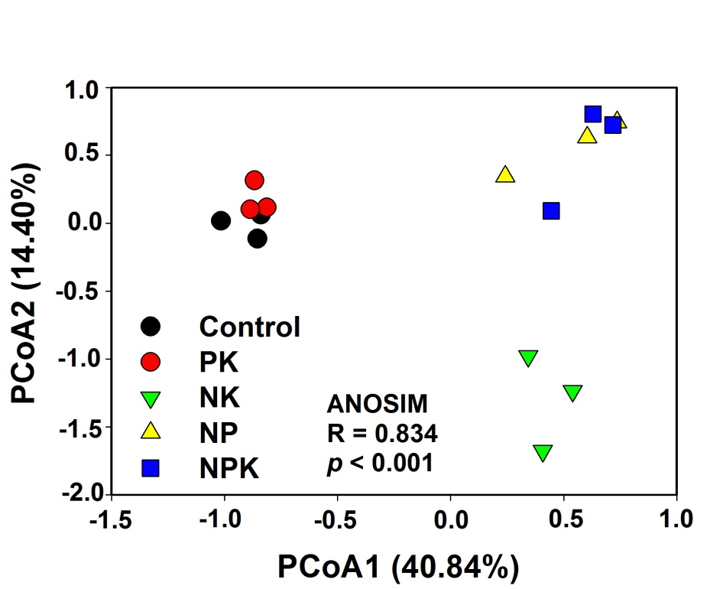
Figure S2 Variation partitioning analysis (VPA) of bacterial community composition explained by soil chemical parameters. NH₄⁺-N: ammonium-N; NO₃⁻-N: nitrate-N; DOC: dissolved organic carbon; TN: total nitrogen.
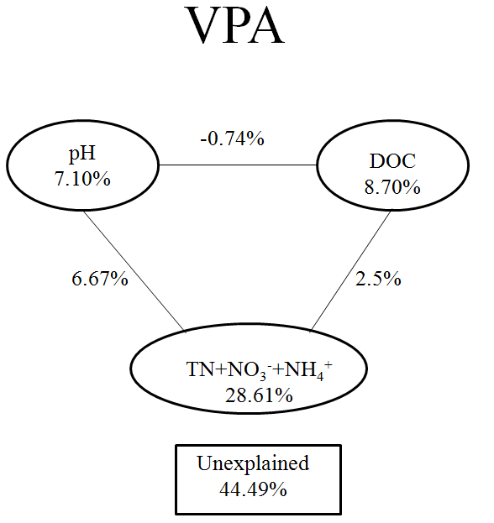

Figure S3 Heatmap of functional community profiles under different fertilizer treatments
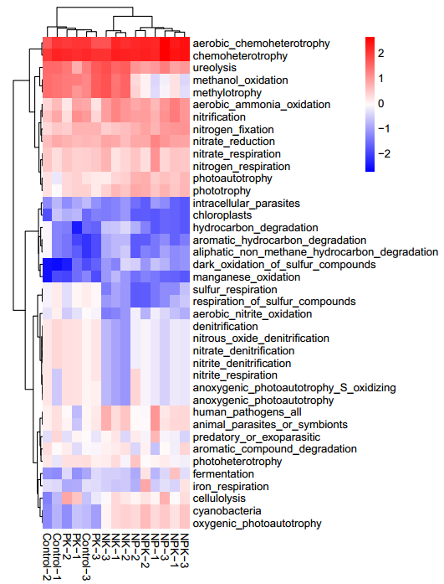
Figure S4 Relative abundances of the dominant genera under different fertilizer treatments.
