Supplementary information
Evaluation of rainfall–runoff model performance under non-stationary hydroclimatic conditions
Proloy Deb and Anthony S. Kiem
Centre for Water, Climate and Land (CWCL), School of Environmental and Life Sciences, Faculty of Science, University of Newcastle, Callaghan, NSW, 2308, Australia

Contents
Hydro-meteorological and catchment characteristics data (Tables S1 and S2); rainfall–runoff model calibration parameters for all thee models and periods at the two catchments (Tables S3–S8); percentage deviation in the percentile flow simulated by the models (Table S9–S14); and soil characteristics of the study catchments (Figure S1 and Table S15).
Schematic of IHACRES model (Figure S2); temporal changes in LAI at the two catchments (Figures S3 and S4); scatter plot of rainfall data with zero as missing values vs AWAP infilled data (Figure S5).
FDC of all thee model calibration (Dry1) and validation (Average2, Dry2 and Wet2) at catchment 410044 with missing rainfall data infilled with AWAP data (Figure S6)
Model calibration parameters for the Dry1 period at catchment 410044 with missing rainfall values replaced by the AWAP dataset (Table S16).
Equations to calculate performance indicators: NSE (Eq. (S1)), RMSE (Eq. (S2)) and PBIAS (Eq. (S3)).

Table S1 Hydro-meteorological data used in this study.
Data | Catchment | Duration | Frequency | Source
Runoff | 405251 | 1974–2013 | Daily | Bureau of Meteorology (BoM), Water data repository
 | 410044 | 1941–2015
Rainfall | 405251 | 1974–2013 | Daily | BoM, Climate data repository
 | 410044 | 1941–2015
Maximum temperature | 405251 | 1974–2013 | Daily
 | 410044 | 1941–2015
Minimum temperature | 405251 | 1974–2013 | Daily
 | 410044 | 1941–2015

Table S2 Catchment characteristic data used in this study.
Data | Catchment | Resolution (m) | Source
Digital elevation model (DEM) | 405251 | 25 × 25 | Department of Environment, Land, Water and Planning, Victoria Government
 | 410044 |  | Geoscience Australia, Elevation Information System
Land use / land cover | 405251 | 25 × 25 | Department of Economic Development, Jobs, Transport and Resources, Victoria Government
 | 410044 |  | Department of Environment and Climate Change, NSW Government
Soil map | 405251 | 25 × 25 | Victoria’s open data directory
 | 410044 |  | NSW Office of Environment and Heritage
Leaf area index (LAI) | 405251 | 55,570 × 55,570 (original)  900 × 900 (resampled) | Bi-monthly reanalysis dataset (ERA-20CM) from ECMWF (1941-2010) and Integrated Climate Data Centre, University of Hamburg, Germany (2011-2015)
 | 410044

Table S3 Calibrated model parameters for the Average1 calibration period at catchment 405251.
Model | Parameter | Unit | Calibrated value
IHACRES | τ_{q} | Day | 4.9
 | τ_{s} | Day | 144.8
 | v_{s} | (-) | 0.44
 | d | mm | 8.2
 | e | (-) | 1
 | f | (-) | 1.2
HEC-HMS | CN | (-) | 85.2
 | I_{p} | % | 2.1
 | I_{a} | mm | 5.6
 | L_{t} | min | 174.2
 | K | h | 0.6
 | x | (-) | 0.1
SWATgrid | GWQMN | mm | 2875
 | SOL_AWC | mm mm⁻¹ | 0.43
 | ALPHA_BF | day⁻¹ | 0.74
 | SOL_K | mm h⁻¹ | 0.09
 | CN2 | (-) | 81
 | ESCO | (-) | 0.08

Table S4 Calibrated model parameters for the Dry1 calibration period at catchment 405251.
Model | Parameter | Unit | Calibrated value
IHACRES | τ_{q} | Day | 2.2
 | τ_{s} | Day | 298.5
 | v_{s} | (-) | 0.85
 | d | mm | 13.6
 | e | (-) | 1
 | f | (-) | 2.6
HEC-HMS | CN | (-) | 88.3
 | I_{p} | % | 2.6
 | I_{a} | mm | 11.1
 | L_{t} | min | 195.3
 | K | h | 1.2
 | x | (-) | 0.2
SWATgrid | GWQMN | mm | 4250
 | SOL_AWC | mm mm⁻¹ | 0.87
 | ALPHA_BF | day⁻¹ | 0.44
 | SOL_K | mm h⁻¹ | 0.08
 | CN2 | (-) | 84
 | ESCO | (-) | 0.06

Table S5 Calibrated model parameters for the Wet1 calibration period at catchment 405251.
Model | Parameter | Unit | Calibrated value
IHACRES | τ_{q} | Day | 8.9
 | τ_{s} | Day | 133.2
 | v_{s} | (-) | 0.36
 | d | mm | 6.8
 | e | (-) | 1
 | f | (-) | 0.3
HEC-HMS | CN | (-) | 83.2
 | I_{p} | % | 2.0
 | I_{a} | mm | 2.9
 | L_{t} | min | 155.6
 | K | h | 0.4
 | x | (-) | 0.2
SWATgrid | GWQMN | mm | 1885
 | SOL_AWC | mm mm⁻¹ | 0.74
 | ALPHA_BF | day⁻¹ | 0.77
 | SOL_K | mm h⁻¹ | 0.12
 | CN2 | (-) | 82.1
 | ESCO | (-) | 0.07

Table S6 Calibrated model parameters for the Average1 calibration period at catchment 410044.
Model | Parameter | Unit | Calibrated value
IHACRES | τ_{q} | Day | 6.2
 | τ_{s} | Day | 169.6
 | v_{s} | (-) | 0.39
 | d | mm | 5.2
 | e | (-) | 1
 | f | (-) | 1.7
HEC-HMS | CN | (-) | 75.2
 | I_{p} | % | 1.6
 | I_{a} | mm | 5.1
 | L_{t} | min | 552.3
 | K | h | 1.5
 | x | (-) | 0.3
SWATgrid | GWQMN | mm | 4550
 | SOL_AWC | mm mm⁻¹ | 0.81
 | ALPHA_BF | day⁻¹ | 0.76
 | SOL_K | mm h⁻¹ | 0.10
 | CN2 | (-) | 73.6
 | ESCO | (-) | 0.05

Table S7 Calibrated model parameters for the Dry1 calibration period at catchment 410044.
Model | Parameter | Unit | Calibrated value
IHACRES | τ_{q} | Day | 3.2
 | τ_{s} | Day | 302.2
 | v_{s} | (-) | 0.76
 | d | mm | 11.6
 | e | (-) | 1
 | f | (-) | 2.4
HEC-HMS | CN | (-) | 76.3
 | I_{p} | % | 1.2
 | I_{a} | mm | 8.9
 | L_{t} | min | 635.2
 | K | h | 1.9
 | x | (-) | 0.4
SWATgrid | GWQMN | mm | 4850
 | SOL_AWC | mm mm⁻¹ | 0.88
 | ALPHA_BF | day⁻¹ | 0.46
 | SOL_K | mm h⁻¹ | 0.13
 | CN2 | (-) | 74.2
 | ESCO | (-) | 0.06

Table S8 Calibrated model parameters for the Wet1 calibration period at catchment 410044.
Model | Parameter | Unit | Calibrated value
IHACRES | τ_{q} | Day | 9.3
 | τ_{s} | Day | 29.3
 | v_{s} | (-) | 0.29
 | d | mm | 3.9
 | e | (-) | 1
 | f | (-) | 0.9
HEC-HMS | CN | (-) | 77.1
 | I_{p} | % | 1.9
 | I_{a} | mm | 3.5
 | L_{t} | min | 489.5
 | K | h | 1.3
 | x | (-) | 0.2
SWATgrid | GWQMN | mm | 1126
 | SOL_AWC | mm mm⁻¹ | 0.41
 | ALPHA_BF | day⁻¹ | 0.75
 | SOL_K | mm h⁻¹ | 0.11
 | CN2 | (-) | 76.3
 | ESCO | (-) | 0.07

Table S9 Percentage deviation in the percentile flow simulated by the models (relative to observed runoff) during Average1 calibration period at catchment 405251.
Percentile flow | Observed (m³/s) | IHACRES (% difference) | HEC-HMS (% difference) | SWATgrid (% difference)
Calibration (Average1)
10% | 0.707 | 6.65 | -0.56 | -2.26
90% | 0.093 | -78.49 | -80.64 | -63.15
Validation (Average2)
10% | 0.881 | 36.32 | 35.98 | 18.27
90% | 0.086 | 5.08×10² | -37.21 | -1.16
Validation (Dry2)
10% | 0.264 | 48.48 | 26.89 | 6.44
90% | 1.0×10⁻⁵ | 2.89×10² | 2.29×10² | 7.99×10⁴
Validation (Wet2)
10% | 1.344 | -12.05 | -12.35 | -5.36
90% | 0.135 | -62.96 | -55.56 | -19.26

Table S10 Percentage deviation in the percentile flow simulated by the models (relative to observed runoff) during Dry1 calibration period at catchment 405251.
Percentile flow | Observed (m³/s) | IHACRES (% difference) | HEC-HMS (% difference) | SWATgrid (% difference)
Calibration (Dry1)
10% | 0.513 | 19.10 | -3.51 | 9.36
90% | 0.025 | -88.00 | -40.00 | -24.00
Validation (Average2)
10% | 0.881 | 45.63 | -20.77 | 23.27
90% | 0.086 | -97.67 | -98.84 | -46.51
Validation (Dry2)
10% | 0.264 | -2.27 | 5.30 | 1.89
90% | 1.0×10⁻⁵ | 1.80×10⁵ | 1.40×10⁵ | 5.99×10⁴
Validation (Wet2)
10% | 1.344 | -5.35 | -0.15 | -2.75
90% | 0.135 | -0.10 | -11.85 | -2.22

Table S11 Percentage deviation in the percentile flow simulated by the models (relative to observed runoff) during Wet1 calibration period at catchment 405251.
Percentile flow | Observed (m³/s) | IHACRES (% difference) | HEC-HMS (% difference) | SWATgrid (% difference)
Calibration (Wet1)
10% | 1.330 | 11.05 | 10.60 | 9.92
90% | 0.132 | 6.06 | -25.00 | 7.57
Validation (Average2)
10% | 0.881 | 5.40 | 59.14 | 25.08
90% | 0.086 | -8.14 | 89.53 | -13.95
Validation (Dry2)
10% | 0.264 | 1.23×10² | 1.18×10² | 61.74
90% | 1.0×10⁻⁵ | 3.89×10⁵ | 6.99×10⁵ | 2.79×10⁵
Validation (Wet2)
10% | 1.344 | 6.77 | 4.68 | 1.64
90% | 0.135 | 6.67 | 16.29 | 8.89

Table S12 Percentage deviation in the percentile flow simulated by the models (relative to observed runoff) during Average1 calibration period at catchment 410044.
Percentile flow | Observed (m³/s) | IHACRES (% difference) | HEC-HMS (% difference) | SWATgrid (% difference)
Calibration (Average1)
10% | 1.764 | 81.18 | 84.69 | 33.50
90% | 0.017 | 1.33×10³ | 1.49×10³ | 1.59×10²
Validation (Average2)
10% | 3.394 | 33.35 | 30.26 | 25.98
90% | 0.009 | 5.41×10³ | 5.22×10³ | 1.56×10²
Validation (Dry2)
10% | 0.308 | 6.35×10² | 6.37×10² | 3.23×10²
90% | 0.002 | 1.65×10⁴ | 1.73×10⁴ | 8.85×10³
Validation (Wet2)
10% | 3.211 | 55.71 | 29.74 | 31.39
90% | 0.052 | 1.00×10³ | 1.02×10³ | 6.04×10²

Table S13 Percentage deviation in the percentile flow simulated by the models (relative to observed runoff) during Dry1 calibration period at catchment 410044.
Percentile flow | Observed (m³/s) | IHACRES (% difference) | HEC-HMS (% difference) | SWATgrid (% difference)
Calibration (Dry1)
10% | 1.771 | -80.52 | -68.15 | -38.85
90% | 0.011 | -99.91 | 36.33 | 37.23
Validation (Average2)
10% | 3.394 | -33.44 | -9.48 | -25.34
90% | 0.009 | -99.89 | 6.82×10² | 11.00
Validation (Dry2)
10% | 0.308 | 2.37×10² | 3.57×10² | 61.68
90% | 0.002 | -99.5 | 2.15×10³ | 1.00×10²
Validation (Wet2)
10% | 3.211 | -33.76 | -8.93 | -53.00
90% | 0.052 | -99.60 | -88.81 | -58.11

Table S14 Percentage deviation in the percentile flow simulated by the models (relative to observed runoff) during Wet1 calibration period at catchment 410044.
Percentile flow | Observed (m³/s) | IHACRES (% difference) | HEC-HMS (% difference) | SWATgrid (% difference)
Calibration (Wet1)
10% | 2.076 | 44.94 | 41.43 | 28.98
90% | 0.003 | -99.67 | -98.52 | -66.67
Validation (Average2)
10% | 3.394 | -6.36 | -8.34 | -8.75
90% | 0.009 | -99.88 | -97.45 | 3.88×10²
Validation (Dry2)
10% | 0.308 | 50.65 | 80.19 | 59.74
90% | 0.002 | -99.87 | -97.96 | 5.50×10²
Validation (Wet2)
10% | 3.211 | -5.26 | -3.22 | -9.12
90% | 0.052 | -99.85 | -98.58 | 23.08

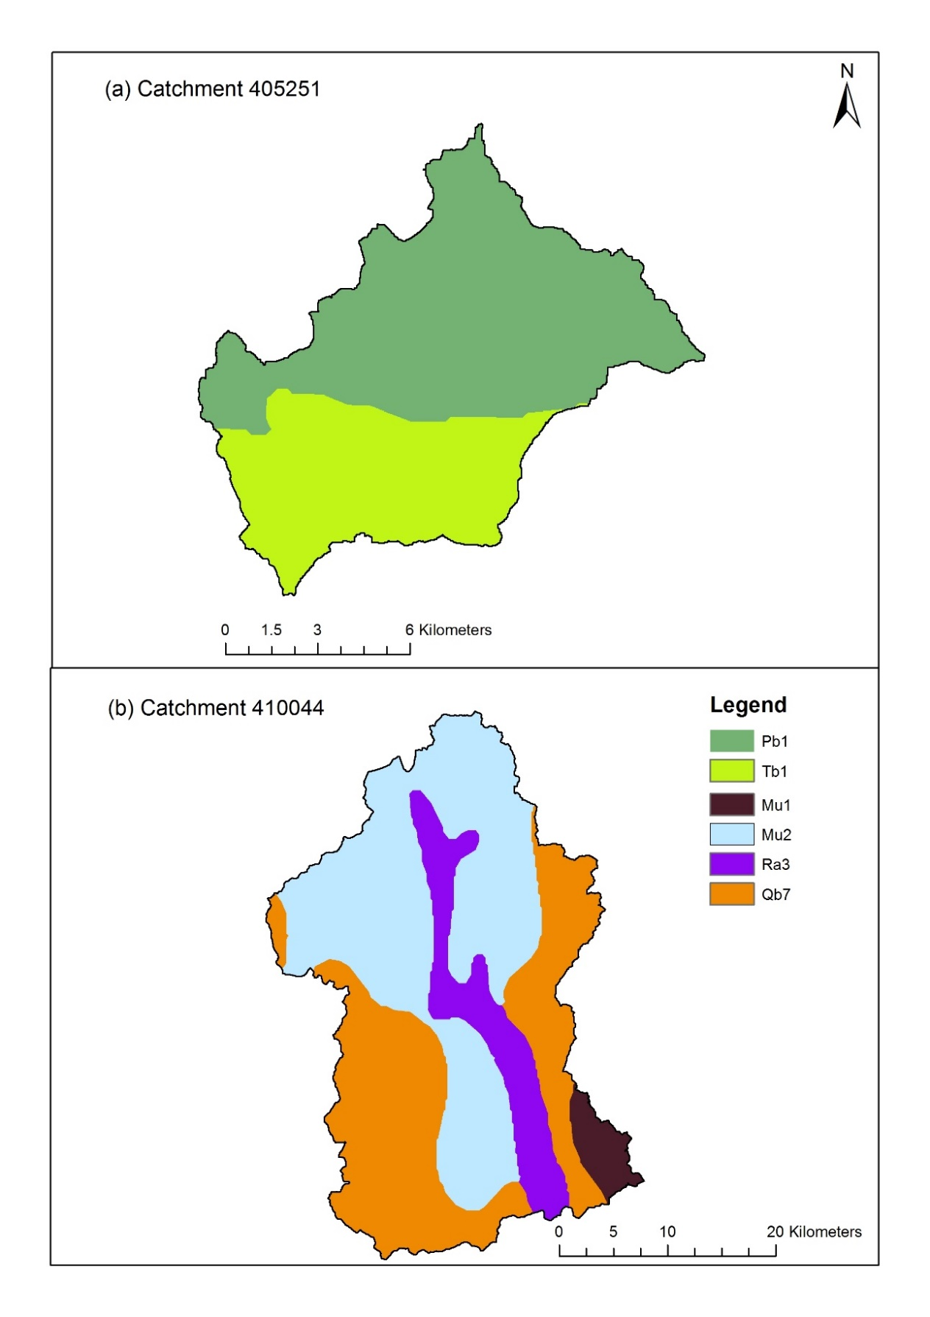
Figure S1 The Factual Key soil classification for catchments (a) 405251 and (b) 410044.

Table S15 Hydrological soil properties of the Factual Key soil classification at the catchments.
Code | Horizon | SDEPTH | WHC | THICK | KSAT | SAT | FC | WP | PAW
Pb1 | A | 0.90 | 93 | 0.30 | 100 | 0.42 | 0.27 | 0.13 | 44
 | B |  |  | 0.60 | 30 | 0.40 | 0.36 | 0.28 | 57
Tb1 | A | 0.90 | 60 | 0.30 | 30 | 0.38 | 0.23 | 0.09 | 39
 | B |  |  | 0.60 | 10 | 0.34 | 0.34 | 0.30 | 21
Mu1 | A | 1.00 | 116 | 0.30 | 100 | 0.42 | 0.23 | 0.09 | 41
 | B |  |  | 0.70 | 100 | 0.37 | 0.31 | 0.21 | 74
Mu2 | A | 1.10 | 114 | 0.30 | 100 | 0.43 | 0.24 | 0.10 | 39
 | B |  |  | 0.80 | 30 | 0.39 | 0.30 | 0.19 | 76
Ra3 | A | 0.80 | 68 | 0.30 | 30 | 0.42 | 0.24 | 0.10 | 38
 | B |  |  | 0.50 | 10 | 0.37 | 0.37 | 0.30 | 30
Qb7 | A | 0.80 | 66 | 0.30 | 100 | 0.40 | 0.25 | 0.11 | 34
 | B |  |  | 0.50 | 30 | 0.36 | 0.36 | 0.30 | 35
SDEPTH: weighted average soil depth in m; WHC: weighted average plant available water holding capacity in mm; THICK: weighted average thickness in m; KSAT: weighted average of median saturated hydraulic conductivity in mm/h; SAT: average weighted saturated volumetric water content in m³/m³; FC: average values of volumetric water content at 0.1 bar suction (field capacity) in m³/m³; WP: average values of volumetric water content at 15 bar suction (wilting point) in m³/m³; PAW: plant available water in mm.

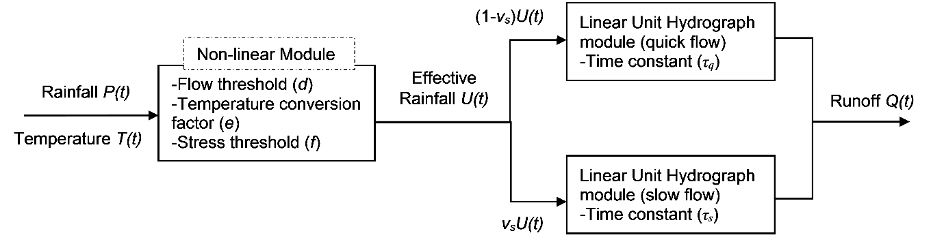
Figure S2 Schematic of the IHACRES model. Adapted from Tegegne et al. (2017).

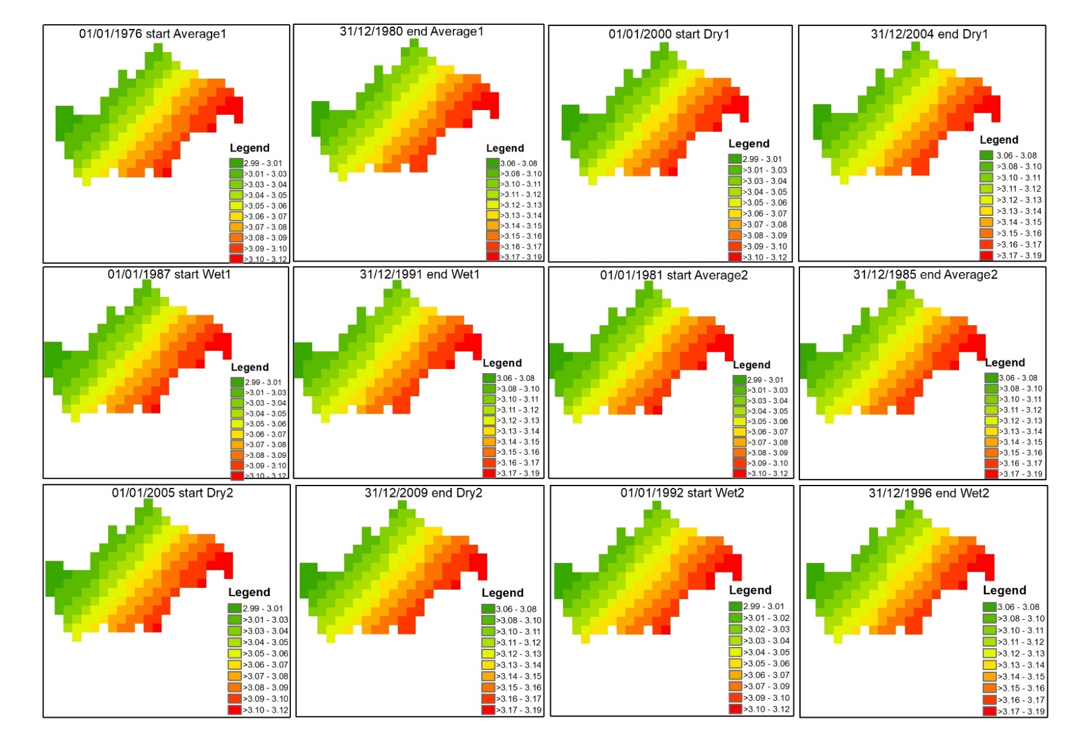
Figure S3 Temporal changes in LAI data for different calibration and validation periods at catchment 405251.

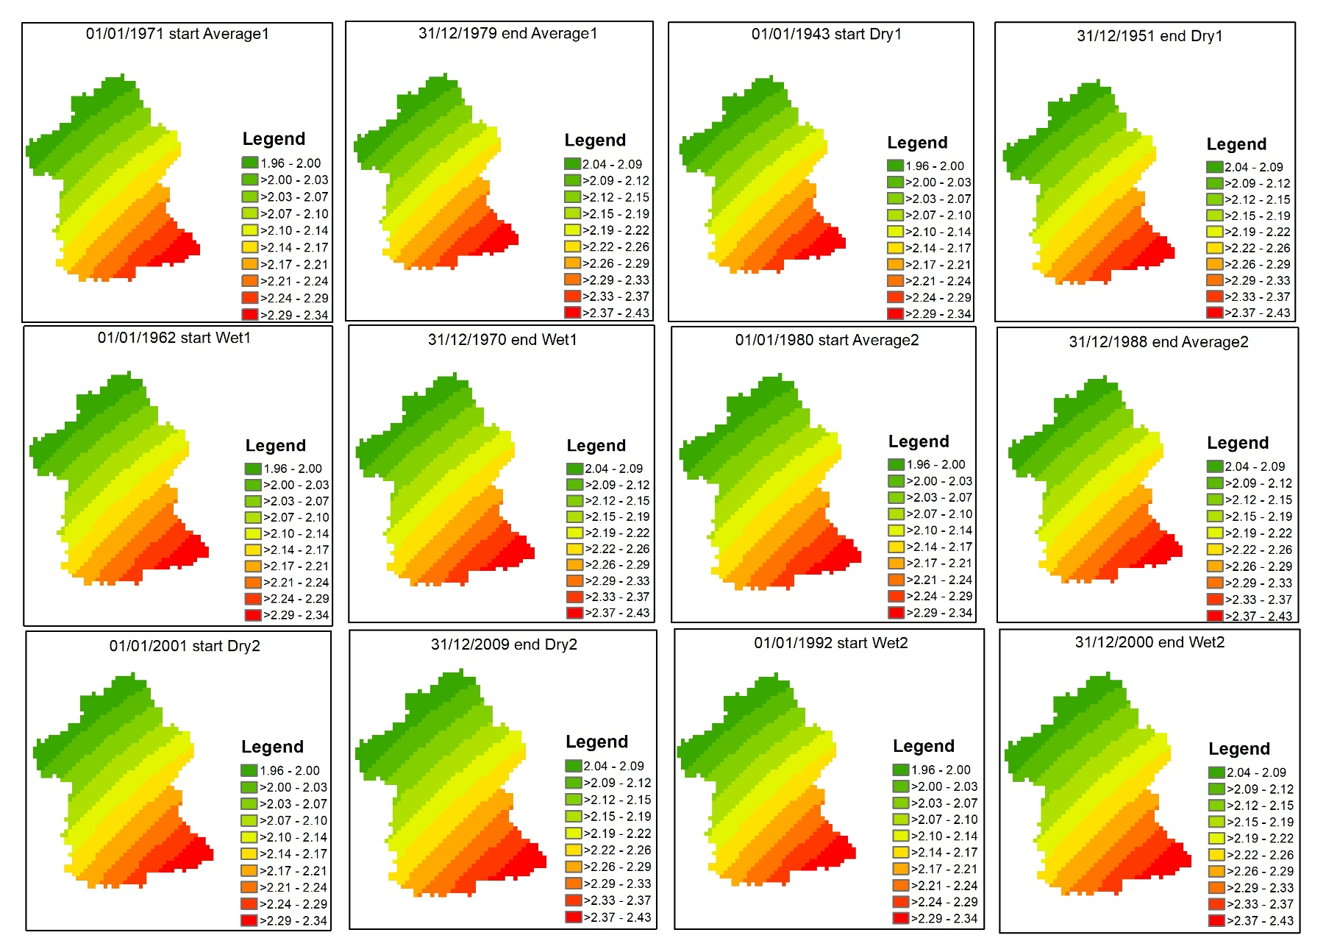
Figure S4 Temporal changes in LAI data for different calibration and validation periods at catchment 410044.

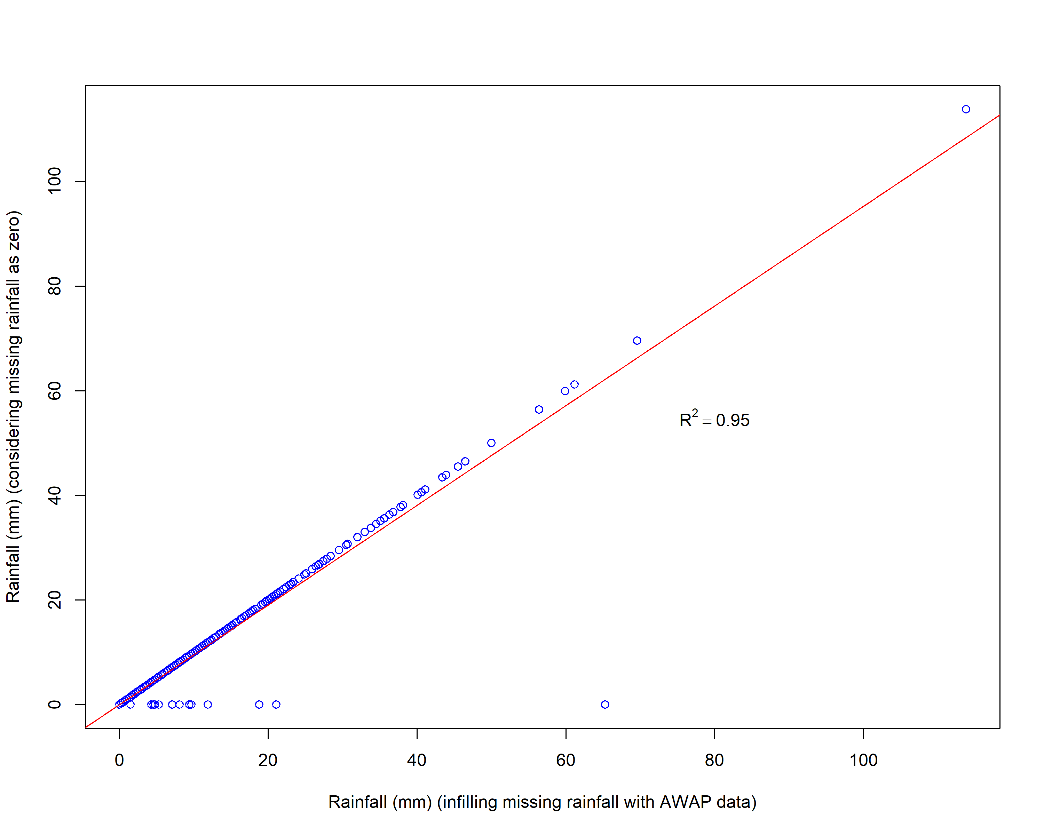
Figure S5 Scatter plot of AWAP infilled missing data vs missing data considered as zero rainfall at the station 73022 for catchment 410044.

$NSE=1- \left[\frac{\sum_{i=1}^{n}{{(Y_{i}^{obs}-Y_{i}^{sim})}^{2}}}{\sum_{i=1}^{n}{{(Y_{i}^{obs}-Y^{mean})}^{2}}}\right]$ (S1)
$RMSE= \sqrt{\frac{\sum_{i=1}^{n}{{(Y_{i}^{obs}-Y_{i}^{sim})}^{2}}}{N}}$ (S2)
$PBIAS= \left[\frac{\sum_{i=1}^{n}{\left(Y_{i}^{obs}-Y_{i}^{sim}\right)×100}}{\sum_{i=1}^{n}{Y_{i}^{obs}}}\right]$ (S3)
where $Y_{i}^{obs}$ is the observed runoff at ith time step, $Y_{i}^{sim}$ is the simulated runoff at the ith time step and $Y^{mean}$ is the mean observed runoff for the whole time period considered.

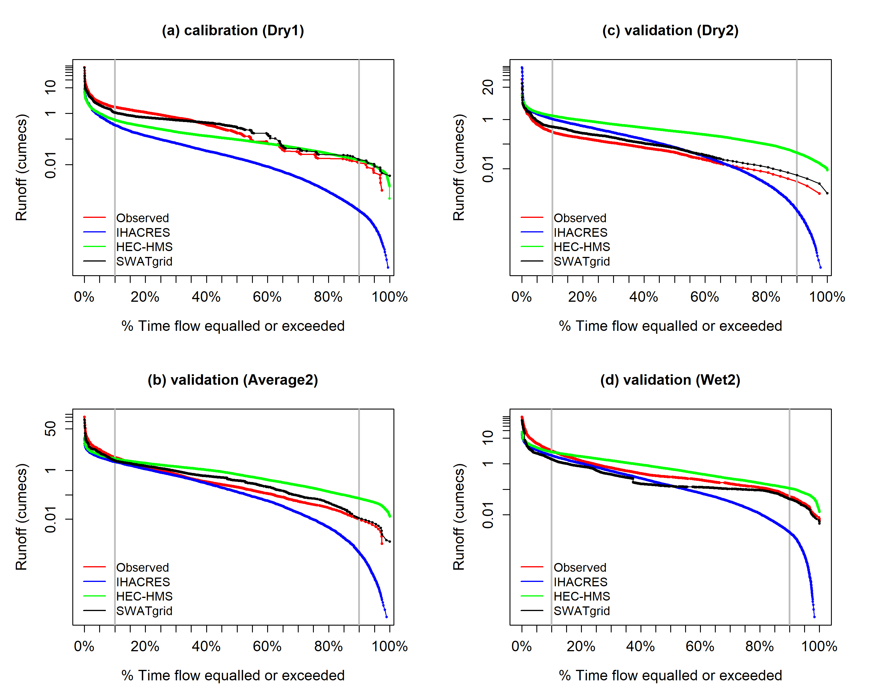
Figure S6 FDC for model simulation during (a) calibration (Dry1), (b) validation (Average2), (c) validation (Dry2) and (d) validation (Wet2) in case of catchment 410044 while considering missing rainfall replaced by Australian Water Availability Project (AWAP) dataset (vertical grey lines indicate the division of 10% and 90% flows).

Table S16 Calibrated model parameters for the Dry1 calibration period at catchment 410044 with missing rainfall values replaced by the AWAP dataset.
Model | Parameter | Unit | Calibrated value
IHACRES | τ_{q} | Day | 3.6
 | τ_{s} | Day | 311.6
 | v_{s} | (-) | 0.77
 | d | mm | 12.4
 | e | (-) | 1.1
 | f | (-) | 1.9
HEC-HMS | CN | (-) | 78
 | I_{p} | % | 1.5
 | I_{a} | mm | 8.8
 | L_{t} | min | 633.9
 | K | h | 1.75
 | x | (-) | 0.3
SWATgrid | GWQMN | mm | 4822
 | SOL_AWC | mm mm⁻¹ | 0.86
 | ALPHA_BF | day⁻¹ | 0.45
 | SOL_K | mm h⁻¹ | 0.15
 | CN2 | (-) | 77
 | ESCO | (-) | 0.07

