**One new sesquiterpene pyridine alkaloid from the stems and leaves of *Euonymus fortunei***

**List of Supporting information Pages**

**Fig. S1. HRESIMS of 1 1**

**Fig. S2. UV spectrum of 1 (CH3OH) 1**

**Fig. S3. IR spectrum of 1 (KBr disc) 2**

**Fig. S4. 1H NMR spectrum of 1 in CD3OD 2**

**Fig. S5. 13C NMR spectrum of 1 in CD3OD 3**

**Fig. S6. DEPT-135 spectrum of 1 in CD3OD 3**

**Fig. S7. 1H-1H COSY spectrum of 1 in CD3OD 4**

**Fig. S8. HSQC spectrum of 1 in CD3OD 4**

**Fig. S9. HMBC spectrum of 1 in CD3OD 5**

**Fig. S10. NOESY spectrum of 1 in CD3OD 5**

**Fig. S11. HRESIMS of 2 6**

**Fig. S12. UV spectrum of 2 (CH3OH) 6**

**Fig. S13. IR spectrum of 2 (KBr disc) 7**

**Fig. S14. 1H NMR spectrum of 2 in CD3OD 7**

**Fig. S15. 13C NMR spectrum of 2 in CD3OD 8**

**Fig. S16. DEPT-135 spectrum of 2 in CD3OD 8**

**Fig. S17. HRESIMS of 3 9**

**Fig. S18. UV spectrum of 3 (CH3OH) 9**

**Fig. S19. IR spectrum of 3 (KBr disc) 10**

**Fig. S20. 1H NMR spectrum of 3 in CDCl3 10**

**Fig. S21. 13C NMR spectrum of 3 in CDCl3 11**

**Fig. S22. DEPT-135 spectrum of 3 in CDCl3 11**

**Fig. S23. HRESIMS of 4 12**

**Fig. S24. UV spectrum of 4 (CH3OH) 12**

**Fig. S25. IR spectrum of 4 (KBr disc) 13**

**Fig. S26. 1H NMR spectrum of 4 in CDCl3 13**

**Fig. S27. 13C NMR spectrum of 4 in CDCl3 14**

**Fig. S28. DEPT-135 spectrum of 4 in CDCl3 14**

**Fig. S29. HRESIMS of 5 15**

**Fig. S30. UV spectrum of 5 (CH3OH) 15**

**Fig. S31. IR spectrum of 5 (KBr disc) 16**

**Fig. S32. 1H NMR spectrum of 5 in CD3OD 16**

**Fig. S33. 13C NMR spectrum of 5 in CD3OD 17**

**Fig. S34. DEPT-135 spectrum of 5 in CD3OD 17**

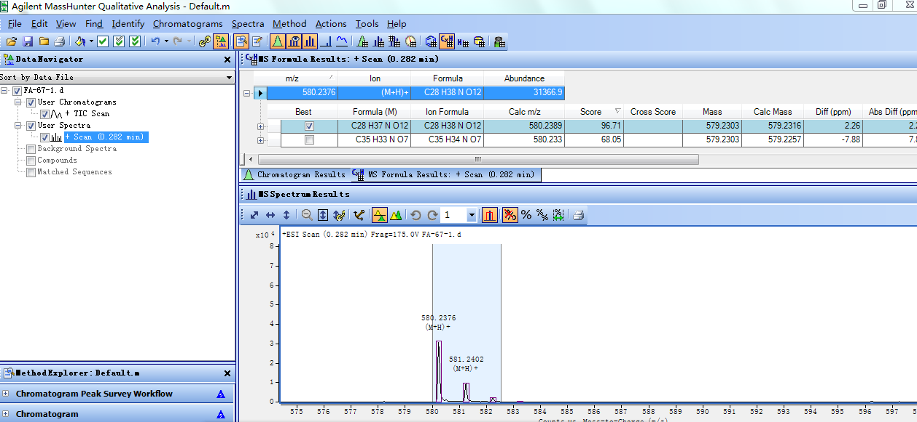

# Fig. S1. HRESIMS of 1

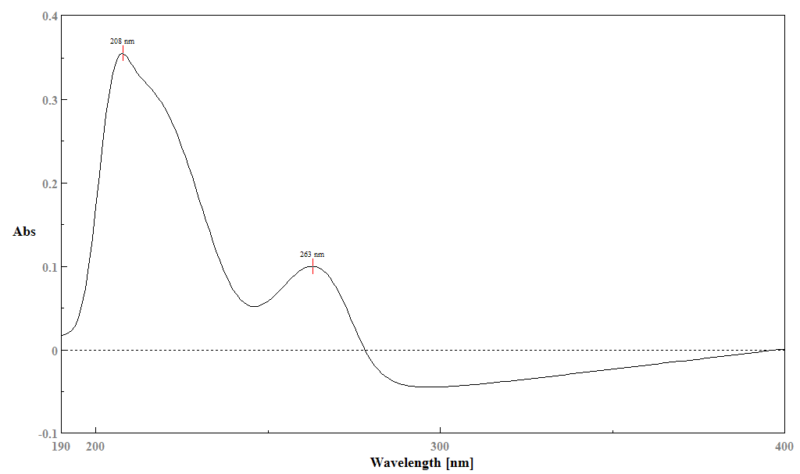

# Fig. S2. UV spectrum of 1 (CH3OH)



# Fig. S3. IR sectrum of 1 (KBr disc)

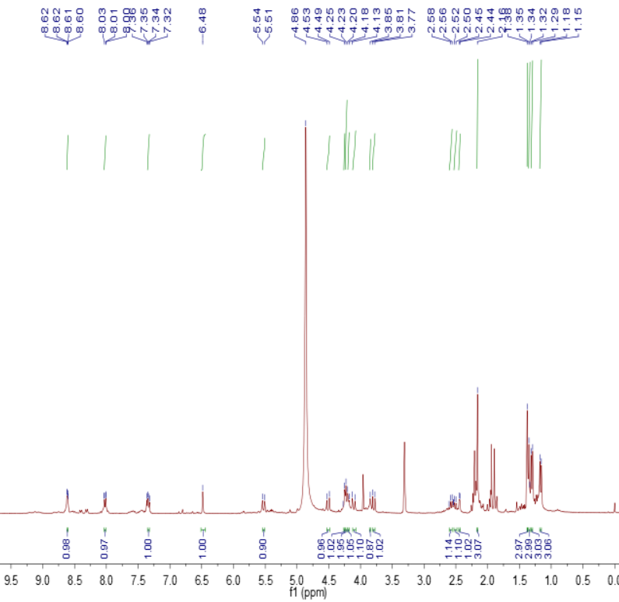

# Fig. S4. 1H NMR spectrum of 1 in CD3OD

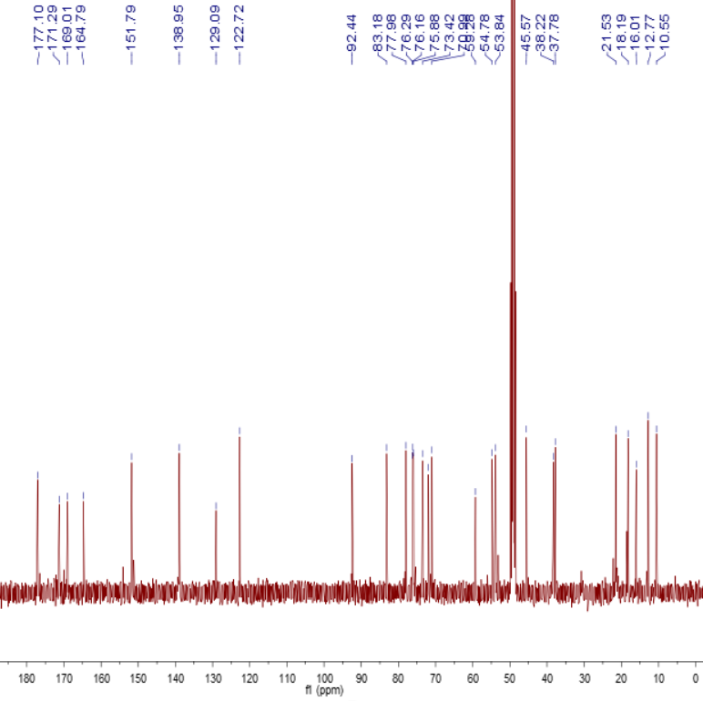

# Fig. S5. 13C NMR spectrum of 1 in CD3OD

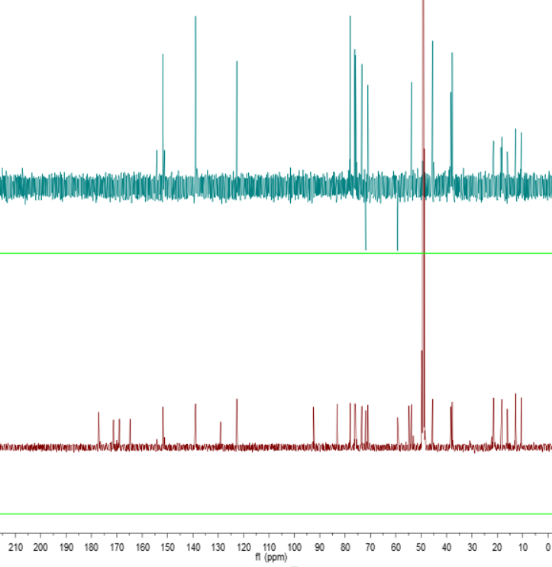

# Fig. S6. DEPT-135 spectrum of 1 in CD3OD

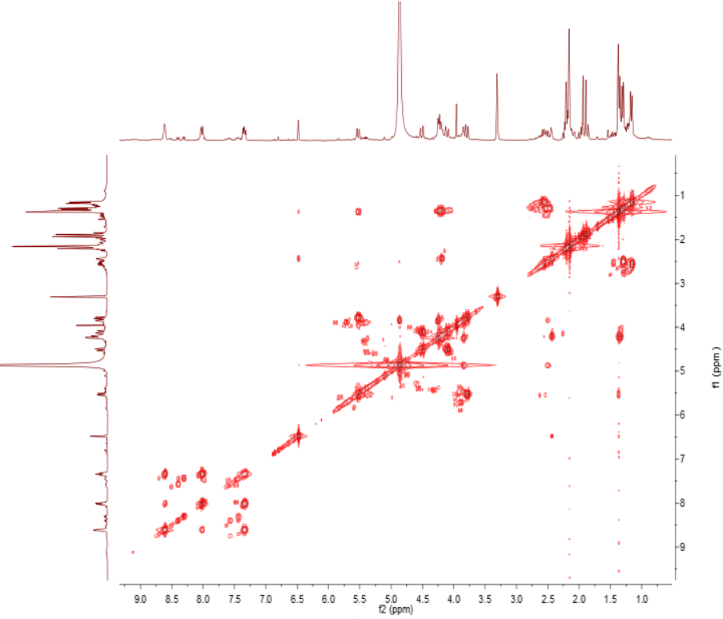

# Fig. S7. 1H-1H COSY spectrum of 1 in CD3OD

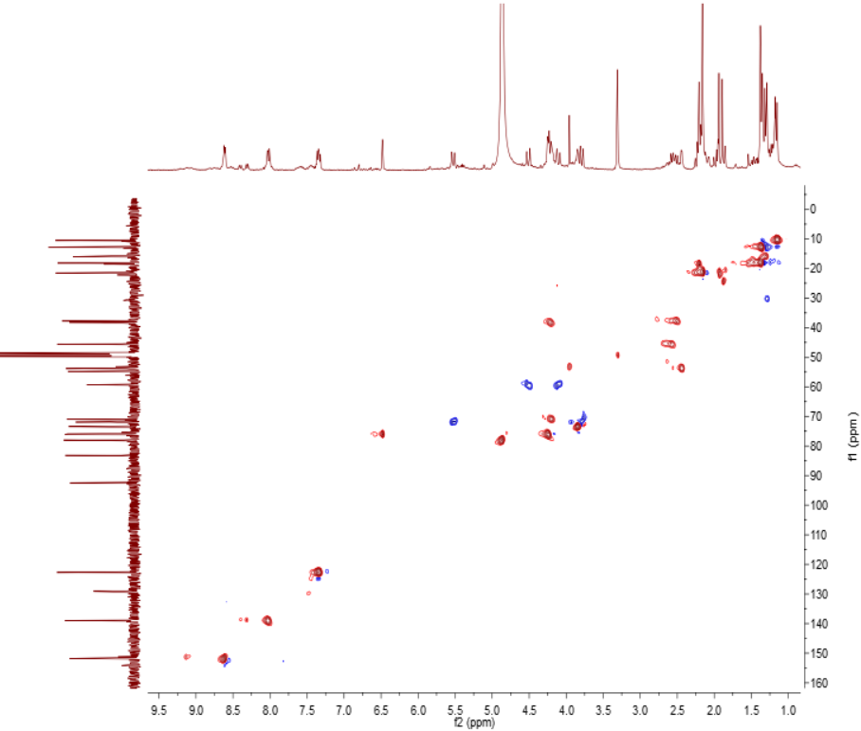

# Fig. S8. HSQC spectrum of 1 in CD3OD

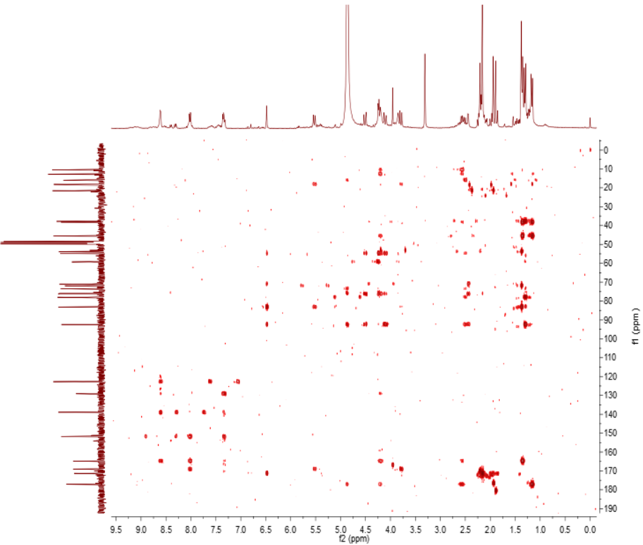

# Fig. S9. HMBC spectrum of 1 in CD3OD

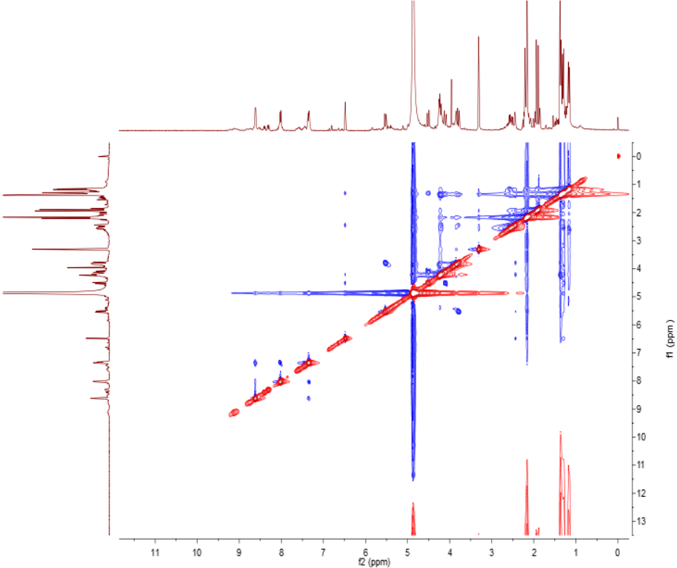

# Fig. S10. NOESY spectrum of 1 in CD3OD

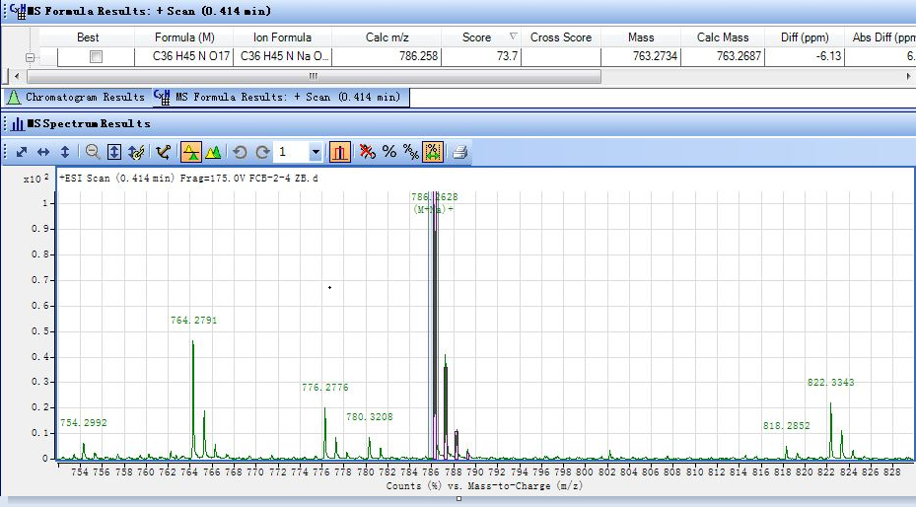

# Fig. S11. HRESIMS of 2

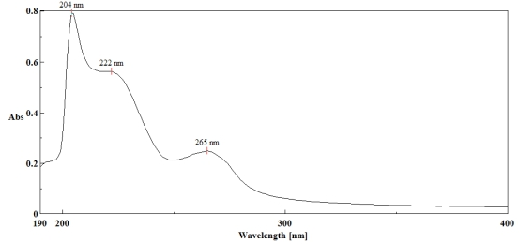

# Fig. S12. UV spectrum of 2 (CH3OH)

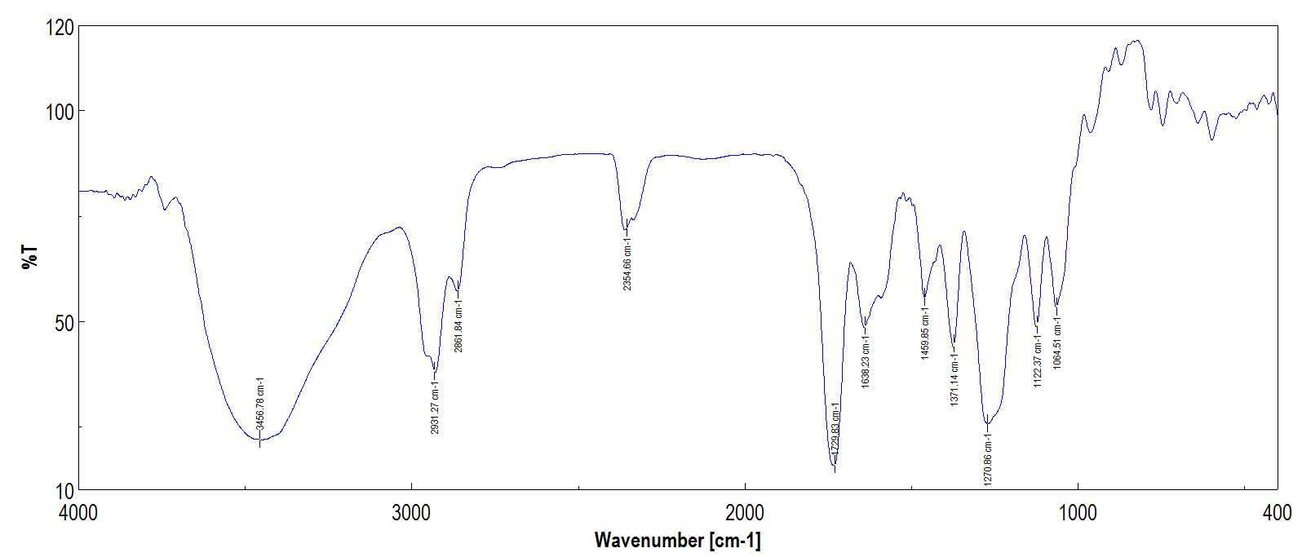

# Fig. S13. IR sectrum of 2 (KBr disc)

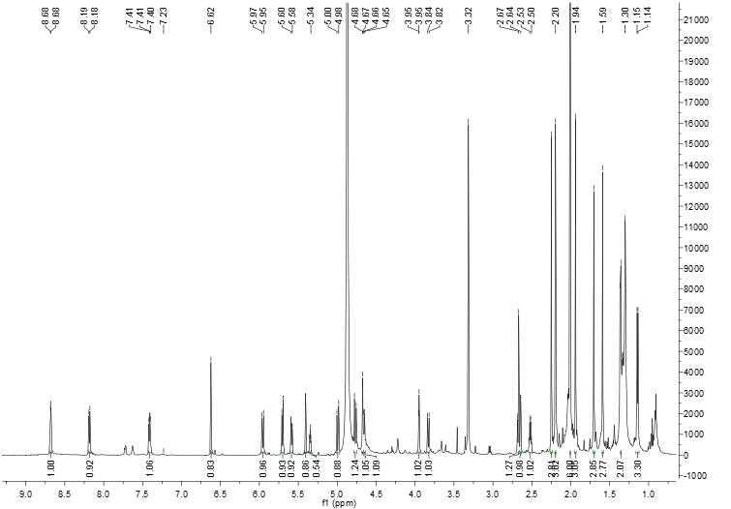

# Fig. S14. 1H NMR spectrum of 2 in CD3OD

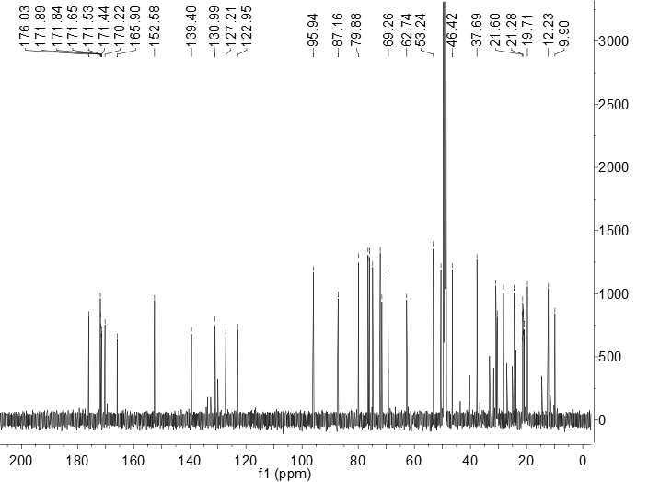

# Fig. S15. 13C NMR spectrum of 2 in CD3OD

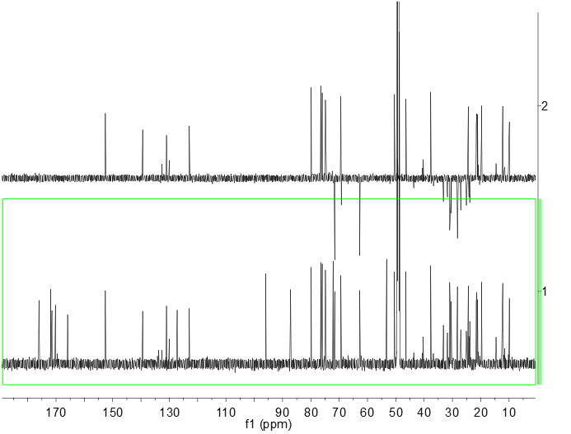

# Fig. S16. DEPT-135 spectrum of 2 in CD3OD

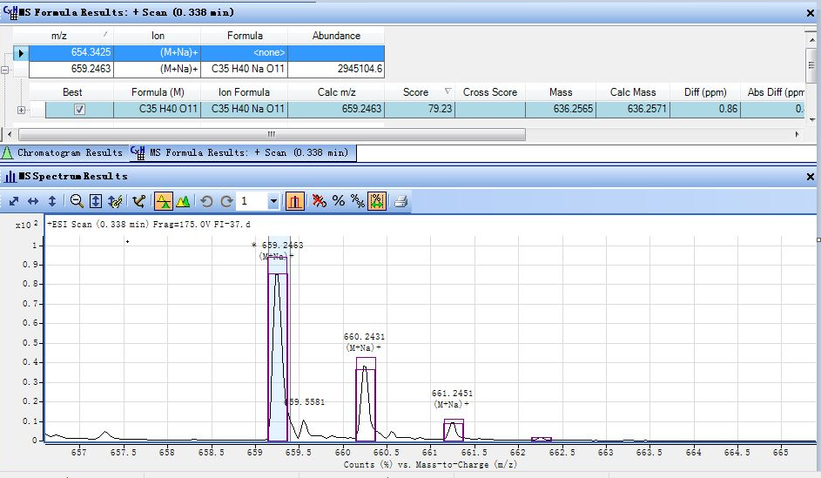

# Fig. S17. HRESIMS of 3

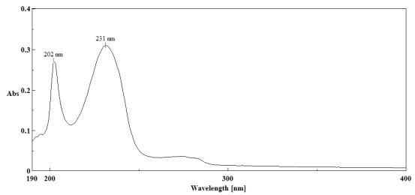

# Fig. S18. UV spectrum of 3 (CH3OH)

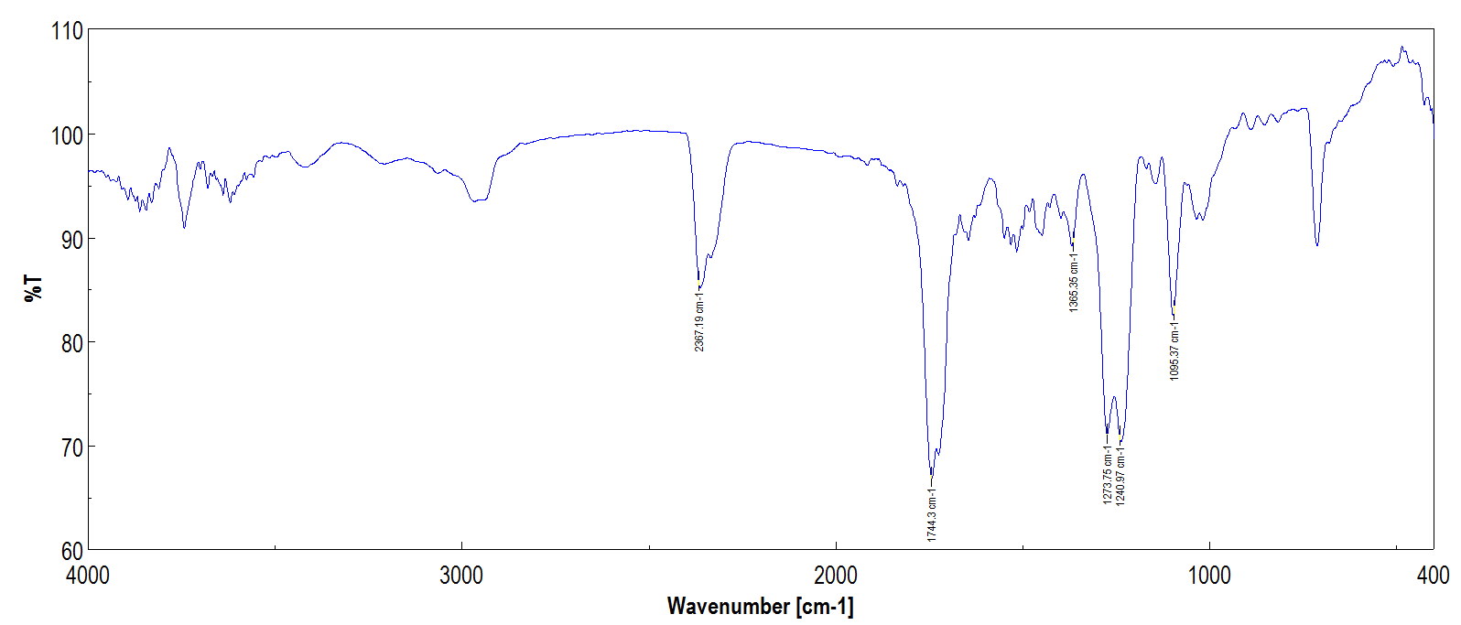

# Fig. S19. IR sectrum of 3 (KBr disc)

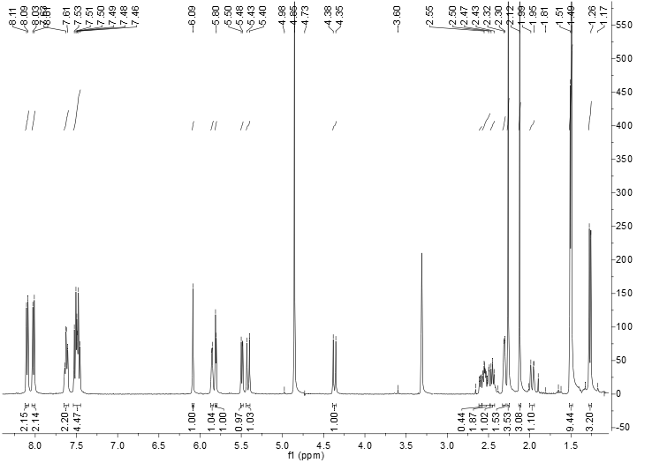

# Fig. S20. 1H NMR spectrum of 3 in CDCl3

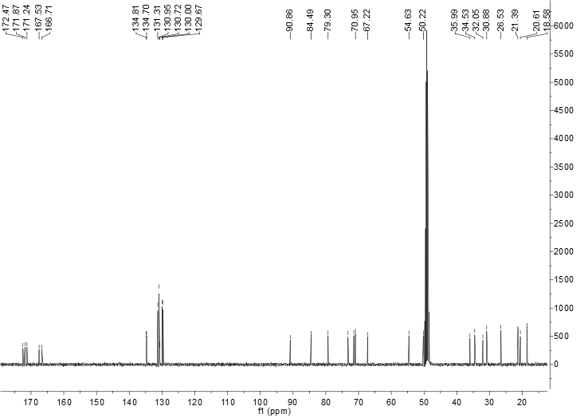

# Fig. S21. 13C NMR spectrum of 3 in CDCl3

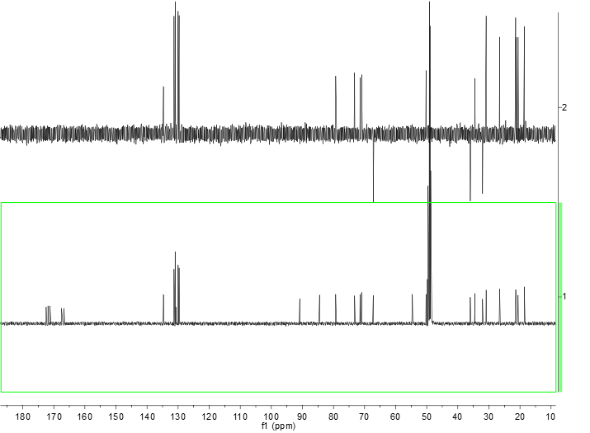

# Fig. S22. DEPT-135 spectrum of 3 in CDCl3

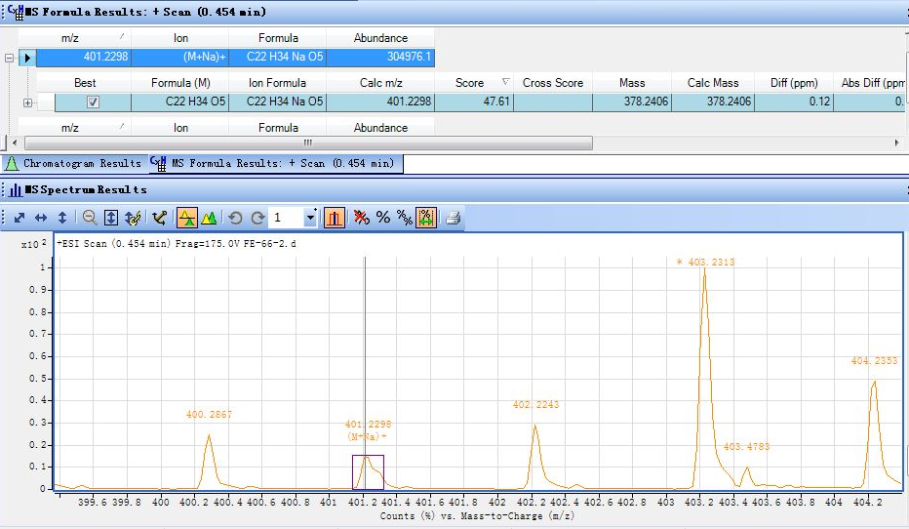

# Fig. S23. HRESIMS of 4

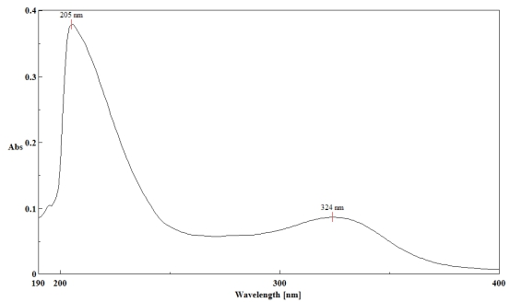

# Fig. S24. UV spectrum of 4 (CH3OH)

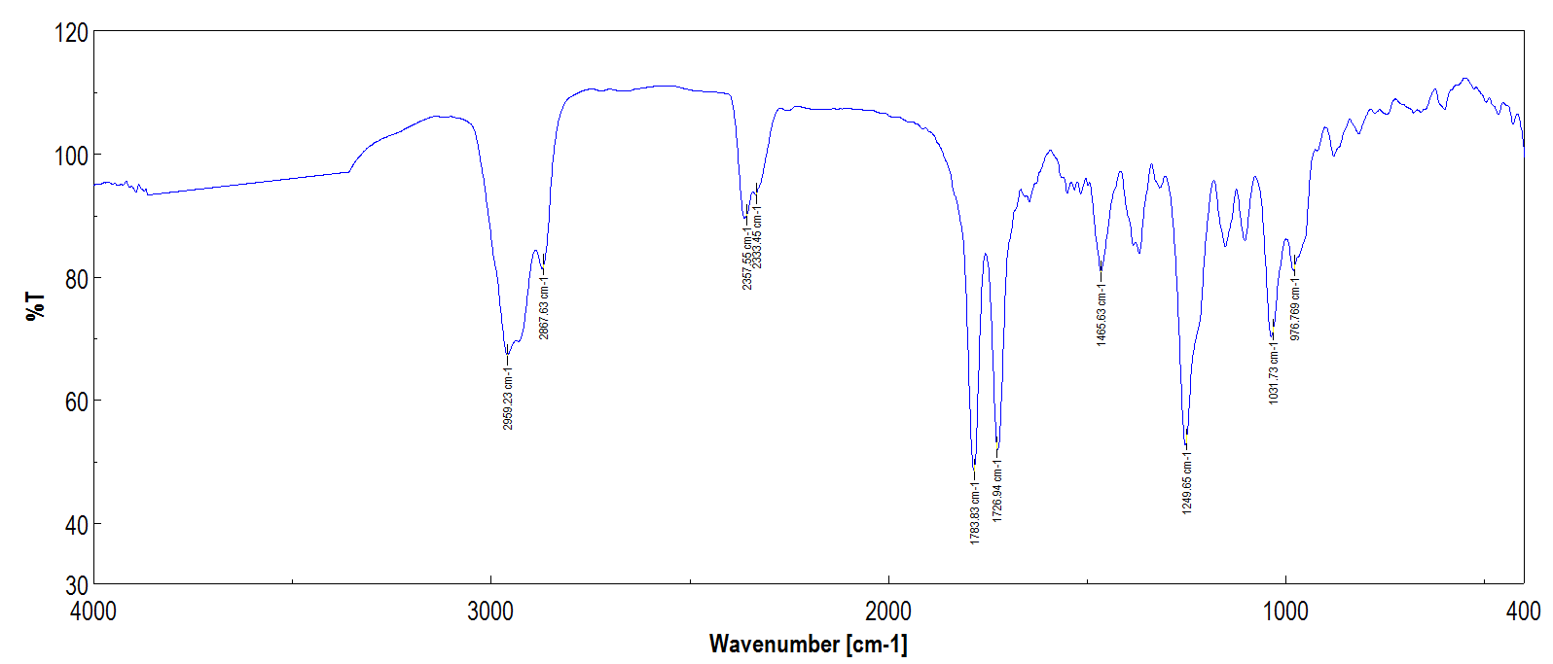

# Fig. S25. IR sectrum of 4 (KBr disc)

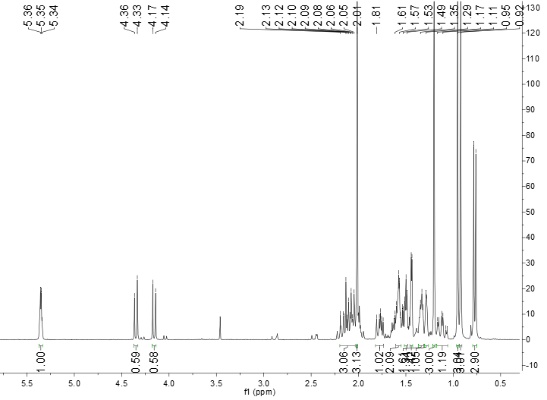

# Fig. S26. 1H NMR spectrum of 4 in CDCl3

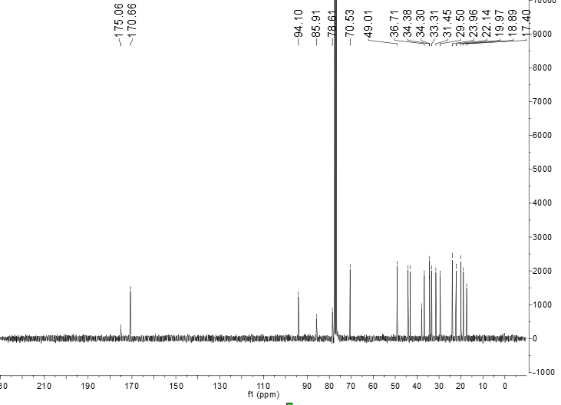

# Fig. S27. 13C NMR spectrum of 4 in CDCl3

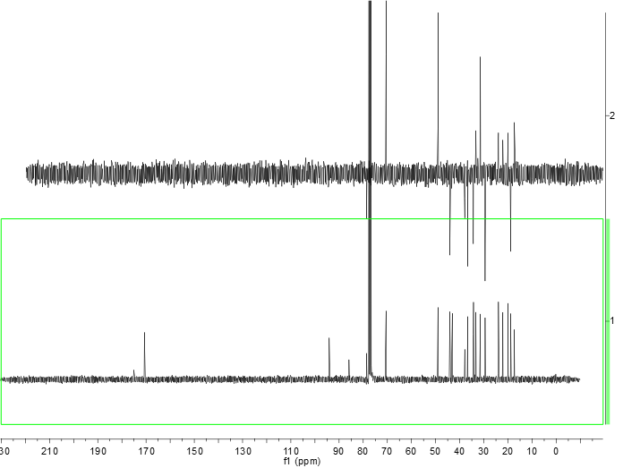

# Fig. S28. DEPT-135 spectrum of 4 in CDCl3

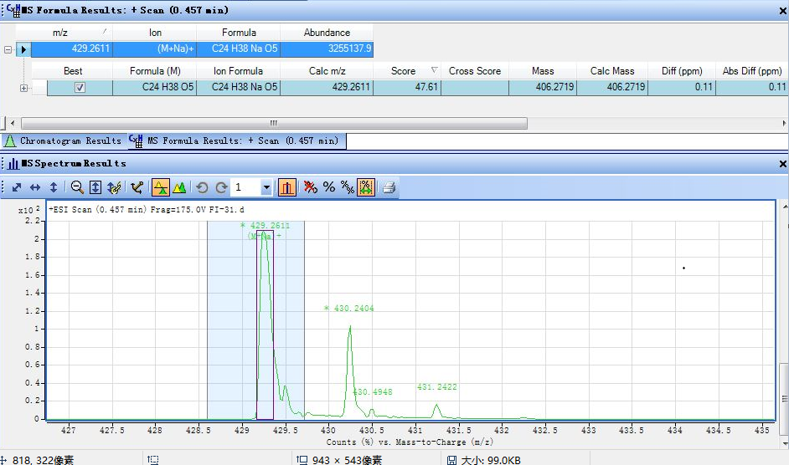

# Fig. S29. HRESIMS of 5

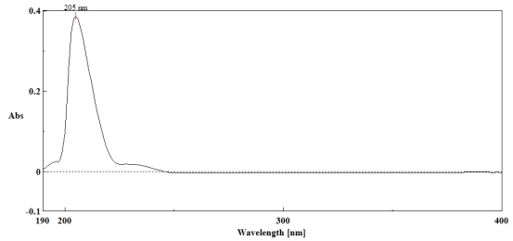

# Fig. S30. UV spectrum of 5 (CH3OH)

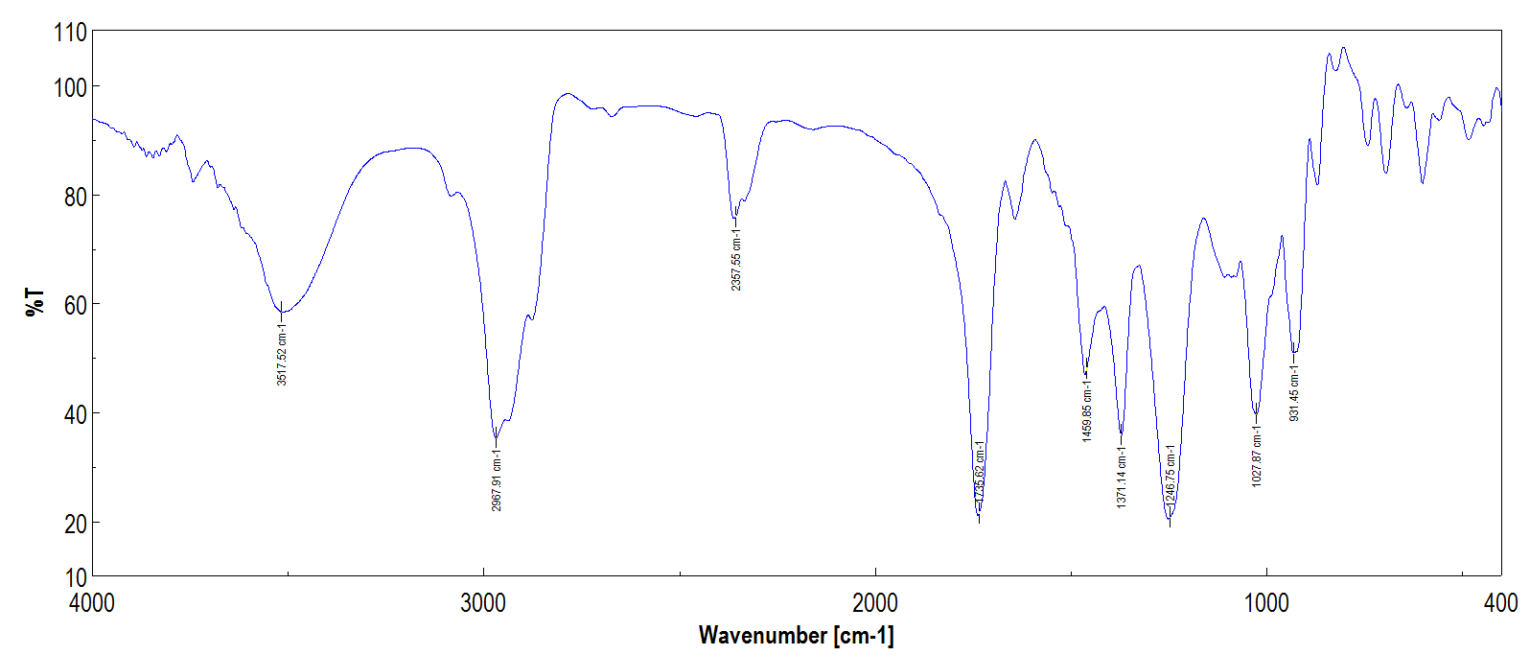

# Fig. S31. IR sectrum of 5 (KBr disc)

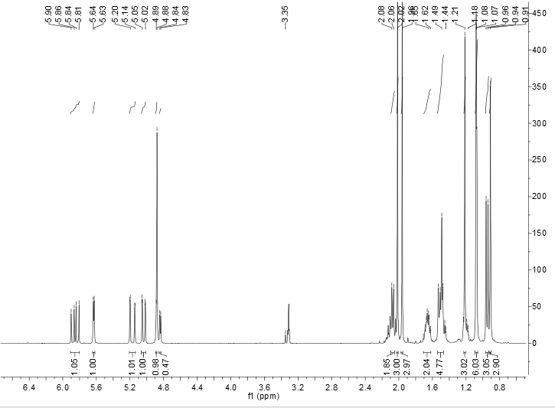

# Fig. S32. 1H NMR spectrum of 5 in CD3OD

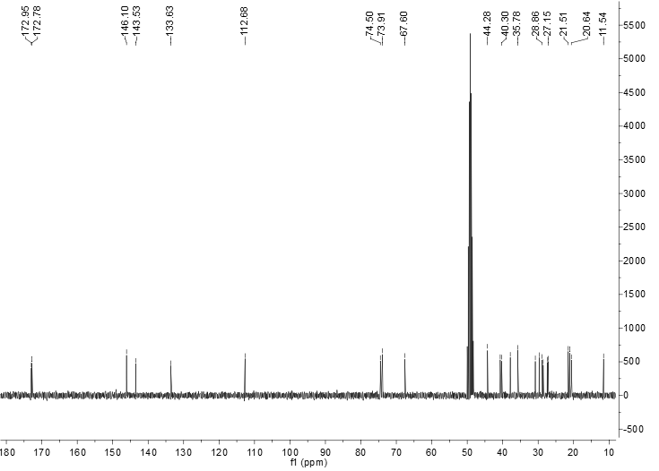

# Fig. S33. 13C NMR spectrum of 5 in CD3OD

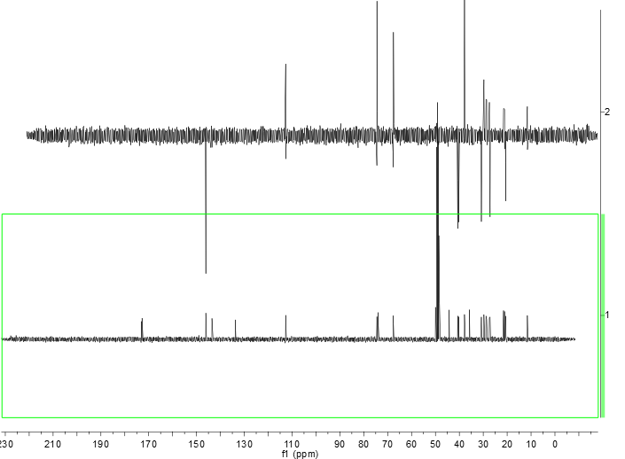

# Fig. S34. DEPT-135 spectrum of 5 in CD3OD