Table S1. Land use and land cover classes used in this study (red color)
6 classes* | 25 classes** | Description
Cropland | Dry land | Cropland for cultivation without irrigating facilities.
 | Paddy land | Cropland that has enough water supply and irrigation facilities for planting paddy rice, lotus etc.
Grassland | Dense grassland | Canopy coverage > 50%.
 | Moderate grassland | Canopy coverage between 20% and 50%.
 | Sparse grassland | Canopy coverage between 5% and 20%.
Woodland | Forest | Canopy coverage > 30%.
 | Shrub | Canopy cover > 40%.
 | Wood | Canopy coverage between 10% to 30%.
 | Others | Other lands such as alpine desert and tundra.
Water bodies | Stream and rivers | Lands covered by rivers and stream.
 | Lakes | Lands covered by lakes.
 | Reservoir | Man-made facilities for water reservation.
 | Permanent ice and snow | Lands covered by perennial snowfields and glaciers.
 | Beach and shore | Lands between high tide level and low tide level.
 | Bottomland | Lands between normal water level and flood level.
Built-up land | Urban built-up | Lands used for urban.
 | Rural settlements | Lands used for settlements in villages.
 | Others | Lands used for factories, quarries, mining, oil-field slattern outside cities and lands for special uses such as transportation and airport.
Bare land | Bare soil | Bare exposed soil with less than 5% vegetation cover.
 | Bare rock | Bare exposed rock with less than 5% vegetation cover.
 | Sandy land | Sandy land covered with less than 5% vegetation cover.
 | Gobi | Gravel covered land with less than 5% vegetation cover.
 | Salina | Lands with salina accumulation and sparse vegetation.
 | Swampland | Lands with a permanent mixture of water and herbaceous or woody vegetation that cover extensive areas.
 | Others | Other lands such as alpine desert and tundra.
Note: this table is adapted from Liu et al. (2005)
* The overall of the six classes was > 93%
** The overall accuracy of the 25 classes was > 90%

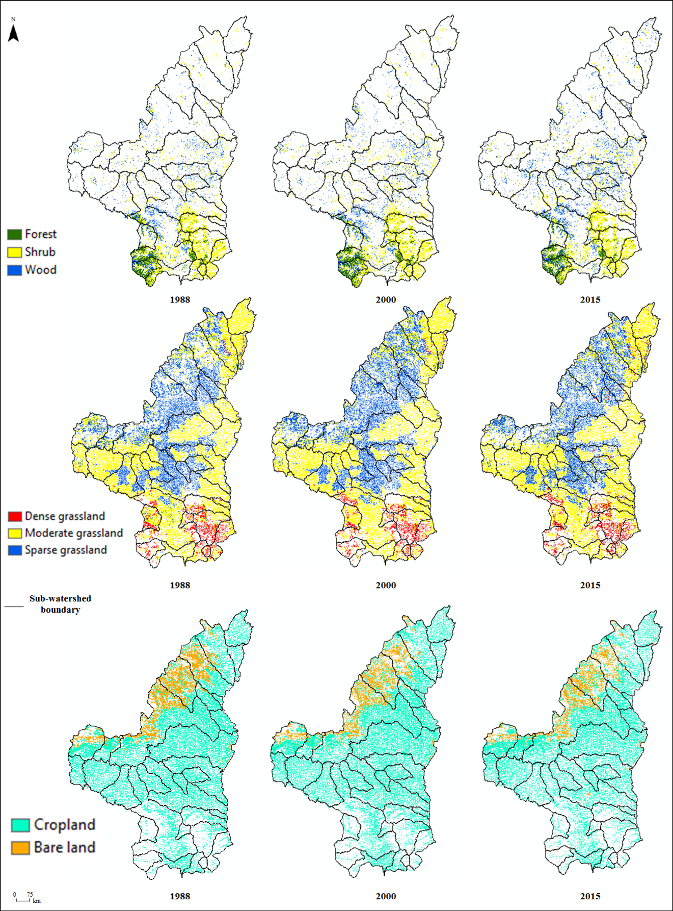
Figure S1 Spatial distribution of land use in northern Shaanxi, 1988 – 2015
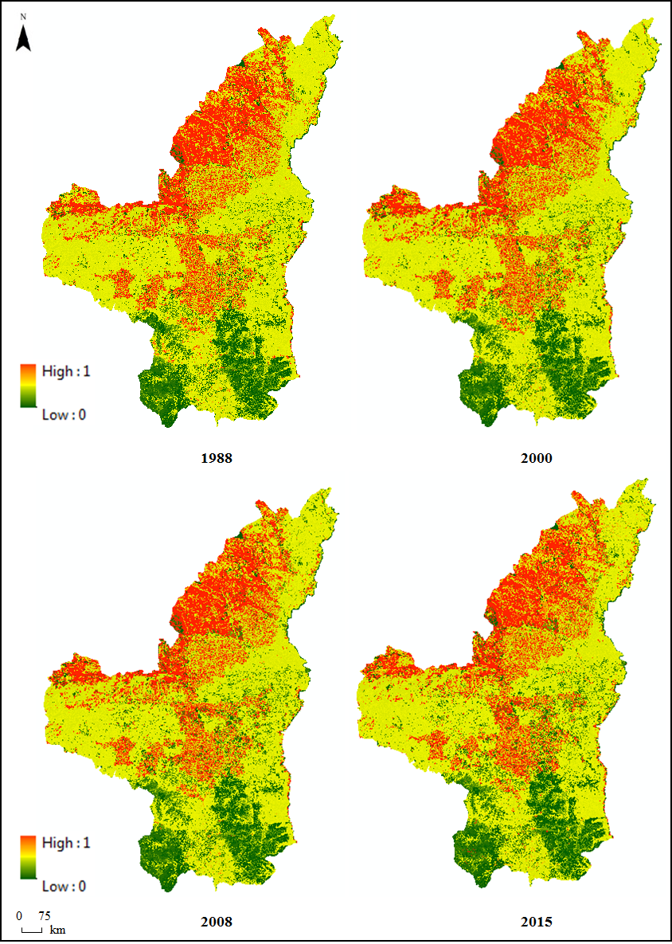
Figure S2 Spatial distribution of C values in northern Shaanxi, 1988 – 2015

