Temperature dependent electrical and optical properties with higher photosensitivity of Cu₂Se absorber thin films for photo voltaic application

J. Henry¹, T. Daniel¹, V. Balasubramanian¹, K. Mohanraj^{1,}*and G. Sivakumar²

¹Department of Physics, Manonmaniam Sundaranar University, Tirunelveli-627 012, Tamil Nadu, India
²Centralised Instrumentation and Service Laboratory, Department of Physics, Annamalai University, Annamalai Nagar-608 002, Tamil Nadu, India
*Corresponding author e-mail: kmohanraj.msu@gmail.com; mohanraj@msuniv.ac.in
Phone number: +91-9788083079;

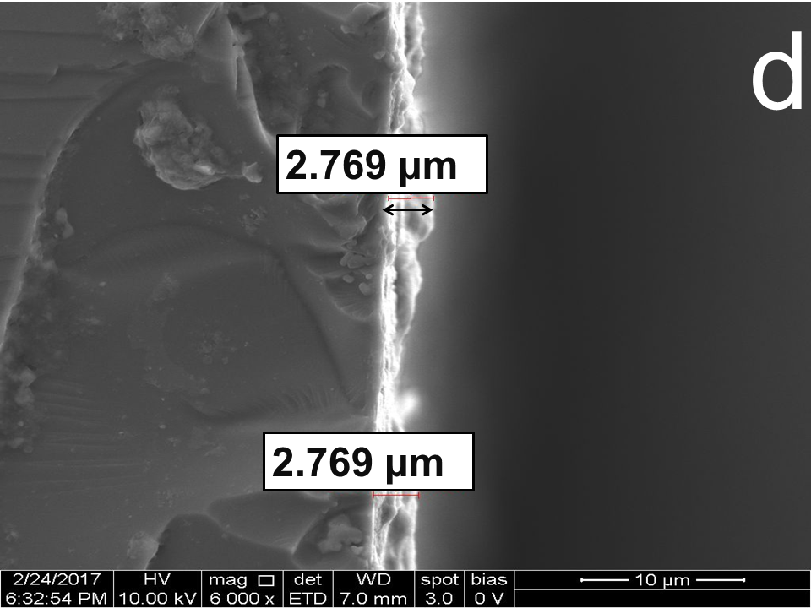

Figure S1. FESEM cross sectional images Cu₂Se thin film

