Supplemental information

Table S1. Primer sequences
genotyping primers | Rybp-Fl/WT-F | CACAGAACCGGACAAGGAGT
 | Rybp-Fl/WT-R | TAGTGTGCAGATCATCGCATA
 | Stra8-Cre-F | GTGCAAGCTGAACAACAGGA
 | Stra8-Cre-R | CCAGCATCCACATTCTCCTT
 | ZP3-Cre-F | CCCAACCAACCGAAGAAATA
 | ZP3-Cre-R | GCCGCATAACCAGTGAAACA
primers for qRT-PCR | Rybp-F | GAAAGATCCTCCTAGTGAAGC
 | Rybp-R | GTGACGTTGCCCACAGTTA
 | LINE1-F | AGTGCAGAGTTCTATCAGACCTTC
 | LINE1-R | AACCTACTTGGTCAGGATGGATG
 | IAP-F | CTCCATGTGCTCTGCCTTCC
 | IAP-R | CCCCGTCCCTTTTTTAGGAGA
 | SINEB2-F | GAGCACCTGACTGCTCTTCC
 | SINEB2-R | ACACACCAGAAGAGGGCATC
 | MuERVL-F | CTCTACCACTTGGACCATATGAC
 | MuERVL-R | GAGGCTCCAAACAGCATCTCTA
 | Zscan4-F | GAGATTCATGGAGAGTCTGACTGATGAGTG
 | Zscan4-R | GCTGTTGTTTCAAAAGCTTGATGACTTC
 | 4-qB3-277-F | TCTTAGGCAATGGGGTTGTC
 | 4-qB3-277-R | AGTGGGAAAATGAGCACCAC
 | 15-qD1-17920-F | AGCAACTATCTCCCGAGCAA
 | 15-qD1-17920-R | GGCTTCCAGAAACAGAGCAC
 | 18-qE1-1295-F | AGCAGAGGCTATCTGGGTGA
 | 18-qE1-1295-R | TTGACTCCTCAGCCTCCTGT
 | Gapdh-F | TCTTCCAGGAGCGAGACCC
 | Gapdh-R | CGGAGATGATGACCCTTTT

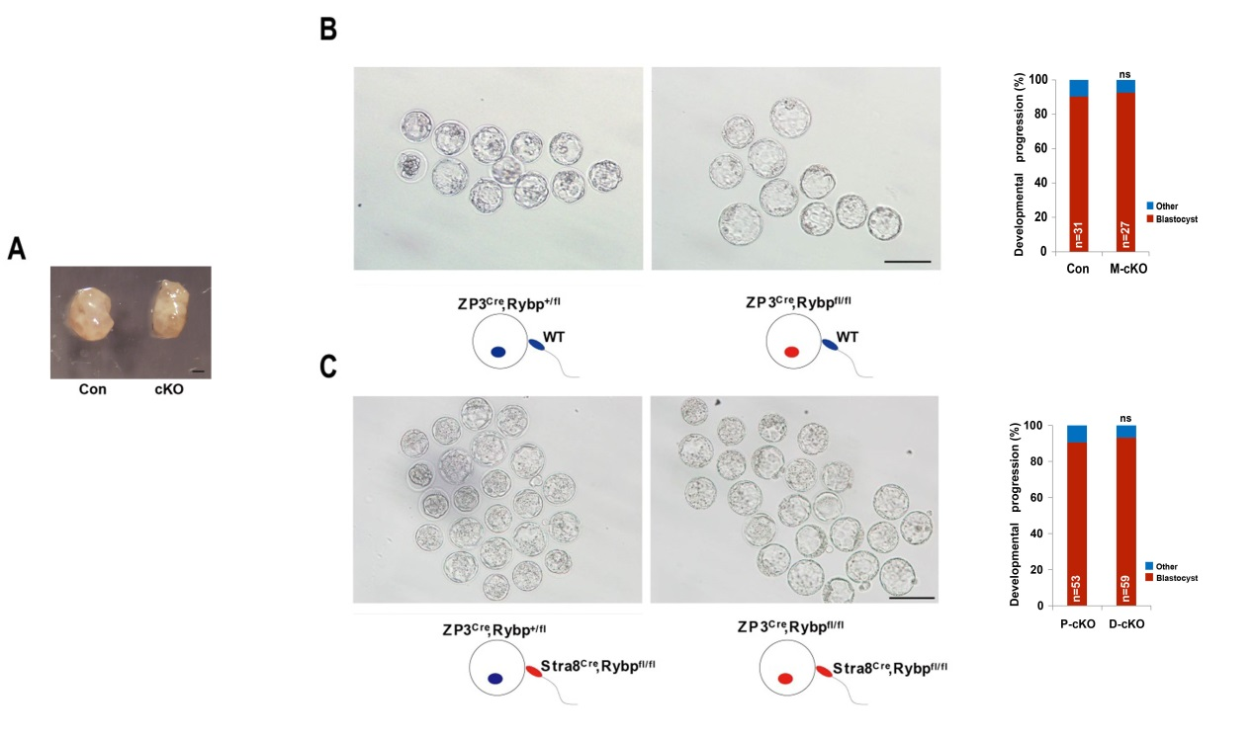

Figure S1. RYBP is dispensable for oocyte maturation and early embryonic development.
- Representative image of ovaries from adult control and cKO mice. Scale bar, 1mm.
- Representative images of blastocysts produced using control and cKO oocytes. Schematic illustration of mating strategy is shown at bottom of representative images. Developmental progression is summarized at right. Scale bar, 100μm.
- Representative images of blastocysts produced using control and cKO gametes. Schematic illustration of mating strategy is shown at bottom of representative images. Developmental progression is summarized at right. Scale bar, 100μm.

