Supplementary Material

Synthesis, Structure and Reactivity of Some Chiral Benzylthio Alcohols, 1,3-Oxathiolanes and their S-Oxides
R. Alan Aitken*, Philip Lightfoot and Andrew W. Thomas
EaStCHEM School of Chemistry, University of St Andrews, St Andrews, UK

Page

¹H NMR and ¹³C NMR spectra of 5 2, 3
¹H NMR and ¹³C NMR spectra of 6 4, 5
¹H NMR and ¹³C NMR spectra of 7 6, 7
¹H NMR and ¹³C NMR spectra of 8 8, 9
¹³C NMR spectrum of 10 10
¹H NMR and ¹³C NMR spectra of 11 11, 12
¹H NMR and ¹³C NMR spectra of 12 13, 14
¹³C NMR spectrum of 13 15
¹H NMR and ¹³C NMR spectra of 15 16, 17
¹H NMR and ¹³C NMR spectra of 16 18, 19
¹H NMR and ¹³C NMR spectra of 17 20, 21
¹H NMR and ¹³C NMR spectra of 19 22, 23
¹H NMR and ¹³C NMR spectra of 20 24, 25
¹H NMR and ¹³C NMR spectra of trans-18 26, 27
¹H NMR and ¹³C NMR spectra of FVP product from 20 28, 29

300 MHz ¹H NMR spectrum of 5

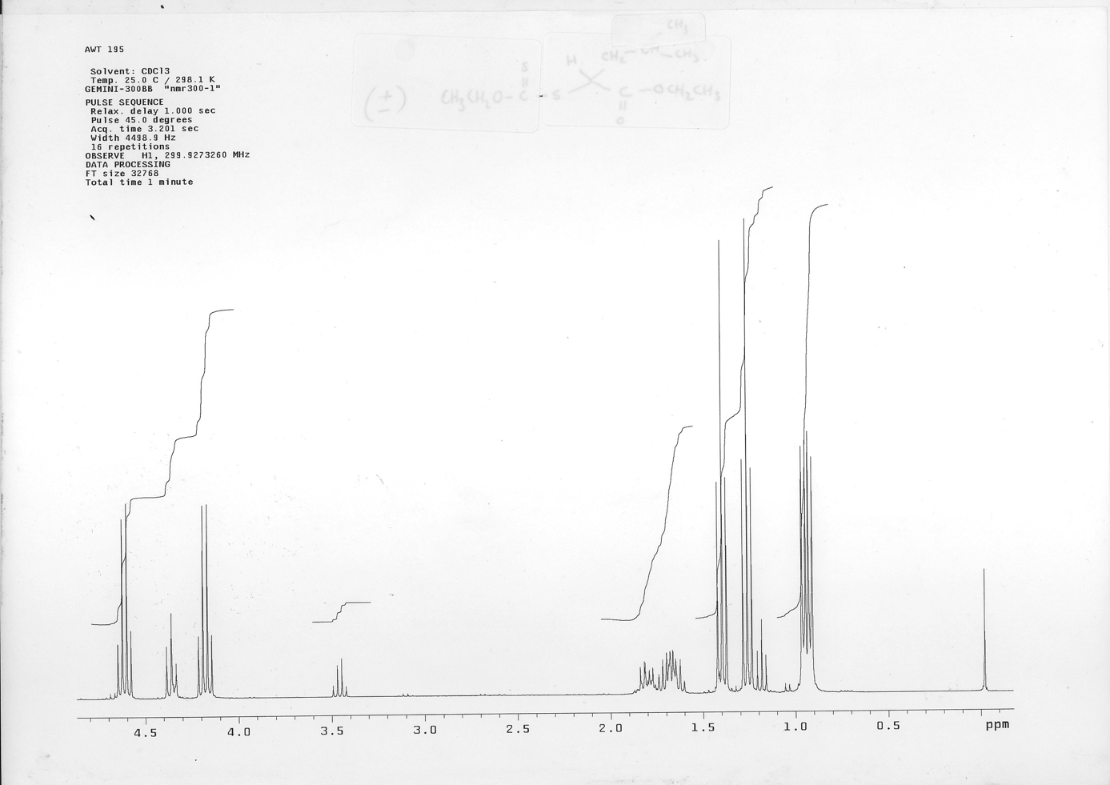
75 MHz ¹³C NMR spectrum of 5

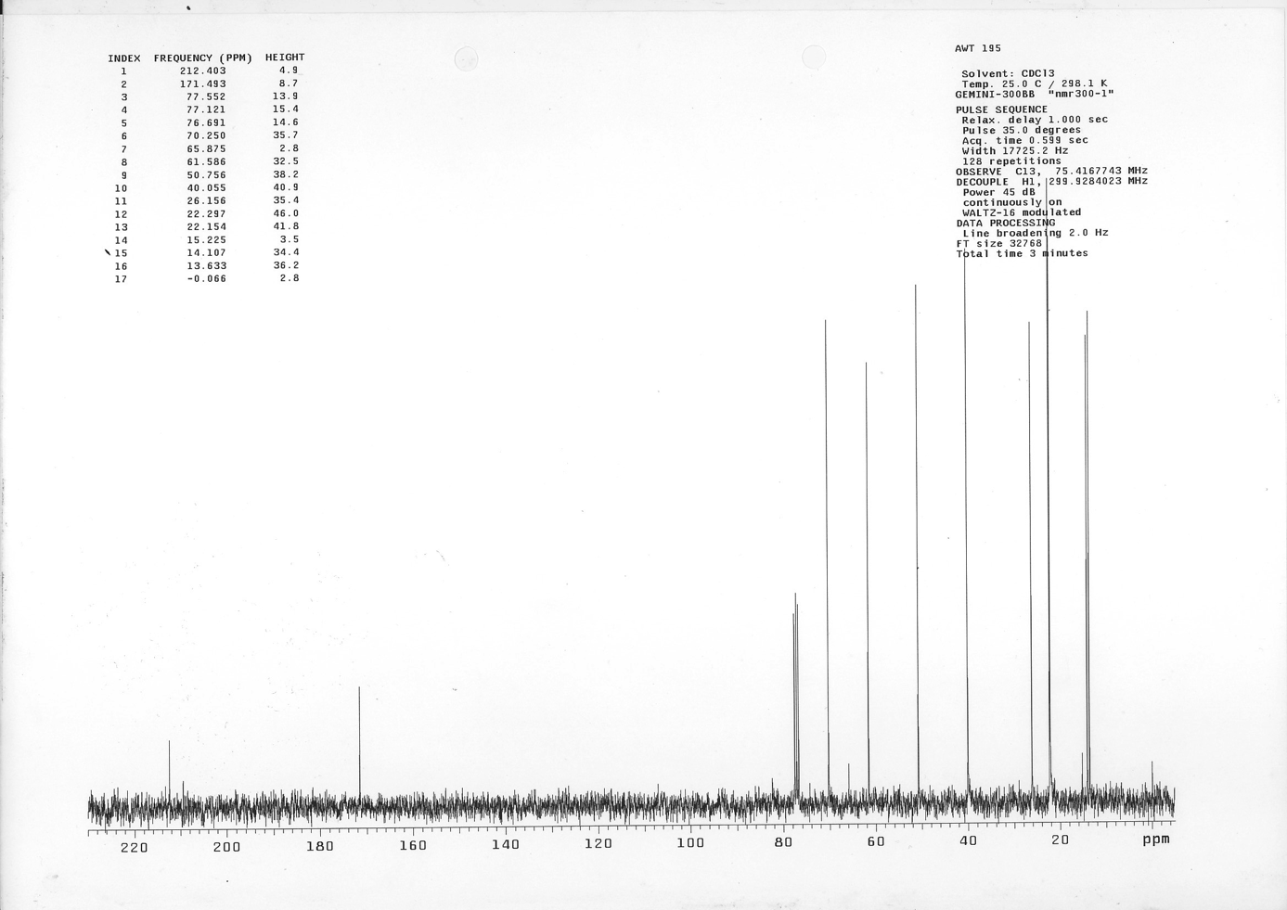
300 MHz ¹H NMR spectrum of 6

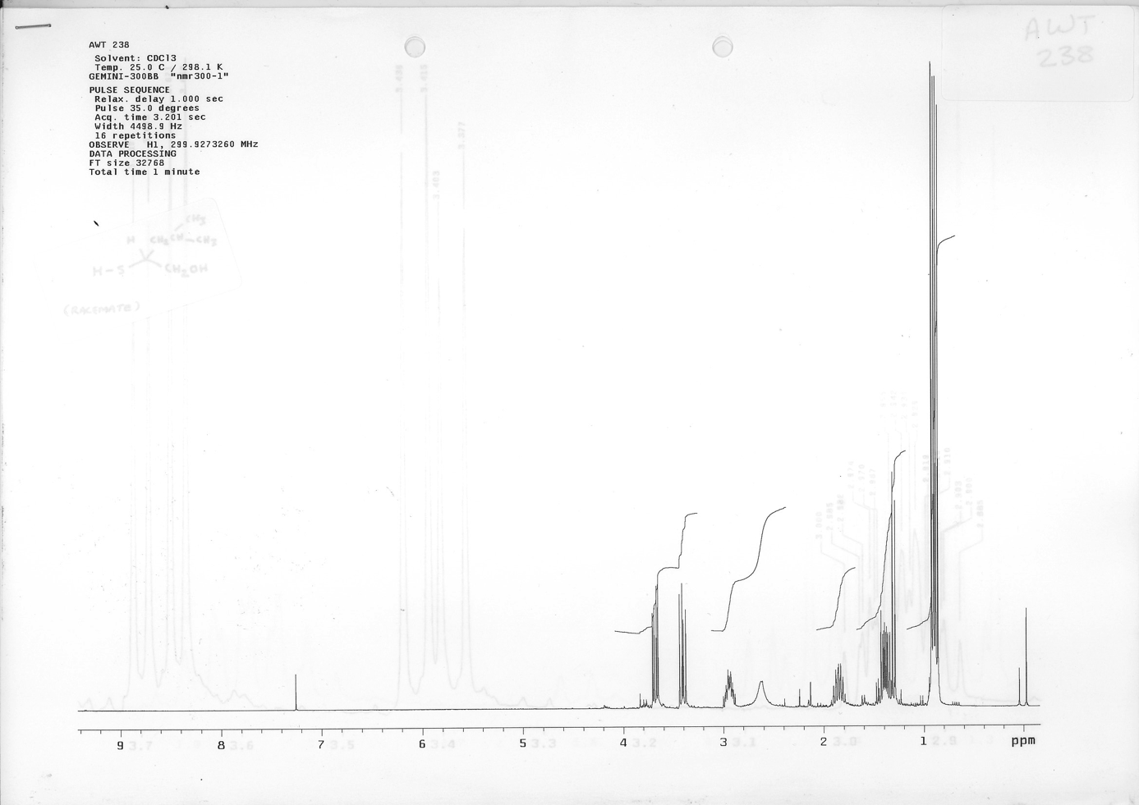
75 MHz ¹³C NMR spectrum of 6

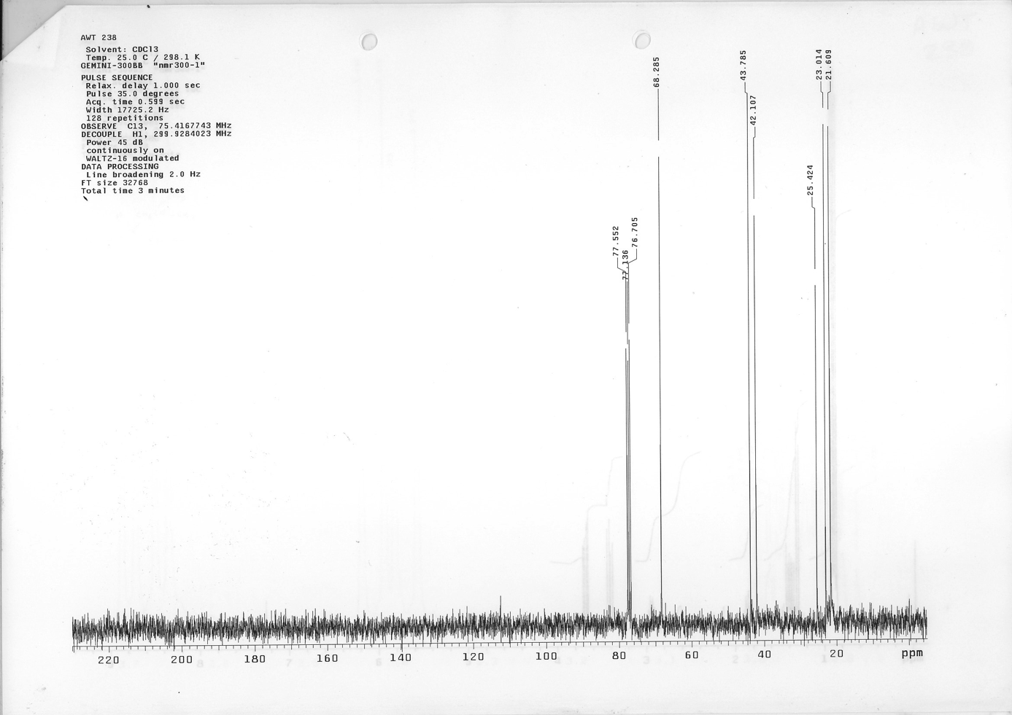
200 MHz ¹H NMR spectrum of 7

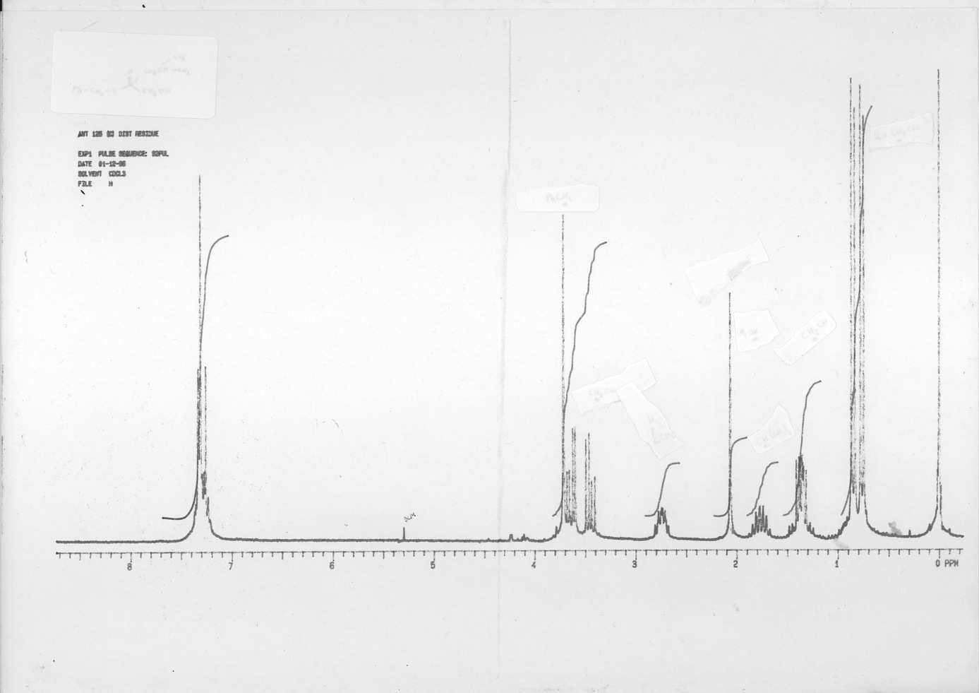
50 MHz ¹³C NMR spectrum of 7

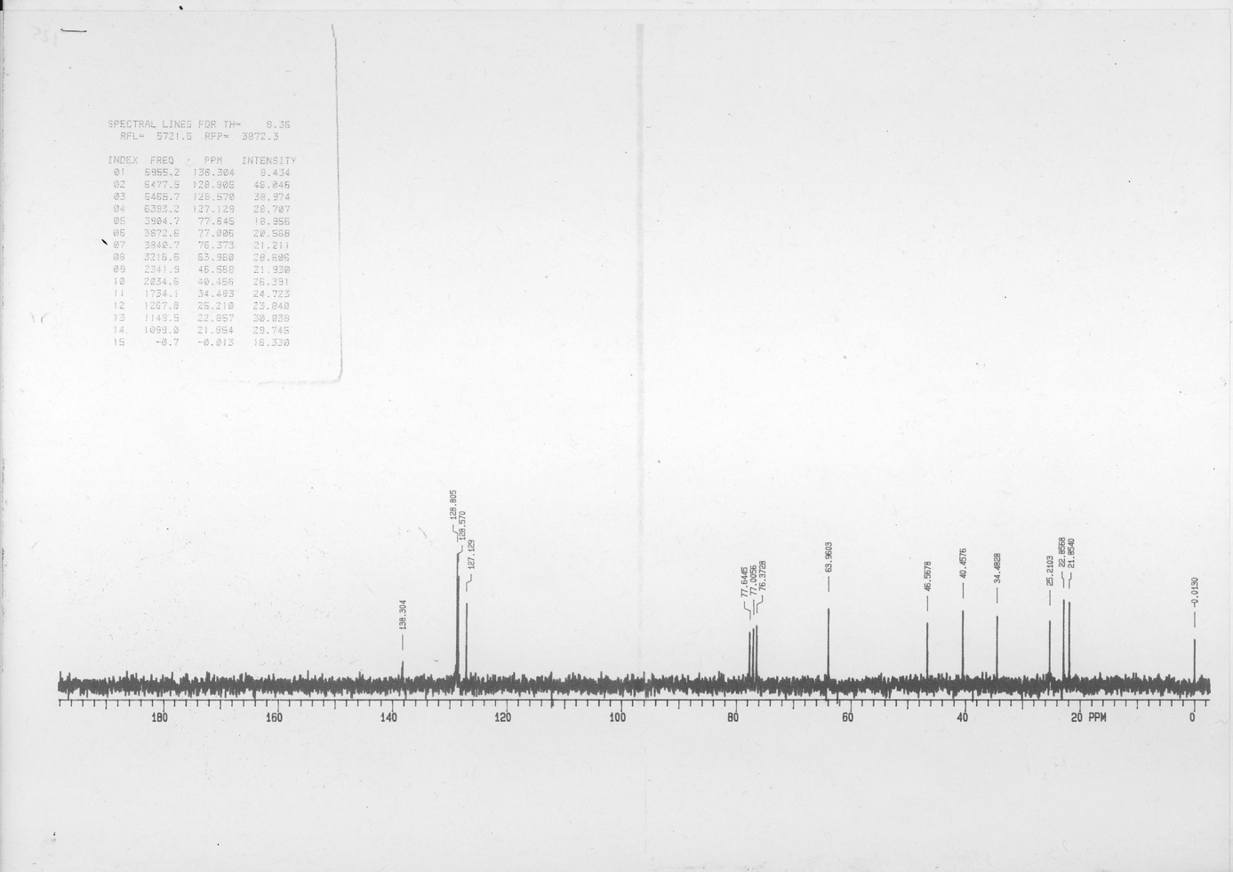
200 MHz ¹H NMR spectrum of 8

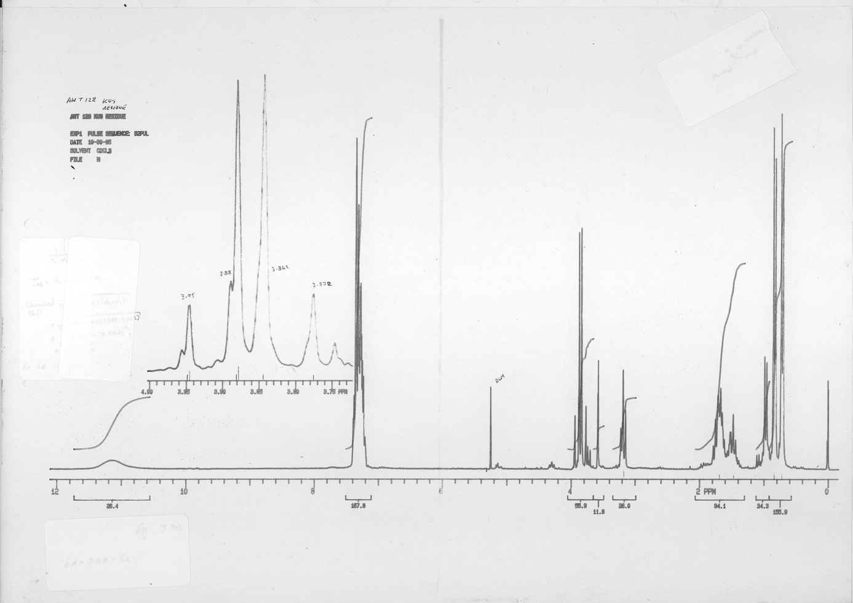
50 MHz ¹³C NMR spectrum of 8

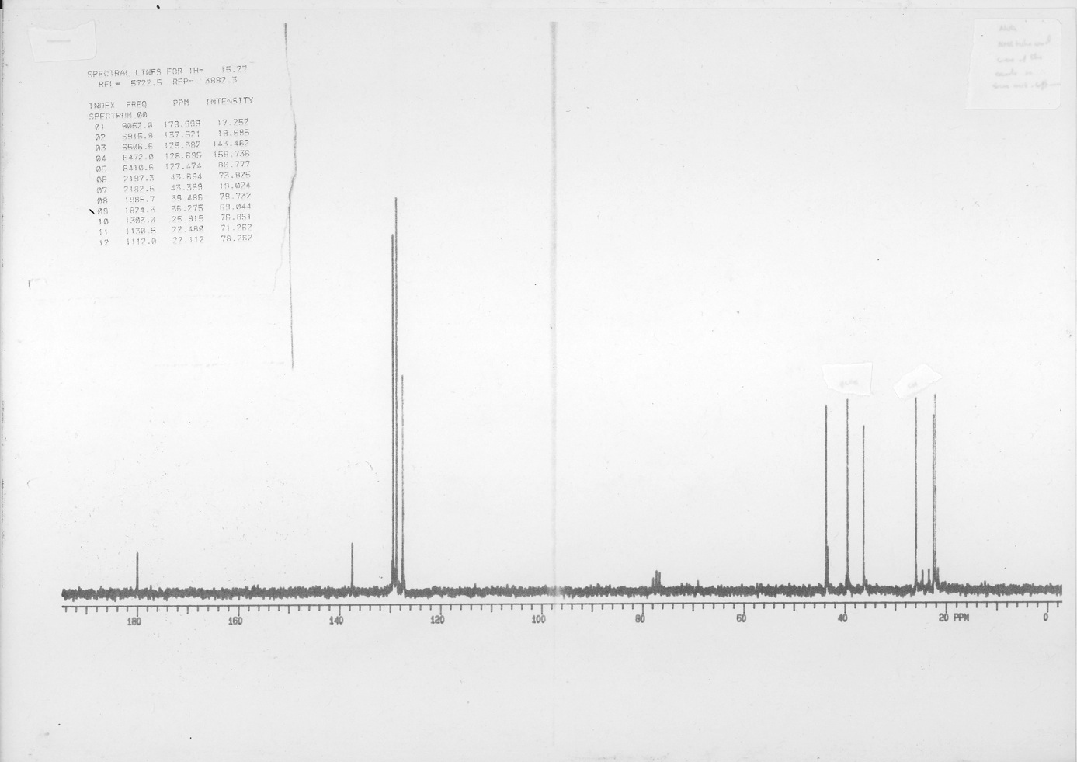
75 MHz ¹³C NMR spectrum of 10

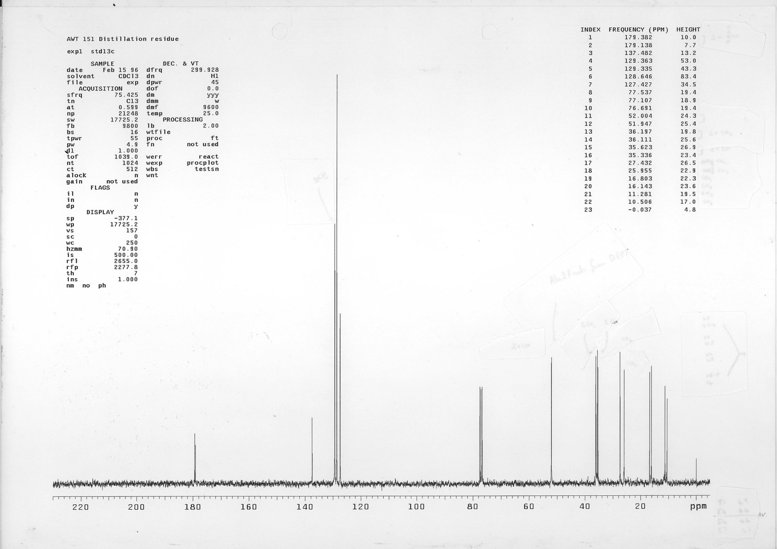
300 MHz ¹H NMR spectrum of 11

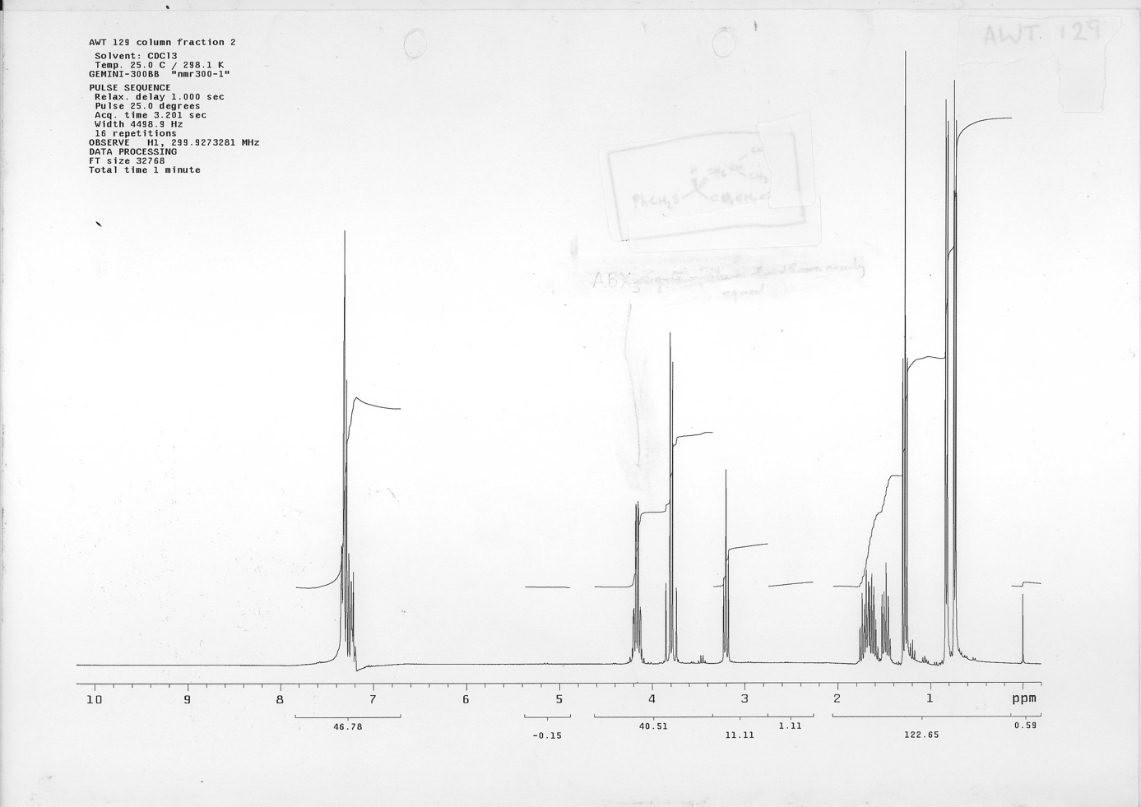
75 MHz ¹³C NMR spectrum of 11

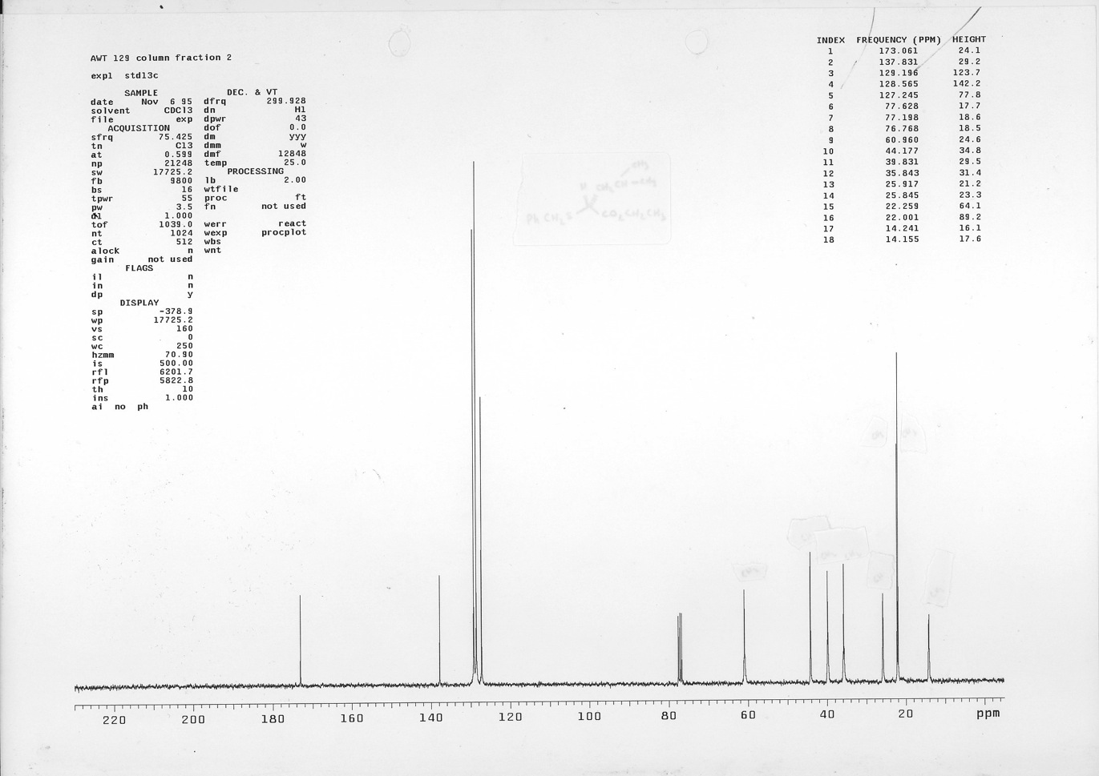
300 MHz ¹H NMR spectrum of 12

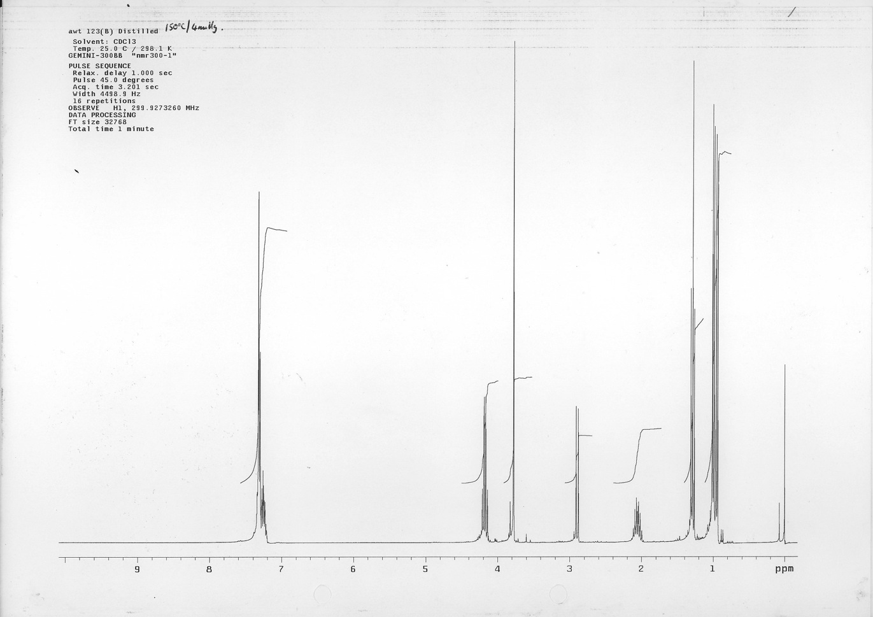
75 MHz ¹³C NMR spectrum of 12

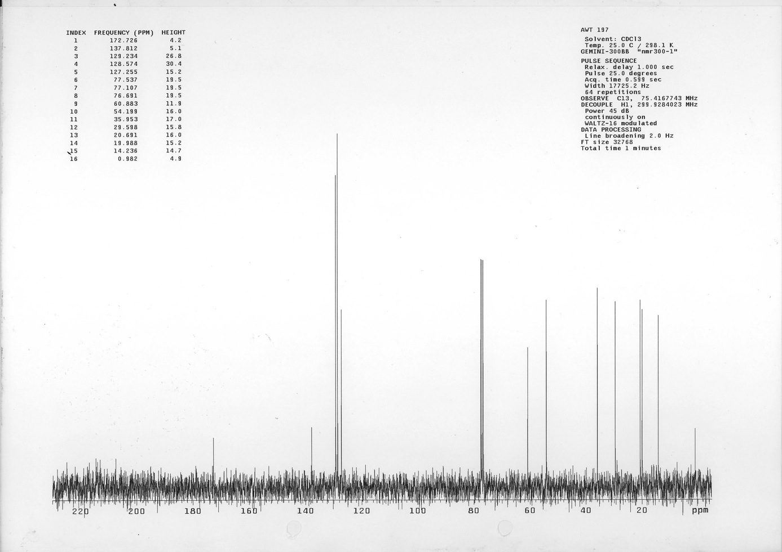
75 MHz ¹³C NMR spectrum of 13

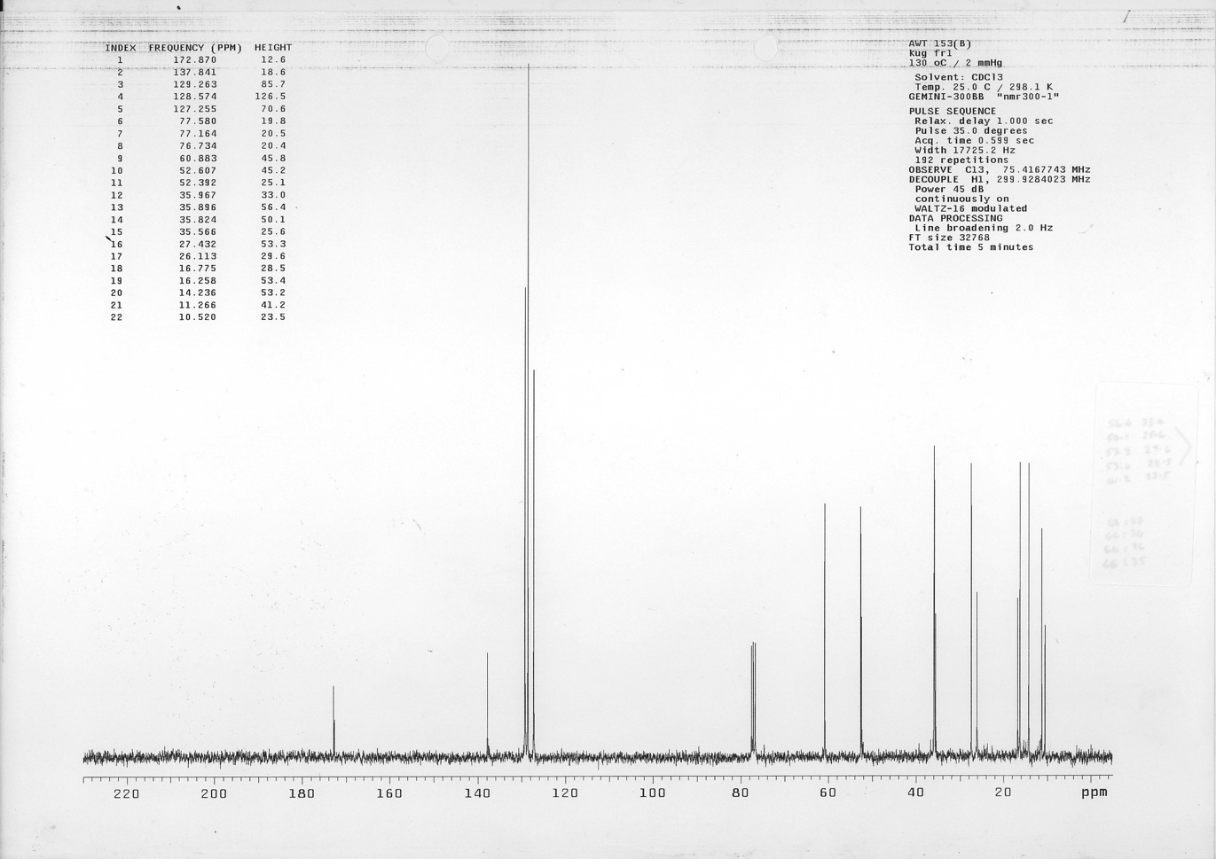
300 MHz ¹H NMR spectrum of 15

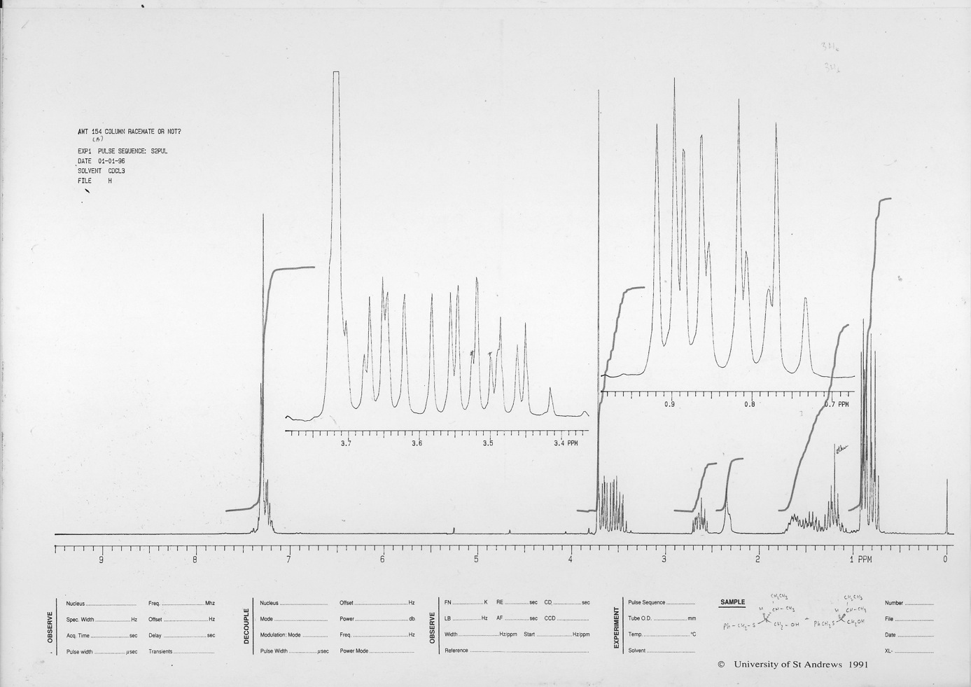
75 MHz ¹³C NMR spectrum of 15

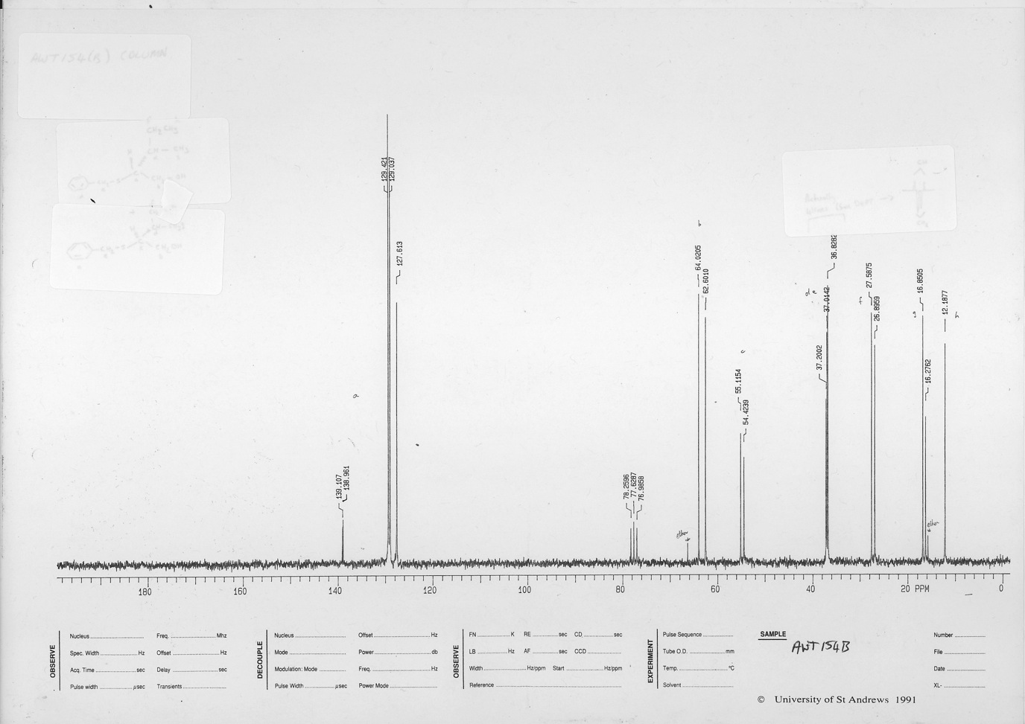
300 MHz ¹H NMR spectrum of 16

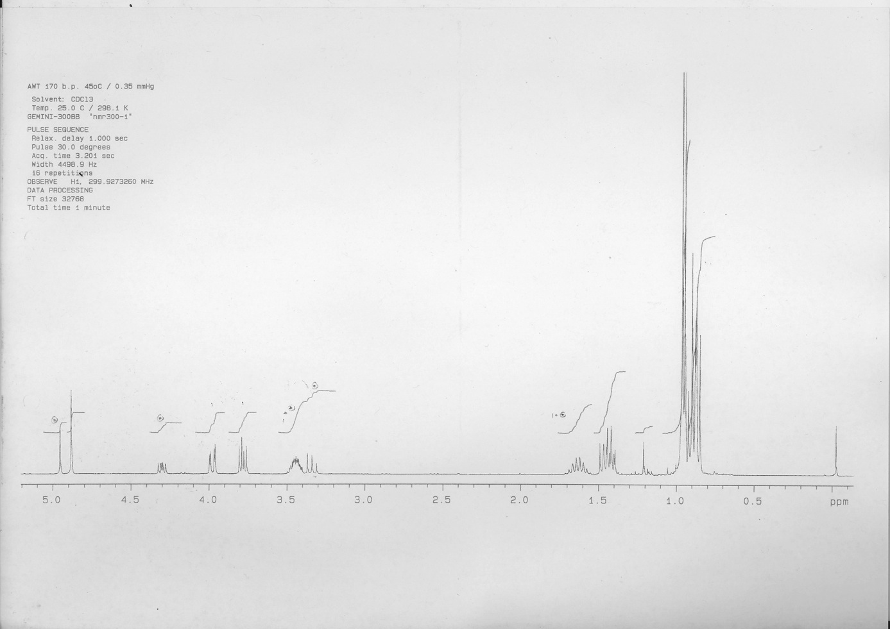
75 MHz ¹³C NMR spectrum of 16

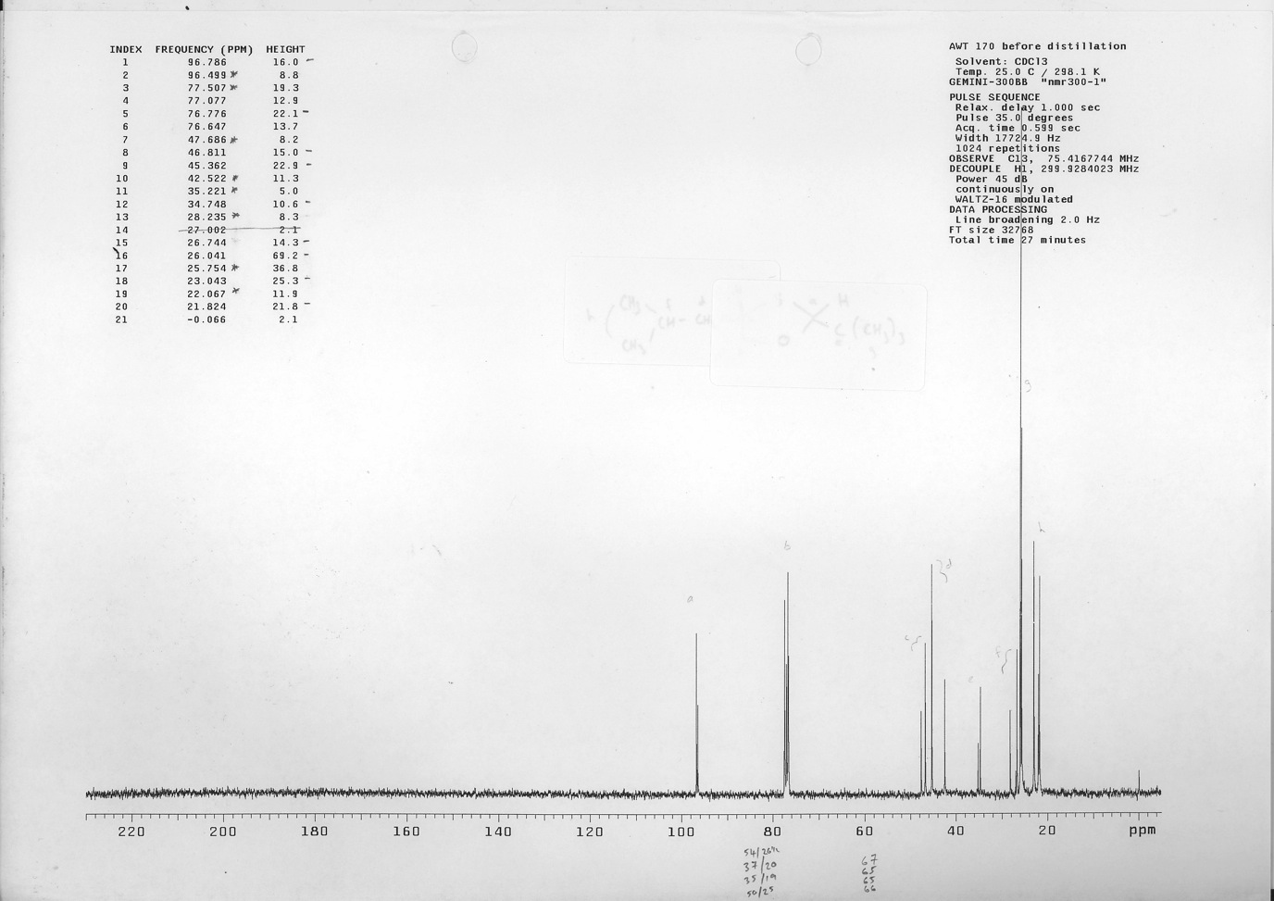
300 MHz ¹H NMR spectrum of 17

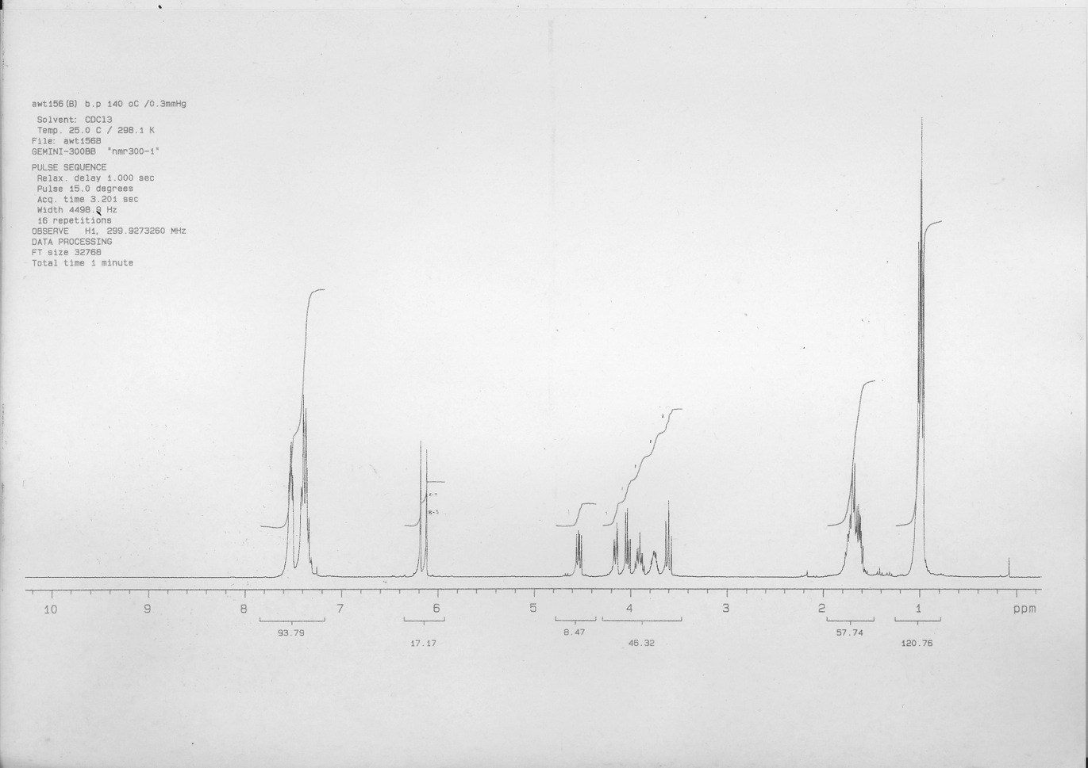
75 MHz ¹³C NMR spectrum of 17

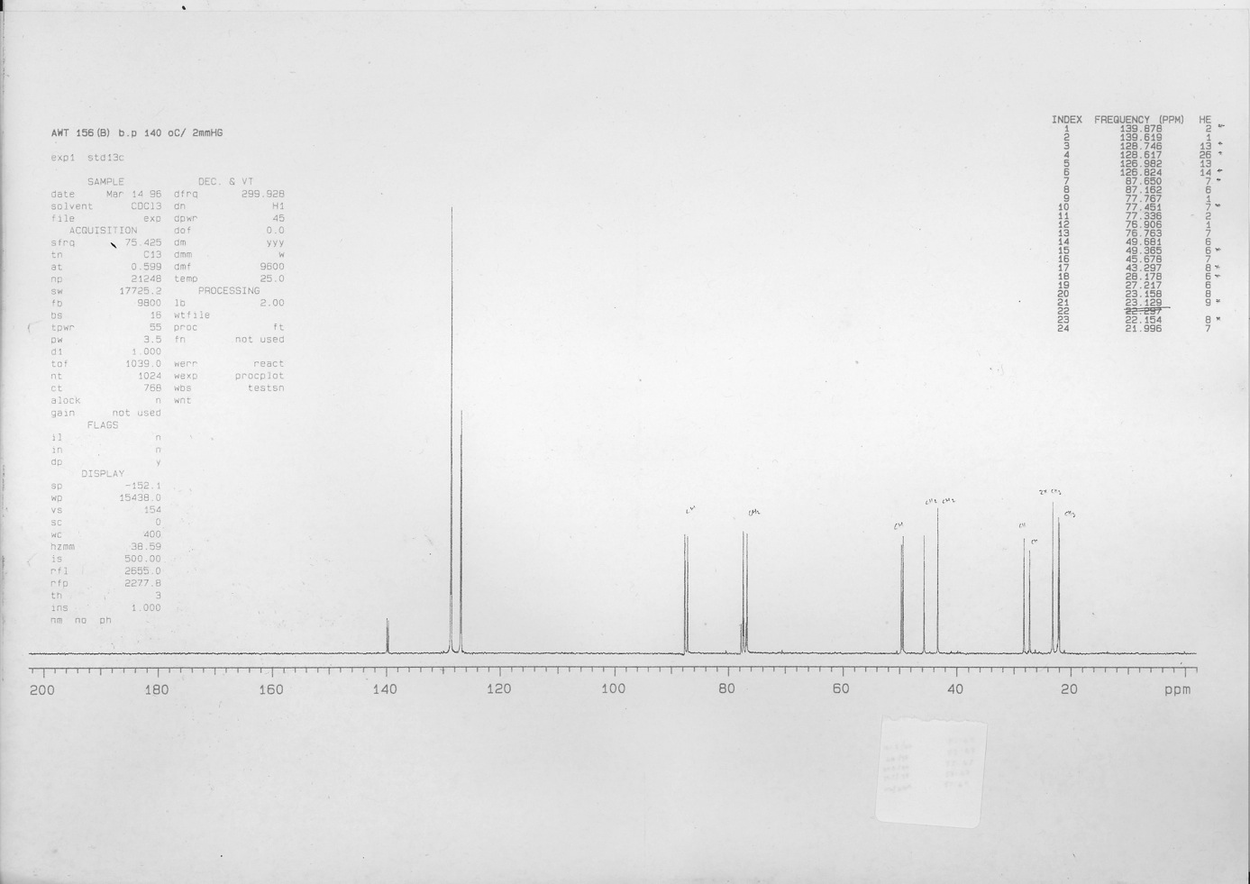
300 MHz ¹H NMR spectrum of 19

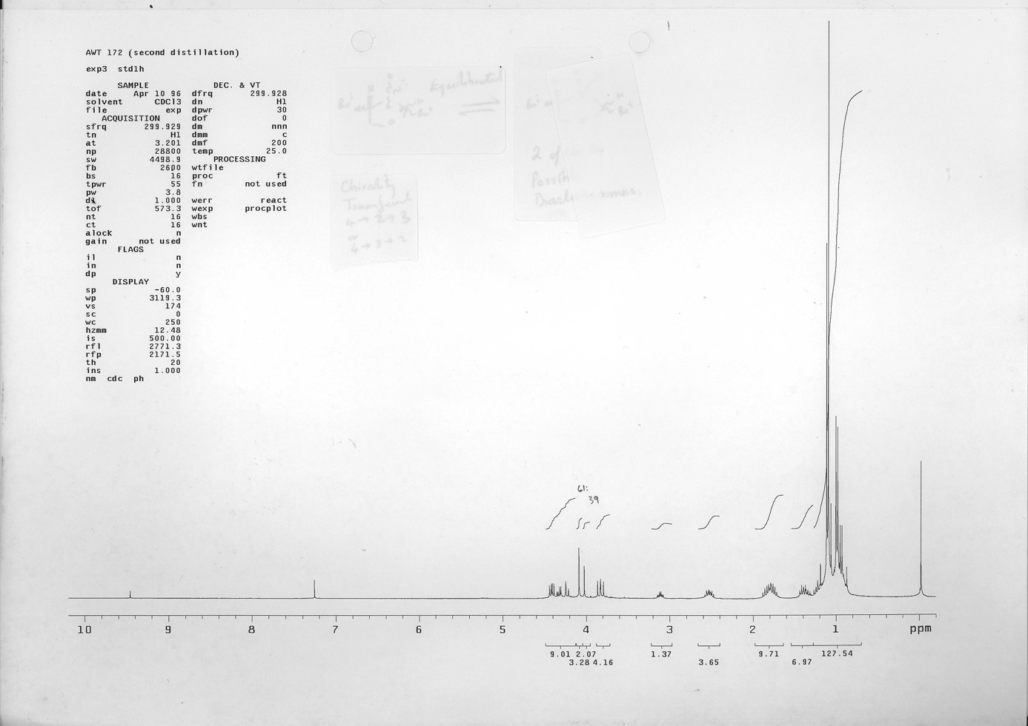
75 MHz ¹³C NMR spectrum of 19

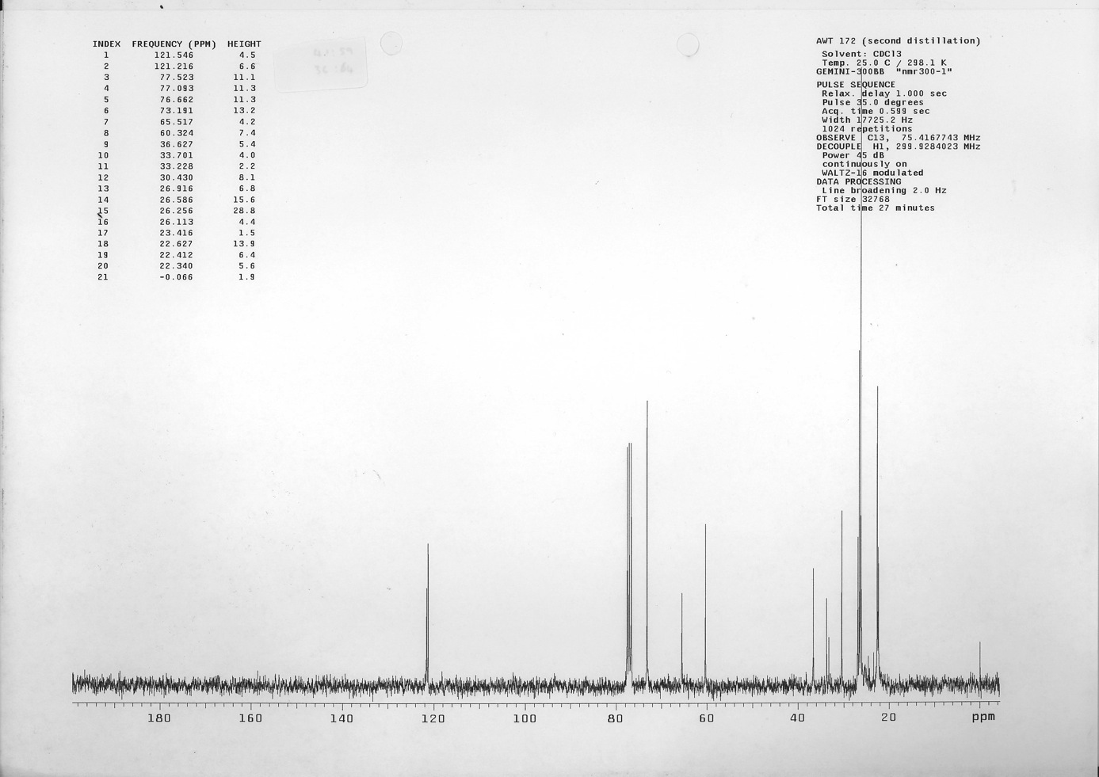
300 MHz ¹H NMR spectrum of 20

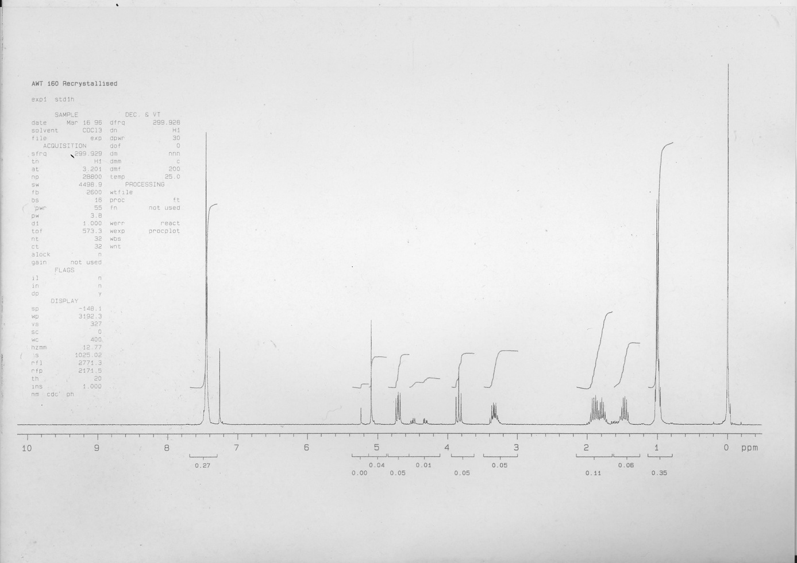
75 MHz ¹³C NMR spectrum of 20

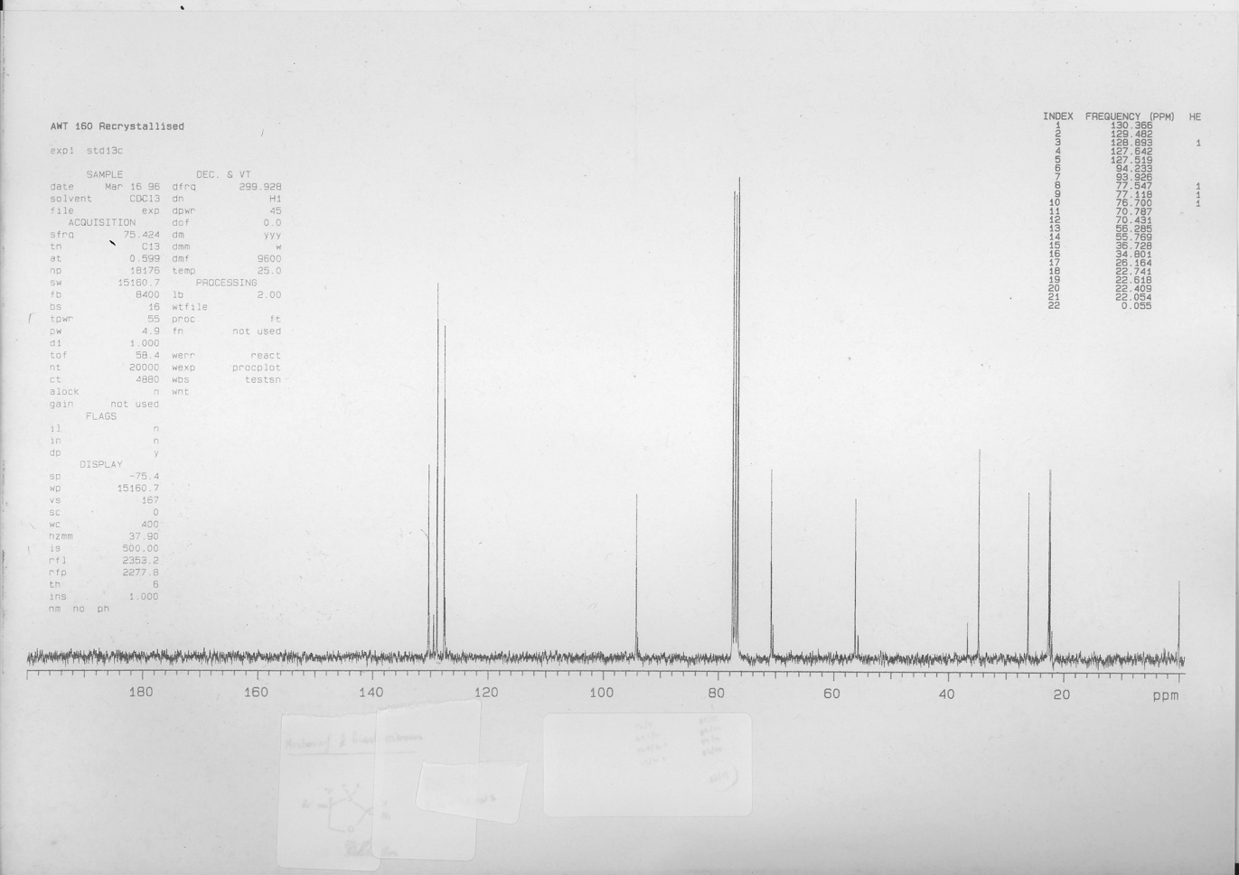
300 MHz ¹H NMR spectrum of trans-18

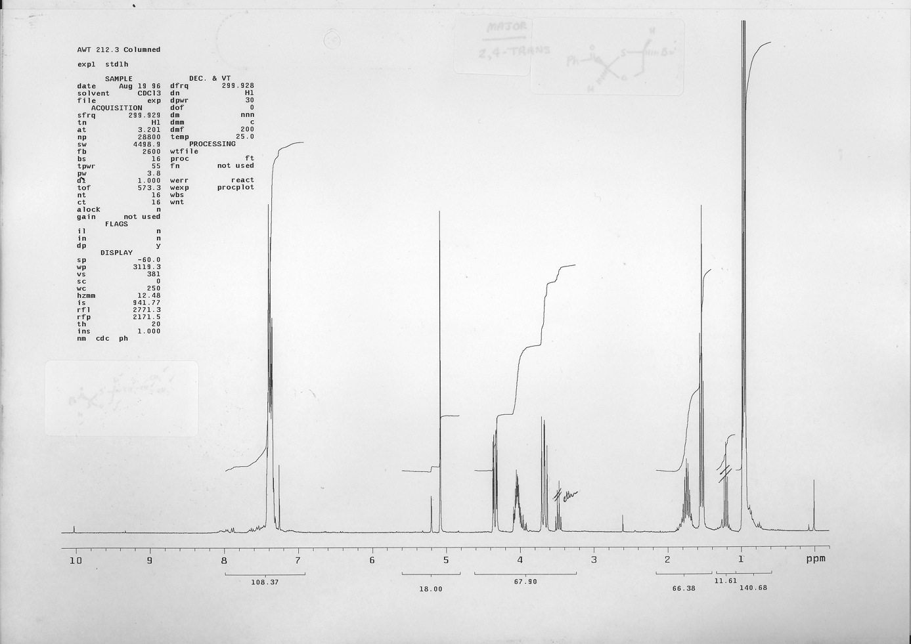
75 MHz ¹³C NMR spectrum of trans-18

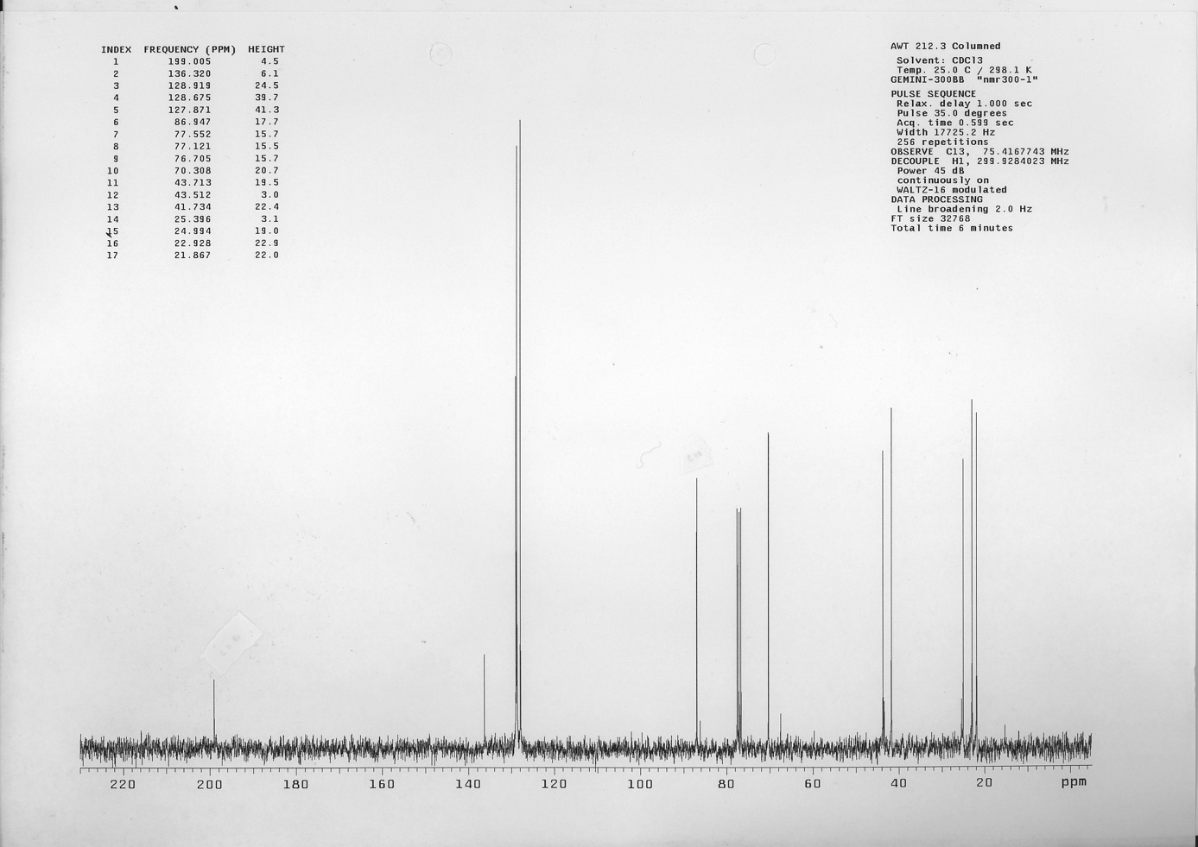
200 MHz ¹H NMR spectrum of FVP product from 20

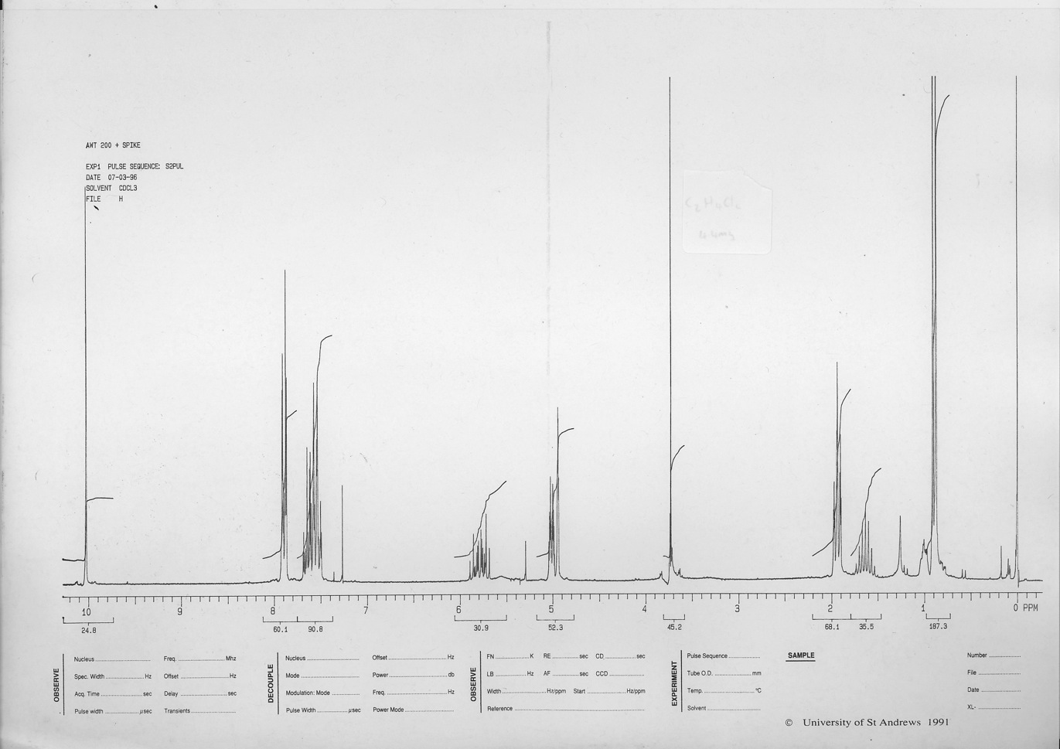
75 MHz ¹³C NMR spectrum of FVP product from 20

