SUPLLEMENTARY DATA

Secondary metabolites produced by Colletotrichum lupini, the causal agent of anthachnose of lupin (Lupinus spp.)

Marco Masiª, Paola Noceraª, Angela Boari^{b}, Maria Chiara Zonno^{b}, Gennaro Pescitelli^{c}, Sabrina Sarrocco^{d}, Riccardo Baroncelli^{e,f}, Giovanni Vannacci^{d}, Maurizio Vurro^{b} and Antonio Evidenteª

ªDipartimento di Scienze Chimiche, Università di Napoli “Federico II”, Complesso Universitario Monte S. Angelo, Via Cintia 4, 80126 Napoli, Italy
^{b}Istituto di Scienze delle Produzioni Alimentari, CNR, Via Amendola 122/O, 70126 Bari, Italy
^{c}Dipartimento di Chimica e Chimica Industriale, Università di Pisa, Via Moruzzi 13, 56124 Pisa, Italy
^{d}Dipartimento di Scienze Agrarie, Alimentari e Agro-ambientali, Università di Pisa, Via del Borghetto, 80, 56124 Pisa, Italy
^{e}Instituto Hispano-Luso de Investigaciones Agrarias (CIALE), University of Salamanca, Calle del Duero 12, 37185 Villamayor (Salamanca), Spain

Supporting Information List

Page 3: Spectra 1. ¹H NMR spectrum of lupindolinone (1) (CDCl₃, 500 MHz).
Page 4: Spectra 2. ¹³C NMR spectrum of lupindolinone (1) (CDCl₃, 500 MHz).
Page 5: Spectra 3. HSQC spectrum of lupindolinone (1) (CDCl₃, 500 MHz).
Page 6: Spectra 4. HMBC spectrum of lupindolinone (1) (CDCl₃, 500 MHz).
Page 7: Spectra 5. COSY spectrum of lupindolinone (1) (CDCl₃, 500 MHz).
Page 8: Spectra 6. HR ESI MS spectrum of lupindolinone (1).
Page 9: Spectra 7. IR spectrum of lupindolinone (1).
Page 10: Spectra 8. UV spectrum of lupindolinone (1).
Page 11: Spectra 9. ¹H NMR spectrum of lupinlactone (2) (CDCl₃, 500 MHz).
Page 12: Spectra 10. ¹³C NMR spectrum of lupinlactone (2) (CDCl₃, 500 MHz).
Page 13: Spectra 11. HSQC spectrum of lupinlactone (2) (CDCl₃, 500 MHz).
Page 14: Spectra 12. HMBC spectrum of lupinlactone (2) (CDCl₃, 500 MHz).
Page 15: Spectra 13. COSY spectrum of lupinlactone (2) (CDCl₃, 500 MHz).
Page 16: Spectra 14. HR ESI MS spectrum of lupinlactone (2).
Page 17: Spectra 15. IR spectrum of lupinlactone (2).

Spectra 1. ¹H NMR spectrum of lupindolinone (1) (CDCl₃, 500 MHz).
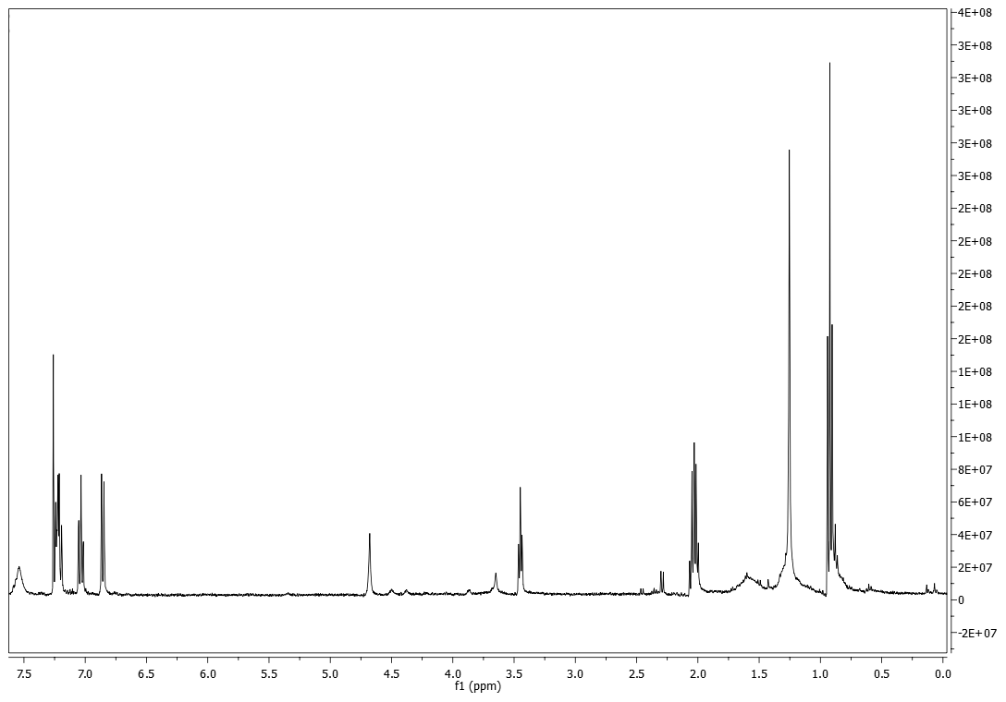
Spectra 2. ¹³C NMR spectrum of lupindolinone (1) (CDCl₃, 500 MHz).
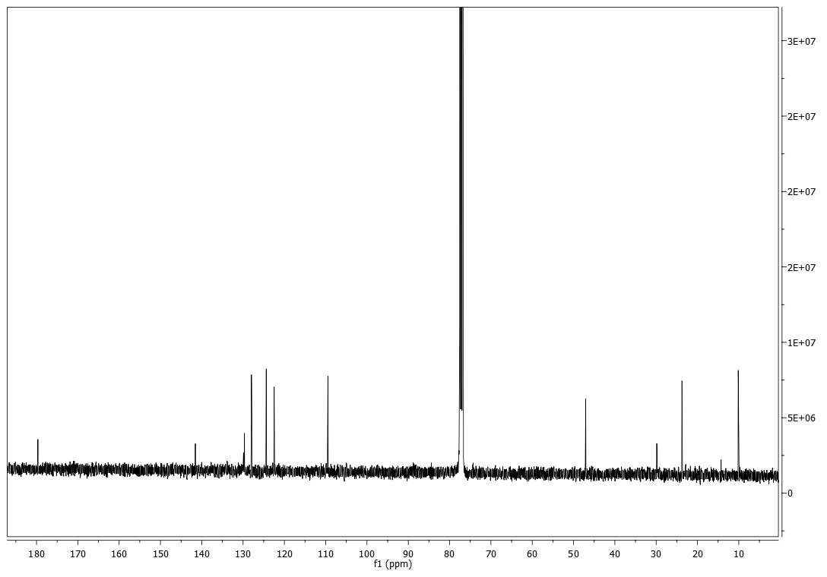

Spectra 3. HSQC spectrum of lupindolinone (1) (CDCl₃, 500 MHz). 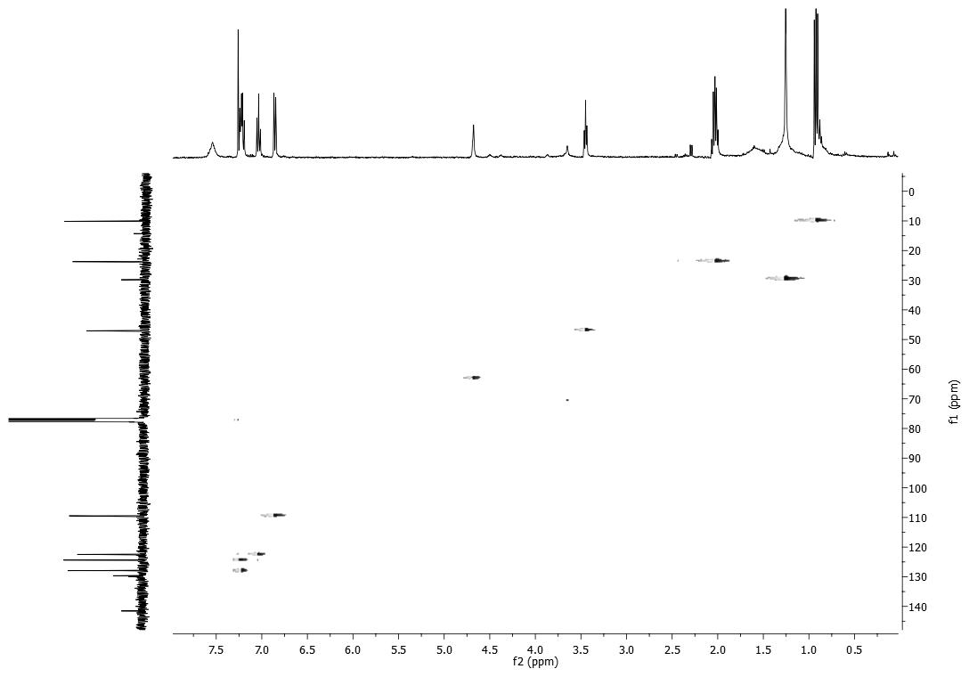

Spectra 4. HMBC spectrum of lupindolinone (1) (CDCl₃, 500 MHz). 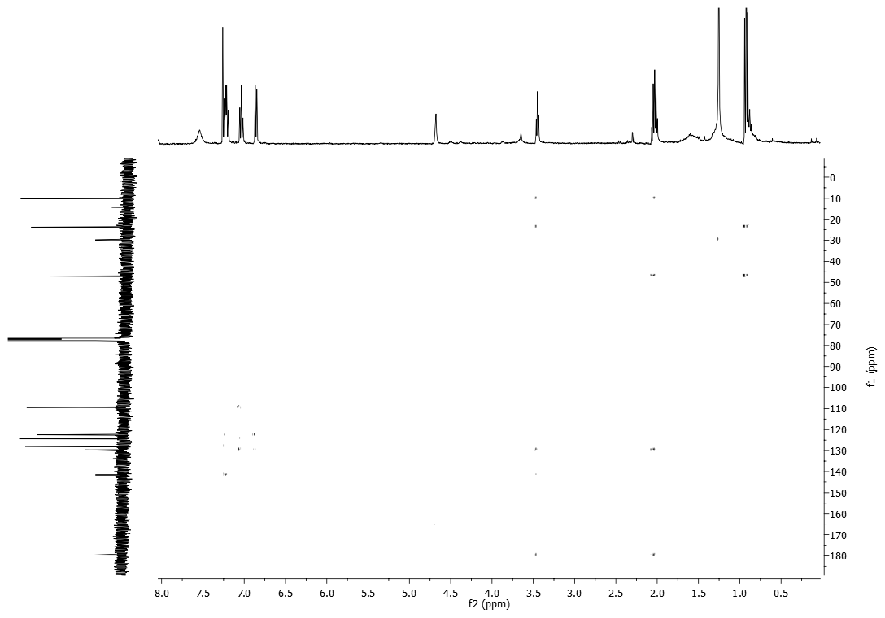

Spectra 5. COSY spectrum of lupindolinone (1) (CDCl₃, 500 MHz).
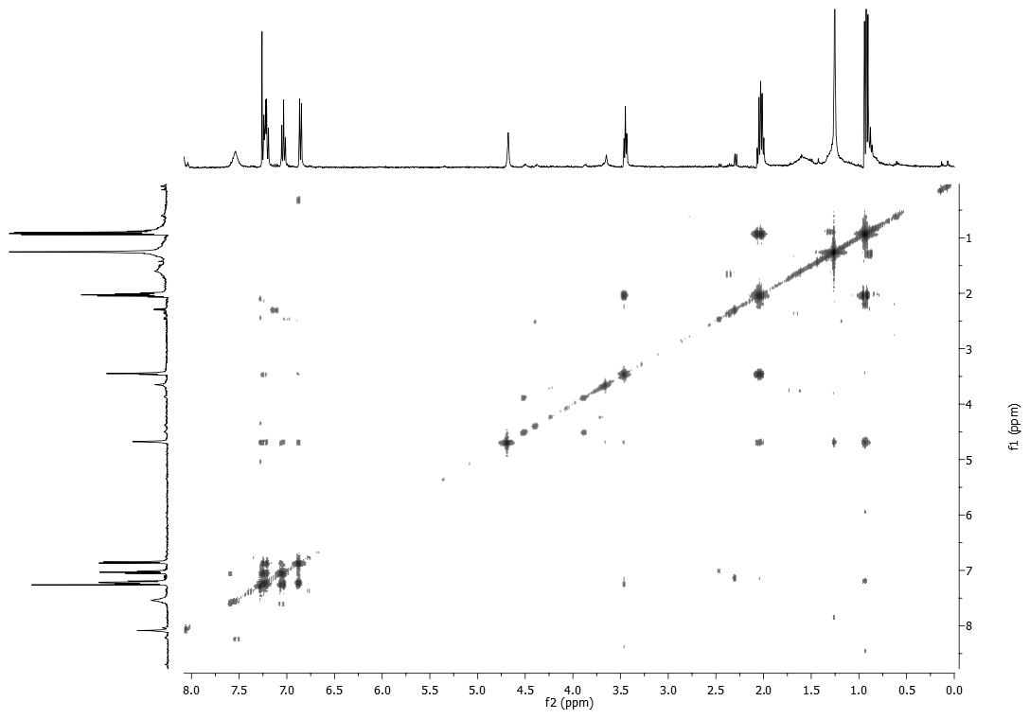

Spectra 6. HR ESI MS spectrum of lupindolinone (1).
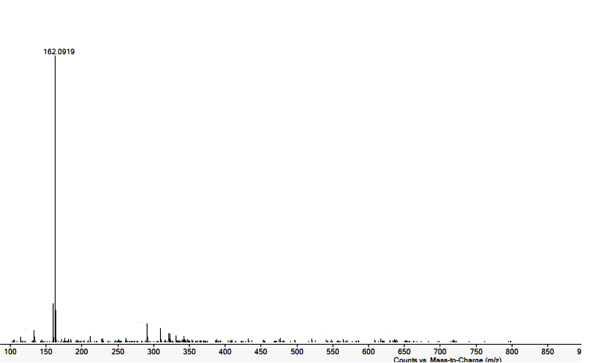

Spectra 7. IR spectrum of lupindolinone (1).

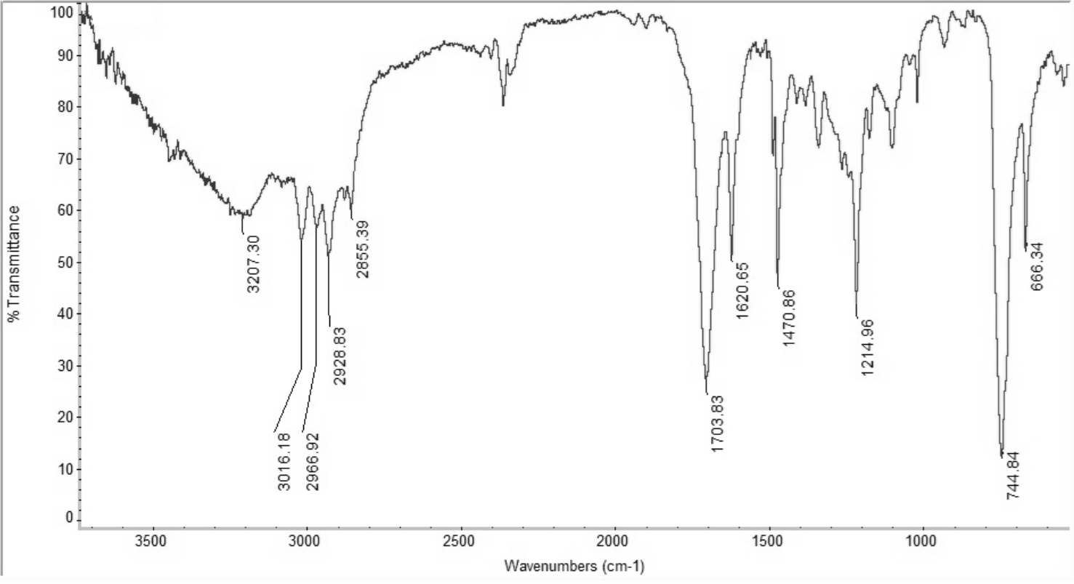

Spectra 8. UV spectrum of lupindolinone (1).
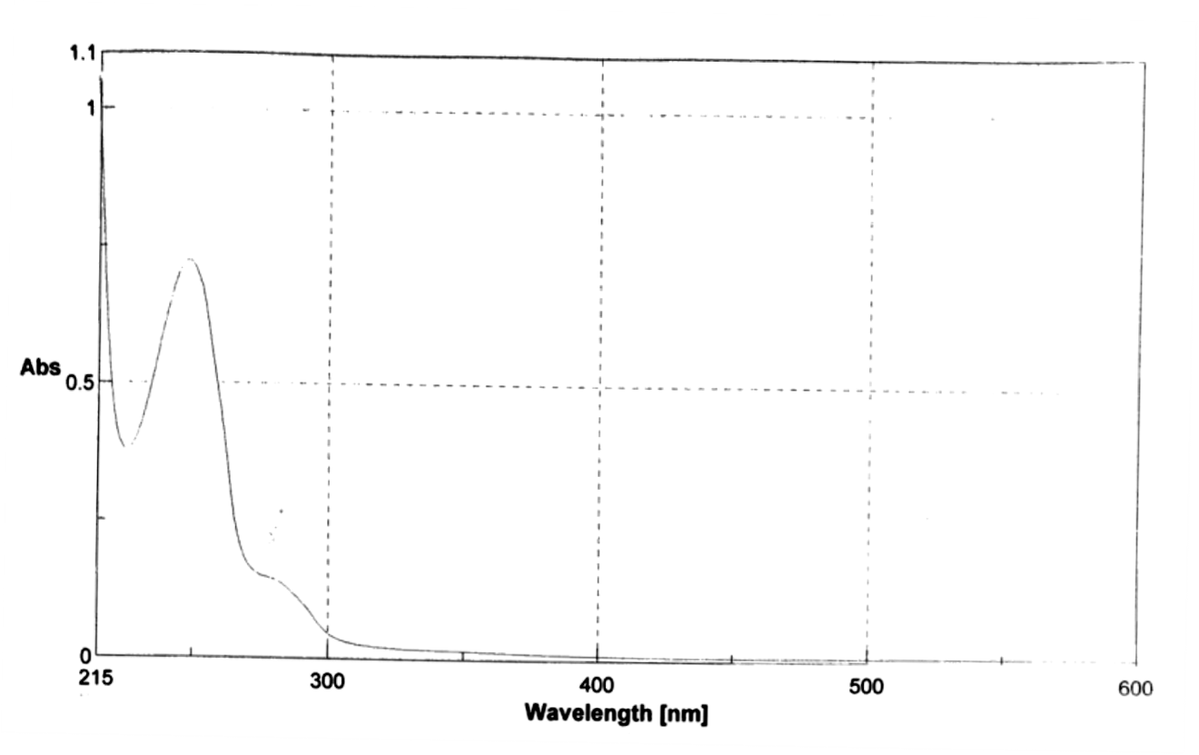

Spectra 9. ¹H NMR spectrum of lupinlactone (2) (CDCl₃, 500 MHz).
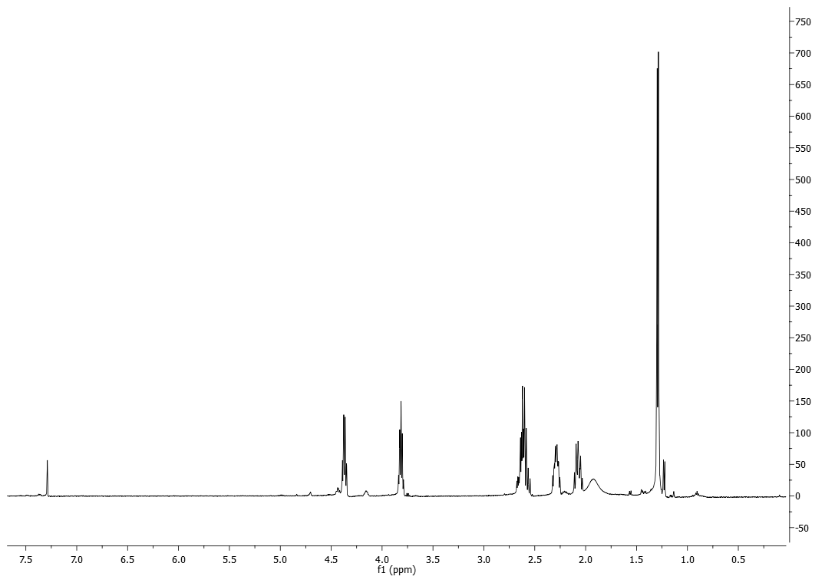

Spectra 10. ¹³C NMR spectrum of lupinlactone (2) (CDCl₃, 500 MHz).

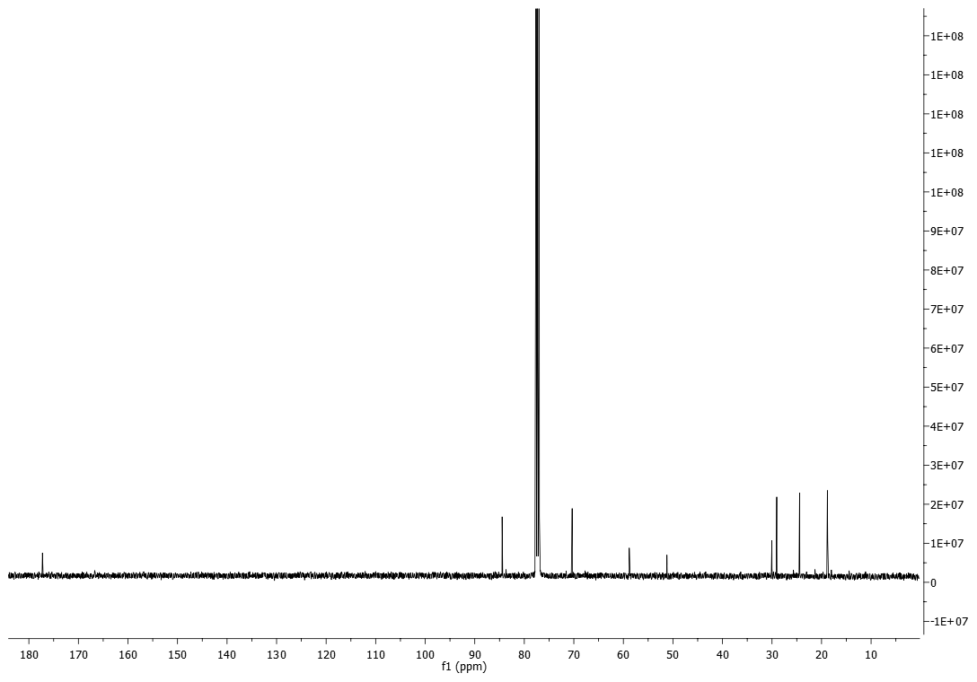
Spectra 11. HSQC spectrum of lupinlactone (2) (CDCl₃, 500 MHz).
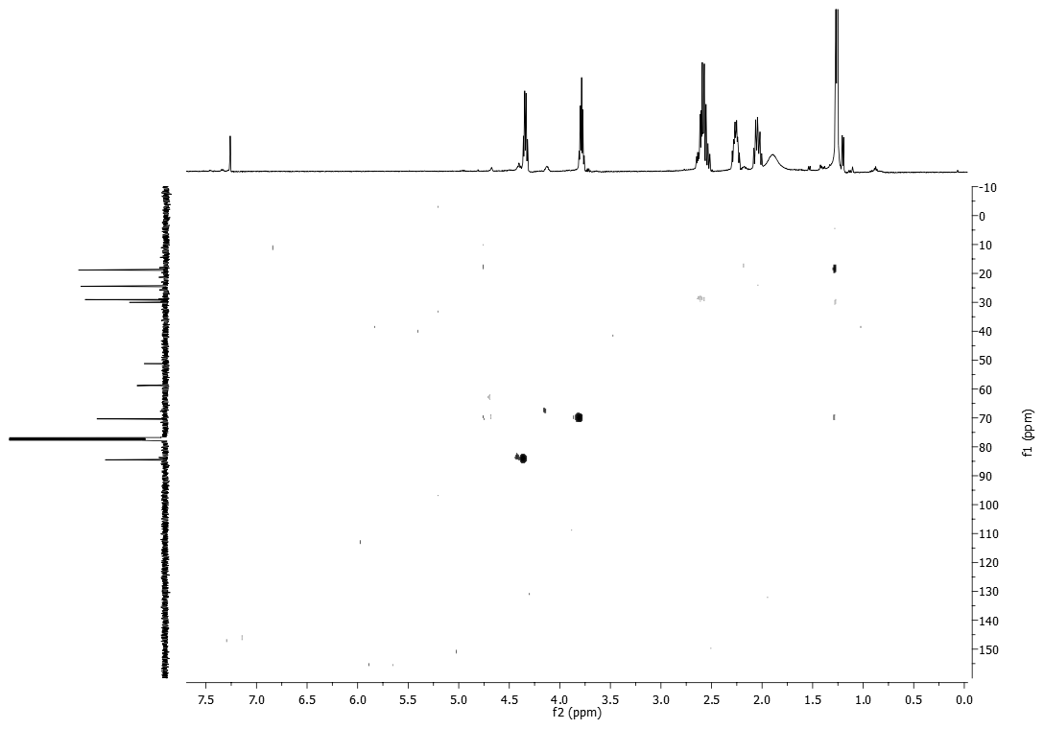
Spectra 12. HMBC spectrum of lupinlactone (2) (CDCl₃, 500 MHz).
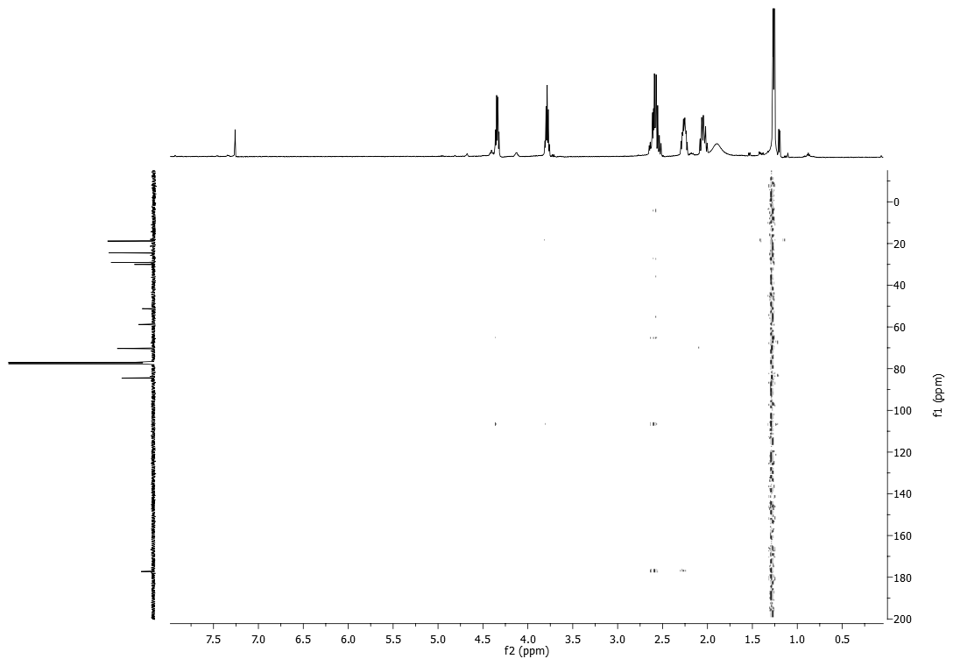

Spectra 13. COSY spectrum of lupinlactone (2) (CDCl₃, 500 MHz).
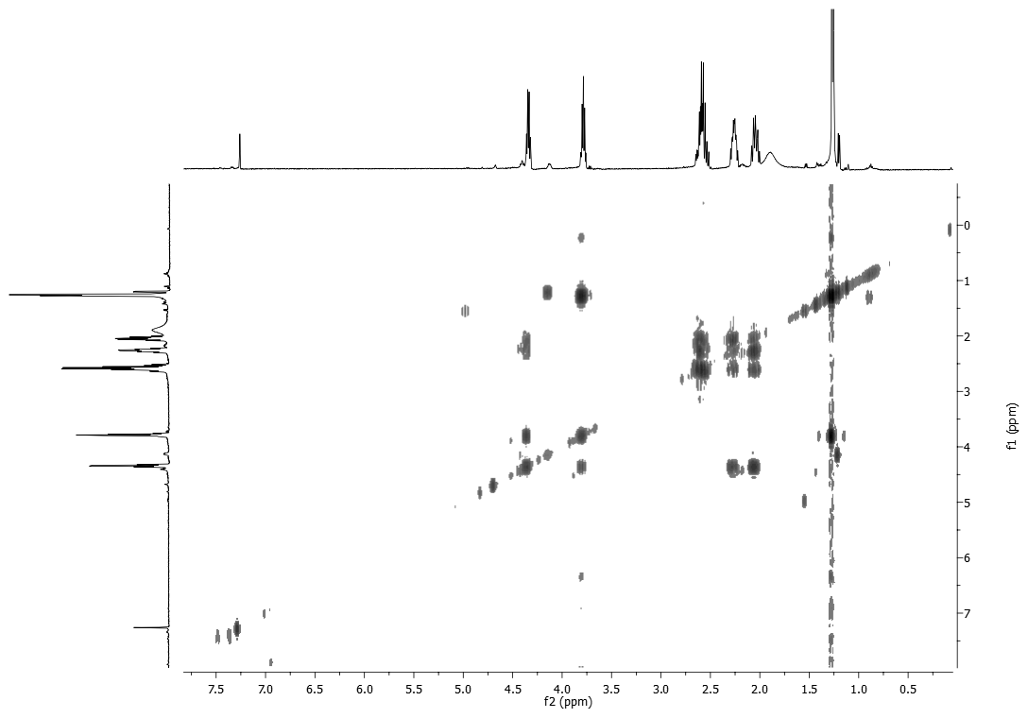

Spectra 14. HR ESI MS spectrum of lupinlactone (2).

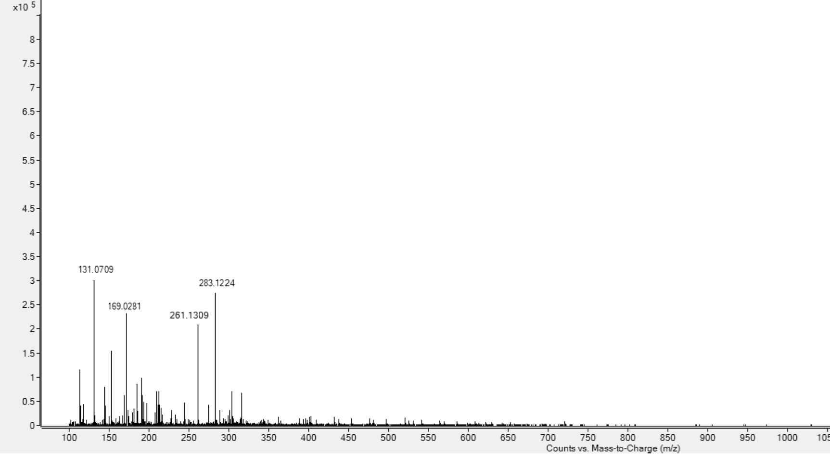
Spectra 15. IR spectrum of lupinlactone (2).

