|  |  |  |  |  |  |  |  |
| --- | --- | --- | --- | --- | --- | --- | --- |
| Supplemental Table 1. mRNA-seq data analysis | | |  |  |  |  |  |
| Samples | Clean Reads | Mapped Reads | Mapping Rate | MultiMap Reads | MultiMap Rate | mapped genes  (FPKM>0) |
| hDNMT3A+brain-rep1 | 47,602,340 | 45,921,073 | 0.965 | 2,508,926 | 0.0527 | 16,535 |
| hDNMT3A+brain-rep2 | 47,145,886 | 45,506,519 | 0.965 | 2,531,604 | 0.0537 | 16,630 |
| hDNMT3A+brain-rep3 | 46,118,318 | 44,574,288 | 0.967 | 2,411,936 | 0.0523 | 16,775 |
| hDNMT3A+testis-rep1 | 45,274,858 | 43,299,538 | 0.956 | 3,181,949 | 0.0703 | 18,316 |
| hDNMT3A+testis-rep2 | 44,802,236 | 42,685,461 | 0.953 | 3,175,984 | 0.0709 | 18,389 |
| hDNMT3A+testis-rep3 | 45,621,024 | 43,563,523 | 0.955 | 3,325,646 | 0.0729 | 18,299 |
| hDNMT3A-brain-rep1 | 53,284,742 | 49,163,354 | 0.923 | 2,830,024 | 0.0554 | 17,014 |
| hDNMT3A-brain-rep2 | 46,397,476 | 42,804,110 | 0.923 | 2,438,636 | 0.0545 | 16,923 |
| hDNMT3A-brain-rep3 | 46,817,414 | 43,858,901 | 0.937 | 2,466,553 | 0.0541 | 17,030 |
| hDNMT3A-testis-rep1 | 49,093,234 | 45,671,930 | 0.930 | 2,859,470 | 0.0602 | 18,728 |
| hDNMT3A-testis-rep2 | 48,101,188 | 44,836,965 | 0.932 | 2,717,082 | 0.0582 | 18,925 |
| hDNMT3A-testis-rep3 | 45,451,690 | 42,157,748 | 0.928 | 2,567,413 | 0.0585 | 18,869 |
| WT-brain-rep1 | 45,613,976 | 44,009,603 | 0.965 | 2,422,194 | 0.0531 | 16,796 |
| WT-brain-rep2 | 44,469,128 | 42,874,772 | 0.964 | 2,326,307 | 0.0523 | 17,343 |
| WT-brain-rep3 | 46,008,944 | 44,451,418 | 0.966 | 2,506,225 | 0.0545 | 16,538 |
| WT-testis-rep1 | 44,683,458 | 42,783,799 | 0.958 | 3,077,243 | 0.0689 | 18,141 |
| WT-testis-rep2 | 44,167,826 | 42,097,627 | 0.953 | 3,266,354 | 0.074 | 18,286 |
| WT-testis-rep3 | 46,701,270 | 44,626,130 | 0.956 | 3,261,207 | 0.0698 | 18,336 |

Supplemental Table 2. Primers used in this study.

|  |  |  |
| --- | --- | --- |
| Primers | Forward primers (5'-3') | Reverse primers (5'-3') |
| **qPCR-primers** |  |  |
| *hDNMT3A* | AGTTAGCAGCAGGGAGACGA | AAGAGGTAACA-GCGGCTTCTA |
| *rDnmt3a* | GAAACCCAGAAAGAGCACAAC | CTTACAGTTCTGGCACATTCCA |
| *rGapdh* | GGCAAGTTCAATGGCACAGT | TGGTGAAGACGCCAGTAGACTC |
| *Ac239701.1* | GAGGATAAGCAAACGGGAG | GCGTCTGGGAATGTAATACTTC |
| *AABR07051450.1* | GCCCACACTGCTACTGTATG | GCGTTTGTCATAGAAGGAGATG |
| *Ccndbp1* | CTGTTCTGACCACACTCTTCTC | TCAGTGGCAATGTGGACTT |
| *retsat* | CCGTTTCATCTTGGACCA | GATGTATTCTTTCCTCCCACTG |
| *acox3* | TGGAAGCCTACCCTGGAATC | AAACAAGCCAACGGTAGG |
| *cyren* | ACACTGGCACTCACTGGAT | AATCACACTCTCATCACACCG |
| *galns* | TGACCTGGGTGTGTATGGA | AGGGTTGGCAGAATAGAAGC |
| *Coq3* | TCTGGGATGAAGATTCTCG | CGATTCCAACAACTGAAGC |
| *Pitpnm1* | CCAAGCCAGACCTACATTGT | CACATAGCCATCTGACAGGA |
| *Cand2* | CGCCTACGGAATGAGATAA | AAATGAAGCGAGGATGGG |
| *Dkc1* | TGGTCAAGTCACAGCAGAGC | GGCTCTCATAGATTGTGCG |
| **BSP-primers** |  |  |
| *Ac239701.1-BSP* | AAATGGTTAATAGTTTGGGGATTGGTTG | CTAATAATTATCCAACTACACTAAAACCATAAC |
| *AABR07051450.1-BSP* | TGATAGTTAGATTTTTGTTTTTATTTGTGT | CTATAAATAACCAACAACAAAATAATAACC |
| *Coq3-BSP* | AATTTATGTAAATGTAAAAGTTTGTAGTTG | CACCTAATCCTAAAAATCATACAAAATAAC |
| *Dkc1-BSP* | TGTTTATTTGTTTTAGTTTGAGGGAGGATA | AACRAAAATAACTACCAAAAAAACAACCC |



**Supplemental Figure 1. Protein and protein interaction (PPI) analysis of differentially expressed genes.** Two PPI sub-cluster networks of differentially expressed genes in the brain (A, C) and their corresponding GO analysis results (B, D). Two PPI sub-cluster networks of differentially expressed genes in the testis (E, G) and their corresponding GO analysis results (F, H).

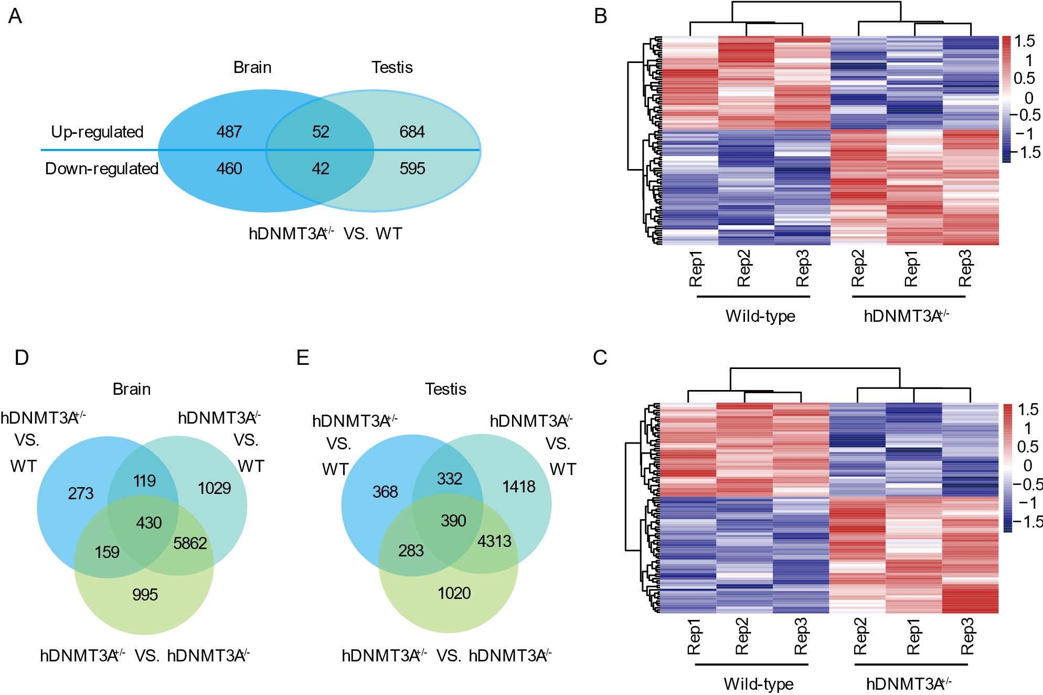

**Supplemental Figure 2. Common differentially expressed genes in both the brain and testis.** A. Common differentially expressed genes in both the brain and testis. B. Heatmap of the common differentially expressed genes in the brain. C. Heatmap of the common differentially expressed genes in the testis. E. Common differentially expressed genes in three comparison combinations in the brain. F. Common differentially expressed genes in three comparison combinations in the testis.

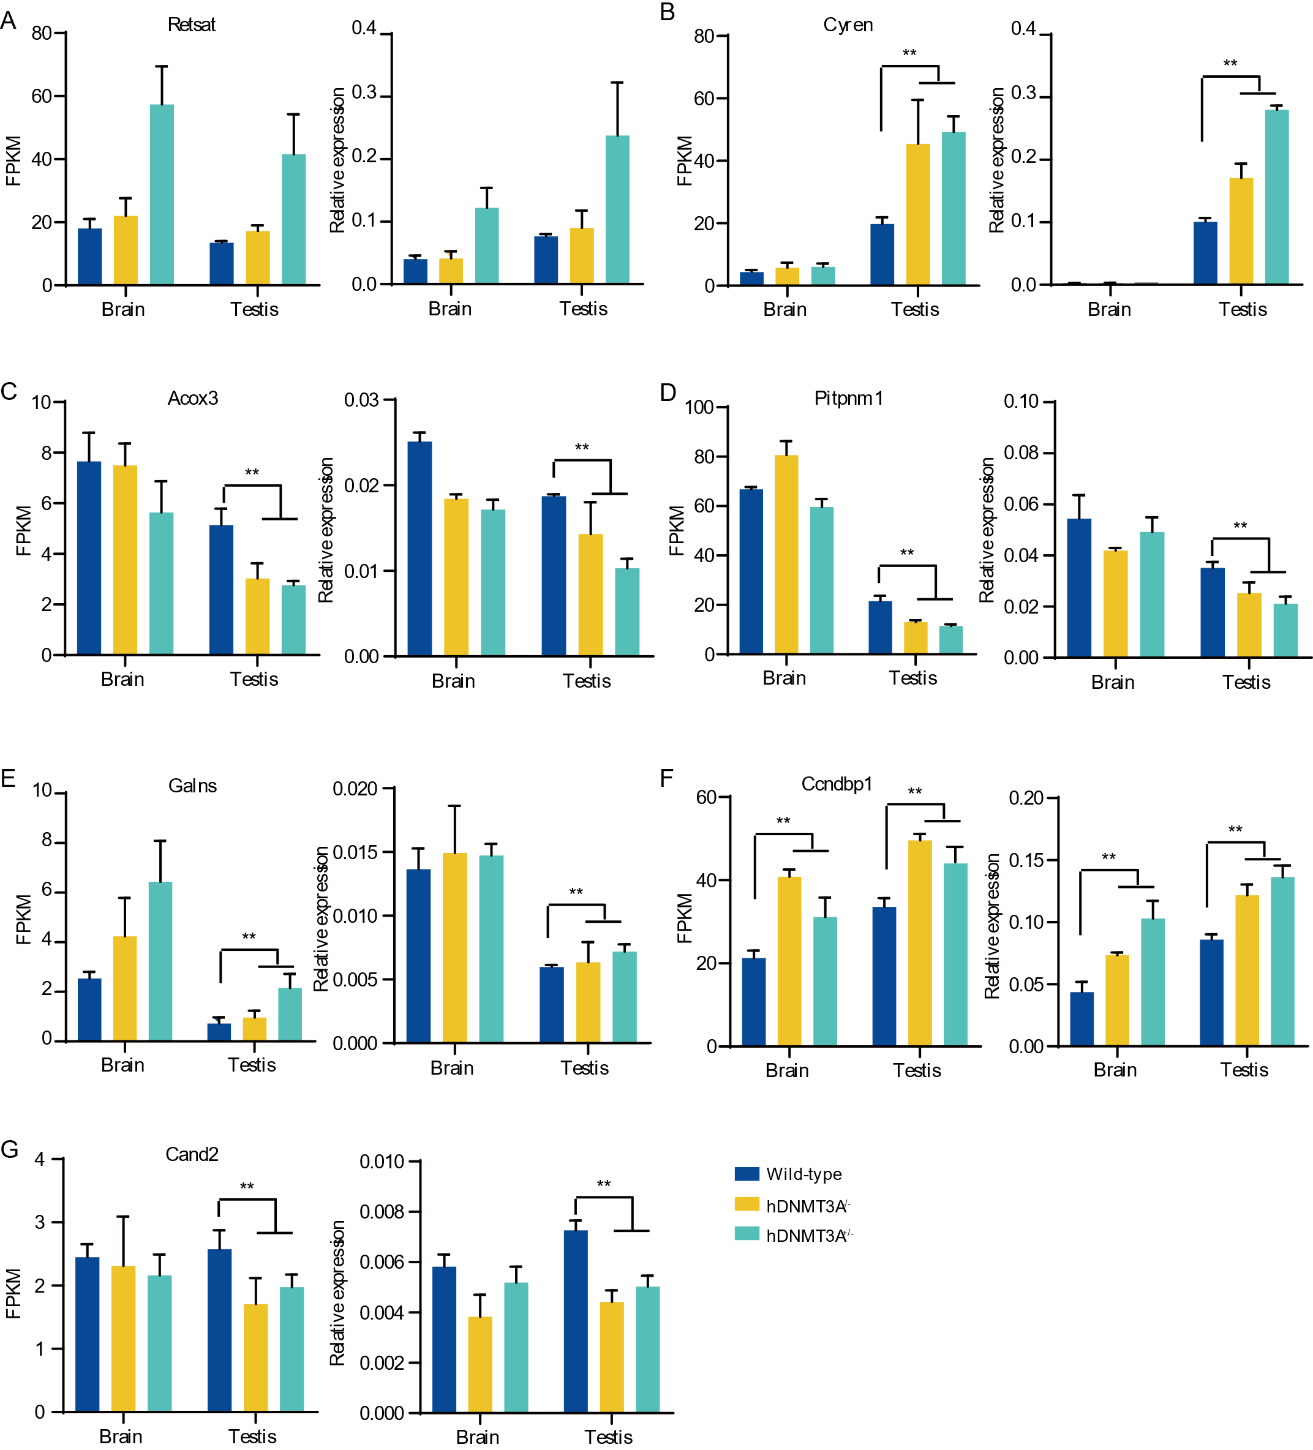

**Supplemental Figure 3. Using qPCR to validate differentially expressed genes between rat lines.** FPKM value that identified by mRNA-seq and relative expression level that identified by qPCR for *Retsat (A), Cyren (B)*, *Acox3 (C)*, *Pitpnm1 (D)*, *Galns (E)*, *Ccndbp1 (F)*, and *Cand2 (G)*.

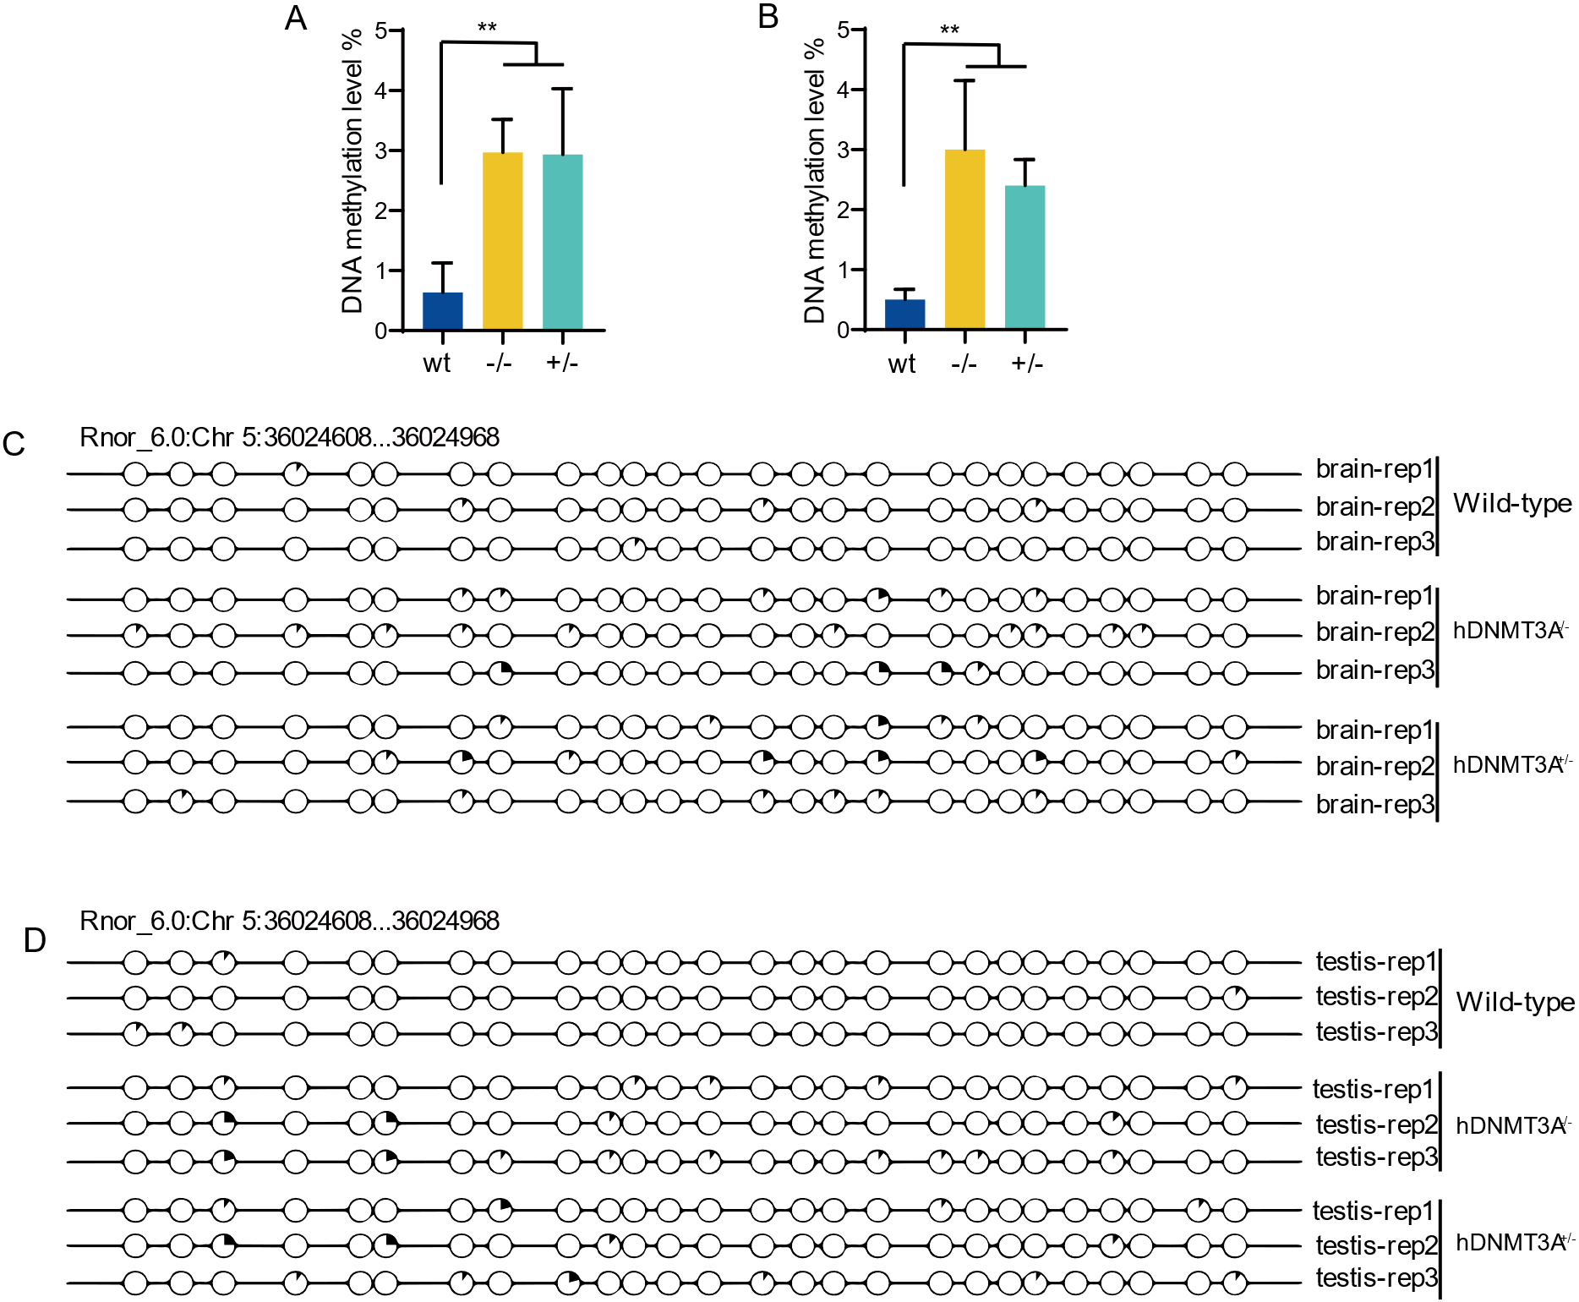

**Supplemental Figure 4. Intergenerational inheritance of the transgene-induced DNA methylation variations in CpG island of *Coq3* exon.** A. DNA methylation variations in the brain of all rat lines. B. DNA methylation variations in the testis of all rat lines. C. DNA methylation levels of the *Coq3 exon* in the brain. D. DNA methylation levels of the *Coq3 exon* in the testis.

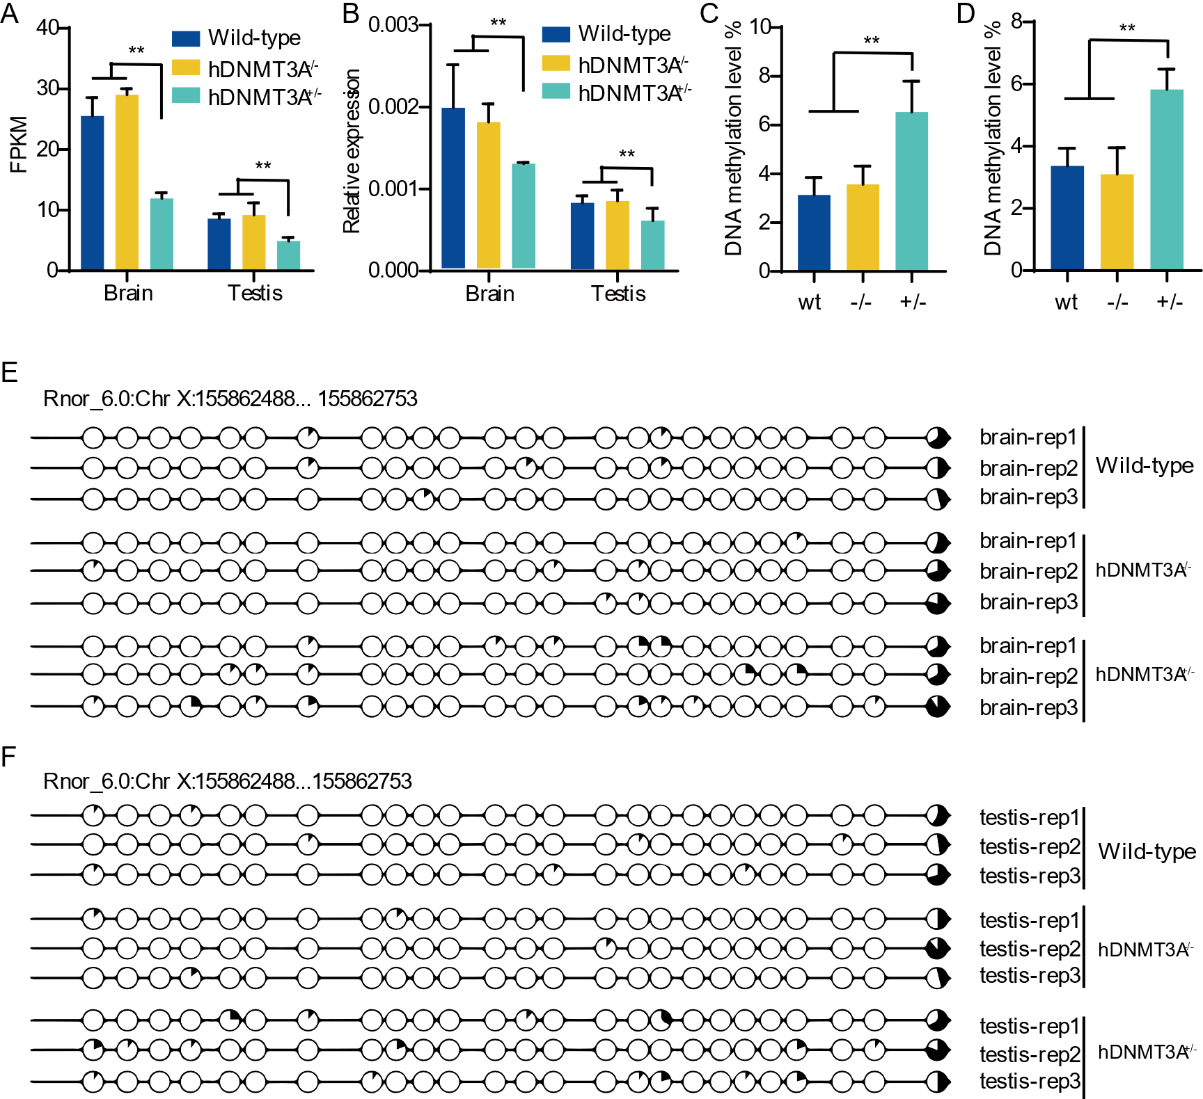

**Supplemental Figure 5. Gene expression patterns and DNA methylation status of the gene, *Dkc1,* which would be affected by the additional expression of hDNMT3A.** A. FPKM value that identified by mRNA-seq for *Dkc1*. B. Relative expression level that identified by qPCR for *Dkc1*. C. DNA methylation levels of the *Dkc1* promoter in the brain. D. DNA methylation levels of the *Dkc1* promoter in the testis. E. DNA methylation patterns of the *Dkc1* promoter in the brain. F. DNA methylation patterns of the *Dkc1* promoter in the testis.