Figure 1
The photographs of composite steamed breads made by EP and UP
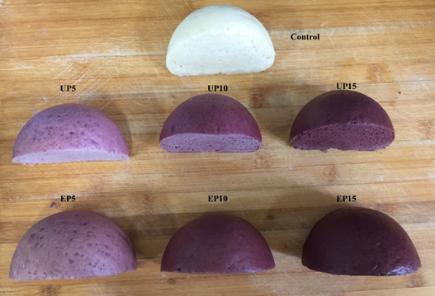
Fig.1

